EXPERIMENTAL INVESTIGATION OF NSC M-30 GRADE RC COLUMN SUBJECTED TO AXIAL LOAD

Prasad K N1

1Amruta Institute of Engineering and Management Science, Bidadi

Email: prasadnagaraj97@gmail.com

Theju R K2

2Navkis College of Engineering

Hassan

Email: thejukumar95@gmail.com

Seema B S 3

3Adichunchangiri Institute Of Technology

Chikkmagaluru

Email: seemabsgowda@gmail.com

Dr.Vinodkumar Biradar4

4Amruta Institute of Engineering and Management Science, Bidadi

Email: biradarvinod075@gmail.com

ABSTRACT

Investigational study was carried out on the short reinforced concrete columns which were subjected to axial load. The main objective of the study was to determine the shear behavior of columns when subjected to concentric loads and to compare the experimental loads with available standard codes. Twelve number of columns were casted with different percentage of main reinforcement and different spacing of stirrups. The outcome of the result was with increase in the percentage of steel, load carrying capacity for the column increased as well as the ductility index also increased..

# INTRODUCTION

Reinforced concrete also called reinforced cement concrete is one of the most significant building constituents in recent days, it is widely utilized in construction of many civil engineering structures. Various characteristics like the productivity, the strength, low cost and rigidity of reinforced concrete manage it to be a significant component for wide spread structural purposes. Concrete is composite material, it is a blend of aggregates, cement and water. Normal strength Concrete possesses compressive strength value less than 50 N/mm2. Normal strength Concrete can also be referred to as Traditional Vibrated or conventional concrete or Ordinary Portland Cement Concrete. Normal strength Concrete is made of four components namely Ordinary Portland cement, fine and coarse aggregate and water. Proportioning of the constituents has been done based on the codes specified in IS:10262-2009. In normal-strength concrete, de-bonding of the cement paste from the aggregate particles occurs due to failure in compression. Quality of Concrete is an important criterion for good bonding. Some of parameters which define the quality of concrete are concrete strength, modulus of elasticity and Poisson's ratio. The tensile strength, compression strength, size and texture of the aggregates used in the mix, mix proportions also have an important consequence such as the difference in strength of the resultant concrete. When cement comes in contact with water chemical reaction known as hydration takes place, during this reaction it forms minute transparent layer enclosing and binding the aggregate to form a firm assembly. The aggregates which are considered for manufacture of concrete should not have the presence of any destructive materials like chemical impurities and soil particles. Compression, flexure, and torsion are some of engineering properties which are related to concrete. Reinforced concrete is a combination of material in which by the provision of reinforcement which possess superior tensile strength overcomes lower tensile strength and ductility property of concrete.

* 1. **IMPORTANT FEATURES OF REINFORCED CONCRETE**

1. It has same coefficient of thermal expansion as that of steel, due to this large stress within resulting from changes in thermal expansion or contraction can be omitted.
2. Stress transfer takes place effectively in between various components of concrete due to the hardening of cement paste within the concrete.
3. As an outcome of the alkaline chemical activity taking place in concrete provides an opaque layer on the surface of the rebar, making it much more corrosion resistant.

Requirement of steel for various structural components is usually small, for the construction of beams it requires around one percent of steel and for the construction of columns and slabs it requires nearly six percent of steel. Rebar are usually round in cross- section and are available in various diameter. Steel bar should undergo same amount of deflection as that of neighboring concrete to reduce the consequences like discontinuity and separation of the two components under the action of load. Stress transfer takes place in between the concrete and steel as a result of this, tensile stress changes in steel bar along its longitudinal direction. Anchorage bond provides mean for transmission of stress among the rebar and concrete. Stress field will be developed nearby the boundary of steel and concrete. Compressive strength was considered as the most important factor in development of concrete and to classify material. Grade of concrete was generally increased in order to obtain durable concrete. However later it was concluded that other parameters such as durability and workability of concrete are also significant factor in development of concrete.

# MATERIALS AND METHODS

## **MATERIALS**

1. Cement: OPC: Ordinary Portland Cement of 53 grade.

2. Fine Aggregate: M. Sand of Zone II.

3. Coarse Aggregate: 20mm downsize Aggregates.

4. Water: Portable water.

5. Steel: 8mm,10mm,12mm & 16mm TMT bars were used

Table:1 Specific Gravity of constituents.

|  |  |  |  |  |
| --- | --- | --- | --- | --- |
| **Sl. No** | **Material** | **Specific gravity** | **IS codal limits** | **Related IS code** |
| 1. | Cement | 3.15 | 3.15 | IS:2720 Part - 3 |
| 2. | Fine aggregate | 2.57 | 2.5 – 2.9 | IS:2386(Part-3):1963 |
| 3. | Coarse aggregate | 2.65 | 2.6 - 3 | IS:2386(Part-3):1963 |

Table : 2 Fineness Index

|  |  |  |  |  |
| --- | --- | --- | --- | --- |
| **Sl. No** | **Material** | **Fineness** | **IS codal limits** | **Related IS code** |
| 1. | Cement | 4 % | Less than10% | IS4031Part-11988 |
| 2. | Fine aggregate | 3.05 | 2.9 – 3.2 | IS383-2016 |
| 3. | Coarse aggregate | 6.5 | More than 5 | IS383-2016 |

Table:3 Fresh property test (Slump test -Is:1199:1959)

|  |  |  |
| --- | --- | --- |
| **Sl. No** | **Mix** | **Slump(W/C= 0.43)** |
| **1** | NSCM-30 | 80mm slump |

Table : 4 Hardened property(Compression test is:516–1959)

|  |  |  |
| --- | --- | --- |
| **Type of concrete** | **Water-cement ratio** | **Cube strength(N/mm2)** |
| Normal strength concrete  M-30 grade | 0.40 | 36.88 |
| 0.43 | 38.08 |
| 0.45 | 37.5 |

* 1. **MIX PROPORTIONS:**

A Mix proportion adopted in current study is Normal strength concrete M-30 as per design procedure given by IS 10262:2009 [24]. The process for mix design of concrete for NSC M30 grade concrete is detailed in appendix. The amount and proportion of materials obtained was used for all column specimens is mentioned in table-5.

Table 5:Mix Design

|  |  |  |
| --- | --- | --- |
| **Materials** | **Quantity** | **Proportion** |
| Cement | 445.58 Kg/m3 | 1 |
| Manufactured Sand | 627.39 Kg/m3 | 1.408 |
| Coarse aggregate | 1120.62 Kg/m3 | 2.514 |
| Water | 191.58 lit/m3 | 0.429 |

TEST SPECIMENS:

In this project total of 12 square columns were casted. All the columns specimens were of cross section dimension 125mm*125mm and the length of column specimen was kept constant i.e. 1000 mm. Different percentage of steel reinforcement was used (Table-6). Steel bars used for shear reinforcement was 8mm. Steel bars used for longitudinal reinforcement were 8mm, 10mm, 12mm and 16mm. A cover of 20mm was provided for all the specimens. Concrete covers were used to make sure that space between the mould and the outer surface of the stirrups had the desired cover.

Range of variables studied were.

* Longitudinal reinforcement.
* Transverse reinforcement and their spacing
  1. **REQUIREMENTS PREVAILING REINFORCEMENT AND DETAILING OF IS CODES(IS 456:2000)**
* The main reinforcement area should be greater than0.8% and it should be less than6% of gross c/s area of column. (26.5.3.1).
* Spacingofthemainbarmeasuredalongsidetheedgeofspecimenshouldbelesser than 300mm. (26.5.3.1).

1. **Nominal cover to Reinforcement(Table16 Clause26.4.2Page46)**
2. Should be greater as compared to the diameter of the rebar.
3. Minimalcovertosteelbarsshouldnotbelessthan20mmunderthemildexposure condition.
4. For main bar having 12mm diameter, nominal cover can be reduced by 5 mm under the mild exposure condition.
5. **Pitch and diameter for stirrups(Clause26.5.3.2Page49) Pitch** - Pitch of lateral ties intend to not be greater than the minimum of the following distance:
6. Minimal lateral measurement of column specimen.
7. 16times the least diameter of main reinforcement bar.
8. 300 mm.

* **Diameter of steel bar:** Diameter of shear bar must be greater than one fourth of diameter of largest main rebar and in no case should be fewer than 16mm.

Table 6: Column specimen details

|  |  |  |  |  |  |
| --- | --- | --- | --- | --- | --- |
| **Dimension (mm)** | **Longitudinal Reinforcement** | | **Shear Reinforcement** | | **SPECIMEN ID** |
| **Arrangement** | **Steel%** | **Bar dia (mm)** | **Spacing (mm)** |
| 125*125*1000 | 4 # 8mm dia | 1.29 | 8 | 100 | NSC/8/100 |
| 8 | 200 | NSC/8/200 |
| 8 | 300 | NSC/8/300 |
| 4 #10mm dia | 2.01 | 8 | 100 | NSC/10/100 |
| 8 | 200 | NSC/10/200 |
| 8 | 300 | NSC/10/300 |
| 4 #12mm dia | 2.89 | 8 | 100 | NSC/12/100 |
| 8 | 200 | NSC/12/200 |
| 8 | 300 | NSC/12/300 |
| 4 #16mm dia | 5.15 | 8 | 100 | NSC/16/100 |
| 8 | 200 | NSC/16/200 |
| 8 | 300 | NSC/16/300 |

**SPECIMEN ID:**NSC/8/100means concrete type/main bar diameter/spacing of stirrup

**TEST PROCEDURE:**

* + 1. **PREPARATION OF FORM WORK**

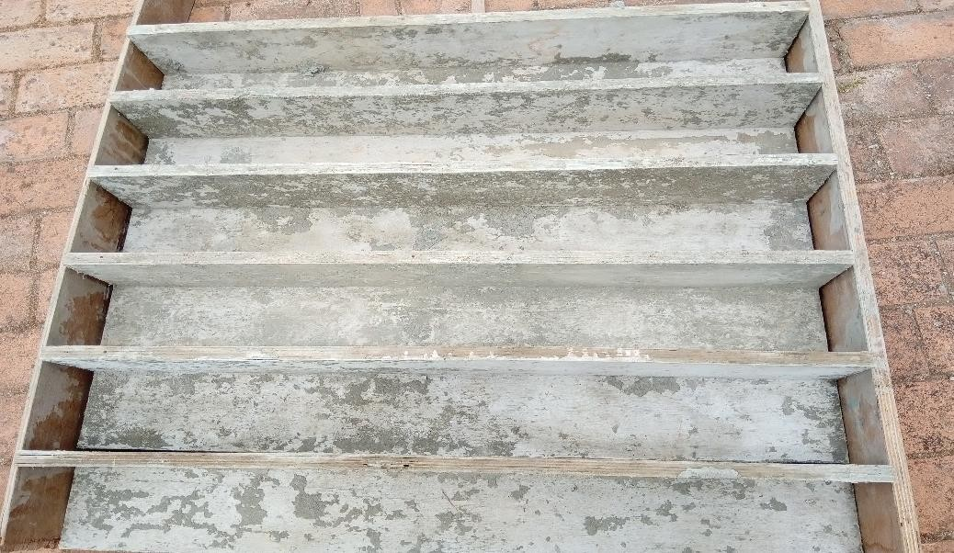Mould were prepared using wood having dimensions 125mm×125mm×1000mm was used as formwork for the casting of column. The mould shall be suitably built so that during placing and compaction of concrete mix it remains rigid without any loss of slurry from the mix. As per **IS 456 – 2000** [20] the variation from specific size of cross section of member supposed to be within limits of - 6 mm or + 12 mm.

**Fig 1: Wooden Mould For Casting Column Specimens**

**MIXING,CASTING AND CURING OF COLUMNS**

Materials essential for concrete was taken as per the mix proportions. The concrete was mixed on the waterproof surface. Reinforcing bars was placed within the mould and were held in position using 10mm concrete blocks. After mixing was done systematically, concrete was transferred into mould, hand compaction was done. Compaction was done accurately to ensure proper filling of concrete without any voids. After filling the mould with concrete,the top portion of the column leveled and it was given a flat surface. As per IS 456 - 2000 minimum Period before removing mould for column is 16 to 24 hrs. After 24 hours, column specimens were demoulded and columns are immersed in water for curing. 28 days of curing shall be employed.

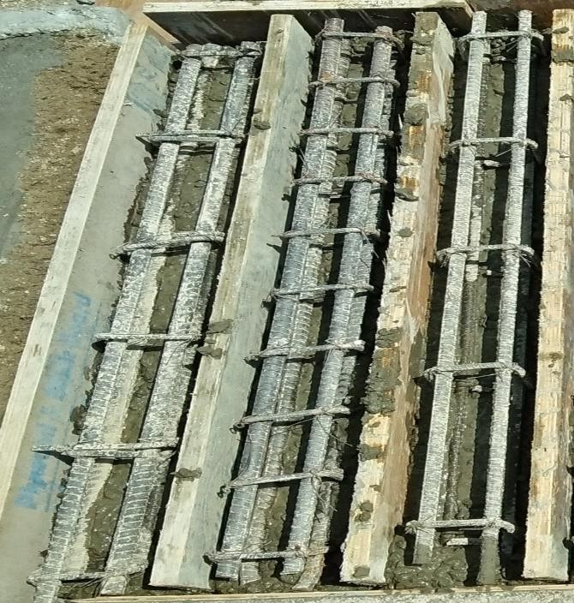 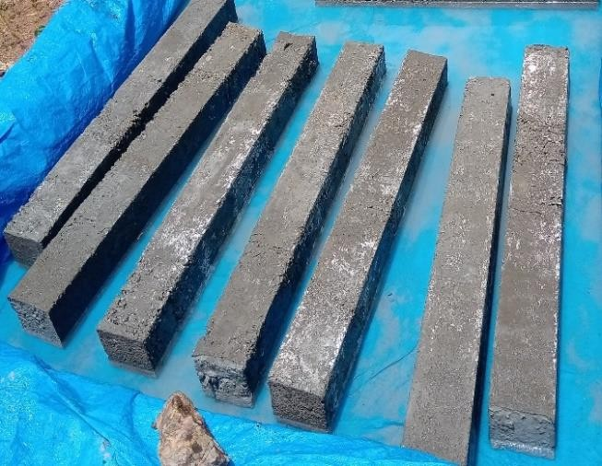

**Fig 2: Column Casting Fig3: Curing**

* 1. 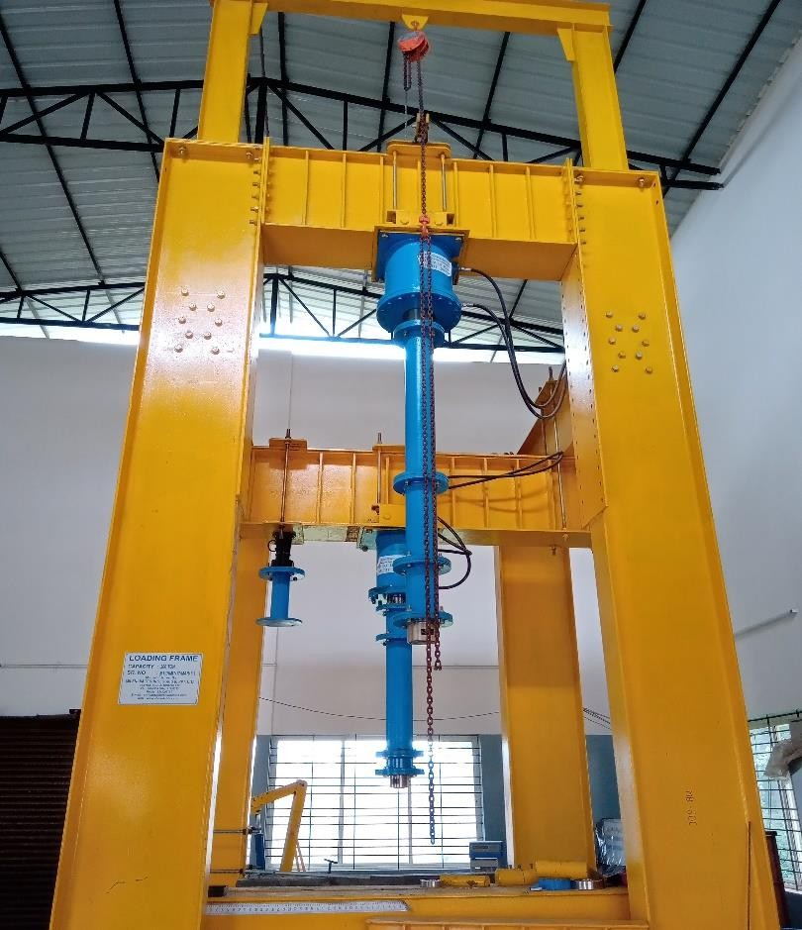**LOADING FRAME INSTRUMENT:** The testing of specimens was conducted in Nitte Meenakshi Institute of Technology, Bangalore. Loading frame instrument of capacity 200 Ton was made use to apply compressive load on column members. Instrument mainly consisted of hydraulic jack nwith load cell arrangement, LVDT and PC - Based Data acquisition system.

**Fig4: Loading frame instrument**

* 1. **TESTING METHOD:**

1. After 28 days of curing, column members were taken out of the water and they were dried in room temperature before testing was done.
2. Loading frame instrument was made use to apply increasing concentric load at a slow proportion. The columns were applied with compressive loading with usage of hydraulic jack.
3. Concentric load was applied to column specimens by 100 tons hydraulic jack, monitored by 2000 kN load cell and transmitted via steel plate assembly.
4. 2 LVDT (Linear variable differential transducers) were used to measure the axial deformation.
5. Position of column on steel frame was adjusted accurately so that the load on column would be exactly concentric. Plump bob was used to check the verticality of the column so as to avoid eccentricity caused by defective placement of the column. Initially hydraulic jack was functioned manually in order to ensure that the load cell comes in interaction with the specimen via steel plate.
6. Later instrument was operated by the mean of automatic application of compression load on the specimen.
7. Compression load was applied on the column specimen and maintained constant.
8. Astheloadgoesonincreasingloadcellconvertscompressionforceintoelectrical signals which are recorded in data acquisition system.
9. Axial load was applied until failure of the column occurs.
10. LVDTs readings, steel strain was also recorded by means of a data acquisition system and micro-compute

# RESULT AND DISCUSSION

## **ANALYSIS OF EXPERIMENTAL RESULTS:**

**AXIAL LOAD V/S DEFORMATION CURVES**

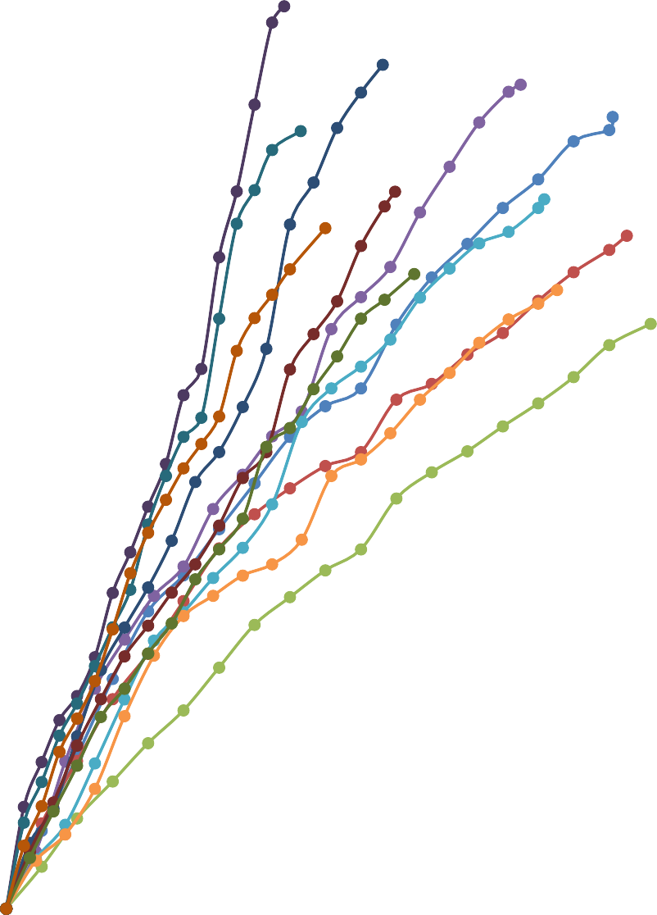

**Load versus Deformation**

700

600

500

NSC/8/100

NSC/8/200

400

NSC/8/300

NSC/10/100NSC/10/200NSC/10/300NSC/12/100

300 NSC/12/200

NSC/12/300NSC/16/100NSC/16/200

200 NSC/16/300

100

0

0

2

4

6

8

10

12

**AXIAL DEFORMATION(mm)**

**ULTIMATELOAD(kN**)



|  |  |  |  |  |  |
| --- | --- | --- | --- | --- | --- |
|  |  | 602.65 |  |  |  |
|  |  | 519.25 | 563.5 | 550.25  52 | 8.76 |
|  |  | 454.5 | 478.8  423.8 | 473.75  413.2 | 449.45  390.5 |
|  |  |  |  |  |  |
|  |  |  |  |  |  |
|  |  |  |  |  |  |
|  |  |  |  |  |  |

Graph-1represents Axial load v/s Deformation curves for different column specimens.

#### Graph1:Load versusdeformationfor NSC/8/100.



**Axial deformation(mm)**

12

10

8

6

4

2

0

500

400

300

200

100

0

10.26,528.76

600

**1.29% Steel Stirrups100mmc/c**

From graph -1 it is noticeable that specimen exhibited maximum deformation of 10.26 mm at an axial load of 528.76kN. Cracking of the specimen was observed at load 370.12kN.



**1.29% Steel Stirrups200mmc/c**

500

450

400

350

300

250

200

150

100

50

0

10.5,449.45

0

2

4

6

8

10

12

**Axial deformation(mm)**

**Axial load(kN)**

|  |  |  |  |  |  |
| --- | --- | --- | --- | --- | --- |
|  |  |  |  |  |  |
|  |  |  |  |  |  |
|  |  |  |  |  |  |
|  |  |  |  |  |  |
|  |  |  |  |  |  |
|  |  |  |  |  |  |
|  |  |  |  |  |  |
|  |  |  |  |  |  |
|  |  |  |  |  |  |
|  |  |  |  |  |  |

#### Graph2 :Loadversusdeformationfor NSC/8/200.

From graph-2 it is noticeable that specimen exhibited maximum deformation of 10.5 mm at an axial load of 449.45 kN. Cracking of the specimen was observed at load 313.86 kN.

.



**1.29% Steel Stirrups300mmc/c**

450

10.9,390.5

400

350

300

250

200

150

100

50

0

0

2

4

6

8

10

12

**Axial deformation(mm)**

**Axial load(kN)**

#### Graph 3:Load versusdeformation for NSC/8/300

From graph 4.4 it is noticeable that specimen exhibited maximum deformation of 10.9 mm at an axial load of 390.5 kN. Cracking of the specimen was observed at load 270.55 kN.



**Axial deformation(mm)**

10

9

8

7

6

5

4

3

2

1

0

600

500

400

300

200

100

0

8.7, 550.25

**2.01%Steel**

**Stirrups100mmc/c**

**Axial load(kN)**

#### Graph 4:Load versusdeformationforNSC/10/100

From graph 4 it is noticeable that specimen exhibited maximum deformation of 8.7 mm at an axial load of 550.25 kN. Cracking of the specimen was observed at load 385.17 kN.

**Axial load(kN)**

#### Graph5:Load versusdeformationforNSC/10/200.



**Axial deformation(mm)**

10

9

8

7

6

5

4

3

2

1

0

450

400

350

300

250

200

150

100

50

0

9.1, 473.75

500

**2.01% Steel Stirrups200mmc/c**

From graph-5 it is noticeable that specimen exhibited maximum deformation of 9.1 mm at an axial load of 473.75 kN. Cracking of the specimen was observed at load 327.42 kN.



**Axial deformation(mm)**

10

9

8

7

6

5

4

3

2

1

0

9.32, 413.2

450

400

350

300

250

200

150

100

50

0

**2.01% Steel Stirrups300mmc/c**

**Axial load(kN)**

#### Graph6:Load versusdeformationforNSC/10/300.

From graph-6 it is noticeable that specimen exhibited maximum deformation of 9.32 mm at an axial load of 413.2 kN. Cracking of the specimen was observed at load 228.4 kN.

#### Graph 7:Load versusdeformationforNSC/12/100.



**Axial deformation(mm)**

7

6

5

4

3

2

1

0

600

500

400

300

200

100

0

6.37,563.5

**2.89% Steel Stirrups100mmc/c**

**Axial load(kN)**

From graph 7 it is noticeable that specimen exhibited maximum deformation of 6.37 mm at an axial load of 563.5 kN. Cracking of the specimen was observed at load 394.45 kN.



**Axial deformation(mm)**

7

6

5

4

3

2

1

0

500

400

300

200

100

0

6.58,478.8

600

**2.89% Steel Stirrups200mmc/c**

**Axial load(kN)**

#### Graph 8:Load versusdeformationforNSC/12/200.

From graph -8 it is noticeable that specimen exhibited maximum deformation of 6.58 mm at an axial load of 478.8 kN. Cracking of the specimen was observed at load 335.16 kN.

**Axial load(kN)**

#### Graph 9:Load versusdeformationforNSC/12/300.



**Axial deformation(mm)**

8

7

6

5

4

3

2

1

0

400

350

300

250

200

150

100

50

0

6.9, 423.8

450

**2.89% Steel Stirrups300mmc/c**

From graph-9 it is noticeable that specimen exhibited maximum deformation of 6.9 mm at an axial load of 423.8 kN. Cracking of the specimen was observed at load 290.26 kN.



**Axial Deformation (mm)**

5

4.5

4

3.5

3

2.5

2

1.5

1

0.5

0

600

500

400

300

200

100

0

4.7, 602.65

700

**5.15% Steel Stirrups100mmc/c**

**Axial load(kN)**

#### Graph 10:Load versusdeformationforNSC/16/100.

From graph -10 it is noticeable that specimen exhibited maximum deformation of 4.7 mm at an axial load of 602.65 kN. Cracking of the specimen was observed at load 421.8 kN.



**Axial load(kN)**

#### Graph 11:Load versusdeformationforNSC/16/200



**Axial Deformation(mm)**

6

5

4

3

2

1

0

500

400

300

200

100

0

4.98,519.25

600

**5.15% Steel Stirrups200mmc/c**

From graph-11 it is noticeable that specimen exhibited maximum deformation of 4.98 mm at an axial load of 519.25 kN. Cracking of the specimen was observed at load 370.42 kN



**5.15% Steel Stirrups300mmc/c**

500

450

400

350

300

250

200

150

100

50

0

5.4, 454.5

0

1

2

3

4

5

6

**Axial Deformation(mm)**

**Axial load(kN)**

|  |  |  |  |  |  |  |
| --- | --- | --- | --- | --- | --- | --- |
|  |  |  |  |  |  |  |
|  |  |  |  |  |  | |
|  |  |  |  |  |  | |
|  |  |  |  |  |  | |
|  |  |  |  |  |  | |
|  |  |  |  |  |  | |
|  |  |  |  |  |  | |
|  |  |  |  |  |  | |
|  |  |  |  |  |  | |
|  |  |  |  |  |  | |

#### Graph 12:Load versusdeformationforNSC/16/300

From graph-12 it is noticeable that specimen exhibited maximum deformation of 4.98 mm at an axial load of 519.25 kN. Cracking of the specimen was observed at load 370.42 kN.

## **CRACKING LOAD AND CRACKING DEFORMATION.**

#### **Table-7:Crackingload andCracking deformationfor1.29%reinforcement**

**Cracking Deformation (mm)**

7.63

NSC/8/300

7.3

NSC/8/200

7.18

NSC/8/100

250

200

150

100

50

0

270.55

300

313.86

350

370.12

400

**1.29%Reinforcement**

|  |  |  |  |  |  |
| --- | --- | --- | --- | --- | --- |
| **SL.**  **No** | **Specimen Id** | **Pcr**  **(kN)** | **∆cr**  **(mm)** | **Percentage change in the values** | |
| **In load** | **In deformation** |
| 1 | NSC/8/100 | 370.12 | 7.18 | **_** | **_** |
| 2 | NSC/8/200 | 313.86 | 7.3 | -15.20 | +1.64 |
| 3 | NSC/8/300 | 270.55 | 7.63 | -13.79 | +4.52 |

**Cracking load(kN)**

**Graph 13: Cracking load versus Cracking Deformation for 1.29% reinforcement.**

From the graph -13 it is noticeable that, Load at Cracking for NSC/8/200 was 15.20% less than NSC/8/100. Load at Cracking for NSC/8/300 was 13.79% less than NSC/8/200. Deformation at Cracking for NSC/8/200 was 1.64%higherthan NSC/8/100. Deformation at Cracking for NSC/8/300 was 4.52% higher than NSC/8/200.

#### **Table-8 :Cracking load and Cracking deformation for 2.01% reinforcement**

6.55

NSC/10/300

6.22

NSC/10/200

**Cracking Deformation(mm)**

6.1

NSC/10/100

0

50

100

150

200

250

284.4

300

327.42

350

385.17

400

450

**2.01%Reinforcement**

|  |  |  |  |  |  |
| --- | --- | --- | --- | --- | --- |
| **SL.**  **No** | **Specimen Id** | **Pcr**  **(kN)** | **∆cr**  **(mm)** | **Percentage change in the values** | |
| **In load** | **In deformation** |
| 1 | NSC/10/100 | 385.17 | 6.10 | _ | _ |
| 2 | NSC/10/200 | 327.42 | 6.22 | -14.98 | +1.92 |
| 3 | NSC/10/300 | 284.4 | 6.55 | -13.13 | +4.30 |

**Graph 14: Cracking load versus Cracking Deformation for 2.01% reinforcement**

**Cracking load (kN)**

From the graph-14 it is noticeable that, Load at Cracking for NSC/10/200 was 14.98% less than NSC/10/100. Load at Cracking for NSC/10/300 was 13.13% less than NSC/10/200. Deformation at Cracking for NSC/10/200 was 1.92% higher than NSC/10/100. Deformation at Cracking for NSC/10/300 was 4.30% higher than NSC/10/200.

#### **Table 9: Cracking load and Cracking deformation for 2.89% reinforcement**

4.84

NSC/12/300

4.6

NSC/12/200

**Cracking deformation (mm)**

4.45

NSC/12/100

0

50

100

150

200

250

290.26

300

335.16

350

394.45

400

450

**2.89%Reinforcement**

|  |  |  |  |  |  |
| --- | --- | --- | --- | --- | --- |
| **SL.**  **No** | **Specimen Id** | **Pcr**  **(kN)** | **∆cr**  **(mm)** | **Percentage change in the values** | |
| **In load** | **In deformation** |
| 1 | NSC/12/100 | 394.45 | 4.45 | _ | _ |
| 2 | NSC/12/200 | 335.16 | 4.60 | -15.03 | +3.26 |
| 3 | NSC/12/300 | 290.26 | 4.84 | -13.39 | +4.95 |

**Cracking load (kN)**

**Graph 15 : Cracking load versus Cracking Deformation for 2.89% reinforcement**

From the graph-15 it is noticeable that, Load at Cracking for NSC/12/200 was 15.03% less than NSC/12/100. Load at Cracking for NSC/12/300 was 13.39% less than NSC/12/200. Deformation at Cracking for NSC/12/200 was 3.26% higher than NSC/12/100. Deformation at Cracking for NSC/12/300 was 4.95% higher than NSC/12/200.

#### **Table10 : Cracking load and Cracking deformation for 5.15% reinforcement**

3.52

NSC/16/300

3.4

NSC/16/200

**Cracking Deformation (mm)**

3.3

NSC/16/100

0

50

100

150

200

250

300

328

350

370.42

400

421.8

450

**5.15%Reinforcement**

|  |  |  |  |  |  |
| --- | --- | --- | --- | --- | --- |
| **SL.**  **No** | **Specimen Id** | **Pcr**  **(kN)** | **∆cr**  **(mm)** | **Percentage change in the values** | |
| **In load** | **In deformation** |
| 1 | NSC/16/100 | 421.8 | 3.3 | _ | _ |
| 2 | NSC/16/200 | 370.42 | 3.4 | -12.18 | +2.94 |
| 3 | NSC/16/300 | 328 | 3.52 | -11.45 | +4.86 |

**Crac**

**Graph16: Cracking load versus cracking deformation for 5.15% reinforcement**

From the graph-16 it is noticeable that, Load at Cracking for NSC/16/200 was 12.18% less than NSC/16/100. Load at Cracking for NSC/16/300 was 11.45% less than NSC/16/200. Deformation at Cracking for NSC/16/200 was 2.94% higher than NSC/16/100. Deformation at Cracking for NSC/16/300 was 4.86% higher than NSC/16/200.

**IV.CONCLUSION**

An experimental study was conducted on Reinforced concrete columns to examine the axial load - deformation performance, ultimate load, ultimate deformation, cracking load, cracking deformation, effect of different spacing of stirrups on the ultimate load and cracking load, ductility index, and comparison of experimental ultimate axial loads with the available standard codes.

1. Mix proportion of M-30 grade was adopted for casting column specimens, mix proportion was adopted from IS 10262 – 2009.
2. Test for slump was conducted as per the code IS 1199 – 1959, and the average slump value was obtained as 80mm.
3. Cube compression test was conducted for 3 specimens with 3 different w/c ratio of 0.40, 0.43 and 0.45. maximum compression strength of 38.08 N/mm2 was obtained for 0.43 w/c ratio. Therefore 0.43 w/c ratio was adopted in mix proportion for casting column specimens.

### **Cracking Load and Cracking Deformation for different Spacing of Stirrups.**

1. It was noticeable that, as the spacing of stirrups increased cracking load decreased and cracking deformation increased.
2. CrackingloadforNSC/8/200was15.20%lessthanNSC/8/100.Crackingloadfor NSC/8/300 was 13.79% less than NSC/8/200. **(Graph -13)**
3. CrackingdeformationforNSC/8/200was1.64%higherthanNSC/8/100.Cracking deformation for NSC/8/300 was 4.52% higher than NSC/8/200. **(Graph -13)**
4. Cracking load for NSC/10/200 was 14.98% less than NSC/10/100. Cracking load for NSC/10/300 was 13.13% less than NSC/10/200**. (Graph -14)**
5. Cracking deformation for NSC/10/200 was 1.92% higher than NSC/10/100. Cracking deformation for NSC/10/300 was 4.30% higher than NSC/10/200. **(Graph-14)**
6. Cracking load for NSC/12/200 was 15.03% less than NSC/12/100. Cracking load for NSC/12/300 was 13.39% less than NSC/12/200. **(Graph -15)**
7. Cracking deformation for NSC/12/200 was 3.26% higher than NSC/12/100. Cracking deformation for NSC/12/300 was 4.95% higher than NSC/12/200. **(Graph-15)**
8. Cracking load for NSC/16/200 was 12.18% less than NSC/16/100. Cracking load for NSC/16/300 was 11.45% less than NSC/16/200. **(Graph-16)**
9. Cracking deformation for NSC/16/200 was 2.94% higher than NSC/16/100. Cracking deformation for NSC/16/300 was 4.86% higher than NSC/16/200. **(Graph-16)**

## **SCOP EOFFUTURE WORK:**

1. Further investigation can be performed by considering the consequence of eccentric load on the column specimen instead of concentric load.
2. Further Studies can be done by considering the influence of different arrangement of longitudinal steel in column.
3. In present investigation 8mm diameter bar is used for stirrups instead of that 6mm diameter bar can be used and studies can be done by considering its effect on the compression behaviour of the column.
4. In present study equal spacing of stirrups was adopted along the entire length of the column, further studies can be done by considering variable spacing of the stirrups along the length of the column.
5. Further investigation can be done by using different grades of concrete and steel in casting column specimen and study its effect on the ultimate load and ultimate deformation.
6. Further studies can be done by considering the effect of temperature on the compression properties of the column specimens.

## **REFERENCES**

1. Abrams, D. P. (1987). Influence of axial force variations on flexural behavior of reinforced concrete columns. *Structural Journal*, *84*(3), 246-254.
2. Saatcioglu,M.,&Razvi,S.R.(1992).Strengthandductilityofconfinedconcrete. *Journal of Structural engineering*, *118*(6), 1590-1607.
3. Elwood, K., &Moehle, J. (2003). Shake Table Tests on the Axial Load Failure of Reinforced Concrete Columns. In*Proceedings of fib Symposium-Concrete Structures in Seismic Regions*.
4. Prabhakara, R., Chethankumar, N. E., Gopinath, A., & Sanjith, J. EXPERIMENTAL INVESTIGATIONS ON COMPRESSION BEHAVIOR PARAMETERS OF NSC AND SCC INTERMEDIATE RC.
5. Bresler, B., & Gilbert, P. H. (1961, November). Tie requirements for reinforced concrete columns. In *Journal Proceedings* (Vol. 58, No. 11, pp. 555-570).
6. Park, R. L., Park, R., &Paulay, T. (1975).*Reinforced concrete structures*. John Wiley & Sons.
7. Sheikh, S. A., &Uzumeri, S. M. (1980). Strength and ductility of tied concrete columns. *Journal of the structural division*, *106*(ASCE 15388 Proceeding).
8. Vinod, K.; Udaya Ravi, M.; Yuvaraja, N. A Study of Surface Morphology and Wear Rate Prediction of Coated Inconel 600, 625 and 718 Specimens. Int. J. Sci. Acad. Res. (IJSAR) 2023, 3, 1–9.
9. Sumanth U S Dr.Vinod Kumar Biradar, Amoghraj, Sridhara M S. A work on Speech Guided Landmine Detector Robot.International Journal of Engineering Inventions, 2024, V13, Issue5, pg no-276-282
10. V Biradar, [The Test method for wear testing Inconel 625 with a pin on disc apparatus](https://scholar.google.com/citations?view_op=view_citation&hl=en&user=c2y8q80AAAAJ&citation_for_view=c2y8q80AAAAJ:M3NEmzRMIkIC), International International Journal of scientific research in mechanical and material engineering (IJSRMME),2022, V6, Issue4, pg no-79-85
11. Sunte, J. The Test Method for Wear Testing Inconel 625 with a Pin-onDisk Apparatus. IJSRMME, 6(4).
12. Vinod, K, Effect, Performance and Conversion of Plastic to Crude Oil, International Journal of Scientific Research in Mechanical and Materials Engineering,2025 v9, issue 3, pg no-8-13
13. Azizinamini, A., Corley, W. G., & Johal, L. P. (1992). Effects of transverse reinforcement on seismic performance of columns. *Structural Journal*,*89*(4), 442- 450.
14. Nagashima,T.,Sugano,S.,Kimura,H.,&Ichikawa,A.(1992,July).Monotonicaxial compression test on ultra-high-strength concrete tied columns. In *10th world conference on earthquake engineering* (Vol. 5, pp. 2983-2988).
15. Watanabe, F., Lee, J. Y., & Nishiyama, M. (1995). Structural performance of reinforced concrete columns with different grade longitudinal bars. *StructuralJournal*, 92(4), 412-418.
16. Hernández-Montes, E., Aschheim, M., & Gil-Martin, L. M. (2004). Impact of optimal longitudinal reinforcement on the curvature ductility capacity of reinforced concrete column sections. Magazine of Concrete Research, 56(9), 499-512
17. Bažant, Z. P., Ožbolt, J., & Eligehausen, R. (1994). Fracture size effect: review of evidenceforconcretestructures.Journalofstructuralengineering,120(8),2377-2398.
18. Sıddık S¸ ener; Ben I. G. Barr; and Hadi F. Abusiaf *“Size Effect in Axially Loaded Reinforced Concrete Columns”* J. Struct. Eng., 2004, 130(4): 662-670
19. Chan,W.W.L.(1955)."Theultimatestrengthanddeformationofplastichinges in reinforced concrete frameworks." Mag. Concr. Res., 7(21), 121-132