the title of the paper

**Digital technologies for the well-being of university students: a literature review and conceptual model proposal**

**Kaoutar El Moutchou1**

1[**Kaoutar.elmoutchou@usmba.ac.ma**](mailto:Kaoutar.elmoutchou@usmba.ac.ma)

1Sidi Mohammed Ben Abdellah University, Faculty of Law, Economic and Social Sciences, The ERMOT Laboratory, Fez, Morocco.

**Samira TOUATE2**

**2**[Samira.touate@usmba.ac.ma](mailto:Samira.touate@usmba.ac.ma)

**2**Sidi Mohammed Ben Abdellah University, Faculty of Law, Economic and Social Sciences, The ERMOT Laboratory, Fez, Morocco.

**Abstract**

In recent years, the transformation of the higher education sector has been continuously accelerated. The university has been recognized as one of the primary instruments for the development of societies. In the digital age, new generations of pedagogies and teaching and learning methods are being implemented. Indeed, it is no longer a traditional learning environment, but rather one based on digital technologies. In this context, a number of effects have been observed among students, notably linked to the use of these new practices, the lack of skills, which may lead to various consequences. Hence the importance of the concept of university student well-being. Technology can contribute to quality learning for all students, which, in turn can promote their well-being. The objective of this literature review is to understand how digital technologies contribute to improving university student's well-being. This article presents a content analysis of the literature published between 2018 and 2024. The study focuses on 20 articles selected to illustrate and analyze existing research. The analysis of the collected studies was conducted using ZOTERO and NVIVO softwarewares. The results of our studies highlight a number of variables that influence students' well-being in relation to their use of digital technologies.

**Keyword**s: higher education, academic engagement, NVivo, e-learning, factors.

**1. Introduction**

The expression "constant change" has probably never described the field of higher education and educational technologies as well as in light of the current global situation. In recent years, countries around the world have been profoundly transformed by digitization, which has opened new perspectives for socio-economic development and international competitiveness. The digital transformation of higher education is now a highly popular topic that generates great interest worldwide. Nevertheless, integrating new and innovative practices in the digital age poses several challenges and factors for students (Asad et al., 2023). This new generation of pedagogies, teaching methods, and learning approaches will undoubtedly prioritize the specificity of the student. Hence the importance of the concept of university student well-being (Al-Kumaim et al., 2021; Dreer-Goethe, 2023). Furthermore, the extensive use of new technologies during the pandemic had a significant impact on students' well-being (Douwes et al., 2023; Ikatova et al., 2021). The development of pedagogical practices that enhance student well-being is a phenomenon that not only leads to success, but also promotes personal development. According to (OCDE & Eurostat, 2019) student well-being is defined as “the set of psychological, cognitive, social, and physical capacities and mechanisms necessary for their happiness and flourishing”. The well-being of university students is an increasingly important issue in higher education. Well-being, as a concept, has a broad scope, which often gives it a multidisciplinary character. In the context of educational institutions, it is an essential component of students' quality of life (Al-Said, 2023). This article focuses on the impact of digital technologies on student well-being, with an emphasis on influencing factors. To achieve this objective, we focus our analysis on the following research question: What is the impact of digital technologies on the well-being of university students?

To answer our question, we have structured the article as follows. After introducing our research object. We presented our methodology. Subsequently, we analyzed the selected articles and discussed the results. Finally, we presented a conceptual model proposed for the future research.

**2. Methods**

The research was conducted using the SCOPUS academic database due to its comprehensiveness and the ability to collect data through keyword searches. Furthermore, in order to identify additional articles to enrich our analysis, Google scholar was used as a complementary resource. The articles selected in Google scholar were rigorously screened based on publications in peer-reviewed journals and credible sources as well as their relevance to our research objective. We summarized the methodology used in this LR in Figure 1.

I

N

C

L

U

S

I

O

N

**Identification**

Articles identified in databases (N= 196)

**Selection**

Selection of articles based on title and keywords(N=64)

Selection of articles based on abstract (N=29)

Full-text review of articles (N=20**)**

**Eligibility**

Article included in the analysis (N=20)

**Figure 1:** selection process

***Source*:** By authors

The search was conducted using the keywords: "higher Education" AND "Learning" AND "Technology" AND "Student" AND "Wellness" OR "Wellbeing" OR "Well-being". The identification process generated 116 articles from Scopus and 80 additional articles from Google Scholar. A summary of the research protocol is presented in Table 1.

**Table 1** Research protocol

|  |  |
| --- | --- |
| Criteria | Description |
| Key words | "higher Education" AND "Learning" AND "Technology" AND "Student" AND "Wellness" OR "Wellbeing" OR "Well-being". |
| Inclusion and exclusion criteria | 1. Publications published between 2018-2024 are considered.  2. articles that examine the impact of digital technologies on student well-being.  3. Sector: Higher education  4. duplicate articles are excluded  5. Articles published in languages other than French and English are excluded. |
| Selection | The selected publications are first examined by title and keywords, then summarized before being analyzed in full text. |
| Extraction Tools | ZOTERO & EXCEL & NVIVO 12 PRO |

*Source:* By authors

The 20 articles were published between 2018 and 2024. Figure 2 illustrates the progression of articles over time. Since 2020, an increase in articles has been observed within the academic community. this can be illustrated by the Covid 19 pandemic (Ribeiro-Silva et al., 2022).Over the last three years, a significant increase has been observed.

**Figure 2** progression of article by years

*Source:* Scopus Databases.

3. Analysis

In this analysis stage, the software NVivo 12 Pro was used to analyze all the selected references. As previously mentioned, our study focused on 20 references, which were exported from ZOTERO in RIS format and then imported into NVIVO. The objective of this step is to provide a visual presentation of the frequency of words. To present these results, the outputs from the NVivo software will be used.

3.1. Word frequency char

Table 2, created after the analysis, allows the observation of word repetition frequencies. These frequencies are used to verify the quality of the selected references. Consequently, it can be deduced that most of the words with the highest number correspond to the keywords of our study.

**Table 2** word repetition frequency

|  |  |  |  |
| --- | --- | --- | --- |
| Word | Length | Number | Percentage weighted (%) |
| Digital | 7 | 28 | 2,36 |
| Education | 9 | 21 | 1,77 |
| Technology | 10 | 17 | 1,43 |
| Learning | 8 | 16 | 1,35 |
| Student's | 8 | 15 | 1,26 |
| Wellbeing | 9 | 15 | 1,26 |

*Source:* NVivo output

3.2.Word cloud

The most frequent words were identified by analyzing the articles. It was observed that the word cloud is centered around our research on the impact of digital technologies on student well-being. As shown in figure X, three levels are detected. At the first level, the most frequent words are: “digital”, “technology”. At the second level, the words “education”, “students”, “learning”, “wellbeing”. Furthermore, at the third level, the following terms are indicated: “university”, “digitalization”, “engagement”, “performance”, “teaching”, “impacts”.

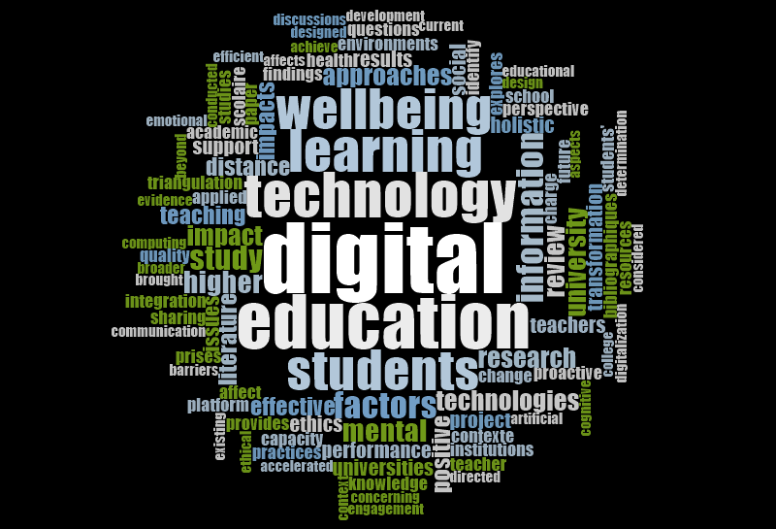

**Figure 3** Word cloud of the selected papers

*Source:* NVivo output

**4. Discussion of results**

1. impact of digital technologies on student well-being

A literature review on well-being and educational technologies was conducted, covering major publications from 2018 to 2024. The term "well-being" is composed of several domains, each specifically defined by its own set of unique indicators (El Aadmi-Laamech et al., 2022). The rapid integration of digital environments is another dimension to be considered as an implicit factor influencing students' learning and well-being (Koivuneva & Ruokamo, 2022). According to the study conducted by (Douwes et al., 2023), well-being is considered by students as a balance between the effort invested in their studies and their personal lives. At this point, we've highlighted a few variables that influence student well-being.

* **Academic commitment:**

According to (Fredricks et al., 2004), “ engagement is a multidimensional concept, with three dimensions generally distinguished: behavioral, cognitive and emotional”. However, several studies have demonstrated an improvement in student engagement within the context of digital pedagogy. It should be noted that student engagement can be enhanced through the use of available educational resources, the quality of teaching and the structure of learning programs, thereby promoting student well-being. Furthermore, it was observed that the relationship between academic engagement and well-being has been less extensively examined in higher education (Abdillah & Madjid, 2023; Boulton et al., 2019; Koivuneva & Ruokamo, 2022; Pluton & Stattner, 2023; Timotheou et al., 2023).

* **Self-efficacy**

A number of studies have highlighted that the digital learning environment enhances student’s self-efficacy. According to Bandura (1982-1993), “self- efficacy is the belief an individual hold about their own ability to perform or not perform a task”. Promoting high levels of self-efficacy not only improves academic performance, but also enhances students' well-being (Al-Kumaim et al., 2021; An et al., 2023; Koivuneva & Ruokamo, 2022).

* **Autonomy**

From the perspective of sustainable development, it is crucial that new technologies have a considerable impact on students' well-being, including their autonomy. The implementation of new digital practices fosters students' autonomy by reinforcing their active involvement and enabling them to better manage their studies (Adomaitienė & Volungevičienė, 2024; Burr et al., 2020; Jeno et al., 2021; Lister et al., 2022; Moldavan et al., 2022).

* **Academic performance**

In recent years, the notion of performance has been the subject of numerous studies, as it plays a dominant role in all human activities. This is why academic performance has become one of the primary concerns of universities. Recently, with new reforms emphasizing the quality of education, technologies have been implemented to enhance learning practices and promote student success. Student performance is boosted by the success of the technology, while ensuring a positive and supportive digital environment where students feel encouraged to achieve good academic results. It can be deduced that academic performance is an important factor in students' well-being (Al-Kumaim et al., 2021; Boulton et al., 2019; Douwes et al., 2023; EL HAFID et al., 2021).

The results of our analysis highlight several factors influencing student well-being, such as engagement, self-efficacy, autonomy, and academic performance, have been identified. These variables are summarized in a conceptual model, as show in figure 4.

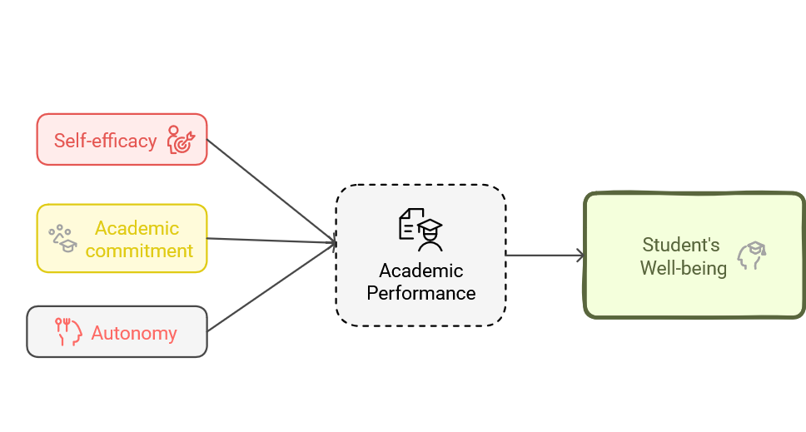

**Figure 4** Conceptual model proposed

Source : by authors

**5. Conclusions and futures** **recommendations**

The objective of our article was to present the impact of digital technologies on university students well-being. A dual analysis was conducted using a visual approach via NVIVO software and a content analysis for a detailed examination of the 20 selected articles. According to our findings, university students’ well-being improves as they adapt to a changing environment. This is why universities must play an important role in improving the well-being of learners, especially with the emergence of artificial intelligence, virtual reality... From this perspective, it can be deduced that adaptive learning, in such a context, can not only promote students’ well-being, but also improve their academic performance. However, our study also has limitations, in particular a restricted database. For future research, other databases could be consulted, such as: Web of science, ERIC...The improvement of databases may highlight additional variables. Finally, the proposed conceptual model could be subjected to a quantitative study to test the relationships between variables.

**References**

Abdillah, H. Z., & Madjid, A. (2023). Enhancing Student Well-being through AI Chat GPT in the Smart Education University Learning Environment : A Preliminary Review of Research Literature. 440. Scopus. https://doi.org/10.1051/e3sconf/202344005005

Adomaitienė, K., & Volungevičienė, A. (2024). Digital Wellbeing : Students’ perspective. Ubiquity Proceedings, 33. https://doi.org/10.5334/uproc.155

Al-Kumaim, N. H., Alhazmi, A. K., Mohammed, F., Gazem, N. A., Shabbir, M. S., & Fazea, Y. (2021). Exploring the impact of the covid-19 pandemic on university students’ learning life : An integrated conceptual motivational model for sustainable and healthy online learning. Sustainability (Switzerland), 13(5), 1‑21. Scopus. https://doi.org/10.3390/su13052546

Al-Said, K. (2023). Effect of ‗Bring Your Own Device‘(BYOD) on Student Behavior, Well-Being, and Learning Economic Disciplines. International Journal of Information and Education Technology, 13(4), 658‑663. Scopus. https://doi.org/10.18178/ijiet.2023.13.4.1850

An, N., Vesty, G., & Cheong, C. (2023). Defining Digital Wellbeing Literacy in Remote Work Integrated Learning. Australasian Journal of Information Systems, 27. Scopus. https://doi.org/10.3127/ajis.v27i0.3969

Asad, M. M., Erum, D., Churi, P., & Moreno Guerrero, A. J. (2023). Effect of technostress on Psychological well-being of post-graduate students : A perspective and correlational study of Higher Education Management. International Journal of Information Management Data Insights, 3(1). Scopus. https://doi.org/10.1016/j.jjimei.2022.100149

Boulton, C. A., Hughes, E., Kent, C., Smith, J. R., & Williams, H. T. P. (2019). Student engagement and wellbeing over time at a higher education institution. PLOS ONE, 14(11), e0225770. https://doi.org/10.1371/journal.pone.0225770

Burr, C., Taddeo, M., & Floridi, L. (2020). The Ethics of Digital Well-Being : A Thematic Review. Science and Engineering Ethics, 26(4), 2313‑2343. https://doi.org/10.1007/s11948-020-00175-8

Douwes, R., Metselaar, J., Pijnenborg, G. H. M., & Boonstra, N. (2023). Well-being of students in higher education : The importance of a student perspective. Cogent Education, 10(1), 2190697. https://doi.org/10.1080/2331186X.2023.2190697

Dreer-Goethe, B. (2023). Well-being and mentoring in pre-service teacher education : An integrative literature review. International Journal of Mentoring and Coaching in Education, 12(4), 336‑349. https://doi.org/10.1108/IJMCE-09-2022-0073

El Aadmi-Laamech, K., Hakami, E., Santos, P., & Hernández-Leo, D. (2022). The term well-being in Technology-Enhanced Learning : A systematic literature review. 2022 International Symposium on Computers in Education (SIIE), 1‑6. https://ieeexplore.ieee.org/abstract/document/9982319/

EL HAFID, K. E., SOUÀD RAFIQ, & SARA AMSIDDER. (2021). L’impact de la technologie d’information sur la performance des universités et la réussite des étudiants. https://doi.org/10.5281/ZENODO.5148432

Fredricks, J. A., Blumenfeld, P. C., & Paris, A. H. (2004). School Engagement : Potential of the Concept, State of the Evidence. Review of Educational Research, 74(1), 59‑109. https://doi.org/10.3102/00346543074001059

Ikatova, I. I., Barynkina, I. V., & Amelina, L. V. (2021). Ensuring students’ wellness : Resources and demands in higher education. 284. Scopus. https://doi.org/10.1051/e3sconf/202128409012

Jeno, L. M., Diseth, Å., & Grytnes, J.-A. (2021). Testing the METUX Model in Higher Education : Interface and Task Need–Satisfaction Predict Engagement, Learning, and Well-Being. Frontiers in Psychology, 12. Scopus. https://doi.org/10.3389/fpsyg.2021.631564

Koivuneva, K., & Ruokamo, H. (2022). Assessing university students’ study-related burnout and academic well-being in digital learning environments : A systematic literature review. Seminar. net, 18(1). https://journals.oslomet.no/index.php/seminar/article/view/4705

Lister, K., Riva, E., Kukulska-Hulme, A., & Fox, C. (2022). Participatory digital approaches to embedding student wellbeing in higher education. Frontiers in Education, 7, 924868. https://doi.org/10.3389/feduc.2022.924868

Moldavan, A. M., Edwards-Leis, C., & Murray, J. (2022). Design and pedagogical implications of a digital learning platform to promote well-being in teacher education. Teaching and Teacher Education, 115, 103732. https://doi.org/10.1016/j.tate.2022.103732

OCDE & Eurostat. (2019). Manuel d’Oslo 2018 : Lignes directrices pour le recueil, la communication et l’utilisation des données sur l’innovation, 4ème édition. OECD. https://doi.org/10.1787/c76f1c7b-fr

Pluton, L., & Stattner, E. (2023). Influence de l’environnement de formation à distance sur l’engagement des apprenants et apprenantes : Une expérimentation autour de la réalité virtuelle. Revue internationale des technologies en pédagogie universitaire, 20(2), 192‑206. https://doi.org/10.18162/ritpu-2023-v20n2-14

Ribeiro-Silva, E., Amorim, C., Aparicio-Herguedas, J. L., & Batista, P. (2022). Trends of Active Learning in Higher Education and Students’ Well-Being : A Literature Review. Frontiers in Psychology, 13. Scopus. https://doi.org/10.3389/fpsyg.2022.844236

Timotheou, S., Miliou, O., Dimitriadis, Y., Sobrino, S. V., Giannoutsou, N., Cachia, R., Monés, A. M., & Ioannou, A. (2023). Impacts of digital technologies on education and factors influencing schools’ digital capacity and transformation: A literature review. Education and Information Technologies, 28(6), 6695‑6726. https://doi.org/10.1007/s10639-022-11431-8