Title: Digital Nomadism vs. Traditional Tourism: A comprehensive review of economic, socio-cultural, and environmental impacts on local economies (2021–2024)
Authors: S. EL Jarroudi^{(*)}, Youssef Rahali^{(*)}, F. Touhami^{(*)}, M.J. EL Adnani^{(*)}

^{(*)} Multidisciplinary Research Laboratory in Economics and Management, Faculty of Economics and Management, Sultan Moulay Slimane Béni Mellal University, Morocco

Abstract
The rise of digital nomadism represents a transformative shift in how individuals engage with work, travel, and community, offering unique opportunities and challenges for local economies. This study systematically reviews 40 recent scholarly works to compare the economic, socio-cultural, and environmental impacts of digital nomads and traditional tourists on host communities. Findings reveal that digital nomads contribute to local economies through prolonged stays, skill transfer, and entrepreneurship, while traditional tourists generate short-term revenue spikes but often leave economies vulnerable to seasonal fluctuations. However, the concentration of digital nomads in specific regions can exacerbate issues such as gentrification, resource strain, and social divides. The integration of data from tools like the Digital Nomad Index highlights disparities in broadband infrastructure, cost of living, and sustainability across popular destinations. Despite its potential for fostering sustainable development, digital nomadism poses regulatory, infrastructural, and environmental challenges that require interdisciplinary research and policy innovation. This study underscores the need for longitudinal analyses, spatial studies, and frameworks addressing taxation, identity transformation, and long-term societal impacts.to bridg the gaps in the literature, this research contributes to a deeper understanding of digital nomadism's role in reshaping global labor, tourism, and regional development.
Key words: Digital nomads, traditional tourists, remote work tourism, economic impact, socio-cultural dynamics, environmental sustainability.
Conflict of interest: On behalf of all authors, the corresponding author states that there is no conflict of interest.

- Introduction

The proliferation of digital technologies and the normalization of remote work post-pandemic have catalyzed the rise of digital nomadism a lifestyle where individuals leverage location-independent work to travel globally while maintaining professional commitments. Concurrently, traditional tourism remains a dominant driver of local economic activity, characterized by short-term visits and leisure-focused spending. While both phenomena contribute to economic dynamics, their distinct behavioral patterns and engagement with host communities generate divergent impacts. Existing scholarship has examined digital nomads and tourists in isolation, yet a critical gap persists in systematically comparing their socio-economic, cultural, and environmental footprints.
This study addresses the research question: How do the economic, socio-cultural, and environmental impacts of digital nomads differ from those of traditional tourists on local economies? By synthesizing insights from 40 recent studies, this paper evaluates disparities in spending patterns, community integration, infrastructure demands, and sustainability challenges posed by these groups. It further explores how policy frameworks can harness their respective strengths while mitigating adverse effects.
The significance of this research lies in its interdisciplinary approach, bridging tourism studies, urban planning, and digital work scholarship. It offers actionable insights for policymakers and destination managers aiming to balance economic growth, cultural preservation, and environmental sustainability. Original contributions include a nuanced comparative analysis of under-researched dimensions such as geoarbitrage-driven gentrification, skill transfer, and long-term residency effects while proposing strategies to optimize benefits for both transient visitors and host communities. By contextualizing these findings within post-pandemic mobility trends, the study advances understanding of evolving labor-leisure paradigms and their implications for inclusive regional development.
- Methodology
This study adopts a systematic and multidisciplinary approach to analyze the economic, socio-cultural, and environmental impacts of digital nomads compared to traditional tourists on local economies. The methodology is designed to ensure rigor, comprehensiveness, and alignment with the research objectives.
A systematic and comprehensive search was performed across leading academic databases, including Google Scholar, Web of Science, and Scopus, renowned for their extensive coverage of peer-reviewed literature. The search strategy utilized a combination of keywords designed to capture relevant studies, as outlined in the table 1.
Table1. key themes and associated keywords
Theme | Keywords
Core Concepts | “Digital nomads,” “digital nomadism,” “remote work tourism”
Economic Impact | “Economic impact of digital nomads,” “traditional tourists vs. digital nomads,” “local economy development,” “geoarbitrage,” “skill transfer”
Socio-Cultural Impact | “socio-cultural impacts of tourism,” “community engagement,” “cultural exchange,” “identity transformation”
Environmental Impact | “Environmental impacts of tourism,” “sustainability,” “urban sustainability,” “resource strain”
Comparative Analysis | “Traditional tourists vs. digital nomads,” “spending patterns,” “long-term vs. short-term economic contributions”
Source: The authors 2025

To ensure recency and relevance, studies published between 2020 and 2024 were prioritized, reflecting recent advancements and trends in digital nomadism and tourism. Additionally, seminal works (e.g., Ferriss, 2007; Makimoto & Manners, 1997) were included to provide historical context and foundational insights. Broader terms such as “flexible work” and “digital work” were also incorporated to capture interdisciplinary perspectives.
The database search yielded a total of 40 relevant studies, which were systematically reviewed and analyzed. Consistent with prior research, Google Scholar offered significantly more results due to its inclusion of books, theses, conference papers, and other publications (Martín-Martín et al., 2018). To refine the dataset, additional filters were applied to prioritize empirical studies, case analyses, and theoretical frameworks directly addressing the research question.
Articles were selected based on their alignment with the four core focus areas of this review as outlined in Table 2. Both quantitative (e.g., surveys, statistical analyses) and qualitative (e.g., case studies, ethnographic research) methodologies were considered to provide a balanced perspective. Peer-reviewed journal articles formed the core of the dataset, but industry reports, policy analyses, and conference papers were also incorporated where they offered valuable insights. Studies that focused exclusively on either digital nomads or traditional tourists were included only if they provided indirect comparative insights.

Table 2. Core focus areas in digital nomadism research
Focus Area | Description
Economic Impact | Studies analyzing spending patterns, income generation, infrastructure demands, and multiplier effects.
Socio-Cultural Impact | Research exploring community integration, cultural exchange, identity formation, and skill transfer.
Environmental Impact | Literature examining resource consumption, sustainability challenges, and carbon footprints.
Comparative Analysis | Works directly comparing digital nomads and traditional tourists or providing frameworks for such comparisons.
Source: Authors 2025
The process of data extraction involved a meticulous and systematic review of each study, with key findings, methodologies, and limitations organized into thematic categories aligned with the four core focus areas of the research. A standardized template was employed to document essential components, including the study context defined by geographic location, population studied, and time frame as well as key insights related to economic contributions, socio-cultural dynamics, and environmental implications. Additionally, the methodologies utilized in each study were critically examined, encompassing research design, data collection methods, and analytical techniques, while identified gaps or biases were recorded as limitations. This structured approach ensured a comprehensive synthesis of the literature, enabling meaningful cross-comparisons between studies (Hensellek & Puchala, 2021; Jiwasiddi et al., 2024).
In the synthesis and analysis phase, the extracted data were subjected to a rigorous examination to identify recurring patterns and novel insights. Common themes emerged, highlighting consistent trends in the economic, socio-cultural, and environmental impacts of digital nomads compared to traditional tourists. For instance, the role of geoarbitrage in shaping local economies was a recurring theme, as noted by (Boakye, 2023), alongside the significance of skill transfer and the proliferation of coworking spaces in fostering community engagement and entrepreneurship (Jaiswal et al., 2024). Emerging trends were also identified, such as the transformative potential of digital nomadism in rural revitalization and its implications for sustainable development (Kókai & Rétfalvi, 2024). Furthermore, gaps in the literature were critically assessed, revealing the need for further exploration of long-term impacts, regulatory frameworks, and equity considerations, as emphasized by Arslan, 2024 and Hannonen, 2023.
To enhance clarity and facilitate the interpretation of complex data, figures and tables were developed to visually represent key findings. These included comparative analyses of spending patterns, geographic distribution of digital nomads, and socio-cultural outcomes, aligning with methodologies previously employed by Nash et al., 2018 and Liegl, 2014.
The integration of visual aids not only provided a clearer understanding of the data but also underscored the multidimensional nature of digital nomadism and its implications for local economies. Through this systematic approach, the review contributes to a deeper understanding of the phenomenon while highlighting opportunities for future research.
- Results
3.1. Overview of academic interest in digital nomadism
3.1.1 Growth and evolution of research on digital nomadism
The growing academic interest in digital nomadism is evident from the increasing number of publications on the topic. Regarding to figure 1. a search using the query TITLE-ABS-KEY ("digital nomads" OR "digital nomadism" OR "remote work tourism") reveals 290 document results, indicating a significant rise in scholarly attention. The first article indexed on this topic was published in 2012 by Oliveira et al., (2012), marking the initial exploration of digital nomadism within academic literature. Since then, the body of research has expanded considerably, with a total of 97 articles published as of 2024. This upward trajectory underscores the growing relevance and multidisciplinary nature of digital nomadism, reflecting its emergence as a critical area of study within fields.
Figure 1. Evolution of annual publications on Digital Nomads, Digital Nomadism, and Remote Work Tourism in Scopus (2012–2024)

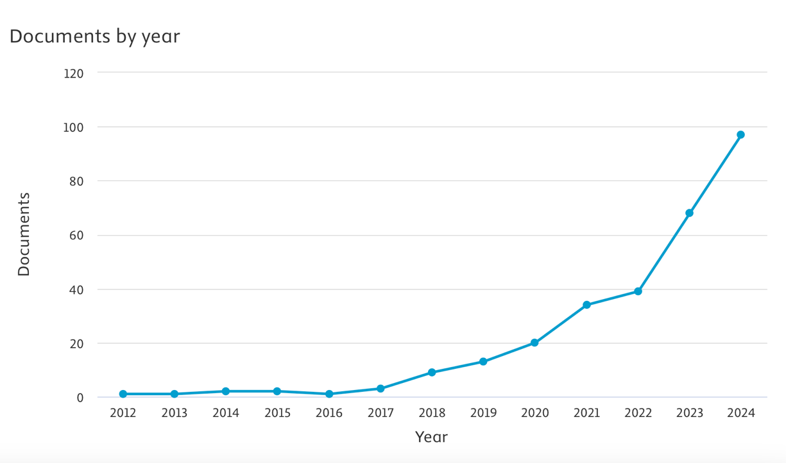
Source: Scopus
3.1.2 Systematic selection process for the study
The systematic selection process for this study is illustrated in Figure 2 and involved multiple stages to ensure a rigorous and transparent approach. Initially, a comprehensive search was conducted across three major academic databases—Google Scholar, Web of Science, and Scopus—using keywords derived from Table 1 (Key Themes and Associated Keywords). These keywords were carefully chosen to cover core concepts, economic impact, socio-cultural dynamics, environmental sustainability, and comparative analysis, yielding a total of 5,250 records. During the screening phase, duplicate records were removed to eliminate redundancy, resulting in 4,385 unique records. Further screening based on relevance, using filters such as titles, abstracts, and keywords, excluded 3,551 records due to irrelevant topics (2,780), non-peer-reviewed sources (490), or outdated studies (>10 years old; 281), leaving 834 records for further evaluation. In the eligibility phase, additional relevant works were identified through citations and reference tracking, adding 89 records, for a total of 923. These records were then sorted by relevance and assessed against specific inclusion criteria. Records were excluded for insufficient focus on digital nomads (345), lack of comparative analysis with tourists (178), weak methodological rigor (187), or other reasons such as inaccessible full text (37), leaving 40 articles for final inclusion. The inclusion phase involved a detailed review of these 40 articles, which were selected for their comprehensive insights into the economic, socio-cultural, and environmental impacts of digital nomads and traditional tourists on local economies. This structured approach ensures the robustness and reliability of the study’s findings.
Figure 2. PRISMA diagram of systematic selection process for studies on digital Nomadism
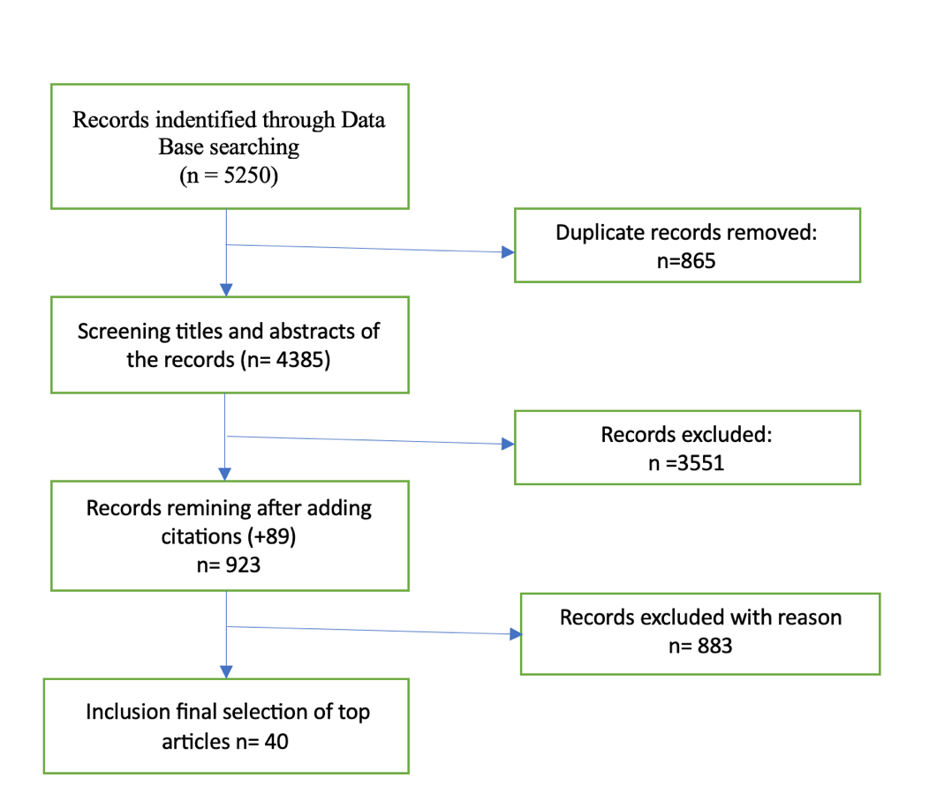
Source the authors 2025
3.2 Comparative Analysis of Digital Nomadism and Traditional Tourism: Economic, Socio-Cultural, and Environmental Dimensions
The review of the literature on digital nomadism and its impacts on local economies reveals several key findings across economic, socio-cultural, and environmental dimensions. This section synthesizes insights from the reviewed studies while integrating data from the Digital Nomad Index (Source: CircleLoop), which offers a comparative analysis of countries based on critical factors such as broadband speed, cost of living, happiness index, migrant population percentage, and remote job searches. By combining qualitative insights from the literature with quantitative metrics from the Digital Nomad Index, this analysis provides a comprehensive understanding of the opportunities and challenges associated with digital nomadism, as well as its implications for local economies and communities.
This dual approach ensures a robust examination of the topic, bridging theoretical perspectives with empirical evidence to address the multifaceted impacts of digital nomads compared to traditional tourists.
Table 3. Digital Nomad scores of African countries
# | Country | Broadband Speed | Mobile Speed | Broadband Cost | Monthly Rent | Happiness Index | Migrant Population % | Remote Jobs Searches | Digital Nomad Score
58 | South Africa | 37.24 | 38.73 | £36.26 | £382 | 4.81 | 7.2 | 10120 | 47.29
71 | Mauritius | 21.62 | 30.38 | £40.74 | £294 | 6.1 | 2.3 | 230 | 36.6
72 | Morocco | 21.51 | 37.03 | £27.39 | £273 | 5.1 | 0.3 | 1290 | 35.49
77 | Tunisia | 9.37 | 28.46 | £11.57 | £149 | 4.39 | 0.5 | 130 | 34.15
78 | Egypt | 34.72 | 19.99 | £11.19 | £162 | 4.15 | 0.5 | 300 | 33.84
79 | Algeria | 4.97 | 12.68 | £21 | £147 | 5.01 | 0.6 | 90 | 33.38
82 | Kenya | 17.66 | 22.47 | £45.45 | £228 | 4.58 | 2 | 3060 | 31.27
83 | Ghana | 47.46 | 15.04 | £56.33 | £515 | 5.15 | 1.5 | 80 | 30.36
85 | Nigeria | 13.23 | 16.93 | £63.35 | £583 | 4.72 | 0.6 | 530 | 26.32
https://www.circleloop.com/nomadindex/

Figure 3. Digital nomad scores of African Countries
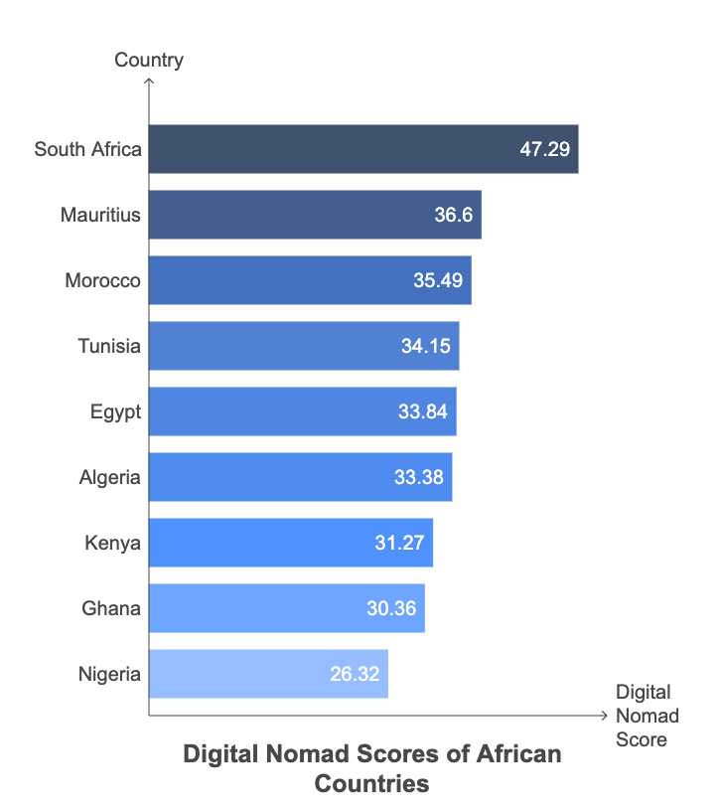
Source: The authors 2025; DATA from https://www.circleloop.com/nomadindex/
3.2.1. Economic Impact
Digital nomads contribute significantly to local economies through prolonged stays, consistent spending, and skill transfer, contrasting sharply with traditional tourists who generate short-term revenue spikes. Studies highlight that digital nomads often engage in geoarbitrage, earning in high-value currencies while residing in low-cost regions, thereby boosting local purchasing power (Boakye, 2023). In Bali, digital nomads have been shown to increase regional income by leveraging extended stays and fostering entrepreneurship (Noviarini & Samputra, 2024).
The Digital Nomad Index further supports these findings. Countries like South Africa, Morocco, and Tunisia rank highly due to their favorable broadband speeds, affordable living costs, and growing migrant populations. For example, South Africa ranks 58th with a Digital Nomad Score of 47.29, driven by its relatively high broadband speed (37.24 Mbps) and affordable monthly rent (£382). Similarly, Morocco (ranked 72nd) offers competitive broadband costs (£27.39 per month) and a strong happiness index (5.1), making it an attractive destination for digital nomads.
However, challenges such as gentrification and inflationary pressures on housing markets remain significant concerns, particularly in popular destinations like Chiang Mai and Bali (Hannonen, 2023). The Digital Nomad Index reflects this tension, as countries like Kenya (ranked 82nd) and Nigeria (ranked 85th) show potential for growth but face infrastructural limitations, such as lower broadband speeds and higher living costs.

3.2.2. Socio-Cultural Impact
Digital nomads play a transformative role in fostering cultural exchange and community integration. Research by (Kókai & Rétfalvi, 2024) demonstrated that digital nomads in rural Hungary contribute to cultural revitalization by engaging with local communities and promoting entrepreneurship. Similarly, Mao & Xu, 2024 argue that digital nomads introduce global perspectives and technological skills, benefiting local economies.
The Digital Nomad Index highlights how certain countries are better positioned to facilitate socio-cultural interactions. For example, Mauritius (ranked 71st) boasts a high happiness index (6.1) and a vibrant migrant population (2.3%), suggesting strong social cohesion. In contrast, Algeria (ranked 79th) has a moderate happiness index (5.01) but faces challenges in attracting digital nomads due to lower broadband speeds (4.97 Mbps) and limited remote job opportunities.
Despite these benefits, socio-cultural dynamics between digital nomads and locals can be complex. Sequera, 2025 notes that digital nomads may inadvertently disrupt local norms and exacerbate social divides, particularly in areas where they concentrate. The Digital Nomad Index underscores this issue, as countries like Egypt (ranked 78th) and Tunisia (ranked 77th) struggle with balancing the influx of digital nomads against existing cultural and social structures.
3.3.3. Environmental Impact
The environmental implications of digital nomadism and traditional tourism differ significantly. While digital nomads contribute to sustainable practices by residing in eco-friendly environments, their frequent travel—often by air—increases carbon footprints (Yang, 2024). Traditional tourists, despite shorter stays, exert less environmental pressure individually but collectively strain resources during peak seasons (Cerisola & Panzera, 2024).
The Digital Nomad Index provides insights into the environmental sustainability of various destinations. For instance, Morocco (ranked 72nd) and Tunisia (ranked 77th) offer relatively low broadband costs and affordable living expenses, reducing resource consumption compared to more developed regions. However, countries like Kenya (ranked 82nd) and Nigeria (ranked 85th) face infrastructural challenges, including lower broadband speeds and higher living costs, which may limit their ability to support sustainable digital nomadism.

4. Comparative Analysis
A comparative analysis of digital nomads and traditional tourists reveals significant differences in their mobility patterns, geographic distribution, economic contributions, socio-cultural interactions, and environmental impacts. These differences underscore the unique roles each group plays in shaping local economies and communities.
4.1 Mobility Patterns and Geographic Distribution
Digital nomads and traditional tourists exhibit markedly different mobility patterns. Digital nomads leverage geoarbitrage to live in low-cost regions while earning in high-value currencies, often choosing destinations with affordable living costs, reliable internet infrastructure, and vibrant coworking spaces (Boakye, 2023). For instance, countries like Thailand, Indonesia, and Portugal have become popular hubs for digital nomads due to their favorable cost of living and supportive remote work ecosystems (Noviarini & Samputra, 2024). In contrast, traditional tourists are more likely to visit established tourist destinations such as Paris, New York, or Bali, prioritizing leisure activities and cultural attractions over long-term stays (Arslan, 2024).
The Digital Nomad Index further highlights these trends, showing that countries like South Africa (ranked 58th) and Morocco (ranked 72nd) attract digital nomads due to their affordable broadband costs (£36.26 and £27.39 per month, respectively) and moderate monthly rents (£382 and £273, respectively). Conversely, traditional tourists are drawn to iconic landmarks and experiences, which often concentrate in urban centers or well-known tourist hotspots (Jiwasiddi et al., 2024). This geographic disparity has significant implications for destination dynamics, including housing markets, infrastructure demands, and cultural preservation (Hannonen, 2023).
4.2 Economic Contributions
The economic contributions of digital nomads and traditional tourists differ significantly in terms of duration, scale, and impact. Digital nomads prioritize extended stays, consistent spending on long-term accommodations, coworking spaces, and local services, and contribute to skill transfer and entrepreneurship (Kókai & Rétfalvi, 2024). For example, in rural Hungary, digital nomads have revitalized declining towns by purchasing goods and services, fostering cultural exchange, and promoting entrepreneurship (Kókai & Rétfalvi, 2024). Similarly, in Bali, digital nomads have been shown to increase regional income through prolonged stays and collaboration with local businesses (Noviarini & Samputra, 2024).
Traditional tourists, on the other hand, generate short-term revenue spikes but may leave local economies vulnerable to seasonal fluctuations and episodic overcrowding (Chavarria, 2024). The study by Aliyudin & Nasir, (2024) on tourism villages in Indonesia highlights how diverse tourism potential positively impacts local welfare, though limited infrastructure remains a challenge. Furthermore, (Nash et al., 2018) define digital nomadic work and its unique characteristics, contrasting it with traditional tourism's episodic nature and highlighting the multiplier effect of remote work on regional economies.
4.3 Socio-Cultural Dynamics
Digital nomads play a transformative role in fostering socio-cultural exchange and community integration. Research by (Kókai & Rétfalvi, 2024) demonstrates that digital nomads in rural Hungary contribute to cultural revitalization by engaging with local communities and promoting entrepreneurship. Similarly, Mao & Xu, 2024 argue that digital nomads introduce global perspectives and technological skills, benefiting local economies. The identity and community element of digital nomadism is further reinforced by the growing professional infrastructure that supports nomadic workers, such as coworking spaces and online communities (Orel, 2021; Thompson, 2019).
In contrast, traditional tourists often engage in superficial cultural exchanges, reinforcing stereotypes rather than fostering meaningful relationships (Jaiswal et al., 2024). The study by (Mei et al.) on sustainable tourism in Leshan Fishing Village, China, underscores the need for government support and community involvement to balance cultural preservation with economic growth. Sequera, 2025 maps transnational teleworkers as a new "creative class" in urban marketplaces, noting their potential to disrupt local norms and exacerbate social divides.
4.4 Environmental Impacts
The environmental implications of digital nomadism and traditional tourism differ significantly. While digital nomads contribute to sustainable practices by residing in eco-friendly environments, their frequent travel—often by air—increases carbon footprints (Yang, 2024). Traditional tourists, despite shorter stays, exert less environmental pressure individually but collectively strain resources during peak seasons (Cerisola & Panzera, 2024).
The Digital Nomad Index provides insights into the environmental sustainability of various destinations. For instance, Morocco (ranked 72nd) and Tunisia (ranked 77th) offer relatively low broadband costs and affordable living expenses, reducing resource consumption compared to more developed regions. However, countries like Kenya (ranked 82nd) and Nigeria (ranked 85th) face infrastructural challenges, including lower broadband speeds and higher living costs, which may limit their ability to support sustainable digital nomadism. Veronica Arcos Bosquez et al. (2023) (Annals-XXI, 2023) provide insights into rural tourism prospects in Ecuador, emphasizing the need for sustainable resource management to support both nomads and locals.
4.5 Opportunities, Challenges, and Research Gaps
Table 4. Opportunities, Challenges, and Research Gaps in Digital Nomadism
Category | Details | Authors
Opportunities | Enhanced local economies through prolonged stays and skill transfer | Kókai & Rétfalvi, 2024
Opportunities | Promotion of sustainable tourism practices in rural areas | Mao & Xu, 2024
Opportunities | Cultural exchange and community revitalization | Ünal, 2024
Challenges | Regulatory gaps, including taxation and legal status | Arslan, 2024
Challenges | Environmental pressures from frequent travel and resource consumption | Yang, 2024
Challenges | Social isolation and identity transformation among digital nomads | Bozzi, 2024
Research Gaps | Limited exploration of the long-term impacts of digital nomads on local economies and societies | (Boakye, 2023)
Research Gaps | Scarcity of studies examining diverse group interactions, particularly between digital nomads and traditional tourists | Yang, 2024
Research Gaps | Need for regulatory frameworks to address issues such as taxation, gentrification, and identity transformation | Arslan, 2024
Source: The authors 2025
This synthesis highlights the dual-edged nature of digital nomadism, emphasizing its potential to enhance local economies through prolonged stays, skill transfer, and sustainable tourism practices (Kókai & Rétfalvi, 2024; Mao & Xu, 2024; Ünal, 2024). However, these benefits are counterbalanced by significant challenges, including regulatory gaps related to taxation and legal status (Arslan, 2024), environmental pressures from frequent travel and resource consumption (Yang, 2024), and the social isolation faced by digital nomads themselves (Bozzi, 2024). Furthermore, the identified research gaps underscore critical areas for future exploration, such as the long-term impacts of digital nomadism on local economies and societies (Boakye, 2023) and the need for frameworks addressing issues like gentrification and identity transformation (Arslan, 2024). Collectively, Table 4 underscores the importance of balanced policies and further research to maximize the benefits of digital nomadism while mitigating its risks.
4. Conclusion
The present study has systematically reviewed and synthesized the existing literature on the economic, socio-cultural, and environmental impacts of digital nomads compared to traditional tourists on local economies. Through a multidisciplinary lens, this research highlights the distinct contributions and challenges associated with each group. Digital nomads, characterized by their prolonged stays, skill transfer, and geoarbitrage practices, offer unique opportunities for sustainable development, community revitalization, and regional economic transformation (ANNAMALAH & PARAMAN, 2023; Jiwasiddi et al., 2024). In contrast, traditional tourists generate short-term economic activity but often leave local economies vulnerable to seasonal fluctuations and environmental degradation (Arslan, 2024; Cerisola & Panzera, 2024).
The findings underscore the dual-edged nature of digital nomadism, which simultaneously fosters innovation and poses significant regulatory, infrastructural, and social challenges. For instance, while digital nomads contribute to rural revitalization and cultural exchange (Kókai & Rétfalvi, 2024), their concentration in specific areas can exacerbate issues such as gentrification, resource strain, and social divides (Hannonen, 2024; Sequera, 2025). Similarly, the environmental implications of frequent travel and resource consumption necessitate careful management to balance growth with sustainability (Yang, 2024).
By integrating qualitative insights from the literature with quantitative metrics from tools like the Digital Nomad Index, this study provides a comprehensive understanding of the opportunities and risks associated with digital nomadism. However, the fragmented nature of the literature across disciplines underscores the need for more interdisciplinary research to address the multifaceted impacts of this phenomenon.
Future Perspectives
Looking ahead, several avenues for future research emerge from the identified gaps and limitations in the current body of knowledge. First, longitudinal studies are needed to explore the long-term impacts of digital nomadism on local economies, societies, and environments. This includes examining how regions adapt to the influx of remote workers over time and whether these changes lead to sustainable development or unintended consequences, such as economic inequality or cultural homogenization (Boakye, 2023).
Second, there is a critical need for spatial and urban studies perspectives to understand how cities and rural areas can integrate digital nomads into their socio-economic fabric without displacing local populations or disrupting cultural norms (Sequera, 2025). This includes developing regulatory frameworks that address taxation, legal status, and housing market dynamics, as well as fostering platforms for meaningful interaction between digital nomads and host communities (Ünal, 2024).
Third, future research should investigate the intersection of digital nomadism with broader trends in remote work, including its implications for job portability, technological innovation, and global labor markets (Nash et al., 2018; Thompson, 2019). The post-pandemic normalization of remote work has blurred the boundaries between leisure and labor, creating new paradigms that require further exploration.
Finally, the environmental dimension of digital nomadism warrants deeper scrutiny. While digital nomads may promote eco-friendly practices in their daily lives, their frequent travel—often by air—raises concerns about carbon footprints and resource consumption (Green et al., 2018; Yang, 2024). Future studies could explore strategies to mitigate these impacts, such as incentivizing low-carbon travel options or promoting destinations with robust sustainability initiatives.
In conclusion, the rise of digital nomadism represents a transformative shift in how individuals engage with work, travel, and community. By addressing the identified gaps and embracing an interdisciplinary approach, future research can inform policies and practices that maximize the benefits of digital nomadism while mitigating its risks. This will ensure that the phenomenon contributes to inclusive, equitable, and sustainable development for both local communities and global economies.

References:
Aliyudin, A., & Nasir, M. (2024). Generating Local Economy through Tourism Village: Case Study of BRILian Benteng Village. An-Nuha: Jurnal Sosial & Humaniora, 2(1), 43–56.
Annals-XXI, E. (2023, August 27). Rural tourism prospects on the example of communities of Parroquia Salinas in Guaranda, Ecuador. Economic Annals-XXI. https://ea21journal.world/index.php/ea-v204-06/
ANNAMALAH, S., & PARAMAN, P. (2023). The Economic Impact of Remote Work: Unpacking Regional Transformations and Economic Multipliers. Journal of Applied Economic Sciences, 18(3).
Arslan, E. (2024). From tourists to nomads: Unveiling the transformative potential of digital nomads in travel and tourism. Worldwide Hospitality and Tourism Themes, 16(3), 269–281.
Boakye, G. O. (2023). Guesthouse and Tourist Accommodation Experience in Lisbon.
Bozzi, A. (2024). Digital nomadism and cities: Exploring the production of mobility infrastructures in Barcelona. Netcom. Réseaux, Communication et Territoires.
Cerisola, S., & Panzera, E. (2024). Heritage tourism and local prosperity: An empirical investigation of their controversial relationship. Tourism Economics, 13548166241234099.
Chavarria, A. D. (2024). Sustainable Tourists, Generous Consumers, Lifestyle Inspirers: The Attitudes and Expectations of Zadar’s Local Authorities vis-à-vis Digital Nomads. Netcom. Réseaux, Communication et Territoires.
Ferriss, T. (2007). The 4-Hour Workweek: Escape 9-5. Live Anywhere, and Join the New Rich.
Green, D. D., McCann, J., Vu, T., Lopez, N., & Ouattara, S. (2018). Gig economy and the future of work: A Fiverr. Com case study. Management and Economics Research Journal, 4(2), 281.
Hannonen, O. (2023). Emergent geographies of digital nomadism: Conceptual framing, insights and implications for tourism. Tourism Geographies, 1–11.
Hensellek, S., & Puchala, N. (2021). The emergence of the digital nomad: A review and analysis of the opportunities and risks of digital nomadism. The Flexible Workplace: Coworking and Other Modern Workplace Transformations, 195–214.
Jaiswal, R., Gupta, S., & Gupta, S. K. (2024). The impending disruption of digital nomadism: Opportunities, challenges, and research agenda. World Leisure Journal, 1–31.
Jiwasiddi, A., Schlagwein, D., Cahalane, M., Cecez‐Kecmanovic, D., Leong, C., & Ractham, P. (2024). Digital nomadism as a new part of the visitor economy: The case of the “digital nomad capital” Chiang Mai, Thailand. Information Systems Journal, 34(5), 1493–1535.
Kókai, N., & Rétfalvi, D. (2024). Digital Nomads as Engines for Rural Revitalization: The Development Strategy of Pécsdevecser, Hungary (pp. 143–149). https://doi.org/10.18485/arh_pt.2024.8.ch16
Liegl, M. (2014). Nomadicity and the care of place—On the aesthetic and affective organization of space in freelance creative work. Computer Supported Cooperative Work (CSCW), 23, 163–183.
Makimoto, T., & Manners, D. (1997). Digital nomad. John Wiley & Sons.
Mao, Q., & Xu, S. (2024). How Digital Nomad Communities Can Empower Rural Revitalisation. Advances in Economics, Management and Political Sciences, 105, 149–156.
Martín-Martín, A., Orduna-Malea, E., Thelwall, M., & López-Cózar, E. D. (2018). Google Scholar, Web of Science, and Scopus: A systematic comparison of citations in 252 subject categories. Journal of Informetrics, 12(4), 1160–1177.
Mei, S. J., Rahmanita, M., & Mumin, A. T. (n.d.). Traditional Village Development Strategies for Sustainable Tourism (Case Study of Leshan Fishing Village, China). Journal of Economics, Finance And Management Studies, 7(09).
Nash, C., Jarrahi, M. H., Sutherland, W., & Phillips, G. (2018). Digital nomads beyond the buzzword: Defining digital nomadic work and use of digital technologies. 207–217.
Noviarini, N., & Samputra, P. L. (2024). Digital Nomad and Analysis of Regional Economic Resilience of Tourism Sector in Bali Province After Covid-19 Pandemic. Jurnal Indonesia Sosial Teknologi, 5(5).
Oliveira, E. A., Tedesco, P., & Chiu, T. P. T. (2012). Creating personalized and distributed virtual learning spaces through the use of i-collaboration 3.0. 477–479.
Orel, M. (2021). Life is better in flip flops. Digital nomads and their transformational travels to Thailand. International Journal of Culture, Tourism and Hospitality Research, 15(1), 3–9.
Sequera, J. (2025). STRUGGLING WITH THE DIGITAL NOMAD: Transnational teleworkers as the new ‘creative class’ in the urban marketplace? International Journal of Urban and Regional Research, 49(1), 204–213.
Thompson, B. Y. (2019). The digital nomad lifestyle:(remote) work/leisure balance, privilege, and constructed community. International Journal of the Sociology of Leisure, 2(1), 27–42.
Ünal, G. (2024). The relationship between regional development and digital nomadism. Worldwide Hospitality and Tourism Themes, 16(3), 375–378.
Yang, Y. (2024). Urban Sustainability in the Age of Digital Nomads-Diverse Group Impacts. Advances in Economics, Management and Political Sciences, 112, 70–74.

