Do Faculty Follow the Crowd? An Empirical Study on Herding Behavior, Gender, and Investment Barriers

Mr. Utpal Sarkar
Research Scholar
Department of Commerce
Jagannath Barooah University, Jorhat
Email – sarkaru674@gmail.com
ORCID ID – https://orcid.org/0009-0006-4559-9063
Dr. Ajit Chandra Das*
Associate Professor
Department of Commerce
Jagannath Barooah University, Jorhat
Email – ajitdasjbc@gmail.com

ABSTRACT
This study examines the behavioral and demographic factors influencing mutual fund investment decisions among teachers in semi-rural North-East India, an under-research yet socially influential professional group. Drawing on behavioral finance theory, the study investigates herding behavior, gender-based differences, and perceived barriers affecting mutual fund participation. Using a quantitative survey design, data were collected from 125 teachers in Namsai district, Arunachal Pradesh. Reliability analysis confirmed acceptable internal consistency of the herding scale (Cronbach’s α = 0.772). Results indicate a moderate level of herding behavior, suggesting that teachers often rely on peer influence when making investment decisions. Non-parametric testing revealed a significant gender difference, with female teachers displaying stronger herding tendencies than males. Among non-investors, lack of financial knowledge and fear of financial loss emerged as key barriers, while financial literacy was significantly associated with trust-related concerns. The findings extend behavioral finance literature by demonstrating that herding tendencies persist even among educated professionals in semi-rural contexts. The study highlights the need for targeted financial literacy initiatives and trust-building mechanisms to promote informed and independent investment behavior among educators and similar professional groups.
Keywords: Herding behavior, Mutual Fund Adoption, Financial Literacy, Investment Barriers, Gender Differences.

Introduction
Mutual funds have become an increasingly common investment option for retail investors because they offer professional management, diversification, and a relatively simple way to participate in financial markets (Rehan et al., 2018; Ghimire & Adhikari, 2023). However, participation in mutual funds remains uneven in many semi-rural areas of India. Even when people are aware of investment options, their decisions are often shaped by behavioural factors rather than only by financial knowledge or rational evaluation.
One such behavioural factor is herding behaviour, which occurs when individuals follow the investment choices of others instead of making independent decisions. In environments where people have limited access to expert financial advice or feel unsure about evaluating investment information, they may depend heavily on friends, colleagues, or community members (Ainia & Lutfi, 2019; Nguyen et al., 2019). This pattern is especially visible in semi-rural regions, where information gaps and uncertainty may encourage individuals to rely on social influence rather than personal judgment (Waheed et al., 2020). Teachers, as educated and respected community members, are an important group to study because their choices can influence others around them.
Another key area of behavioural finance relates to gender differences in financial decision making. Several studies show that women are generally more risk-averse, seek more reassurance, and rely more on social networks while making financial choices (Dickason & Ferreira, 2018; Lawrenson & Dickason-Koekemoer, 2020). These tendencies can lead to stronger herding behaviour among female investors. Understanding such gender-based differences is important for designing financial education programs and improving investment participation.
Teachers are an interesting group of investors because they possess higher educational levels yet still experience the same behavioural biases and uncertainties that affect typical retail investors. Their financial choices are shaped by their social environment, access to information, and personal confidence in financial matters. Studying their behaviour can therefore provide insight into how educated individuals in semi-rural areas approach investment decisions.
Although behavioral finance literature has widely examined herding, risk perception, and gender differences, most studies focus on urban investors or general retail populations, very limited research has investigated educated professional groups such as teachers in semi-rural settings. Teachers are financially aware individuals who also influence community financial behavior, making them an important yet under-explored group. Furthermore, previous studies rarely integrate herding behavior, gender differences, and perceived investment barriers within a single empirical framework. This study addresses this gap by examining these dimensions together in a semi-rural Indian context.
Objectives:
- To measure the impact of herding behaviour on mutual fund investments among teachers.
- To examine whether herding behaviour differs significantly across gender.
- To identify barriers among non-investors.
Literature Review
Herding Behavior and Mutual Fund Investments
A key concept in behavioral finance is herding, which refers to how investors mimic the behavior of others instead of coming to their own conclusions. Studies show that herding reduces decision-making effort under uncertainty but often results in suboptimal financial outcomes. According to Ainia and Lutfi (2019) and Nguyen et al. (2019), people tend to follow peers they believe to be more knowledgeable rather than seeking professional advice, especially in developing markets. According to Waheed et al. (2020), this tendency is particularly strong in situations where advisory systems are weak and financial information is asymmetrical. According to Bikhchandani et al. (1992), informational cycles in the mutual fund industry demonstrate how prior inflows and popularity draw in more investors despite underlying fundamentals. Herding is both a coping mechanism and a hindrance to logical investment evaluation for semi-rural communities, like teachers.
H1: Teachers exhibit a measurable level of herding behaviour in their mutual fund investment decisions.
Gender Differences in Behavioural Biases
One known factor influencing financial behaviour is gender. According to empirical evidence women tend to be more risk averse and are more likely to rely on social networks for financial decisions than men (Dickason & Ferreira, 2018; Lawrenson & Dickason-Koekemoer, 2020). This dependence raises the probability that female investors will engage in herd mentality. According to Brooks et al. (2018), gender and age have a combined influence on decision-making through perceived financial security and time horizons. It is essential to understand these gendered behavioural patterns to create inclusive.
H2: There is a significant difference in herding behaviour between male and female teachers.
Financial Literacy and Perceived Barriers
The adoption of mutual funds is significantly hindered by behavioural biases as well as barriers like lack of financial knowledge, mistrust of financial institutions, limited savings, and fear of loss. Ahmed et al. (2021), Song et al. (2023), and Kanagasabai & Aggarwal (2020) find that financial literacy improves investment planning but is insufficient without confidence and trust. Owusu et al. (2023) show that mistrust of financial intermediaries reduces participation despite adequate knowledge. Nosita et al. (2020) show that inadequate savings act as a structural barrier, and Rahman (2020) associates fear of financial loss with avoiding equity-related products.
H3: Perceived barriers such as lack of knowledge, savings, trust, and fear of financial loss significantly influence the likelihood of non-investment in mutual funds.
Theoretical Framework
This study is grounded in the principles of Behavioral Finance Theory, which suggests that investors don’t always make logical decisions. Rather, their financial behavior is shaped by psychological, social, and emotional aspects (Bikhchandani et al., 1992). Herding behavior, which characterizes the tendency of individuals to mimic the acts of others while making investment decisions, particularly in circumstances of uncertainty or incomplete information, is crucial in this context.
Such behavior becomes more prevalent in semi-rural financial environments where access to professional advice is limited, as investors rely on the actions and perceived wisdom of their peers (Ainia & Lutfi, 2019; Waheed et al., 2020). This is consistent with the study’s primary goal, which examines the presence and strength of herding behavior among teachers.
The framework also makes use of Gender Socialization Theory, which describes how societal and cultural factors affect men’s and women’s risk tolerance and financial behavior. According to earlier research, women tend to be more cautious and rely more on the opinions of their peers and group judgment when making financial decisions (Lawrenson & Dickason-Koekemoer, 2020). The second objective of the study which examines whether gender has a substantial impact on herding tendencies, is supported by this theoretical framework.
Together, these theories explain how behavioral bias and demographic factors interact to influence mutual fund investment decisions among teachers. The conceptual model connects the study’s objectives and hypotheses as shown in Figure 1.
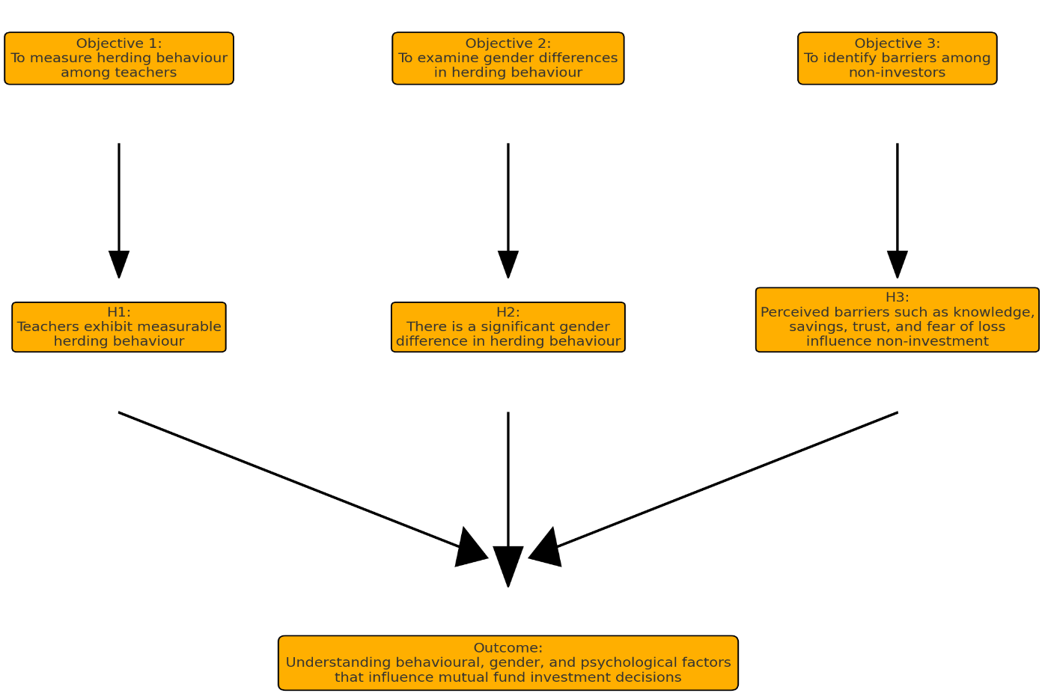
Figure 1: Theoretical Framework Showing Objectives and Hypotheses
Research Methodology
The study used a quantitative survey design and collected data from 125 teachers in Namsai district, Arunachal Pradesh. Because teachers were selected based on their availability and willingness to respond, the study followed a convenience sampling technique. Out of 125 respondents, 93 were investors in mutual funds and 32 were non-investors. The questionnaire included demographic details, herding behaviour questions, and financial literacy measures. While convenience sampling limits the generalization of results, it is suitable for exploratory studies like this, especially when access to the population is limited.
A total of 150 questionnaires were distributed, both physically and through online mode, of which 125 valid responses were received, resulting in an effective response rate of approximately 83%. This mixed-mode approach ensured wider coverage and improved participation from teachers.
Cronbach's alpha, which evaluates internal consistency across several items, was used to assess the herding construct's reliability. The equation is:
$α=\frac{k}{k-1}\left(1-\frac{\sum_{i=1}^{k}{σ_{i}^{2}}}{σ_{t}^{2}}\right)$
Where ‘k’ is the number of items, and $σ_{i}^{2}$ is the variance of the total score. The obtained value (α = 0.772) exceeded the recommended threshold of 0.70, confirming the scale’s reliability.
To test gender-based differences in herding behavior, both the Shapiro-wilk and Kolmogorov-Smirnov tests were used to test for normality of the composite herding score (HERD_SCORE); the Shapiro-Wilk is better suited for small to medium samples. The equation is:
$w=\frac{(\sum_{i=1}^{n}{a_{i}} x_{(i)})^{2}}{\sum_{i=1}^{n}{{(x}_{i}}- \overline{x})^{2}}$
Where $x_{(i)}$ are ordered sample values, $a_{i}$ are constants derived from expected order statistics, and $\overline{x}$ is the sample mean. Results indicated that HERD_SCORE distributions for both male and female groups were not normally distributed (Shapiro–Wilk p < 0.05; see Appendix Table A1).
As a result, the Mann-Whitney U test was applied. This test compares the distribution of scores between two independent groups and is calculated as:
$U=n_{1}n_{2}+ \frac{n_{1}(n_{1}+1)}{2} -R_{1}$
Where $n_{1}$ and $n_{2}$ are the group sample sizes, and $R_{1}$ is the sum of ranks for group 1.
For non-investors, barrier frequencies were computed, followed by Chi-square tests of independence to assess the relationship between financial literacy and reported barriers. The equation for Chi-square tests is:
$X^{2}= \sum{\frac{(O_{ij}-E_{ij})^{2}}{E_{ij}}}$
Where $O_{ij}$ is the observed frequency and $E_{ij}$ is the expected frequency in cell (i, j). Effect sizes (Cramer’s V, Phi) were also reported to measure association strength.
Data Analysis and Interpretation
The three stated objectives were followed in conducting the analysis. To guarantee methodological accuracy, reliability and normality checks were performed before hypothesis testing. The findings are shown in a step-by-step manner, starting with the measurement of herding behaviour, then gender-based comparisons, and ending with the evaluation of barriers among non-investors.
Objective 1: To measure the impact of herding behaviour
First, a reliability analysis was performed using Cronbach's alpha to determine the herding construct's internal consistency. The alpha coefficient for the five Likert-scale items measuring peer influence and associated behavioural tendencies was 0.772, above the suggested cut-off of 0.70 (see Table 1). This demonstrates that the items can be effectively combined to create a composite index (HERD_SCORE) and measure a cohesive construct when taken as a whole.
Table 1: Reliability of Herding Behavior Scale
Reliability Statistics
Cronbach's Alpha | N of Items
.772 | 7
Source: Compiled by author using SPSS output
Case Processing Summary
 |  | N | %
Cases | Valid | 93 | 74.4
Cases | Excludedª | 32 | 25.6
Cases | Total | 125 | 100.0
a. Listwise deletion based on all variables in the procedure.

On a five-point scale, the mean score for HERD_SCORE was 3.30 (SD = 0.62), with scores ranging from 1.71 to 4.14, according to descriptive statistics (see Table 2). This implies that when it comes to their mutual fund investment choices, teachers generally display a moderate level of herding behaviour. With fewer extreme instances of very low or very high herding, the comparatively narrow spread suggests that responses are grouped around the moderate level.
Table 2: Descriptive Statistics of HERD_SCORE
Source: Compiled by author using survey data
Descriptive Statistics
 | N | Minimum | Maximum | Mean | Std. Deviation
HERD_SCORE | 93 | 1.71 | 4.14 | 3.3026 | .61728
Valid N (listwise) | 93
Interpretation: According to findings, one noteworthy aspect of teachers' mutual fund behaviour in semi-rural settings is herding. In line with behavioural finance research that highlights the importance of social influence in investment decisions, teachers frequently seem to rely more on the behaviour of their peers, colleagues, or community members than on their own judgement.
So, H1: Teachers shows significant herding behaviour in mutual fund investments is supported, as the overall mean score lies well above the neutral midpoint of 3.0, indicating inclination towards herding tendencies.
Objective 2: To examine gender differences in herding behaviour.
To test for gender differences in herding descriptive statistics were first calculated independently for male and female respondents. The mean HERD_SCORE for male teachers was 3.16 (SD=0.65), whereas the mean for female teachers was higher at 3.49 (SD=0.52) (see Table A2). The pattern suggested a stronger tendency for herding among females, even though the variance was marginally greater for males.
The Mann-Whitney U test was used to compare the two independent groups because both groups' normality assumptions were violated (Shapiro-Wilk p < 0.05) (see Table A1, Fig1). At the 5% significance level, the test's U-value of 760.5, Z statistic of -2.335, and associated p-value of 0.020 showed a statistically significant difference between male and female teachers (see Table 3).
Table 3: Mann–Whitney U Test Results for Gender Differences in Herding Behavior
Source: Compiled by author using SPSS output
Test Statisticsª
 | HERD_SCORE
Mann-Whitney U | 760.500
Wilcoxon W | 2191.500
Z | -2.335
Asymp. Sig. (2-tailed) | .020
a. Grouping Variable: gender
Interpretation: The findings indicate that compared to their male colleagues, female teachers are noticeably more likely to engage in herding behaviour. The finding that female teachers demonstrate stronger herding behavior reinforces behavioral finance theory, particularly gender-based differences in risk perception and social learning mechanisms. It suggests that educational attainment alone does not eliminate behavioral biases, but rather that social and psychological factors continue to shape financial decision-making even among professionals.
These interpretations confirm H2: There is significant gender difference in herding behaviour, with females showing stronger herding tendencies, which is supported by the analysis.
Objective 3: To identify barriers among non-investors
To determine the perceived obstacles to mutual fund participation, 32 valid responses from the 33 non-investors were examined. According to the frequencies, the most frequent obstacle was lack of knowledge (46.9%), which was followed by fear of financial losses (31.3%), lack of savings (15.6%), lack of trust in financial institutions (6.3%) (see Table 5). These results highlight the dominance of informational and psychological factors over purely financial constraints.
Table 4: Frequency Distribution of Barriers to Mutual Fund Investment
Source: Compiled by author using SPSS output
$BarriersSet Frequencies
 |  | Responses |  | Percent of Cases
 |  | N | Percent | Percent of Cases
$BarriersSetª | knowledge barriers | 15 | 46.9% | 46.9%
$BarriersSetª | savings barriers | 5 | 15.6% | 15.6%
$BarriersSetª | trust barriers | 2 | 6.3% | 6.3%
$BarriersSetª | financial loss barriers | 10 | 31.3% | 31.3%
Total |  | 32 | 100.0% | 100.0%
a. Dichotomy group tabulated at value 1.
To investigate whether financial literacy affects the likelihood of reporting particular barriers the Chi-square tests of independence were used. Although a moderate effect size indicated a possible relationship, the association between literacy and lack of knowledge was not statistically significant (χ²(2) = 4.62, p = 0.099). Financial loss barriers did not reach the 5% threshold, but they did exhibit a trend towards significance (χ²(2) = 4.71, p = 0.095). Financial loss barriers did not reach the 5% threshold, but they did exhibit a trend towards significance (χ²(2) = 4.71, p = 0.095). But a significant relationship emerged between financial literacy and trust barriers (χ²(2) = 6.40, p = 0.041) (see Table 6), with respondents with intermediate literacy levels more likely to express mistrust of institutions.
Table 5: Chi-Square Tests of Association between Financial Literacy and Trust Barriers
Source: Compiled by author using SPSS output
Chi-Square Tests
 | Value | df | Asymptotic Significance (2-sided)
Pearson Chi-Square | 6.400ª | 2 | .041
Likelihood Ratio | 5.965 | 2 | .051
Linear-by-Linear Association | 2.246 | 1 | .134
N of Valid Cases | 32
a. 4 cells (66.7%) have expected count less than 5. The minimum expected count is .13.
Interpretation: Although perceptions of knowledge and risk are common issues, the analysis shows that people with limited financial literacy are especially concerned about the lack of trust in financial institutions. This points to a paradoxical effect: while moderate literacy may lead to doubt without always resulting in participation, low financial awareness lowers participation because of ignorance. These results highlight the necessity of literacy campaigns and trust-building initiatives to encourage greater participation in mutual funds.
H3: Perceived barriers (knowledge, savings, trust, financial loss) significantly influence non-investors’ adoption of mutual funds is partially supported. Among the barriers, only the trust factors showed a statistically significant association.
Findings and Discussion
The present study examined the behavioural aspects of mutual funds investing among teachers in Namsai, Arunachal Pradesh, India, with particular attention to gender disparities, herding tendencies, and the obstacles that keep non investors from adopting. The findings offer several significant important insights.
First, a moderate level of herding was found overall (M = 3.30, SD = 0.62) based on the analysis of herding behaviour. This suggests that when making investment decisions, teachers generally rely heavily on peer pressure and general trends. The findings align with the literature on behavioural finance, which has repeatedly demonstrated that investors are not entirely logical agents and are frequently influenced by informational streams and behavioural signals (Ainia & Lutfi, 2019; Nguyen et al., 2019). Many investors perceive that instead of spending money on financial advisors or taking expert guidance, the better alternative is to simply follow others whom they consider more knowledgeable. This reliance allows them to avoid the effort of conducting their own investment analysis, ultimately leading to a stronger inclination towards herding behaviour.
Second, a statistically significant gender difference in herding behaviour was found in the study, with female teachers showing stronger herding tendencies than male teachers (Mann–Whitney U = 760.5, p = 0.020). According to earlier studies, women are more likely to be risk averse and, as a result, to follow group decisions when it comes to money (Dickason & Ferreira, 2018; Lawrenson & Dickason-Koekemoer, 2020). Important implications of the findings include the need for financial inclusion strategies, to recognise gendered differences in financial behaviour and create solutions that address women's dependence on peer networks while also empowering them with the ability to make independent financial decisions.
Third, among respondents who did not invest, the most frequent obstacles were lack of knowledge (46.9%) and fear of financial loss (31.3%). Fewer respondents mentioned a lack of savings (15.6%) or a lack of trust (6.3%). This pattern demonstrates that psychological and informational barriers, are the main barriers to the adoption of mutual fund rather than just financial ones. Furthermore, the chi-square analysis showed a significant correlation between financial literacy levels and trust barriers (χ²(2) = 6.40, p = 0.041). It's interesting to note that respondents with intermediate literacy levels were more likely to express mistrust, indicating that having only a limited understanding of finance can lead to suspicion rather than confidence. According to behavioural finance research, "a little knowledge" can occasionally amplify uncertainty or mistrust, echoing this paradox (Waheed et al., 2020).
Overall, the results show that teachers in semi-rural North-East India face contextual constraints (knowledge and trust barriers) and behavioural biases (herding) when making financial decisions. This identifies two major policy priorities (i) enhancing structured financial literacy programs that go beyond basic knowledge to develop analytical and evaluative skills, and (ii) creating mechanisms that increase trust, like transparent financial advisory systems and community-level awareness campaigns, that prevent an excessive dependence on unofficial peer networks.
To sum up, this study not only provides empirical support for the behavioural finance literature, but it also provides useful advice on how to enable educators, who have a significant impact on how society behaves, to make autonomous and well-informed financial decisions. Achieving inclusive financial participation in India's semi-rural areas will require addressing herding tendencies, closing literacy gaps, and addressing trust deficits.
Conclusion
This study looked at how teachers in semi-rural North-East India make mutual fund investment decisions based on perceived barriers, gender disparities, and behavioral biases. It examined gender-based disparities, herding tendencies, and the things that discourage non-investors from investing in mutual funds by drawing on behavioral finance theory.
The findings showed that teachers exhibited a moderate degree of herding behavior, suggesting that many of them rely on peers and colleagues when making investment decisions. This research emphasizes the impact of social learning and group behavior in settings with limited access to trustworthy market information and financial advising support. Additionally, it lends validity to behavioral finance theory, which contends that investors frequently make decisions based more on emotional and psychological cues than on pure reason.
Herding tendencies were shown to differ significantly by gender, with female teachers exhibiting a greater reliance on social opinions than male teachers. This finding is consistent with other research demonstrating that, in financial situations, women typically exhibit more risk aversion and a larger dependence on social validation. The results imply that gender-sensitive financial literacy initiatives could support female investors' confidence and autonomous decision-making.
Lack of financial understanding and fear of financial loss were the most often mentioned obstacles among non-investors, followed by insufficient savings and mistrust of financial institutions. Interestingly, trust obstacles were found to be substantially correlated with financial literacy, indicating that a lack of understanding could result in mistrust regarding formal investing possibilities.
The study's overall findings indicate that teachers in semi-rural India have psychological and behavioral obstacles when trying to participate in mutual funds. Reducing herding tendencies and improving educators' ability to make well-informed financial decisions can be achieved by boosting financial literacy, encouraging confidence in financial systems, and offering clear, trustworthy investing advice.

References:
Adil, M., Singh, Y., & Ansari, M. S. (2022). How financial literacy moderate the association between behaviour biases and investment decision?. Asian Journal of Accounting Research, 7(1), 17-30.
Ahmad, M., & Shah, S. Z. A. (2022). Overconfidence heuristic-driven bias in investment decision-making and performance: mediating effects of risk perception and moderating effects of financial literacy. Journal of Economic and Administrative Sciences, 38(1), 60-90.
Ahmad, M., Shah, S. Z. A., & Abbass, Y. (2021). The role of heuristic-driven biases in entrepreneurial strategic decision-making: evidence from an emerging economy. Management Decision, 59(3), 669-691.
Ahmed, Z., Noreen, U., Ramakrishnan, S. A., & Abdullah, D. F. B. (2021). What explains the investment decision-making behaviour? The role of financial literacy and financial risk tolerance. Afro-Asian Journal of Finance and Accounting, 11(1), 1-19.
Ainia, N. S. N., & Lutfi, L. (2019). The influence of risk perception, risk tolerance, overconfidence, and loss aversion towards investment decision making. Journal of Economics, Business, & Accountancy Ventura, 21(3), 401-413.
Alquraan, T., Alqisie, A., & Al Shorafa, A. (2016). Do behavioral finance factors influence stock investment decisions of individual investors? (Evidences from Saudi Stock Market). Journal of American Science, 12(9), 72-82.
Arora, M., & Kumari, S. (2015). Risk taking in financial decisions as a function of age, gender: mediating role of loss aversion and regret. International Journal of Applied Psychology, 5(4), 83-89.
Aryal, M. (2024). Rationality and behavioral biases in investment decision making. Apex Journal of Business and Management, 3(2), 113-129.
Baker, H. K., Kumar, S., Goyal, N., & Gaur, V. (2019). How financial literacy and demographic variables relate to behavioral biases. Managerial Finance, 45(1), 124-146.
Barber, B. M., & Odean, T. (2001). Boys will be boys: Gender, overconfidence, and common stock investment. The quarterly journal of economics, 116(1), 261-292.
Bashir, T., Azam, N., Butt, A. A., Javed, A., & Tanvir, A. (2013). Are behavioral biases influenced by demographic characteristics & personality traits? Evidence from Pakistan. European Scientific Journal, 9(29).
Bikhchandani, S., Hirshleifer, D., & Welch, I. (1992). A theory of fads, fashion, custom, and cultural change as informational cascades. Journal of political Economy, 100(5), 992-1026.
Brooks, C., Sangiorgi, I., Hillenbrand, C., & Money, K. (2018). Why are older investors less willing to take financial risks?. International Review of Financial Analysis, 56, 52-72.
Chawla, D. (2014). An empirical analysis of factors influencing investment in mutual funds in India. Global Business Review, 15(3), 493-503.
Dickason, Z., & Ferreira, S. (2018). Establishing a link between risk tolerance, investor personality and behavioural finance in South Africa. Cogent Economics & Finance, 6(1), 1519898.
Garg, A., & Gulati, R. (2013). Do investors herd in Indian market. Decision, 40(3), 181-196.
Ghimire, D. M., & Adhikari, M. (2023). Impact assessment of investment motivation toward mutual funds. Journal of Emerging Management Studies, 1(1), 37-51.
Herawati, N. T., Candiasa, I. M., Yadnyana, I. K., & Suharsono, N. (2018). Factors that influence financial behavior among accounting students in Bali. International Journal of Business Administration, 9(3), 30-38.
Kanagasabai, B., & Aggarwal, V. (2020). The mediating role of risk tolerance in the relationship between financial literacy and investment performance. Colombo Business Journal, 11(1).
Kasoga, P. S. (2021). Heuristic biases and investment decisions: multiple mediation mechanisms of risk tolerance and financial literacy—a survey at the Tanzania stock market. Journal of Money and Business, 1(2), 102-116.
Kengatharan, L., & Kengatharan, N. (2014). The influence of behavioral factors in making investment decisions and performance: Study on investors of Colombo Stock Exchange, Sri Lanka. Asian Journal of Finance & Accounting, 6(1), 1.
Lawrenson, J., & Dickason-Koekemoer, Z. (2020). A model for female South African investors’ financial risk tolerance. Cogent Economics & Finance, 8(1), 1794493.
Lin, H. W. (2011). Elucidating rational investment decisions and behavioral biases: Evidence from the Taiwanese stock market. African Journal of Business Management, 5(5), 1630.
Nguyen, L., Gallery, G., & Newton, C. (2019). The joint influence of financial risk perception and risk tolerance on individual investment decision‐making. Accounting & Finance, 59, 747-771.
Nosita, F., Pirzada, K., Lestari, T., & Cahyono, R. (2020). Impact of demographic factors on risk tolerance. Journal of Security & Sustainability Issues, 9(4).
Owusu, G. M. Y., Korankye, G., Yankah, N. Y. M., & Donkor, J. B. A. (2023). Financial risk tolerance and its determinants: The perspective of personnel from security services in Ghana. Borsa Istanbul Review, 23(4), 852-864.
Prosad, J. M., Kapoor, S., & Sengupta, J. (2015). Behavioral biases of Indian investors: a survey of Delhi-NCR region. Qualitative research in financial markets, 7(3), 230-263.
Rahman, M. (2020). Propensity toward financial risk tolerance: an analysis using behavioural factors. Review of Behavioral Finance, 12(3), 259-281.
Rasool, N., & Ullah, S. (2020). Financial literacy and behavioural biases of individual investors: empirical evidence of Pakistan stock exchange. Journal of Economics, Finance and Administrative Science, 25(50), 261-278.
Rehan, R., Naz, S., Umer, I., & Ahmed, O. (2018). Awareness and perception of investors towards mutual funds industry. RADS Journal of Social Sciencess & Business Management, 5(1), 01-14.
Song, C. L., Pan, D., Ayub, A., & Cai, B. (2023). The interplay between financial literacy, financial risk tolerance, and financial behaviour: the moderator effect of emotional intelligence. Psychology Research and Behavior Management, 535-548.
Waheed, H., Ahmed, Z., Saleem, Q., Din, S. M. U., & Ahmed, B. (2020). The mediating role of risk perception in the relationship between financial literacy and investment decision. International Journal of Innovation, Creativity and Change, 14(4), 112-131.
Appendix:
Table A1: Tests of Normality for HERD_SCORE by Gender
Source: Compiled by author using SPSS output
Tests of Normality
 | gender | Kolmogorov-Smirnovª |  |  | Shapiro-Wilk
 | gender | Statistic | df | Sig. | Statistic | df | Sig.
HERD_SCORE | male | .131 | 53 | .023 | .943 | 53 | .013
HERD_SCORE | female | .186 | 40 | .001 | .864 | 40 | .000
a. Lilliefors Significance Correction

Fig 1: Box Plot of HERD_SCORE by Gender
Source: Compiled by author using SPSS output
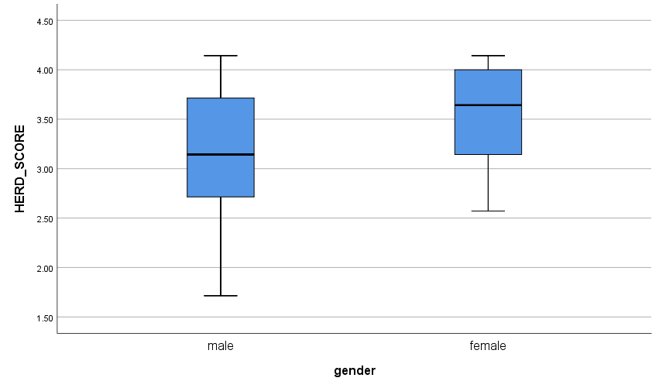
Table A2: Extended Descriptive Statistics of HERD_SCORE by Gender
Source: Compiled by author using SPSS output
Descriptives
 | gender |  |  | Statistic | Std. Error
HERD_SCORE | male | Mean |  | 3.1617 | .08951
HERD_SCORE | male | 95% Confidence Interval for Mean | Lower Bound | 2.9821
HERD_SCORE | male | 95% Confidence Interval for Mean | Upper Bound | 3.3413
HERD_SCORE | male | 5% Trimmed Mean |  | 3.1876
HERD_SCORE | male | Median |  | 3.1429
HERD_SCORE | male | Variance |  | .425
HERD_SCORE | male | Std. Deviation |  | .65167
HERD_SCORE | male | Minimum |  | 1.71
HERD_SCORE | male | Maximum |  | 4.14
HERD_SCORE | male | Range |  | 2.43
HERD_SCORE | male | Interquartile Range |  | 1.00
HERD_SCORE | male | Skewness |  | -.310 | .327
HERD_SCORE | male | Kurtosis |  | -.578 | .644
HERD_SCORE | female | Mean |  | 3.4893 | .08214
HERD_SCORE | female | 95% Confidence Interval for Mean | Lower Bound | 3.3231
HERD_SCORE | female | 95% Confidence Interval for Mean | Upper Bound | 3.6554
HERD_SCORE | female | 5% Trimmed Mean |  | 3.5079
HERD_SCORE | female | Median |  | 3.6429
HERD_SCORE | female | Variance |  | .270
HERD_SCORE | female | Std. Deviation |  | .51952
HERD_SCORE | female | Minimum |  | 2.57
HERD_SCORE | female | Maximum |  | 4.14
HERD_SCORE | female | Range |  | 1.57
HERD_SCORE | female | Interquartile Range |  | .86
HERD_SCORE | female | Skewness |  | -.631 | .374
HERD_SCORE | female | Kurtosis |  | -.922 | .733

