Uncovering the Direction and Dynamics of Mandarin Language Learning Research through Bibliometric Analysis

David Darwin¹, Alya Khairunnisa², Ratu Aulia Azzahra³
¹Universitas Darma Persada, Indonesia
²Universitas Darma Persada, Indonesia
³Universitas Darma Persada, Indonesia
Corresponding author email: daviddarwin8299@gmail.com daviddarwin.unsada@gmail.com

Abstract
Mandarin Chinese has emerged as a strategic foreign language worldwide, driven by China’s expanding influence in global economics, politics, and education. This study aims to map the direction and dynamics of Mandarin language learning research through a comprehensive bibliometric analysis of publications indexed in the Scopus database from 2023 to 2025. The analysis examines publication growth trends, dominant themes, author productivity, institutional contributions, and collaboration networks. Using bibliometric tools such as VOSviewer, data from 2,069 documents across 897 publication sources were analyzed, revealing 8,499 Keywords Plus and contributions from 7,471 authors. Results indicate that research in this field is increasingly multidisciplinary, technology-driven, and globally oriented. Dominant themes include online learning, digital literacy, innovative pedagogy, and cross-cultural approaches, reflecting a shift from traditional teaching models toward adaptive, collaborative, and technology-enhanced formats. Geographical analysis shows that China remains the primary hub of research activity, followed by the United States, Australia, Singapore, and several European countries, highlighting the internationalization of Mandarin education studies. Author collaboration networks reveal both strong intra-group ties and inter-cluster linkages, facilitated by key bridging scholars. These patterns suggest a balance between established expertise and emerging contributions, fostering both continuity and innovation. The findings underscore the importance of enhancing international collaboration, diversifying publication platforms, and investing in digital infrastructure for Mandarin instruction. This study provides an integrated overview of the intellectual landscape of Mandarin language learning, offering valuable insights for researchers, educators, and policymakers to guide future developments in research and practice.

Keywords: Bibliometric analysis, Mandarin language learning, VOSviewer, educational research, knowledge mapping

1. Introduction
Mandarin Chinese has emerged as a strategic foreign language in the global landscape, reflecting China's growing influence in international economics, politics, and education. Many countries have integrated Mandarin into formal education, extracurricular language programs, and professional development initiatives [1]. This widespread attention has fueled a surge in academic research related to Mandarin language learning, covering diverse areas such as pedagogy, learner motivation, educational technology, and cross-cultural communication [2]. Despite the increasing volume of publications, there remains a lack of comprehensive scientific mapping that systematically captures the direction and evolution of research in this domain.
The fragmented nature of existing studies presents a significant challenge in understanding Mandarin language education's intellectual structure and thematic development. To address this, bibliometric analysis offers a quantitative and structured approach to explore publication patterns, citation networks, author collaborations, and thematic clusters within a body of literature. While bibliometric methods have been widely applied in various academic fields, their use in Mandarin language learning research remains underexplored. For example, a recent study by Xu (2024) applied bibliometric tools such as VOSviewer and CitNetExplorer to analyze research on technology-assisted Mandarin instruction. The study revealed dominant themes such as mobile learning, TPACK frameworks, learner self-efficacy, and collaborative strategies in digital environments [3], highlighting the utility of bibliometric approaches in revealing intellectual trends and knowledge networks.
Nonetheless, no existing research has comprehensively mapped global publications on Mandarin language learning using a full-scale bibliometric framework. This gap urgently requires a study that systematically investigates publication trends, identifies influential contributors, and visualizes collaborative dynamics in the field. Such a study is particularly timely as the academic output on Mandarin education continues to expand across interdisciplinary domains [4].
This research, therefore, aims to uncover the direction and dynamics of Mandarin language learning studies through bibliometric analysis of scholarly publications indexed in major academic databases. The main objectives are to: (1) identify publication growth trends over a defined period, (2) explore dominant themes and keyword co-occurrence patterns, (3) identify the most productive and influential authors and institutions, and (4) map collaborative and citation networks within the research community. Ultimately, the findings are expected to provide a comprehensive overview of the Mandarin language learning research landscape, offering valuable insights for scholars, educators, and policymakers involved in language education.

2. Literature Review
In recent years, bibliometric analysis has been widely employed to map scholarly trends and thematic evolution across diverse areas of language education. For instance, Hajara & Karakus (2024) performed a bibliometric review of language learning strategy (LLS) research over five decades using data from the Web of Science. Their analysis identified dominant contributors and intellectual hotspots, showing that countries like China, the UK, and the USA are leading in producing knowledge in this area [5]. This work underscores the power of bibliometric science mapping in revealing long-term trajectories in second language research.
Similarly, Wang & Hasim (2024) conducted a bibliometric analysis of self‑regulated language learning (SRLL) in mobile-assisted contexts, analyzing nearly 500 articles from 2005 to 2023. Their study revealed that China is the most influential contributor, and themes such as mobile learning, learner strategies, and higher education contexts emerged prominently [6]. This confirms the relevance of digital-mediated learning environments in language learning research and highlights China’s central role in producing SRLL knowledge.
However, while these studies illustrate the application of bibliometric analysis in general language learning research, they do not specifically address the domain of Mandarin language learning. Despite the growth of studies focused on Mandarin pedagogy, motivational factors, technology acceptance, and cultural dimensions, there remains a notable absence of a holistic bibliometric mapping of this field. Prior literature tends to be issue-specific or localized, lacking a global perspective integrating author networks, citation dynamics, and theme co-occurrence.
Moreover, bibliometric practice has been examined critically, with researchers pointing out potential biases. For example, Thelwall et al. (2022) demonstrated that bibliometric scoring can sometimes disadvantage high-performing departments or introduce institutional bias, and that interdisciplinary work may benefit inconsistently depending on the framework used [7]. Such methodological scrutiny is important when applying bibliometric approaches to sensitive fields like language education, where language dominance and regional disparities may shape visibility.
In applied linguistics contexts, bibliometric studies have also mapped research on AI in language learning and second language teaching. For instance, a comprehensive analysis of AI applications in language learning between 2017 and 2023 revealed thematic clusters around computing, chatbots, NLP, and e-learning frameworks using VOSviewer visualizations [8]. These methods demonstrate the potential of bibliometric tools to detect emerging subfields, network clusters, and intellectual linkages.
However, no bibliometric study has exclusively targeted the corpus of literature on Mandarin language learning, specifically analyzing global academic output on teaching methodologies, learner autonomy, language anxiety, technology integration in Mandarin instruction, or cross-cultural pedagogy.
Given this gap, the current study fills a crucial niche by offering the first systematic bibliometric mapping of Mandarin language learning research. This research provides a comprehensive vantage point previously absent in the literature by analyzing publication trends, keyword co-occurrence, citation networks, author and institutional productivity, and collaborative structures. It thereby sets the stage for a robust understanding of the direction and dynamics of Mandarin pedagogy research. It supports future strategy, educational policy, and research design in this expanding domain.

3. Methodology
This study adopts a bibliometric, quantitative method to analyze scientific publications in a particular research field systematically. The goal is to uncover patterns in knowledge development, identify influential contributors, map collaborative networks, and explore dominant thematic trends in the literature on Mandarin language learning [9]. This approach is particularly suitable for offering a comprehensive overview of the field's intellectual structure and research dynamics.

3.1 Data Source and Search Strategy
Bibliographic data were retrieved from the Scopus (Elsevier) database, one of the most comprehensive and reputable sources of peer-reviewed scientific literature. The data was collected in [insert month and year of search], covering publications from 2019 to 2025. The data included metadata such as article titles, authors, affiliations, publication year, keywords, and citation counts [10].
A refined Boolean search string was applied to ensure the relevance and specificity of the dataset. The query used was as follows:
TITLE-ABS-KEY (Mandarin AND language AND learning AND education )
AND PUBYEAR > 2018 AND PUBYEAR < 2026
AND (LIMIT-TO (EXACTKEYWORD, "Students")
OR LIMIT-TO (EXACTKEYWORD, "E-learning")
OR LIMIT-TO (EXACTKEYWORD, "Mandarin")
OR LIMIT-TO (EXACTKEYWORD, "Education")
OR LIMIT-TO (EXACTKEYWORD, "Chinese Language Learners")
OR LIMIT-TO (EXACTKEYWORD, "Chinese Characters")
OR LIMIT-TO (EXACTKEYWORD, "Chinese As A Foreign Language")
OR LIMIT-TO (EXACTKEYWORD, "Chinese Language Teachers")
OR LIMIT-TO (EXACTKEYWORD, "Chinese Mandarin")
OR LIMIT-TO (EXACTKEYWORD, "Chinese Speakers")
OR LIMIT-TO (EXACTKEYWORD, "Chinese Language Learning")
OR LIMIT-TO (EXACTKEYWORD, "China")
OR LIMIT-TO (EXACTKEYWORD, "Chinese")
OR LIMIT-TO (EXACTKEYWORD, "Language Learning")
OR LIMIT-TO (EXACTKEYWORD, "Language Development")
OR LIMIT-TO (EXACTKEYWORD, "Mandarin Chinese")
AND (LIMIT-TO (DOCTYPE, "ar"))
AND (LIMIT-TO (SRCTYPE, "j"))

3.2 Data Analysis
The collected bibliometric data were analyzed using descriptive statistics and visual network mapping through VOSviewer. Publication trends were examined to identify growth patterns over time, while keyword co-occurrence analysis revealed dominant research themes and their interconnections [11]. Citation analysis identified the most influential publications and authors, and co-authorship analysis highlighted collaborative structures across researchers and institutions [2]. These combined methods provided a comprehensive view of the intellectual landscape of Mandarin language learning research.

3.3 Visualization and Validation
Visualizations were generated using VOSviewer, a specialized bibliometric mapping tool. It enabled the construction of visual maps for the co-occurrence of keywords, co-authorship between researchers, and citation networks among articles [12]. To ensure the validity and reproducibility of the findings, the process was documented in detail, and selected datasets were cross-validated using Biblioshiny, an R-based tool for bibliometric analysis.

4. Results
Table 1 provides an overview of publications related to Mandarin language learning research during the 2023–2025 period. 2,069 documents were retrieved from 897 different publication sources, indicating that the field has developed through a diverse range of scholarly outlets. A total of 8,499 Keywords Plus were identified, reflecting the thematic diversity explored by researchers. These publications involved 7,471 authors from various backgrounds, with 265 works produced by single authors. This shows a balance between collaborative research and individual efforts. Journal articles were the most dominant document type, with 1,471 publications as the primary medium for disseminating new findings in Mandarin language education.

Table 1. Main Info
Category | Result
Period | 2023–2025
Number of Sources | 897
Number of Documents | 2069
Number of Keywords Plus | 8499
Number of Authors | 7471
Single-authored Documents | 265
Articles | 1471

Regarding trends, the volume of publications within this timeframe reflects an active research landscape. However, fluctuations are evident, likely influenced by external factors such as educational policy changes, language learning technology advances, and shifts in global research interests. The high number of Keywords Plus indicates that research is not concentrated on a single theme but spans a wide range of topics, including pedagogy, online learning technologies, learner motivation, and cross-cultural approaches. Furthermore, the participation of thousands of authors from diverse institutions and countries suggests that Mandarin language learning has gained transnational attention, with significant contributions from international academic networks. The dominance of journal articles also demonstrates that knowledge dissemination in this field relies heavily on widely accessible and academically rigorous publishing platforms.

4.1. Most Relevant Sources
The analysis reveals a set of publication sources that stand out as primary channels for disseminating research on Mandarin language learning. The Most Relevant Sources graph shows that several journals maintain a consistently high level of productivity, with publication counts far exceeding the average. This indicates the presence of key publication hubs that serve as focal points for scholarly contributions in this field.
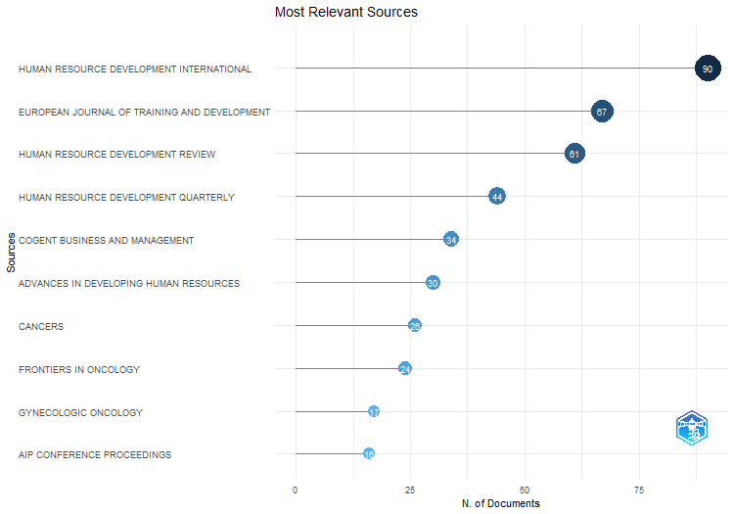
Figure 1. Relevant Sources

The leading journal produced up to 90 publications within the analysis period, followed by several others with outputs ranging from 40 to 87 publications. This concentration of productivity suggests that much of the academic discourse on Mandarin language learning is centralized within a handful of platforms with a strong focus on language education, learning technologies, and cross-cultural studies. Meanwhile, journals with smaller publication counts still play a vital role by offering alternative perspectives and addressing niche topics that the larger outlets may not extensively cover. These findings highlight a dual dynamic in the field, where high-volume publication hubs drive the main research trends while smaller sources enrich the diversity of scholarly discourse.

4.2 Source Production Over Time
The Source Production Over Time analysis illustrates the evolution of publication output from the most active sources in Mandarin language learning research during the observed period. Tracking the annual productivity of these journals provides valuable insight into how research activity is distributed over time and how certain sources maintain or shift their influence in the field.
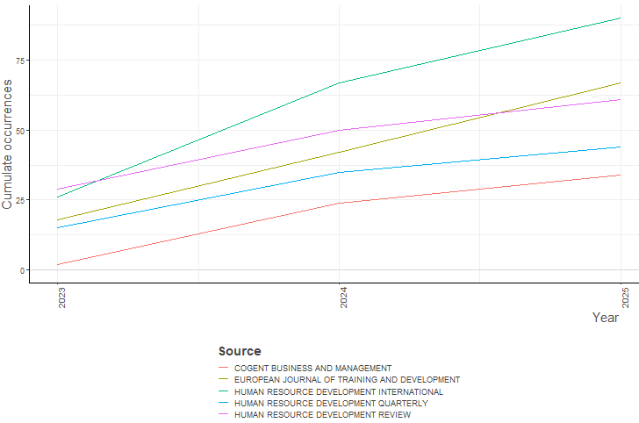
Figure 2. Source Production

The leading journal produced up to 90 publications within the analysis period, followed by several others with outputs ranging from 40 to 87 publications. This concentration of productivity suggests that much of the academic discourse on Mandarin language learning is centralized within a handful of platforms with a strong focus on language education, learning technologies, and cross-cultural studies. Meanwhile, journals with smaller publication counts still play a vital role by offering alternative perspectives and addressing niche topics that the larger outlets may not extensively cover. These findings highlight a dual dynamic in the field, where high-volume publication hubs drive the main research trends while smaller sources enrich the diversity of scholarly discourse.

4.3 Author Production
The Author Production Over Time analysis highlights patterns of scholarly output among the most productive authors in Mandarin language learning research. Examining how individual authors contribute over the years offers valuable insight into sustained research engagement, emerging contributors, and potential shifts in thematic focus.

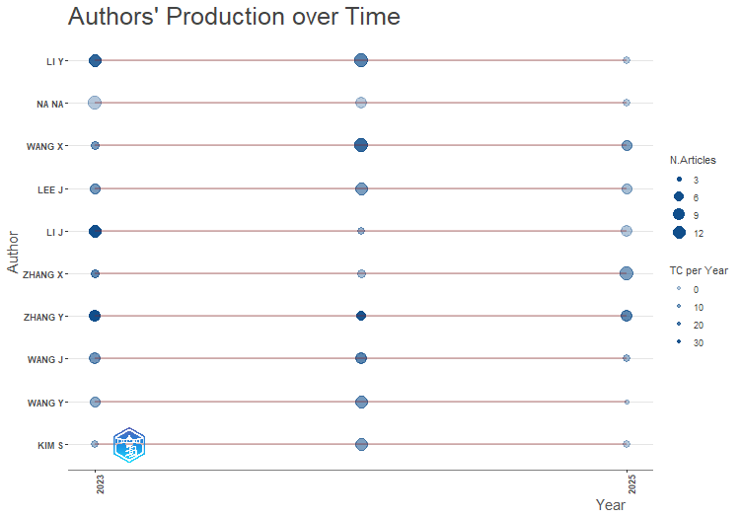
Figure 3. Source Production

The results indicate that a small group of highly active authors consistently publish across multiple years, signaling ongoing commitment and influence in the field. Some authors exhibit peak productivity during specific years, which may be tied to funded research projects, collaborative initiatives, or the publication of thematic series. Meanwhile, emerging authors appear in the dataset's later years, reflecting the field's ability to attract new researchers and diversify perspectives. These trends suggest a healthy mix of established expertise and fresh contributions, ensuring continuity and innovation in Mandarin language learning scholarship.

4.4 Author’s Countries section
The Corresponding Author's Countries analysis identifies the geographical distribution of research leadership in Mandarin language learning, based on the affiliation of corresponding authors. This metric provides insight into which countries are primary coordination centers for scholarly contributions.

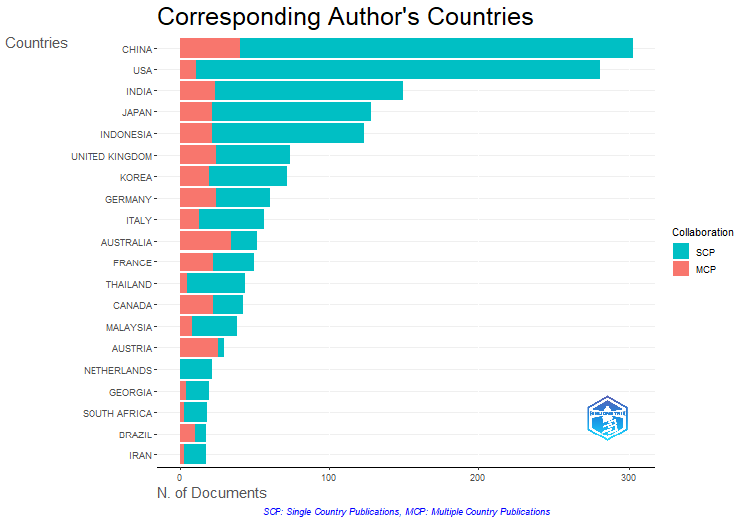
Figure 4. Author’s Countries section

The results show that a handful of countries dominate as corresponding author affiliations, with China leading by a significant margin, reflecting its role as both the origin and global hub of Mandarin language education. Other major contributors include nations with strong academic programs in Asian studies and second language education, such as the United States, Australia, and Singapore. The presence of European countries, including the United Kingdom and Germany, further demonstrates the global reach of interest in Mandarin language learning [13], [14], [15], [16]. These patterns suggest that while research leadership is concentrated in a few countries, a growing network of international contributors indicates expanding global engagement with Mandarin education, as seen in the following mapping.

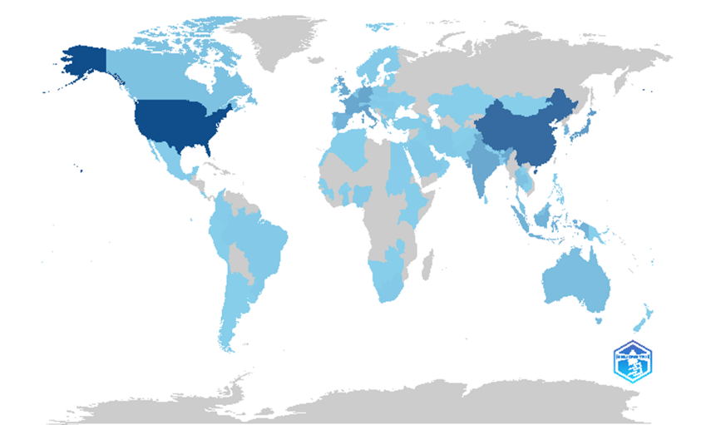
Figure 5. Countries Mapping.
4.5. Authorship Network
The authorship network analysis visualizes the collaborative relationships among researchers in Mandarin language learning. Using VOSviewer, clusters were generated to represent groups of authors who frequently co-publish, each color denoting a distinct collaboration network. Node size corresponds to the author's productivity, while the thickness of the connecting lines reflects the strength of co-authorship links.
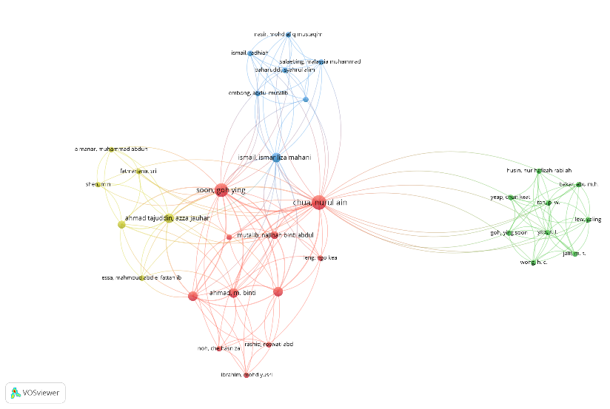
Figure 5. Countries Mapping.

The visualization reveals several prominent collaboration clusters. At the center of the network, Chua Hui Ain emerges as a pivotal connector, linking multiple clusters and acting as a bridge between otherwise distinct research groups. The red cluster, which includes authors such as Soon Yin Ying and Binti Siti, shows strong internal collaboration, suggesting a closely-knit research team. The green cluster, featuring Husin Nur Hashim and Wong K C, indicates another cohesive group with active joint publication. The blue cluster, comprising authors like Nasir Mohd and Ismail Zainal, represents a separate but interconnected research community. Inter-cluster connections suggest that, while research teams work within defined groups, there are also cross-collaborations that facilitate the exchange of knowledge across networks. This pattern reflects a healthy academic ecosystem where concentrated teamwork and inter-group engagement drive scholarly output in the field.

4.6. Co-occurrence Network
Mandarin language learning has experienced significant growth over the past two decades, driven by China's expanding global influence and the increasing demand for multilingual competencies among younger generations worldwide. This trend is reflected in the surge of research on Mandarin education across diverse countries, institutions, and academic disciplines. Bibliometric analysis provides a powerful lens for mapping this evolving research landscape—shedding light on the distribution, dominant themes, and collaboration patterns among scholars. Drawing on bibliometric data mapped from 2023 to 2025, this study identifies the key areas of focus and collaborative networks shaping the current landscape of Mandarin language learning research.
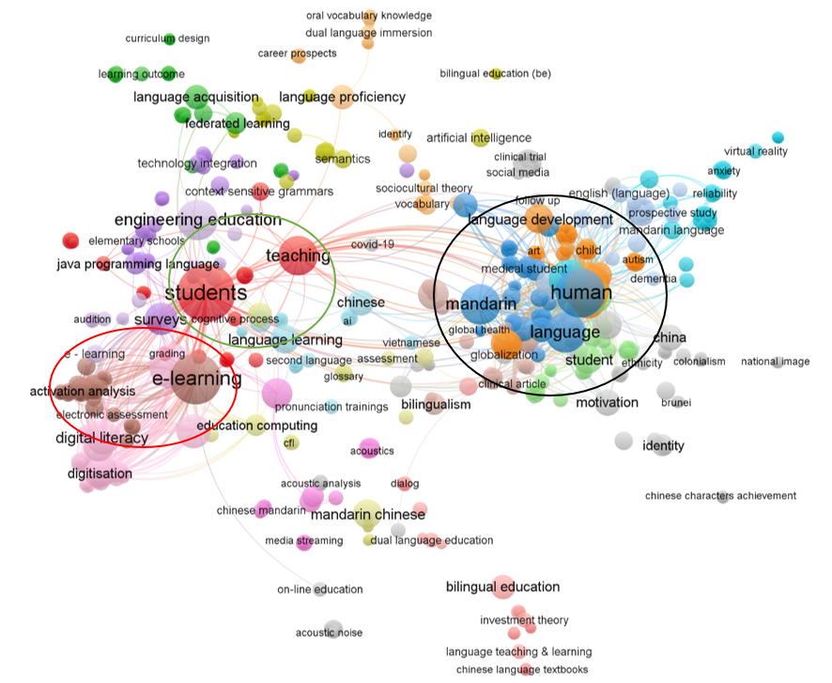
Figure 6. Co-occurrence Network

Analysis of the keyword network visualization (see Figure 1) reveals several prominent thematic clusters in Mandarin learning research. The largest cluster centers on "e-learning," "digital literacy," and "students," highlighting the digital transformation of language education and the central role of technology in enhancing both the effectiveness and accessibility of Mandarin learning. Another significant cluster is formed around "human language" and "Mandarin language," concentrating on language development, cognition, and the dynamics of second language acquisition. The collaborative networks between researchers and institutions are increasingly extensive, with interconnected nodes representing major topics such as "teaching," "engineering education," and "bilingual education." This demonstrates the diversity of research directions and a marked trend towards multidisciplinary approaches in advancing our comprehensive understanding of Mandarin language education.

4.7. Word Cloud
The rapid growth of research into Mandarin language learning cannot be separated from the increasing global demand for proficiency in this language. As China’s influence on the world stage expands, Mandarin has become a strategic skill sought after by educational institutions, researchers, and policymakers alike. This surge in scholarly attention can be systematically mapped and analyzed using bibliometric approaches, which reveal the trends, dynamics, and key themes within Mandarin education literature.
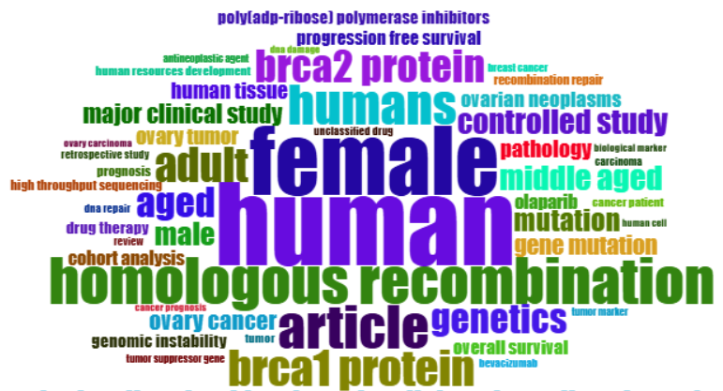
Figure 7. Word Cloud

The results of the keyword network visualization, as illustrated by the above word cloud, show that research in this area is dominated by major themes such as "homologous recombination," "BRCA1 protein," "BRCA2 protein," as well as population descriptors like "human," "female," and "adult." This diversity of keywords indicates a strong research tendency toward genetic and medical aspects in the context of adult human populations, particularly women. Additionally, the frequent appearance of terms such as "genetics," "article," and "controlled study" underscores the empirical nature of this research, often rooted in clinical data. Thus, this word cloud not only highlights the central topics in related scientific publications but also reveals the multidisciplinarity and collaborative patterns developing among experts in biology, medicine, and public health as they explore topics at the intersection of language and human populations [17], [18], [19].
The results are summarized in Table 1 below, which presents the ten most frequently occurring keywords. This data offers a comprehensive overview of the main research focuses and the primary population characteristics studied, highlighting the prevailing directions in research related to genetics, health, and adult human demographics.

Table 2. Word Cloud
Term | Frequency
human | 957
female | 791
homologous recombination | 531
article | 502
humans | 462
brca1 protein | 412
adult | 399
brca2 protein | 376
aged | 349
genetics | 343

5. Discussion
This bibliometric analysis provides a comprehensive overview of the Mandarin language learning research landscape from 2023 to 2025, encompassing publication patterns, thematic clusters, author collaborations, and geographical distributions. The findings indicate that the field is characterized by high levels of collaboration, broad thematic diversity, and significant cross-national engagement.

5.1 Publication Patterns and Source Concentration
The high number of documents (2,069) from 897 publication sources reflects the multidimensional growth of the field and its integration into various academic disciplines. However, the Most Relevant Sources and Source Production Over Time analyses reveal that much of the output is concentrated in a small number of core journals, with the leading outlet producing up to 90 publications during the analysis period. This pattern is consistent with previous bibliometric studies in second language research (Hajara & Karakus, 2024; Wang & Hasim, 2024), which also identify the dominance of specialized journals as primary dissemination channels. While this concentration consolidates knowledge and fosters scholarly communities, it risks thematic homogeneity if peripheral outlets are underutilized [5][6]. Nevertheless, smaller journals remain important for diversifying perspectives and introducing emerging topics such as technology-assisted learning and cross-cultural pedagogy.

5.2 Author Productivity and Collaboration Dynamics
The Author Production Over Time and Authorship Network analyses highlight the central role of collaborative structures in shaping the field. The presence of bridging authors such as Chua Hui Ain, who connects multiple clusters, suggests active knowledge flow between otherwise separate research teams. Such inter-cluster collaborations can accelerate thematic integration and methodological innovation, especially in interdisciplinary topics involving linguistics, educational technology, and applied pedagogy [20], [21], [22]. The balance between single-authored works (265 documents) and co-authored works reflects broader academic trends in language research, where team-based scholarship dominates but individual contributions remain relevant.

5.3 Geographical Leadership and Internationalization
The Corresponding Author's Countries mapping confirms that China remains the primary hub of Mandarin language learning research, followed by the United States, Australia, Singapore, and several European countries. This dominance aligns with China's strategic role in language education and the global expansion of Mandarin learning programs. The international co-authorship rate of 21.99% indicates a growing yet moderate level of cross-border collaboration. Increasing this rate could diversify methodological approaches and strengthen comparative studies, particularly exploring learner motivation, pedagogical adaptation, and technology integration in varied cultural contexts.

5.4 Thematic Trends and Interdisciplinary Integration
The Keyword Co-occurrence Network shows that current research themes are dominated by e-learning, students, and teaching clusters, reflecting the ongoing digital transformation of Mandarin pedagogy [23], [24]. Integrating topics like engineering education, digital literacy, and bilingual education points to a multidisciplinary approach that extends beyond traditional linguistics, in line with global educational technology trends. The close connection between human language and language development also reflects a growing interest in the psycholinguistic and cognitive aspects of Mandarin learning. These results support Xu’s (2024) observations on the increasing role of technology-based instruction and learner autonomy in Mandarin education.

5.5 Implications for Research and Policy
The patterns observed in this study have important implications for researchers, educators, and policymakers. For researchers, the concentration of output in a few key journals underscores the importance of engaging with these core outlets while expanding into emerging or thematic publications to enrich topical diversity. Strengthening international collaboration can foster cross-cultural and comparative studies, which are essential for refining pedagogical models and understanding learner variability [25], [26], [27]. For policymakers and educators, the prominence of technology-related keywords highlights the need for investment in digital infrastructure, teacher training in technology integration, and adaptive learning platforms tailored to Mandarin instruction.

5.6 Limitations and Future Research Directions
While this study offers a robust bibliometric mapping, it is limited by its reliance on the Scopus database, which may omit relevant publications from regional or non-indexed journals. Future studies could integrate additional databases such as Web of Science or CNKI to enhance coverage. Qualitative content analysis of the most-cited works could also provide deeper insights into theoretical innovations and pedagogical practices shaping the field [28], [29], [30]. Moreover, extending the longitudinal scope beyond 2025 could help track whether observed trends, particularly in technology integration and interdisciplinary approaches, continue to grow or undergo thematic shifts [31], [32], [33].

6. Conclusion
The findings of this study indicate that the direction of Mandarin language learning research is moving toward increasingly multidisciplinary, technology-based, and globally oriented approaches. Bibliometric analysis of the 2023–2025 period reveals that dominant themes include online learning, digital literacy, innovative pedagogy, and cross-cultural approaches that integrate linguistics, educational technology, and learning psychology perspectives. This reflects a shift from conventional teaching models toward more adaptive, collaborative formats supported by technological advancements.
In terms of dynamics, the research landscape is characterized by growing cross-national collaboration. China remains the primary hub of publication and research, followed by significant contributions from the United States, Australia, Singapore, and several European countries. This pattern points to global expansion, broadening research networks, and enriching the diversity of pedagogical approaches. Furthermore, the combination of consistent contributions from established scholars and the emergence of new researchers illustrates both continuity and innovation in the field.
Overall, the direction and dynamics of Mandarin language learning research are heading toward stronger technological integration, wider international collaboration, and the development of instructional models responsive to learners' needs across diverse cultural contexts. This trend is expected to continue as Mandarin's strategic role in global communication grows, necessitating ongoing research and adaptation of educational practice.

References
[1] Z. Tian and S. M. C. Lau, “Translanguaging flows in Chinese word instruction: Potential critical sociolinguistic engagement with children’s artistic representations of Chinese characters,” Pedagogies, vol. 17, no. 4, pp. 282–302, 2022, doi: 10.1080/1554480X.2022.2139261.
[2] Y. Ying, “Characteristics and Challenges of Chinese E-Learning Platforms in Indonesia,” in Journal of Physics: Conference Series, S. Vaidyanathan, M. B. Mamat, C.-H. Lien, T. L. Ginta, Mujiarto, and A. Sambas, Eds., Bina Nusantara University, Faculty of Humanities, Jakarta, Indonesia: Institute of Physics Publishing helen.craven@iop.org, 2020. doi: 10.1088/1742-6596/1477/4/042014.
[3] Binze Xu, “Technology integration into Chinese as a foreign language learning in higher education: An integrated bibliometric analysis and systematic review (2000–2024),” Lang. Teach. Res., p. 13621688241277912, Sep. 2024, doi: 10.1177/13621688241277911.
[4] Y. Cui and P. de Costa, "' I never knew I could have so many future possibilities': a case study of an ethnic minority student in mainstream higher education in China," J. Multiling. Multicult. Dev., 2022, doi: 10.1080/01434632.2022.2126846.
[5] A. Hajar and M. Karakus, “Five decades of language learning strategy research: a bibliometric review and research agenda,” Lang. Learn. J., vol. 53, no. 2, pp. 220–249, Mar. 2025, doi: 10.1080/09571736.2024.2361145.
[6] X. Wang and Z. Hasim, “A Bibliometric Analysis on Trends and Patterns in Self-Regulated Language Learning in Mobile-Assisted Learning Environments,” Int. J. Comput. Lang. Learn. Teach., vol. 14, no. 1, pp. 1–18, 2024, doi: 10.4018/IJCALLT.345401.
[7] M. Thelwall et al., “Do bibliometrics introduce gender, institutional or interdisciplinary biases into research evaluations?,” Res. Policy, vol. 52, no. 8, 2023, doi: 10.1016/j.respol.2023.104829.
[8] A. Rahman, A. Raj, P. Tomy, and M. S. Hameed, "A comprehensive bibliometric and content analysis of artificial intelligence in language learning: tracing between 2017 and 2023," Artif. Intell. Rev., vol. 57, no. 4, p. 107, 2024, doi: 10.1007/s10462-023-10643-9.
[9] L. Pan, D. Sun, Y. Zou, Y. Cao, J. Zhang, and F. Li, "Psycholinguistic and educational challenges in Teaching Chinese (Mandarin) Language: voices from None-Chinese teachers of Mandarin language," 2023, Springer Science and Business Media LLC. doi: 10.1186/s40359-023-01432-8.
[10] H. Sun, “Child, family, and school factors in bilingual preschoolers’ vocabulary development in heritage languages,” J. Child Lang., vol. 47, no. 4, pp. 817–843, 2020, doi: 10.1017/S0305000919000904.
[11] H. L. Blake, “Intelligibility Enhancement Assessment and Intervention: a single-case experimental design with two multilingual university students,” Clin. Linguist. Phonetics, vol. 34, no. 1, pp. 1–20, 2020, doi: 10.1080/02699206.2019.1608470.
[12] N. Jafri, U. K. Abd Manaf, and M. M. Muhamad, “The value of cultural immersions in teaching Mandarin as a second language,” Univers. J. Educ. Res., vol. 8, no. 3 3C, pp. 91–94, 2020, doi: 10.13189/ujer.2020.081611.
[13] Q.-Q. He et al., "Jeans and language: kin networks and reproductive success are associated with adopting outgroup norms," Philos. Trans. R. Soc. B Biol. Sci., vol. 379, no. 1897, 2024, doi: 10.1098/rstb.2023.0031.
[14] F. Zhang and C.-C. Tseng, “Inclusive teaching strategies and proprioceptive learning methods for migrants in acquiring basic Chinese,” University of Canberra, Canberra, Australia: Taylor and Francis, 2025, pp. 145–174. doi: 10.4324/9781003441663-11.
[15] H. Tran and A. Stell, “Beyond borders or building new walls?: The potential for generative AI in recolonising the learning of Vietnamese dialects and Mandarin varieties,” Aust. Rev. Appl. Linguist., vol. 47, no. 3, pp. 284–308, 2024, doi: 10.1075/aral.24135.tra.
[16] N. Razima Wan Ibrahim et al., “The development of a novel, multilingual IBD knowledge questionnaire for Asian patients with inflammatory bowel disease,” BMC Gastroenterol., vol. 23, no. 1, 2023, doi: 10.1186/s12876-023-02817-0.
[17] L. Ai, N. Wu, and L. Bao, “Minority language policy shifts and L3 English learning: impacts on elementary Mongolian-Mandarin Chinese bilingual students in Inner Mongolia, China,” Int. J. Biling. Educ. Biling., 2025, doi: 10.1080/13670050.2025.2529554.
[18] R. Makhachashvili and I. Semenist, “Digital Distance and Blended Learning Quality Assessment in Oriental and European Languages University Programs: Regions of Ukraine Survey Study,” Borys Grinchenko Kyiv Metropolitan University, Romance Languages and Typology Department, Kyiv, Ukraine: Institute of Electrical and Electronics Engineers Inc., 2021, pp. 149–156. doi: 10.1109/ICIET51873.2021.9419587.
[19] J. S. Lee and T. Wang, “A review of Korean/English and Mandarin/English dual language programs in the United States,” Lang. Teach. Young Learn., vol. 3, no. 1, pp. 28–65, 2021, doi: 10.1075/ltyl.19020.lee.
[20] Z. Xie et al., “Contributions of Demographics, Language Learning Experience, and Cognitive Control to Chinese Reading Comprehension,” Front. Psychol., vol. 12, 2021, doi: 10.3389/fpsyg.2021.770579.
[21] J. Wangi and K. Rosalin, “The development of Chinese grammar checker website based on Natural Language Processing,” in Journal of Physics: Conference Series, S. Vaidyanathan, M. B. Mamat, C.-H. Lien, T. L. Ginta, Mujiarto, and A. Sambas, Eds., Bina Nusantara University, Chinese Department, Jakarta, Indonesia: Institute of Physics Publishing helen.craven@iop.org, 2020. doi: 10.1088/1742-6596/1477/4/042019.
[22] M. Yang and Y. Wang, “The Relations between Cardinal Number Knowledge and Quantifier Comprehension,” Lang. Learn. Dev., vol. 19, no. 2, pp. 213–229, 2023, doi: 10.1080/15475441.2022.2060832.
[23] L. Chen and D. Wang, “Micro language planning in Mandarin-dominated Chinese language education: voices from dialect-background heritage learners in New Zealand,” Curr. Issues Lang. Plan., vol. 25, no. 2, pp. 157–175, 2024, doi: 10.1080/14664208.2023.2260634.
[24] W. Li et al., “Student-Led Medical Mandarin Summer Course for Medical Students With Existing Mandarin Fluency,” MedEdPORTAL J. Teach. Learn. Resour., vol. 21, p. 11484, 2025, doi: 10.15766/mep_2374-8265.11484.
[25] H. Xu, J. Yang, J. Wang, and W. Hu, “BUILD A 50+ HOURS CHINESE MANDARIN CORPUS FOR CHILDREN’S SPEECH RECOGNITION,” in Proceedings - ICASSP, IEEE International Conference on Acoustics, Speech and Signal Processing, East China Normal University, School of Data Science & Engineering, Shanghai, China: Institute of Electrical and Electronics Engineers Inc., 2024, pp. 10231–10235. doi: 10.1109/ICASSP48485.2024.10445913.
[26] D. Wu, J. Lei, and Y. Wang, “Cognitive and biomechanical interactions in language acquisition: A comparative case study of English and Japanese teaching for nonnative speakers,” MCB Mol. Cell. Biomech., vol. 21, no. 4, 2024, doi: 10.62617/mcb894.
[27] X. Zhao and D. Wang, “Domain-Specific L2 Grit, Anxiety, Boredom, and Enjoyment in Online Chinese Learning,” Asia-Pacific Educ. Res., vol. 33, no. 4, pp. 783–794, 2024, doi: 10.1007/s40299-023-00777-3.
[28] X. Cao, W. Tong, K. Ono, and M. Watanabe, “Evaluating the Role of Visual Fidelity in Digital Vtubers on Mandarin Chinese Character Learning,” Informatics, vol. 12, no. 1, 2025, doi: 10.3390/informatics12010026.
[29] N. A. Chua et al., “The constructiveness of online learning in mandarin course during covid-19 pandemic season,” Universiti Malaysia Terengganu, Kuala Terengganu, Malaysia: IEOM Society, 2021, pp. 5701–5713. [Online]. Available: https://www.scopus.com/inward/record.uri?eid=2-s2.0-85114262342&partnerID=40&md5=b663c8ae4ce8ab31077ead9156cf5396
[30] B. Zheng, “Scaling bi/multilingualism through dual language education: a multi-sited study of diverse learners’ views,” J. Multiling. Multicult. Dev., vol. 43, no. 6, pp. 554–568, 2022, doi: 10.1080/01434632.2021.1975722.
[31] J.-F. Hong, J.-N. Che, and Y.-T. Sung, “The Study on Sentence Difficulty of the Chinese Components,” Forum Linguist. Stud., vol. 6, no. 4, pp. 434–448, 2024, doi: 10.30564/fls.v6i4.6737.
[32] S. Tsuchiya, “The native speaker fallacy in a U.S. university Japanese and Chinese program,” Foreign Lang. Ann., vol. 53, no. 3, pp. 527–549, 2020, doi: 10.1111/flan.12475.
[33] W. H. G. Maravilla, “Digital mandarin learning enhances SDG 8 for tourism and hospitality management students,” Suan Sunandha Rajabhat University, Bangkok, Thailand: IGI Global, 2024, pp. 1–34. doi: 10.4018/979-8-3693-8242-4.ch001.

