Thia-Coumarin-Chalcone Hybrids as Promising Therapeutic Agents: A Review of Synthesis and Biological Evaluation

Saif Al-Deen Mohsen^{1*}, Leaqaa Abdulrida Arubaie²
Department of Pharmaceutical Chemistry, College of Pharmacy, University of Basrah

Abstract
The construction of new medicinal agents by molecular hybridization strategies is a powerful and emerging medicinal chemistry strategy to make novel medicinal agents with unique mechanisms of action through current discovery and development. Molecular hybridization is an important strategy in medicinal chemistry that can be effectively utilized to design multifunctional molecules through the combination of varied pharmacophores to obtain synergistic or additive effects. In this review, we analyze the synthesis and biological evaluation of a new class of hybrid thia coumarin-chalcone derivatives. Thia coumarins are well-established preferred scaffolds with a wide array of biological activities.
Chalcones are an additional α,β-unsaturated ketone system which is well known for its anticancer, antifungal, antimicrobial and anti-inflammatory properties. Similarly, the conjugation of these two bioactive molecules seems to be a promising approach to design and synthesise new molecules with better efficacy and high potential to overcome existing resistance.
This review highlights on the synthetic methodologies utilized for the synthesis of hybrid scaffold, particularly for the synthesis of coumarin–chalcon precursors and Claisen Schmidt condensation for hybrid molecules.
Additionally, it outlines the in vitro activities of these derivatives against a range of diseases and also highlights pertinent SAR findings. The discussion goes on to the possible mechanisms of action such as interfering with signaling pathways and biofilm inhibition that highlight the potential of thia coumarin-chalcone derivatives-as next-generation antimicrobials..

Introduction

The Challenge of Antimicrobial Resistance
In recent times, microorganisms have become a serious threat to general health by converting themselves to a super bug thus causing a pandemic. The microorganisms are developing a resistance to the anti-microbial drugs making them more powerful than before. For instance, medications are failing to work on bacteria, viruses, fungi and parasites. Microbes become drug-resistant and tougher to treat with medicine as they have the capacity to fight against drugs. Various outbreaks are inflicting high human and economic costs to the country and example is COVID 19 outbreak and many others. It is essential to identify the problem and solution for antimicrobial resistance.

Antimicrobial Resistance: its Problem and Solution.
To understand the problem and solution for antimicrobial resistance, we must understand the causes of antimicrobial resistance. What is Antimicrobial? (15 words) | Antimicrobial is a type of drug which is used in various infections. These can kill bacteria, parasites, fungi and viruses and more. These microbes are now evolving in order to resist the drug and become ineffective. There are several reasons like due to overuse, underuse, and misusing.

Excessive use of antimicrobial leads to the resistance of the drugs. For instance, people encountered more misinformation during the Coronavirus pandemic so venture used more. Underuse can be just as harmful as overuse.

Coumarins: A Privileged Scaffold in Medicinal Chemistry
Coumarins (2H-1-benzopyran-2-ones) are a vast and diverse group of organic compounds with natural occurrences characterized by Mark . The coumarin scaffold is found in many plants, such as tonka bean, sweet clover, and some citrus fruits. It has also been used in traditional medicine for centuries. Given their ability to bind multiple biological targets with high affinity, the coumarin moiety was termed a privileged structure from the medicinal chemistry perspective [3,4].
This versatility is indicated by the broad pharmacological activity displayed by coumarin derivative like antimicrobial, antioxidant, anticancer, anti-inflammatory, anticoagulant, antiviral, antidiabetic and neuroprotective. The coumarin nucleus is made up of a lactone ring (C-ring) and a benzene ring (A-ring). Coumarin structure modifications at different sites to introduce different substituents resulted in the formation of derivatives with varied biological activities. For instance, converting at the 7-position produces

compounds have antioxidant and anti-inflammatory properties. The furan and pyran ring’s introduction-photo coupling which helps in formation of guranocoumarins (e.g. psoralen, bergapten) and pyranocoumarins, respectively exhibits stronger biological activity after introduction in the coumarin core. Warfarin is a coumarin derivative which is used as an anticoagulant drug in the clinical practice for a long time.

.
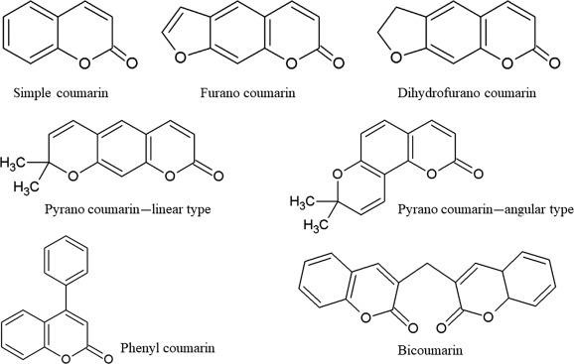

Figure 1: Basic structure of coumarin (2H-1-benzopyran-2-one) and examples of different coumarin types, including simple coumarins, furanocoumarins, and pyranocoumarins. The coumarin scaffold is a privileged structure in medicinal chemistry due to its ability to bind to multiple biological targets [5].

Chalcones: Versatile Bioactive Molecules
Chalcones (1,3-diaryl-2-propen-1-ones) are another important class of natural products, belonging to the flavonoid family. They serve as open-chain precursors for the biosynthesis of flavonoids and isoflavonoids in plants .The core structure of chalcones consists of two aromatic rings linked by a three-carbon α,β-unsaturated carbonyl system (Figure 2). This reactive enone moiety is a key determinant of their biological activity, acting as a Michael acceptor that can covalently interact with nucleophilic groups (e.g,thiols in cysteine residues) in proteins and enzymes [6]. This reactivity underlies their wide range of pharmacological effects, which include potent antimicrobial, antifungal, anti-inflammatory, and anticancer activities [7]. The synthetic accessibility of chalcones via the Claisen-Schmidt condensation allows for the facile generation of a vast library of derivatives with diverse substitution patterns on both aromatic rings, enabling extensive exploration of their structure-activity relationships.

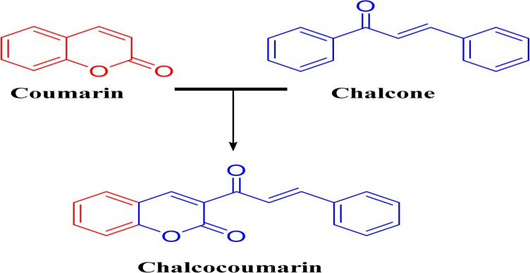

Figure 2: The general structures of Coumarin and Chalcone, and their combination into a Chalco-coumarin hybrid [6] .

Sulfur (thia) substituents

Thiazole and other sulfur moieties frequently enhance antibacterial, antifungal, antiviral, anticancer, and enzyme inhibitory profiles when merged with coumarins; hybridization of two bioactive pharmacophores (coumarin + thiazole/chalcone) is a validated design approach in modern drug discovery[8]. Dedicated work on thiazole–chalcone hybrids shows strong antitubercular and antiproliferative activity with low cytotoxicity, supporting sulfurated chalcone fragments as privileged motifs to pair with coumarins[9].

Molecular Hybridization as a Drug Design Strategy

Molecular hybridization is a rational drug design strategy that involves covalently linking two or more distinct pharmacophores to create a single hybrid molecule. The goal is to develop compounds with improved affinity and efficacy, a broader spectrum of activity, or the ability to modulate multiple targets simultaneously[10]. Coumarin–chalcone hybrids are commonly assembled by forming a chalcone at C-3 of 3-acetylcoumarin via Claisen–Schmidt (aldol) condensation with aromatic aldehydes, furnishing 3-benzyliden- e-1-(coumarin-3-yl)-prop-2-en-1-ones that can be further modified by adding sulfur functionalities on either ring or the linker. Recent reviews schemes converting 7-hydroxycoumarin to 3-acetylcoumarin, then to coumarin– chalcones, with subsequent functionalization steps suitable for introducing thio or thiazole motifs[11].This approach can lead to synergistic effects, where the

activity of the hybrid is greater than the sum of its individual components. It can also help in overcoming drug resistance by providing multiple points of attack on a pathogen. Given the well-documented biological activities of both coumarins and chalcones, their fusion in to a single molecular entity presents a highly promising strategy for the development of novel antimicrobial agents. There salting coumarin- chalcone hybrids are expected to leverage the biological properties of both parent scaffolds, potentially leading to compounds with enhanced potency, novel mechanisms of action, and improved activity against resistant bacterial and fungal strains.

Synthesis of Thia Coumarin and Chalcone Scaﬀolds
The construction of thia coumarin-chalcone hybrids relies on robust and efficient synthetic methodologies for preparing the individual scaffolds and then coupling them together. This section details the key synthetic transformations involved in preparing thia coumarin precursors, chalcone moieties, and the final hybrid molecules.

Synthesis of coumarin Derivatives

Build 3-acetylcoumarin from salicylaldehyde and ethyl acetoacetate (Knoevenagel/Perkin-type), then Fries/acetylation variants to the 3-acetyl handle as detailed in recent trend reviews with annotated schemes for converting
7-hydroxycoumarin to 3-acetylcoumarin [12].



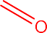

Scheme (1) synthesis procedures of coumarin heterocycles [12].

  - Synthesis of Chalcones: The Claisen-Schmidt Condensation

Perform Claisen–Schmidt condensation between 3-acetylcoumarin and a sulfur-bearing or activatable aromatic aldehyde under ethanolic base(piperidine , KOH, or NaOH) to

furnish 3-coumarin–chalcone hybrids; multiple articles describe this under mild conditions and then derivatize to heterocycles [11]. 3-acetylcoumarin in ethyl alcohol, 4- nitrobenzaldehyde or isovanillin and few drops of piperidine were added. The mixture was refluxed for 6 hours and the resulting solid was picked up by filtration and recrystallized via boiling in MeOH [11].
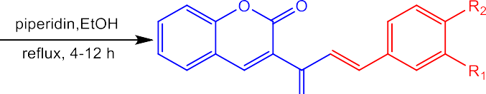

Scheme (2): Synthesis of coumarin–chalcones [11].

  - Synthesis of Thia Coumarin-Chalcone Hybrids

The nitro group is a strong electron-withdrawing group, which enhances the electrophilicity of the chalcone moiety, making it more reactive towards biological nucleophiles figure 5[31] . Thiol addition of p-nitrophenyl thiol to the β-carbon of a coumarin–chalcone α,β-unsaturated carbonyl is a classic thia-Michael reaction that proceeds efficiently under mild base or even catalyst-free conditions, delivering the
β-thioether adduct as depicted in the attached structure [14]. Thio phenol adds to activated enones at room temperature, and increasing thiol equivalents accelerates conversion; this operationally simple protocol translates to arylthiols and provides a green entry to
β-thioethers of p-nitrophenyl thiol in ethanol, methanol, or water/ethanol at 20–50 °C for 0.5–24 h; monitor by TLC or LC-MS; purify by silica gel chromatography to obtain the β-thioether [15].
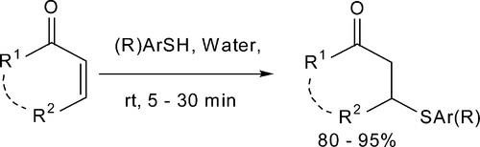

Scheme 3: Catalyst-free conjugate addition of thiols to α,β-unsaturated carbonyl compounds [15] .

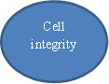
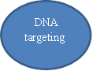

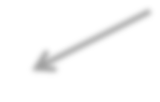

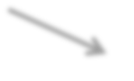








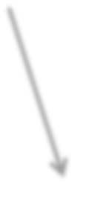





- Evaluation of biological Activity of coumarin derivative
Apoptosi s induction
Cell arrest
DNA
damage
Cell wall disrupti
Mitochondri al disfunction
Biofilm inhibition
Oxidative stress
Caspase activatio
DNA
gyrase
inhibition
Toposom inhibition
Tubulin inhibitio
Glucan Synthase inhibitor
Biofilm reductio
Membrane disruption
chitin synthase
Membrane Potential loss
DNA
intercalati
Antimicrobial effect
Antifungal effect
Anticancer effect

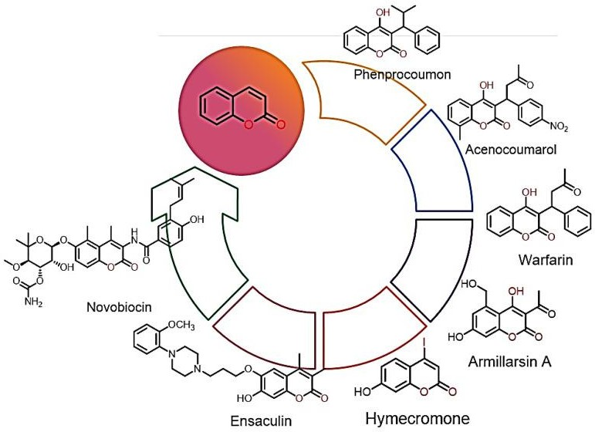
Coumarin-chalcone hybrid compounds exhibit different biological activity for example Warfarin , Phenprocoumon, and Acenocoumarolare well-known as potent anticoagulant agents ; Novobiocin and Armillarisin A are antibiotic ; Ensaculinis also a well-known for its antidementia effects ; and Hymecromoneis a choleretic and antispasmodic agent figure 6and figure 7 [16] [9].

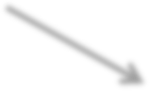
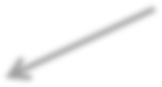

Figure 3 Pharmacological spectrum of coumarins
Coumarin chalcon hybrid

Figure 4 : A comprehensive overview of the multiple mechanisms by which thia coumarin- chalcone hybrids exert different biological eﬀects, including anticancer, antifungal and antimicrobial vigor [17] [18].

  - anticancer activities

Molecular Mechanisms of Anticancer Action

The anticancer activity of coumarin-chalcone hybrids operates through multiple interconnected mechanisms, reflecting the complexity of cancer biology and the multi targeted nature of these compounds. DNA damage response signaling represents a critical pathway through which these hybrids exert cytotoxic effects. the coumarin-chalcone hybrid S009-131 induces DNA damage through minor groove binding, leading to phosphorylation and activation of ataxia telangiectasia mutated (ATM) and DNA- dependent protein kinase (DNA-PK), but not ATM and Rad3-related (ATR), at early time points to initiate DNA repair processes. This DNA damage triggers downstream signaling cascades, including posttranslational modifications of the tumor suppressor p53 at multiple serine residues (Ser15, Ser20, Ser37, Ser46), which impair MDM2-mediated proteosomal degradation and enhance p53 stability [17] . A landmark synthesis of a neo- tanshinlactone-chalcone hybrid molecules that exhibited excellent to moderate in vitro anticancer activity against breast cancer cell lines MCF-7 (estrogen receptor-positive) and MDA-MB-231 (estrogen receptor-negative), as well as endometrial (Ishikawa) and cervical (HeLa) cancer cell lines[18] . The Coumarin-chalcone hybrids have demonstrated potent inhibitory activity against this pathway, with molecular docking studies revealing favorable binding interactions within the ATP-binding pockets of PI3K and related kinases. Similarly, mitogen-activated protein kinase (MAPK) cascades, including the extracellular signal-regulated kinase (ERK) 1/2 and p38 MAPK pathways, represent critical downstream effectors of growth factor signaling that promote cancer cell proliferation and survival [19] . Glutathione S-transferase (GST) inhibition represents an emerging mechanism of action for coumarin-based hybrids, particularly those incorporating sulfonamide functionality. GSTs are overexpressed in many cancer types and play a crucial role in multidrug resistance by conjugating chemotherapeutic drugs with glutathione, thereby reducing their efficacy Multidrug resistance (MDR) mechanisms in cancer cells are greatly influenced by human glutathione transferase P1-1 (hGSTP1-1).

The use of synthetic or natural compounds as hGSTP1-1 inhibitors is consideredan effective approach to overcome MDR [19].

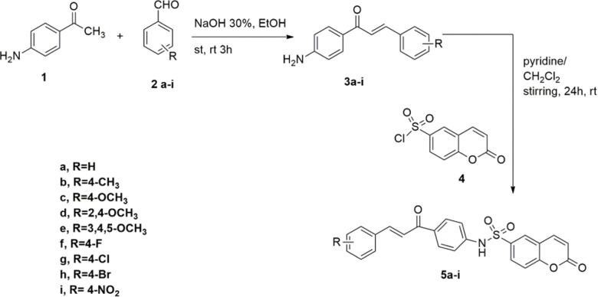

Scheme 4: synthesis of the coumarin-6-sulfonamide-chalcone conjugates .

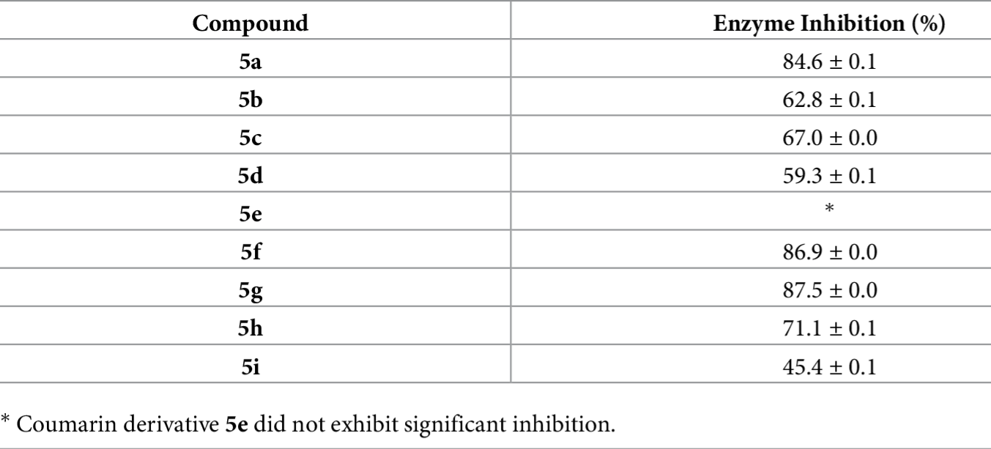
Table 1. Assessment of hGSTP1-1 isoenzyme inhibition by coumarin derivatives [19].

all the synthesized compounds demonstrated inhibitory activities, except for
compound 5e, which exhibited no activity. Compounds 5i, 5c, 5d, 5h, and 5b exhibited medium inhibition potency (45.4–71.1%), whereas compounds 5a, 5f, and 5g showed the highest potency (>85%) and were chosen for additional examination as show in table 1
[19] .

Antibacterial Activity And Mechanisms of Antimicrobial Action

Understanding the mechanism of action(MoA) of new antimicrobial agent is fundamental to their development and to predicting their potential for resistance. The hybrid nature of thia coumarin-chalcone derivatives suggests that they may act on multiple cellular targets, a desirable attribute for combating drug-resistant pathogens.

Disruption of Bacterial Cell Wall/Membrane

The characteristics of bacteria are defined by Bacterial Cell Envelope which is an important structure. This is a useful target that is employed by a range of successful antibiotics. Due to a presence of lipophilic property, the chalcone moiety is likely to penetrate into the lipid bilayer of bacterial cell membrane [25]. It disrupts the membrane structure and electrochemical potential, which leads to the leakage of important components such as ions and metabolites from the bacterial cell. As a result, bacterial cell death may occur [20]. The reaction of the α,β- unsaturated ketone system with nucleophilic residues of cell wall biosynthesis membrane-bound enzymes (like penicillin-binding) and related targets.
.
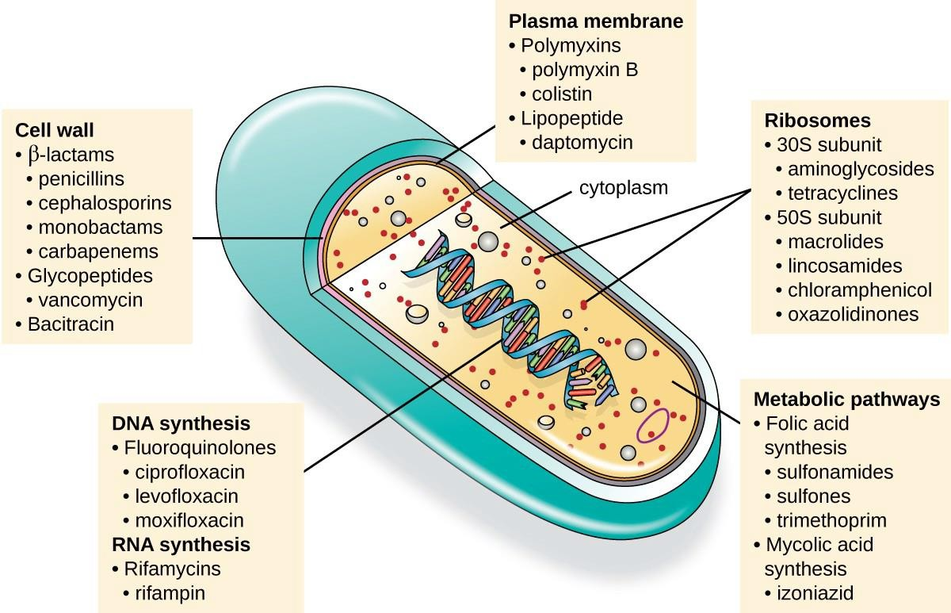
Figure 8: An overview of the various cellular targets for antimicrobial drugs in a bacterial cell, including the cell wall, plasma membrane, ribosomes, and DNA synthesis pathways [20].

Inhibition of Biofilm Formation

Bacterial biofilms play a significant role in chronic disease and antibiotic resistance. A biofilm’s bacteria are embedded in an extracellular polymeric matrix produced by bacteria.

which shields them from antibiotics and the immune system of the host. Commercially available agents that disrupt biofilms are available. According to recent studies, the formation of biofilm can be inhibited by coumarin-chalcone conjugates[21]. A research conducted by Zhang et al. on a coumarin-chalcone conjugate C9 displayed a two-action mechanism. The C9 was proved to prevent biofilm formation in P. aeruginosa, S. aureus and E coli There are two main routes involved.

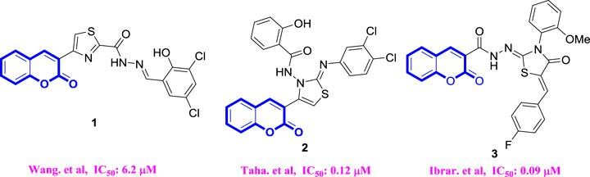
Inhibition of extracellular polymeric substances (EPS) Synthesis: C9 decreases the the exopolysaccharide (EPS) is a major biofilm matrix component of P. aeruginosa. The biofilm structure is disturbed by the compound’s interference with its matrix, increasing the susceptibility of the bacteria embedded in it to conventional antibiotics. The compound stops the bacteria from forming a mature biofilm by disrupting their signaling processes, according to new research.

Figure 9: A proposed mechanism for biofilm inhibition, where coumarin-chalcone hybrids interfere with key bacterial signaling pathways like quorum sensing and cyclic- di-GMP.

4.2.C. Enzyme Inhibition

The electrophilic enone moiety of the chalcone scaffold makes it a reactive Michael acceptor. This allows it to form covalent bonds with nucleophilic residues, particularly the thiol group of cysteine, in the active sites of various essential enzymes. This irreversibleinhibitioncandisruptcriticalmetabolicpathways.Potentialenzyme targets include DNA gyrase, which is essential for DNA replication, and other enzymes involved in protein synthesis or cellular metabolism. The coumarin scaffold can also contribute to enzyme inhibition; for example, certain thiocoumarins are known to be effective inhibitors of carbonic anhydrase, an enzyme present in some bacteria [22]. The ability to inhibit

multiple enzymes could contribute to the broad-spectrum activity and lower the probability of resistance development.The structure-activity relationship studies indicate that the introduction of electron-withdrawing groups, such as halogenated substituents or nitro groups, enhances antibacterial activity against gram-negative organisms. For example, coumarin-6-sulfonamide-chalcone hybrids demonstrated broad-spectrum antibacterial activity against multiple gram-negative species [23]. the Coumarin-chalcone hybrids have demonstrated significant antibacterial activity against Gram-positive bacteria, particularly Staphylococcus aureus and related species, including methicillin- resistant strains (MRSA). The antibacterial mechanism appears to involve disruption of bacterial membrane architecture, inhibition of essential bacterial enzymes (particularly DNA gyrase and topoisomerase II), and generation of reactive oxygen species that damage bacterial proteins and nucleic acids [24].
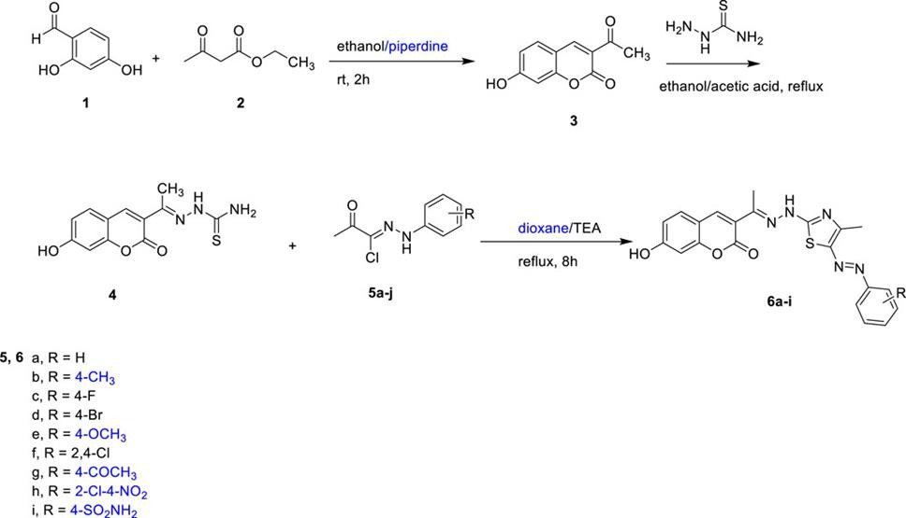

Scheme 8. Synthesis of the target compounds 6a-I [25].

The target compounds 6a-i were prepared, and their antibacterial activities were investigated against Extensive drug resistant (XDR) and Multidrug resistant (MDR) pathogens. As can be seen in table 2. the sensitivity of the XDR pathogens (C.
jejuni and S. fonticola) towards the tested compounds was found to be negligible, as no inhibition zone appeared around all tested molecules. High resistance demonstrated by these pathogens emphasized the ineffective action of the tested compounds; hence, those

were excluded from our examination. Interestingly, the efficiency of the targeted compounds was notably performed toward the MDR pathogens (A. xylosoxidans) and XDR (E. faecalis) [25].
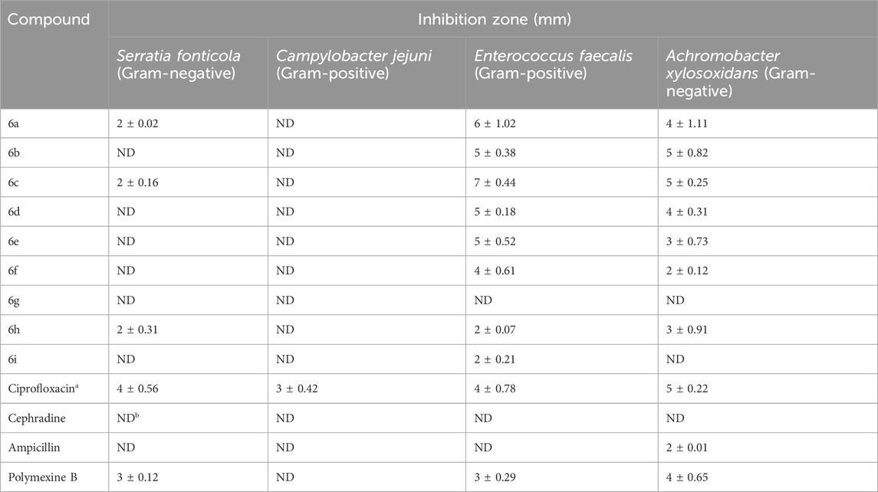

Table 2. Antibacterial activity of the targeted molecules using agar-well diffusion( note ND=not determined) [25].

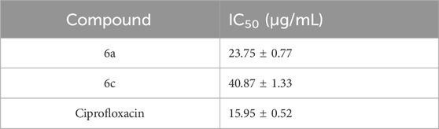
An assay to evaluate the inhibition of E. coli DNA gyrase was conducted for the two most potent compounds, 6a and 6c, with Ciprofloxacin serving as a reference control table 3 .

Table 3 Inhibitory activities of the most active compounds (6a and 6c) against E.Coli DNA [25]

Antifungal Activity of Coumarin-Chalcone Compounds

Coumarin-chalcone hybrids target key enzymes involved in fungal cell wall biosynthesis, which is their mechanism of anti-fungal action. Chalcone derivatives and their coumarin-containing hybrids have been found to inhibit β(1,3)-glucan synthase and chitin synthase, two essential enzymes that catalyze the biosynthesis of.

The key components of the fungal cell wall are important structural polymers. When these enzymes are inhibited, the cell wall structure gradually becomes weakened, which leads to lysis of the cell and its death [26]. Assays of fluorescent probes revealed that treatment of Candida albicanswith coumarin leads to dose- dependent buildup of intracellular reactive oxygen species (ROS). Increased ROS levels stimulated enhanced lipid peroxidation, and these processes stimulated the formation of malondialdehyde (MDA).
Simultaneously, coumarin treatment caused a significant decrease in mitochondrial membrane potential and alterations in mitochondrial morphology [27].

Conclusion and Future Perspectives

Compounds like Thia-coumarin-chalcone hybrids are critical bioactive molecules that combine the complementary features of natural coumarin and chalcone scaffolds with new sulfur-containing linker systems.
These molecules are endowed with a multiple mechanisms based anticancer efficacy which acts through simultaneous inhibition of multiple protein kinases, disruption of the cell cycle, induction of mitochondrial apoptosis, and inhibition of GST mediated drug detoxification which offers survival advantage to cancer cells. Also, the sulfur substitution which has been incorporated along with the specialized p-nitrophenyl thiol moieties provide exceptional antifungal and antimicrobial properties with low toxicity towards normal mammalian cells. The thorough structure-activity relationship studies have provided clear design principles for the optimization of the compounds such as the beneficial effect of certain substitutions (particularly methoxy and halogenated groups), perfect positioning of heterocycles, and the efficacy of two pharmacophores in one compound. Despite challenges in bioavailability and metabolic stability, recent advances in pro-drug design, green synthetic methodologies, and computational chemistry help in reaching the clinical setting. The anticancer, antifungal, and antimicrobial activities of compounds, as well as their low toxicity and rational design, make coumarin-chalcone hybrids very attractive scaffolds for the design of next-generation pharmaceuticals against resistant cancers and multi-drug-resistant pathogenic micro-organisms[28].
- References
- World Health Organization. (2021). Antimicrobial resistance. https://www.who.int/news-room/fact-sheets/detail/antimicrobial-resistance
- Tuka Hassan Abd-Elhussain*,1 and Muthanna Saadi Farhan2Iraqi J Pharm Sci, Vol.33(1) 2024 , Synthesis of New Pyrimidine Derivatives From 3-Acetylcoumarin–
Chalcone Hybrid and Evaluation Their Antimicrobial Activity

- Lončarić, M., Gašo-Sokač, D., Jokić, S., & Molnar, M. (2020). Recent Advances in the Synthesis of Coumarin Derivatives from Different Starting Materials. Biomolecules, 10(1), 151. https://pmc.ncbi.nlm.nih.gov/articles/ PMC7022947/
- Stefanachi, A., Leonetti, F., Pisani, L., Catto, M., & Carotti, A. (2018). Coumarin: a natural, privileged and versatile scaffold for bioactive compounds. Natural product reports, 35(1), 6-43.
- Küpeli Akkol, Esra, et al. "Coumarins and coumarin-related compounds in pharmacotherapy of cancer." Cancers 12.7 (2020): 1959.
- Moya-Alvarado, Guillermo, et al. "Coumarin-chalcone hybrids as inhibitors of MAO- B: Biological activity and in silico studies." Molecules 26.9 (2021): 2430.
- Leitão, Emília PT. "Chalcones: Retrospective synthetic approaches and mechanistic aspects of a privileged scaffold." Current Pharmaceutical Design 26.24 (2020): 2843- 2858. [8] Zeydi, Masoud Mohammadi, Seyed Jafar Kalantarian, and Zahra Kazeminejad. "Overview on developed synthesis procedures of coumarin heterocycles." Journal of the Iranian Chemical Society 17.12 (2020): 3031-3094.
- Kasetti, Ashok Babu, et al. "Thiazole–chalcone hybrids as prospective antitubercular and antiproliferative agents: Design, synthesis, biological, molecular docking studies and in silico ADME evaluation." Molecules 26.10 (2021): 2847.
- Sunil, R. J., S. Pal, and A. Jayashree. "Molecular hybridization-an emanating tool in drug design." Med Chem 9.6 (2019): 93-95.
- Abdel-Latif, E., et al. "Synthesis of Some Coumarin Hybrids and Evaluating their Anticancer Activity." Curr Res Bioorg Org Chem: CRBOC-109. DOI 10 (2018). Chemistry, 9, S1748-S1753.

- Rohman, Nur, et al. "Recent trends in the synthesis and bioactivity of coumarin, coumarin–chalcone, and coumarin–triazole molecular hybrids." Molecules 29.5 (2024): 1026. https://pmc.ncbi.nlm.nih.gov/articles/PMC10934738/

- Khatik, Gopal L., Raj Kumar, and Asit K. Chakraborti. "Catalyst-free conjugated addition of thiols to α, β-unsaturated carbonyl compounds in water." Organic Letters 8.11 (2006): 2433-2436.

- Samanta, Barsha, et al. "Base catalyzed one-pot thia-Michael addition-oxidation reaction of hetero-aromatic thiols to 2-aryl-3-nitro-2 H-chromenes and their antibacterial evaluation." New Journal of Chemistry 48.11 (2024): 4953-4959.

- Khatik, Gopal L., Raj Kumar, and Asit K. Chakraborti. "Catalyst-free conjugated addition of thiols to α, β-unsaturated carbonyl compounds in water." Organic Letters 8.11 (2006): 2433-2436.
- Cheke, Rameshwar S., et al. "Molecular insights into coumarin analogues as antimicrobial agents: Recent developments in drug discovery." Antibiotics 11.5 (2022): 566.

- Kumar, Vishal, et al. "Recent advances in chalcone-based anticancer heterocycles: A structural and molecular target perspective." Current Medicinal Chemistry 28.33 (2021): 6805-6845.

- Ngaini, Zainab, Mohamad Asri Jefferi, and Saba Farooq. "Synthesis, molecular docking, ADMET studies and antimicrobial activities of coumarin-chalcone hybrid derivatives." Natural Product Research (2024): 1-10.

- Sabt, Ahmed, et al. "Novel coumarin-6-sulfonamide-chalcone hybrids as glutathione transferase P1-1 inhibitors." PloS one 19.8 (2024): e0306124.

- Okolo, Emelda N., et al. "New chalcone derivatives as potential antimicrobial and antioxidant agent." Scientific reports 11.1 (2021): 21781.

- El-Sawy, Eslam R., et al. "Coumarins: quorum sensing and biofilm formation inhibition." Molecules 29.19 (2024): 4534.

- Matos, Maria J., et al. "Thiocoumarins: From the synthesis to the biological applications." Molecules 27.15 (2022): 4901.

- Khaleel, Eman F., et al. "Discovery of N'-(1-(coumarin-3-yl) ethylidene) benzenesulfonohydrazide as a novel wound healing enhancer: synthesis, biological

assessment, and molecular modeling." Frontiers in Chemistry 13 (2025): 1621717.

- Thawabteh, Amin Mahmood, et al. "Antibacterial activity and antifungal activity of monomeric alkaloids." Toxins 16.11 (2024): 489.
- [Ebaid, Manal S., et al. "Design, synthesis, and biological assessment of a novel series of coumarin-tethered thiazole derivatives as potential antibacterial
agents." Frontiers in Chemistry 13 (2025): 1627186.
- Lopez, Silvia N., et al. "In vitro antifungal evaluation and structure–activity relationships of a new series of chalcone derivatives and synthetic analogues, with inhibitory properties against polymers of the fungal cell wall." Bioorganic & medicinal chemistry 9.8 (2001): 1999-2013.

- Jia, Chang, et al. "Antifungal activity of coumarin against Candida albicans is related to apoptosis." Frontiers in Cellular and Infection Microbiology 8 (2019): 445.
- Ungureanu, Daniel, et al. "An overview of the structure–activity relationship in novel antimicrobial thiazoles clubbed with various heterocycles (2017–2023)." Pharmaceutics 16.1 (2024): 89.

