**The Resurgence of Onitsha Market Art and the Theatricality of Prophet Odumeje**

**Emmanuel Ebere Uzoji PhD**

**Department of Performing Arts and Film Studies**

**Lead City University, Ibadan.**

**Senior Research Fellow, Centre for Socially Engaged Theatre (C-SET),**

**University of Regina, Canada**

**+2348055487305, [uzoji.emmanuel@lcu.edu.ng](mailto:uzoji.emmanuel@lcu.edu.ng)**

ORCID: https://orcid.org/0000-0002-1521-4015

**Abstract**

Pentecostalism has been a movement that has gained immense prominence since its advent at the dawn of the renaissance following the break away from the middle age church. More recently it has gained wide acceptance and followership as modernity and its attendant consequences puts humanity in a consistent quest for answers to life’s many questions. This study takes a cursory look at the trend of the new age gospel and the new generation pentecostal movement especially its deployment of theatrical craftsmanship in its quest to gain the admiration of large audiences across the globe. The study focusses on the trajectory of the comical Onitsha Market Art and the ministry of Chukwuemaka Cyril Ohanaemere predominantly known as Prophet Odumeje aka *Indaboski Bahose*, the General Overseer of The Mountain of Holy Ghost Intervention and Deliverance Ministry. The approach to this study is the post-dramatic theory and the objective is to explore the interconnections between religion and dramatic arts. The study also further gives credence to the fact that religious practices overtime have now been laced with elements of dramaturgy and the activities of Prophet Odumeje provide a rich resource for triangulating the data around the discourse of theatrical spiritualities. The study hence recommends that the study of drama and all its elements of stagecraft be viewed beyond conventional and mainstream spaces to include other congregational houses such as churches, mosques and other religious sanctuaries. Theatre is fast becoming a veritable tool in ecclesiastic activities and other religious circles and more study needs to be done to situate the power of arts in a fast-paced contemporary world.

***Keywords: Pentecostalism, Theatrics, Drama, Religion, New Generation***

**Introduction**

Theatre overtime has transcended the world of religion. From ancient anthology of theatre, the religious and the sacred elements of life have given impetus to the growth of theatre. This gives credence to the fact that the interconnectivity of divinity and the veneration of same has played a vital role in shaping the theatre across many divides of human existence.

The African clime and the birth of theatre that can be safely described as indigenous has always had religion at the centre of its metamorphosis. This study hence takes a cursory look into the contemporaneity of pentecostalism especially in the eastern part of Nigeria and how the practice and acts of new generation preachers have adopted elements of drama and theatre to give their vocation popularity and attract more adherents. The searchlight of this study beams on the ‘ministry’ of Chukwuemeka Cyril Ohanaemere popularly known as *Prophet Odumeje* and how his work infuses theatrics to single him out as not only a preacher but a performer.

Religion and the religious over the years has not escaped the scrutiny of the artist. It is not in doubt that this aspect of the cultural matrix of humans have formed a rich ensemble from which the artist has formed his craft. Examples exist in Wole Soyinka’s *Trials of Brother Jero* (1964) and Saint Gbilekaa’s *Bishop Bassey* (2014). Interestingly however, the preacher is returning the favour by adopting elements of the theatre to build a personae and advance his practice. These elements have gained the admiration and followership of the audience for the preacher. These elements are x-rayed in the ministry of Prophet Odumeje and the focus is to further explore the dominance of these elements in art and practice of new generation pentecostalism.

A critical view of the preacher and the craft or art of preaching speaks of what Aristotle in his *Poetics* refers to as ‘the spectacle.’ From the costuming, vocalization and message delivery to the music and dance - the modern day evangelist is more of a performer and there is seemingly no better adjective for the description of the new generation pentecostal preacher than an artist/performer.

**New Generation Pentecostalism: A Conceptual Review**

Pentecostalism is a complex term to define due to multiple variations that spread across Africa, Asia and Latin America. However, Asamoah-Gyadu sees it as a movement which emphasizes salvation in Christ as a transformative experience wrought by (the) Holy Spirit and in which pneumatic phenomena including “speaking in tongues”, prophecies, visions, healing and miracles in general, perceived as standing in historic continuity with the experiences of the early church as founded especially are sought, accepted, valued and consciously encouraged among members as signifying the presence of God and experiences of his spirit (2005:13). It is a movement which began a century ago and continues to grow rapidly in the 21st century (Anderson. 2013:10).

New Generation Pentecostalism on the other hand derives its origin from the advent of prophecy and the prophetic movements in Nigeria. This dates back to 1891-1920 when churches arose as a result of break-away from the orthodox/mainline or mission churches like the Church Missionary Society (CMS) now known as the Anglican Communion, the Methodist Church known as Wesley Church and the Baptist. To this, Adetumbi describes the movement as that which was founded in Africa, by Africans and for Africans (2018:324).

One of the characteristics of this breed of ‘pentecostals’ is a strong belief in prophecy and the prophetic. It is not out of place therefore to see many of the leaders in these circles with the title of ‘Prophet’ and quite significant to this trend of prophecy is the presence of the exotic and the dramatic. This is replete in their mode of operation. It is hence not strange to see a rich display of resplendent and very outlandish costumes that goes with acts that drive the audience/members to a state of frenzy and awe.

**The Postdramatic Attributes of the Onitsha Market Art**

The 21st century has thrown up to the front burner of intellectual discourse new frontiers and dimensions of drama. The world has seen the growth and limitless boundaries opened to these seemingly new and experimental forms of theatre. The trajectory of these new art forms has moved from traditional spaces to the streets and then to digital spaces. The postdramatic theatre therefore presupposes a theatre after drama. This theory has provided a new parameter for exploring the attributes of a new reality of understanding vocations that project a performance in the guise of reality, a non-textual activity that carries all the semblance of actuality, yet not dichotomous from the attributes of a performance. Despite their diversity, Lehmann believes these new forms and aesthetics that have evolved have one essential quality in common: they no longer focus on the dramatic text (2006:6). The rapid growth and fluidity in the use of digital spaces has served as a major catalyst for the growth of non-conventional art forms. No one can underestimate the use of cyberspace and the platforms it create for street theatre and other unorthodox performances that have been popularized by the social media. This new theatre in this way is much more immediately informed by cultural practices other than traditional drama (from visual art and live art, to movies, TV channel hopping pop music and the internet) (Lehmann, 2005:21). The postdramatic theatre hence, presents a world open to its audience, an essentially possible world, pregnant with potentiality.

Lehmann’s study of the ‘postdramatic’ denotes a theatre that feels bound to operate beyond drama, at a time ‘after’ the authority of the dramatic paradigm in theatre. ‘After’ drama means that it lives on as a structure - however weakened and exhausted - of the normal ‘theatre’: “as an expectation of large parts of its audience, as a foundation for many of its means of representation, as a quest automatically working norm of its dramaturgy” (Lehmann, 2006: 7).

Such is apt of an evolving genre of theatre seen and staged on the streets of Onitsha, a stage where ordinary citizens and presented to live out their own reality and commonality. At the end of the Second World War in the 1940s, this genre of art otherwise known as Onitsha Market Literature came as a spate of pamphleteering which later developed as phenomenon in the West African literary scene. According Ogayi and Ogiri, the authors sometimes presented works written with colourful and idiomatic expressions with malapropism (2020: 55). The language of this art is spoken and understood by everyone, the content is a replica of the struggle and contestations within the circle of the majority and the channel of delivery and distribution is the social media. The Onitsha Market art hence is an art that has flourished overtime. The plays according to Ogunbiyi (2014: 29-30), provide us with useful insights into the meaning of the lives of an important segment of a part of the Nigerian society. The plays centre on a wide range of subjects and themes such as the imprisonment of Adolf Hitler, dramatised biographies of African leaders, love themes and didactic pieces. Dudson also in a critical survey of some of these works captured one of such instances in *Veronica My Daughter* where Bomber Billy regalling Veronica’s brothers with the story of his accident thus:

As I was descending from declivity yesterday with an excessive velocity I suddenly lost the centre of my gravity and was precipitated on mecadenized thoroughfare (Dudson, 1979: 626)

This use of flowery and bogus vocabulary has also been associated with Prophet Odumeje, a major trait that has endeared him to his audience.

**The Preacher as a Performer**

Theatre is an expressive vocation that distils all aspects of human existence and religion has over the years had its connections with this art. From ancient antiquity, the church has formed part of the historiography of drama especially during the middle ages and up to the 21st century. Preaching on the other hand is about sermonization - an art that uses speech delivery that also involves communicating the dictum of faith to an audience. To bring these sermons to life, theatrics are deployed in most cases. Turner believes it is not unusual to think about ritual action (a major catalyst for the growth and development of the theatre) and performance in relation to the role of the priest or the pastor (2008: 73). Kevin Vanhoozer’s recent work *The Drama of Doctrine* makes this point when he suggests that the theologian and the preacher might be best understood if the metaphor of dramaturgy is used, the one who advises on how best to interpret and perform a script. “if we understand preaching to share in Christ’s ongoing work of redemption, then preachers are performers who participate in the on-going ministry of Christ on our behalf” (Vanhoozer, 2014: 170) . In this sense, preaching embodies the promise to be a “faithful performance” that involves a script of the scriptures, rehearsal of embodied movement and voice, and entails interaction with the congregation and other dramatic qualities.

Preaching is a performance that involves active participation by all present. Preaching is a part of that dialogical liturgical movement of performance that involves not only those who perform, but also those who attend the performance. Johnson says to ignore the performative quality of preaching is an error of judgement, “to shy away from matters of performance is to misunderstand the nature of the current arts that make up worship. To perform in worship is simply to do what preachers and worship leaders train and prepare to do: to give experience to musical, dramatic, dance, or discursive forms that make up the patterns of worship” (Johnson, 2014: 171). Frymire on the other hand categorizes preaching into two categories: didactic and the narrative. While didactic preaching distils the truth in the text; narrative preaching displays the truth of the text. The drama is in the story not the performer (2022: 179).

From the above, it is trite to link the performative with the liturgical. Clerics have often found themselves unconsciously but yet inextricably engaged with the theatrical in the course of their pulpit functions. Every performer on stage projects a character at variance with the real his or her real personality so likewise most preachers. Eslinger in his study of the pitfalls in preaching, believes that a number of homileticians have broadened the attack on ‘performance’ in the pulpit by calling attention to the persona a preacher adopts, which projects a larger-than-life personality.

Here, the projective style of personality is larger than life and may come packaged with practised facial expressions and even a hairstyle tinted to match his or her pulpit outfit. Such a preacher is easily labelled a performer, which most commentators would view as a distinctly unfavourable description. Drawing attention to one’s pulpit persona is at the opposite pole from the description of the preacher as a “servant of God” (Eslinger, 1996: 132).

The above analysis of the preacher/performer dichotomy aptly encapsulates what has come to be identified with some new generation pentecostal preachers. The emphasis on creating a unique persona as a form of signature or brand resonates with the audience easily than digging out the authenticity of the preacher. This uniqueness comes in form of mode of speech delivery, sense of humour, costumes, gestures and stunts or altar and pulpit design (set design).

**The Man Odumeje: The Prophet/Artist Connection**

Chukwuemeka Cyril Ohanaemere, commonly known as Pastor Odumeje (A.K.A Indaboski Bahose, The Lion, The Fight, The War, Wrestling Pastor) is a Nigerian musician and pastor who is the head of The Mountain of Holy Ghost Intervention and Deliverance Ministry located at Onitsha, Anambra State in South-eastern Nigeria. Information available at *Kevinsplug*, a major biography webpage says Odumeje was born on 9th September, 1982 in Anambra State of South-eastern Nigeria, and hails from Orsu Ihete Ukwa, in Orlu LGA in Imo State. He is the third out of six children born to Mr. and Mrs. Pius Ohanaemere. He completed his basic education at a primary school at Nweje after which he attended Providence Secondary School.

Odumeje grew to cater for himself at an early age as [his](http://kelvinsplug.com.ng/) family were not well-to-do. He initially pursued a career as a leather designer on the bustling streets of Onitsha city in Anambra state before eventually dedicating himself to full-time gospel ministry. Despite his growing interest to further his education, he entered the leather business as an apprentice due to his inability to fund his schooling.

Pastor Odumeje’s church, The Mountain of Holy Ghost Intervention Ministry is located at Onitsha in Anambra State where he started his ministry while still an apprentice in his leather business. On September 10, 2010, Prophet Odumeje founded the Mountain of Holy Ghost Intervention and Deliverance Ministry as a deliverance ministry in a public yard at No 14 Osumu street, and then moved to Okija hall and subsequently to Arondizuogu hall, all located at Odakpu, Onitsha in Anambra State. The Church was later moved to its permanent site at No. 88B, Bida road, Modebe Avenue, Odakpu Onitsha.

He gained the nickname “The wrestling pastor” due to his purported healing techniques. He became embroiled in a dispute with a former associate, Ada Jesus, who accused him of being a fraudulent prophet and orchestrating fake miracles. In response to being labeled a “money-focused entertainer,” he dismissed his critics as mere troublemakers.

Prophet Odumeje has caused a lot of stir online after video of his church services went viral. On these videos, Odumeje can be heard calling the names of his powers. Some of the powers he mentioned are: *Ribadu, Sepree, Ramade, Abidoshaker, Gandugagandusa, Lefase’ Farell, Palebo-Skendelebo, Dabuskabash, Indaboski – Bahose.*

What is evident especially from the foregoing is that Odumeje is not just a preacher who runs a typical Nigerian new generation and populist church movement, but he is one with a niche for the artistic and the theatrical. In some circles such as the music industry, he has gone ahead to collaborate with well acclaimed and famous afro-beat and afro-hiphop artists such as *Phyno* and *Flavour* to release top-hits songs that seems to resonate with young music lovers. Top songs include: *Umu Jesus* (featuring Flavour), *Alabasidi, Yakuzili Nwa, Onye Amuma, Okwa mu na gi bu enyi, Iron Like Lion in the Zion, Ike Billion Billion* (featuring Phyno), *Morocco, Powers* (featuring Flavour). Some of these songs have been performed on events and musical concerts with sold out tickets. The music videos as well have large views on social media. No doubt this artistic voyage into the music industry has further earned Odumeje a celebrity status. Some of his hit songs has enjoyed radio airplay and are quite popular in clubs and parties across the country.

**Theatrical Elements in the Work and Ministry of Prophet Odumeje**

While it may not be absolutely true to describe Prophet Odumeje as an actor as this may further add to the many controversy and diverse opinions surrounding the authenticity of his ministry, certain acts and the ministerial style of this preacher comfortably puts him in the line of a performer. It is also worthy of mention that he has always had an interest with the entertainment industry particularly movie production and music. This is more evident in the number of Nollywood (Nigerian movie industry) celebrities and music artistes who have openly identified with him. Another dimension to these theatrics is also the description of the preacher as a comedian. As can be deduced from some of his social media content, Odumeje has severally denounced and loathed the comic labelling of his style but recent reviews of his work have classified him as such even though some of these videos come from live recordings of his church services. The stunts and sometimes unorthodox display in his messages and the manner in which he conducts his healing and deliverances is viewed as his own style. Interestingly, it is this style that has singled him out from other contemporaries and placed him in the context of the theatrical. Some of the theatrical elements are comedy, costume, music and dance, as well as the use of certain props like coloured candles lit on the stage (though believed to possessed certain spiritual significance) all which have made him unique and popular.

Costume: The dress code of Odumeje is one major theatrical element that is worthy of note. The preacher dresses in the typical Onitsha Market style of free-flowing designer shirt an a pair of jeans or chinos while on the pulpit, an outfit not usually akin to most Nigerian preachers who will normally adorn a corporate wear or a traditional attire.

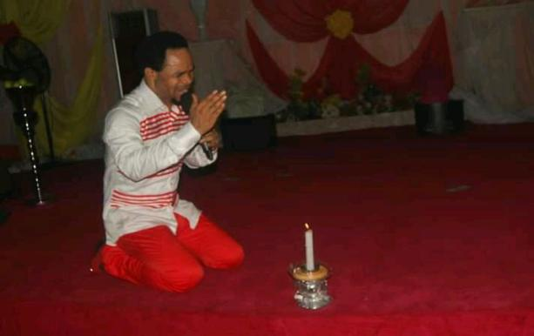 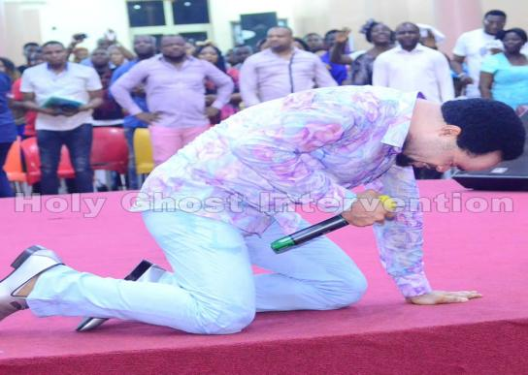

*Prophet Odumeje in his unique dress code while ministering in his church*

Music and Dance: Odumeje is also a musician and incorporates music in his ministry. His songs are often energetic and praise-filled, reflecting his dynamic personality. Dance is also a significant part of his ministry. He is known for his energetic and sometimes theatrical display of dance moves which he performs during church services and events. These dances are often accompanied by his music, creating a lively and engaging atmosphere. One highpoint of his career is his London tour in April of 2024 at the Lighthouse Theatre where he performed most of his songs including *Powers*, a collaboration with popular Nigerian artiste Flavour.

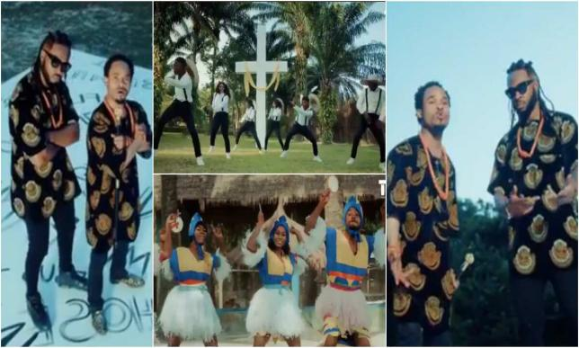 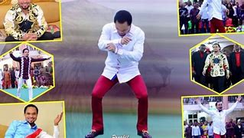

Comedy: In a YouTube channel documenting some of the best comedy videos of Odumeje, the preacher could be seen hilariously performing deliverance ministration on someone who is purported to have lost every sense of sexual potency. The conversation is captured thus:

Odumeje: Somebody’s manhood become teni. Somebody’s manhood become backward, that is back to sender and that is return back, that it means became like something like up and down. Is it up and down?

Member: It is not erecting anymore.

Odumeje: Okay the thing is no more erecting? That is before e big but now your manhood is small. Aaah! That is elephant come down. It is too bad! <http://www.youtube.com/watch?v=CCkMzXzpWE>

Another video sees the Odumeje telling the church congregation about his looks and state of preparedness for the church service: “I look vivacious today. I looks volumnious today. I look corocious and I look fantamaglorious and I look papakious and also mamakious” <http://www.youtube.com/watch?v=CCkMzXzpWE>. In yet another clip, he is again seen interviewing a person said to be having insomnia. The conversation goes thus:

Odumeje: Since yesterday you haven’t sleep?

Member: Yes sir.

Odumeje: Heeee! Madam!

Member: I’m not exaggerating sir! I don’t sleep.

Odumeje: You’re not exaggerating?

Member: Yes sir!

Odumeje: What is exaggi…. what is exaggerating?

Member: I’m not saying what is not real.

Odumeje: That is you are saying the reality. The fact. So you have not sleep. You have never close this your eyes - this your small eyes?

Member: Yes sir! In sleep.

Odumeje: Where do you come down from?

Member: From Umuahia sir. I remember I used a cream that has hydroquinon.

Odumeje: You use what?

Member: A cream. They said it has hydroquinon.

Odumeje: You use what?

Member: A cream. . which can cause skin disease, skin cancer.

Odumeje: Is it what you call hygloglara?

Member: The name of the sickness is melanorma.

Odumeje: Melanorma! Where is that person from?

The above typifies what a normal day looks like in the ministry of Odumeje where many seeking healing and deliverance throng with the belief that he possesses the power to set them free. The style of Odumeje which makes him unique from all other preachers is the humour that goes on with what he does. While striving to elicit information from them, the interviewees most times use words or phrases beyond his comprehension and in a bid to get at par with what they are saying; he appears to be making a joke out of it. He identifies with the street. His use of Igbo slang which is sometimes a corruption or a remix of Igbo idioms, which in most cases begins with or end with English or have an English word thrust in there, his deliberate (or not) massacre of the English language, and his use of unknown words such as ‘indaboski bahose’ have made him popular and famous with the street and the random seeker of entertainment on social media.

**Conclusion**

This study establishes the connections between religious preachers and the business of the theatre. The pulpit and the stage share common traits of performance before an audience with the dramatis personae of the former being the preacher and the later the stage. The case study used for this work has excavated the theatrics and some elements of the theatre used by new generation preachers to further gain public appeal while propagating their faith to the audience. With this study, it is evident that the postdramatic age has opened a new vista of opportunity for theatrical engagement beyond the mainstream theatre. In an age of cutting edge technology, growing mass of people connecting with popular culture and emergent theatre spaces, there is need to re-evaluate existing data on the study of new age theatre and how the practice of same permeates these non-conventional spaces.

Works Cited

Adetumbi, Moses. “Prophecy/Prophetic Preaching in Nigeria and the Biblical Prophecy in Historical Perspective” in *Prophecy, Politics and Power in Ancient Israel and Nigerian Context: A Festschrift in Honour of Most Rev. Dr G.L. Lasebitan*. O.A. Dauda et al (eds) , Ibadan: 2018.

Anderson, A.H. *An Introduction to Pentecostalism: Global Charismatic Christianity.* Cambridge: University Press, 2013.

Asamoah-Gyadu, J.K. *African Charismatic Current Developments within Independent Indigenous Pentecostalism in Ghana*. Leidon & Boston: Brill, 2005.

Dudson, D. *Critical Perspectives on Nigerian Literature.* London: Heinemann, 1979.

Eslinger, Richard. L. *Pittfalls in Preaching.* Cambridge: William B. Eardmans Publishing Company, 1996.

Frymire, Jeffrey L.  *Preaching from Inside the Story: A Fresh Journey into Narrative.* Oregon: Cascade Books, 2022.

Johnson, Trygve D. *The Preacher as Liturgical Artist: Metaphor, Identity and the Vicarious Humanity of Christ.* Oregon: Cascade Books, 2014.

Kennisplug. <http://kevinsplug.com.ng/prophet-odumeje-biography-real-name- church/ Accessed 31st July 2024

Lehmann, Hans-Theies. *Postdramatic Theatre.* New York: Routledge, 2006.

Ogayi, Martin C & Ogiri, ThankGod. “Onitsha Market Literature in Language and Literary in Language and Literary Development of Nigeria” in *International Journal of Humanities and Social Science Invention* (IJHSSI), Vol. 9, Issue 6. Ser. 1, June 2020. pp. 54-60.

Ogunbiyi, Yemi. “Nigerian Theatre and Drama: A Critical Profile” in *Nigerian Theatre and Drama: A Critical Sourcebook,* Ogunbiyi, Yemi (ed). Abuja: Tanus Books, 2014.

Turner, Mary D. “The Performance of a Prophet” in *Performance in Preaching: Bringing the Sermon to Life.* Childers Jana & Schmit Clayton J. (eds). Grand Rapids: Baker Academic, 2008.

YouTube. <http://www.youtube.com/watch?v=CCkMzXzpWE> Accessed 31/7/2024.