**The Interpretation of Ritualism in Èkpè Ólōkōrō Igbo Traditional Drama**

By

Mpamugo Emmanuel Emenike

Department of Igbo Language and Culture

University of Agriculture and Environmental Sciences,

Umuagwo, Imo State, Nigeria

. E-mail: [empamugo4@gmail.com](mailto:empamugo4@gmail.com)

+2347034937398

And

Orji, Chidi Paul Ph.D

Department of Philosophy,

University of Agriculture and Environmental Sciences,

Umuagwo, Imo State, Nigeria

E-mail: paul.orji@uaes.edu.ng,

hipaulco@gmail.com

+234 (0)8149412995

**Abstract**

Culture and tradition are a way of people’s life. It is through culture and traditions that the Igbos showcases their life, world view and belief. Traditional drama is one of the ways through which cultures, traditions and beliefs are showcased and this is prevalent in Igbo land. This research work looked at traditional drama and brought to fore the Èkpè traditional drama of the Ólōkōrō Igbo people. This research is a descriptive type of research whereby the researchers described the Ólōkōrō Igbo people and one of their unique traditional dramas embedded in ritualism. The Èkpè traditional drama is performed once every year during new yam festival. It involves a lot of singing, dancing, perambulating and rituals which are performed by members of the Ọ̀kọ̀ńkọ́ traditional cult who are the custodians of the Èkpè traditional drama.

**Keywords:** Ritualism, Traditional drama,Ólōkōrō Igbo, Èkpè.

**Introduction**

This research work looked at the Èkpè traditional drama of the Ólōkōrō Igbo people found in the south-eastern part of Nigeria. The Èkpè traditional drama is a cultural heritage of the Ólōkōrō Igbo, which they are known for. The Igbo tribe in Nigeria is known for so many traditions, just like in other parts of the world, and most of these traditions are not known outside their locality. Just as towns, communities, and villages are different and diverse in Igbo land, so are the traditions, and each town, community, or village has traditions that are peculiar to them, just as the Èkpè traditional drama is peculiar to the Ólōkōrō Igbo people. It is through culture and tradition that people showcase their way of life and their beliefs. To understand a people intricately, it is pertinent to understand their culture, tradition, and beliefs. For this sole purpose and for the purpose of general knowledge, the researchers found it worthy to carry out expository research on the Èkpè traditional drama of the Ólōkōrō Igbo to bring to light their heritage, traditional way of life, and their beliefs.

**Tone-Marking**

The Igbo language is a tonal language and uses tone marks to showcase the pitch of sounds in words. There are three known tones in the Igbo language, which are: high tone (high pitch), low tone (low pitch), and down-step (moderate pitch). The high tone is marked with an acute diacritic (´), the low tone is marked with a grave accent diacritic ('), and the down-step is marked with a hyphen diacritic (-). For the purpose of clarity, the researchers adopted the Welmers and Welmers (1968) tone-marking convention. This tone-marking convention states that all tones in a word are to be marked using the appropriate tone mark. High tones are marked with (´), low tones are marked with ('), and down-steps are marked with (-).

**The Ólōkōrō Igbo**

Ólōkōrō, one of the towns that make up Ụmụahịa, the capital city of Abia State in the south-eastern part of Nigeria, is in Ụmụahịa South Local Government Area of the state. Other towns in Ụmụahịa South Local Government Area are: Ụ́bàkàlà and Ụ́mụ̀ọ́párá. Other towns surrounding Ólōkōrō are: Ìbékù to the north, Ísíàlàńgwà to the south, Òbòró to the east, and Ụ́bàkàlà to the west. The villages that make up Ólōkōrō are grouped into three:  Ụ́mụ̀tówé, Épé, and Àzụ́íyī.

The history of the origin of Ólōkōrō has two myths embedded in it. These two myths were handed over to us by our forefathers, who also received them from their fathers before them. The first myth has it that Ólōkōrō is the son of Ùvúọ̀mà, a man from Árọ̀ (a town in the present day Abia North), who came to live in the southern part of Ụ́mụ̀áhị̀à. Ùvúọ̀mà, as the myth has it, was without a male child for so many years. One day, he was returning from his farm, and on entering his compound, he heard the cry of a baby and asked whose cry he was hearing, and the people who had gathered in his compound answered him and said ‘ólú òkóró’ (the voice of a boy). In joy and amazement, Ùvúọ̀mà shouted ólú-òkóró! In remembrance of what transpired at the birth of this child, people started calling him ólú-òkóró (olu + okoro = olokoro in pronunciation). That is, there is a retrogressive assimilation here, whereby the vowel ‘o’ in okoro assimilated the vowel ‘u’ in olu). Ùvúọ̀mà welcomed this name and gave his son the name, which he bears to date.

Ólōkōrō later gave birth to three male children, who are: Ụ́mụ̀tówé, Épé, and Àzụ́íyī. Ụ́mụ̀tówé has seven kindreds: Ágbámā, Ámụ́zū, Àvọ́ńkwū, Ị́tájā, Ìtù, Ọ́kwụ́, and Ụ́mụ̀ọ́páráọ̀zàrà. Épé has five kindreds: Ámáǹgwò, Ámízī, Ụ́mụ̀ájátà, Ụ́mụ̀dérè, and Ụ́mụ̀ǹtù. Àzụ́íyī has three kindreds: Ámákāmà, Ụ́mụ̀ìbèjì, and Ụ́mụ̀ọ́bị̀à.

The second myth has it that the villages that make up Ólōkōrō migrated from the towns surrounding it. The myth explained that Ụ́mụ̀ájátà in Ólōkōrō migrated from Ajata-Ibeku in Ụ́mụ̀áhị̀à North Local Government Area of Abia State and came to live in Ólōkōrō.  Also, Ámízī in Ólōkōrō migrated from Amizi-Isuọgụ in Bende Local Government Area of Abia State. Ìtù in Ólōkōrō migrated from Itu-nta, Itu-mba-ụzọ, and Itu in Akwa-Ibom state. Ụ́mụ̀òkóróúkwú-Ámákāmà in Ólōkōrō migrated from Okoroukwu in Bende Local Government Area of Abia State. Ọ́kwụ́ in Ólōkōrō migrated from Ọkwụta-Ibeku in Ụ́mụ̀áhị̀à North Local Government Area of Abia state. Ámụ́zū in Ólōkōrō migrated from Amụzụ-oro-Ibeku in Ụ́mụ̀áhị̀à North Local Government Area of Abia state. These kindreds in Ólōkōrō and the towns where they are said to have migrated from do not intermarry till today, as they are from one father (Onyema, 1993:21). In these two myths about the origin of Ólōkōrō, we have learned that the people of Ólōkōrō were not originally living in the place they found themselves today; they migrated from either Arọ or from the towns surrounding Ólōkōrō.

The people of Ólōkōrō, who believe strongly in Igbo culture and tradition, have cultures that they imbibe and that are peculiar to them. These cultures revolve around traditional drama and ritualism. Some of these cultures include: Ọ̀kwụ̀kwụ̀ (Second burial ceremony), Ị́zọ̀ áhị́á (Fiesta of common masquerades), Írī jī (New yam festival),  ị́dà ḿmírī (First initiation into ọ̀kọ̀ńkọ́), íkpū ụ́lọ̀ (Second initiation into ọ̀kọ̀ńkọ́), Ị́gbā èkpè (Ritual traditional drama), Ògbòm (Traditional dance drama), and Èdèrè (Traditional dance drama). These cultural ceremonies have traditional cults that are in charge of them. These traditional cults are mainly for men, and they are: Ọ̀kọ̀ńkọ́, Ékpè, Mbọ́kọ̀, and Èkètéńsī.

In the belief system of the Ólōkōrō people, just like other Igbo communities, they believe in Chíúkwú (big God), Òbìlígwē (that lives in heaven), who sustains life. They also believe in other smaller gods through which they communicate with the big God. These smaller gods include: Àlà (earth goddess), Kámánū (god of thunder), Ékwé (god of justice), and Ọ̀fọ́-Áhị́áúkwú (god of ritual ceremonies).

Ólōkōrō people are hardworking people. They are mostly farmers who produce cassava, corn, melon, three-leaf yam, coco yam, yam and palm oil in large quantities.

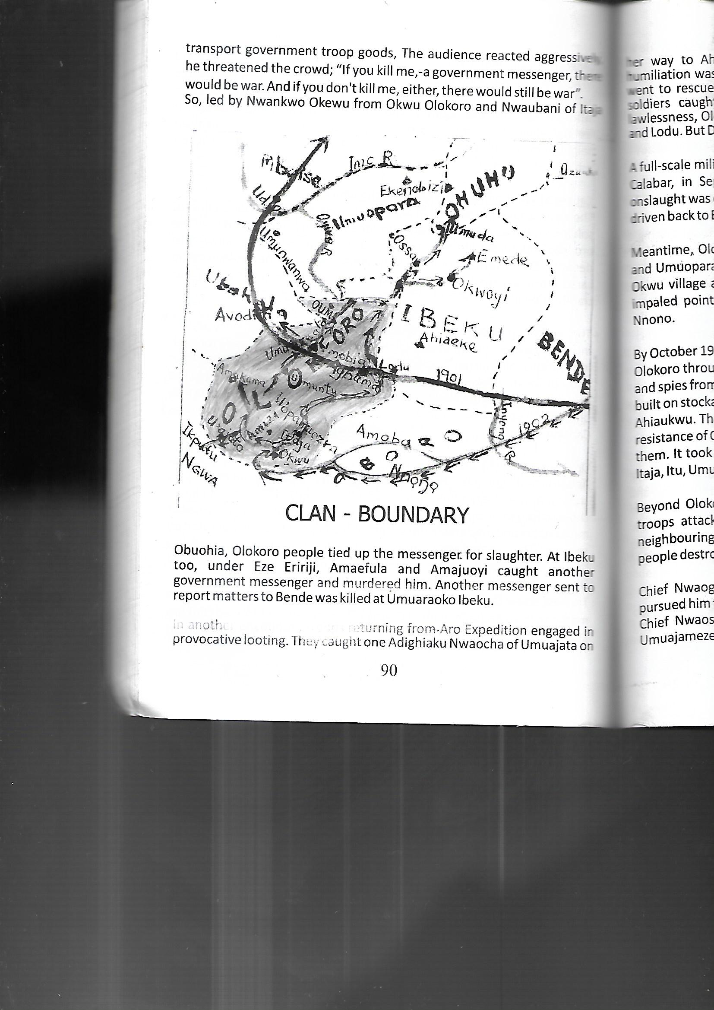

**Map of Abia showing location of Olokoro (Adapted from Onyema 1993)**

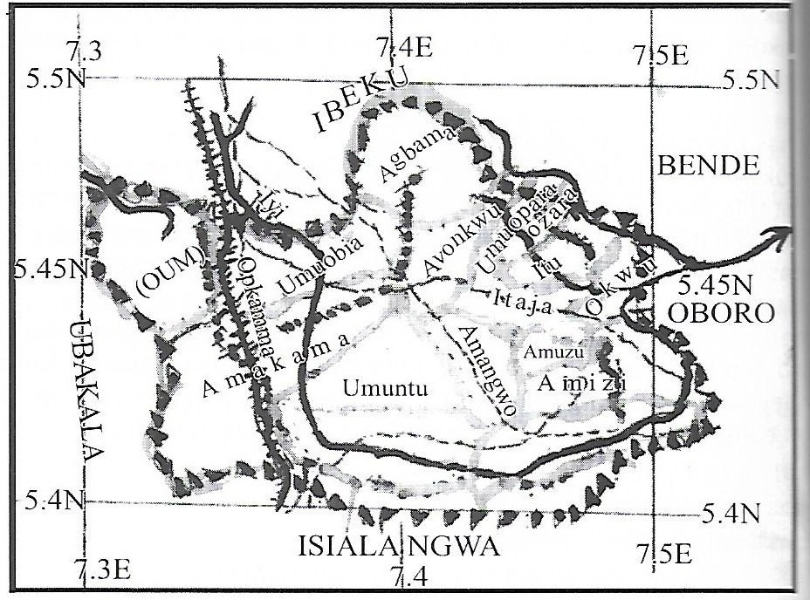

**Map of Olokoro showing its neighbours and the villages in it (Adapted from Edoh 2015)**

**History And Origin of Èkpè in Ólōkōrō**  
Èkpè is a traditional dance drama that is seen in some towns in the states of Abịa, Akwa-Ibom, and Cross River. The cultural display of Èkpè differs among the towns in these states. In Ólōkōrō, Èkpè is done in Ọ́nwá Ífèjíọ́kụ (sixth month of the Igbo traditional calendar) every year during the celebration of the New Yam Festival. In the towns of Ọ̀hụ́hụ́ in Ụmụahịa North Local Government Area and Ụ́mụ̀ọ́párá in Ụmụahịa South Local Government Area of Abịa state, Èkpè is done in Ọ́nwá Ụ́zọ̀ Álụsị (thirteenth month of the Igbo traditional calendar), while the people of Efik and Oron, which are both in Cross River and Akwa-Ibom states, do theirs whenever there is a big festival, especially during the Yuletide season.  
Èkpè Ólōkōrō has its roots in the Ékpè cultual celebration of the Ikot-Ekpene people of Akwa-Ibom state. It was through the cultural and business dealings of the forefathers of Ólōkōrō and Ikot-Ekpene in the olden days that they (the forefathers of Ólōkōrō) borrowed some parts of the cultural display of Ikot-Ekpene Ékpè, which they used to establish their own Èkpè. In the Ékpè cultural celebration of the Ikot-Ekpene people, they showcase a masquerade, which they call Ékpè, through whom they commune with their forefathers. They sing, dance, and perform rituals in thanksgiving to their forebears. Èkpè in Ólōkōrō is done during the celebration of the New Yam Festival. Two masquerades are showcased: the male Èkpè called Óké-Èkpè and the female Èkpè called Ńné-Èkpè. Rituals are performed, and a goat is killed, spilling its blood on the land, as a way of thanking Àlà (the earth goddess) for the good yield of crops planted that year.  
Èkpè in Ólōkōrō is a big festival. It is the Ãdé-Ézè (council of traditional rulers) of Ólōkōrō that fixes the date for the celebration. It is done in two days within two weeks in Ọ́nwá Ífèjíọ́kụ. The first day of the celebration in the first week is done on Àfọ̀-úkwú market day and it is called Íhú-írī-jī, while the second day in the second week will be on Àfọ̀-ńtà market day and it is called Ḿméghérí-írī-jī.  
**Problem of Researching on Èkpè Ólōkōrō**Carrying out research on the activities of Igbo traditional cults, especially for someone who is not a member of these cults, is not an easy one. The ọ̀kọ̀ńkọ̀ traditional cult group who are the custodians of Èkpè in Ólōkōrō do not reveal according to their rules and regulations, their activities to non-members, that is, those who have not perfumed the ị́dà ḿmírī (first initiation) and íkpū ụ́lọ̀ (second initiation) rites of the group. The non-members who are not initiates are referred to as òkpóò. It is pertinent to note that the ọ̀kọ̀ńkọ̀ traditional cult group is exclusively for boys and men; girls and women are not allowed to be members. Though this barrier of being non-initiates existed for the researchers, they were able to break it by convincing the approached initiates of the importance of this research. Another barrier the researchers encountered was not being able to snap the èkpè masquerades pictures, as it was against the rules of the custodians of the èkpè masquerades. This barrier was broken by extracting pictures of these masquerades from recorded videos compiled for those in the diaspora.  
**Drama: An Overview**According to Athenian history, drama, which means ‘to display’ or ‘to showcase’, originated in ancient Greece through Thespis, who created the tradition of ancient Greek drama, which was a kind of ritual choral hymn called ‘Dithyramb’. This drama was performed by men and boys in honor of Dionysus, the Greek god of wine. In essence, drama can be said to be a medium through which people imitate life and their worldview as it pertains to their daily activities.  
Nwadike (2003:51) defined drama as the imitating of creation, showcasing different activities. This implies people re-doing their daily activities from year to year in order to make themselves happy. These activities include playing, dancing, working, taking care of the family, burying the dead, etc. When people re-do these activities in the form of showcasing, it becomes drama. Okebalama (2003:80) explained that drama is imitating character, stature, wild animals, domestic animals, spirits, and humans; in truth, everything in this world, both seen and unseen, is imitated in drama.  
**Traditional Drama**      
Igbo traditional drama is an age-long activity of the Igbo people that showcases the belief system of the Igbos and their cultures. Ikedimma (2008:107) explained that Igbo tradition started with the creation of the Igbos. He further explained that Igbo traditions are standard and peculiar to the Igbos and do not conform to external activities or standards.  
Okebalama (2003:81) defined traditional drama as an activity that showcases the faith of the Igbos in creation, life, and things that are seen and unseen. He further postulated that traditional drama showcases the standard people want for a good life. It also showcases what people do not want, bringing out the evil in it, thereby making people shy away from doing evil. Ikeokwu and Onyejekwe (2004:11) supported the above assertion as they agreed that traditional drama is an activity that showcases the philosophy and the belief of the Igbos as it relates to life—things that are seen and unseen. They further stated that traditional drama exposes good character and condemns bad character. Through traditional drama, some gods of the land are also worshipped.  
Traditional drama is done in a specific manner, place, and time. Nwadike (2003:51) agrees with this, as he explained that special attention is given to the time and manner in which traditional drama is done. The time may be during big festivals or during important ceremonies.  
Okebalama (2003:86) pointed out that some traditional dramas are performed annually, some biennially, and some quinquennially. In the year it is to be performed, there is a particular month for the performance of each of the dramas. He further explained that it is not what people do when they want or when it pleases them.  
Ikeokwu and Onyejekwe (2004:15) used some traditional dramas to give an example of when traditional dramas are perfumed. They stated that there are ones that are done annually, like Ị́gbā Èkpè Ọhụhụ-Ụmụọpara in Abia State, and biennially, like Ńkwà-Ùtó-Ǹsúdè in Enugu State. They also stated that the New Yam Festival is done between the seventh and ninth months of the year. It was not done before or after this time. Traditional drama is performed in specific places; it is not performed anyhow or anywhere. In some places, it is performed in the shrine and in the village square. Okebalama (2003:88) explained that in Igbo land and other parts of Africa, traditional drama is performed at the village square. He further stated that the main actors stay in the middle of the village square to perform while the co-participants and spectators encircle them.  
The actors in traditional drama are usually people who belong to one traditional group or another. It is not an all-comer affair. Members of these traditional groups always swear an oath of secrecy in order not to divulge the secrets of their group. Each actor, according to Ikeokwu and Onyejekwe (2004:8), represents a particular character in which he exhibits his character. Action and body movement are major parts of traditional drama. Ikeokwu and Onyejekwe (2004:17) explained that traditional drama is filled with body movements, which is why it is best performed at the village square where there is enough space. Ikedimma (2008:73) postulated that music and body movements in traditional drama are more important than the talks in it. Body movements that are in traditional drama include singing, playing musical instruments, killing animals, running, and walking around. All these body movements joined together to bring out the beauty of traditional drama. That is why Okebalama (2003:80) stated that body movement is the most important aspect of traditional drama.  
Language is another integral part of traditional drama, as a people’s language showcases their beliefs. Ikeokwu and Onyejekwe (2004:17) explained that the language used in traditional drama is usually the dialect of the language of the people performing the drama. They further explained that the words used while performing traditional drama are only understood by the owners of the dialect. They gave an example with some words in the language of Èkpè Ọhụhụ-Ụmụọpara in Abia state, like: Ọ̀ gị́ị́bọ̀ chí, Ényì Déèdè léè, Íkpū là mgbè, dgz., have what they mean in the Ọhụhụ-Ụmụọpara dialect of Igbo. This is to buttress the point that the language of Igbo traditional drama is not what anybody who is not from that particular environment can understand at once.

**Ritualism in Igbo Traditional Drama**  
Ritualism and major Igbo traditional dramas are inseparable, especially in traditional dramas that involve traditional cults. These traditional cult members, being the custodians of such traditional dramas, perform rituals that are sine qua non with each drama. Okebalama (2003:84) explained that most activities in the Igbo traditional drama involve rituals. These rituals have designated places where they are performed with respect to the god, spirit, or deity that the people performing them worship or adore. This is in line with the postulation of Okoli (2022:1) that it is through rituals that Igbo traditional societies speak to their object of worship, which may be the Supreme Being, ancestors, or divinities. These rituals range from pouring libation, throwing kola nuts, tying palm fronds, and killing and sprinkling the blood of different types of animals.

**The Make-Up of Èkpè Ólōkōrō**Èkpè Ólōkōrō has different make-up or activities. These activities are done in stages. The stages are: Ọ́sọ́ Èkpè, Ǹchíchí Èkpè, Ífō ámá, Ǹtọ́àjà jí la Ị́gọ ọ̀fọ́, Ḿfóghérí, Ǹtọ́àjà Ị́tụ máị́, Ǹtọ́àjà Ígbū Éwú, Ḿfóghérí la Ḿméchí.

**(A) Ọ́sọ́ Èkpè (Announcing the coming of Èkpè)**This is the first stage in Èkpè. Ọ́sọ́ Èkpè starts immediately after the council of traditional rulers announces the date of the Èkpè festival. This activity is carried out at night, and it is done every night for two weeks in preparation for the Èkpè day. It is an activity carried out by young ọ̀kọ́ńkọ̀ initiates. They go around the village singing and dancing while cutting down any obstacles along the way with their cutlasses. After going around the village, they come back to their takeoff point, which is the village square, and close for the night. The significance of Ọ́sọ́ Èkpè is to put people in a festive mood.

**(B) Ǹchíchí Èkpè (Masquerade Preparation)**This activity is done the night before the main Èkpè day. It is done by kọ́ńkọ̀ initiates both old and young. In this activity, ọ̀kọ́ńkọ̀ members choose four (4) persons from among themselves to practice cutting off the head of a goat with a cutlass in one strike. The person that cuts it will be the one to wear the Óké-Èkpè masquerade regalia the following day, and he will also be the one to cut down the goat that will be presented for ritual on the Èkpè day. He will be prayed for and blessed by his fellow initiates, while wishing him good luck in the following day’s performance. This activity is accompanied by singing and dancing by the kọ́ńkọ̀ initiates at the village square.

**(C) Ífō Ámá (Going Round the Village)**This activity is done in the morning of the Èkpè day. Young boys, young girls, and children will assemble at the village square for about half an hour, after which they will go around the village singing and dancing while reminding people that the long-awaited day has come. Once they are done going around the village, they come back to the village square and close their activity, after which they will disperse to prepare for the bigger part of the ceremony, which will take place later in the day.

**(D) Ǹtọ́àjà Jí La Ị́gọ Ọ̀fọ́ (Ritual of Yam and Prayer)**  
This ritual activity is done in the morning of the Èkpè day. The heads of families will assemble at the village square with one (1) tuber of yam each, where the council of traditional rulers will pray and thank Là for granting them a good harvest. They will split some of the yams and drop some parts for Àlà. After this, they will all disperse.

1. ***Ḿfóghérí* (Going Round The Village Visiting Families)**

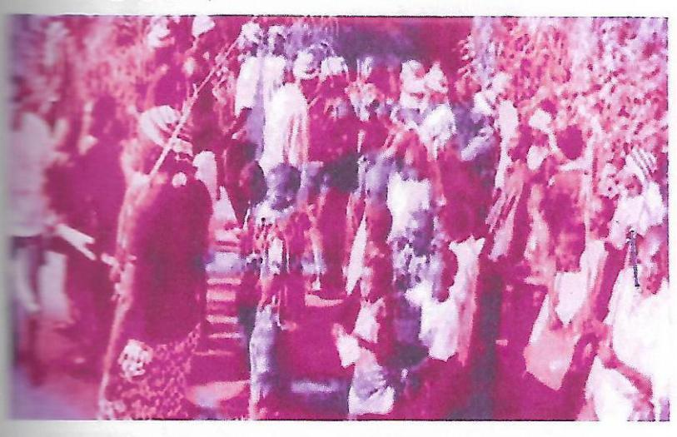

This activity is done in the afternoon of the Èkpè day. Ńné-Èkpè, together with youths and children, will go around the village, visiting families one after the other. Wherever they enter, they will be given gifts as they sing and dance along.

1. ***Ǹtọ́àjà Ị́tụ Máị́* (Pouring of Libation)**

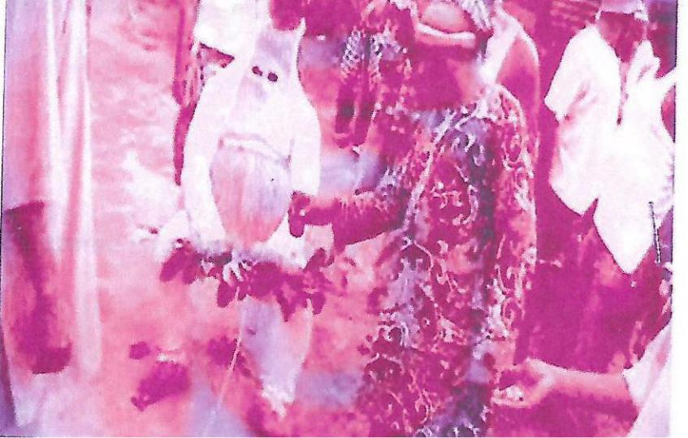

This ritual activity is carried out by ọ̀kọ́ńkọ̀ initiates. They perform this activity in a hidden place; anybody who is not an initiate doesn’t go close to this place. This activity involves invoking the spirit of the forefathers of the land to come and be with the Óké-Èkpè that will cut down the goat prepared for the blood ritual. The leader of the group will pour a little hot drink into a cup and pour it on the ground while calling on the forefathers of the land saying:

*‘Nde nnwe anyị, o ruolenu, anyị gi-imekwe ye mkpọ anyị*

*nna-eshi eme ye, ife e bụ ife anyị nna-eme mgbe liile mgbe liile.*

*Ọ dụghụ ụka anyị la unu ji, unu bịa nọịrụ anyị ka anyị mmee*

*ife e ka o zhie.’*

*(Our fathers, the time has come, we will do it the way we*

*have always done, this is what we do all the time.*

*We do not have any issue with you people,*

*come and be with us so that things will go well)*

When he finishes, others will respond chorusing *‘iseee!’* (we agree). He will also talk to *Óké-Èkpè* and say:

*‘*

*Deede ukwu o ruodule l’omume o, ọ lala dụkwa gụ l’aka.’*

*(Big brother the time has come, everything is now in your hands)*

When this is done, other ọ̀kọ́ńkọ̀ initiates will throw lobes of kola nuts on the ground where the hot drink was poured. Óké-Èkpè will stand up and walk majestically to show that he understood and was in agreement with all that was said.

1. ***Ǹtọ́àjà Ígbū Éwú* (Ritual of Goat Killing)**

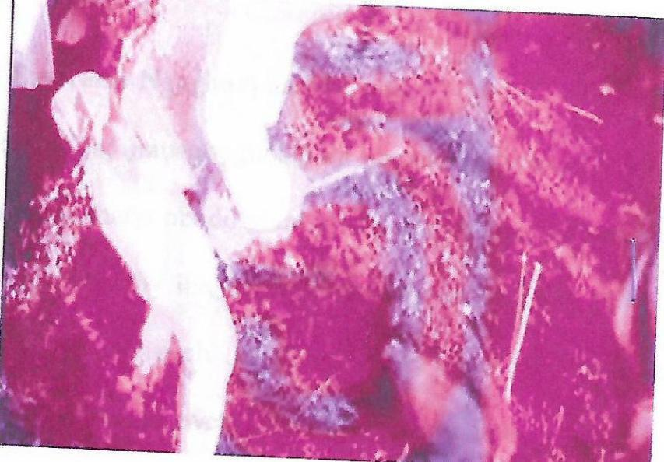

This is the high point of the Èkpè. This activity is done in the evening of the Èkpè day. People will gather at the village square, where singing and dancing will be going on. After a while, Óké-Èkpè and his guides will appear. He will be giving a sharp cutlass, òkòbòrò with which he will cut the head of the goat tied to a stake at the centre of the village square in one strike. If he cuts the head of the goat in one strike, it becomes ètèǹtèghèrí. But if he fails to cut it in one strike, it becomes mkpọ̀ghọ̀lị́. Ètèǹtèghèrí brings joy and fulfillment, while mkpọ̀ghọ̀lị́ brings sadness and shame. The blood from the goat is sprinkled on the ground to complete the ritual performed for Àlà.

1. ***Ḿfóghérí La Ḿméchí* (Going Round The Village And Closure)**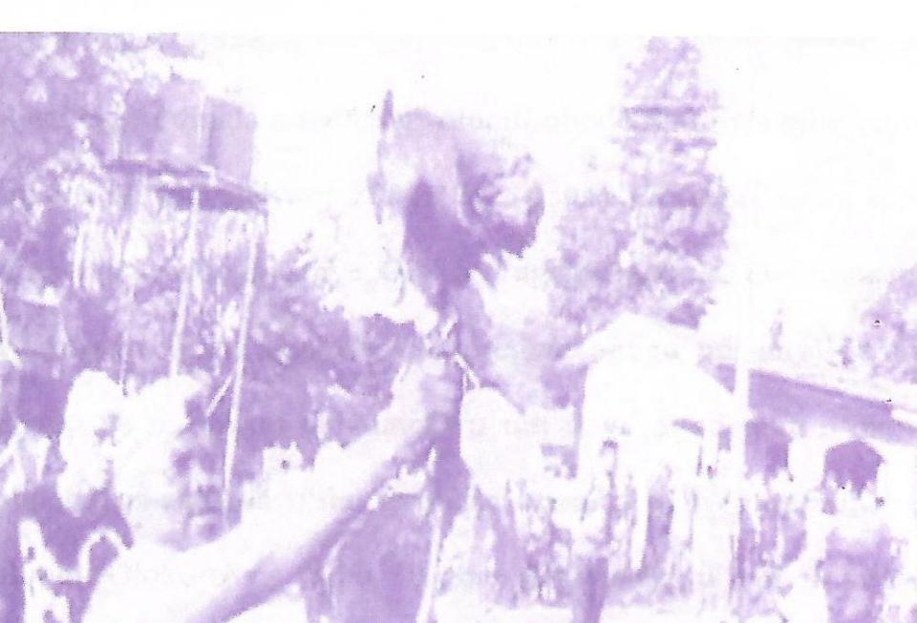

Youths and children will put the head of the goat cut by Óké-Èkpè on a long stick and carry it around the village while singing and dancing. As they go around, people will be giving them gifts while praising the Óké-Èkpè for a job well done. When they are done going around, they will go to the house of Óké-Èkpè and give him the head of the goat. They will eat, drink, and make merry, after which they will go back to their respective houses. And this brings the Èkpè activity to an end.

**Co-actors in** **Èkpè Ólōkōrō**

Except for the male and female Èkpè, there are other actors who bring out the beauty in the activities of Èkpè. These actors are: Ọ̀chụ́ mbárá, Òhí Èkpè, and Ńdé Ǹsòèmé.

1. **Ọ̀chụ́ mbárá (Path clearer)**

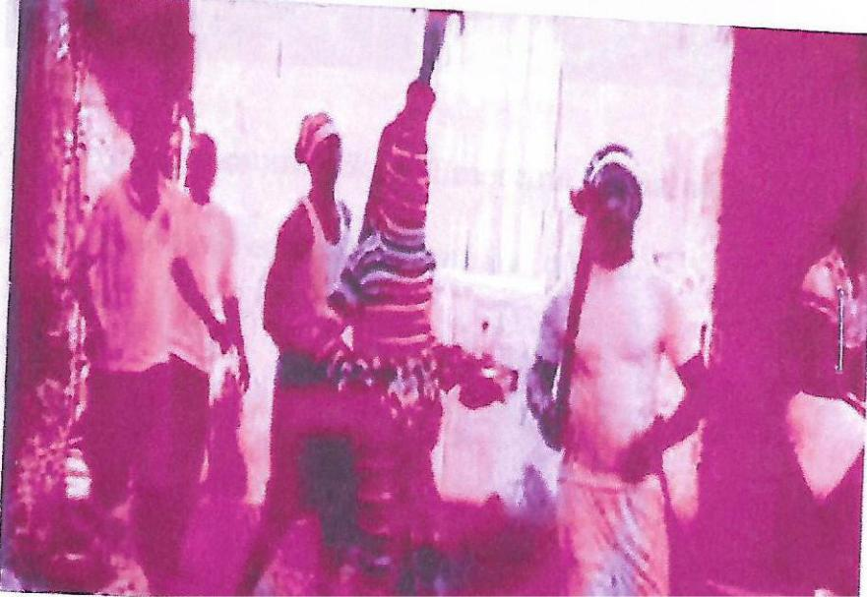

Ọ̀chụ́ mbárá leads both *Óké-Èkpè* and *Ńné-Èkpè.* His duty is to use broom to clear the path that both *Óké-Èkpè* and *Ńné-Èkpè* pass through.

1. ***Òhí* *Èkpè* (Guider)**

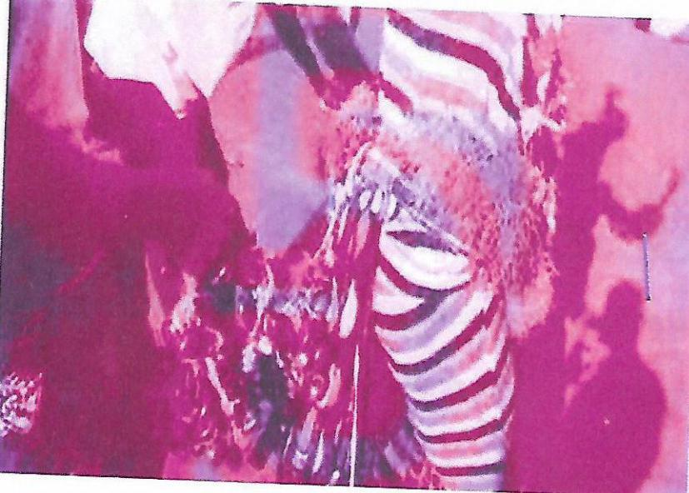

Òhí *Èkpè* guides both *Óké-Èkpè* and *Ńné-Èkpè*. His duty is to encourage and strengthen both *Óké-Èkpè* and *Ńné-Èkpè* by shaking the *Ọ́yọ̀* tied around their waists.

**Ńdé Ǹsòèmé (Co-Participants)**

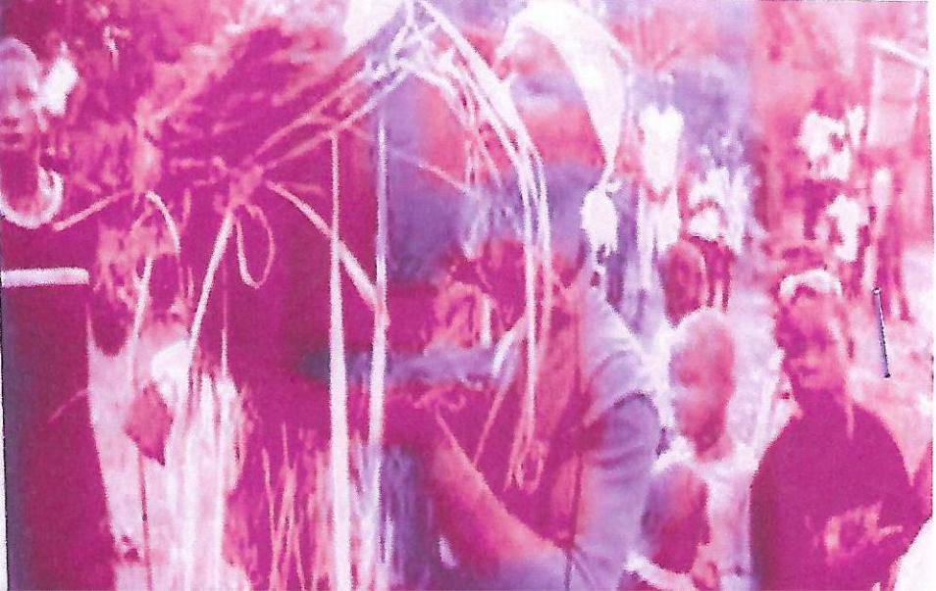

Ńdé Ǹsòèmé bring out the complete beauty in Èkpè. They play instruments, sing, and dance, which showcases joy, happiness, and contentment.

***Èkpè* Costume**

Costumes are important in traditional drama. Costumes bring out the beauty of the activities in traditional drama. For Èkpè traditional drama, there is a costume for Óké-Èkpè and Ńné-Èkpè.

1. ***Óké-Èkpè* Costume**

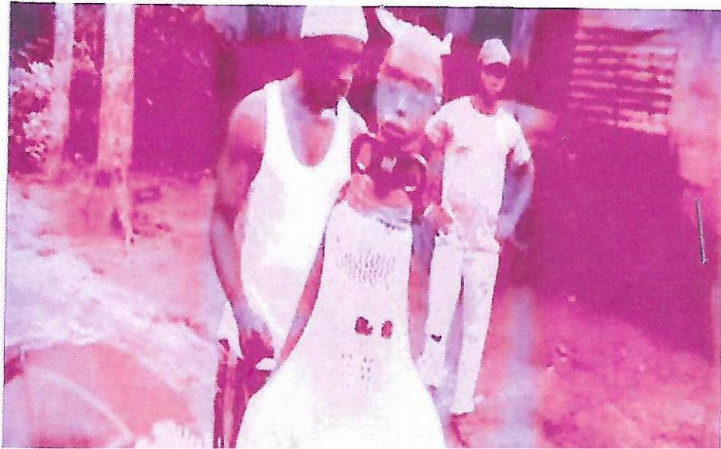

The costume for Óké-Èkpè includes white wool-woven regalia that cover from his head to his legs. He carries Óké-Íshí-Èkpè on his head, tied with a pad. This Óké-Íshí-Èkpè is the head of a warrior carved out of wood. Óké-Èkpè also ties wrappers of different colors and designs around his waist to bring out the beauty of his costume. Óké-Èkpè represents the spirit of a strong man who can do anything within a twinkle of an eye.

1. ***Ńné-Èkpè* Costume**

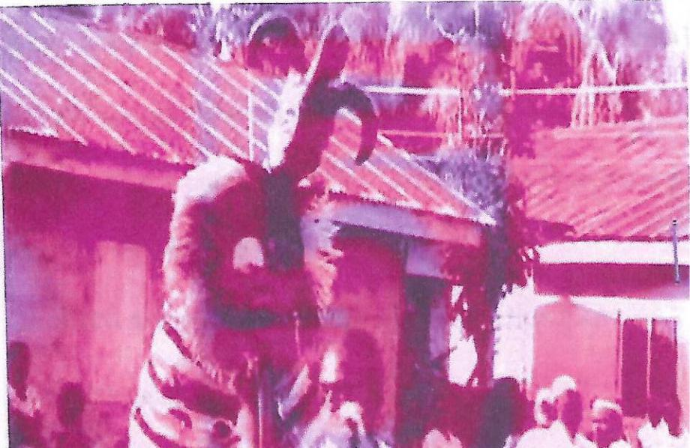

The costume for *Ńné-Èkpè* includes a multi-colored wool-woven regalia that covers from his head to his legs. He carries *Ńné-Íshí-Èkpè* on his head, tied with a pad. This *Ńné-Íshí-Èkpè* is the head of a beautiful maiden carved out of wood. *Ńné-Èkpè* also ties wrappers of different colors and designs around his waist to bring out the beauty of his costume and to enable him to dance well. *Ńné-Èkpè* represents the spirit of a beautiful maiden.

**Accoutrements in *Èkpè***

The accoutrements that are used in *Èkpè* are:

* ***Ákwụ́kwọ́ ńdụ̀*** - Green leaf. This signifies life. (Both *Óké-Èkpè* and *Ńné-Èkpè* use it to wave at people.)
* ***Ázị́zà*** – Broom. This signifies a pure heart. (Óké-Èkpè-Èkpè*Ńné-Èkpè* use it to clear their paths.)
* ***Òkòbòrò*** - Cutlass (This is the cutlass that *Óké-Èkpè* uses to cut off the head of the goat prepared for ritual*.* (It signifies youthful strength.)
* ***Àkùpé ènyò*** - mirror hand fan (This signifies beauty. *(Ńné-Èkpè-Èkpè*s it in his left hand.)
* ***Ọ́yọ̀*** – rattle. This signifies encouragement. It is tied around the waist of *Óké-Èkpè* and *Ńné-Èkpè;* their guides shake it in order to encourage them.)
* ***Ìtè ọ́gwụ̀*** - Sacred pot. This is a sacred pot that is tied with a palm frond. It contains burning charcoal sprinkled with incense. (It is used to invoke the spirit of the forefathers of the land.)
* ***Ọ́mụ́ ńkwụ*** - Palm frond. This signifies sacredness. It is tied around the place the *Èkpè* drummers stay to beat their drums.)
* ***Ḿkpáḿkpá*** - Clapper (This is a type of clapper carved from bamboo. (It is beating to bring out rhythm.)
* ***Èkpètè*** - Drum There are three different sets of drums used in *Èkpè*. The first one is *‘ọ̀sá Èkpè’* which is three in number. The second one is *‘ábị̀à’* which is two in number. The last one is *‘ìkpèríkpè’* which is just one. These drums make different sounds, which elicit different dance steps when played.

***Úrí Èkpè* (Èkpè songs)**

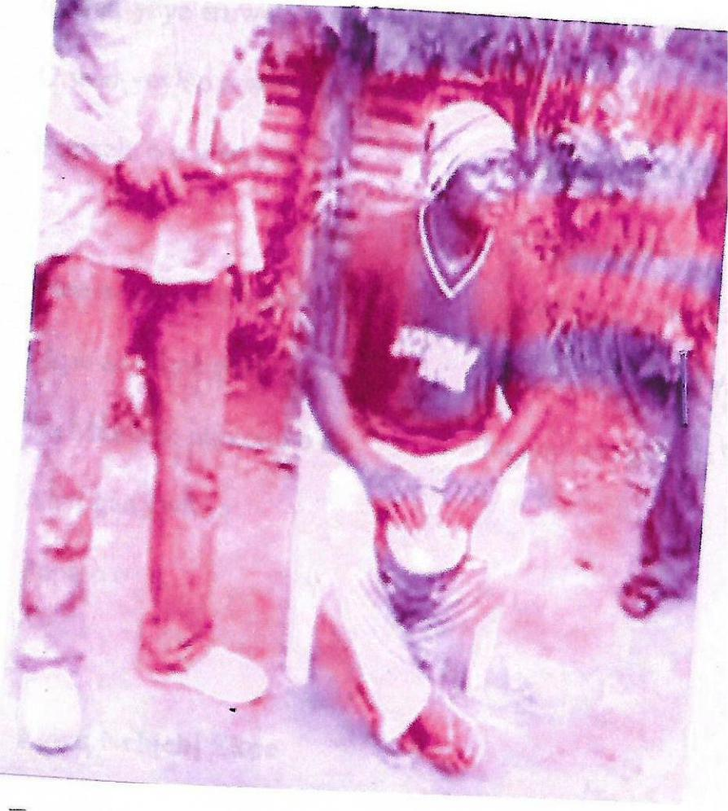

The *Èkpè* traditional drama is full of traditional songs that accompany all its activities*.* These songs are:

1. ***Úrí Ọ́sọ́ Èkpè* (Song For Announcing The Coming Of *Èkpè*)**
2. *O wen-yeye eruwele o Time for Èkpè dance is coming*

*O wen-yeye o Time for Èkpè*

*O wen-yeye eruwele o Time for Èkpè dancing is coming*

*O wen-yeye Time for Èkpè*

1. *Olende shị anyị agbala ekpe Who said we should not dance Èkpè*

*Anyị ga gwa ya mama o We will tell our mother*

*O o o o Oh oh oh oh*

*Anyị ga gwa ya papa o We will tell our father*

1. ***Úrí Ǹchị́chị́ Èkpè***
2. *Chụ ekpe yo-iyo Select Èkpè oh oh*

*A na-achụ ekpe yo-iyo We are selecting Èkpè oh oh*

*A na-achụ ekpe We are selecting Èkpè*

1. *Chụnụ nwa ele o Catch the Èkpè goat*

*Ele wọm wọm wọm n’ọhịa The goat is running away*

*Chụnụ nwa ele o Catch the Èkpè goat*

*Ele wọm wọm wọm n’ọhịa The goat is running away*

1. ***Úrí Ífō Ámá* (Song For Going Round The Village)**
2. *ḷ bụrụ nwoke ka’ịn ga If you are a man let us go*

*Ga abụrụ nwaanyị ka’ịn ga If you are a woman let us go*

*Ga abụrụ nwata ka’ịn ga If you are a child let us go*

*Na chi avọọla o o That morning has come o o*

*Iyohoho iyohoho Iyohoho iyohoho*

*Iyohoho na chi avọọla o o Iyohoho that morning is come o o*

1. *Ekpe he ekpe Ekpe oh ekpe*

*Ka’ịn ga Let us go*

*O o Oh oh*

*Ka’ịn ga ka’ịn ga Let us go let us go*

1. ***Úrí Ḿfóghérí* (Song For Going Round The Village Visiting Families)**
2. *Ole nde na-agba ekpe Who are those dancing ekpe*

*Mbule mbule haya Mbule mbule haya*

*Eehe ee E e e e*

*Mbule mbule haya Mbule mbule haya*

1. *Olokoro evuru l’obu a na-eje o Olokoro we go with our intentions in our hearts*

*Evuru l’obu o With our intentions in our hearts*

*Evuru l’obu a na-eje everu l’obu With our intentions in our hearts we go*

1. ***Úrí*** ***Ǹtọ́àjà Ígbū Éwú* (Song For The Ritual Of Goat Killing)**
2. *Oke-Ekpe lei Oke-Ekpe e e*

*Evule bụ onye ike e e The ram that is strong*

*Evule bụ onye ike The ram that is strong*

1. *A yu a visitọ Are you a visitor*

*ḷ bụ onye ebole Where are you from*

*A yu a visitọ Are you a visitor*

*ḷ bụ onye ebole Where are you from*

1. *Ekpe egbubeele ewu Ekpe has cut the goat*

*Sam Sam*

*Sam sam Sam sam*

1. ***Úrí*** ***Ḿfóghérí La Ḿméchí* (Song For Going Round The Village And Closure)**
2. *Oke-Ekpe egbuole ewu Oke-Ekpe has killed a goat*

*Ee he he he Eh eh eh eh*

*Ewu lei Goat o*

*Amambelembele Your life is finished*

*Ewu lei Goat o*

*Amambelembele Your life is finished*

1. *Iwe o iwe o Anger o anger o*

*Iwe anụghụ ewenụ anyị ewe We don’t get angry*

*Mgbe o werenụ anyị ewe But when it happens*

*Anyị amarụ mkpọ o shi mee We will know how it happened*

**Language of Èkpè Ólōkōrō**

The language of every traditional drama is usually the language or dialect of the owners of the traditional drama. (Ikeokwu and Onyejekwe, 2004:17). The language of ekpe Ólōkōrō, as seen in the songs, is the Ólōkōrō dialect of Igbo spoken in Ólōkōrō, which is found in Umuahia South Local Government Area of Abia State, Nigeria.

**Summary and Conclusion**

This research showcased that Èkpè is a traditional drama that completely brings out the way of life and the beliefs of the Ólōkōrō people. Culture is a people’s identity, and through culture, one gets to understand the root of certain behaviors, characteristics, and peculiarities amongst a people. It is true that we live in a world that is constantly changing, but these changes should not interfere with the cultures and traditions of people. The researchers observed that changes in society, which have to do with development and foreign interference and/or exposure, are affecting the participation of people in traditional dramas, and Èkpè is not left out. This calls for much-needed attention on traditional dramas, and it is on this premise that the researchers embarked on this research. The Èkpè traditional drama of the Ólōkōrō people prior to now have not been given the much-needed attention that it requires. It is the wish of the researchers that this research gives enough exposure to this traditional drama and also makes way for further interest in African traditional dramas that are embedded in ritualism.

**References**

Edoh M U (2015) *Olokoro-uvuoma, our father land.* Umuahia: Alozie Ukaegbu & Sons.

Ikedimma C E (2008)  *Agụmagụ ọdịnala na nke ederede.* Onitsha:

Uchac Productions Ltd.

Ikeokwu E S and Onyejekwe M C (2004) *Mmalite ọmụmụ na nghọta ejije igbo ọdinala na ọlọrọọhụụ.* Enugu: CIDJAP.

Nwadike I U (2003) *Agụmagụ ọdịnala igbo.* Onitsha: Africana First Publishers Ltd.

Okebalama C N (2003) *Mkpọlite agụmagụ ọnu igbo.* Enugu: Snaap Publishing Company.

Okoli C M (2022) Music and rituals in igbo traditional society. *Journal of the association of nigerian musicologists, 16(2)*, 1-28.

Onyema B O (1993) *A history of olokoro uvuoma.* Owerri: Ihem Davis Press.

Welmers B F and Welmers W E (1968) *Igbo; a learner’s manual.* Germany: Selbstverl.