Ngozi-Omeje Ezema’s Terracotta Dry Leaves:
Signposting Radicalism at the 2021 Kó Exhibition, Lagos, Nigeria

Introduction
The wave of artistic radicalism that greeted the Fine Arts department of the Nigerian College of Arts, Science and Technology, later re-named Ahmadu Bello University, Zaria, in 1958, was unprecedented. Perhaps in queue with the general quest for freedom at the dusk of the decade before 1960, when Nigeria got her independence, the art students of the institution systematically punctured the balloon of intellectual suppression. Agitation was rife against the Euro-centric curriculum for art learning imposed on the students by the largely British educators; they wanted to do art the Nigerian way, not the British way. However, the young art students wanted a combo of Nigerian art forms and some of the British ones ‘useful’ on ground at the moment. They wanted to use art to find originality within Nigeria, not to lose it, and so, the agitation for synthesis of Nigerian art forms and those of Britain was the subject of rebellion, for they were branded the ‘Zaria rebels’. The brand name was later to transmute into the ‘Zaria Art Society’.
The experimental days that heralded the aftermaths of the call for the synthesis of traditional artistic ideologies with some of the foreign ones taught by white art lecturers at the Zaria Art School, opened a vista of opportunities for Nigerian artists to think inwards a lot more. (Alu et al, 2024). Members of the Zaria rebels later spread into different parts of the country, their ethnic origins, to find Nigerian based metaphors for artistic content projection, an attitude held beyond their undergraduate days in Zaria. Uche Okeke, a leading member, from the Igbo ethnicity started projecting Uli art in very dynamic ways. Uli, an indigo seed, of same colour was processed by Igbo women for use in body painting and murals. The linear motifs anchored by the Igbo women of South East Nigeria, got more popularised by Uche Okeke and his protégés in ‘metaphorising’ the Igbo cultural compass very stylistically. Uli motifs, therefore, tooled the liberalisation of the artists of the Nsukka School extraction a great deal, thereby presenting them as exponential in artistic experimentalism.
The department of Fine and Applied Arts, University of Nigeria is one of the foremost art institutions in Nigeria. Established in 1961, the art department was duly born into the waiting hands of freshly gotten Nigeria’s independence. Regrettably, the art programmes of the Nsukka art school, like the Zaria art School, earlier on, were highly ‘Europeanised’. By Europeanisation we mean that the European art lecturers in the institution flagged art teaching structures that showed much Euro-centric educational curriculum. In the wake of the upheavals leading to the Nigeria-Biafra civil war and its encumbrances, signs were high enough that schooling was going to be disturbed in the Eastern region, so, the expatriate art lecturers were driven away by the prevailing unsafe. After the war, when indigenous artists took over, artistic experimentation was combined with theoretical pedagogies to form the core bipod of the art learning structure in the institution (Alu et al, 2024).
Right from the 1970s, the present driving force of studio art in Nsukka School, according to Okoro (2021), has been exploration and experimentation with Uli motifs and commonplace materials. Okuyeme (2021) added that the Nsukka School is best known for the revival of Uli, an Igbo art tradition that was historically used for the body and wall mutrals, placing this visual language into contemporary art discourses. From the foregoing, one can deduce that whereas Uli motifs became ideological, experimentation in Nsukka was taken beyond Uli. The efforts of Chike Aniakor, El Anatsui, Obiora Udechukwu, Olu Oguibe, Chijioke Onuora, Tayo Adenaike, Krydz Ikwuemesi, Eva Obodo, to mention a few, have confirmed this permissible navigation in the explorative track of the un-foreknown.
We are in a postmodern age. But because of globalization and its attendant effects, some authorities may quarrel with this assertion. Nevertheless, the characterization of the postmodern age are fragmentation, trans-historical experiences, shifting boundaries and sites, an easy access to art materials where artists destroy, only to constitute, as a voice of their creative freedom away from patronizing institutions. Their creative choices are unbounded while their creative directions know no limits. They have replaced institutional patronage with the triumph of a radical creative temperament and innovation (Aniakor, 2015). In the long queue of Nsukka bred explorative artists is Ngozi-Omeje Ezema, ceramic artist and one of the three selected by the Kó Art Space in Lagos, for a tripartite exhibition themed: ‘The New Nsukka Art School: Between Continuity and Change’.
The Nsukka School as a Force in Global Art Radicalism
Initially known as Enweonwu College of Art, the Department of Fine and Applied Arts, University of Nigeria, Nsukka was established in 1961 as one of the earliest departments in the University. The Nsukka art school or Nsukka School, is, however, not exactly a code name for the department, rather, it represents artists trained in the department whose ideological inclinations stream from the experimentalist mannerisms that the school is known for. In other words, ours is more of a school of thought, fuelled by individual radical searches for ‘something new’ in the art horizons, than a physical art school epitomised by methodical sameness. According to Rice (2018), the Nsukka School, which is named after the University of Nigeria at Nsukka, was a group of artists and faculty members associated with the use of Uli-a form of body and mural decorative painting indigenous to the Igbo culture of Nigeria-in their work and are considered disciples of Uche Okeke’s teachings and artistic influence. The Uli experiment sought to address Okeke’s call for ‘natural synthesis’ in the visual arts of Nigeria and the formation of an art appropriate for the post-Independence age. Other members of the group who experimented with uli forms through painting and drawing were Chike Aniakor and Obiora Udechukwu, followed by their students Tayo Adenaike and Olu Oguibe.
The formal and aesthetic codes of the Nsukka School draw primarily from the art school’s creative ideology which places emphasis on experimentation as a critical aspect of the creative process (Okuyeme, 2021). If the name, Nsukka School or Nsukka Art School simply represent the department of Fine and Applied Arts, then it would have also staged an encapsulation of the same curricula convention rolled over the years, since after the civil war. The permission for students and artists of the ideological family to spread out in search of individual artistic protectorates fruitfully resulted in sundry findings. Though the initial progenitor, Uche Okeke and his immediate acolytes succeeded in entrenching the Uli creative ideology in the school, there has been a paradigm shift from the course; one in which a spectrum of postmodern radicalism seems to have been ignited, in the making of the likes of Ngozi-Omeje Ezema; a neo-Uli art activist.
The Nsukka art signature is, apart from having the Uli linear abstraction tendencies, richly embedded in diverse individual approaches to doing art in a different or new-found way. Okuyeme (2021) stated that the Nsukka School is a term used to distinguish artists who have studied and taught at the Fine and applied Arts Department at the University of Nigeria, Nsukka, in South Eastern Nigeria, and who share a critical engagement in both their visual and theoretical fields. The emergent stylistics of the neo-Nsukka class promises the world very prominent findings in the sojourn to artistic individuality.

Kavita Chellaram, Kó Art Space and Contemporary Nigerian Art
The Yoruba word, kó means “to gather” or “to build”. Having known that the kó art space is about art, a layman can, at least, adduce that the objective of setting up such a gallery was hinged on gathering art and artists. Indian-born Kavita Chellaram has invested a lot of time and attention developing and gathering art in Nigeria. In exploring the art map of Nigeria, she seems to have drawn a fresh map for herself, surveying and pulling up radically creative minds, a project that led to the founding of the Lagos-based auctioneers Arthouse Contemporary Ltd, which focuses on modern and contemporary art from West Africa. She established Arthouse Foundation to also provoke discourses on contemporary art in Nigeria, through residencies for artists. Establishing the kó art space was aimed at supporting contemporary art in Nigeria, though as a project parallel to the art auction house. In the words of Chellaram (2020), our aim is to support the creativity of contemporary art in Africa by providing a platform to communicate, share and grow.
According to Donnan (2012), when Arthouse, the Lagos gallery and auctioneer, held its first sale in 2008, Kavita Chellaram, the managing director, had a simple goal. A long-time collector of Nigerian modern and contemporary art- the walls at her Lagos home hang heavy with works by some of the lions-she was eager to establish a market. “There was no transparency of price,” she says of the days before that first auction, which saw a painting by Bruce Onobrakpeya, one of Nigeria’s famed “Zaria rebels”, fetch more than $80,000. Just four years on, the market Mrs Chellaram helped establish is booming and prices are soaring for the best works by Nigerian contemporary artists, the finest of which are now celebrated around the world
I am excited to create Kó as a separate and unique gallery entity. This will allow us to create focused exhibitions on a regular basis, delve more deeply into artists and art historical topics, generate research and publications, and continue to promote Nigerian art on the global stage (Chellaram, 2020). Having ventured into a myriad of art exhibitions and marketing projects in Nigeria, the kó art space, in 2021decided to do a three-phase show of artists from the famed Nsukka School of Art, seemingly interested in installations at the time. It appears that the baseline for selection was the propensity with which the artists digressed from unilateral Uli experimentalism, into more aggressively complex paths that further signpost the Nsukka School as unique, hence, the sub-theme; Between Continuity and Change. The initial allotment for the threesome show was: (i) Ngozi Omeje-Ezema (ceramic artist); Jan 28 - Feb 11, 2021, (ii) Eva Obodo (sculptor and art educationist); Feb 25 - March 11, 2021, and (iii) Ozioma Onuzulike (ceramic artist and art historian); March 25-April 8, 2021. The third phase was however, later rescheduled for: March 29-May 6, 2021.
Brief Profile of Ngozi Omeje Ezema
Born 1979, ceramic artist, Ngozi Ezema, (Nee Omeje) was trained at the Department of Fine and Applied Arts, University of Nigeria, Nsukka where she obtained her Bachelor of Arts, BA degree in 2005. She hails from Nsukka in Enugu State of Nigeria. Ezema joined the teaching staff of her alma mater in 2009, same year she completed her Master of Fine Arts, MFA degree in ceramic art. Like most products of the Nsukka School ideology, Ezema steadily interrogates the seemingly impossible, challenging conventionalism and boldly veering into the path of newness in which a gong beckons on the world to come see eureka. She is a strong poster face in the infusion of modernity into a tradition that in itself, stirs the world of creativity. Like Onuzulike, she believes that manipulating clay is not for the purposes of making vessels, casseroles, pitchers, trinket boxes and industrial tiles, only. In other words, Ezema likes to take ceramic art beyond the utilitarian specs, proving that ‘something else’ can come out of clay with very complex assemblage of terracotta forms in mixed media installation.
In 2014 she won the Life in My City Art Foundation Prize. In 2015, her project, ‘Against all Odds’, won the Outstanding Concept Award of Nigeria’s National Art Competition. In 2016 Ezema participated in the first International Biennale in Central China and le Pinceau de L’integration in Senegal during the Dakar Biennale. Same year she was commissioned for a special installation project at Art X in Lagos. In 2018 the Centre for Contemporary Art, CCA, hosted Ezema’s first solo exhibition in Lagos. In 2019 Ezema won the High Excellence award at the Cheongju International Craft Biennale in South Korea. She has participated in art residencies with the centre for Contemporary Art, CCA/Trianglar Art Trust, Lagos; Goethe Institute Nigeria, Nsukka, Nigeria; Sevshoon Art centre, Seattle; Goethe Institute, Kumasi, Ghana; and the Trianglar Art Trust, Jos, Nigeria.
Ngozi-Omeje Ezema’s Unique Art-Voice
As artists, the desire to make unique art can drive us mad. For most of us, this motivation is what inspires us, or what torments us. When I’m at my worst, it’s usually because I don’t feel like my work is saying anything special. When I’m at my best, it feels like I’m making things I haven’t seen before, and that feels pretty damn good (Cicak, 2023). Chicago illustrator Nicole Cicak in the above statement captures succinctly the mindset of every explorative artist, especially given the prevailing competitive preponderances which most times seem to carve a gender-led partition among artists. It is unarguably; in this calibre of ‘saying something special’ that Ngozi-Omeje Ezema belongs. In furtherance, she expressly essays the female gender as comparatively masculine in exerting artistic energy via diverse media.
Having to conceive the making of leaves in terracotta is worth applauding. The processes involved in treating and baking clay to such a state is intriguingly configurative. The earth-brown colour of the terracotta leaves suggest dryness; no dry leaf is green anymore. This was how Ezema chose to address the tenderness of the female gender, among other themes. Some leaves are dry to the point of turning black or some other colours deeper than brown; this is suggestive of decay, a state of despondency in which many women are painfully watching the world today. Whereas women could be addressed as assorted vases, the shrivelled, green-less and disfigured shapes of the dry leaves, suspended from the heights with fishing twines, also suggest that its only a matter of time before the unwanted happens, as each hanging leaf could possibly disengage when the suspender becomes weak, old or cut off, thereby, making the unfortunate leaf to fall lifelessly down, to join a myriad of others on the ground of despair. Hanging the terracotta leaves however suggests giving life to the lifeless or hope to the hopeless. See plates 3, 4 and 5. Apart from female gender-related issues Ezema also addresses social matters with her manipulation of several shapes of animals and other things with the suspended dry leaves. Cicak (2023) justifies the vigorousness attended to by Ezema in her works by stating thus: “I wish making unique art were as simple as picking up some paints and hoping and hoping your personality comes through in your work”

On her relationship with clay, during an interview by Olivia Barrell of Art Formes, South Africa, Ngozi reports: “It is a very temperamental medium, malleable to touch and disobedient to impatient hands. When asked about artists who likely influenced her she expatiated: “El Anatsui has a big impact on my work. He guided me to discover artists who work with suspended elements in their large scale installations, such as Cornelia Parker and Jaehyo Lee- both of whom I consider great sources of inspiration” (Barrell, 2021). On the explorative pedigree of Ngozi-Omeje Ezema, according to Agujiobi-Odoh (2024), she realised that transporting ceramic works to an art exhibition location or site is quite burdensome becaue of their size and weight, she set out to solve the problem. Using the clay medium she began to produce clay fragments in large numbers. Toning some with chosen colours, she fired them in the kiln, from which she now obtained her terracotta clay fragments. She soon learnt that these clay fragments could easily be transported to any art gallery and installed on site as works of art.
In the kó 2021 art exhibition, Ezema sub-themed her solo show: Boundless Vases. It was a show of her very dexterous approaches towards creating dry leaves with terracotta using fishing twines to hang the ceramic pieces till all the fragments form admirable shapes. The dry leaf motifs, presented in this paper as Ezema’s voice during the exhibition really spoke for themselves and for the artist, in breaking away from conventionalism. Elements of pigmentation were also used to inject perspectives in ‘metaphorising’ her messages. Her works address life’s issues like: family, the female gender, fragility and other environment-bound themes. ‘Boundless Vases’ indeed showcased multiple vase-like shapes made of: terracotta, acrylic, monofilament, fishing line and metal.
This paper is sequel to two earlier publications on the participation of Omeje’s colleagues, Eva Obodo and Ozioma Onuzulike: (i) Social Narratives in Polychromatic Embroidery as Hallmarks of Eva Obodo’s Works at the February 25 - March 11, 2021 Ko Art Exhibition, Lagos, Nigeria; Published in Innovations Vol. 76. (March, 2024) and (ii) Appraisal of Ozioma Onuzulike’s Stoneware and Terracotta Ceramic Keloids at the March 29 - May 6, 2021 Kó Art Exhibition, Lagos, Nigeria; published in Innovations. Vol. 77 (June, 2024).

 | 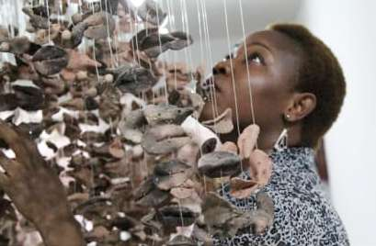
Plate 1 | Plate 2
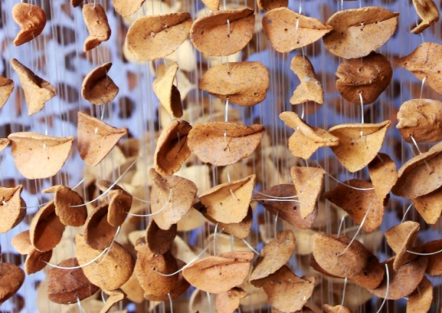
Plate 3
Ngozi-Omeje Ezema and her Terraccotta Dry Leaves Installation Process
Media: Terracotta, acrylic. Monofilament, fishing line, metal.
Source: Source: Nkem Fortyunes Alu et al: Research 2024

Research Design
The desktop research design was adopted for this study because it suits the theme and nature of contents. Owa (2024) stated that desk research uses existing data from various sources, such as books, articles, websites and databases to answer your research questions. Desk research or desktop research uses documented information available in books, websites, videos, podcasts, journals, magazines, etc. Desk research does not require the gathering of new information from primary sources; you rather depend on information already gathered by previous researchers, that’s why it can also be called secondary information research. Desk research undertakes both qualitative and quantitative methodologies. Specifically this paper adopted the qualitative desk research design.

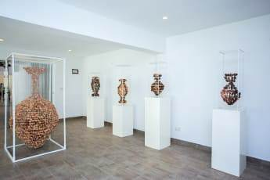 | 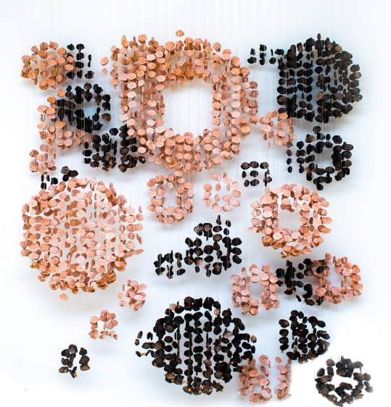
Plate 4 | Plate 5
Installations of Images in Teraccotta Dry Leaves on Display
Media: Terracotta, acrylic. Monofilament, fishing line, metal.
Source: Source: Nkem Fortyunes Alu et al: Research 2024

Objectives
The aim of this review was to come up with artist-respondent-based analyses on Ngozi-Omeje Ezema’s Terracotta Dry Leaves exhibited at the Ko 2021 tripartite art exhibition. The respondents were allowed to align to selected content and feature options, as calibrated. Specifically the study objectives were:
- To find out the amount of colouration and assemblage that can bring out intended motives in Ngozi-Omeje Ezema’s Terracotta Dry Leaves.
- To weigh up Ngozi-Omeje Ezema’s Terracotta Dry Leaves for idiomatic expressions of artistic self-freedom.
- To measure the extent of comparative evaluation of aesthetics and idealism in Ngozi-Omeje Ezema’s Terracotta Dry Leaves installations.
- To find out the extent to which ‘Boundless Vases’ are relevant in contemporary ceramic art.

Participants and Sampling
There were 148 art entrepreneurs, lecturers and postgraduate students randomly selected as respondents. All the respondents are resident in Eastern Nigeria. After being treated to sampling and participation eligibility requirements, 48 were dropped and the picturesque questionnaire tagged Ngozi-Omeje Ezema Terracotta Dry Leaves Pictorial Questionnaire (NOETDL-PQ) was sent to 100 respondents. Each respondent was to return only one copy of the NOETDL-PQ, meaning that duplication was not allowed. All the 100 copies of the NOETDL-PQ were returned electronically, as sent, but 12 had incomplete data issues, and therefore, were dropped. Data from 88 copies were finally analysed. The sampling and participation eligibility processes are reflected below:
Scope of the Study
This review concentrated on Ngozi-Omeje Ezema, who was the first in the three-phase art exhibition with the theme: The New Nsukka Art School: Between Continuity and Change. Exhibition originally allotted as follows: (i) Ngozi Omeje-Ezema (ceramic artist); Jan 28 - Feb 11, 2021, (ii) Eva Obodo (sculptor and art educationist); Feb 25 - March 11, 2021, and (iii) Ozioma Onuzulike (ceramic artist and art historian); March 25-April 8, 2021. The third phase was however, later rescheduled for: March 29-May 6, 2021. Ngozi-Omeje Ezema’s works, sub-themed: Boundless Vases, as exhibited from: January 28 - February 11, 2021 at the ko art gallery, were foci. Ezema’s works are presented and reviewed in this study as guided by the objectives and consequently, the review questions.
Exhibition Review Questions
Accordingly, the following interrogations piloted the study:
- To what extent do colouration and assemblage bring out intended motives in Ngozi-Omeje Ezema’s Terracotta Dry Leaves?
- Can Ngozi-Omeje Ezema’s Terracotta Dry Leaves weigh up for idiomatic expressions of artistic self-freedom?
- To what extent is there a comparative evaluation of aesthetics and idealism in Ngozi-Omeje Ezema’s Terracotta Dry Leaves installations?
- To what extent are ‘Boundless Vases’ relevant in contemporary ceramic art?

Instruments for Data Collection
The first instrument for data collection was a researcher-designed picturesque questionnaire labelled: Ngozi-Omeje Ezema Terracotta Dry Leaves Pictorial Questionnaire (NOETDL-PQ), used to poll responses from the artist-respondents. The first section contained interrogations streaming from the review questions, while the next section showed 24 plates of Ngozi-Omeje Ezema’s works as exhibited (See Appendix 2).
The second instrument was the Ngozi-Omeje Ezema Terracotta Dry Leaves Respondents Data Chart (NOETDL-RDC) designed for collation of personal and bio data of the artist-respondents. All data in this instrument were for documentation purposes, not for discussion (See Appendix 3).
The third instrument was the Ngozi-Omeje Ezema Terracotta Dry Leaves Evaluation Frequency and Percentage Rating Desk (NOETDL-FPRD) designed for frequency and percentage conversion of responses. All data collated form the respondents were converted to percentage ratings and discussed afterwards (See Table 2 and Appendix 4).

Method of Data Distribution and Analysis
Data from the NOETDL-FPRD were split into four sets per row, for acceptance and rejection assessment ease, and rated thus: 51-88 (HA- Highly accepted); 36-50 (A- accepted); 26-35 (R- rejected); 0-25 (R- Highly rejected). There were 4 questions under each of the review interrogations, the number of respondents ticking for each option, affirmative or non-affirmative, weighed on the scale above, for its classification. The final stage was the conversion of the polls to simple percentage ratings.
Findings
The study findings were derived from the data spread on the tables below:

Table 1:
The Ngozi-Omeje Ezema Terracotta Dry Leaves Respondents Data Chart (NOETDL-RDC)

Sex |  | Designation |  | State of residence |  | Familiarity with Ezema |  | Familiarity with her works |  | Description of her works
Male- | 50 | Studio artists- | 39 | Abia- | 8 | Yes- | 47 | Yes- | 47 | Boring- | 0
Female- | 38 | Art lecturers- | 30 | Anambra- | 30 | No- | 41 | No- | 41 | Creative- | 81
 |  | PG std artists- | 19 | Enugu- | 20 |  |  |  |  | Too experimental- | 7
 |  |  |  | Ebonyi- | 15
 |  |  |  | Imo- | 15

Source: Source: Nkem Fortyunes Alu et al: Research 2024

From the inference on the NOETDL-RDC there were 50 male and 38 female final artist-respondents that participated. Further breakdown shows: 39 studio artists, 30 art lecturers and 19 art postgraduate students. On States of residency 8 were resident in Abia, 30 in Anambra, 20 in Enugu, 15 in Ebonyi and 15 in Imo states of South-East Nigeria. A total of 47 respondents were familiar with Ezema and her works but 41 were not. On rating her works, using three scales provided, 81 accepted that she is creative, 7 said she is too experimental but none stated that her works were boring.

Table 2:
The Ngozi-Omeje Ezema Terracotta Dry Leaves Evaluation Frequency and Percentage Rating Desk (NOETDL-FPRD)
Frequency and percentage rating of data on: (i) the extent to which colouration and assemblage bring out intended motives in Ngozi-Omeje Ezema’s Terracotta Dry Leaves (ii) the possibility of Ngozi-Omeje Ezema’s Terracotta Dry Leaves weighing up for artistic self-freedom, (iii) the extent to which there is a comparative evaluation of aesthetics and idealism in Ngozi-Omeje Ezema’s Terracotta Dry Leaves installations, and (iv) the extent to which ‘Boundless Vases’ are relevant in contemporary ceramic art (n=88)

 | Interrogations  (n=108) | Answer options | Acceptance  /rejection |  | Translation
 |  |  | ^{F} | % | ^{HA} | ^{A} | ^{R} | ^{HR}
1 | To what extent do colouration and assemblage bring out intended motives in Ngozi-Omeje Ezema’s Terracotta Dry Leaves | It’s more of colouration | 42 | 47.3% |  | √
 |  | It’s more of assemblage | 40 | 45.45% |  | √
 |  | It’s both, on equal proportion | 6 | 6.82% |  |  |  | √
 |  | Its none of the two | - | - |  |  |  | √
2 | Can Ngozi-Omeje Ezema’s Terracotta Dry Leaves weigh up for idiomatic expressions of artistic self-freedom? | She is too innovative for ceramic art | - | - |  |  |  | √
 |  | She risks being misconstrued | 15 | 17.05% |  |  |  | √
 |  | It has been achieved already | 73 | 82.95 | √
 |  | She cannot compete with the men | - | - |  |  |  | √
3 | To what extent is there a comparative evaluation of aesthetics and idealism in Ngozi-Omeje Ezema’s Terracotta Dry Leaves installations? | Moderate extent | 22 | 25% |  |  |  | √
 |  | The comparison is needless | - | - |  |  |  | √
 |  | Idealism is uppermost | 61 | 69.32% | √
 |  | She panders towards sculpture installations | 5 | 5.68% |  |  |  | √
4 | To what extent are ‘Boundless Vases’ relevant in contemporary ceramic art? | They mean little in industrial ceramics | - | - |  |  |  | √
 |  | They mean more to the artist than to the world | - | - |  |  |  | √
 |  | They are relevant for artistic innovation | 16 | 18.18% |  |  |  | √
 |  | They represent the artists peculiar signature | 72 | 81.82% | √
Key: 51-88 (HA- Highly accepted); 36-50 (A- accepted); 26-35 (R- rejected); 0-25 (R- Highly rejected).

Source: Source: Nkem Fortyunes Alu et al: Research 2024

Data on table 2 shows that, to an appreciable extent, colouration and assemblage are elements that bring out intended motives in Ngozi-Omeje Ezema’s Terracotta Dry Leaves experiment. Specifically, 42(47.3%) ticked colouration and 40(45.45%) ticked assemblage; both scores standing on a near-equal, and within the affirmative category. On the second question of whether the Terracotta Dry Leaves weigh up well for idiomatic expressions of artistic self-freedom, 15(17.05%) respondents disagreed by stating that she risks being misconstrued, but 73(82.95%) agreed on the grounds that the aim had been achieved already, however, none accepted the notions that she is too innovative for ceramic art and that she cannot compete with the men, respectively. Assessing the extent to which there is comparative evaluation of aesthetics and idealism in Ngozi-Omeje Ezema’s Terracotta Dry Leaves installations had 61(69.32%) in the positive, postulating that idealism is uppermost on her mind, but 22(25%) stated that it is to a moderate extent. However, 5(5.68%) were in the non-affirmative, on the grounds that she panders towards sculpture installations. None agreed that the comparison is needless. Investigating the extent to which ‘Boundless Vases’ are relevant in contemporary ceramic art polled a whopping 72(81.82%) of the respondents in the affirmative, on the grounds that the works represent the artists peculiar signature, 16(18.18%) however stated that her styled vases were relevant for artistic innovation.
Discussion
The four-prong investigation polled interesting findings and remarks among the artist-correspondents. Colouration and assemblage were discovered as key factors that justify the motives of the artist, with 47.3% and 45.45% ticking for colouration and assemblage apiece. When clay is prepared and fired to achieve leaf-shaped pieces of terracotta, the imagery of fallen leaves is attained, but refusing to glaze them in colours, rather preferring to leave them in the natural brownish colours of baked clay, or further pigmenting some into varied colours of dry, faded or decaying leaves, helps to attain colouration. Furthermore, stringing the leaf-fragments into the desired overall shape by suspending them from the roof of each casing helps to attain their calibrated titles and desired positions.
The major reason it could be said that Ezema’s experiments could weigh up positively for idiomatic expressions of artistic self-freedom was because only a few percentage of the respondents rejected or challenged the notion. A whopping 82.95% asserted that the aim had been achieved already, so the need for questioning does not arise. On the extent to which there is comparative evaluation of aesthetics and idealism in Ezema’s works 25% postulated that the level of comparison is moderate while an insignificant 5.68% rejected the notion on the grounds that she panders towards sculpture installations. However 69.32% of the respondents stated that because idealism is uppermost on her mind, comparative evaluation exists to a high extent. In all none accepted the notion that there is no need for such comparison.
Findings showed that to a huge extent ‘Boundless Vases’ being the group name for all the works exhibited by Ezema, in their uniqueness, are relevant in contemporary ceramic art, with 81.82% of the respondents affirming, based on the fact that the works represent the peculiar signature of the artist. 18.18% agreed but on the grounds that her styled vases were relevant for artistic innovation.
Author Contributions
All the authors contributed to the exhibition review from the outset to design of instruments and choice of essay pattern. Before implementation, the authors agreed on the instruments, made reasonable adjustments and tested them together. The manuscript was as well, proof-read and approved with the consent of, and by all the authors.
Funding
There was no outside funding or sponsorship for this exhibition review research. The authors took the sponsoring by themselves.
Conflict of Interests
There were no conflicts of interests, whatsoever, encountered by the authors at any stage.
Ethical Considerations
The artist Ngozi-Omeje Ezema was accordingly, consulted, before the assessment of her works began, and she gave her consent. All the artist-respondents were also formally notified. There was no violation of ethical procedures at any stage.

References

Agujiobi-Odoh, N. (2024). Creative Radicalism in Contemporary Nigerian Art. Int’l. J. Dev.
Strategies in Humanities, Managt. & Soc. Sciences (IJDSHMSS) Vol. 14 (1). Pp123-131. Retrieved: 9 November, 2024. https://internationalpolicybrief.org

Alu, N. F., Anikpe, E. A., Echem, S. O. & Ogu, J. C. (2024). Social Narratives in
Polychromatic Embroidery as Hallmarks of Eva Obodo’s Works at the February 25-March 11, 2021 Ko Art Exhibition, Lagos, Nigeria. Innovations. 76. P. 55. Retrieved: 7th June, 2024. www.journal-innovations.com.

Alu, N. F., Ubah, R. E., Anikpe, E. A. & Aji, Y. K. (2024). Appraisal of Ozioma Onuzulike’s
Stoneware and Terracotta Ceramic Keloids at the March 29 - May 6, 2021 Kó Art Exhibition, Lagos, Nigeria. Innovations 77. Pp 394. Retrieved: 18th July, 2024.
www.journal-innovations.com.

Aniakor, C.C. (2015). Art and the village square: Krydz Ikwuemesi’s creative explorations
into the Uli art pedigree. In The Village Square (pp. 16-20). Enugu: The PanAfrika Press. Pp 16-17, 43

Barrell, O. (2021). Interview with ceramic Artist Ngozi-Omeje Ezema. Art Formes blog. Retrieved:
6th August, 2024. https://www.artformes.com/ngozi-omeje-ezema/
Chellaram, K. (2020). Introducing Ko. In Ko. Retrieved: &th June, 2024. www.ko-artspace.com/
Cicak, N. (2023). How to Make Unique Artwork. Retrieved: 12th Novermber, 2024.
www.nicolecicak.com
Okoro, M. N. (2021). Quantum leap beyond the frontiers: ‘Currentism’ in visual arts
production in the Nsukka School. Rupkatha Journal on Interdisciplinary Studies in Humanities. Vol. 13 (1) P.3. Retrieved: 6th July, 2023. https://rupkatha.com/V13/n1/v13n106.pdf
Okuyeme, T. (2021). The New Nsukka School: Ezema’s Boundless Vases opens in Lagos.
New Telegraph, Jan 27. Retrieved: July 21, 2024
https://newtelegraphng.com/the-new-nsukka-school-ezemas-boundless-vases-opens-in-lagos/

Owa, M. (2024). Desk research: definition, types, application, pros & cons. Formplus. P. 1.
Retrieved: 2nd july, 2024. www.formpl.us

Rice, E. (2018). Nsukka School. In The Routledge Encyclopedia of Modernism. Taylor
and Francis.. doi: 10.4324/0123456789-REMI1900-1 Retrieved: May 04, 2023 https://www.rem.routledge.com/articles/nsukka-school

APPENDICES

Appendix 1

Department of Fine and Applied Arts
University of Nigeria Nsukka,
Enugu State,
Nigeria.
...................

Dear Artist-respondent,
REQUEST FOR COMPLETION OF PICTURESQUE QUESTIONNAIRE

You are humbly requested to fill out the following questionnaire using the indices provided. It is not your usual kind of questionnaire but the instructions will guide you. Our review topic is: Ngozi-Omeje Ezema’s Terracotta Dry Leaves: Signposting Radicalism at the 2021 Kó Exhibition, Lagos, Nigeria.
We believe that as one in the formal art terrain you will not find the terminologies strange to grapple with. You are therefore requested to follow the instructions carefully. Be assured that any response provided will be confidential and used for your anticipated maximum cooperation. Thanks.

Yours Sincerely,
..........................
Dr. Nkem Fortyunes Alu
(For the group)

Appendix 2
The Ngozi-Omeje Ezema Terracotta Dry Leaves Pictorial Questionnaire (NOETDL-PQ)

THE NGOZI-OMEJE EZEMA TERRACOTTA DRY LEAVES PICTORIAL QUESTIONNAIRE (NOETDL-PQ)

Note:
* Not to be duplicated. * Carefully mail back to us using the e-mail address provided.
SECTION A: PRELIMINARY DATA
Instruction: Tick √ in the appropriate box per item.
1 | Sex | Male [ ] |  |  |  |  |  |  | Female [ ]
2 | Designation | Studio  [ ] |  |  | Art lecturer  [ ] |  |  |  | PG Student artist  [ ]
3 | State of residence in Eastern Nigeria | Abia  [ ] |  |  | Anambra  [ ] |  | Ebonyi  [ ] |  | Enugu  [ ] |  | Imo  [ ]
4 | Do you know Ngozi-Omeje Ezema? | Yes [ ] |  |  |  |  | No [ ]
5 | Are you familiar with her works? | Yes [ ] |  |  |  |  | No [ ]
6 | How would you describe most of her works? | Boring  [ ] |  |  |  | Creative  [ ] |  | Too experimental  [ ]
SECTION B: NOETDL REVIEW QUESTIONS
Instruction: Carefully study the images in section C, then return here to respond with √.
You may zoom in on the images for better understanding of the visual imports.
 | Research questions |  | Answer options |  |  |  |  |  |  | Answer boxes
7 | To what extent do colouration and assemblage bring out intended motives in Ngozi-Omeje Ezema’s Terracotta Dry Leaves? |  | It’s more of colouration |  |  |  |  |  |  | [ ]
 |  |  | It’s more of assemblage |  |  |  |  |  |  | [ ]
 |  |  | It’s both, on equal proportion |  |  |  |  |  |  | [ ]
 |  |  | Its none of the two |  |  |  |  |  |  | [ ]
8 | Can Ngozi-Omeje Ezema’s Terracotta Dry Leaves weigh up for idiomatic expressions of artistic self-freedom? |  | She is too innovative for ceramic art |  |  |  |  |  |  | [ ]
 |  |  | She risks being misconstrued |  |  |  |  |  |  | [ ]
 |  |  | It has been achieved already |  |  |  |  |  |  | [ ]
 |  |  | She cannot compete with the men |  |  |  |  |  |  | [ ]
9 | To what extent is there a comparative evaluation of aesthetics and idealism in Ngozi-Omeje Ezema’s Terracotta Dry Leaves installations? |  | Moderate extent |  |  |  |  |  |  | [ ]
 |  |  | The comparison is needless |  |  |  |  |  |  | [ ]
 |  |  | Idealism is uppermost |  |  |  |  |  |  | [ ]
 |  |  | She panders towards sculpture installations |  |  |  |  |  |  | [ ]
10 | To what extent are ‘Boundless Vases’ relevant in contemporary ceramic art? |  | They mean little in industrial ceramics |  |  |  |  |  |  | [ ]
 |  |  | They mean more to the artist than to the world |  |  |  |  |  |  | [ ]
 |  |  | They are relevant for artistic innovation |  |  |  |  |  |  | [ ]
 |  |  | They represent the artists peculiar signature |  |  |  |  |  |  | [ ]
SECTION C: PICTURE SPREAD OF NOETDL WORKS
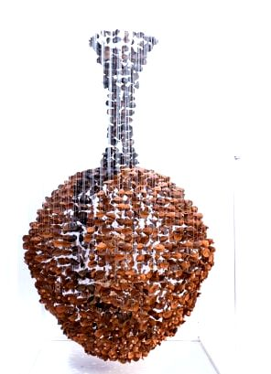 |  |  |  | 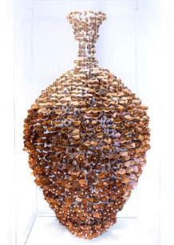
Plate 5 : Stunted (leaf series) |  |  |  | Plate 6: Subjugation (leaf series)
Media: Terracotta, acrylic. Monofilament, fishing line, metal. |  |  |  | Media: Terracotta, acrylic. Monofilament, fishing line, metal.
Dimension: 35 7/8 x 35 7/8 x 76 ¾ in 91 x 91 x 195 cm (2020) |  |  |  | Dimension: 35 7/8 x 35 7/8 x 76 ¾ in 91 x 91 x 195 cm (2020)
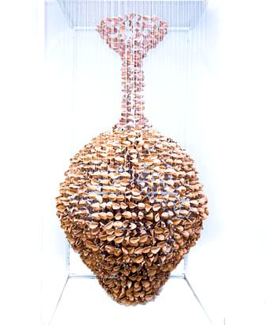 |  |  |  | 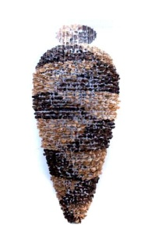
Plate 7: Freedom (leaf series) |  |  |  | Plate 8: Vase 1
Media: Terracotta, acrylic. Monofilament, fishing line, metal. |  |  |  | Media: Terracotta, acrylic. Monofilament, fishing line, metal.
Dimension: 35 7/8 x 35 7/8 x 76 ¾ in 91 x 91 x 195 cm (2020) |  |  |  | Dimension: 35 7/8 x 35 7/8 x 103 1/8 in 91 x 91 x 262 cm (2020)
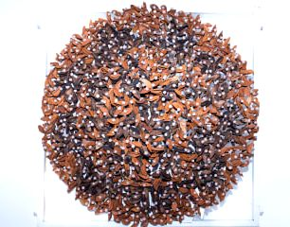 |  |  |  | 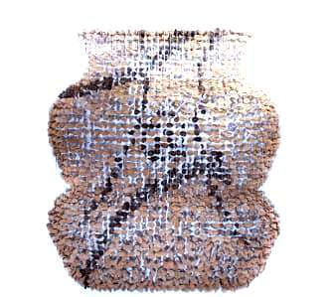
Plate 9: Keeper of Light |  |  |  | Plate 10: Union 1
Media: Terracotta, acrylic. Monofilament, fishing line, metal. |  |  |  | Media: Terracotta, acrylic. Monofilament, fishing line, metal.
Dimension: 35 7/8 x 35 7/8 x 11 ¾ in 91 x 91 30 cm (2020) |  |  |  | Dimension: 59 7/8 11 ¾ x 83 7/8 in 152 x 30 x 213 cm (2020)
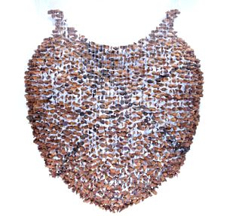 |  |  |  | 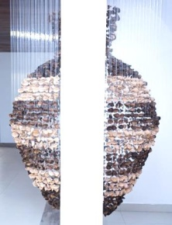
Plate 11: Union 2 |  |  |  | Plate 12: Eavesdropper
Media: Terracotta, acrylic. Monofilament, fishing line, metal. |  |  |  | Media: Terracotta, acrylic. Monofilament, fishing line, metal.
Dimension: 59 7/8 11 ¾ x 83 7/8 in 152 x 30 x 213 cm (2020) |  |  |  | Dimension: 35 7/8 x 35 7/8 x 83 x 7/8 in 91 x 91 x 213 cm (2020)
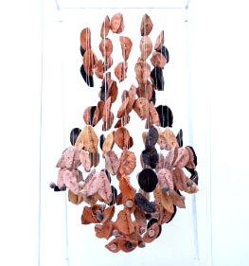 |  |  |  | 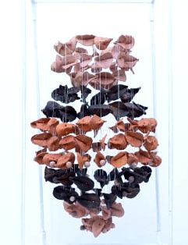
Plate 13: Vase 2 |  |  |  | Plate 14: Vase 3
Media: Terracotta, acrylic. Monofilament, fishing line, metal. |  |  |  | Media: Terracotta, acrylic. Monofilament, fishing line, metal.
Dimension: 11 ¾ x 11 ¾ x 24 1/8 in 30 x 30 x 61 cm (2020) |  |  |  | Dimension: 11 ¾ x 11 ¾ x 24 1/8 in 30 x 30 x 61 cm (2020)
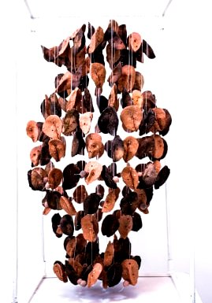 |  |  |  | 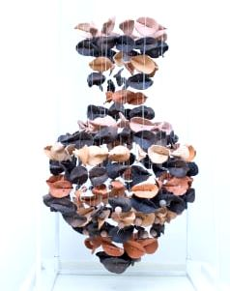
Plate 15: Vase 4 |  |  |  | Plate 16: Vase 5
Media: Terracotta, acrylic. Monofilament, fishing line, metal. |  |  |  | Media: Terracotta, acrylic. Monofilament, fishing line, metal.
Dimension: 11 ¾ x 11 ¾ x 24 1/8 in 30 x 30 x 61 cm (2020) |  |  |  | Dimension: 11 ¾ x 11 ¾ x 29 7/8 in 30 x 30 x 76 cm (2020)
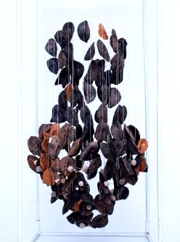 |  |  |  | 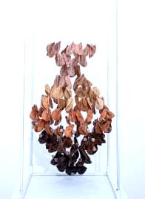
Plate 17: Vase 6 |  |  |  | Plate 18: Vase 7
Media: Terracotta, acrylic. Monofilament, fishing line, metal. |  |  |  | Media: Terracotta, acrylic. Monofilament, fishing line, metal.
Dimension: 11 ¾ x 11 ¾ x 29 7/8 in 30 x 30 x 76 cm (2020) |  |  |  | Dimension: 11 3/3 x 11 ¾ x 29 7/8 in 30 x 30 x 76 cm (2020)
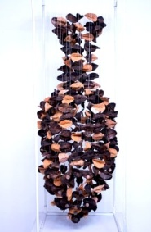 |  |  |  | 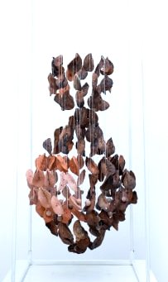
Plate 19: Vase 8 |  |  |  | Plate 20: Vase 9
Media: Terracotta, acrylic. Monofilament, fishing line, metal. |  |  |  | Media: Terracotta, acrylic. Monofilament, fishing line, metal.
Dimension: Dimension: 11 ¾ x 11 ¾ x 35 7/8 in 30 x 30 x 91 cm (2020) |  |  |  | Dimension: Dimension: 11 ¾ x 11 ¾ x 35 7/8 in 30 x 30 x 91 cm (2020)
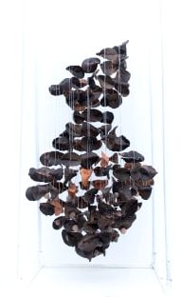 |  |  |  | 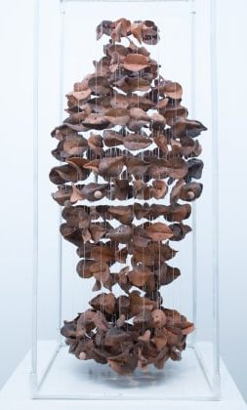
Plate 21: Vase 10 |  |  |  | Plate 22: Vase 11
Media: Terracotta, acrylic. Monofilament, fishing line, metal. |  |  |  | Media: Terracotta, acrylic. Monofilament, fishing line, metal.
Dimension: 11 ¾ x 11 ¾ x 35 7/8 in 30 x 30 x 91 cm (2020) |  |  |  | Dimension: 11 ¾ x 11 ¾ x 35 7/8 in 30 x 30 x 91 cm (2020)
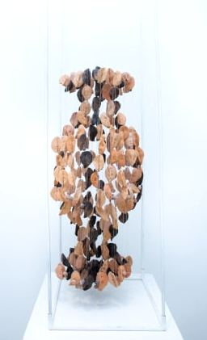 |  |  |  | 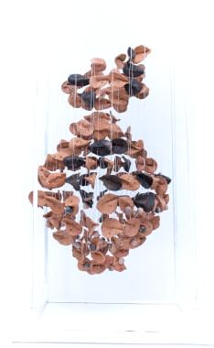
Plate 23: Vase 12 |  |  |  | Plate 24: Vase 13
Media: Terracotta, acrylic. Monofilament, fishing line, metal. |  |  |  | Media: Terracotta, acrylic. Monofilament, fishing line, metal.
Dimension: 11 ¾ x 11 x ¾ x 42 1/8 in 30 x 30 x 107 cm (2020) |  |  |  | Dimension: 11 ¾ x 11 x ¾ x 42 1/8 in 30 x 30 x 107 cm (2020)
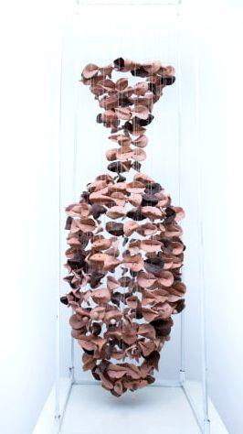 |  |  |  | 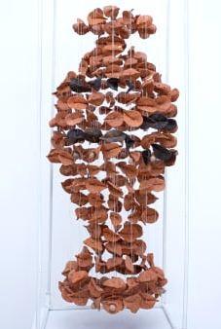
Plate 25: Vase 14 |  |  |  | Plate 26: Vase 15
Media: Terracotta, acrylic. Monofilament, fishing line, metal. |  |  |  | Media: Terracotta, acrylic. Monofilament, fishing line, metal.
Dimension: 11 ¾ x 11 ¾ x 42 1/8 in 30 x 30 x 107 cm (2020) |  |  |  | Dimension: 11 ¾ x 11 ¾ 42 1/8 in 30 x 30 107 cm (2020)
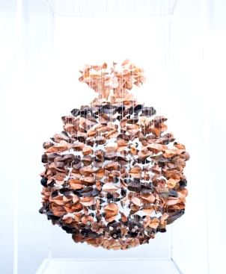 |  |  |  | 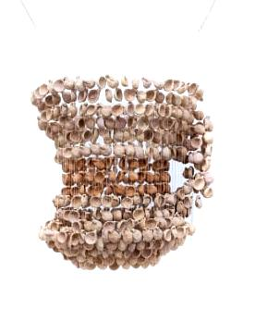
Plate 27: Vase 16 |  |  |  | Plate 28: My Goal
Media: Terracotta, acrylic. Monofilament, fishing line, metal. |  |  |  | Media: Terracotta, acrylic. Monofilament, fishing line, metal.
Dimension: 61 x 61 x 122 cm. (2020) |  |  |  | Dimension: 61 x 61 x 122 cm. (2020)
Source: Nkem Fortyunes Alu et al: Research 2024

