Improved Stock Price Prediction Using CEEMDAN-Based Signal Processing and GWO-CATBoost Optimization
- Dr. V. Bhoopathy, Department of Computer Science and Engineering, Sree Rama Engineering College, Tirupathi, India, v.bhoopathy@gmail.com

ABSTRACT
Stock market prediction involves attempting to ascertain the future value of a company's stock or other financial instruments traded on an exchange. Accurate forecasting of a stock's future price will optimise investor profits. The stock market is a multifaceted and dynamic arena in which investors and traders endeavour to make informed judgements to optimise gains or mitigate losses. Accurately predicting stock prices has historically been a formidable challenge due to the myriad factors affecting the market. With the emergence of machine learning techniques, academics have sought to utilise these technologies to predict stock prices more accurately. This thesis seeks to investigate the utilisation of DL Models for stock price prediction, comparing different models and features, and evaluating their efficacy on historical data. The proposed system combines GWO-CATBoost with CEEMDAN. GWO-CATBoost is improved for daily stock price forecasting using the CEEMDAN method. Technical indicators and historical stock data analysis forms the basis of the proposed approach. Initially, the researchers developed a coal price predicting index approach by reducing the complexity of the attribute set using Spearman correlation analysis. Second, the stock price index data is deconstructed using the CEEMDAN method into seven intrinsic modal functions and one residual term, hence reducing the volatility caused by complex components. While the stock price data feeds the integrated forecasting model, the Grey Wolf Optimiser approach helps to optimise the hyperparameters of the CATBoost model. At last, the SHAP interpretation method is offered for analysis of the main elements affecting stock prices. The results show that the proposed model highlights the possibility of the CEEMDAN algorithm in optimizing GWO-CATBoost and shows better predictive accuracy.

Keywords

Complementary Ensemble Empirical Mode Decomposition with Adaptive Noise (CEEMDAN), Grey Wolf Optimizer (GWO), Principal Component Analysis (PCA), Missing Not at Random (MNAR), Multivariate Principle Component Analysis (MPCA), Stock Price Prediction.

INTRODUCTION
The long-term unpredictability of stock values makes the prediction process an inherently difficult problem. Although most stock prices are reflected in archived data, according to modern technical analysis, the dated market hypothesis maintains that stock values cannot be predicted and that stocks behave randomly. Consequently, movement trends are crucial for effective value prediction[1]. Political events, overall economic conditions, the commodity price index, investor expectations, the behaviour of other stock markets, investor psychology, and other economic factors all have an impact on the groups and movements of the stock market. Groups of stocks with a large market capitalisation are considered valuable. Statistical information can be derived from stock price values using a variety of technical criteria. Stock indexes often provide an estimate of a country's economic status based on the prices of stocks with considerable market investment[2]. For example, data shows that a country's stock market capitalisation has a beneficial effect on economic growth. Investors face risk due to the uncertain nature of stock value movements. In addition, governments typically have a hard time detecting the market status. In fact, stock values are typically non-linear, non-parametric, and dynamic; as a result, statistical models frequently fail to accurately anticipate stock values and movements. Along with the fast expansion of the economy in recent years has come an explosion in the variety and complexity of financial operations[3]. Analysis in academic and financial circles aims to understand the pattern of financial activities and predict their development and changes. Investors and for-profit organisations can maximise profits by using micro-level trade decisions and plans based on macro-level understanding of the financial market's development and changes made possible by an approximation of financial data using one or more methods. Forecasting the trajectory of financial data's development is a formidable obstacle due to the data's complicated, incomplete, and ambiguous nature. Analysis into financial time series analysis and the forecasting of stock price values and movements has been going strong for quite some time[4]. While some academics adhere to the famous efficient market hypothesis and assert that accurate stock price forecasting is impossible, there are arguments in the literature that show that well-designed predictive models can achieve very high levels of accuracy. Evaluation has also shown that the variables utilised to develop the model, the methods used, and the optimisation process all have a role in the predictive model's accuracy. The source material contains proposals that centre on decomposing time series with the aim of predicting stock prices[5]. They have long been interested in the possibility of using archived data to forecast the direction of stock prices. The remainder of the paper is structured as follows. Section 2 provides an extensive analysis of the literature concerning the modelling and prediction of stock price movements. Section 3 provides a comprehensive analysis of the technique employed in this study. This document offers a concise overview of the operational concepts of the classification and regression models utilised in this study within deep learning. Section 4 provides a comprehensive analysis of the performance of machine learning and deep learning models. This section also presents a comparative examination of the models' performances. Ultimately, Section 5 finishes the manuscript.

LITERATURE SURVEY
The importance of accurately predicting stock trends in the stock market has prompted a lot of academic interest. Based on the key sources of information used, classical methodologies can be broadly divided into two main camps: technical analysis and fundamental analysis[6]. Predictions in technical analysis are based on time-series historical market data, including trade volume and price. Finding patterns in the market that can be used to forecast future events is the primary objective of this strategy[7]. The AR model is a popular choice for linear and stationary time-series data. The usefulness of AR models is, however, constrained by the fact that stock prices are neither linear nor stationary[8]. So, earlier research sought to use non-linear learning techniques to identify the trend's underlying complicated patterns. Study into using DNN for financial prediction has increased alongside the development of DL[9]. Financial prediction has also made use of RNN, particularly the LSTM network, to better model the long-term dependency in time series[10]. Their most recent proposal was an RNN named SFM that could find patterns in stock price prediction based on transaction frequencies[11]. They used NN and ARIMA, two methods for predicting stock prices, respectively. While the NN benefits in nonlinear data prediction were evident from the experiments, it was clear that the network's accuracy could use some work[12]. To use a multi-layer BP network to analyse the stock price of Jordanian stocks, but failed to note that conventional BP networks are prone to a local minimum[13]. In order to combine the SVM model with the DT technique[14]. To forecast the future price trend, they used the SVM to handle the second stage training data after filtering out most of the noise with the DT algorithm. They trained a MLP to forecast the stock market index using an ACRO technique[15]. In addition, they imply that when traders use their adaptive decision support system, they can get larger profits[16]. In addition, as NN classification algorithms are better able to capture non-linearities, the results of imply that these algorithms generate larger risk-adjusted profits[17]. More specifically, they show that DRPNN, compared to other NN specifications, has better predictive performance. Attest, in a separate body of research, that ANN and PCA, when used together, can produce superior results[18]. Similarly, to forecast stock price volatility, they will propose a series of models that combine LSTM with GARCH, and they will demonstrate that these models minimise prediction errors[19]. When it comes to financial forecasting, it seems that the best approach is to combine statistical ML with advanced DL techniques[20]. The remainder of the paper is structured as follows. Section 2 provides an extensive analysis of the literature concerning the modelling and prediction of stock price movements. Section 3 provides a comprehensive analysis of the technique employed in this study. This document offers a concise overview of the operational concepts of the classification and regression models utilised in this study within deep learning. Section 4 provides a comprehensive analysis of the performance of machine learning and deep learning models. This section also presents a comparative examination of the models' performances. Ultimately, Section 5 finishes the manuscript.

PROPOSED METHOD
Stock price prediction is a topic of much study that interests academics as well as business professionals. The development of artificial intelligence has made numerous algorithms useful for equities market fluctuations forecast. This Propsoed paper investigates several techniques used in share value prediction, from neural network approaches to classic machine learning and deep learning methods. It offers a thorough overview of the strategies applied in stock value forecasting.

Figure 2
Proposed Model Architecture
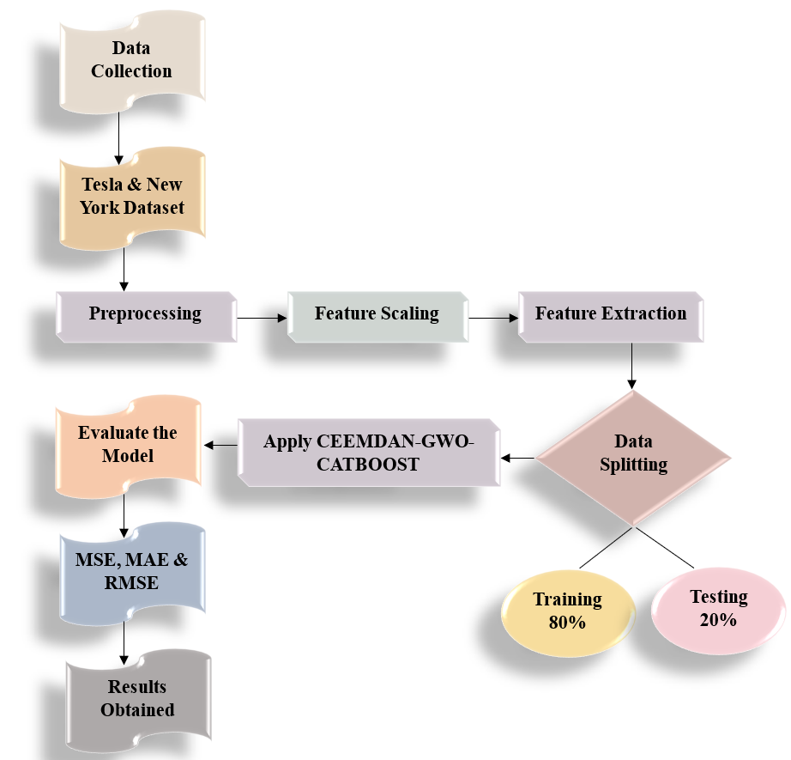
Figure 2 illustrates the use of a CNNTrans model to verify blockchain transactions and predict whether they are legitimate or malicious. The CNNTrans model predicts using a transaction-based dataset, which is trained and tested [21].

Preprocessing

Sorting Out the Many Forms of Missing Data:

Three types of data that are missing are recognised when dealing with it: missing at random (MAR), missing completely at random (MCAR), and missing not at random (MNAR). When time is included as a variable in multivariate analysis, it becomes more complicated. Time series features and covariance must be taken into account for imputation. It is not too difficult to do univariate interpolation on MCAR data. Multiple regression, on the other hand, accounts for the correlation between columns [22]. Missing data in MCAR is frequently recovered and can be substituted with the median or mean values. The data is inexplicably missing. In equation $(1)$, MCAR is defined as the product of complete data $Q$ and missing data $Z$.

$$O\left(Qj | Zj\right)=O\left(Qj\right) (1)$$

There is usually fewer null data in MCAR datasets, and no significant link is seen when using statistics like Cramer's rule, Chi-Square, or the correlation coefficient. It is possible to omit or impute instances with data missing in large databases. When there are few missing data points, list-wise deletion is the best deletion strategy for MCAR. Another option is pairwise deletion, which involves keeping data for pairs of quantities with available information, retaining additional data. When deletion approaches don't work, imputation is the next best option. Depending on the type of data, different strategies are used for imputation, which entails replacing missing data with predicted values. When it comes to MAR, missing data can sometimes be found in a specific order, while other times they can appear randomly. Markov analysis refers to the process of finding a link between missing and existent data. If your data is not time series, you can address MAR by using one of several imputation approaches, such as mean, mode, median, or interpolation. If your data is time series, you can use interpolation. Equation $(2)$ gives MAR.

$$O\left(Qj | Zj\right)=O\left(Qj|Z_{j,p}\right) (2)$$

Because it depends on unobserved data, prediction becomes difficult in MNAR when individual instances share missing data. When there is a high frequency of values not present but little to no correlation between other columns, and no strong associations are discovered upon analysis, this is referred to be MNAR. Obtaining the data that is missing is the only clear way to handle MNAR, which is non-ignorable. Only someone with domain knowledge can identify MNAR, and it usually has more null values than MCAR. The formula for MNAR is (3).

$$O\left(Qj | Zj\right)≠O\left(Qj|Z_{j,p}\right) (2)$$

Feature Scaling
MPCA
A statistical method called MPCA is employed to decrease the dimensionality of intricate multivariate data sets while preserving a maximum amount of dataset variability. It does this by identifying the most salient patterns and fluctuations in the data and then extracting a smaller set of vectors that are orthogonal called principal components. Assuming the second instant exists, $γ=F\left(W\right),\sum{var(W)}$ is a $m$ dimensional random variable defined as$W={\left(w_{1},w_{2},w_{3},…,w_{m}\right)}^{S}$. Afterwards, the subsequent linear function is present [23].
$$\left\{\begin{aligned}z_{1}=b_{11}w_{1}+b_{21}w_{2}+b_{31}w_{3}+…+b_{m}w_{m}=B_{1}^{S}W \\ z_{2}=b_{12}w_{1}+b_{22}w_{2}+b_{32}+b_{3}+…+b_{m}w_{m}=B_{2}^{S}W \\ . \\ . \\ . \\ z_{m}=b_{1m}w_{1}m+b_{2n}w_{2}+…+b_{mm}w_{m}=B_{m}^{S}W \end{aligned}\right. (8)$$
It gets by applying a linear transformation.
$$var({z_{j}}_{=B_{j}}^{S}\sum{B_{j}, j=1,2,…,m} (10)$$
$$cov\left(z_{j},z_{i}\right)=B_{j}^{S}\sum{B_{i}, j,i=1,2,…,m} (11)$$
In general, the variable $z$ reflects more information when $var(z)$ is larger. Find $B_{1}$ such that $var(z_{1})$ is maximised, where $z_{1}$ is the first main component variable, given that $\left\|B_{1}\right\|=1$. They go on to the second most important variable if the first one doesn't have enough data. For the principal components to be considered uncorrelated, the condition $cov\left(z_{1},z_{2}\right)=0$must be satisfied, and the same holds for the succeeding principal components [24] .
Several PC capture the primary variability in the data, and the core notion of MPCA is to identify a linear adaptation that projects the original multi-dimensional data into a lower-dimensional space. Assume the following for the population-based sample data matrix:
$$W=\left[\begin{matrix}w_{11} & w_{21} & … & w_{1o} \\ w_{12} & w_{22} & … & w_{2o} \\ . & . & . & . \\ . & . & . & . \\ . & . & . & . \\ w_{1m} & w_{2m} & … & 2_{mo}\end{matrix}\right]=\left[W_{1},W_{2}^{S},…,W_{m}^{S}\right] (12)$$
Here are the sample relationship and sample covariance matrices:
$$T=\frac{1}{(m-1)}\sum_{j=1}^{m}{(w_{j}-\overline{w}}){\left(w_{j}-\overline{w}\right)}^{S}=\left(W_{1},W_{2}^{S},…,W_{m}^{S}\right) (13)$$
$$Q={\left(q\right)}_{o×o}={\left(\frac{T_{jj}}{\sqrt{T_{jj}}∙\sqrt{T_{ii}}}\right)}_{o×o} (14)$$
exactly where$\overline{w}=\frac{1}{m}\sum_{j=1}^{m}{W_{j}}$. To do MPCA, one must first determine the eigenvectors and eigenvalues of the centred data's covariance matrix $T$, and then use these values to choose the PC.
The capacity of MPCA to simplify and compress complicated data while preserving useful information for modelling tasks is the driving force behind its selection. When working with datasets that include correlated variables or investigating correlations across various dimensions, this technique shines.
Figure 2 shows the process flow for using MPCA on data, with the individual stages of data transformation and primary component extraction highlighted.
In the context of stock market data analysis, MPCA is a powerful tool for simplifying multidimensional data and extracting important features that improve model interpretability and predictive power.

Figure 2
Hybrid Preprocessing Model Process Flow

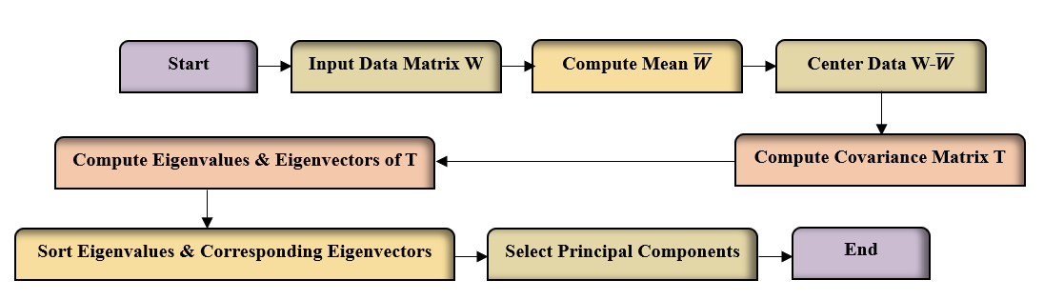
With the use of MPCA, the basic trends and variances in stock price movements can be better captured by reducing high-dimensional stock measurements to a smaller collection of major components. This method is useful in financial analytics since it streamlines the modelling process and makes better predictions of market patterns and volatility.

MODEL TRAINING
CEEMDAN
Mode mixing is one of the drawbacks of the EMD method. Adding Gaussian variation to the data makes this flaw disappear; this version of EMD is called EEMD. Unfortunately, the data is not properly decomposed and reconstruction errors are introduced due to the inability to quickly eliminate the Gaussian fluctuation when utilising the EEMD for data decomposition. As a result of EEMD's inefficiency in removing Gaussian noise during the decomposition phase and EMD's mode mixing constraint, the authors of developed a new version of EMD called CEEMDAN [25].
Here is a detailed timeline of the CEEMDAN process:
Initially, the signal that has been tainted with Gaussian noise is broken down using the test signal EMD. The following equational structure defines the first IMF component $(14)$.
$$\overline{IMF_{1}}=\frac{1}{K}\sum_{j=1}^{K}{IMF_{j1}} (14)$$
Using Equation $(15)$, they can determine the initial residual component:
$$q_{1}\left(s\right)=z\left(s\right)-\overline{IMF_{1}} (15)$$
To derive the second mode, decompose the residue $q_{1}\left(s\right)+α_{1}F(x_{j}\left(s\right))$ according to Equation $(16)$.
$$\overline{IMF_{2}}=\frac{1}{K}\sum_{j=1}^{K}{F_{1}[q_{1}\left(s\right)+α_{1}F_{1}(x_{j}\left(s\right))]} (16)$$
By iterating steps 1–4 for each IMF, they may obtain the final flat residue component, as shown in Equation $(17)$:
$${ Q}_{n}\left(s\right)=z\left(s\right)-\sum_{i=1}^{n}{\overline{IMF_{i}}} (17)$$
Figure 3 below shows a schematic view of the CEEMDAN approach.

Figure 3
CEEMDAN Method Schematic View
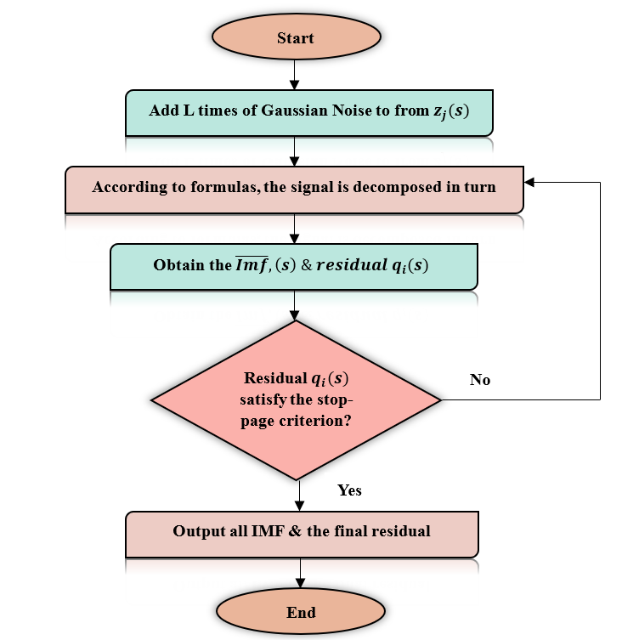

After the Gaussian random added signal is decomposed, the number of IMFs is denoted by $n$. Not only do these IMFs span a wide range of frequencies, from very low to very high, but their amplitudes and timeframes are also distinct.
GWO
A novel evolutionary algorithm that draws inspiration from nature is Grey Wolf Optimiser (GWO) [26]. In GWO, the hunt is modelled after the way grey wolves do it in the wild. In the past, wolves often lived in packs, with a dominant male and female grey wolf serving as pack leaders. In every pack, there is a highly dominant social hierarchy. On average, there are anywhere from five to twelve items per pack. The following is the established order of the pack based on its social hierarchy:

Algorithm 1

Algorithm For GWO

Algorithm 1: GWO Algorithm

The chief wolves $γ$: Those wolves who are in charge of the pack and have the last say. It is the pack that dictates to the alphas and ders.

The beta wolf $δ$: The subordinate wolves following the alphas within the pack hierarchy. The primary role of beta wolves is to assist and support choices of the alphas.

The wolves from the delta $β$: Delta wolves make up the third echelon of the pack. Alpha and beta wolves used to lead them. Here are the five types of delta wolves:

Scouts: Wolves are employed to keep the pack safe by keeping an eye on the territory's borders and calling out for help when threatened.

Sentinels: Keep the group safe by protecting them.

Elders: In the past, dominant wolves served as alpha or beta.

Hunters: In the past, wolves would aid the pack's alpha and beta by hunting and sharing their catch.

Caretakers: It is the responsibility of the wolves to tend to the sick, injured, and frail wolves.

Alpha wolves $φ$: are subordinate wolves that must adhere to the rules set up by the pack's leaders, the alpha, beta, and delta.

The GWO method recognises alpha $γ$ wolves as the most suitable option within the pack, while beta $δ$ and delta $β$ are the names of the second and third best options, respectively. Omega $φ$ refers to the outcomes of solutions within the population. The variables $γ,δ,and φ$ serve as guides during the hunting process.
Circumambulating the prey with α, β, and ω is the initial phase of hunting. Equations $(18)$, $(19)$, $(20)$, and $(21)$ illustrate the mathematical model of the circling process.
$$W\left(s+1\right)=W_{o}\left(s\right)+B∙C (18)$$
which is where the grey wolf is located $W$. $s$ represents the iteration count. The prey's position is denoted by $W_{o}$and $C$ is determined using Equation (20).
$$C=\left|D∙W_{o}\left(s+1\right)-W\left(s\right)\right| (19)$$
Equations $(21)$ and $(22)$ are used to evaluate the coefficient vectors $B$ and $D$, respectively.
$$B=2b∙q_{1}-b (20)$$
$$D=2q_{2} (21)$$
where $b$ control the trade-off between exploration and exploitation; it is linearly decreasing from 2 to 0 via the number of iterations.
CEEMDAN-GW-CATBoost:
There are two parts to the CEEMDAN-GW-CatBoost model that this article presents for predicting stock prices: decomposition and prediction [27]. The initial step is to use CEEMDAN to break out the raw data from the stock price index. Afterwards, the GWO optimisation technique is used to seek the CatBoost model's hyperparameters after individually predicting the IMF components and residual RES. The final outcome is the sum of all the predictions. The particular implementation path is shown in Figure 4 [28].

Figure 4
CEEMDAN-GW-CATBoost Method Flow Chart for Stock Price Prediction
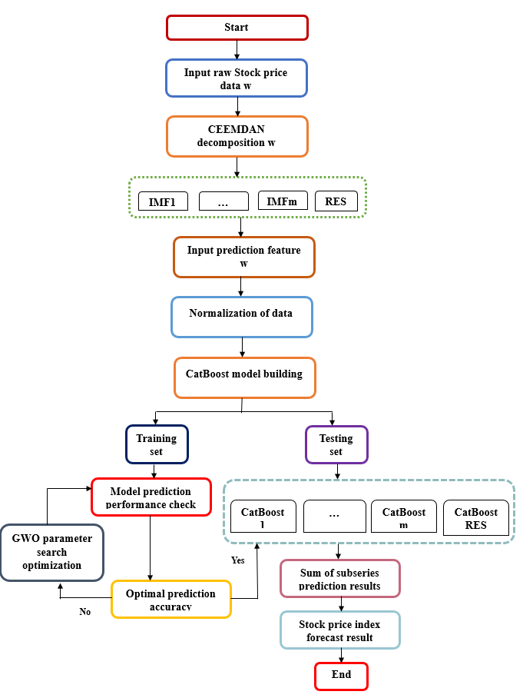
The Method of SHAP interpretation:
The difficulty of understanding the results significantly limits the use of ML to real-world problems, despite its widespread success. Predictive science places a premium on interpretability. The CatBoost model becomes nearly opaque as its complexity rises; this is despite the fact that the integration algorithm-based ML model outperforms its counterparts. The paper introduces the SHAP framework to elucidate the model's outcomes and enhance its reliability, targeting the issue of inadequate interpretability.
SHAP follows the conventional ex post explanation paradigm and is based on game theory and local interpretation. This technique treats each feature variable in the dataset as a player and trains the model to predict outcomes based on that dataset, drawing on the concept of the Shapley value from game theory. This can be regarded as the outcome of numerous participants collaborating to accomplish a project, taking into account each participant's effort and equitably distributing the advantages via SHAP value. By quantifying the contribution of each feature to predictions and clarifying the relationship between individual feature values and prediction results, the SHAP technique provides a model interpretation tool for tree-based algorithms. The SHAP value denotes the significance assigned to each feature in a specific sample, whereas the model generates a prediction value for each sample. Let the $j^{th}$ sample be denoted as $w_{j}$, the $i^{th}$ characteristic of $w_{j}$ as $w_{ji}$, the model's predicted value for that sample as $z_{j}$, and the baseline of the entire model as $zbase$. The SHAP value is computed as illustrated in Equation $(22)$.
$$z_{j}=zbase+e(w_{j1})+e\left(w_{j2}\right)+….+e\left(w_{jl}\right) (22)$$
The SHAP value of $w_{ji}∙e(w_{j1})$. The value that the $j^{th}$ sample's first feature adds to the final predicted value $z_{j}$ is denoted as $e(w_{j1})$. When a feature is included, the SHAP value for that feature shows how the expected model prediction changes, and the analysis is based on the positive or negative magnitude of that value. It is generally the case that a feature's influence on the model is proportional to its SHAP value. On the other hand, the effect is less pronounced when the SHAP value is lower. A positive value indicates a beneficial effect, whereas a negative one indicates a detrimental one.

RESULT AND DISCUSSION
Stock market trading is an endeavour that requires investors to possess rapid and precise knowledge to make informed selections. Numerous elements influence the decision-making process due to the trading of multiple equities on a stock exchange. Furthermore, the behaviour of stock prices is unpredictable and difficult to forecast. Consequently, stock price prediction is a significant and arduous endeavour. This entails the investigation of identifying the most effective predictive model that yields the highest accuracy with the minimal error rate. This paper examines research on hybrid deep learning approaches and algorithms utilised to enhance the precision of stock price forecasting.
We have examined our studies on two datasets: the New York Stock Exchange and Tesla Stock Price. The New York Stock Exchange houses data pertinent to historical and fundamental study. The dataset comprises seven columns: date, symbol, open, close, low, high, and volume pertaining to various stocks. It comprises a substantial volume of market pricing data (851,000) from various companies. The second dataset, the Tesla Stock Price dataset, encompasses stock prices from its initial public offering in 2010 to 2020 [29]. The dataset comprises seven columns: Date, Open, High, Low, Close, Volume, and Adjusted Close. It comprises historical prices of 2,416 records pertaining to stocks. The complete data is partitioned into two segments: 80% for training and 20% for testing.

Table 1
Training Results of Models
MODEL | MAPE | MAE | RMSE
CAT | 0.692 | 11.692 | 14.543
GWO-CatBoost | 0.593 | 12.792 | 14.467
CNN-LSTM | 0.737 | 14.283 | 14.595
TransLSTM | 0.473 | 12.397 | 14.732
BiGRU | 0.676 | 13.546 | 14.639
BiGRU-BiRNN | 0.538 | 15.639 | 14.765
CEEMDAN-GWO-CatBoost | 0.426 | 10.413 | 14.326

Table 2 shows how different machine learning and deep learning models compare to one other in terms of Mean Absolute Percentage Error (MAPE), Mean Absolute Error (MAE), and Root Mean Square Error (RMSE). The hybrid CEEMDAN-GWO-CatBoost model does the best overall out of the models that were tested: CAT, GWO-CatBoost, CNN-LSTM, TransLSTM, BiGRU, BiGRU-BiRNN, and the suggested CEEMDAN-GWO-CatBoost. It has the lowest MAPE of 0.426, which means it is the most accurate in making predictions. TransLSTM (0.473) and BiGRU-BiRNN (0.538) come in second and third, respectively. Furthermore, CEEMDAN-GWO-CatBoost boasts the lowest MAE (10.414), surpassing both hybrid and classical choices including CAT (11.692) and GWO-CatBoost (12.792). CEEMDAN-GWO-CatBoost is more stable and accurate even if the RMSE values are very close between models since it shows lowest RMSE at 14.326. Although deep learning models such as CNN-LSTM and BiGRU have lower RMSEs than other models, their higher MAPE and MAE scores indicate that their performance suffers. These results show that forecasting is significantly more accurate and error reduction results from employing CEEMDAN for signal decomposition, GWO for hyperparameter optimisation, and CatBoost for strong prediction. Thus, the given paradigm is the ideal approach to approach this analysis.

Figure 5
Accuracy Comparison of Classifiers for Tesla and New York Datasets
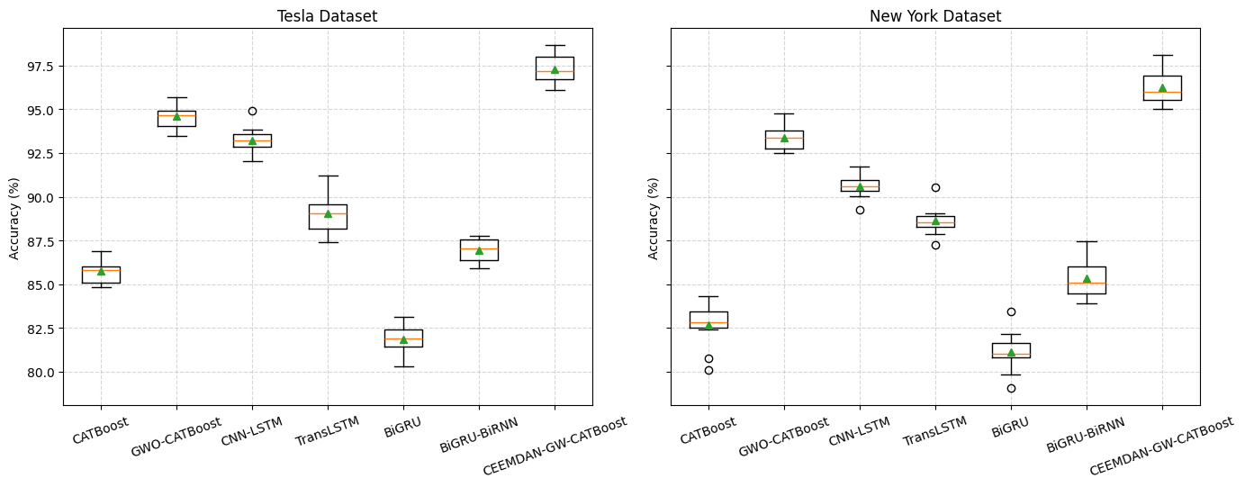
The performance comparison of the chosen classification models on the Tesla and New York datasets is depicted in Fig. 3.
The accuracies for the Tesla dataset span almost 82% to 97%. At 97.29%, the CEEMDAN-GW-CATBoost model beats CNN-LSTM at 93.46% and GWO-CATBoost at 95.37%. Showing rather good performance with accuracy of 89.34% and 86.73%, respectively, the TransLSTM and BiGRU-BiRNN models CATBoost and BiGRU have rather poor performance, with respectively 85.29% and 82.09%.
The model accuracies for the New York set span 80.99% to 96.54%. With 96.54% maximum accuracy, the CEEMDAN-GW-CATBoost model follows GWO-CATBoost at 93.29% and CNN-LSTM at 90.73%. TransLSTM and BiGRU-BiRNN demonstrate continuously good performance with accuracies of 88.67% and 85.29%, respectively.

Figure 6
ROC Curve for New York and Tesla Dataset
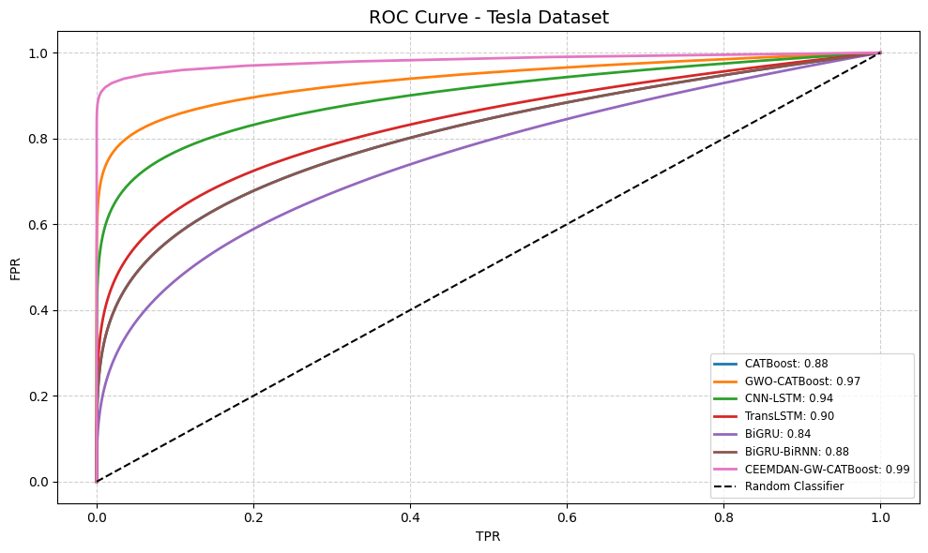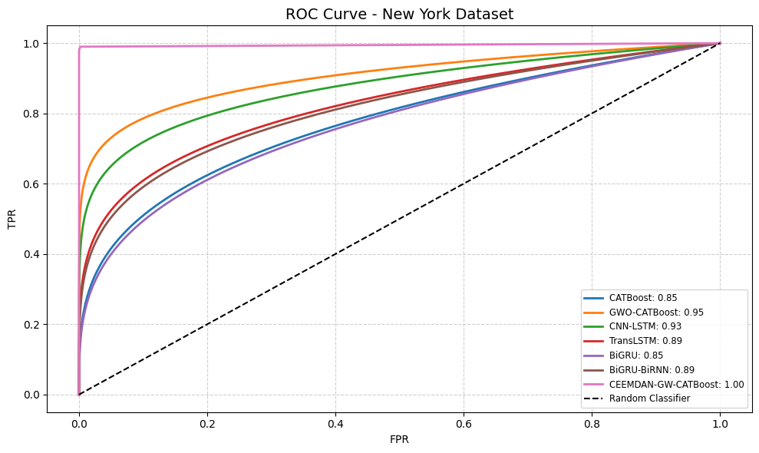
Figures 3 shows the performance comparison of the selected classification models on the Tesla and New York datasets. For the Tesla dataset, the accuracies run from about 82% to 97%. Attaining an average accuracy of 97.29%, the CEEMDAN-GW-CATBoost model exceeds GWO-CATBoost at 95.37% and CNN-LSTM at 93.46%. Showing rather good performance with accuracy of 89.34% and 86.73%, respectively, the TransLSTM and BiGRU-BiRNN models CATBoost and BiGRU have rather poor performance, with respectively 85.29% and 82.09%. The model accuracies for the New York set span 80.99% to 96.54%.

Table 2
Proposed Model Vs Traditional Methods Comparison
MODEL | Sensitivity | Specificity | F1-Score | AUC | Accuracy
CAT | 85.65 | 84.23 | 85.48 | 85.36 | 85.29
GWO-CatBoost | 95.39 | 94.26 | 95.72 | 93.29 | 95.77
CNN-LSTM | 93.49 | 92.75 | 93.68 | 94.82 | 93.46
TransLSTM | 89.37 | 88.64 | 89.77 | 92.82 | 89.34
BiGRU | 82.01 | 80.73 | 83.21 | 89.23 | 82.09
BiGRU-BiRNN | 86.77 | 85.28 | 87.29 | 88.57 | 86.73
CEEMDAN-GWO-CatBoost | 97.65 | 96.29 | 97.63 | 99.92 | 97.29

The Table 1 uses the experimental results to perform the visualisation and analysis of the real and projected values together with the model evaluation measures. The results of the model predictions are applied to restore the natural order of magnitude for model evaluation.

Figure 7
Prediction Results.
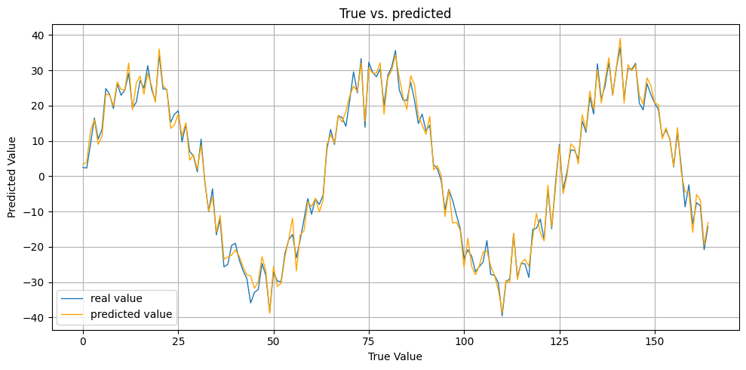
The third stage is to use the experimental results to do the model evaluation metrics and the visualisation and analysis of the real and projected values. The findings from the model predictions are utilised to bring the original order of magnitude back to normal for model evaluation. Figure 8 also shows pictures of real and anticipated data.

Figure 9
MAPE Prediction for Tesla and New York Dataset

It is clear from the graph in Figure 4 that the CEEMDAN-GWO-CatBoost model has the lowest MAPE for both datasets. This means that it is better at making predictions and generalising. On the other hand, models like TransLSTM and CNN-LSTM have larger MAPE values, especially for the New York dataset, which means they don't perform as consistently. CAT and BiGRU also have rather high error rates, which shows that hybrid optimisation and decomposition strategies work better than other methods. In most models, the New York dataset has slightly higher MAPE values than the Tesla dataset. This could be because the New York data is more volatile or has more noise. The fact that CEEMDAN-GWO-CatBoost is consistent and has smaller error margins shows that it is strong and can work with diverse sorts of data. This shows that the suggested model is a good fit for a range of real-world forecasting applications that use time series data.

CONCLUSION
These days, neural networks are a very important instrument for research and practically employed in almost every field. Neural networks are built and driven just by the input; they learn without reference to a model to identify parameters and connections. In the field of finance, this has great consequences and applications. Stock prices can be influenced by numerous factors including geopolitics, company performance, and commodities pricing. Sometimes US uncertainty in terms of inflation, government policy, and reserve bank policy causes stock values to fluctuate. Finding the volatility of a stock is among the toughest tasks traders have to perform. Through correct stock price prediction, investors can reduce the risk in their portfolio or investment. Stock prices do not run straight forward. We present a hybrid stock prediction model to handle nonlinear data using the prediction CEEMDAN-GWO-CatBoost. The hybrid stock prediction model's results are deduced using mean absolute error (MAE) and root mean square error (RMSE). With an RMSE score between 3% and 4% better than the single prediction model, CATBoost and GWO-CatBoost, the hybrid stock prediction model performs better. The paper examines Tesla's and New York's stock prices.

REFERENCES
[1] J. Patel, S. Shah, P. Thakkar, and K. Kotecha, “Predicting stock market index using fusion of machine learning techniques,” Expert Syst. Appl., vol. 42, no. 4, pp. 2162–2172, 2015, doi: 10.1016/j.eswa.2014.10.031.
[2] B. M. Henrique, V. A. Sobreiro, and H. Kimura, “Stock price prediction using support vector regression on daily and up to the minute prices,” J. Financ. Data Sci., vol. 4, no. 3, pp. 183–201, 2018, doi: 10.1016/j.jfds.2018.04.003.
[3] X. Pang, Y. Zhou, P. Wang, W. Lin, and V. Chang, “An innovative neural network approach for stock market prediction,” J. Supercomput., vol. 76, no. 3, pp. 2098–2118, 2020, doi: 10.1007/s11227-017-2228-y.
[4] E. Chong, C. Han, and F. C. Park, “Deep learning networks for stock market analysis and prediction: Methodology, data representations, and case studies,” Expert Syst. Appl., vol. 83, pp. 187–205, 2017, doi: 10.1016/j.eswa.2017.04.030.
[5] W. Long, Z. Lu, and L. Cui, “Deep learning-based feature engineering for stock price movement prediction,” Knowledge-Based Syst., vol. 164, pp. 163–173, 2019, doi: 10.1016/j.knosys.2018.10.034.
[6] J. Qiu, B. W. Id, and C. Zhou, “Forecasting stock prices with long-short term memory neural network based on attention mechanism,” pp. 1–15, 2020.
[7] M. R. Vargas, B. S. L. P. De Lima, and A. G. Evsukoff, “Deep learning for stock market prediction from financial news articles,” 2017 IEEE Int. Conf. Comput. Intell. Virtual Environ. Meas. Syst. Appl. CIVEMSA 2017 - Proc., pp. 60–65, 2017, doi: 10.1109/CIVEMSA.2017.7995302.
[8] P. Yu and X. Yan, “Stock price prediction based on deep neural networks,” Neural Comput. Appl., vol. 32, no. 6, pp. 1609–1628, 2020, doi: 10.1007/s00521-019-04212-x.
[9] M. Li, Y. Zhu, Y. Shen, and M. Angelova, “Clustering-enhanced stock price prediction using deep learning,” World Wide Web, vol. 26, no. 1, pp. 207–232, 2023, doi: 10.1007/s11280-021-01003-0.
[10] X. Zhang, Y. Zhang, S. Wang, Y. Yao, B. Fang, and P. S. Yu, “Improving stock market prediction via heterogeneous information fusion,” Knowledge-Based Syst., vol. 143, pp. 236–247, 2018, doi: 10.1016/j.knosys.2017.12.025.
[11] W. Jiang, “Applications of deep learning in stock market prediction: Recent progress,” Expert Syst. Appl., vol. 184, pp. 1–97, 2021, doi: 10.1016/j.eswa.2021.115537.
[12] J. Shen and M. O. Shafiq, “Short-term stock market price trend prediction using a comprehensive deep learning system,” J. Big Data, vol. 7, no. 1, 2020, doi: 10.1186/s40537-020-00333-6.
[13] R. K. Nayak, D. Mishra, and A. K. Rath, “A Naïve SVM-KNN based stock market trend reversal analysis for Indian benchmark indices,” Appl. Soft Comput. J., vol. 35, pp. 670–680, 2015, doi: 10.1016/j.asoc.2015.06.040.
[14] S. P. Chatzis, V. Siakoulis, A. Petropoulos, E. Stavroulakis, and N. Vlachogiannakis, “Forecasting stock market crisis events using deep and statistical machine learning techniques,” Expert Syst. Appl., vol. 112, pp. 353–371, 2018, doi: 10.1016/j.eswa.2018.06.032.
[15] L. A. Laboissiere, R. A. S. Fernandes, and G. G. Lage, “Maximum and minimum stock price forecasting of Brazilian power distribution companies based on artificial neural networks,” Appl. Soft Comput. J., vol. 35, pp. 66–74, 2015, doi: 10.1016/j.asoc.2015.06.005.
[16] Z. Hu, W. Liu, J. Bian, X. Liu, and T. Y. Liu, “Listening to chaotic whispers: A deep learning framework for news-oriented Stock trend prediction,” WSDM 2018 - Proc. 11th ACM Int. Conf. Web Search Data Min., vol. 2018-Febua, pp. 261–269, 2018, doi: 10.1145/3159652.3159690.
[17] W. Lu, J. Li, J. Wang, and L. Qin, “A CNN-BiLSTM-AM method for stock price prediction,” Neural Comput. Appl., vol. 33, no. 10, pp. 4741–4753, 2021, doi: 10.1007/s00521-020-05532-z.
[18] Y. Baek and H. Y. Kim, “ModAugNet: A new forecasting framework for stock market index value with an overfitting prevention LSTM module and a prediction LSTM module,” Expert Syst. Appl., vol. 113, pp. 457–480, 2018, doi: 10.1016/j.eswa.2018.07.019.
[19] A. M. Rather, A. Agarwal, and V. N. Sastry, “Recurrent neural network and a hybrid model for prediction of stock returns,” Expert Syst. Appl., vol. 42, no. 6, pp. 3234–3241, 2015, doi: 10.1016/j.eswa.2014.12.003.
[20] M. Göçken, M. Özçalici, A. Boru, and A. T. Dosdoʇru, “Integrating metaheuristics and Artificial Neural Networks for improved stock price prediction,” Expert Syst. Appl., vol. 44, no. September, pp. 320–331, 2016, doi: 10.1016/j.eswa.2015.09.029.
[21] C. Reads, “ENHANCING STOCK PRICE PREDICTION : A COMPREHENSIVE ANALYSIS International Journal of Core Engineering & Management ISSN No : 2348-9510,” no. February 2023, 2024.
[22] M. Usmani, Z. A. Memon, A. Zulfiqar, and R. Qureshi, “Preptimize: Automation of Time Series Data Preprocessing and Forecasting,” Algorithms, vol. 17, no. 8, 2024, doi: 10.3390/a17080332.
[23] M. Sui, C. Zhang, L. Zhou, S. Liao, and C. Wei, “An Ensemble Approach to Stock Price Prediction Using Deep Learning and Time Series Models,” 2024 IEEE 6th Int. Conf. Power, Intell. Comput. Syst. ICPICS 2024, pp. 793–797, 2024, doi: 10.1109/ICPICS62053.2024.10796661.
[24] J. L. Li and W. K. Shi, “Hybrid preprocessing for neural network-based stock price prediction,” Heliyon, vol. 10, no. 24, p. e40819, 2024, doi: 10.1016/j.heliyon.2024.e40819.
[25] D. S. Metwally, M. Ali, S. M. Alghamdi, and D. M. Khan, “A novel hybrid model to forecast the stock price based on CEEMDAN and support vector regression,” J. Radiat. Res. Appl. Sci., vol. 18, no. 2, p. 101385, 2025, doi: 10.1016/j.jrras.2025.101385.
[26] X. Wang, Y. Mao, Y. Duan, and Y. Guo, “A Study on China coal Price forecasting based on CEEMDAN-GWO-CatBoost hybrid forecasting model under Carbon Neutral Target,” Front. Environ. Sci., vol. 10, no. September, pp. 1–16, 2022, doi: 10.3389/fenvs.2022.1014021.
[27] H. Turabieh, “A Hybrid ANN-GWO Algorithm for Prediction of Heart Disease,” Am. J. Oper. Res., vol. 06, no. 02, pp. 136–146, 2016, doi: 10.4236/ajor.2016.62016.
[28] R. Hafezi, J. Shahrabi, and E. Hadavandi, “A bat-neural network multi-agent system (BNNMAS) for stock price prediction: Case study of DAX stock price,” Appl. Soft Comput., vol. 29, pp. 196–210, 2015, doi: 10.1016/j.asoc.2014.12.028.
[29] S. C. Agrawal, “Deep learning based non-linear regression for Stock Prediction,” IOP Conf. Ser. Mater. Sci. Eng., vol. 1116, no. 1, p. 012189, 2021, doi: 10.1088/1757-899x/1116/1/012189.

