ABSTRACT
Precise stock market forecasting and profit augmentation are essential yet arduous due to the extreme volatility and instability of financial markets, which are shaped by public sentiment, economic conditions, and the vast array of diverse data produced from numerous sources every second. Conventional SMP models predominantly depend on historical price data, constraining their capacity to apprehend intricate and nonlinear market dynamics. This paper provides an integrated predictive framework that incorporates efficient data preparation, feature extraction, and hybrid modelling strategies to overcome this issue. Data cleansing and normalisation are utilised to prepare datasets for machine learning, while Multilinear Principal Component Analysis (MPCA) is performed for effective feature extraction and dimensionality reduction. A hybrid ARIMA–SVM model is constructed for prediction, utilising the linear time-series forecasting efficacy of the Autoregressive Integrated Moving Average (ARIMA) model and the nonlinear regression proficiency of SVM. The suggested model was evaluated using actual stock market datasets and shown enhanced performance. The ARIMA–SVM methodology attained a prediction accuracy of 0.966%, surpassing the ARIMA (0.901%), SVM (0.932%), TDNN (0.873), PINN (0.808%) and ARIMA-LSTM (0.842%) models. The findings affirm that the proposed hybrid framework substantially improves prediction accuracy and facilitates dependable investment decision-making, while effectively contributing to profit augmentation in stock market applications.
Keywords
Stock Market Prediction (SMP), Multivariate Principal Component Analysis (MPCA), Min-Max Normalization, Mean Normalization, Z-score Normalization, Autoregressive Integrated Moving Average (ARIMA), Multi-source Data-Fusion (MDF).

INTRODUCTION
One of the most significant financial institutions in every capitalist economy is the stock market. Businesses are able to access capital for expansion and day-to-day operations through this method. However, investors face a high degree of risk due to its unpredictable nature. So, businesses and individuals in the financial sector, such as banks, have long sought methods to foresee shifts in stock values and act accordingly[1]. More and more people and organisations started investing in the stock market as a result of rising incomes and the desire for better returns on investment. Despite this expansion, substantial dangers arose from the unpredictability and intrinsic volatility of stock values. Most investors, particularly those with a low loss-absorbing capacity, could suffer severe economic setbacks as a result of these changes. Investment theories and practices that help investors maximise profits while minimising risks have thus always been in high demand[2]. Most people who are interested in the stock market would want to find a way to accurately predict market trends so they may increase their earnings, yet the market is so volatile and trends are so hard to predict. The stock market is essentially just a marketplace where people may buy and sell shares of a company's stock, and the prices of those shares can fluctuate substantially over time. It would be foolish to disregard the factors that may be causing such wild swings in the stock market, such as politics, public perception of brands, and the present international situation; for example, pharmaceutical businesses saw a significant uptick in sales during the epidemic[3]. The stock market is highly sensitive to the aforementioned variables because they reflect the views and opinions of prospective investors. Due to the ever-present uncertainties and transformations on a global scale, it is not enough to just identify potential change-causing elements; a methodology for reliable trend prediction is also required. Traditional methods for predicting stock market movements often involve analysing stock data sets from the past. Information amalgamation, however, is a crucial component of decision-making procedures in modern information age and technological era. Also, there is an ever-increasing deluge of data coming from places like the Internet, databases, chat, email, and social media sites; the stock market is only one of many places where this data is generated on a daily basis in the terabytes and petabytes[4]. However, effective information fusion in market analysis is a difficult undertaking due to the widespread availability of stock market data. However, as stock market data is complex and interrelated, the capacity to create intelligence from data by combining it with fresh information would provide clear benefits in stock market prediction. As a result, recent research in this sector has made MDF a major topic of study. In other words, MDF seeks to make the greatest investment choice by obtaining a comprehensive understanding of all the variables influencing the movement of the stock price. However, the fact that these characteristics stock price indicators are produced from multiple sources in various formats makes it difficult to combine them into meaningful information.
Here is how the paper is organised: Corresponding work is covered in Section 2. In Section 3, the hybrid preparation model is described in full. The findings and explanations of the experiments are presented in Section 4. The paper is concluded in Section 5.

LITERATURE SURVEY
The stock market is an important part of the world economy because it facilitates the exchange of capital and serves as a gauge of the overall health of the economy[5]. The complexity and volatility of the market make it extremely difficult for analysts, investors, and financial practitioners to predict exactly stock prices will move[6]. Given the dynamic nature of the market and the importance of making informed investment decisions, new approaches to predicting stock prices are urgently required[7]. In order to forecast stock prices, they suggested using a combination of AE and LSTM[8]. When compared to the standalone structure, the outcomes demonstrate an improvement in both prediction accuracy and profitability[9]. Additionally, novel deep learning frameworks such as RL, GAN, and others are increasingly being tested on the stock prediction problem[10]. For the purpose of predicting stock market movements, they reviewed the current state of deep learning applications[11]. They used exponential smoothing data to train XGBoost and RF, and as the time window got better, the trend prediction accuracy of both classifiers got better as well. When comparing random forest to XGBoost, the results reveal that random forest is superior[12]. Using stock market technical indicators, they trained a random forest model to forecast stock price movements; experiments proved that random forests outperformed LR and SVM in predicting stock price movements[13]. The profit linked with successful prediction has led to a growth in study in this sector, despite the fact that market trend prediction is viewed as a sophisticated and challenging endeavour[14]. Recently, academics have been utilising several business analytics tools, such as artificial intelligence, statistical methods, and soft computing, to enhance the accuracy of stock market predictive models[15]. An assortment of methods has been employed in the construction of algorithmic trading systems, including DT, LR, RF, SVM, ANN, and countless more[16]. The SVM's capacity to handle complex nonlinear patterns has contributed to its rise in popularity among these methods[17]. An effective ANN for regression, MLP can forecast stock market price with reasonable accuracy[18]. Additionally, a BPNN is used to address the issue of stock market index predictions[19]. A fully connected MLP, such as a CNN allows for reduced computational complexity without compromising the data's substance[20]. A study is conducted on the improvement analysis of CNN for intraday price forecasting[21]. They compared the SVR model to the BPNN model for predicting stock prices and discovered that the SVR model had better accuracy[22]. Next, the SVR model becomes the go-to tool for stock price forecasts among investors[23]. While attempting to anticipate stock prices using the SVR model, they discovered that individual stock price forecasts were significantly inaccurate. Using a variety of time series data sets, they examined the predictive power of ARIMA models[24]. Their extensive research into developing an ARIMA model for use on two different national stock exchanges led them to conclude that the resulting model outperforms conventional stock price forecasting methods in the short term[25].
Model identification, parameter estimation, and diagnostic checking are the three steps of the ARIMA model in this study. All of the firms' stock values can be accurately predicted using ARIMA (0,1,0) models, which are random walk models, with the exception of SBC Communications Inc. Three parameters σ,ε and C, were tweaked for the support vector machines (SVMs) models according to the validation sets.In order to remove the linear pattern from the data sets, ARIMA was used as a preprocessor by the hybrid models. Subsequently, the ARIMA error terms were inputted into the SVMs of the hybrid models. In order to lower the ARIMA error function, SVMs were run. We tweaked the SVMs' three parameters: ε, C, and σ. When parameters are not chosen correctly, the training data can be over-fitted or under-fitted.

PROPOSED METHOD
Predicting and trading stock values is an intriguing and intricate area of study that keeps getting more and more attention. Generating quick and accurate decisions is essential for generating money in the stock market. Investment strategies have been transformed by the introduction of superior prediction algorithms brought about by technological advancement. A key component of this shift is the increasing use of automated decision-making processes driven by historical data analysis, especially in the context of individual stocks. Researchers' attention has recently shifted to deep reinforcement learning algorithms, which have recently made significant progress and show promise for use in SMP.
Figure 1
Process Flow of the Proposed Methodology
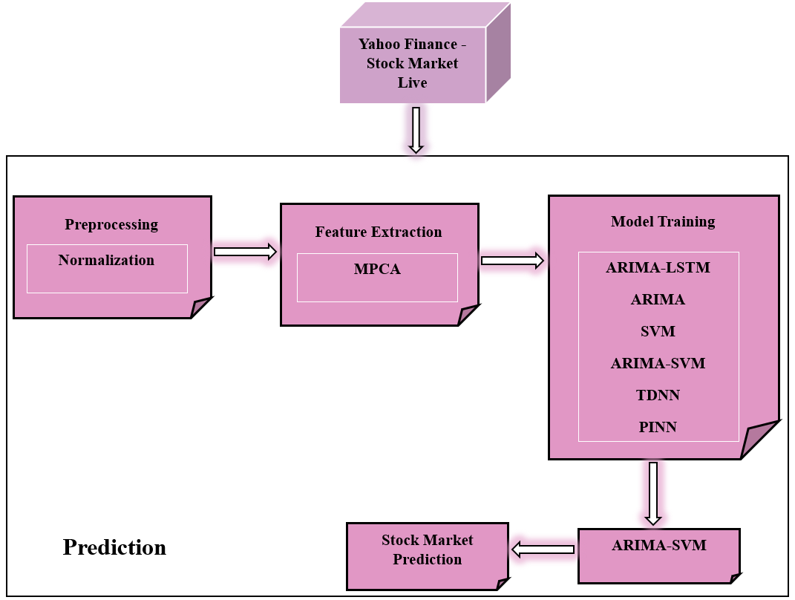
Predicting stock prices is the focus of this research. The model takes in data from Yahoo Finance - Stock Market Live and decides whether to purchase or sell in order to maximise profit. Figure 1 shows the architecture[26].

Dataset Description
They can access stock market index and company historical data from Yahoo! Finance and Google Finance. This historical data can be downloaded into Yahoo Finance between any two dates. Training and testing our technique on the publicly available stock exchange dataset from Yahoo Finance - Stock Market Live allowed us to evaluate our suggested system[27]. Various stock exchanges' repositories are housed on the site, including the New York Stock Exchange, Karachi Stock Exchange, and London Stock Exchange. Additionally, our suggested approach has been tested using stock market data from numerous highly regarded technological companies, including Apple, Google, and Microsoft. This Big Data set provides weekly stock market movements for the period from July 10, 1998, to July 10, 2018. We have utilised the identical dates to download the dataset for each stock market since we also want to analyse the effect of the dependency between them. As seen in Table 1, the Yahoo Finance dataset has the following attributes[28].
Table 1

Attributes of Yahoo Finance dataset.
Feature | Description
Data | Date that corresponds to stock value.
Open | A stock's opening price on a given day.
High | Stock value at its peak for a single trading day.
Low | The share price that has fallen to its lowest point on a specific day.
Close | Includes the stock's worth as of a specific day's close.
Volume | The total value of shares purchased or sold on a specific day.
Adjusting Close | The stock's final price after dividend payments to shareholders.

Preprocessing and Normalization
Data cleansing frequently include normalisation as a method for getting data ready for DL. Scaling all attributes consistently is the main objective of normalisation. This facilitates discussions regarding the model's effectiveness and training stability. Normalisation is required if there is a discrepancy between the feature ranges[29]. Among the many methods for rescaling, or normalisation, are the following:
- Min-Max Normalization: This method uses the following equation $(1)$ to scale a feature such that it falls inside a predetermined range, often from 0 to 1:
$$v^{'}=\frac{v-min⁡(v)}{\max\left(v\right)-min⁡(v)} (1)$$
where the initial value is represented by $v$ and the minimum and highest values found in the dataset are $min⁡(v)$ and $\max\left(v\right)$, respectively.
- Mean Normalization: Equation ($2)$provides the formula for this technique, which normalizes the data according to the mean:
$$v^{'}=\frac{v-average⁡(v)}{\max\left(v\right)-min⁡(v)} (2)$$
where the dataset's mean is utilised $average⁡(v)$.
- Z-score Normalization: DL algorithms frequently employ this method, which is also called standardisation, and it employs the Z-score or standard score. Here is the equation $(3)$ to compute it:
$$y=\frac{v-ρ}{τ} (3)$$
where $τ$ represents the dataset's standard deviation and $ρ$ represents its mean.
Because the volume and turnover variables in this study can vary greatly and are quite volatile, it employs Min-Max normalisation to scale all attributes from 0 to 1.

Feature Extraction

MPCA
Multivariate principal component analysis (MPCA) is a statistical tool for desaturating complicated multivariate datasets while preserving variability to a large extent so far as the dataset will allow[30]. It does this by identifying the most salient patterns and fluctuations in the data and then extracting a smaller set of orthogonal vectors called principal components.
Let $V={\left(v_{1},v_{2},v_{3},…,v_{p}\right)}^{R}$be established. Assuming the second instant exists, let $ρ=G\left(V\right)Σ=var(V)$for the a-dimensional random variable. Then, as stated in Equation $(4)$, the following linear function exists:
$$\left\{\begin{aligned}z_{1}=c_{11}v_{1}+c_{21}v_{2}+c_{31}v_{3}+…+c_{p}v_{p}=C_{1}^{R}V \\ z_{2}=c_{12}v_{1}+c_{2222}v_{2}+c_{32}v_{3}+…+c_{p2}v_{p}=C_{2}^{R}V \\ ⋮ \\ z_{p}=c_{1p}v_{1}p+c_{2p}c_{2}+…+c_{pp}v_{p}=C_{p}^{R}V\end{aligned}\right. (4)$$
It gets Equations $(5)$ and $(6)$ by applying a linear transformation:
$$var\left(z_{k}\right)=C_{k}^{R}ΣC_{k}, k=1,2,…,p (5)$$
$$con\left(z_{k},z_{l}\right)=C_{k}^{R}ΣC_{l}, k,l=1,2,…,p (6)$$
In general, a larger value for $var(z)$ indicates that the variable reflects more information. Find $C_{1}$ such that $var(z_{1})$ is maximised, where $z_{1}$is the first main component variable, given that $\left\|C_{1}\right\|=1$. They go on to the second principal component variable if the first one doesn't have enough data. It is necessary for each successive principle component to have $con\left(z_{1},z_{2}\right)=0$in order to guarantee that the principal components are uncorrelated.
The fundamental principle of MPCA is to identify a linear transformation that maps the original multi-dimensional data to a space with a lower dimension. This space with lower dimensions is made up of several PC that capture the primary variability in the data. Here is the population sample data matrix, as illustrated in Equation $(7)$:
$$V=\left[\begin{matrix}v_{11} & v_{21} & … & v_{1n} \\ v_{12} & v_{22} & … & v_{2p} \\ ⋮ & ⋮ & ⋱ & ⋮ \\ v_{1p} & v_{2p} & ⋯ & v_{pn}\end{matrix}\right]=\left[V_{1}{,V}_{2}^{R},…,V_{p}^{R}\right] (7)$$
Equations $(8)$ and $(9)$ contain the matrices for the sample correlation and sample covariance, respectively:
$$Q=\frac{1}{\left(p-1\right)}\sum_{k=1}^{p}{\left(v_{i}-\overline{v}\right)}{\left(v_{i}-\overline{v}\right)}^{R}={\left(q_{kl}\right)}_{n×n} (8)$$
$$T={\left(t\right)}_{n×n}={\left(\frac{Q_{kk}}{\sqrt{Q_{kk}}∙\sqrt{Q_{ll}}}\right)}_{n×n} (9)$$
Where $\overline{v}=\frac{1}{p}\sum_{k=1}^{p}{V_{k}}$. To implement MPCA, one must first determine the eigenvalues eigenvectors of the centred data's covariance matrix $Q$, and then use these eigenvalues to choose the PC.
For modelling jobs, MPCA's capacity to simplify and compress complex data while preserving useful information was a deciding factor. When working with datasets that include correlated variables or investigating correlations across various dimensions, this technique shines.
With the sequential stages required in modifying and extracting PC from the original dataset highlighted in Figure 2, the workflow for applying MPCA to data is shown.
Figure 2
Multivariate Principal Component Analysis (MPCA) Workflow.
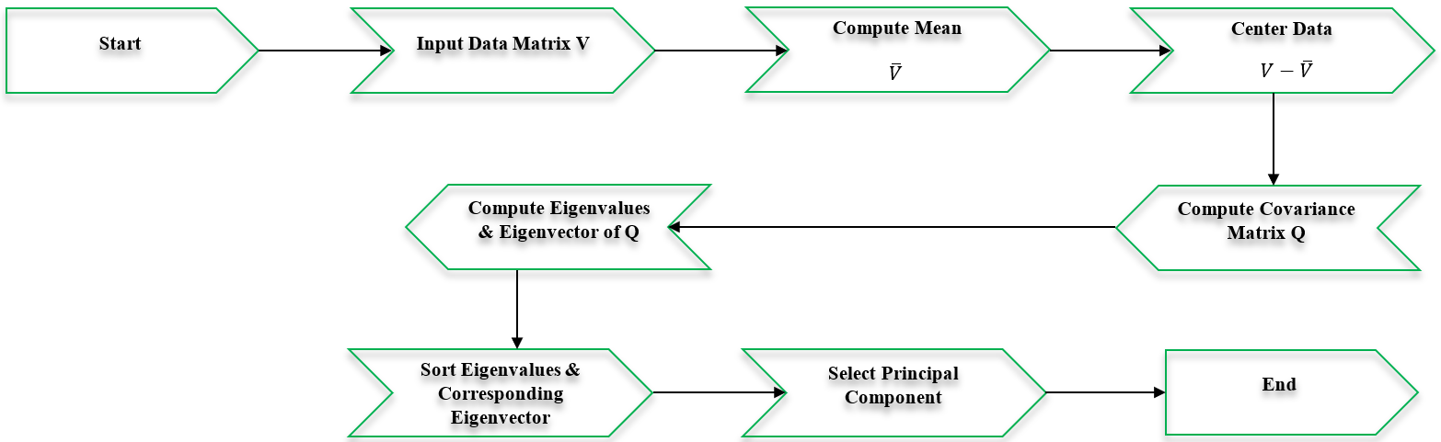
By simplifying multidimensional data and identifying important features, MPCA improves model interpretability and prediction performance, making it a useful tool for stock market data analysis. Using MPCA, we may reduce complex stock data to their essential components, which allows us to better understand the patterns and fluctuations that drive stock price movements. This method is useful in financial analytics since it streamlines the modelling process and makes better predictions of market patterns and volatility.

Hybrid TL and BLS

The Model ARIMA
When it comes to Prediction, the ARIMA model is among the most well-known options. As shown in Equation $(10)$, an ARIMA model assumes that a variable's future value is a linear mixture of its previous values and its past errors.
$$z_{r}=θ_{0}+φ_{1}z_{r-1}+φ_{2}z_{r-2}+…+φ_{n}z_{r-n}$$
$$+ε_{r}-θ_{1}ε_{r-1}-θ_{2}ε_{r-2}-…-θ_{s}ε_{r-s} (10)$$
When the real value is represented by $z_{r}$ and the random error at time $r$ is denoted by $ε_{r}$; the coefficients are $φ_{k}$ and $θ_{l}$, and the integers $n$ and $s$, which are commonly called autoregressive and moving average polynomials, respectively, are used[31]. Parameter estimation, model identification, and diagnostic checking are the three main aspects of this procedure. To illustrate, the following is one way to depict the ARIMA (1,0,1) model in Equation $(11)$.
$$z_{r}=θ_{0}+φ_{1}z_{r-1}+ε_{r}-θ_{1}ε_{r}-1 (11)$$
A technique to data analysis that takes cues from the structure of the data itself is the ARIMA model. Nevertheless, the ARIA is constrained by any substantial nonlinear data collection. Consequently, SVMs were employed by the suggested hybrid model to handle the nonlinear data pattern.

SVM
Vapnik was the one who first suggested using support vector machines, or SVMs. Instead than focussing on the empirical error, SVMs, which are based on the structural risk minimisation (SRM) concept, aim to minimise an upper bound of the generalisation error. The SVM models also use a series of high-dimensional linear functions to create the regression function. Here is Equation 12, which forms the basis of the SVM regression function.
$$z=uφ\left(v\right)+d (12)$$
When the input space $v$ is used as the feature $φ\left(v\right)$ and is mapped in a nonlinear fashion. By minimising the expressions in Equations 13 and 14, they can approximate the values of $u$ and $d$.
$$T\left(A\right)=D\frac{1}{P}\sum_{k=1}^{P}{J_{ε}(b_{k},z_{k})}+\frac{1}{2}{\left\|u\right\|}^{2} (13)$$
$$J_{ε}\left(b,z\right)=\left\{\begin{aligned}\left|b-z\right|-ε \left|b-z\right|≥ε, \\ 0 others\end{aligned}\right. (14)$$
where $ε$ and $A$ are parameters that are given to you. The $ε$-intensive loss function is the first term derived from the equation $J_{ε}(b,z)$. The real stock price during the $k^{th}$ time is denoted by $b_{k}$. This function signifies that the faults below are not subject to penalties. The expression $D(1/{P)}\sum_{l=1}^{P}{J_{ε}}\left(b_{k},z_{k}\right)$represents the empirical error. The second term, $\frac{1}{2}{\left\|u\right\|}^{2}$ quantifies the flatness of the function. $A$ evaluates the compromise between model flatness and empirical risk. To begin, there are the positive slack variables zeta $ζ$and zeta $ζ^{*}$, which stand for the distance between the actual values and their respective $ε$-tube boundary values. The following Equation 15 is limited form is obtained by transforming Equation 13:
Minimize
$$T\left(u,ζ,ζ^{*}\right)=\frac{1}{2}uu^{R}+A^{*}\left(\sum_{j=1}^{P}{(ζ_{k}+ζ_{k}^{*})}\right) (15)$$
Equation $(16)$ takes on the following form after the introduction of Lagrangian multipliers and maximisation of the dual function of Equation $(15)$:
$$T\left(β_{k}-β_{k}^{*}\right)=\sum_{j=1}^{P}{b_{k}\left(β_{k}+β_{k}^{*}\right)}-ε\sum_{j=1}^{P}{\left(β_{k}+β_{k}^{*}\right)}$$
$$-\frac{1}{2}\sum_{j=1}^{P}{\sum_{j=1}^{P}{\left(β_{k}+β_{k}^{*}\right)}}×\left(β_{k}+β_{k}^{*}\right)I\left(v_{k}-v_{l}\right) (16)$$
What are known as Lagrangian multipliers in Equation are $β_{k} and β_{k}^{*}$.
The equality in Equation $(17)$ is satisfied by them.
$$β_{k}*β_{k}^{*}=0,$$
$$h\left(v,β,β^{*}\right)=\sum_{k=1}^{j}{\left(β_{k}+β_{k}^{*}\right)I}\left(v,v_{k}\right)+d (17)$$
$I\left(v,v_{k}\right)$ is referred to as the kernel function. The kernel value is equivalent to the inner product of two vectors $v_{k} and v_{l}$ and their corresponding feature space representations $φ(v_{k})$ and $φ(v_{l})$, so that $I\left(v_{k},v_{l}\right)=φ\left(v_{k}\right)*φ\left(v_{l}\right)$. Any function that satisfies Mercer's theorem can be utilised as a kernel function. The Gaussian kernel function, as expressed in Equation $(18)$.
$$I\left(v_{k},v_{l}\right)=exp⁡(-{\left\|v_{k}-v_{l}\right\|}^{2}/(2τ^{2})) (18)$$
This study specifies. SVM were utilised to assess the nonlinear characteristics of the forecasting dataset, as Gaussian kernels typically exhibit superior performance under general smoothness assumptions.

Hybrid Methodology
The behaviour of stock prices is not easily quantifiable. A hybrid technique incorporating both linear and nonlinear modelling capabilities is an effective alternative for forecasting stock values. The suggested hybrid model in this work combines the strengths of the ARIMA and SVMs models because of their respective strengths in capturing data features in both nonlinear and linear domains. The ARIMA and SVM components make up the study. As a result, the hybrid model has better overall forecasting performance and can represent both linear and nonlinear patterns. After that, the following is one way to express the hybrid model $Z_{r}$ is shown in equation $(19)$.
$$Y_{r}=Z_{r}+P_{r} (19)$$
whereby the nonlinear component of the hybrid model is denoted as $P_{r}$ and the linear component is $Z_{r}$. The data set is used to estimate both $Z_{r}$ and $P_{r}$. The ARIMA model's forecast value at time $r$ is denoted by ${\tilde{Z}}_{r}$. Assume that the ARIMA model yielded the residual at time $r$ as $ε_{r}$shown in Equation $(20)$.
$$ε_{r}=Y_{r}-{\tilde{Z}}_{r} (20)$$
The SVM simulate the residuals, which can be represented by Equation $(21)$.
$$ε_{r}=h\left(ε_{r-1},ε_{r-2},…,ε_{r-p}\right)+∆_{r} (21)$$
where the random error is represented by $∆_{r}$ and $h$ is a nonlinear function that is modelled by the SVMs. Thus, equation $(22)$ displays the combined forecast.
$${\tilde{Y}}_{r}={\tilde{Z}}_{r}+{\tilde{P}}_{r} (22)$$
The predicted value of equation $(21)$, denoted as ${\tilde{P}}_{r}$, is crucial.
Figure 3 shows the flow diagram of the multistep-ahead ARIMA-SVM modelling framework that has been suggested[32].
Figure 3
The Flowchart of Proposed ARIMA-SVMs Modeling Framework
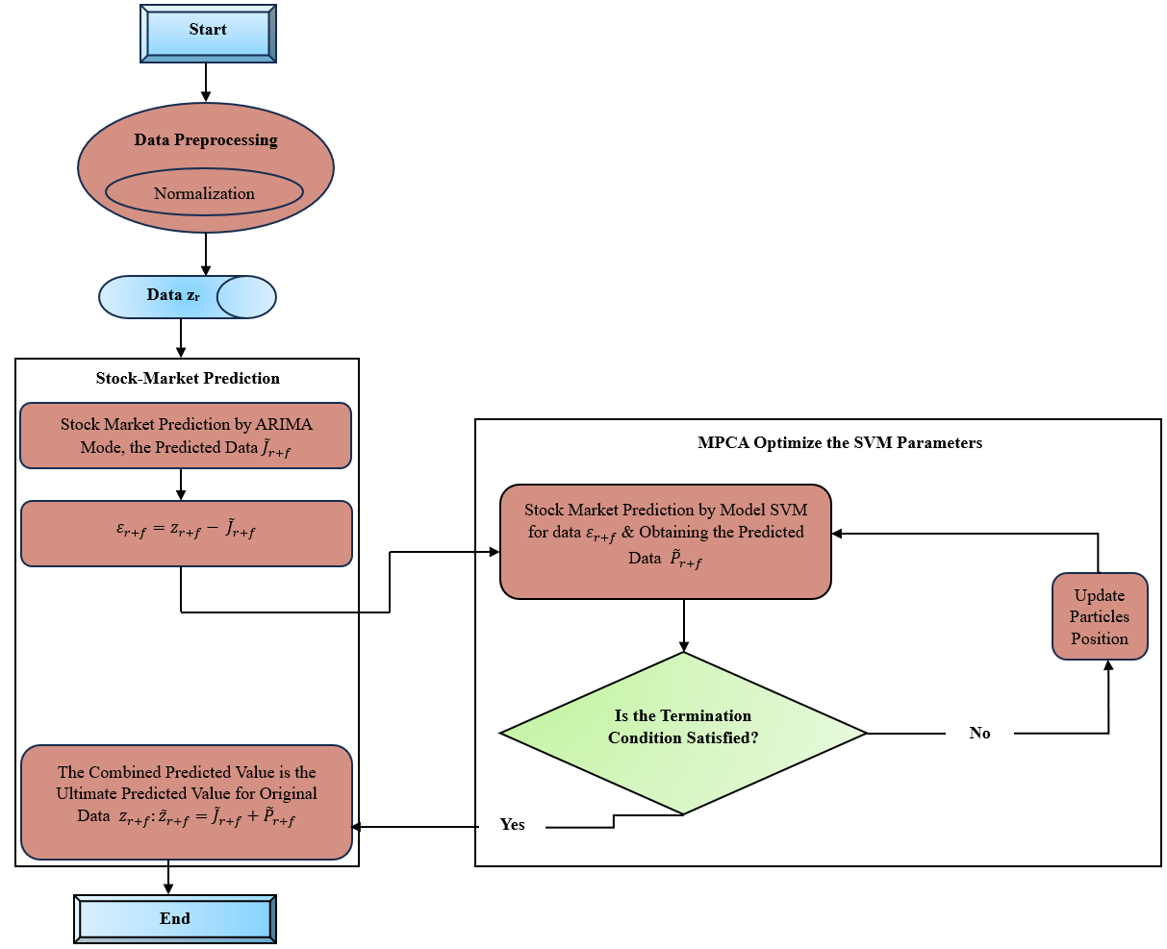
Figure 3 shows the three components of the suggested modelling framework: data preprocessing, Stock Market prediction, and the PSO module for optimising SVM parameters. The Stock Market Prediction model based on ARIMA-SVM is used once the data has been normalised in the data pretreatment method. Additionally, the parameter optimisation technique MPCA is used to optimise the SVM's parameters in the nonlinear Predicting section.

RESULT AND DISCUSSION
Intelligent systems can now be used for pattern identification and classification tasks, thanks to the everyday availability of big data collected from various sources. Every day, a plethora of sources provide the stock market with vast amounts of data. Due to its many advantages, the stock market is occasionally considered a leading indicator of a country's economic strength and progress. As a result, the stock market is a crucial topic of study for anyone working in finance. The profit associated with accurate prediction has led to a rise in study in this sector, despite market trend prediction being considered as a complicated and tough task.
Table 2

Test for Stationarity of Stock Data using Augmented Dickey–Fuller (ADF)
Company/Stock Market | P-Value of Stock Data | P-Value of First Difference of Stock Data
MSFT | 96.5 | 0.01
APPLE | 96.1 | 0.01
LSE | 96.5 | 0.01
NASDAQ | 96.5 | 0.01
GOOGLE | 96.5 | 0.01
KSE | 96.5 | 0.01
NYSE | 06.5 | 0.01

All of the stock market data were examined for stationarity using the ADF test, which was successful in rejecting the null hypothesis of non-stationarity. The data was determined to be stationary at the first difference level. Table 2 displays the p-values for the first difference and the unit root of the stock market data. The null hypothesis was rejected since the significance value p was less than 5% at the first difference level, according to the ADF test. After then, additional processing was done using the stock market data.
Figure 4
Confusion Matrix
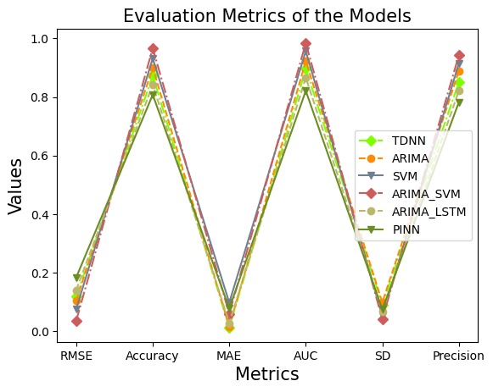
Multiple prediction models are compared in the first subplot using common performance metrics such as RMSE, Precision, Accuracy, MAE, AUC, and Standard Deviation (SD). The ARIMA-SVM hybrid model routinely outperforms all of the other methods that were considered. Its top performance in Accuracy, AUC, and Precision is accompanied by decreased RMSE, MAE, and SD, suggesting a decrease in prediction error and an improvement in stability in Figure 4. This exemplifies how integrating ARIMA's statistical time-series forecasting with SVM's strong nonlinear classification capabilities yields superior stock market forecasts.
Table 3

Statistical Analysis

Metric | TDNN | ARIMA | SVM | ARIMA-SVM | ARIMA-LSTM | PINN
Accuracy | 0.873 | 0.901 | 0.932 | 0.966 | 0.842 | 0.808
AUC | 0.896 | 0.922 | 0.957 | 0.984 | 0.866 | 0.821
Precision | 0.850 | 0.888 | 0.914 | 0.942 | 0.821 | 0.782
RMSE | 0.118 | 0.105 | 0.076 | 0.036 | 0.141 | 0.184
MAE | 0.0127 | 0.0161 | 0.098 | 0.06 | 0.028 | 0.078
SD | 0.0914 | 0.0987 | 0.0526 | 0.0421 | 0.0678 | 0.0748

When it comes to GSE in stock prediction, Table 3 displays comparable findings of RMSE, MAE, and AUC for TDNN, ARIMA, SVM, ARIMA-SVM, ARIMA-LSTM, and PINN. Table 3 shows that when compared to benchmarked models, ARIMA-SVM had better RMSE and MAE performances. Once again, when comparing the models in Table 6, the ARIMA-SVM achieved the best AUC compared to its competitors. This result demonstrates that a randomly selected positive observation in our dataset would be ranked higher by the ARIMA-SVM than a randomly selected negative representation in the same dataset.
Figure 5
Different Model Average Learning Curve
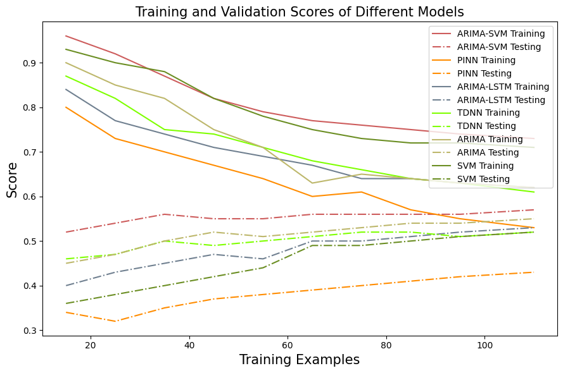
Figure 5 shows how various models' training and testing performance tend to change with increasing training example numbers. By keeping the training and testing curves tightly matched, the ARIMA-SVM hybrid model minimises overfitting and has good generalisation capacity. Testing results show that the hybrid model learns both linear patterns of time and nonlinear dynamics of the market, and this is confirmed as the dataset size increases. A balanced trade-off between bias and variance is maintained by the ARIMA-SVM model, in contrast to standalone models like ARIMA, SVM, TDNN, PINN, and ARIMA-LSTM.
Table 4

Computational Training and Testing Time

Metric | Training Time | Testing Time
TDNN | 11.26 | 3.12
ARIMA | 8.64 | 1.71
SVM | 5.21 | 0.85
ARIMA-SVM | 2.87 | 0.56
ARIMA-LSTM | 15.34 | 8.62
PINN | 22.48 | 12.28

The suggested model ARIMA-SVM's computational time compared to TDNN, ARIMA, SVM, ARIMA-LSTM, and PINN is displayed in Table 4. In conclusion, as shown in Table 4, the ARIMA-SVM achieved the fastest training (2.87 s) and validation (0.56 s) times, while the SVM came in second with training taking 5.21 s and validation taking 0.85 s. However, when comparing training and validation times, the PINN method comes out on top with values of 22.48 and 12.28 seconds, respectively.
Figure 6
Testing Time Comparison
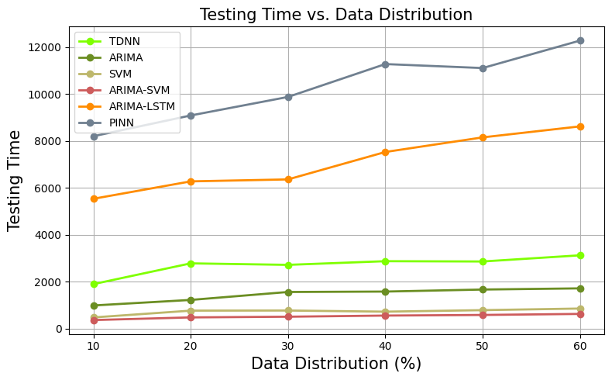
By changing the data distribution in years and recording the corresponding computing time for training and testing, the suggested method is tested for robustness. Predictions based on regression analysis of data distributed as a percentage were part of the test. In a similar vein, Figure 6 displays the testing results for various models. The results are displayed in relation to the data's rising distribution order. Among the algorithms tested, ARIMA-SVM demonstrated significantly improved performance in terms of computing time compared to ARIMA, SVM, TDNN, PINN, and ARIMA-LSTM.
Figure 7
TPR and FPR Comparison

The models' True Positive Rates (TPRs) and False Positive Rates (FPRs) are displayed in Figure 7. True positives were predicted more accurately by ARIMA-SVM, ARIA, and SVM than by PINN, TDNN, and ARIMA-LSTM, according to the results. The values indicate that the proposed ARIMA-SVM model for predicting stock price movement.
Figure 8
AUC Comparison

Figure 8 shows the results of comparing various stock market prediction models' Area Under the Curve (AUC) values, which show how well they can distinguish between trends and classify data. Out of all the models that were tested, the ARIMA-SVM hybrid model has the best area under the curve (AUC), which means it can differentiate between lucrative and non-profitable market movements better than the others. The synergy between ARIMA's linear time-series forecasting power and SVM's nonlinear decision bounds has been shown beneficial. The image shows that the best model for predicting the stock market and increasing profits is the Hybrid Deep Learning-Statistical ARIMA-SVM model, which delivers the most accurate and robust results. Enhanced confidence for real-world financial forecasting applications, reduced misclassification risk, and increased decision-making reliability are all signs of a higher AUC.

CONCLUSION
Academics and businesses alike have taken an interest in stock market prediction. The stock market is so complicated that how much of it can be forecast is still a mystery. The Efficient Market Hypothesis (EMH) laid the groundwork for the early works addressing this issue; according to this theory, stock market prices accurately reflect all relevant information. Quantitative data and qualitative representations of financial status are the two main types of stock-related information. Investment decisions are derived from publicly available quantitative data through quantitative analysis. In contrast, qualitative analysis focusses on the company's management, products, and strategy as a whole in an effort to draw conclusions about the company's performance. As part of data cleansing, normalisation is a typical method for getting data ready for ML. The MPCA Feature Extraction method is used to extract the features. Based on previous research showing that several forecasting models can enhance each other's ability to approximate data sets, this study developed a hybrid model combining ARIMA and SVMs. According to experts, the given model significantly outperforms the single ARIMA model and the single SVMs model when it comes to predicting stock values. Theoretically and experimentally, combining two different models yields better predictions. Comparing the dataset it reveals an impressive 0.966% prediction accuracy, 0.984% AUC, and 0.942% Precision.

