**RAZZMATAZZ AND RẸ̀GBẸRẸ̀GBẸ: FAROOQ OREAGBA’S *STEEZE* AS A BRIDGE BETWEEN TRADITION AND INNOVATION AT OJUDE OBA 2024**

Michael Olamide OKEKUNLE, Yvonne Ikpemhinoghena EWEDEMI,

Babatunde Olanrewaju ADEBUA.

Department of Languages and Literary Studies,

Babcock University,

Ilishan-Remo, Ogun State.

Email: okekunle0805@pg.babcock.edu.ng,

ewedemi7011@pg.babcock.edu.ng, adebuab@babcock.edu.ng.

***Abstract***

*This study explores the interplay of razzmatazz and rẹ̀gbẹrẹ̀gbẹ; the Ijebu age grade system, at the 2024 Ojude Oba Festival in Ijebu-Ode, Nigeria, with a focus on Farooq Oreagba’s sartorial performance. Drawing on Homi K. Bhabha’s hybridity and Judith Butler’s performativity theories, the research examines how Oreagba’s lemon-green aso-oke agbada, adorned with coral beads, tattoos, and modern accessories, negotiates Yoruba heritage and global modernity. Through qualitative analysis, findings reveal that Oreagba’s ensemble and horseback display embody Ijebu resilience and pluralism, amplified by social media’s global reach. The festival’s multisensory elements; colors, music, and dance alongside the rẹ̀gbẹrẹ̀gbẹ system, highlight a dynamic balance of tradition and innovation. The study accentuates how individual agency, shaped by cultural and personal narratives, redefines Ijebu identity, advocating for inclusive platforms that celebrate evolving heritage.*

***Keywords:*** *Costumes and accessories, Cultural hybridity, Farooq Oreagba, Ijebu age-grade system, Multi-sensory elements, Ojude Oba Festival, , Performance aesthetics.*

**Introduction**

The Ojude Oba Festival, a vibrant homage to the Awujale, the paramount ruler of Ijebuland, has transcended its roots to become a global beacon of Yoruba culture, drawing tourists, diaspora communities, fashion aficionados, and cultural scholars to Ijebu-Ode’s sunlit streets. Held annually on the third day after Eid al-Adha the 2024 edition pulsed with an unprecedented energy, amplified by social media’s reach and Nigeria’s burgeoning creative renaissance. In the bustling heart of Ijebu-Ode, Ogun State, Nigeria, the 2024 Ojude Oba Festival erupted as a radiant mosaic of Yoruba heritage, interlacing vibrant traditions, bold fashion, and unyielding communal pride.

While spectators marvelled at the rhythms, colours and ancestral echoes of the festival, a figure majestically rode into the spotlight. It was none other than Farooq Oreagba, a cancer survivor and business magnate whose braggadocios style earned him the social media title: *King of Steeze*. Galloping on horseback, draped in a luminous lemon-green *aso-oke agbada* adorned with coral beads and a gold cross body chain, Oreagba was more than a sartorial spectacle; he was a living emblem of *razzmatazz* an extravagant yet purposeful celebration of life and legacy. His presence, accentuated by tattoos and a tobacco pipe, wove a narrative of resilience and reinvention, capturing the festival’s essence as a stage for both honoring the past and embracing the future. The agbada he donned was a beautiful interplay of traditional Yoruba weaves and modern accents such as his Apple smartwatch and dark-coloured sunglasses. All of these sparked an uproar and led to the viral hashtags of #OjudeOba2024 and #KingOfSteeze that trended across social media platforms like X. Beyond the glamour, his participation underscored Ijebu’s ethos of unity and resilience, where every bead, rhythm, and step tells a story of a people fiercely proud of their heritage yet unafraid to evolve (Adeboye 47-48).

It must be noted that this article is an examination of how Oreagba’s clothing choice at the Ojude Oba Festival of 2024 fuses contemporary charisma, individual triumph, and cultural reverence against the backdrop of the aesthetical and historical landscape of the much celebrated festival. Through his lens, this research unravels the origins of this iconic celebration, its multisensory grandeur, and the dynamic interplay of tradition and individuality that shapes Ijebu identity.

**Origin and Purpose of the Ojude Oba Festival**

With its meaning being “The King’s Forecourt”, the Ojude Oba Festival is a celebration that has gone on for centuries and held yearly in Ijebu-Ode on the third day after the Ileya celebration. Its origins trace back to the late 19th century, evolving from a gesture of gratitude by Muslim converts to the Awujale, the paramount ruler of Ijebuland, for granting them religious freedom. Historical accounts credit Balogun Kuku, a prominent Ijebu figure who embraced Islam, with formalizing the festival around 1896 as a way to honour the Awujale’s tolerance (Oke 10 ). Initially a modest gathering, it replaced the earlier Odeda Festival, where traditional Yoruba worshippers of deities like Sango and Osun performed for the king. In no time the festival transformed into a pan-Yoruba celebration that aimed to unite indigenes of Ijebu and their diaspora in a joyful display of cultural pride and loyalty (Oke 11).

The overwhelming purpose of this festival is one that transcends paying homage to the Awujale and serves as a platform for both economic vitality and cohesion of social activities. It is a highly recognized festival known to capture the attention of over one million attendees, thus, capable of boosting local commerce and tourism with upcoming plans to secure recognition from UNESCO (Musa-Musawa). The *rẹ̀gbẹrẹ̀gbẹ* (age-grade groups) are central, fostering community development through collective initiatives, a practice reinvigorated by Awujale Oba Adetona in the 18th century Ojude Oba festival. Today, Ojude Oba is a celebration of Ijebu identity, where tradition meets modernity, and every participant, from horse riders to dancers contributes to a shared narrative of resilience and splendour (Ademuleya 54).

Rooted deep within the historical tale of the Ijebu locals, the Ojude Oba festival has for a long time, being the visual archive of both Yoruba identity and aesthetics. Traditionally, clothing at the festival functioned as both an expression of status and a marker of historical continuity. Ogundiran (112) posits that precolonial Yoruba dressing emphasized locally woven textiles such as *aso-oke*, *sanyan*, and *etu*, often dyed with indigenous materials like indigo or camwood, symbolizing affluence and social rank. However, with the onset of colonial rule and subsequent modernization, Yoruba elites incorporated European tailoring techniques into their *agbada* and *dansiki*, blending traditional cuts with Western-influenced precision. This hybridization of styles continued into the postcolonial era, as imported fabrics like lace and brocade became status symbols among the Yoruba elite (Adeyemi 98).

**Colors, Costumes, Spectacles, Music, Songs, and Dance**

Ojude Oba, an annual festival celebrated by the Ijebu people of southwestern Nigeria, is not just a display of cultural heritage but also a major fashion spectacle. Over decades, the festival has evolved into a significant platform for showcasing Yoruba sartorial elegance, blending tradition with modernity.

Historically, the festival has been a venue for regal, elaborate attire, with attendees especially Yoruba elites making bold fashion statements. In earlier decades, the dominant styles were heavily influenced by traditional textiles such as *aso-oke*, *damask*, and *adire*, often handwoven and richly embroidered. Men traditionally wore *agbada* or *buba* and *sokoto*, complemented by *fila* (caps), while women adorned *iro* and *buba*, accessorized with *gele* (headgear) and coral beads. The color coordination of family groups, known as *aso ebi*, became a central feature, reinforcing cultural identity and social cohesion (Adebayo 48).

By the late 20th century, Western influences started shaping the aesthetics of Yoruba fashion at Ojude Oba. Velvet caps, lace fabrics, and gold-thread embroidery became status symbols, reflecting affluence and global exposure. The festival became a space for social competition, where attendees sought to outshine one another with their intricate ensembles, a trend that continues today. Ojude Oba is a sensory feast where colours burst forth like a painter’s palette unleashed. The streets of Ijebu-Ode shimmer with vibrant hues; crimson, emerald, gold, and sapphire as attendees don intricately woven aso-oke, adire, and lace. These fabrics, often handcrafted, reflect Yoruba artistry, with families and *rẹ̀gbẹrẹ̀gbẹ* coordinating outfits to outshine one another in friendly rivalry. The 2024 edition was no exception, as social media platforms went ablaze with images of cascading headgear, beaded accessories, and flowing agbadas, thus, turning the festival into a living runway (Adeyemi 25).

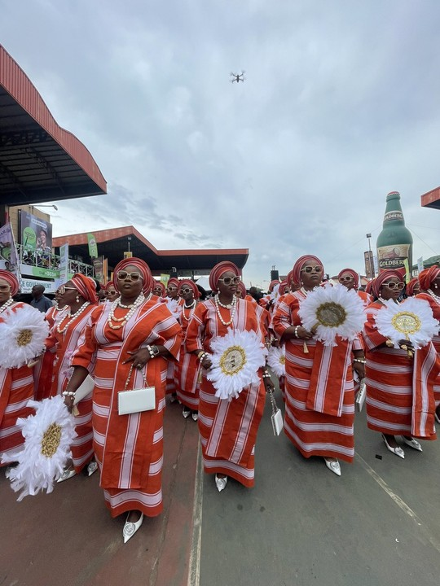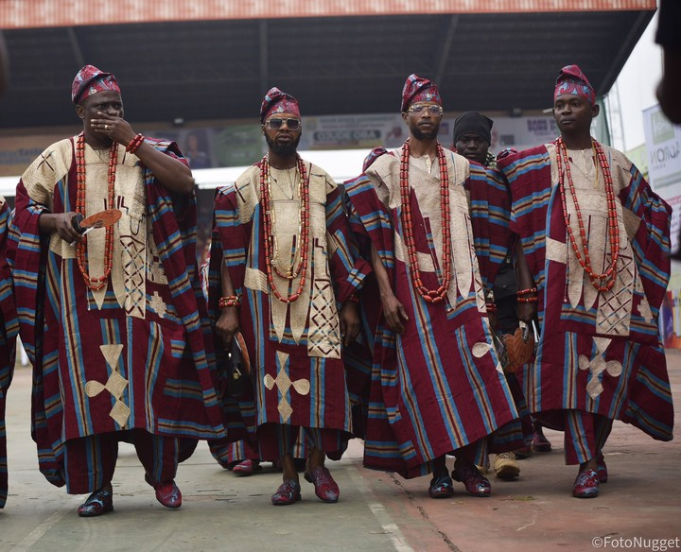

Costumes are more than adornment; they are storytellers. Men’s *agbadas*, with their voluminous folds, signify wealth and status, while women’s *gele* (headwraps) soar skyward, embodying elegance. Horse riders, or *Baloguns*, like Oreagba, elevate the spectacle, their mounts draped in beadwork and bright fabrics, symbolizing the warrior heritage of Ijebu’s past. The equestrian displays, marked by synchronized gallops and stunts, draw gasps from crowds, blending bravery with artistry.

Music and dance pulse through the festival, binding participants in rhythm. Drummers wield *gangan* and *bata*, their beats summoning ancestral spirits and urging dancers forward. Songs, often in Yoruba, praise the Awujale, recounting Ijebu history, or teasing rival groups, hence, fostering camaraderie. Dance troupes, from young girls swaying in synchronized steps to elders performing stately moves, embody continuity across generations. The 2024 festival featured modern twists, with Afro beats and hip-hop blending seamlessly with traditional sounds, reflecting the festival’s ability to evolve while honouring its roots (Daily Trust).

Spectacles abound from the Awujale’s royal parade to impromptu street performances. Fireworks, though rare, punctuate the night, while food stalls offer jollof rice, pounded yam, and suya, grounding the celebration in shared sustenance. Ojude Oba is a multisensory ode to Ijebu pride, where every sight, sound, and taste reinforces communal bonds.

Scholarship on African festivals highlights the role of dress as a performative medium for cultural identity. For Eicher and Sumberg (312), the context of clothing in African ceremonies is a vehicle for the continuity of history, affiliation of ethnicities, language visualization and the communication of social status. The Ojude Oba Festival, in particular, has been examined as a site where Yoruba identity is reaffirmed through elaborate attire (Adeboye 48).

Recent studies have expanded this discourse by analyzing the influence of social media in amplifying traditional festivals. Ogunleye (201) argues that platforms like Instagram and Twitter have transformed local events into global spectacles, where fashion influencers like Oreagba shape perceptions of African aesthetics. This also goes in line with Rabine’s (92) global spread of African fashion concept wherein local styles earn recognition internationally via digital dissemination.

**Biography of Farooq Oreagba**

He was born in July 1966 in Ijebu-Ode, and had clocked 58 years at the time of the 2024 festival. He is a seasoned participant carrying a family legacy of horse riding that dates back to his grandfather in the 1960s (Oreagba). Educated at Ijebu-Ode Grammar School, King’s College Lagos, and prestigious institutions like Oxford and Coventry University, Oreagba built a formidable career in finance, spanning London, Amsterdam, and South Africa. As Managing Director of NG Clearing Limited, he has driven innovations in Nigeria’s financial markets since 2023 (ThisDay).

In 2014, Oreagba faced a life-altering diagnosis of bone marrow and skin cancer, undergoing chemotherapy and a bone marrow transplant. Declared cancer-free after years of treatment, he emerged with a renewed zest for life, counselling other patients and embracing each moment (Oreagba). As a father of three sons, his personal journey mirrors the festival’s themes of endurance and celebration. His tattoos, acquired post-50, symbolize his survival, with inscriptions like “Only God can judge me” reflecting his defiance of convention (Arise News).

**Farooq Oreagba’s Costume and Dressings**

Farooq Oreagba’s appearance at the 2024 Ojude Oba Festival was a masterclass in cultural alchemy. Clad in a lemon-green *aso-oke agbada*, he rode a decorated horse, exuding regal confidence. His outfit was a symphony of tradition and modernity: the *agbada’s* rich weave paid homage to Yoruba craftsmanship, while red coral beads and a gold cross body chain added opulence. Dark sunglasses, a tobacco pipe, and an Apple wristwatch introduced a contemporary edge, but it was his sleeve-length tattoos; rare in traditional settings that sparked conversation. One tattoo, reading “Carpe Diem,” encapsulated his philosophy of seizing each day, a testament to his cancer survival (Oreagba).

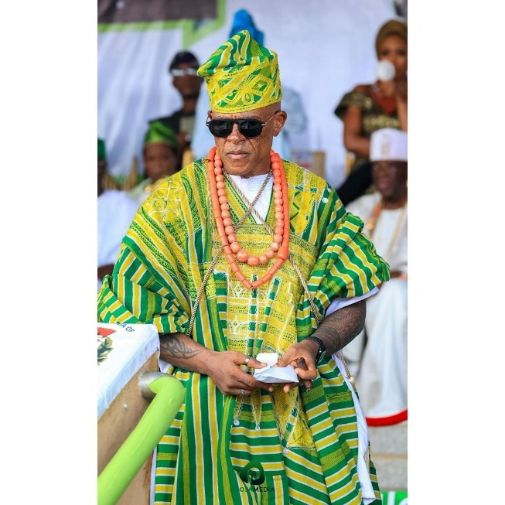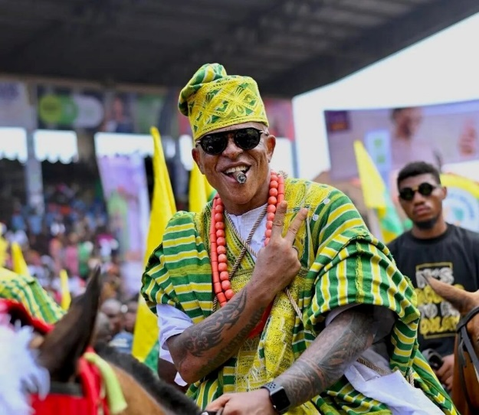

Oreagba’s *“steeze”* was deliberate, blending Ijebu heritage with global influences. His choice of vibrant colours; green symbolizing prosperity, lemon evoked joy, aligned with the festival’s exuberance. Yet his accessories, like the cigar and smartwatch, signalled a cosmopolitan identity. Social media erupted with praise, dubbing him the festival’s face, as his images went viral, capturing the imagination of Nigerians and beyond. His costume was not just attire but a narrative of resilience, individuality, and cultural pride, redefining what it means to honour tradition in the 21st century.

**Several Age Groups and Farooq’s Age Group**

The rẹ̀gbẹrẹ̀gbẹ system is the backbone of Ojude Oba. It entails grouping participants by age to promote mentorship and community projects (Ogunnaike 23). These groups, ranging from youth to elders, parade before the Awujale, each showcasing distinct styles and contributions. Younger groups, like those in their 20s, often incorporate trendy accessories, while older groups, in their 60s and beyond, favor stately attire, reflecting wisdom and status (Ogunnaike 24).

The *rẹ̀gbẹrẹ̀gbẹ* system of Ijebu-Ode organizes participants into age-based groups, each with distinct names and roles during the Ojude Oba festival. The oldest groups include Egbe Mafowoku (Okunrin), for men born between January 1, 1932, and December 31, 1934 (ages 91–93), and Egbe Olugbadebo (Okunrin and Obinrin - Elite), for those born between January 1, 1935, and December 31, 1937 (ages 88–90). Following them are Egbe Bobabayo (Okunrin and Obinrin), born between January 1, 1938, and December 31, 1940 (ages 85–87), and Egbe Bobagbuyi (Okunrin and Obinrin), born between January 1, 1941, and December 31, 1943 (ages 82–84). The next cohorts include Egbe Obaleke (Okunrin and Obinrin), born between January 1, 1944, and December 31, 1946 (ages 79–81), and Egbe Bobajolu (Okunrin and Obinrin), born between January 1, 1947, and December 31, 1949 (ages 76–78). Middle-senior groups consist of Egbe Obafuwaji (Okunrin and Obinrin), born between January 1, 1950, and December 31, 1952 (ages 73–75), Egbe Bobagbimo (Okunrin and Obinrin), born between January 1, 1953, and December 31, 1955 (ages 70–72), and Egbe Bobakeye (Okunrin and Obinrin), born between January 1, 1956, and December 31, 1958 (ages 67–69). Younger senior groups include Egbe Bobagunte (Okunrin and Obinrin), born between January 1, 1959, and December 31, 1961 (ages 64–66), and Egbe Gbobaniyi (Okunrin and Obinrin), born between January 1, 1962, and December 31, 1964 (ages 61–63). The younger cohorts are represented by Egbe Arobayo (Okunrin and Obinrin), born between January 1, 1971, and December 31, 1973 (ages 52–54), and Egbe Obayori (Okunrin), born between January 1, 1977, and December 31, 1979 (ages 46–48). These groups collectively uphold the cultural and communal spirit of the festival (Ijebu Cultural Heritage 45–50).

At 58, Farooq Oreagba belongs to the middle-senior rẹ̀gbẹrẹ̀gbẹ, a cohort blending experience with vitality. His group, **Egbe Bobakeye (Okunrin)**, includes peers born between January 1, 1956, and December 31, 1958, and is known for commanding respect while embracing innovation, as seen in Oreagba’s fusion of traditional *agbada* with modern flair. His horse-riding role, tied to the Balogun family, elevates his status within this group, making him a bridge between generations ("Farooq Oreagba: Ojude Oba’s Stylish Star"). His viral moment amplified his rẹ̀gbẹrẹ̀gbẹ’s visibility, inspiring younger attendees to reimagine their cultural expressions (Adekunle 45).

**The Traditional Essence of Ojude Oba**

At its core, Ojude Oba is a celebration of Ijebu unity and reverence for the Awujale, embodying values of loyalty, community, and cultural preservation. The festival’s traditional essence lies in its ability to bridge past and present, as seen in the *rẹ̀gbẹrẹ̀gbẹ* system, which organizes participants by age to foster development and solidarity (Ojude Oba). Horse riding, a nod to Ijebu’s warrior history, remains a potent symbol of bravery and prestige, while traditional attire and music anchor the event in Yoruba cosmology. Yet, the festival is not frozen in time. Its inclusivity; welcoming Christians, Muslims, and traditionalists reflects Ijebu’s pluralism, a legacy of Awujale Adetona’s reign. The 2024 edition, with its blend of Afrobeats and global media coverage, accentuates Ojude Oba’s adaptability, ensuring its relevance for younger generations. This dynamic traditionalism allows figures like Oreagba to shine, their modern expressions enriching rather than diluting the festival’s heritage (Olusanya 89).

**Theoretical Framework**

This study draws on Homi K. Bhabha’s postcolonial theory of hybridity and the performativity framework of Judith Butler. Bhabha (1994) conceptualizes hybridity as the “Third Space,” a site of negotiation where cultural meaning is neither fixed nor singular but is constituted in the interplay of differences. As a site of articulation for culture, the popular Ojude Oba festival is an exemplification of the space where the traditional values of the Yorubas merge with aesthetics of modernity.

Additionally, Butler’s (1990) theory of performativity helps us understand how identity especially masculine identity in this context is constituted through repeated acts, such as dressing, movement, and speech. Oreagba’s presentation of self, rooted in Yoruba masculinity yet styled with cosmopolitan flair, exemplifies how fashion becomes a performative act of identity and cultural critique.

**Discussion of Findings**

Using the fashionable expertise of Farooq Oreagba, the Ojude Oba Festival of 2024 has come to the limelight as a sturdy landmark of cultural negotiations for the Ijebus. Homi K. Bhabha’s concept of the “Third Space” provides a critical lens for understanding Oreagba’s ensemble; a luminous lemon-green *aso-oke agbada* adorned with coral beads, a gold crossbody chain, and accented by tattoos, sunglasses, and an Apple wristwatch. This attire transcends the binary of tradition versus modernity, creating a hybrid aesthetic that resonates with Ijebu’s historical pluralism, evident in the festival’s embrace of Muslims, Christians, and traditionalists. The handwoven fabric of the *agbada* is succinctly rooted in the craftsmanship of the Yorubas, and it blends with modern markers such as the smartwatch which is a symbol of Oreagba’s navigation of international exposure and pride in his locality. His viral fame, propelled by hashtags like #OjudeOba2024 and #KingOfSteeze, illustrates how social media amplifies this Third Space, transforming a regional celebration into a global spectacle where Yoruba identity is both preserved and rearticulated (Ogunleye 201). This digital dissemination aligns with Rabine’s notion of the “global circulation of African fashion,” where local styles gain international resonance, positioning Oreagba as a cultural ambassador who redefines African aesthetics for a worldwide audience (92).

Judith Butler’s performativity framework further illuminates Oreagba’s role, casting his horseback entrance as a deliberate performance of Yoruba masculinity that both honors and subverts tradition. As a Balogun rider, Oreagba embodies Ijebu’s warrior heritage, his voluminous agbada and beaded horse evoking the bravery of historical figures like Balogun Kuku (Oke). Yet, his tattoos particularly “Carpe Diem” and “Only God can judge me” and cosmopolitan accessories challenge conventional expectations of a 58-year-old Ijebu elder, disrupting normative scripts of masculinity and age. For Butler, identity is constituted via repetitive acts, and the “steeze” of Oreagba creates a smooth blend of style and ease thus enacting a persona that joins resilience (cancer survivor) with the reverence of culture (Arise News). His tobacco pipe, a nod to aristocratic Yoruba elders, contrasts with his tattoos, a rarity in traditional settings, creating a visual dialogue that invites reinterpretation of what it means to be Ijebu in the 21st century. This performativity resonates across generations, as evidenced by social media posts from younger attendees mimicking his style, suggesting that Oreagba’s performance inspires a reimagination of cultural expression (Asika).

The festival’s multisensory landscape colours, costumes, music, dance, and spectacles serves as a living archive of Ijebu identity, reinforcing its role as a site of continuity and innovation. The streets of Ijebu-Ode pulse with crimson, emerald, gold, and sapphire, as families and *rẹ̀gbẹrẹ̀gbẹ* don coordinated aso ebi outfits, their handcrafted aso-oke and adire reflecting Yoruba artistry’s enduring vitality (Adeboye 48). These vibrant hues, as Ogundiran notes, historically symbolized affluence and social rank, a tradition that persists in the 2024 festival’s friendly sartorial rivalries (112). Women’s gele, soaring like architectural marvels and men’s flowing *agbadas* narrate stories of elegance and status, while equestrian displays, with horses draped in intricate beadwork, evoke Ijebu’s martial past. The gangan and bata drums, paired with modern Afrobeats and hip-hop, create a sonic bridge between ancestral spirits and contemporary youth, illustrating the festival’s adaptability (Daily Trust). Songs praising the Awujale or teasing rival groups foster camaraderie, while dance troupes ranging from young girls in synchronized steps to elders in stately movements embody generational continuity. This sensory richness aligns with Eicher and Sumberg’s view of African dress as a “visual language” that communicates identity and history, positioning Ojude Oba as a performative stage where every element contributes to a collective narrative (312).

Oreagba’s personal narrative as a cancer survivor and financial tycoon deepens the festival’s cultural significance, highlighting the interplay of individual agency and communal identity. Born in Ijebu-Ode in 1966, Oreagba carries a family legacy of horse riding dating back to his grandfather, grounding his performance in local tradition (Oreagba). His global education at Oxford and Coventry University, coupled with a finance career spanning London, Amsterdam, and South Africa, informs his cosmopolitan aesthetic, yet his role as Managing Director of NG Clearing Limited since 2023 reflects a commitment to Nigeria’s growth (ThisDay). His 2014 cancer diagnosis; bone marrow and skin, and subsequent recovery through chemotherapy and a bone marrow transplant infuse his “Carpe Diem” ethos with profound meaning, making his flamboyant attire a celebration of life itself (Arise News). This duality; global citizen and Ijebu son, positions Oreagba as a cultural broker, embodying Bhabha’s hybridity by weaving personal triumph into the festival’s communal tapestry. His tattoos, acquired post-50, challenge Yoruba norms around bodily adornment, sparking debates on social media about tradition versus individuality, yet the acceptance among younger audiences signals a shifting cultural landscape.

The *rẹ̀gbẹrẹ̀gbẹ* system, central to Ojude Oba’s structure, highlights how age groups mediate this balance between heritage and innovation, with Oreagba’s middle-senior cohort (50s) playing a pivotal role. Unlike younger groups in their 20s, who favor trendy accessories, or elders in their 60s, who opt for stately attire, Oreagba’s cohort blends respectability with vitality, as seen in his fusion of *agbada* with modern flair (Oke). More so, his status as a part of the Balogun family helped build his visibility thus turning him into the bridge between generations due to his viral moment inspiring the youths to reimagine their expressions of culture while simultaneously reinforcing the mentorship role of the *rẹ̀gbẹrẹ̀gbẹ’s* (Arise News). This finding highlights the festival’s social architecture, where age-grade solidarity fosters development, a practice reinvigorated by Awujale Oba Adetona (Ojude Oba). Oreagba’s alignment with historical figures like past Awujales, whose regal *agbadas* set sartorial standards, and contemporary icons like Nike Okundaye, whose *adire* revitalizes Yoruba textiles, places him within a continuum of aristocratic elegance and innovation, enriching the festival’s legacy.

Ojude Oba’s global spotlight in 2024, amplified by Nigeria’s creative renaissance, raises critical questions about authenticity and commodification. The festival’s million-plus attendees and plans for UNESCO recognition signal economic vitality, yet the influx of commercial interests’ risks overshadowing sacred elements like the Awujale’s parade (Musa-Musawa). Oreagba’s viral fame, while celebrating Ijebu pride, exemplifies this tension, as his “steeze” becomes a marketable brand, echoing Rabine’s caution about African fashion’s global commodification (92). Nevertheless, the festival’s traditional essence; unity, loyalty, and cultural preservation remains robust, as seen in its inclusivity and the *rẹ̀gbẹrẹ̀gbẹ* system’s enduring relevance. This resilience aligns with Adeboye’s view of Ojude Oba as a site where Yoruba identity is reaffirmed through performance, suggesting that individual acts like Oreagba’s can coexist with collective heritage without dilution (48).

Comparatively, Oreagba’s influence parallels other African cultural figures who navigate global-local dynamics, such as Ghana’s Nana Osei Tutu, whose Kente-clad appearances at the Akwasidae Festival blend tradition with modernity. This broader African context underscores Ojude Oba’s contribution to a continental narrative of cultural dynamism, where festivals serve as platforms for negotiating postcolonial identities. Oreagba’s performance also challenges Western stereotypes of African fashion as static, aligning with Ogunleye’s argument that digital platforms empower Africans to shape their own narratives (201). His role as a father of three further humanizes his story, reflecting Yoruba values of family and legacy, which resonate with the festival’s communal ethos (Oreagba). Collectively, these findings position Ojude Oba as a microcosm of Yoruba modernity, where personal stories like Oreagba’s intersect with collective history to craft a vibrant, evolving identity.

**Conclusion**

The Ojude Oba Festival, showcased by Farooq Oreagba’s amazing performance stands high as a testament to the enduring strength of Yoruba culture in a changing world. Through his razzmatazz and steeze, Oreagba wove a narrative of personal triumph and cultural pride, embodying the festival’s power to harmonize tradition with modernity. With this study, it is brought to the limelight how his fashion choice, solidified in the hybridity of Bhabha and performativity of Butler, reflects the wider ethos of unity, resilience and development of the Ijebus. The festival’s vibrant colours, rhythms, and communal bonds, amplified by figures like Oreagba, affirm its role as a living archive of Yoruba identity, bridging generations and geographies.

Oreagba’s journey; from cancer survivor to cultural icon mirrors the festival’s own evolution, adapting to contemporary currents while honoring its roots. His influence, alongside the *rẹ̀gbẹrẹ̀gbẹ* system and historical legacies of Yoruba fashion, underscores the potential for individual agency to shape collective narratives. As Ojude Oba gains global acclaim, it challenges us to celebrate not just its spectacle but its deeper values: a community that dares to shine, evolve, and endure. Future scholarship and cultural initiatives must nurture this legacy, ensuring that the festival remains a vibrant stage for stories like Oreagba’s stories that remind us of the beauty and power of embracing both who we are and who we can become.

**Recommendations**

Cultural bodies like the National Council for Arts and Culture should invest in preserving the evolving aesthetics of Ojude Oba, including the influence of icons like Farooq Oreagba. Digital archives featuring fashion, music, and oral histories can aid cultural preservation and support Nigeria’s UNESCO recognition efforts.

Schools and universities should incorporate Ojude Oba into African cultural studies to highlight its performative and hybrid nature. Institutions could lead academic workshops analyzing the festival through cultural theory, fostering deeper youth engagement.

Festival organizers must manage commercialization carefully to protect core traditions like the Awujale’s parade from being trivialized. Involving local communities in planning can ensure that tourism benefits directly support Ijebu-Ode residents.

Social media should be used to educate global audiences about Yoruba heritage beyond visual appeal. Collaborations between influencers like Oreagba and cultural institutions can spotlight the festival’s cultural depth and communal values.

Further studies should explore women’s roles in the festival, such as through *gele* artistry and dance, to balance the focus on male performers. When compared with other festivals such as the Olojo, the understanding of performativity and cultural hybridity is deepened.

**Works Cited**

Adebayo, Temitope. *Yoruba Fashion and Cultural Identity*. Lagos, Cultural Press, 2020, p.48.

Adeboye, Olufunke. “Festivals and Cultural Identity: The Case of Ojude Oba in Ijebu-Ode.”

Journal of Yoruba Studies, vol. 10, no. 1, 2020, pp. 47–48.

Adekunle, Tunde. "How Farooq Oreagba Became the Face of Ojude Oba 2024." *Vanguard*

*Nigeria*, 20 June 2024, [www.vanguardngr.com/2024/06/how-farooq-oreagba-became-the-face-of-ojude-oba-2024/](http://www.vanguardngr.com/2024/06/how-farooq-oreagba-became-the-face-of-ojude-oba-2024/). Accessed 13 Apr. 2025.

Ademuleya, Bamidele. “Yoruba Dress and Modernity: A Historical Perspective.” African Arts,

vol. 45, no. 3, 2012, pp. 54–65.

Adeyemi, Folake. *Fashion Trends at Ojude Oba: A Cultural Evolution*. Lagos, Style Heritage

Press, 2024, pp 24-26.

Adeyemi, Tolu. “Textiles and Social Status in Postcolonial Yoruba Culture.” West African Review, vol. 22, 2018, pp. 98–110.

Arise News. “Farooq Oreagba: The King of Steeze at Ojude Oba 2024.” Arise News, 20 June 2024, [www.arisenews.tv/farooq-oreagba-king-of-steeze-ojude-oba-2024](http://www.arisenews.tv/farooq-oreagba-king-of-steeze-ojude-oba-2024).

Asika, Nkiru. “Social Media and Cultural Performance: Ojude Oba’s New Icons.” Nigerian

Tribune, 25 June 2024, www.nigeriantribune.com/social-media-cultural-performance-ojude-oba

Bhabha, Homi K. The Location of Culture. Routledge, 1994.

Butler, Judith. Gender Trouble: Feminism and the Subversion of Identity. Routledge, 1990.

Daily Trust. “Ojude Oba 2024: A Blend of Tradition and Modernity.” Daily Trust, 18 June 2024,

[www.dailytrust.com/ojude-oba-2024-blend-tradition-modernity](http://www.dailytrust.com/ojude-oba-2024-blend-tradition-modernity).

Eicher, Joanne B., and Barbara Sumberg. “World Fashion, Ethnic, and National Dress.” Dress and Ethnicity: Change Across Space and Time, edited by Joanne B. Eicher, Berg, 1995, pp. 295–317.

Farooq Oreagba. “Ojude Oba’s Stylish Star.” *Arise News*, 18 June 2024,

[www.arise.tv/farooq-oreagba-ojude-obas-stylish-star/](http://www.arise.tv/farooq-oreagba-ojude-obas-stylish-star/). Accessed 13 Apr. 2025.

*Ijebu Cultural Heritage: A Compendium of Traditions and Festivals*. Edited by Olusegun

Adeyemi, Ijebu Heritage Press, 2023

Musa-Musawa, Hannatu. “Ojude Oba’s Path to UNESCO Recognition.” The Punch, 15 July 2024, [www.punchng.com/ojude-oba-unesco-recognition](http://www.punchng.com/ojude-oba-unesco-recognition).

Ogundiran, Akinwumi. “Material Culture and Yoruba Identity.” The Yoruba Diaspora in the

Atlantic World, edited by Toyin Falola and Matt D. Childs, Indiana UP, 2004, pp. 112– 130.

Ogunnaike, Adebayo. "The Rẹ̀gbẹrẹ̀gbẹ System and Its Role in Ojude Oba." *Journal of Yoruba Cultural Studies*, vol. 12, no. 1, 2022, pp. 20–30.

Ogunleye, Foluke. “Digital Platforms and African Cultural Narratives.” Journal of African Media Studies, vol. 12, no. 2, 2020, pp. 201–215.

Ojude Oba. “The Rẹ̀gbẹrẹ̀gbẹ System: Pillars of Ijebu Unity.” Ojude Oba Festival Official Website, 2024, [www.ojudeobafestival.com/regberegbe-system](http://www.ojudeobafestival.com/regberegbe-system).

Oke, Tunde. “The Origins of Ojude Oba Festival.” Ijebu Historical Review, vol. 5, no. 2, 2019, pp. 10–22.

Olusanya, Temitope. *Ojude Oba: Tradition and Modernity in Ijebuland*. Ijebu-Ode, Cultural

Dynamics Press, 2024, pp. 89-90.

Oreagba, Farooq. “My Journey, My Steeze: Farooq Oreagba on Ojude Oba 2024.” Vanguard, 22

June 2024, [www.vanguardngr.com/my-journey-steeze-farooq-oreagba-ojude-oba-2024](http://www.vanguardngr.com/my-journey-steeze-farooq-oreagba-ojude-oba-2024).

Rabine, Leslie W. The Global Circulation of African Fashion. Berg, 2002.

ThisDay. “Farooq Oreagba: Driving Financial Innovation at NG Clearing.” ThisDay, 10 Mar.

2023, [www.thisdaylive.com/farooq-oreagba-ng-clearing](http://www.thisdaylive.com/farooq-oreagba-ng-clearing).