**Introduction**

Researching on Mawakan Zumunta Mata (MZM) musical performances in Northern Nigeria is an immersion in a rich faith-based musical tradition that has successfully infused different shades of the social life of indigenous Christians in Northern Nigeria. Therefore, we align ourselves with the thoughts of Elisio Macamo (2018) about Africa when he said: “Africa is not what it is because of what it is like. Africa is what it is because of what the world is like, and vice versa. So we study Africa to understand the world” (p. 8). This thought captures and resonates what we know about Mawakan Zumunta Mata musical performances. Their musical performances are not what they are because of what they are like, rather they are what they are because of what their general environment is like. Therefore, we must study their musical performances to understand how these women perceive the social and religious order around them and how they relate with and respond to such variables through music. The music is shaped by several factors – identity formation and projection, gender, faith, the church, the local environment, economics, and globalization among others. These dynamics constantly intertwine to define what Mawakan Zumunta Mata performances generally really are.

Research on church music in northern Nigeria generally has been very scanty, resulting in generalizations that undermine the peculiar musical cultures of the region. Understandably, efforts at studying types and forms of indigenous music in the north have yielded some results that include investigations into festival music, traditional musical instruments, as well as contemporary musical forms like popular music and film music. However, the information lacuna on the form and performance as well as other music-related enquiries on church music in the north suggests much needs to be done by musicologists. Whereas the social media has revolutionized the way music is recorded, shared or shared and consumed today, this research focuses on the art of studio music recording by the Mawakan Zumunta Mata in the recent past for the purpose of gaining insight into how they expand their musical space and influence through studio music recording of their songs and their sales. Christian religious music enjoys high patronage among Christians in northern Nigeria because of the efforts of professional music studio workers who have contributed immensely toward promoting such music. This encouraged a steady growth in the number of Christian records on sales in areas where there are high population of Christians. Remarkably, most of these records are releases of both older and younger artistes establishing their foot on the Christian music record terrain.

Curiously, individual gospel music recorded albums far out-number albums by choirs in northern Nigeria. Further still, the most prominent choral group contributing to recorded Christian gospel music in this part of the country is the Mawakan Zumunta Mata*.* Idealizing the Christian mother and the biblical virtuous woman in their performances, they have carved out a performance tradition for themselves that is uniquely different from other Christian gospel artistes and records in northern Nigeria.

Ibitoye (2021) observes that music and religion are inter-related in such ways that makes the effect of religion on music undeniable. Hence the character and nature of music performances associated with religious processes or expressions are generally determined by the religion in question. This is evident with practices among different faiths in their usage of music as indelible feature of their worship process or as indispensable determinant for a religious experience of the sacred. The relationship between religion and music is not founded on the inherent nature or quality of music as being religious; rather that the makers and their audiences often associate religious meanings to the music, which they consider to be consistent with and supporting their faith life. Within given religious circles, internal group nuances account for further factors that impact on the music. Whereas sub-groups include denominations within a given religious spectrum, gender-related groups within a given religious locale, and other recognizable social or age groups also form smaller groups.

Generally, women composers in Nigeria are not as recognized as their male counterparts. Although the low level of women’s concert music representation in America, Europe and Australia is well established in researches (Macarthur, 2012), similar research providing statistical data about women’s music Africa has not been inadequately documented, if not non-existing altogether. However, to the contrary, the cases of women musical performances in churches in northern Nigeria as represented by the Mawakan Zumunta Mata in this study is much higher than that of men. Data obtained for this research women musical groups in churches optimize every worship occasion as optimal time for involving in and contributing to the worship process. They further create their own musical spaces, which essentialize women group music-making as ventilating and aesthetic contexts that support women’s perspectives and contributions to how the society runs. While some of the churches organize men’s programmes, the impact of men’s singing group in this part of Nigeria is very minimal.

**Religion**

Zang et al. (2019) reveal that religion plays very significant role as a ‘guiding force’ in most people’s lives. Hence, Diener et al. (2011) claim that not less than 68% of global human population state that religion is an indispensable part of their lives. They believe it serves as an effective social phenomenon that enhances “belonging and meaning because many religious traditions offer structures that help religious individuals” in diverse ways. Further still, they submit that the sense of community belonging leads to validation of one’s beliefs, thereby providing motivation for vitality and commitment to the group. Such commitments include:

1. Readiness to evangelize and bring more members to the group;
2. Financial commitment to support the group to achieve set goals;
3. Willingness to render services to the group without remuneration;
4. Commitment to and advancing the welfare of the group

Psychologists have identified religion and religious behaviours as the major process through which many individuals organize their search for the sacred in a socially accepted manner (Snyder & Lopez, 2007; Sharma & Singh, 2019). To achieve this, activities and behaviours may be codified in both explicit and implicit ways as to reflect particular religious patterns agreed by adherents as divinely accepted, and sometimes as sacrosanct. Ultimately, this culminates in spirituality, which is one of the major goals of religion (Miller, 1998). In this regard, the practice of religion and expression of spirituality underlies the commitment of adherents to activities like music performances and praying (among others) as means of declaring their religious faith, and ‘doings’ that are believed to enhance the faith experience. Beyond the cultivation of spirituality, Sharma and Singh (2019) further observe that researches (Ellison & Fan, 2008; Levin & Chatters, 1998; Myers & Diener, 1995; Patrick & Kinney, 2003) have shown that “individuals who are more committed to their religious faith and spiritual convictions are happier, are healthier and have more coping resources at their disposal than those for whom religion and spirituality are less important” (p. 119). Hence, Mawakan Zumunta Mata members derive fulfilment and a sense of spirituality from their commitment to musical performances in the churches as ways of expressing and acting out their religious faith. Further still, their overarching narrative of life generally and cultural worldview that influence their construction of meaning and purpose in life are largely moulded by their religious traditions (Vail et al, 2010) and cultural experiences. Cultural worldview referred to here is not a restricted religious view that is inimical to society in general, seeing that religion itself is a domain of culture in general. Therefore, their musical performance, which correlates with and accentuates their specific cultures, is a form of Africanness that is typical of African Christians style of worship (Moses, 2023).

**Mawakan Zumunta Mata**

As earlier stated, Mawakan Zumunta Mata (MZM) is the Hausa expression for Women Fellowship Choir in many churches in northern Nigeria. It is the music unit of the bigger umbrella body - Zumunta Mata, whose activities are actively visible in churches that could be regarded as the ‘first generation churches’ who pioneered missionary activities in northern Nigeria. Prominent among these churches are Church of Christ in Nigeria (COCIN), Evangelical Church Winning All (ECWA), Ekklisiya Yanuwa Nigeria (EYN), Lutheran Church of Christ in Nigeria (LCCN), Catholic church, Methodist church, Anglican church, and Baptist church among others. Zumunta Mata first emerged in COCIN church around 1942 in form of a unified umbrella group as part of efforts to unify diverse independent women fellowship groups existent in different churches, which were coordinated by the pastors’ wives of those churches. This is in contrast to Badejo’s (2017) claim that the group started in late the 1960s as “a grassroots movement in protestant churches across northern Nigeria” (p. 5). Over time, Zumunta Mata has developed into one of the most influential groups in these churches, impacting the churches’ social image, providing spiritual, financial and social support to both members and leaders. According to Davou and Joshua (2021) and Cooper (2010), activities of the Zumunta Mata are visible in some churches in countries like Niger and Cameroon which share common borders with northern part of Nigeria.

Membership of the Mawakan Zumunta Mata is drawn from the larger Zumunta Mata group, which was originally composed of only married female members of the church. As a requirement for joining the choir, members are expected to have become communicant members of the church. No doubt, this drive which encourages a higher level of spirituality and commitment is symbolic of the African philosophy of religion that promotes “people’s participation in ‘religious’ rituals and the ritualized embodiment of knowledge” (Meyer, 2020, p. 161). As observed in MZM musical performances, Birgit is right when she further states that the philosophy of participation provides the impetus for “music, dance, and the body.”

Depending on the structure of the church, Mawakan Zumunta Mata adopts an organizational structure that is in tandem with the church where they function. Using the ECWA as an illustration, the church is organized in the following pattern:

Prayer House – Local Church (LC) – Local Church Council (LCC) – District Church Council (DCC) - General Church Council (GCC)

This provides a template for the larger organizational framework of the MZM structure. Hence, MZM is organized in different levels, with recognizable leadership at all the levels in the structure.

Figure 1: Organizational structure of MZM in ECWA church

Source: Field work, 2023

Although the goals of their activities are to enhance higher level of spirituality among women, their impact in the church generally reaches beyond just the women. Their commitment to spirituality and gendered expression encourages some of members to consider participating in the music section as a divine calling for sacred engagement. This has fertilized an atmosphere of music creativity among the women, considering the fact that they compose most of their songs, play all their instruments during performances, and conduct their songs themselves. As Onyeji (2004), observed, “the act of creating new music is a recognized skill” among women folks in Africa, which is avidly demonstrated by the Mawakan Zumunta Mata. The songs are culturally conceived and communicated in ways that reflect musical performance indices that are culturally inclusive and assertive. From Lomax’s (1970, p. 11) position that "singing is … an act of communicative behaviour that must conform to a culture's standard of performance if it is to achieve its social ends", their singing privileges both culture and faith. Hence, their songs are usually in Hausa language or the indigenous language of the locality where the group is located. Occasional use of English is regarded as an expressive spice, which is an exception rather than the norm. Further still, the choice of Hausa as their major language of performance is to enhance audience comprehension owing to the multi-ethnic and multi-lingua nature of the environment.

Picture 1: Mawakan Zumunta Mata performing in COCIN Headquarters church, Jos.

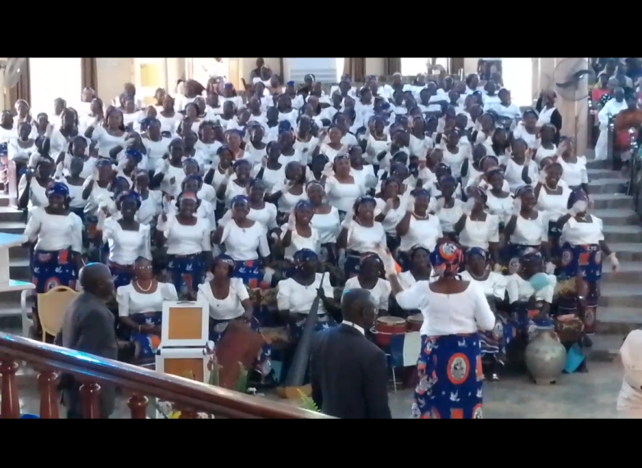

Source: Field work, 2020

The instruments adopted by MZM in general performances are indigenous instruments belonging to three families in African music. They are: idiophones, membranophones and aerophones. In the idiophone family, the groups use *Karfe* (big iron gong with a single beater), *Kachakacha* (gourd rattle), *Katakwo* (wooden block or slit drum), *Tulu* (a big earthen pot beaten with a foam or a round wooden hand-held beater padded with foam), and *Kundung* (xylophone) (Davou & Nwamara, 2022). The kundung is not in common usage but found mostly in places like Pankshin where the older women in the group employ it as part of their musical resources. In the membranophone family, a single player may play more than a single drum (between 1 and 3 drums) during every given performance, depending on the skill of the player. The drums have single membrane heads, and often supported by metallic frames that holds the drum at an upright position. The third category is the aerophone family, which involve the *Gora* (a long pipe fixed to a pot with round openings at alternate positions of the pot), which usually produces a very deep sound.

Picture 2: MZM performing with some of the musical instruments

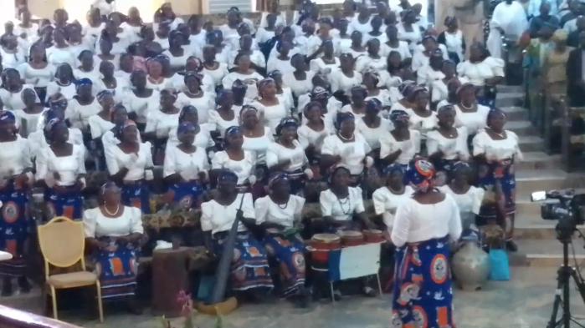

Source: Field work, 2020

Picture 3: MZM members playing the *Gora*, *kachakacha* and *karfe*

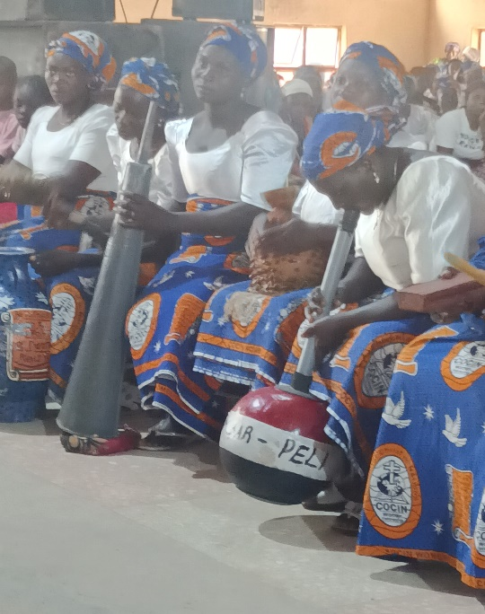

Source: Field work, 2024.

Picture 4: MZM members playing the *Kundung* during performance.

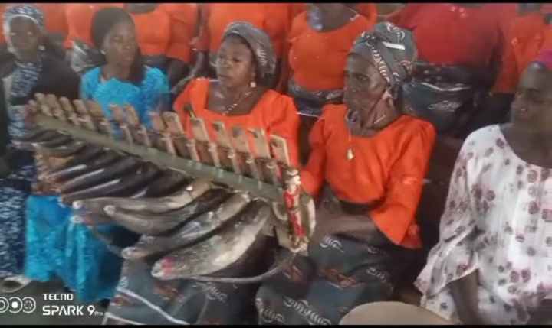

Source: Obtained from Samuel Dungs personal archive in 2023

**Method of data collection**

Data was collected within Jos metropolis only, which serves as a representative city for this research. This is attributed to the paucity of fund, inability to secure time off from our places of work, and the attendant risks of road travels in northern Nigeria generally. Further still, the choice of Jos as the location to collect data for this research is predicated on the fact that it is one of the major economic cities in the entire north. Jos possesses remarkable social, economic and religious similarities with many other cities in northern Nigeria, making it an ideal proto-type for understanding social behaviours in northern Nigeria generally. Besides, Jos (which is the capital of Plateau state) is the operational headquarters of most churches that started in the north. Among these are, Church of Christ in Nigeria (COCIN), Evangelical Church Winning All (ECWA), EkklisiyaYanuwa Nigeria (EYN) among others. Owing to the cultural history of the city and its surrounding environment that are largely indigenous people who have largely converted to the Christian faith, it is home to a large population of non-muslim indigenous people of Plateau origin as well as people from other ethnic groups in Nigeria (McCain, 2022).

The researchers adopted the ethnographic method to collect the data. This was employed in three approaches – oral interview, surveys of recorded songs on sale, and audio visual analysis of recorded works. Respondents for the oral interview include individual members of the Mawakan Zumunta Mata in Jos, music producers who have been involved in the production of Mawakan Zumunta Mata music, as well as members of the society. Members of the group and non-MZM members interviewed were randomly selected. Whereas all MZM members interviewed were all women (a reflection of the gender composition of the groups), other members of the society interviewed include both men and women who form part of their audience. However, the producers interviewed were purposively selected based on their professional experience of having recorded and produced Mawakan Zumunta Mata records.

About sixteen recorded works from different Mawakan Zumunta Mata groups from different states in northern Nigeria and Lagos were found on sales in Jos as at the time of this research. The groups were drawn from different churches.

**Presentation of data**

**Interviews**

Respondents for the interview were drawn from women who are members of the Mawakan Zumunta Mata, other non-MZM women as well as men in the society who were all selected randomly. These participants claimed they are members of the following churches in Jos – Ekklisiya Yanuwa Nigeria, Jos; St. Theresa Catholic Church, Jos; COCIN LCC, Dawul, Jos; COCIN Headquarters, Jos; Lutheran Church of Christ in Nigeria, Jos; and ECWA Church, Heipang, Jos. All the respondents agree that they have watched Mawakan Zumunta Mata present live performances every Sunday during the service in their churches where they are members. According to the respondents, members of the Mawakan Zumunta Mata are generally matured women who are female members of their respective churches. Further than the weekly Sunday services, the choir performs at other faith-based occasions like women conferences (which are often congregation-specific), burial services and marriage services.

In live performances, the choir accompanies their performances with indigenous musical instruments. The most common instruments are: *karfe* (a big metal gong played with a single beater), *kachakacha* (gourd rattle, some groups adopt the tambourine in place of the rattle), *ganga* (three or a pair of single-headed membrane drum played by a member of the group), *tulu* (a big earthen pot with a single opening above it which is beaten with a foam or a round wooden hand-held beater padded with a foam, and *katakwo* (wooden block or a slit drum). Beside this, other instruments which are common with every group but found among some groups include the *kundung* (zylophone) and the *gora* (a smaller earthen pot with two openings – one on top and underneath the instrument. A long bamboo or pipe is attached to the opening on top of the instrument where the player blows air that produces a deep sound). The instruments are indigenous to many ethnic groups in Nigeria, where they are widely used as part of their musical resources. Further still, while the choirs compose some of their songs themselves and conduct their performances themselves, they engage some men who are known for compositional skills to compose songs for them especially for special occasions where they are expected to present new songs as part of their repertoire. It is common practice among these groups that men are not permitted to be involved in the actual musical performances of the group regardless of the time and occasion for the performance. This entrenches the women’s control of their gendered space and demonstration of their quest for negating the sense for continuous dependence on men in all things.

In response to questions bothering if they are aware that the Mawakan Zumunta Mata had been involved in digital recording of their songs in studios, all the respondents affirmed that they are aware several of the Mawakan Zumunta Mata often engage in studio recording of their songs. Specifically, some of the respondents who are Mawakan Zumunta Mata members admit that the groups where they are members have recorded their songs in digital studios at one time or the other. Mawakan Zumunta Mata Similarly, all the respondents who are non- Mawakan Zumunta Mata members admit that they have listened to studio-recorded Mawakan Zumunta Mata music performances through CD or personal phones or phones of their friends. Among these respondents, 40% claim they possess Mawakan Zumunta Mata recorded music in CD format or in their phones. When asked of possible motivation for this, the respondents revealed that many of the groups undertake studio recordings of their songs in order to satisfy the yearnings of their audiences, who desire to listen to the songs in the comfort of their houses outside the church. Other reasons advanced for recording of the songs is their attempt to widen the scope of circulation of the songs for purposes of attracting more listeners and evangelism.

In view of the traditional and more prevalent practice of the Mawakan Zumunta Mata performing at church services or other faith-based occasions, our interlocutors were asked if they prefer watching the groups’ live performances or watching and listening to studio recorded version of the songs in video or audio formats. 60% percent of the respondents are of the opinion that they prefer Mawakan Zumunta Mata live performances to studio recorded performances of their songs. Responding to a related question which sought to know what the respondents think about the general preference of Mawakan Zumunta Mata audiences to either live performances or studio recorded performances, all the respondents affirmed that most Mawakan Zumunta Mata audiences prefer to watch their live performances than their studio recorded performances.

Two prominent music producers in Jos were interviewed. These producers were purposively selected based on their antecedents in digital music recordings and production of Christian artists and groups like the Mawakan Zumunta Mata within and outside Jos. The producers interviewed are:

1. Edwin Ladan – Producer and Chief Executive Officer (CEO) of Eddy Music World, Jos. He has been in the music production business in Jos for more than 20 years. According to him, within the last five (5) years, he has produced above 30 Mawakan Zumunta Mata records from within and outside Jos in his studio. Some of these recordings include COCIN Mawakan Zumunta Mata choir RCC Central Mangu in Plateau state (2010), ECWA Mawakan Zumunta Mata Choir, Tafawa Balewa in Bauchi state (*Ka tsare mu*- 2013), Christian Association of Nigeria (CAN) Mawakan Zumunta Mata choir, Tafawa Balewa in Bauchi state (2014), Assemblies of God Church Mawakan Zumunta Mata Choir, Mangu (*Mu dage*– 2017), Catholic Mawakan Zumunta Mata choir, Bokkos (2018), Catholic Mawakan Zumunta Mata Choir Bokkos, Pankshin Diocese (*Yaya tafiyarmu yake?* – 2019), Catholic Mawakan Zumunta Mata Choir LCC Yanya Gwandara, Abuja (*Corona* - 2020), COCIN Mawakan Zumunta Mata choir RCC Zaria (*Zaman dayantaka*- 2022) among others.
2. Nehemiah G. Nandi – Producer and Chief Executive Officer of Nemis Future Sounds Studio (aka NEMIS), Jos. His career as music producer has spanned over 30 years, during which he produced several Mawakan Zumunta Mata choirs within and outside Jos. Among some of the Mawakan Zumunta Mata music performances he recorded and produced within the last five (5) years are two different recordings of All Denominational Christian Congregation of Police Staff College, Maiduguri, ECWA Mawakan Zumunta Mata, Tajudu in Bassa LGA in Plateau state, and COCIN LCC Mawakan Zumunta Mata Yanya, Abuja in 2022.

These producers affirm that Mawakan Zumunta Mata groups in northern Nigeria have been active in studio recordings of their songs. To achieve this, the musical groups raise funds among themselves as well as solicit the support of their church management and other members of the churches.

Studio recordings of the songs engage only programmed digital sounds, without the use of indigenous musical instruments. Reacting to the question on audience response to Mawakan Zumunta Mata music produced in digital studios, the producers submit that studio-recorded Mawakan Zumunta Mata have very high acceptance level among audiences that cut across ethnic and denominational affiliations, as well as status and educational background. On the perceived motivation for the recordings along with their regular church performances, the producers infer that the group engage in recordings of their songs for greater audience coverage, satisfying the yearnings of their audiences who desire to have their music in recorded formats, contextualizing their music within modern trends, as well as for economic reasons.

**Surveys**

To determine the prevalence of Mawakan Zumunta Mata recorded music on sales in Jos, some retail music vendors were selected and surveyed including Equity Christian Plaza (a popular dealer in recorded Christian music in Jos). The result of the survey as presented in the table below reveals that the practice of digital music studio recording of MZM songs is wide spread in northern Nigeria. Data presented in the table below shows that about eighteen (18) different Mawakan Zumunta Mata studio-recorded albums were on sale in Jos as at the time of the survey.

Table 1: Mawakan Zumunta Mata recorded songs on sale in Jos.

|  |  |  |  |  |
| --- | --- | --- | --- | --- |
| **S/N** | **Performing Group** | **Album Title** | **Place of Production** | **Date** |
| 1 | WF Choir, Bishara Baptist Church | Muyi wa allah godiya | Mangor, Bokkos, Plateau state | 2021 |
| 2 | WF Choir, ECWA No. 1 | RanarUbangiji | Madakiya, Kaduna State | 2018 |
| 3 | WF Choir, 1st Baptist Church | AsirinGidan Kristi | Malali, Kaduna |  |
| 4 | WF Choir, St. Thomas Royal Parish Catholic Church | WaiyoNaijeriya | Old Airport Road, Kano |  |
| 5 | WF Choir, EYN | Gwanji Krista | Michika, Adamawa state |  |
| 6 | WF Choir, COCIN 1, 2, and 3 | YesuMasoyina | Ikeja, Lagos |  |
| 7 | WF Choir, LCCN Church | Ku KasaKunnen Ku | Tsau-Biri, Song, Adamawa State |  |
| 8 | WF Choir, Lutheran Church of Christ in Nigeria Cathedral | Ceto Kyauta Ne | Jimeta, Yola |  |
| 9 | WF Choir, 1st ECWA Church | Mun Zo Yau 3 | Damakasuwa, Kaduna State |  |
| 10 | WF Choir, 1st ECWA Church | Mun Zo Yesu 2 | Damakasuwa, Kaduna State |  |
| 11 | WF Choir, ECWA Church | Mu Sojoji Ne | Garaku, Nasarawa State |  |
| 12 | WF Choir, LCCN Majam’iar Ceto | Zanje Sama | Kaha Section, Taraba State |  |
| 13 | WF Choir, 1st ECWA Church | Ranar, Ubangiji | Damakasuwa, Kaduna state |  |
| 14 | WF Choir, COCIN Church | YesuRuwan Rai | Dadin-Kowa LCC, Jos |  |
| 15 | WF Choir, COCIN Central Women Fellowship (CWF) | Ga Adalun Allah | Kabong LCC, Jos |  |
| 16 | WF Choir, COCIN Church | UyesuWaUponzhi o ponzhi | Zangwar LCC, Pilgani RCC, Langtang PCC, Plateau State |  |

Source: Field work in Jos, 2023.

Out of this number, two (2) were recorded by Mawakan Zumunta Mata groups in Jos metropolis, two (2) were from towns outside Jos but within Plateau state, fourteen (14) were recorded by Mawakan Zumunta Mata from other states in Nigeria (Kaduna, Kano, Nasarawa, Adamawa, Taraba, Sokoto, Borno and Lagos). The churches involved are Baptist church, ECWA church, Catholic Church, EYN, COCIN, LCCN and a non-denominational protestant church.

**Discussion of findings**

Mawakan Zumunta Mata is an active arm of the Zumunta mata (Women Fellowship) group of the church in Northern Nigeria. Established in the churches to provide a platform for married and matured women in the churches to fellowship and inter-relate, the group’s performances on Sundays have become a major reference for a satisfying worship experience. Their performances provide a much needed alternative to the prevalent contemporary gospel music performances in the church by conventional choirs. Whereas the conventional choirs appropriate musical characteristics that align with modern faith-based music especially built upon evolving western trends and performance styles, Mawakan Zumunta Mata uphold musical ideals that are totally self-evolving and culturally relevant. This explains their belief in composing their own songs or by men from their communities that appropriate musical idioms that are in tandem with their musical culture and performing such music only. This performance philosophy helps to uphold and support the African identity through projecting their local identities (Lefapa, 2010). The intentionality of their musical preference reflects their underlying motivation of projecting faith in ways that are mutually consistent with cultural contexts, as well as constructing faith as a force for self-assertion. This agrees with what Marshall (2009) describes as the crystallization of self-expression that ultimately “manifests itself as a force” (p. 48).

Originally, the Mawakan Zumunta Mata perform only in the church, as part of the women’s contribution to worship in their respective churches. This assumed a much wider engagement when occasions for performances went beyond just worship sessions to include evangelization, inspiring religious vocation and musicking in other church-officiated programmes like Christian marriages and burials (Badejo, et al. 2017). Further still, other special programmes like women conferences, youth weeks, men’s week provided further occasions for translocating their performances to the society outside the walls of the churches. Although the constitution of the group cannot be viewed outside gendered lenses, their gendered expression of faith underscores the indescribable roles women play in building societies. They express their faith through their musical performance in ways that reflect individual and group sacrifice, passion, commitment that is contagious and resilience. Once again, Marshal (2009) captured this beautifully when she said: “The irreducible element we have designated as belief or faith is neither an essence nor a substance, nor a function, nor a form of thought that might be opposed to reason, truth, or knowledge, but rather the dimension of subjectivity whose form is affectivity, desire, which finds its expression through the possibility of acting …” (p. 50). Therefore, every performance is a representation of active and fervent faith, that demonstrate the content of belief and the fundamental essence of their spiritual convictions that lies beyond verbal expression. Musical performance in this sense becomes a ‘doing’ and ‘acting’ of their faith, a captivating ‘presentation and re-presentation’ of the visual dimension of faith for everyone to behold Kidula, 2008).

The original motivation to explore other mediating agencies that can help to take their music beyond their churches is evidently plausible. Evangelism was an ever-present goal that motivated the need to reach out to new audiences through the message of their songs, an audience that exists beyond the immediate walls of their churches. Hence, the need for a mediated agency for this purpose was born – the agency of the recording studio. This is akin to the transformation of the *Ayo nio* Seraphim and Seraphim church in Lagos who reinvented themselves by going beyond church service performances to a choir that sought to make musical impact beyond the walls of their church. According to Brenan (2010), this action resulted in the circulation of their music beyond the church to a wider and much diverse audience and public space, which popularized the choir. In the same way, Mawakan Zumunta Mata songs have widely circulated in northern Nigeria far beyond their source of origin. Data obtained in Jos clearly reveal that recorded Mawakan Zumunta Mata music from distant cities are accessible in Jos by anyone who is interested.

The data presented in this work opens up another front for arguing that although the group frequently claim that evangelizing the world is the primary goal for recording their songs, the economic side of the endeavour demands closer interrogation. Some of our interlocutors who are members of the Mawakan Zumunta Mata in different churches aver that proceeds from sales of their studio recorded music have usually been deployed to support mission works, the needy among them and in the church in general, as well as invest in several group projects like acquiring landed properties. For instance, Mrs. Victoria Dadit of the COCIN LCC, Dahwol in Jos, revealed that the Women Fellowship of their LCC was able to purchase two plots of land around Kwang (an area in Jos) using the proceeds from sales of their studio recorded music. Furthermore, although records of individual gospel artistes of northern extraction on sales in Jos metropolis far outnumber that of the Mawakan Zumunta Mata, their presence on the gospel music market enterprise is indicative of their efforts to carve a niche for themselves within this wider music business space. This suggest that beyond just evangelistic purposes, the real drivers of Mawakan Zumunta Mata digital music recording are multi-layered.

Closely related to this is the fact that the approval rating of Mawakan Zumunta Mata choir recorded music is seemingly rising among northern Nigeria indigenous Christians. The growth of Christianity in northern Nigeria (North Central, North West and North East geo-political regions of Nigeria) has been extremely remarkable. Despite the repressive stance of Islam in northern Nigeria in opposition to the spread and growth of Christianity in the area, Christianity has continued to expand both in size and influence, permeating both art and culture in the region. The result of this is that there is a large body of indigenous Christians in the region who are reinforced by others from the southern part of Nigeria (McCain, 2022), thereby forming a social block that projects her ideals and perspectives in unmistakeable ways. Within these faith block, there is a growing appeal for Mawakan Zumunta Mata music that cuts across ethnic and denominational lines, blurring old traditional sectarian divides. The level of multi-dimensional satisfaction audiences derive from their performances as well as the expressed desire to watch their performances during every service are indications of the high level of acceptance the music enjoy within and outside the churches.

Also, some church members stated that they desire to listen to Mawakan Zumunta Mata songs every time even in their homes, therefore necessitating studio recording of these songs that would make them accessible outside the church. For instance, Mr. Joshua William, a member of the St. Piran Anglican Church in Jos indicated that he purchased some of the Mawakan Zumunta Mata CDs because of his interest in their songs. Although he claimed majority of the audience prefer live performances by the group above their recorded music, his preference for studio recorded versions stems from the inclusion of modern studio sounds used as accompaniment. Also, the recorded format provides constant access to the music at all times for listening pleasure. This further substantiates Nehemiah G. Nandin (CEO of NEMIS)’s claims that in 2022, COCIN LCC Mawakan Zumunta Mata of Yanya, Abuja sold the entire 1000 pieces of CD he produced for them at the lunch site of the album. In contrast with other physical art forms like sculptors and paintings that can remain in a given position for years, musical sound possess an inherent dynamism that is immersed in temporality, therefore requiring present reproducing (either through live performances or in recorded formats) for continuous experiencing (Foley, 2015).

Shifting performance spaces to keep pace with current changes and realities brings into focus the impact of modernization on traditional forms of performance generally. Whereas the desire to evangelize may be a germane reason, these music groups have effectively explored non-liturgical spaces that are relevant for maximum audience impact across traditional boundaries. Mawakan Zumunta Mata’s response to changing times manifests itself in their adoption of modern synthesized programmed beats to accompany their performance, as well as adopting of studio procedures for recording musical works, which vary from their traditional practices. This is a reflection of the women’s desire to accommodate change to the extent that their identity and ideals are still preserved. Today’s society, but secular and sacred, is immersed in an information and digital influence that transforms the ways almost everything is done. The way music is conceived, perceived, created, mediated, transmitted or analysed are all affected by technology. Hence, technology has occupied the central place in artistic practice, artistic conception and experiencing art itself in both urban and non-urban spaces, by those adept in engaging with technology as well as those who are novices. Mawakan Zumunta Mata is fast responding to this ever-changing performance world by exploring current social media spaces like the youtube to extend their musical visibility and influence in northern Nigeria. Although the groups have been slow in immersing themselves into modern media spaces, the omnipresent characteristic of the digital world (Portevedo, 2024) has left them with no choice if they must achieve their goals of reaching to audiences in more effective ways.

**Conclusion**

Mawakan Zumunta Mata has become a phenomenon on the music landscape of northern Nigeria. Performing as mothers and women who desire to communicate their faith in pungent ways, self-assertion and impactful performance underlie their efforts. Their music support the expression of faith, deployment of indigenous musical instruments as well as adoption of studio recording of their songs for the purpose extending their musical circle of influence. While studio recording enhance their contemporary relevance among northern Nigerian Christians (and others from elsewhere), live performances in the church as part of worship service and other church-organized meetings have endeared the group to their teeming church audiences. This binary approach to performance by the MZM is laudable in seeking to maintain a commanding level of relevance on the musical landscape of Christian music in northern Nigeria.

**References**

Baba, E. D. (2022). The chronicles of SIM missions in Nigeria between 1893-1950. *International Journal of Humanities, Social Sciences and Education, 9*(9), 9-24. <https://doi.org/10.20431/2349-0381.0909002>

Badejo, A. F., Majekodunmi, A. O., Kingsley, P., Smith, J. & Welburn, S. C. (2017). The impact of self-help groups on pastoral women’s empowerment and agency: A study in Nigeria. *Pastoralism: Research, Policy and Practice.* <https://doi.org/10.1186/s13570-017-0101-5>

Brennan, V. L. (2010). Mediating “The voice of the Spirit”: Musical and religious transformations in Nigeria’s oil boom. *American Ethnologist, 37*(2), 354-370. [Mediating “The Voice of the Spirit”: Musical and religious transformations in Nigeria's oil boom - BRENNAN - 2010 - American Ethnologist - Wiley Online Library](https://anthrosource.onlinelibrary.wiley.com/doi/epdf/10.1111/j.1548-1425.2010.01260.x)

Carter-Enyi, Q. O. (2023). Perspectives of Nigerian women composers. An unpublished M.A. Thesis submitted to the Graduate Faculty of the University of Georgia, Athens. [Perspectives of Nigerian Women Composers - ProQuest](https://www.proquest.com/openview/905b1f61c930e6ac1b7cbd1267cbf83f/1?pq-origsite=gscholar&cbl=18750&diss=y)

Cooper, B. (2010). Engendering a Hausa vernacular Christian practice. In A. Haour and B. Rossi (Eds.), *Being and Becoming Hausa: Interdisciplinary Perspectives,* 257-277. Brill. <https://doi.org/10.1163/ej.9789004185425.i-310.81>

Davou, S. Y. & Nwamara, A.. (2022). The Kundung (Xylophone) of the Berom people and the classification of indigenous African musical instruments. *International Journal of Arts, Humanities and Social Sciences, 4*(4). <https://www.ijahss.in/2582-3647>

Davou, S. Y. & Joshua, G. A. (2021). Improving the Nigerian musical arts through the creative ability in the music composition style of WatuYohanna. An unpublished article presented at the national conference of Society of Music Educators in Nigeria, Federal College of Education, Pankshin.

Diener, E., Tay, L. & Myers, D. G. (2011). The religion paradox: If religion makes people happy, why are so many dropping out? *Journal of personality and social psychology*, *101*(6), 1278–1290. <https://doi.org/10.1037/a0024402>

Fred, S. (1984). Sound structure as social structure. *Ethnomusicology, 28*(3), 383-409. <https://doi.org/10.2307/851232>

Foley, E. (2015). Music and spirituality: Introduction. *Religions*, *6*, 638–641. <https://doi:.org/10.3390/rel6020638>

Ibitoye, O. J. (2021). Indigenous music and religion among Ilorin people of north central Nigeria. *Journal of the Association of Nigerian Musicologists, 15,* 236-247.

Kidula, J. N. (2008). Music culture: African life. In R. King, *Music in the Life of the African Church,* 37-54. Baylor University Press.

Macamo, E. (2018). Urbane scholarship: Studying Africa, understanding the World. *Africa, 88* (1), 1–10.  <https://doi.org/10.1017/S0001972017000626>

Macarthur, S. (2012). The power of virtual music in scholarship: Composing a women’s musical future as a ‘Becoming-Other-Than-Itself’. *Journal of Music Research Online,* p. 1 – 13. <https://www.researchgate.net/publication/277244863>

McCain, C. (2022). Censorship, citizenship and cosmopolitan unity in Muslim and Christian creative responses to repression in northern Nigeria. *Africa, 92*, 739-758. <https://doi.org/10.1017/S0001972022000651>

Meyer, B. (2020). What is religion in Africa? Relational dynamics in an entangled world. *Journal of Religion in Africa, 50,* 156-181. [What Is Religion in Africa? Relational Dynamics in an Entangled World in: Journal of Religion in Africa Volume 50 Issue 1-2 (2020)](https://brill.com/view/journals/jra/50/1-2/article-p156_8.xml)

Miller, W. R. (1998). Researching the spiritual dimensions of alcohol and other drug problems. *Addiction*, *93*(7)*,* 979–990. <https://doi.org/10.1046/j.1360-0443.1998.9379793.x>

Moses, If-Not-God. (2023). Negotiating intersectional identities in the music culture of the Deeper Christian Life Ministries in Nigeria. An unpublished M.A. Thesis submitted to the Department of Music, University of Mississippi. <https://egrove.olemiss.edu/etd/2550>

Osigwe, C. N. (2016). Contemporary Nigeria church music: A search for true identity and cultural relevance. *International Journal of Music and Performing Arts, 6*(2), 65-71.

Portovedo, H. (2024). Computer-Assisted Music as Means of Multidimensional Performance  
and Creation: A Post Approach to “Singularity Study 3”. In J. Gullö, R. Hepworth-Sawyer, D. Hook, M. Marrington, J. Paterson, and R. Toulson, *Innovation in Music: Innovation Pathways,* 223-233. Routledge.

Sharma, Swati and Singh, Kamlesh. (2019). Religion and well-being: The mediating role of positive virtues. *J Relig Health 58*, 119–131. <https://doi.org/10.1007/s10943-018-0559-5>.

Lopez, S; Pedrotti, J. T. & Snyder, C. R. (2007). *Positive psychology*: *The scientific and practical explorations of human strength*. SAGE Publications.

Society of African Missions. (2009). History of the church in northern Nigeria. [History of the Church in Northern Nigeria | Society of African Missions (sma.ie)](https://sma.ie/history-of-the-church-in-northern-nigeria/)

Vail, K. E., Rothschild, Z. K., Weise, D. R., Solomon, S., Pyszczynski, T. & Greenberg, J. (2010). A terror management analysis of the psychological function of religion. *Personality and Social Psychology Review*, *14*, 84–94. <https://docslib.org/doc/12542856/>

Van Tongeren, D. R., Hakim, S., Hook, J. N., Johnson, K. A., Green, J. D., Hulsey, T. L., & Davis, D. E. (2016). Toward an understanding of religious tolerance: Quest religiousness and positive attitudes toward religiously dissimilar others. *The International Journal for the Psychology of Religion*, *26*, 212–224. <https://doi.org/10.1080/10508619.2015.1039417>

Vidal, A. O. (2012). From classics to pops: The Africanization of western institution. *Distinguished Lecture Series, Faculty of Arts, Lagos State University.*

Zhang, H., Hook, J. N., Farrell, J. E., Mosher, D. K., Captari, L. E., Coomes, S. P., Van Tongeren, D. R. & Davis, D. E. (2019). Exploring social belonging and meaning in religious groups. *Journal of Psychology and Theology, Vol. 47*(1), 3-19. <https://doi.org/10.1177/0091647118806345>

* Victoria Dadit is the Leader o