Advancing Sustainable Workforce Development through Green Skills Integration in VET: A Systematic Literature Review

Authors:
Hani Febriyanti^{1*}, Sri Sumaryati², Fatma Sukmawati³, Ali Abdi Hassan⁴

Affiliantion & Address :
^{1,3}Department of Educational Technology, Sebelas Maret University, Ir. Sutami 36A Street, Surakarta, 57126, Indonesia.
²Department of Accounting Education, Sebelas Maret University, Ir. Sutami 36A Street, Surakarta, 57126, Indonesia.
⁵Department of Business Administration, Seattle University, 901 12th Ave, Seattle, WA 98122, United States

Emails:
¹hanifebri11@student.uns.ac.id (corresponding author)
²srisumaryati@staff.uns.ac.id
³fatmasukmawati@staff.uns.ac.id
⁴ahassan1@seattleu.edu
Abstract
Purpose: This study synthesises research on green skills integration in Vocational Education and Training (VET). It aims to map research trends, identify dominant themes, examine integration strategies, and highlight key challenges and opportunities to support sustainable workforce development. Design/methodology/approach: A PRISMA-guided systematic literature review was conducted on 25 peer-reviewed journal articles (2015–2025) retrieved from Scopus. Bibliometric analysis using Biblioshiny was combined with thematic synthesis to examine publication patterns and empirical findings. Findings: Publications increased markedly after 2019. Three dominant strands emerged: system-level policy frameworks, teacher competencies, and curriculum and programme innovations. Strategies include curriculum reform, project-based and work-integrated learning, and partnerships with industry. Key barriers involve conceptual ambiguity, fragmented governance, limited teacher preparation, and resource constraints. Research implications/limitations:The review highlights the need for clearer conceptual frameworks and more comparative and longitudinal studies. Limiting the sample to English-language Scopus articles may underrepresent regional and practice-based research. Originality: This review integrates bibliometric mapping and systematic synthesis to provide a structured overview of how green skills are conceptualised and operationalised in VET.
Keywords
bibliometric analysis; education for sustainable development; green skills; systematic literature review ; vocational education; workforce transition

Introduction
The accelerating transition towards sustainable and low-carbon economies has intensified the demand for green skills, particularly within Vocational Education and Training (VET) systems responsible for preparing job-ready graduates (Antonazzo et al., 2023). As economies seek to decarbonise production, embrace circularity, and respond to climate-related risks, the need for a workforce equipped with green skills, encompassing the knowledge, competencies, values, and behaviours that support environmentally sustainable practices, hass become increasingly pronounced (Holst et al., 2020; Pavlova, 2019). In this context, VET is widely recognised as a strategic lever for navigating the twin transitions towards greener and more digital economies (McGrath & Powell, 2016; Pavlova, 2019). Consequently, VET is no longer expected merely to supply technically competent workers; it is also tasked with preparing graduates who can contribute to sustainable development, foster innovation in low-carbon technologies, and support just transitions within labour markets (Lambini et al., 2021; McGrath & Powell, 2016). This shift aligns with international agendas, particularly the 2030 Agenda for Sustainable Development and the call to integrate Education for Sustainable Development (ESD) across all levels of education, including vocational and professional training (UNESCO, 2017).
Despite this growing policy emphasis, “greening the workforce” poses complex and systemic challenges for VET systems. Green skills are inherently multidimensional, intersecting with occupational standards, environmental policy, technological change, and social justice concerns (Holst et al., 2020; Singer-Brodowski et al., 2019). Their integration therefore requires more than the addition of environmental topics to existing curricula; it entails rethinking curriculum design, pedagogical approaches, assessment practices, institutional cultures, and partnerships with industry and communities (Furdui et al., 2021; Holst et al., 2020; Lambini et al., 2021). While many countries have articulated “green TVET” or “sustainable VET” strategies, the translation of these ambitions into coherent institutional and classroom practices remains uneven, raising concerns about VET’s capacity to effectively support sustainable workforce development (Holst et al., 2024; McGrath & Powell, 2016).
Over the past decade, research on green skills in VET has expanded rapidly and diversified. Existing studies have examined system-level policies and monitoring frameworks (Holst et al., 2020; Igberaharha, 2021; McGrath & Powell, 2016), teacher competencies and professional development for ESD-oriented teaching (Chinedu et al., 2023; Handayani et al., 2020b; Yang et al., 2024), and curriculum and programme innovations across sectors (Budi et al., 2024; Chee Sern et al., 2021; Furdui et al., 2021). Other contributions have explored context-specific models embedding cultural or religious values in sustainability education (Fauziah et al., 2024; Juwitasari, 2024), as well as pedagogical approaches such as project-based learning, entrepreneurship education, and work-integrated learning to foster green competencies (Asikainen & Tapani, 2021; Nikoloudakis & Rangoussi, 2024; Ramli et al., 2020). In parallel, an emerging strand of scholarship employs bibliometric techniques and literature reviews to map the intellectual structure of TVET and sustainability research (Holst et al., 2020; Özmen et al., 2025).
Despite this growing body of work, significant gaps remain. First, existing studies are highly fragmented across themes, sectors, and national contexts, making it difficult to develop an integrated understanding of how green skills are conceptualised and operationalised within VET systems worldwide (Chinedu et al., 2023; Holst et al., 2024). Second, limited synthesis systematically connects macro-level developments, such as policies, frameworks, and labour-market agendas, with micro-level practices, including pedagogy, institutional initiatives, and learner experiences. Third, although some reviews address TVET and sustainability more broadly, relatively few combine systematic qualitative synthesis with bibliometric mapping to provide a structured overview of both the intellectual landscape and the empirical evidence base (Özmen et al., 2025). As a result, policymakers, practitioners, and researchers lack a consolidated knowledge base to inform coherent strategies for advancing sustainable workforce development through VET. A systematic literature review is therefore needed to synthesise existing evidence, clarify dominant conceptualisations and approaches, and identify persistent challenges and future directions.
In response to these gaps, this article presents a systematic literature review (SLR) of research on green skills integration in VET. Drawing on 25 peer-reviewed journal articles published between 2015 and 2025 and selected through a PRISMA-guided process, the study combines bibliometric analysis using Biblioshiny for R with thematic synthesis of empirical and conceptual findings (Donthu et al., 2021). The review aims to map the existing knowledge base and identify dominant trends, integration strategies, persistent challenges, and emerging opportunities related to green skills in VET. In doing so, this study seeks to advance conceptual clarity, support evidence-informed policymaking, and inform institutional practice.
Accordingly, this review addresses the following research questions:
RQ1: What are the current trends in the study and application of green skills in VET?
RQ2: What strategies have been used to integrate green skills into VET curricula or training programs?
RQ3:What are the key challenges and barriers to implementing green skills in VET institutions?
RQ4: What are the potential future opportunities for green skills integration in VET institutions?

Methods
2.1. Review Design
This study adopts a Systematic Literature Review (SLR), which integrates the systematic and transparent selection procedures of a traditional systematic review with the quantitative insights of bibliometric analysis to explore the implementation of green skills in VET. The SLR design allows both the conceptual synthesis of empirical findings and the quantitative mapping of publication characteristics (Donthu et al., 2021).
The purpose of this review is to systematically identify, analyse, and synthesise the existing body of knowledge on green skills integration in Vocational Education and Training (VET). All review procedures followed the PRISMA 2020 guidelines to ensure methodological rigour, transparency, and replicability. In addition, a bibliometric review was conducted using the Biblioshiny tool of the Bibliometrix package in RStudio.
2.2. Search Strategy
A systematic literature search was conducted in the Scopus database. This database was selected for its comprehensive coverage of publications in education, green skills, sustainability, and vocational training. The search strings were formulated by combining relevant keywords and Boolean operators. Three main blocks of descriptors used are presented in Table 1.
Table 1. Advanced search query on database
Block |  | Descriptor | String (TITLE-ABS-KEY)
#1 | Intervention | “green skills” | “green skill” OR "green skills" OR “sustainability skill” OR "sustainability skills" OR “ESD” or “education for sustainable development”
#2 | Population of interest | “vocational education” | "vocational education" OR "vocational education and training" OR "VET" OR "TVET" OR "technical vocational education and training"
#3 | Search string |  |  | (#1) AND (#2)

The search was limited to journal articles published between 2015 and 2025. The year 2015 was chosen because it marks the formal adoption of the 2030 Agenda by the United Nations, which introduced the 17 Sustainable Development Goals (SDGs) and provided the foundation for Education for Sustainable Development (ESD), thereby accelerating the development of green skills among learners.
2.3. Inclusion and Exclusion Criteria
Inclusion and exclusion criteria were established to ensure that only relevant and high-quality studies were selected for the review. The inclusion criteria were as follows: (1) articles that discuss green skills or their application in vocational education and training, (2) articles published between 2015 and 2025, (3) documents classified as journal articles, and (4) articles written in English. Accordingly, the exclusion criteria were: (1) articles that do not address green skills or their application in vocational education and training, (2) articles published outside the 2015–2025 time frame, (3) documents classified as conference papers, book chapters, reviews, books, or other non-article types, (4) articles that are review papers or that do not report empirical data, and (5) articles not written in English.
2.4. Screening and Selection Process
The selection process followed the PRISMA 2020 framework, consisting of three main stages: identification, screening, and inclusion. A PRISMA flow diagram (Fig. 1) illustrates each stage of the screening process.
Figure 1. PRISMA flow diagram
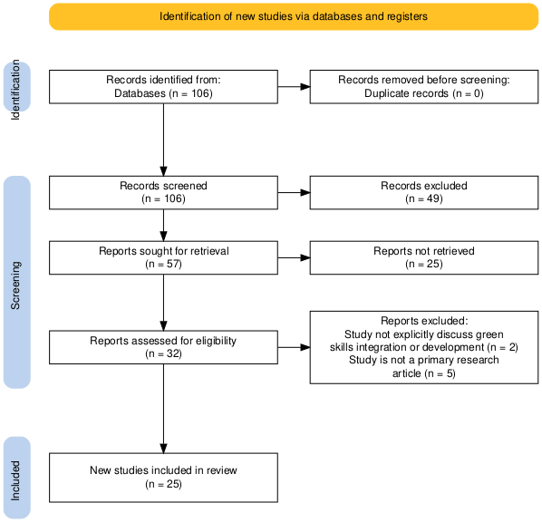
In the identification stage, 106 records were retrieved from the Scopus database using the predefined search strategy. During the screening stage, titles and abstracts were examined to exclude duplicates and clearly irrelevant studies. In the eligibility stage, the full texts of the remaining articles were assessed against the inclusion and exclusion criteria. Through this step-by-step reduction process, the final sample consisted of 25 journal articles that met all criteria and were included in the qualitative synthesis and bibliometric analysis. Articles that were deemed irrelevant or did not meet the criteria were gradually excluded at each stage.
2.5. Bibliographic Review
After identifying the relevant articles through the PRISMA protocol, a deeper bibliographic analysis was conducted to understand the structure and evolution of research on green skills in Vocational Education and Training (VET). To determine the direction of the field and map its development from multiple perspectives, RStudio was employed for its strong capabilities in bibliometric mapping.
Metadata for this study were obtained from Scopus and exported in CSV format. These files were then harmonised into a consistent structure using RStudio. The final metadata set accurately represented the 25 selected journal articles. The unified metadata were then analysed using Biblioshiny, the interactive interface of the Bibliometrix package in R, which supports comprehensive bibliometric exploration. This analysis included identifying annual scientific productions, keywords analysis, authors' production over time, country production over time, and citation analysis.

Result
3.1. Distribution based on production time
The Annual Scientific Production graph (Fig. 2) shows a fluctuating but generally upward trend in publications on green skills in VET between 2015 and 2025. The search window starts in 2015 to align with the adoption of the 2030 Agenda and the Global Action Programme on ESD, which positioned skills for sustainability as a key policy priority for education and training systems (UNESCO, 2023, 2017).

Figure 2. Article distribution based on Annual Scientific Production
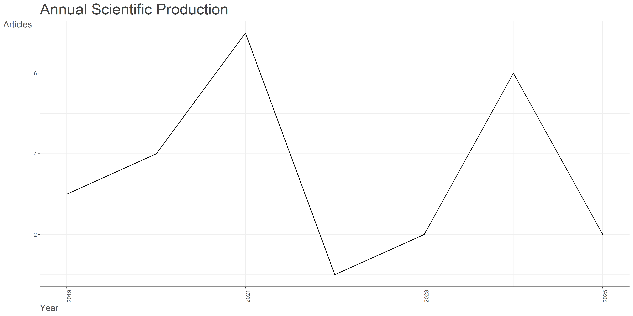
Although the search covered 2015–2025, the 25 articles that met all inclusion criteria were published from 2019 onwards. In the earlier years (2015–2018), many outputs were conference papers, conceptual commentaries, or used broader terms such as “sustainable skills” or “green TVET,” and thus fell outside our criteria focused on empirical journal articles and specific search strings. Publication numbers rise noticeably after 2019 and peak around 2021, followed by a slight decline in 2025. This pattern suggests a time lag of several years between global policy commitments on SDGs/ESD and the consolidation of an empirical research base on green skills in VET, echoing similar delays observed in other ESD-related fields.
3.2. Keywords Analysis
Keyword co-occurrence analysis (Fig. 3) highlights “green skills,” “vocational education,” “sustainable development,” and “education for sustainable development (ESD)” as the most frequent and central terms. These are closely linked to pedagogical and institutional descriptors such as “curriculum,” “teaching,” “learning,” “teacher training,” and “governance,” indicating that the literature primarily focuses on how green skills are embedded into curricula and teaching–learning processes within VET institutions.
Figure 3. Wordcloud mapping
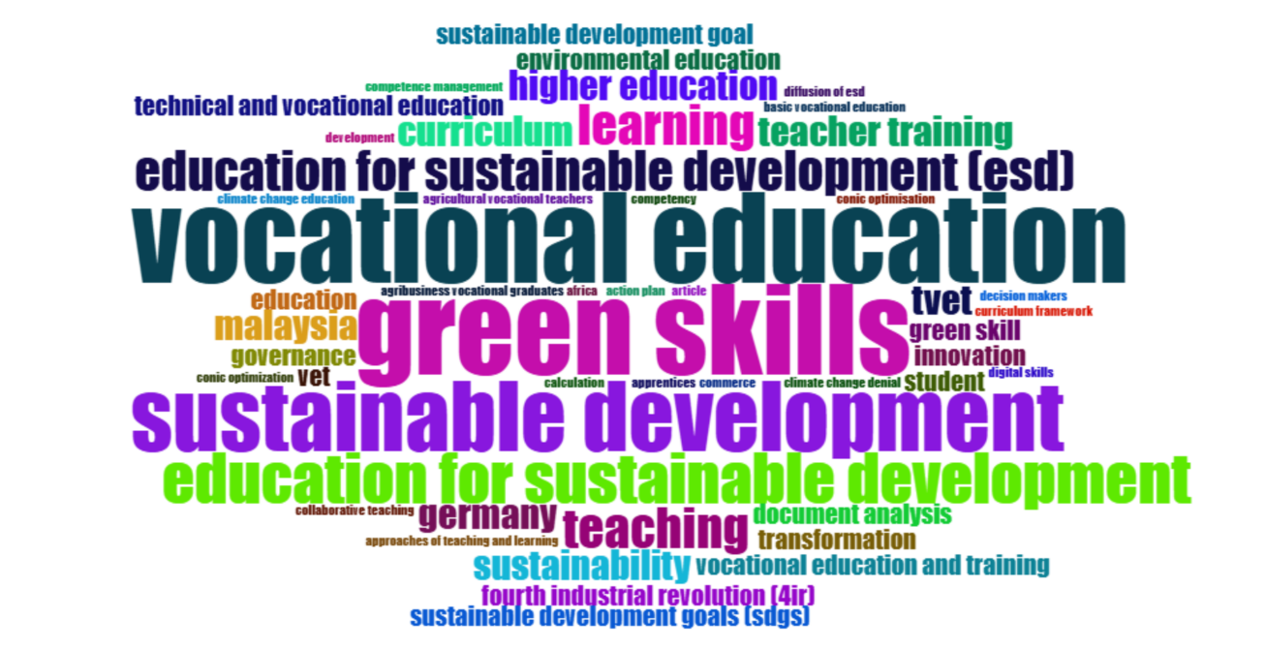
In addition, terms such as “TVET,” “technical and vocational education,” and “higher education” suggest that research spans different levels and types of provision, although upper-secondary and post-secondary VET remain the main locus of analysis. Country-specific keywords (e.g. “Malaysia,” “Germany,” “Indonesia”) and sectoral terms (e.g. “manufacturing,” “hospitality,” “renewable energy”) point to the importance of national and industry contexts in shaping how green skills are interpreted and implemented. The prominence of these clusters resembles keyword patterns found in other bibliometric mappings of technology-enhanced or sustainability-oriented vocational education, where core concepts (e.g. AR, digital skills, green skills) are strongly entangled with pedagogical and governance-related terms.
3.3. Most productive countries and authors
The analysis of authors’ production over time (Fig. 4) shows that research on green skills and vocational education is characterized by a relatively dispersed authorship pattern, with most contributors publishing only a single article within the 2019–2025 window. A few authors, however, stand out as more central. For example, Holst J. and Singer-Brodowski M. appear early in the period and maintain relevance across several years, indicating their role in shaping foundational debates on green TVET and ESD in vocational contexts. Likewise, authors such as Chinedu G.C., Ali M., Handayani M.N., and Mukhlis M. are positioned as important contributors from the Global South, particularly in relation to teacher competencies, curriculum development, and localised models of sustainability in VET. The size of the bubbles suggests that even these leading authors typically contribute one or two publications, which implies that the field is still emerging and not yet dominated by a small group of highly prolific scholars. Instead, it reflects a broad but still fragmented community of researchers working on green skills from different disciplinary and geographical standpoints.
Figure 4. Distribution based on author’s production over time
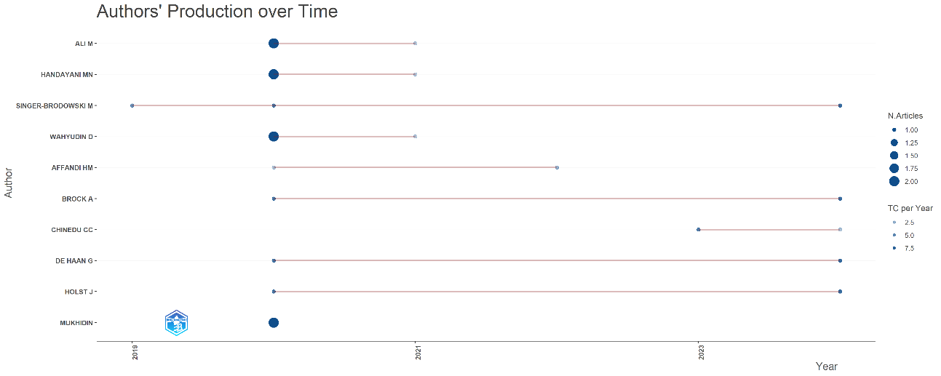
The country production over time (Fig. 5) plot reinforces this picture of a field that is both growing and geographically diversified. From 2019 onwards, Germany, Indonesia, and Malaysia show a consistent increase in cumulative article output, gradually becoming the most productive countries in the dataset. Germany’s growth is associated with strong policy- and system-oriented work on ESD in VET, while Indonesia and Malaysia contribute substantially to empirical studies on curriculum integration, teacher development, and context-specific models of green skills. China presents a more moderate but steady increase, pointing to rising interest in green and digital skills within its TVET reforms. Poland emerges later in the period, indicating that new national contexts are beginning to enter the debate. Overall, the upward trajectories across these countries suggest that research on green skills in VET is moving from isolated initiatives towards a more sustained international research agenda, with particular dynamism in Asian contexts and continued leadership from selected European countries.
Figure 5. Distribution based on country production over time
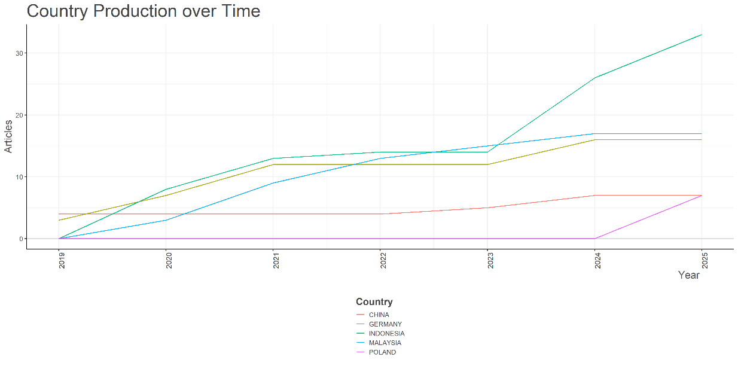
3.4. Citation Analysis
The citation analysis (Fig 6) reveals that a small group of publications plays a particularly influential role in shaping the discourse on green skills and sustainability in vocational education. The most globally cited document is Handayani MN (2020, Indonesian Journal of Science and Technology), with 42 citations. This article focuses on the development of green skills through specially designed teaching materials and pedagogical strategies in Indonesian vocational education, and its high citation count suggests that it has become a key reference for empirical work on classroom-level integration of green skills.
Figure 6. Distribution based on number of citation
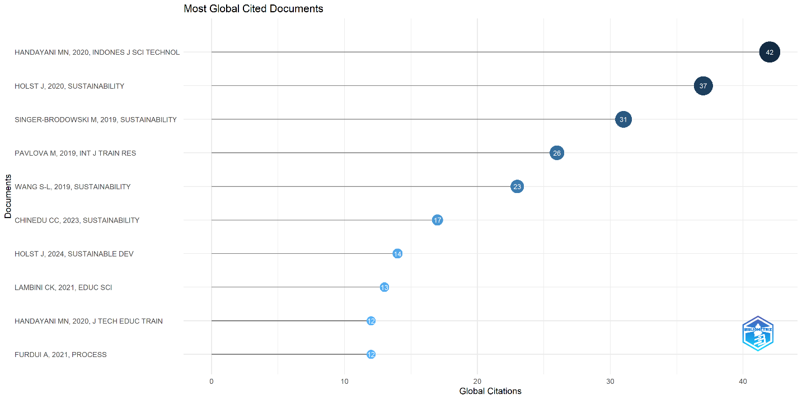

The second most cited article, Holst J (2020, Sustainability), has 37 citations and provides a system-level analysis of green TVET monitoring and implementation. Together with Singer-Brodowski M (2019, Sustainability), which has 31 citations, and Pavlova M (2019, International Journal of Training Research) with 26 citations, these publications form a core cluster of widely cited works that link TVET, ESD, and sustainable development at policy and conceptual levels. Wang S.-L. (2019, Sustainability), with 23 citations, adds an important dimension by examining technology-enhanced learning, indirectly connecting digital learning environments with the broader VET and sustainability agenda.
More recent contributions such as Chinedu CC (2023, Sustainability), Holst J (2024, Sustainability Development), Lambini CK (2021, Education Sciences), Handayani MN (2020, Journal of Technical Education and Training), and Furdui A (2021, Processes) have citation counts ranging from 12 to 18, indicating growing recognition. These studies extend the debate into areas such as teacher re-orientation for green TVET, updated monitoring frameworks, industry–education partnerships, and circular economy skills.
Overall, the citation pattern shows that a combination of conceptual–policy papers (Holst, Singer-Brodowski, Pavlova) and practice-oriented empirical studies (Handayani, Wang, Lambini, Furdui, Chinedu) are driving the field. The prominence of journals like Sustainability and regionally focused outlets (e.g., Indonesian and Malaysian journals) also illustrates how both international and national platforms contribute to the consolidation of knowledge on green skills in VET.
RQ1: What are the current trends in the study and application of green skills in VET?
The analysis of the 25 selected articles shows a clear increase in research on green skills in VET since 2019, even though the search window covered 2015–2025. This pattern reflects a lag between the adoption of the 2030 Agenda and the emergence of empirically grounded studies that explicitly use “green skills” and “vocational education” as core descriptors. Across the corpus, three major thematic trends emerge.
First, there is a strong focus on policy and system-level integration of ESD and green skills into VET. Studies discuss green TVET strategies, governance mechanisms, and monitoring frameworks designed to align vocational systems with sustainability goals (Holst et al., 2020, 2024; Igberaharha, 2021; McGrath & Powell, 2016; Singer-Brodowski et al., 2019). These works highlight how different countries attempt to embed sustainability in qualifications, national curricula, and institutional mandates, while also pointing to gaps between policy rhetoric and implementation.
Second, a growing body of research addresses teacher competencies and professional development for green skills. Handayani et al. (2020) and Yang et al. (2024) examine how teachers’ knowledge, beliefs, and pedagogical repertoires shape the integration of sustainability into vocational subjects, while Chinedu et al., (2023) calls for deliberate re-orientation of TVET teachers as sustainability educators rather than solely technical trainers.
Third, studies increasingly explore curriculum and program innovations in sector-specific contexts, such as renewable energy, agriculture, manufacturing, and circular economy-oriented industries (Budi et al., 2024; Chee Sern et al., 2021; Furdui et al., 2021). These contributions experiment with project-based learning, entrepreneurship education, and work-integrated learning as vehicles for developing green competencies, often linked to local labour-market needs and policy agendas.
RQ2: What strategies have been used to integrate green skills into VET curricula or training programs?
The reviewed articles highlight a range of strategies for embedding green skills into VET. At the curriculum level, several studies report the integration of sustainability learning outcomes and environmental competences into existing occupational standards, either as cross-cutting competencies or as dedicated green modules (Budi et al., 2024; Chee Sern et al., 2021; Pavlova, 2019). These reforms often involve revising qualification frameworks, aligning course content with national SDG strategies, and incorporating industry-based standards related to energy efficiency, waste management, and resource conservation.
Pedagogically, project-based learning, problem-based learning, and work-integrated learning are frequently used to situate green skills in authentic tasks. Asikainen & Tapani, (2021) and Ramli et al., (2022) show how sustainability projects, community-based initiatives, and reflective practices can cultivate students’ environmental awareness, critical thinking, and collaborative problem-solving. Entrepreneurship-oriented approaches also appear as strategies for linking green skills to innovation and local economic development (Nikoloudakis & Rangoussi, 2024).
At the institutional and governance level, some studies emphasize partnerships between VET institutions, local governments, and industries to co-design green curricula and create work-based learning opportunities in green sectors (Furdui et al., 2021; Lambini et al., 2021). Others underline the importance of teacher professional development programmes that embed ESD principles and sustainability literacy into teacher education standards (Chinedu et al., 2023; Handayani et al., 2020; Yang et al., 2024).
RQ3: What are the key challenges and barriers to implementing green skills in VET institutions?
Despite promising initiatives, the literature identifies several persistent barriers. A first set of challenges relates to conceptual ambiguity and fragmented frameworks. Chee Sern et al., (2021) and (Singer-Brodowski et al., 2019) note inconsistencies in how green skills are defined and operationalised within national VET standards, making it difficult to design coherent curricula or assess learning outcomes. Holst et al., (2020, 2024) highlight gaps in monitoring systems and indicators, which limit the ability of policymakers to track progress in green TVET implementation.
Second, governance and coordination problems are frequently reported. Igberaharha, (2021) describes fragmented policies, weak inter-agency coordination, and inadequate funding in the Nigerian TVET system, while McGrath & Powell, (2016) argues that without stronger links between education, labour, and environmental policies, green TVET risks remaining a rhetorical aspiration rather than a systemic practice.
Third, resource constraints and infrastructural limitations impede the adoption of new technologies, updated equipment, and innovative pedagogies. This is particularly evident in low- and middle-income contexts, where outdated facilities, large class sizes, and limited digital infrastructure make it difficult to provide hands-on green skills training aligned with emerging green occupations (Mutohhari et al., 2025; Ramli et al., 2020).
Finally, several studies identify attitudinal and cultural barriers. Hepper (2021) and Ramli et al. (2022) show that some vocational educators perceive sustainability as peripheral to “core” technical learning, while Fauziah et al. (2024) and Juwitasari (2024) observe that sustainability messages can appear abstract or externally imposed if not connected to culturally meaningful frames, such as religious or local community values.
RQ4: What are the potential future opportunities for green skills integration in VET institutions?
Despite these challenges, the reviewed literature points to several promising opportunities. A widely emphasised opportunity is the strengthening of teacher professional development and identity as sustainability educators. Chinedu et al. (2023) and Yang et al., (2024) propose capacity-building programmes that integrate ESD, green skills, and future-skills frameworks into teacher training, while Holst et al., (2024) advocate embedding sustainability into institutional development plans and quality assurance mechanisms.
A second opportunity lies in leveraging digital transformation. Wang et al. (2019) demonstrate how e-learning environments can support flexible learning paths in technical and vocational programmes, which could be used as platforms for integrating sustainability content and green competences. Özmen et al., (2025) propose models that connect green and digital competencies with labour-market demands, suggesting that data-driven planning and learning analytics can help align VET provision with emerging green job profiles.
Third, there is potential for more context-sensitive and culturally grounded models of green skills integration. Studies from Indonesia and other majority-world contexts show that linking sustainability to local values, religious teachings, and community practices can increase student engagement and the perceived relevance of green skills (Fauziah et al., 2024; Juwitasari, 2024; Lambini et al., 2021).

Discussion
The findings of this review indicate that research on green skills in VET is moving from scattered, policy-level discourse toward more systematic engagement with curricula, pedagogy, and teacher development. This trajectory mirrors broader international agendas that position VET as a key lever for achieving the SDGs and facilitating just green transitions in labour markets (McGrath & Powell, 2016; UNESCO, 2023, 2017).
However, the analysis also reveals a persistent gap between the potential of VET to drive sustainable development and the actual implementation of green skills at institutional and classroom levels. Conceptual ambiguity around what counts as “green skills”, fragmented frameworks, and weak monitoring systems make it difficult for policymakers and practitioners to translate high-level strategies into coherent programmes and assessment practices (Chee Sern et al., 2021; Holst et al., 2024; Singer-Brodowski et al., 2019).
From a pedagogical perspective, many of the successful integration strategies identified in the literature, such as project-based learning, work-integrated learning, and entrepreneurship education, share a common emphasis on authentic, problem-oriented tasks that link environmental issues to concrete vocational activities (Asikainen & Tapani, 2021; Furdui et al., 2021; Ramli et al., 2022). This suggests that green skills are most effectively developed when they are not treated as add-on topics, but as embedded dimensions of occupational practice and identity. Yet, these examples remain relatively localized and often depend on individual champions or short-term projects, rather than being scaled through system-wide reforms.
The centrality of teachers emerges as a critical theme. Studies consistently show that teachers’ beliefs, competencies, and professional identities significantly shape whether and how green skills are integrated into VET (Chinedu et al., 2023; Handayani et al., 2020; Yang et al., 2024). At the same time, many teachers operate in contexts characterised by limited resources, heavy workloads, and competing policy demands. This points to a tension between policy expectations that position teachers as agents of socio-ecological transformation and the realities of everyday practice in under-resourced institutions.
The findings also underline the importance of attending to cultural and contextual dimensions of sustainability education. Contributions from Indonesia, Nigeria, and other majority-world contexts illustrate that sustainability discourses are more likely to resonate with learners when they are linked to local values, religious traditions, and community priorities (Fauziah et al., 2024; Igberaharha, 2021; Juwitasari, 2024). This suggests that future work on green skills in VET should move beyond universalist competencies frameworks to incorporate context-sensitive approaches that recognise diverse knowledge systems and socio-economic conditions.
Methodologically, the dominance of qualitative case studies and small-scale interventions indicates that the field is still in an exploratory phase. While such studies provide rich insights into local practices and innovations, there is a need for more comparative, longitudinal, and mixed-methods research that can link micro-level practices with system-level trends and outcomes. Bibliometric and mapping approaches, as used in this review, can support this agenda by identifying clusters, gaps, and neglected regions or sectors, but they need to be complemented by deeper empirical work in under-researched contexts.
The results suggest three broad implications. First, policy frameworks for green TVET must be accompanied by clear operational definitions, indicators, and monitoring tools that connect system-level ambitions with concrete curricular and pedagogical changes. Second, teacher education and professional development need to be reconfigured to position VET teachers as sustainability educators, supported by institutional cultures and leadership that value green innovation. Third, future research should prioritise context-sensitive, equity-oriented perspectives that recognise the uneven capacities of VET systems and the risks that poorly designed “greening” agendas may exacerbate social and regional inequalities, rather than alleviating them.

Conclusion
This study systematically reviewed how green skills are conceptualised and integrated within Vocational Education and Training (VET). Using a PRISMA-guided SLR combined with bibliometric analysis of 25 articles published between 2015 and 2025, it identified three main thematic areas: policy and system-level frameworks for green TVET, teacher competences and professional development, and curriculum and programme innovations in sector-specific contexts.
Across these strands, green skills are understood as multidimensional competences that combine technical, cognitive, and socio-emotional dimensions. Strategies for integrating green skills include curriculum and qualification reform, project- and work-based learning, and partnerships between VET institutions, industry, and communities. However, implementation remains fragmented and is constrained by conceptual ambiguity, limited teacher preparation, resource shortages, and weak governance arrangements.
The findings suggest that greening VET requires a systemic, multi-level approach that aligns policy frameworks, institutional strategies, and classroom practices, supported by sustained investment in teacher education and institutional innovation. Future research should prioritise comparative and longitudinal studies, particularly in under-represented regions, to generate stronger evidence on how green skills initiatives affect learners, institutions, and labour-market outcomes and to support more context-sensitive, equitable strategies for sustainable workforce development.

Acknowledgements
The authors would like to express their sincere gratitude to the editors and anonymous reviewers for their constructive comments and suggestions, which significantly improved the quality of this manuscript.
References
Antonazzo, L., Weinel, M., & Stroud, D. (2023, June 30). ESSA Identification of National (Sector) VET Qualification and Skills (Regulatory) Frameworks for Steel [Monograph]. European Steel Skills Agenda and Strategy. https://www.estep.eu/essa/download-area/deliverables/
Asikainen, E., & Tapani, A. (2021). Exploring the connections of education for sustainable development and entrepreneurial education—A case study of vocational teacher education in Finland. Sustainability (Switzerland), 13(21). Scopus. https://doi.org/10.3390/su132111887
Budi, A. H. S., Juanda, E. A., Indrawan, D., Henny, H., & Masek, A. (2024). Integration of Sustainable Development Competency Points into the Telecommunication System Subjects at Vocational High School. Journal of Technical Education and Training, 16(3), 232–237. Scopus. https://doi.org/10.30880/jtet.2024.16.03.016
Chee Sern, L. C., Baharom, N., Lee, L. M., Nadrah, W. M. W. H., Islamiah, R. D., & Ana, A. (2021). Integrating green skills into tvet curricula in polytechnics malaysia. Journal of Technical Education and Training, 13(3), 15–19. Scopus. https://doi.org/10.30880/jtet.2021.13.03.002
Chinedu, C. C., Saleem, A., & Wan Muda, W. H. N. (2023). Teaching and Learning Approaches: Curriculum Framework for Sustainability Literacy for Technical and Vocational Teacher Training Programmes in Malaysia. Sustainability (Switzerland), 15(3). Scopus. https://doi.org/10.3390/su15032543
Donthu, N., Kumar, S., Mukherjee, D., Pandey, N., & Lim, W. M. (2021). How to conduct a bibliometric analysis: An overview and guidelines. Journal of Business Research, 133, 285–296. https://doi.org/10.1016/j.jbusres.2021.04.070
Fauziah, R. S. P., Purnomo, A. M., Firdaus, U., Nanyanto, A. B. D., Roestamy, M., Rusli, R. K., Apriliani, A., & Lathifah, Z. K. (2024). PROMOTING ISLAMIC VALUE FOR GREEN SKILL DEVELOPMENT IN ISLAMIC VOCATIONAL HIGH SCHOOL. Jurnal Pendidikan Islam, 10(1), 53–64. Scopus. https://doi.org/10.15575/jpi.v10i1.35383
Furdui, A., Lupu-Dima, L., & Edelhauser, E. (2021). Implications of entrepreneurial intentions of romanian secondary education students, over the romanian business market development. Processes, 9(4). Scopus. https://doi.org/10.3390/pr9040665
Handayani, M. N., Ali, M., & Wahyudin, D. (2020a). Green skills understanding of agricultural vocational school teachers around west java indonesia. Indonesian Journal of Science and Technology, 5(1), 21–30. Scopus. https://doi.org/10.17509/ijost.v5i1.22897
Handayani, M. N., Ali, M., & Wahyudin, D. (2020b). Industry perceptions on the need of green skills in agribusiness vocational graduates. Journal of Technical Education and Training, 12(2), 24–33. Scopus. https://doi.org/10.30880/jtet.2020.12.02.003
Hepper, J. (2021). Making Change Visible-An Explorative Case Study of Dealing with Climate Change Deniers in Forest Education. Journal of Teacher Education for Sustainability, 23(1), 58–68. Scopus. https://doi.org/10.2478/jtes-2021-0005
Holst, J., Brock, A., Singer-Brodowski, M., & de Haan, G. (2020). Monitoring progress of change: Implementation of Education for Sustainable Development (ESD) within documents of the German education system. Sustainability (Switzerland), 12(10). Scopus. https://doi.org/10.3390/su12104306
Holst, J., Singer-Brodowski, M., Brock, A., & de Haan, G. (2024). Monitoring SDG 4.7: Assessing Education for Sustainable Development in policies, curricula, training of educators and student assessment (input-indicator). Sustainable Development, 32(4), 3908–3923. Scopus. https://doi.org/10.1002/sd.2865
Igberaharha, C. O. (2021). Improving the quality of Technical Vocational Education and Training (TVET) for sustainable growth and development of Nigeria. Journal of Education and E-Learning Research, 8(1), 109–115. Scopus. https://doi.org/10.20448/JOURNAL.509.2021.81.109.115
Juwitasari, R. (2024). Education for Sustainable Development (ESD) in Post-modernity: A Case Study of Japanese Value Manifestation in Vocational Education in Greater Mekong Sub-Region Country. Journal of Technical Education and Training, 16(3), 216–231. Scopus. https://doi.org/10.30880/jtet.2024.16.03.015
Lambini, C. K., Goeschl, A., Wäsch, M., & Wittau, M. (2021). Achieving the sustainable development goals through company staff vocational training—The case of the federal institute for vocational education and training (Bibb) inebb project. Education Sciences, 11(4). Scopus. https://doi.org/10.3390/educsci11040179
McGrath, S., & Powell, L. (2016). Skills for sustainable development: Transforming vocational education and training beyond 2015. International Journal of Educational Development, 50, 12–19. Scopus. https://doi.org/10.1016/j.ijedudev.2016.05.006
Mutohhari, F., Sudira, P., Isnantyo, F. D., & Majid, N. W. A. (2025). Generic green skills: Maturity level of vocational education teachers and students in Indonesia. International Journal of Evaluation and Research in Education, 14(1), 179–187. Scopus. https://doi.org/10.11591/ijere.v14i1.29191
Nikoloudakis, N., & Rangoussi, M. (2024). Introducing Green, Eco-Friendly Practices and Circular Economy Principles in Vocational Education Through a Novel Analysis-Synthesis Method: Design, Implementation and Evaluation. International Journal for Research in Vocational Education and Training, 11(3), 429–459. Scopus. https://doi.org/10.13152/IJRVET.11.3.5
Özmen, A., Graczyk-Kucharska, M., Szafrański, M., Golińśki, M., Weber, G.-W., Gütmen, S., Włodarczak, Z., Cevik, A., & Broda, M. (2025). Modelling problems in a regional labour market in Poland with MARS and CMARS - supported by optimisation. Engineering Management in Production and Services, 17(1), 52–65. Scopus. https://doi.org/10.2478/emj-2025-0005
Pavlova, M. (2019). Emerging environmental industries: Impact on required skills and TVET systems. International Journal of Training Research, 17(sup1), 144–158. Scopus. https://doi.org/10.1080/14480220.2019.1639276
Ramli, S., Rasul, M. S., & Affandi, H. M. (2020). Identifying technology competency of green skills in the fourth revolution industries amongst teacher trainee. Universal Journal of Educational Research, 8(11), 33–42. Scopus. https://doi.org/10.13189/ujer.2020.082105
Ramli, S., Rasul, M. S., Affandi, H. M., Rauf, R. A. A., & Pranita, D. (2022). Analysing Teaching Strategy, Reflection and Networking Indicators Towards Learning for Sustainable Development (LSD) of Green Skills. Journal of Technical Education and Training, 14(1), 64–75. Scopus. https://doi.org/10.30880/jtet.2022.14.01.006
Singer-Brodowski, M., Etzkorn, N., & von Seggern, J. (2019). One transformation path does not fit all-insights into the diffusion processes of education for sustainable development in different educational areas in Germany. Sustainability (Switzerland), 11(1). Scopus. https://doi.org/10.3390/su11010269
UNESCO. (2023). New report by UNESCO, World Bank and ILO says Technical and Vocational Education and Training must improve to meet skills and labour mismatch. https://www.unesco.org/en/articles/new-report-unesco-world-bank-and-ilo-says-technical-and-vocational-education-and-training-must
UNESCO, R. (2017). Education for Sustainable Development Goals: Learning objectives. UNESCO Publishing.
Wang, S.-L., Chen, H.-P., Hu, S.-L., & Lee, C.-D. (2019). Analyzing student satisfaction in the technical and vocational education system through collaborative teaching. Sustainability (Switzerland), 11(18). Scopus. https://doi.org/10.3390/su11184856
Yang, W., Chinedu, C. C., Chen, W., Saleem, A., Ogunniran, M. O., Ñacato Estrella, D. R., & Vaca Barahona, B. (2024). Building Capacity for Sustainability Education: An Analysis of Vocational Teachers’ Knowledge, Readiness, and Self-Efficacy. Sustainability (Switzerland), 16(9). Scopus. https://doi.org/10.3390/su16093535

