Development of the MISDIS Application as an Interactive Learning Media for Rhythmic and Melodic Musical Instruments in Primary Schools

J. Julia^{1*}
Email: juli@upi.edu

Rana Gustian Nugraha¹
Email: ranaagustian@upi.edu

Ahmad Taufik Nurhidayatuloh¹
Email: ahmad.taufik2103304@upi.edu

Normurotova Aziza Karim Qizi²
Email: azizanormurodova68@gmail.com

Jabbor Eshbekovich Usarov³
Email: jabborusarov68@gmail.com

Saodat Khamidovna Gayupova³
Email: s.gayupova@cspu.uz

Meyliyeva Mutabar Sayfullayevna³
Email: meyliyevamutabar1984@gmail.com

¹ Primary Teacher Education Program, Universitas Pendidikan Indonesia, Bandung, Indonesia
² Departement of Primary Education Methodology, Denov Institute of Entrepreneurship and Pedagogy, Denau, Uzbekistan
³ Department of Рedagogy, Chirchik State Pedagogical University, Chirchik, Uzbekistan

Abstract
This study developed and evaluated MISDIS, an Android-based interactive learning application designed to teach rhythmic and melodic musical instruments to primary school students. Built using the Smart Apps Creator (SAC) and based on the ADDIE instructional design model, the application integrates multimedia features to support music education through audio-visual interactivity. Validation was conducted by three media experts and three content experts, who rated the application's technical quality and pedagogical alignment as “Highly Suitable for Use,” with average scores of 96% and 96.4%, respectively. Implementation trials involved 45 fourth-grade students in three stages: individual (n = 3), small group (n = 12), and large group (n = 30). Across all groups, usability ratings ranged from 86.0% to 91.0%, categorized as “Very Practical.” Improvements were made based on expert feedback to enhance user instructions, interface contrast, and language clarity. The results indicate that MISDIS is valid, practical, and effective in increasing student engagement and understanding of musical instruments. This study highlights the potential of mobile learning applications to enhance culturally relevant, interactive music instruction in resource-limited primary education contexts.
Keywords: Music education, Mobile learning, Interactive media, Instructional design, Primary school, Multimedia application

Introduction
The integration of technology in primary education, particularly in music education, facilitates active engagement and practical learning experiences. Traditional approaches, primarily textbook-based and teacher-centered, can limit students' experiential understanding of music concepts, particularly concerning instrumental skills. Research indicates that innovative technological tools like digital audio workstations and interactive music apps can transform music instruction, enriching both auditory and visual learning avenues, thereby making concepts more tangible for students (Sun & Wang, 2024; Yusoff et al., 2023). Furthermore, the application of computer technology enhances music teaching modes by fostering autonomous learning and motivation among students (Zhang & Ding, 2021). This shift towards technology-mediated pedagogy is especially relevant in contexts like Indonesian primary schools, where engagement in music education can be limited and abstract (Bruin, 2021; Jian, 2022). The advent of online learning platforms and resources promotes accessible and personalized learning experiences, empowering students to connect theoretical music principles with practical applications, ultimately enhancing their musical competency (Ni & Chen, 2024; Shin, 2023).
The advancement of mobile applications in music education offers a crucial opportunity to connect abstract musical concepts with practical application. These digital tools serve as interactive platforms that leverage audio-visual interactivity, thereby enhancing student engagement and motivation, a vital aspect highlighted by prior research (Fan et al., 2020). Mobile technologies facilitate the accessibility of learning materials and democratize music education, allowing students to learn anytime and anywhere, which is particularly beneficial in traditional education settings (Dai, 2021). Evidence shows that these platforms can lead to more effective teaching methods that resonate with contemporary learners, fostering a deeper understanding of music through interactive experiences (Özer & Demirbatır, 2023). However, research specifically targeting mobile-based learning media for primary music education remains scarce, indicating a significant gap that warrants further exploration (J. H. Park & Seo, 2024). Addressing this gap can thus enhance the efficacy of music instruction and align it with modern pedagogical practices.
In response to the identified gap in music education, the MISDIS application has been developed as an Android-based interactive learning tool. This app is designed to facilitate primary school students' exploration of rhythmic and melodic musical instruments, with its title derived from the Indonesian terms "RitMIS" (rhythmic) and "MeloDIS" (melodic), reflecting its educational objectives. The platform utilizes the ADDIE instructional design model, which provides a structured and iterative framework ensuring continuous improvement based on expert feedback and user engagement (Mohammed, 2021; Shakeel et al., 2022). The ADDIE model proves advantageous in creating educational applications, as it promotes a systematic approach that aligns well with the shifting demands of modern pedagogies in music education (Sera et al., 2021). Overall, such interactive media like MISDIS can help bridge the gap between theoretical knowledge and practical experience, enhancing students' understanding and engagement with music (Sularso et al., 2024).
This research aims to assess the feasibility and practicality of the MISDIS application in a primary school context by involving both media and content experts, as well as students as end users. The main objectives of this study are to: (1) design and develop a multimedia learning application aligned with the Indonesian primary school curriculum; (2) evaluate the validity of the application through expert judgment; and (3) examine the practicality of the application through student trials conducted in individual, small group, and large group settings.
By presenting an empirically grounded and developmentally appropriate educational media tool, this study contributes to the field of open and technology-enhanced learning, particularly within the domain of arts education in developing country contexts. It also highlights the potential for mobile applications to foster active and multimodal learning among young learners in resource-constrained environments.

Literature Review

Music Education in Primary Schools: Importance and Challenges
Music education contributes significantly to the holistic development of primary students by enhancing creativity, emotional expression, coordination, and cognition. It also fosters values such as discipline, collaboration, and cultural appreciation (Li, 2023; L. Tang, 2024). In Indonesia’s national curriculum, music is integrated into the arts subject to support age-appropriate performance and appreciation. However, its implementation often encounters challenges, especially in under-resourced contexts. Teachers typically lack formal music training, and instruction tends to rely on static textbook content with limited experiential engagement (Barton & Riddle, 2021).
To overcome these limitations, innovative strategies that support hands-on and multimodal learning are essential. The use of digital tools can expand access to musical content and enable more inclusive instructional practices (Cao, 2021; Lan, 2022). Mobile-based resources allow students to engage with music through sound, visuals, and interaction, increasing motivation and comprehension (Gondwe, 2021). However, traditional methods still dominate many classrooms, underscoring the need for reform. A technology-integrated approach aligns with curriculum goals and student needs, making music education more effective and equitable (Lee & Liu, 2021; Mulenga et al., 2021).

Digital Tools and Mobile Applications for Music Learning
The integration of digital technologies in education, particularly in the arts, has transformed conventional pedagogy by creating flexible, interactive learning environments. Multimedia tools and mobile applications can simplify abstract musical concepts through animations, sound, and visuals, accommodating diverse learning styles (Chukwuemeka & Garba, 2024; Tran et al., 2020). Mobile apps also offer scalable solutions via smartphones, incorporating features such as videos, quizzes, and interactive elements to improve motivation and learning (Birch, 2023; Pugacheva et al., 2020). However, their use in primary music education—especially in developing countries—remains limited, due to infrastructural and pedagogical barriers (Gunawardena, 2020; Ntalindwa et al., 2021).
To be effective, digital tools must be aligned with local curricula and culturally relevant. Studies emphasize the importance of educational media that reflect students' backgrounds, especially in low-resource settings where conventional support systems are weak (Gheitasi et al., 2023; Shroff et al., 2023). Culturally adapted apps help students form meaningful connections with content, promoting inclusion and equity (Kameneva, 2021; Liu & Shi, 2023). Educators are thus encouraged to design mobile resources that are both pedagogically sound and locally resonant (Silva & Arroio, 2022; Tammets et al., 2022). While digital tools hold great potential for music education, further efforts are needed to ensure their relevance, accessibility, and impact across diverse learning contexts (Oliynyk et al., 2024; Riboldi et al., 2024).

Instructional Design Frameworks for Educational Media Development
The ADDIE model—comprising Analysis, Design, Development, Implementation, and Evaluation—serves as a structured and iterative framework for developing effective educational media. Its flexible design supports refinement through user feedback and expert validation, ensuring alignment with pedagogical objectives and learner needs (Aydιn et al., 2023; Crompton et al., 2023; Jones et al., 2021; Nwizu et al., 2023; M. Park & Huffman, 2020). In mobile learning contexts, ADDIE has been widely adopted to guide content organization, user interaction, and quality control throughout the development process.
Complementing this, Smart Apps Creator (SAC) offers educators a coding-free platform for creating interactive multimedia applications, integrating audio, video, and visual components suitable for music learning (Fahru et al., 2023; Saeidnia et al., 2022; Sánchez-García et al., 2023). While SAC has been applied in various subjects like science and math, its use in music education remains underexplored. This study addresses that gap by employing ADDIE and SAC to develop the MISDIS application—a validated, curriculum-aligned tool for primary students in Indonesia. Such integration reinforces user-centered design while supporting broader calls for systematic, adaptable instructional design in contemporary educational media (W.-L. Tang et al., 2020; Σπατιώτη et al., 2022).

Methodology

Research Design
This study employed a developmental research approach using the ADDIE model (Analysis, Design, Development, Implementation, and Evaluation) as its core framework for instructional media development (Arisanti et al., 2022; Fitrianingsih et al., 2023). The ADDIE model was selected for its structured and iterative design, allowing for systematic planning, creation, testing, and refinement of learning media based on theoretical foundations and practical feedback (Sánchez-García et al., 2023). Through its five phases, the model facilitates a continuous improvement cycle aimed at producing educational tools that are both pedagogically sound and user-friendly.
The primary goal of this study was to design, develop, and validate the MISDIS application—an Android-based interactive learning media for teaching rhythmic and melodic musical instruments to fourth-grade primary students. The application was built using the SAC platform (Emmons & Nagy, 2016), which enables the integration of multimedia components such as text, images, audio, video, and quizzes into a single mobile interface.

Participants
The study involved two categories of participants: expert validators and student users. The expert validators included three media experts and three subject matter experts. The media experts consisted of university lecturers and instructional technology practitioners, who evaluated the technical quality, interface design, and usability of the application. The subject matter experts were music educators—including elementary school teachers and university lecturers—who assessed the accuracy, relevance, and pedagogical alignment of the content with the national curriculum.
For the implementation stage, the MISDIS application was tested with 45 fourth-grade students in a public elementary school in Bandung Regency, Indonesia. The students were divided into three groups for testing: Individual testing (n = 3), small group testing (n = 12), and large group testing (n = 30). This staged approach allowed for iterative feedback collection and refinement, consistent with best practices in user-centered educational media development.

Instruments and Data Collection
Data were collected through structured questionnaires administered to both expert validators and student participants. The expert validation instruments used a Likert-scale rubric to assess criteria such as design quality, navigation, interactivity, clarity of content, and alignment with learning objectives. For student users, the questionnaire evaluated their perceptions of the application's usability, attractiveness, clarity, and motivational value during use.
Each questionnaire consisted of multiple items rated on a 5-point Likert scale, ranging from 1 ("Very Poor") to 5 ("Excellent"). Additionally, open-ended items were included to allow participants to provide qualitative feedback and suggestions for improvement. The questionnaires were distributed after users had completed a guided session with the MISDIS application.

Data Analysis
Quantitative data collected during both the expert validation and user implementation stages were analyzed using descriptive statistics, including average scores, percentages, and standard deviations. The interpretation of percentage scores was guided by two sets of criteria: one for assessing expert validation (quality of the media and content), and another for evaluating student-perceived practicality during implementation. The scoring categories are shown below.
Table 1: Interpretation Criteria for Expert Validation Results
Percentage Score | Category
81–100 | Highly Suitable for Use
61–80 | Suitable for Use
41–60 | Less Suitable for Use
21–40 | Not Suitable for Use
0–20 | Highly Unsuitable for Use
Table 2: Interpretation Criteria for Practicality Scores
Percentage Score | Category
81–100 | Very Practical
61–80 | Practical
41–60 | Moderately Practical
21–40 | Less Practical
0–20 | Not Practical
Expert validation results were used to assess the quality of the application in terms of content relevance, interface design, technical performance, and alignment with instructional goals. Meanwhile, student responses were used to evaluate ease of use, clarity, engagement, and motivation. The calculated percentage scores and their corresponding categories are presented in the Findings section.

Ethical Considerations
This study adhered to standard ethical guidelines for research involving human participants. Prior to data collection, informed consent was obtained from all participants, including expert validators and student users. Parental consent was also secured for all student participants involved in the implementation stage. Participants were informed about the purpose of the study, the voluntary nature of their involvement, and their right to withdraw at any time without penalty. The study ensured anonymity and confidentiality of all participants. No personally identifiable information was recorded or disclosed. Data collected were used solely for the purposes of research and analysis and securely stored in accordance with institutional guidelines. The research received approval from the academic supervisor and followed ethical standards consistent with educational research involving minors in classroom settings.
To support the clarity and academic quality of the manuscript, the authors used ChatGPT-4.0 Plus to assist in checking and refining the English language, grammar, clarity, and structure. All content remains the responsibility of the authors, and the tool was used only for language enhancement purposes.

Results
This section presents the results of the MISDIS application development and implementation process. Following the structure of the ADDIE instructional design model, the findings are organized into five key phases: Analysis, Design, Development, Implementation, and Evaluation. Each phase highlights the sequential procedures and empirical outcomes derived from expert validation and user trials. The practical usability of the application was assessed through student testing in three distinct formats—individual, small group, and large group—offering a comprehensive understanding of the application's functionality and pedagogical effectiveness in real classroom contexts.

Analysis
The development of the MISDIS application was informed by firsthand observations made during the researcher’s teaching practicum at a primary school in Indonesia. During this practicum, it became evident that music instruction was predominantly reliant on textbooks, with minimal use of audiovisual resources. Students were introduced to musical instruments primarily through static images and written descriptions, lacking the opportunity to hear sounds or observe demonstrations of how instruments are played. This limited their engagement and understanding, particularly given the inherently auditory and experiential nature of music education.
These findings mirror those of previous studies that have documented similar limitations in music instruction within under-resourced schools—particularly the lack of supporting media, inadequate teacher training in the arts, and insufficient classroom infrastructure (Anggraini et al., 2024; Fitriani, 2023). The observations further emphasize the need for contextually relevant digital tools that can simulate real-world musical experiences and align with students’ familiarity with mobile technology, ultimately enhancing the accessibility and quality of learning.

Design

Designing the Media Program Framework (MPF)
As part of the design phase, a structured Media Program Framework (MPF) was developed to guide the content structure and flow of the MISDIS application. The MPF served as a blueprint aligning instructional goals, key content areas, and user interface elements with the learning competencies outlined in the national curriculum for Grade IV primary students.
The framework was formulated based on the earlier needs analysis and ensured that all components of the application—objectives, content, and format—were integrated coherently. It outlined essential design elements, such as subject matter, media type, subtopics, and delivery format, thus supporting a systematic approach to media development.
Table 3: MISDIS Media Program Framework
Component | Description
Program Name | MISDIS
Grade Level / Phase | Grade IV / Phase B
Subject | Music Education
Main Topic | Varieties of Rhythmic and Melodic Musical Instruments
Learning Objective | To identify the characteristics and sounds produced by different instruments
Subtopics | - Definition of rhythmic instruments  - Definition of melodic instruments  - How to play rhythmic instruments  - How to play melodic instruments
Media Format | - Text and reading material  - Animated illustrations  - Instructional videos and demonstrations  - Interactive quizzes (drag-and-drop, matching, multiple choice)
Development Platform | SAC, exported in APK format for Android devices
The MPF played a crucial role in maintaining focus and coherence throughout the design and development process. It also ensured that the multimedia features supported both the cognitive and affective aspects of student learning, consistent with the goals of music education in Indonesia’s primary curriculum.

Creating the Flowchart
To ensure coherent and intuitive navigation within the MISDIS application, a comprehensive flowchart was designed as the structural blueprint for user interaction. This flowchart visualizes the sequence of operations and content accessibility from the initial splash screen to the interactive learning features, ensuring alignment with the instructional goals of the application.
The structure emphasizes ease of use for primary school students, guiding them through a logical path that includes access to learning outcomes, instructional materials, videos, musical instruments (categorized into rhythmic and melodic), and quizzes. Special attention was given to ensure that each interactive element was connected to specific learning objectives and could be operated independently by young learners. The flowchart (see Figure 1) illustrates the following main components.
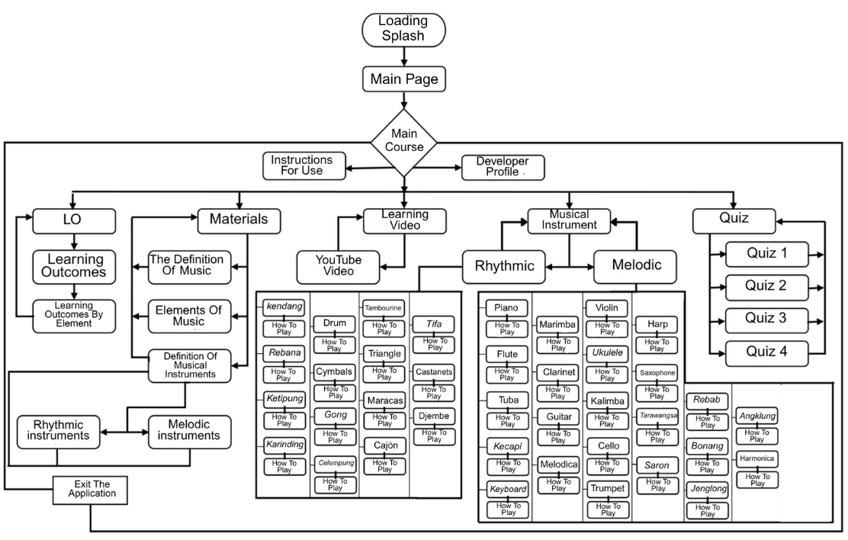
Figure 1: Flow of navigation and content structure in the MISDIS mobile application
Each pathway in the flowchart was deliberately constructed to support self-paced exploration, reduce cognitive load, and encourage engagement through interactivity and multimedia support. The visual structure helped guide the subsequent development of the user interface in SAC.

Creating the Storyboard
To complement the application’s flowchart and reinforce the consistency of the user interface, a detailed storyboard was developed to visualize the design of each screen in the MISDIS application. This storyboard outlines the layout, content placement, and interface elements for every major page, serving as a bridge between the MPF and the actual development in SAC.
The storyboard was created using Canva and reflects the design logic previously mapped in the flowchart. Each screen design includes both visual components and functional descriptions to ensure coherence with pedagogical goals and ease of use for primary school students. The storyboard also facilitates communication between instructional designers and developers, ensuring mutual understanding of layout and interaction expectations.
Each screen was designed with simplicity, readability, and child-friendly aesthetics in mind. Interface elements are organized vertically to accommodate the typical navigation behavior of young users on mobile devices. The structure and key elements of the storyboard for the initial screens of the application are presented below in Table 4.

Table 4: Screen Layout and Interface Descriptions for the Splash Screen, Main Page, and Main Menu
Num | Screen | Screen Design | Information
1 | Loading splash | 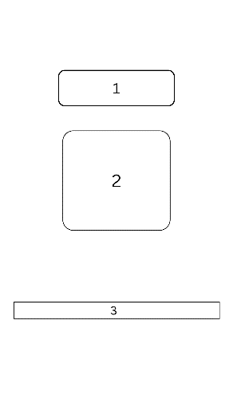 | - Application name  - Logo/image  - Introductory label
2 | Main Page | 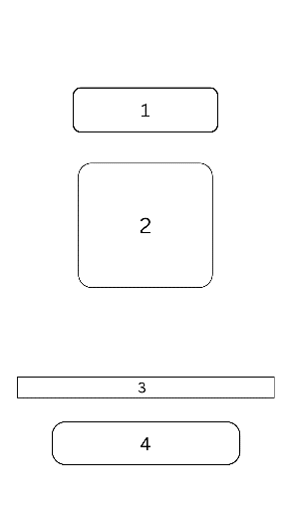 | - Application name  - Logo/image  - Introductory label  - Start/Menu button
3 | Main Menu | 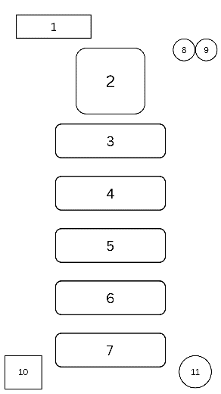 | - Main menu title  - Application logo  - Learning outcomes  - Instructional materials  - Learning videos  - Musical instruments  - Quizzes  - Play sound  - Pause sound  - Exit  - Developer profile
Each screen was designed with simplicity, readability, and child-friendly aesthetics in mind. Interface elements are organized vertically to accommodate the typical navigation behavior of young users on mobile devices.

Development

Interface Overview
Figure 2 below presents the finalized interface design of the MISDIS application, which was carefully crafted to be ready for validation and classroom implementation. With its user-friendly layout and visually engaging elements, the interface was designed to optimize the learning experience for primary school students.
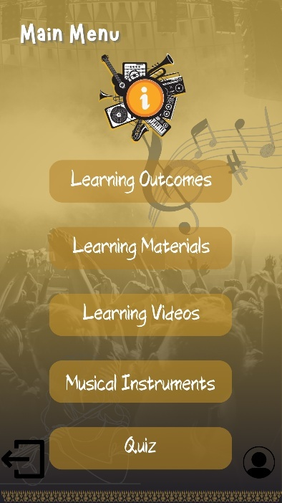 | 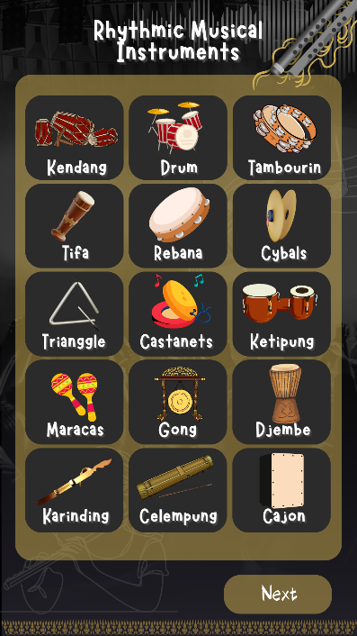 | 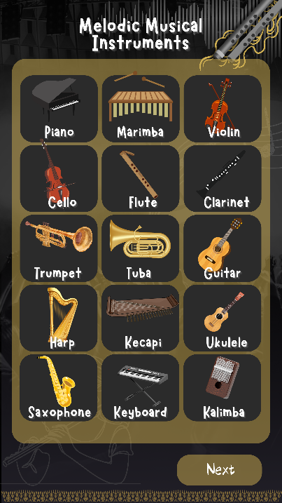
Note: The language in the MISDIS App is created in Indonesian and translated for international audiences.
Figure 2: Final Interface Overview of the MISDIS Application, Ready for Validation and Implementation

Design and Quality Validation
After the MISDIS application was fully developed and ready for classroom use, the next step involved expert judgment to evaluate its feasibility as an interactive learning media. The primary objective of this validation process was to assess whether the MISDIS application met the criteria for effective instructional media—particularly in terms of content relevance, visual presentation, technical quality, and pedagogical alignment. Validation was conducted by both media experts and content experts to ensure that the application addressed student needs and supported the achievement of intended learning outcomes.
Each evaluation criterion was established in advance and reflected best practices in multimedia learning. The expert feedback gathered during this stage served as a critical reference point for determining the final quality and readiness of the application for classroom implementation.
The media validation focused specifically on visual layout, navigation, interactivity, and technical aspects. Three media experts with diverse professional backgrounds were engaged to provide objective and comprehensive assessments. Each expert evaluated the application based on two main categories: Media Design Quality (maximum score: 30), and effectiveness (maximum score: 20). This yielded a maximum combined score of 50 points per validator.
Table 5
Media Design and Quality Validation Scores for the MISDIS Application
Validator | Media Design  (30 pts) | Media Quality  (20 pts) | Total Score  (50 pts) | Percentage | Category
Validator 1 | 28 | 20 | 48 | 96% | Highly Suitable for Use
Validator 2 | 27 | 20 | 47 | 94% | Highly Suitable for Use
Validator 3 | 29 | 20 | 49 | 98% | Highly Suitable for Use
The results of the media expert validation confirmed that the MISDIS application met a “Highly Suitable for Use” standard across all assessed criteria. The feedback also indicated strong consistency in the application's usability, visual coherence, and technical functionality. These results demonstrated that the application was well-suited for use as interactive media in classroom settings and supported further implementation trials with students.

Content Validation
In addition to media validation, the development of the MISDIS application also included content validation to ensure the instructional accuracy, relevance, and developmental appropriateness of the material provided. This validation aimed to evaluate the degree to which the content aligned with the intended learning outcomes, covered essential topics, and matched the cognitive and linguistic levels of primary school students.
Three content experts assessed the application using a set of predefined criteria across the following dimensions: Relevance (maximum score: 15), accuracy (maximum score: 20), and language Use (maximum score: 30). The total maximum score per validator was 65. The results of this validation are summarized in the following table 6.
Table 6: Content Expert Validation Scores for the MISDIS Application
Validator | Content Relevance  (15 pts) | Accuracy  (20 pts) | Language  (30 pts) | Total Score  (65 pts) | Percentage | Category
Validator 1 | 15 | 18 | 27 | 60 | 92.3% | Highly Suitable for Use
Validator 2 | 15 | 20 | 30 | 65 | 100% | Highly Suitable for Use
Validator 3 | 14 | 20 | 29 | 63 | 97% | Highly Suitable for Use
The average percentage across the three validators was 96.4%, placing the MISDIS content in the “Highly Suitable for Use” category. These results confirm that the instructional content—both in terms of substance and language—met academic standards and did not require any significant revisions prior to implementation. The content was judged to be accurate, complete, and appropriate for the learning level and objectives of Grade IV primary school students.

Implementation

Individual Testing
The first phase of implementation involved individual testing with three fourth-grade students selected for their ability to operate mobile devices independently. This stage aimed to obtain initial insights into the application's usability and instructional clarity based on students' direct experiences. Each student was asked to interact with the MISDIS application, explore its features (text, video, and quizzes), and then complete a 15-item questionnaire using a 5-point Likert scale.
Descriptive statistical analysis was conducted to evaluate the consistency and general perception of the application across various usability indicators. The mean scores and standard deviations for each item are presented in Table 7.
Table 7: Descriptive Statistics of Individual Student Responses
Statement | Mean | SD
The design of the MISDIS application is appealing and makes me more enthusiastic to learn. | 4.33 | 0.577
The color combination and resolution are pleasant and non-distracting. | 4 | 0
The illustrations and visuals clearly support the material. | 4.67 | 0.577
The navigation buttons and features are easy to use and function properly. | 4.33 | 0.577
The material presented is easy to understand. | 4 | 0
The material aligns with the accompanying visuals and videos. | 4.67 | 0,577
The content is structured logically and easy to follow. | 4 | 1
I enjoy learning with the MISDIS application. | 4.33 | 0.577
I experienced no difficulty during the installation process. | 4.33 | 0.577
I was able to use the application independently. | 4.33 | 0.577
I could easily access features like videos and quizzes. | 4 | 1
The video and audio quality is good and easy to understand. | 4 | 0
MISDIS increased my motivation and focus during learning. | 4.67 | 0.577
The language used in the application is easy to understand. | 4.67 | 0.577
The usage instructions are clearly explained. | 4 | 0
N = 3
The results indicate that student perceptions were highly positive, with most items scoring above 4.00 and standard deviations generally low, suggesting consistency across individual responses. The highest-rated items were related to visual support (M = 4.67), motivational impact (M = 4.67), and language clarity (M = 4.67), indicating that the application effectively engaged students and supported comprehension. The lowest standard deviation values (.000) for several items confirm unanimous agreement among students on aspects such as ease of understanding, visual comfort, and instructional clarity.
Following the descriptive analysis, individual total scores were calculated to assess overall practicality. Each student was evaluated based on their questionnaire responses, yielding the following results (see Table 8):
Table 8: Individual Student Usability Scores
Student | Total Score | Percentage | Category
Student 1 | 65 | 86.6% | Very Practical
Student 2 | 68 | 91.0% | Very Practical
Student 3 | 60 | 80.0% | Practical
Average | 64.3 | 86.0% | Very Practical
These scores confirm that two out of three students rated the application as "Very Practical," while one rated it as "Practical." With an overall average score of 86.0%, the application falls within the "Very Practical" category. These results support the conclusion that the MISDIS application is perceived positively by individual users, both in terms of usability and pedagogical value.

Small Group Testing
The second phase of implementation involved small group testing with twelve fourth-grade students. This phase aimed to assess the practicality and usability of the MISDIS application in a more collaborative learning environment, where students interacted with the application individually or in pairs. After using the application, students completed a 15-item usability questionnaire rated on a 5-point Likert scale, ranging from 1 ("Very Poor") to 5 ("Excellent").
Descriptive statistics were calculated to analyze students’ perceptions across various indicators related to interface design, ease of use, clarity of instructional content, and overall learning experience. The mean and standard deviation scores for each questionnaire item are presented in Table 9.
Table 9: Descriptive Statistics of Small Group Student Responses
Statement | Mean | SD
The design of the MISDIS application is appealing and makes me more enthusiastic to learn. | 4.42 | 0.669
The color combination and resolution are pleasant and non-distracting. | 4.00 | 1.206
The illustrations and visuals clearly support the material. | 4.67 | 0.492
The navigation buttons and features are easy to use and function properly. | 4.67 | 0.651
The material presented is easy to understand. | 4.33 | 0.778
The material aligns with the accompanying visuals and videos. | 4.58 | 0.669
The content is structured logically and easy to follow. | 4.50 | 1.168
I enjoy learning with the MISDIS application. | 4.50 | 0.674
I experienced no difficulty during the installation process. | 3.33 | 1.557
I was able to use the application independently. | 4.33 | 1.231
I could easily access features like videos and quizzes. | 4.17 | 1.267
The video and audio quality is good and easy to understand. | 4.92 | 0.289
MISDIS increased my motivation and focus during learning. | 4.67 | 0.492
The language used in the application is easy to understand. | 4.75 | 0.452
The usage instructions are clearly explained. | 4.92 | 0.289
N = 12
The results show that students rated the application highly across all dimensions. The highest mean scores were observed in "video and audio quality" and "clarity of instructions" (both 4.92), with very low standard deviations, indicating strong agreement and a consistently positive experience. The lowest mean score was for the installation process (M = 3.33; SD = 1.557), suggesting minor technical difficulties that may have been device-related.
To further assess the practicality of the application, the total scores for each student were converted to percentages and categorized according to standard interpretation criteria. The summary of student performance is provided in Table 10.
Table 10: Summary of Small Group Usability Testing Results
Score Range (%) | Number of Students | Category
81–100 | 10 | Very Practical
61–80 | 2 | Practical
These results demonstrate that the majority of students (83%) rated the application as "Very Practical," while the remaining students (17%) found it "Practical." The consistently high ratings reflect the application’s effectiveness in supporting student engagement, accessibility, and comprehension during music instruction. These findings suggest that the MISDIS application is highly practical for classroom implementation in small group settings, offering an intuitive and motivating learning experience.

Large Group Testing
The final phase of implementation involved large group testing with thirty fourth-grade students in a full classroom setting. This phase aimed to evaluate the scalability and overall practicality of the MISDIS application when used independently by a larger group of learners under teacher supervision. After interacting with the application during a structured session, students completed a 15-item usability questionnaire on a 5-point Likert scale, rating their experiences in terms of visual appeal, usability, content clarity, motivation, and accessibility.
Descriptive statistical analysis was performed to determine the general trends and consistency of student perceptions across the tested usability dimensions. Table 11 presents the mean scores and standard deviations for each questionnaire item.
Table 11: Descriptive Statistics of Large Group Student Responses
Statement | Mean | SD
The design of the MISDIS application is appealing and makes me more enthusiastic to learn. | 4.50 | 0.731
The color combination and resolution are pleasant and non-distracting. | 4.57 | 0.504
The illustrations and visuals clearly support the material. | 4.67 | 0.547
The navigation buttons and features are easy to use and function properly. | 4.73 | 0.521
The material presented is easy to understand. | 4.57 | 0.679
The material aligns with the accompanying visuals and videos. | 4.53 | 0.860
The content is structured logically and easy to follow. | 4.53 | 0.571
I enjoy learning with the MISDIS application. | 4.57 | 0.728
I experienced no difficulty during the installation process. | 3.87 | 0.973
I was able to use the application independently. | 4.57 | 0.898
I could easily access features like videos and quizzes. | 4.60 | 0.498
The video and audio quality is good and easy to understand. | 4.67 | 0.547
MISDIS increased my motivation and focus during learning. | 4.67 | 0.479
The language used in the application is easy to understand. | 4.77 | 0.504
The usage instructions are clearly explained. | 4.77 | 0.430
The analysis revealed strong user satisfaction, with most items scoring above 4.50 and low standard deviations, indicating consistent responses among the thirty students. The highest-rated items were “clarity of instructions” and “language clarity” (M = 4.77), while the lowest mean score was found in “ease of installation” (M = 3.87), suggesting occasional technical challenges. Nonetheless, the general trends point to a favorable user experience and strong alignment with student needs.
To assess the application’s overall practicality at scale, total scores from student responses were converted to percentages and categorized according to established benchmarks. Table 12 provides a summary of student response distribution.
Table 12: Summary of Large Group Usability Testing Results
Score Range (%) | Number of Students | Category
81–100 | 28 | Very Practical
61–80 | 2 | Practical
The results indicate that 93% of the students categorized the MISDIS application as “Very Practical,” with the remaining 7% rating it as “Practical.” This high level of acceptance across a large and diverse group of learners reinforces the scalability of the MISDIS application and its effectiveness in supporting interactive and engaging music instruction in primary schools.

Evaluation

Validation and Implementation Outcomes
This subsection presents the results of expert validation and implementation testing as the basis for assessing the technical and pedagogical soundness of the MISDIS application. Validation by media experts yielded an average score of 96%, indicating that the application's interface design, navigation, interactivity, and technical quality were highly suitable for use in educational settings. Content validation by subject-matter experts resulted in an average score of 96.4%, confirming the instructional relevance, accuracy, and language appropriateness of the material for primary school learners.
Implementation testing was carried out with students across three different formats: individual, small group, and large group. In individual trials, 86.0% of students rated the application as “Very Practical,” while in small group trials, 10 of 12 students (83%) gave the same rating. In the large group setting, 28 of 30 students (93%) rated it “Very Practical,” confirming the application’s positive reception across varying contexts. The consolidated results of these stages are shown in Table 13.
Table 13: Summary of Evaluation Results
Evaluation Aspect | Validation Source | Score (%) | Category
Media Design & Technical Quality | Media Experts | 96 | Highly Suitable for Use
Content Relevance & Accuracy | Content Experts | 96.4 | Highly Suitable for Use
Usability – Individual Testing | Student Responses | 86.0 | Very Practical
Usability – Small Group | Student Responses | 89.0 | Very Practical
Usability – Large Group | Student Responses | 91.0 | Very Practical
In addition, several refinements were made based on feedback from expert validators prior to implementation. These included the addition of usage and quiz instructions, the adjustment of background colors for better visual comfort, improvements to the visibility of navigation elements, and simplification of language to better align with the comprehension levels of primary school students.

Effectiveness of the MISDIS Application
The effectiveness of the MISDIS application as an educational tool can be inferred from the convergence of three key indicators: expert validation scores, student usability responses, and the successful integration of revision feedback. High scores from both media and content experts confirmed that the application meets the necessary criteria for technical quality and pedagogical appropriateness. Moreover, the consistently positive responses from students across all testing stages affirm the application's practicality and ability to engage learners in a meaningful way.
The improvements made in response to expert suggestions—such as clarifying instructions, improving interface contrast, and adjusting language complexity—enhanced the overall user experience. Importantly, no major revisions were required following the validation process, indicating that the initial development cycle had successfully anticipated and addressed most pedagogical and usability concerns.
Taken together, these outcomes suggest that the MISDIS application is not only valid and practical but also effective in supporting the intended learning outcomes. It can be confidently recommended for use in primary school music education, particularly for introducing rhythmic and melodic instruments through interactive, multimedia-based instruction.

Discussion
The integration of interactive digital media in primary school music education is essential, especially when traditional methods may not fully engage students or provide immersive learning experiences. The MISDIS application exemplifies this approach, utilizing the ADDIE model to create multimedia-rich content that fosters auditory and tactile involvement in learning musical concepts. Research supports the use of multimedia, indicating that combining audio-visual tools enhances student engagement and retention of information in music education contexts (Ismara et al., 2021; Kartika et al., 2023; Yang, 2023). Furthermore, multimedia facilitates diverse learning styles, ensuring that instructional design caters to a wider range of sensory preferences and enhances students' understanding and enjoyment of music (Astiti et al., 2024; Esteve-Faubel et al., 2023). By transforming abstract concepts into interactive learning experiences, MISDIS not only addresses prior pedagogical limitations but also promotes a more immersive and effective music education for young learners (Dasovich-Wilson et al., 2022; Herianto & Wilujeng, 2021).
Validation results from both media and content experts indicate that the MISDIS application demonstrates a high feasibility level, scoring an average exceeding 96% in usability, content accuracy, and pedagogical alignment. This supports claims that MISDIS adheres to robust academic and technical standards requisite for effective classroom integration (Damaševičius & Sidekerskienė, 2024). In student trials conducted across varying group sizes, ratings for usability consistently surpassed 85%, further affirming the application's practicality and accessibility (Cheung et al., 2021). Notably, student feedback highlighted positive experiences tied to the visual appeal and navigational simplicity of the application, reflecting its motivational value and functionality (Sharma & Gupta, 2022). Such findings underline the efficacy of MISDIS in enhancing learning experiences through engaging pedagogical strategies aligned with technological advances (Reilly & Reeves, 2022).
The effectiveness of the MISDIS application is substantiated through expert validation, student usability trials, and the incorporation of revision feedback. Expert evaluations confirmed that MISDIS adhered to formal instructional standards and was congruent with the cognitive capacities of fourth-grade learners, thus supporting its educational validity (Umamah et al., 2023). Student usability trials demonstrated that learners could independently navigate the application and engage meaningfully with the content, indicating its user-friendliness and pedagogical effectiveness (Yeo & Jang, 2022). Moreover, the integration of feedback into the learning process—whereby students utilized audio-visual aids and gamification elements—enhanced their understanding of musical concepts significantly more than traditional methods. This aligns with findings that highlight the role of feedback mechanisms in fostering learning (Blouin et al., 2023; Hwang et al., 2023). Such an immersive framework thereby not only supports knowledge retention but also encourages students to reflect upon their learning and make necessary adjustments, demonstrating the role of adaptive learning environments (Tay & Lam, 2022).
The findings underscore the significance of a learner-centered approach in educational technology, wherein the integration of multimedia and iterative refinement based on user feedback enhances digital learning tools. This aligns with literature that emphasizes the necessity for educators to possess digital competencies to foster effective technology-based learning environments. For instance, it is critical for teachers to engage with digital tools in ways that support participatory learning and continuous feedback mechanisms for students (Aydın et al., 2024). Despite minor technical issues such as delays in video loading on older devices, these challenges were managed during the application's development, highlighting the importance of adaptability in educational tools (Songkram et al., 2023). Additionally, the MISDIS application's compatibility with widely used devices like Android smartphones facilitates its broader implementation across diverse educational settings, enhancing accessibility (Canese et al., 2022).
The MISDIS application represents a valuable contribution to the field of technology-enhanced music education for primary students. It demonstrates how locally developed, curriculum-aligned mobile media can bridge the gap between theoretical content and experiential learning, particularly in resource-constrained environments. The strong expert endorsements, favorable student responses, and evidence of learning support suggest that the application is not only valid and practical but also effective in achieving its instructional goals. As such, MISDIS may serve as a model for future efforts to integrate interactive digital media into primary-level arts education, fostering deeper engagement, motivation, and conceptual understanding among young learners.

Conclusion
This study developed and evaluated the MISDIS application, an Android-based interactive learning media designed to introduce primary school students to rhythmic and melodic musical instruments. Using the ADDIE model as the instructional design framework and SAC as the development platform, the application was validated by media and content experts and tested with fourth-grade students in individual, small group, and large group settings. The results demonstrate that the MISDIS application is highly suitable for use in classroom instruction, with expert validation scores averaging over 96% and student usability ratings consistently categorized as "Very Practical" across implementation stages. The application was found to be visually appealing, easy to navigate, and effective in enhancing students’ motivation and conceptual understanding of music. The integration of multimedia components such as videos, audio, and interactive quizzes contributed significantly to the application’s success in supporting multimodal and learner-centered instruction.
Despite these promising outcomes, several limitations must be acknowledged. First, the study was conducted in a single school with a limited number of participants, which may affect the generalizability of the findings. Second, the application was tested on Android devices only, which may limit its accessibility for users of other platforms such as iOS. Third, the study relied primarily on descriptive statistical analysis; more robust measures of learning outcomes, such as pre- and post-tests, were not employed.
Future research should explore the long-term impact of the MISDIS application on students' musical skills and learning retention. Comparative studies involving control and experimental groups, as well as diverse school settings, would provide deeper insights into its instructional effectiveness. In addition, expanding the application to cover broader music topics—such as vocal training, notation literacy, and ensemble performance—could enhance its pedagogical reach. Finally, efforts to develop cross-platform versions and integrate teacher-guided modules could further increase its scalability and adoption in diverse educational contexts.

References
Arisanti, D., Derlina, D., & Rahmatsyah, R. (2022). Tool development effectiveness display mirrors and lenses (multi shapes) as a physics learning media with addie design. Jurnal Ilmiah Pendidikan Fisika, 6(2), 403–410. https://doi.org/10.20527/jipf.v6i2.5483
Astiti, P. J., Parwati, N. N., Tegeh, I. M., & Sudarma, I. K. (2024). Multiple intelligences-based interactive multimedia to improve students’ multiple intelligences in kindergarten. Journal of Education Technology, 8(1), 194–204. https://doi.org/10.23887/jet.v8i1.73411
Aydın, M., Yıldırım, T., & Kuş, M. (2024). Teachers’ digital competences: a scale construction and validation study. Frontiers in Psychology, 15, 1–13. https://doi.org/10.3389/fpsyg.2024.1356573
Aydιn, A., Gürsoy, A., & Karal, H. (2023). Mobile care app development process: using the addie model to manage symptoms after breast cancer surgery (step 1). Discover Oncology, 14(1), 1–10. https://doi.org/10.1007/s12672-023-00676-5
Barton, G., & Riddle, S. (2021). Culturally responsive and meaningful music education: multimodality, meaning-making, and communication in diverse learning contexts. Research Studies in Music Education, 44(2), 345–362. https://doi.org/10.1177/1321103x211009323
Birch, H. J. S. (2023). Inviting music students to identify as content creators to encourage participation and learning. Iadis International Journal on WWW/Internet, 20(2), 1–15. https://doi.org/10.33965/ijwi_2023210201
Blouin, V., Bénard, F., Pelletier, F., Abdo, S., Meloche‐Dumas, L., Kapralos, B., Dubrowski, A., & Patocskai, É. (2023). Optimizing the learner’s role in feedback: development of a feedback-preparedness online application for medical students in the clinical setting. Cureus, 15(5), article-e38722. https://doi.org/10.7759/cureus.38722
Bruin, L. d. (2021). Instrumental music educators in a covid landscape: a reassertion of relationality and connection in teaching practice. Frontiers in Psychology, 11, 1–12. https://doi.org/10.3389/fpsyg.2020.624717
Canese, V., Mereles, J. I., & Amarilla, J. (2022). Changes in educational adaptation during the covid-19 pandemic in Paraguay, 2020-2021. Religación Revista De Ciencias Sociales Y Humanidades, 7(34), article-e210989. https://doi.org/10.46652/rgn.v7i34.989
Cao, H. (2021). Innovation and practice of music education paths in universities under the popularity of 5G network. Wireless Communications and Mobile Computing, 2021, article-3570412. https://doi.org/10.1155/2021/3570412
Cheung, S. K. S., Wang, F. L., & Kwok, L. F. (2021). The continuous pursuit of smart learning. Australasian Journal of Educational Technology, 37(2), 1–6. https://doi.org/10.14742/ajet.7207
Chukwuemeka, E. J., & Garba, M. (2024). Technology as a catalyst for learning and unlearning: a tool for navigating education in a dynamic society. European Journal of Interactive Multimedia and Education, 5(2), article-e02404. https://doi.org/10.30935/ejimed/15640
Crompton, H., Jones, M., Sendi, Y., Aizaz, M., Nako, K., Randall, R. S., & Weisel, E. W. (2023). Examining technology use within the addie framework to develop professional training. European Journal of Training and Development, 48(3/4), 422–454. https://doi.org/10.1108/ejtd-12-2022-0137
Dai, D. (2021). Artificial intelligence technology assisted music teaching design. Scientific Programming, 2021, 1–10. https://doi.org/10.1155/2021/9141339
Damaševičius, R., & Sidekerskienė, T. (2024). Virtual worlds for learning in metaverse: a narrative review. Sustainability, 16(5), article-2032. https://doi.org/10.3390/su16052032
Dasovich-Wilson, J. N., Thompson, M. R., & Saarikallio, S. (2022). Exploring music video experiences and their influence on music perception. Music & Science, 5, 1–18. https://doi.org/10.1177/20592043221117651
Emmons, M., & Nagy, D. Á. (2016). Welcoming our new sac members [student’s corner]. IEEE Robotics and Automation Magazine, 23(2), 90–92. https://doi.org/10.1109/MRA.2016.2550999
Esteve-Faubel, J.-M., Botella-Quirant, M. T., & Esteve-Faubel, R. P. (2023). Use of animated stories to improve music education practices of trainee primary school teachers in Spain. British Journal of Music Education, 41(1), 87–102. https://doi.org/10.1017/s0265051723000244
Fahru, A. R. S., Astija, A., & Jamhari, M. (2023). Development of canva application-based learning media on excretion system in mts an-nur buuts school, palu. International Journal of Social Science and Human Research, 6(9), 5405–5409. https://doi.org/10.47191/ijsshr/v6-i9-07
Fan, K. Y. K., Lo, P., Ho, K. K., So, S., Chiu, D. K., & Ko, E. (2020). Exploring the mobile learning needs amongst performing arts students. Information Discovery and Delivery, 48(2), 103–112. https://doi.org/10.1108/idd-12-2019-0085
Fitrianingsih, A., Hasanudin, C., Fitriyana, N., & Saadoon, A. (2023). Developing website-based learning media to improve students’ 5cs skills. Al-Ishlah Jurnal Pendidikan, 15(4), 4772–4780. https://doi.org/10.35445/alishlah.v15i4.4504
Gheitasi, M., Arnedo-Moreno, J., Hermon, S., & Schnabel, M. A. (2023). Gaming the past– commercial video games with historical contexts: evaluation of the iranian lotf ali khan game. Journal of Games Game Art and Gamification, 8(1), 24–36. https://doi.org/10.21512/jggag.v8i1.9874
Gondwe, F. (2021). Technology professional development for teacher educators: a literature review and proposal for further research. Sn Social Sciences, 1(2021), article-200. https://doi.org/10.1007/s43545-021-00184-9
Gunawardena, C. N. (2020). Culturally inclusive online learning for capacity development projects in international contexts. Journal of Learning for Development, 7(1), 5–30. https://doi.org/10.56059/jl4d.v7i1.403
Herianto, H., & Wilujeng, İ. (2021). Increasing the attention, relevance, confidence and satisfaction (arcs) of students through interactive science learning multimedia. Research in Learning Technology, 29, 1–13. https://doi.org/10.25304/rlt.v29.2383
Hwang, W., Nurtantyana, R., Purba, S. W. D., Hariyanti, U., Indrihapsari, Y., & Surjono, H. D. (2023). AI and recognition technologies to facilitate english as foreign language writing for supporting personalization and contextualization in authentic contexts. Journal of Educational Computing Research, 61(5), 1008–1035. https://doi.org/10.1177/07356331221137253
Ismara, K. I., Suharjono, A., & Supriadi, D. (2021). Ubiquitous Learning in Occupational Health and Safety for Vocational Education. International Journal of Evaluation and Research in Education (Ijere), 10(1), 285–292. https://doi.org/10.11591/ijere.v10i1.20823
Jian, Z. (2022). Sustainable engagement and academic achievement under impact of academic self-efficacy through mediation of learning agility—evidence from music education students. Frontiers in Psychology, 13, article-899706. https://doi.org/10.3389/fpsyg.2022.899706
Jones, M. S., Main, M. E., Garrett-Wright, D., Malin, C., & Pennington, A. (2021). Mental health issues among farmers: an online continuing education program for nurses. The Journal of Continuing Education in Nursing, 52(10), 482–488. https://doi.org/10.3928/00220124-20210913-08
Kameneva, I. (2021). The actual questions of the realization of the personality-oriented educational paradigm in the context of digitalization. E3s Web of Conferences, 273, 12060. https://doi.org/10.1051/e3sconf/202127312060
Kartika, I. M., Sila, I., Priantini, D. A. M. M. O., Suastra, I. W., & Arnyana, I. B. P. (2023). Role play game-based learning multimedia for elementary school students. Jurnal Pendidikan Dan Pengajaran, 56(1), 1–10. https://doi.org/10.23887/jpp.v56i1.60734
Lan, X. (2022). Construction of a music education model based on internet big data. Wireless Communications and Mobile Computing, 2022, 1–6. https://doi.org/10.1155/2022/3732776
Lee, L., & Liu, Y.-S. (2021). Use of decision trees to evaluate the impact of a holistic music educational approach on children with special needs. Sustainability, 13(3), article-1410. https://doi.org/10.3390/su13031410
Li, K. (2023). A comparative study of the music education systems of china and the united states. Journal of Education Humanities and Social Sciences, 23, 178–183. https://doi.org/10.54097/ehss.v23i.12873
Liu, Y., & Shi, Y. (2023). Digital transformation of college teacher education from the perspective of behaviorist psychology: initiatives, effectiveness and pitfalls. Applied Mathematics and Nonlinear Sciences, 9(1), 1–15. https://doi.org/10.2478/amns.2023.2.01598
Mohammed, I. J. (2021). Evaluation in instructional design. Journal of Al-Frahedis Arts, 13(44), 375–391. https://doi.org/10.51990/jaa.13.44.1.19
Mulenga, E. T., Yan, T., & Teng, D. (2021). Contemporary problems and solutions for early childhood music education in Zambia. International Journal of Visual and Performing Arts, 3(1), 53–61. https://doi.org/10.31763/viperarts.v3i1.340
Ni, X. Y., & Chen, X. (2024). Characteristics and development trends of internet plus music education. International Journal of Web-Based Learning and Teaching Technologies, 19(1), 1–14. https://doi.org/10.4018/ijwltt.355249
Ntalindwa, T., Nduwingoma, M., Karangwa, E., Soron, T. R., Uworwabayeho, A., & Uwineza, A. (2021). Development of a mobile app to improve numeracy skills of children with autism spectrum disorder: participatory design and usability study. Jmir Pediatrics and Parenting, 4(3), article-e21471. https://doi.org/10.2196/21471
Nwizu, U., Sariem, C. N., & Malhotra, J. (2023). Training Nigerian pharmacy interns for leadership and clinical pharmacy advancement using the addie method of instructional design. Pharmacy Education, 22(4), 143–149. https://doi.org/10.46542/pe.2022.224.143149
Oliynyk, V. V, Gushchyna, N. I., Kondratova, L., & Касьян, С. П. (2024). Developing digital competence of teachers in postgraduate education using google workspace for education. Cte Workshop Proceedings, 11, 356–380. https://doi.org/10.55056/cte.662
Özer, Z., & Demirbatır, R. E. (2023). Examination of steam-based digital learning applications in music education. European Journal of Stem Education, 8(1), 1–11. https://doi.org/10.20897/ejsteme/12959
Park, J. H., & Seo, Y.-J. (2024). Analysis of video contents for teaching and learning used in school music classes. Asia-Pacific Journal of Convergent Research Interchange, 10(2), 639–649. https://doi.org/10.47116/apjcri.2024.02.49
Park, M., & Huffman, S. (2020). Developing an aeronautical english training unit based on the addie model in an efl context. The Especialist, 41(4), 1–26. https://doi.org/10.23925/2318-7115.2020v41i4a6
Pugacheva, N. B., Кириллова, Т. В., Kirillova, O., Luchinina, A., Korolyuk, I., & Lunev, A. (2020). Digital paradigm in educational management: the case of construction education based on emerging technologies. International Journal of Emerging Technologies in Learning (Ijet), 15(13), 96–115. https://doi.org/10.3991/ijet.v15i13.14663
Reilly, C., & Reeves, T. C. (2022). Refining active learning design principles through design-based research. Active Learning in Higher Education, 25(1), 81–100. https://doi.org/10.1177/14697874221096140
Riboldi, I., Calabrese, A., Piacenti, S., Capogrosso, C. A., Paioni, S. L., Bartoli, F., Carrà, G., Armes, J., Taylor, C., & Crocamo, C. (2024). Understanding university students’ perspectives towards digital tools for mental health support: a cross-country study. Clinical Practice and Epidemiology in Mental Health, 20(1), 1–13. https://doi.org/10.2174/0117450179271467231231060255
Saeidnia, H. R., Kozak, M., Ausloos, M., Herţeliu, C., Mohammadzadeh, Z., Ghorbi, A., Karajizadeh, M., & Hassanzadeh, M. (2022). Development of a mobile app for self-care against covid-19 using the analysis, design, development, implementation, and evaluation (addie) model: methodological study. Jmir Formative Research, 6(9), article-e39718. https://doi.org/10.2196/39718
Sánchez-García, J. R., Galeana-Victoria, L. G., Azcanio, N. P. F., & Vázquez, E. S. (2023). ADDIE model as a methodology for the design of distance courses. Revista De Tecnología Informática, 30(10), 16–26. https://doi.org/10.35429/jit.2023.30.10.16.26
Sera, M. A., Situmorang, R., & Siregar, E. (2021). Curriculum development for the subject of “jadi pendamping adik” in grade x of senior high school. Journal of Education Research and Evaluation, 5(2), 200–207. https://doi.org/10.23887/jere.v5i2.32416
Shakeel, S. I., Mamun, M. A. A., & Haolader, M. F. A. (2022). Instructional design with addie and rapid prototyping for blended learning: validation and its acceptance in the context of tvet Bangladesh. Education and Information Technologies, 28(6), 7601–7630. https://doi.org/10.1007/s10639-022-11471-0
Sharma, S., & Gupta, B. (2022). Investigating the role of technostress, cognitive appraisal and coping strategies on students’ learning performance in higher education: a multidimensional transactional theory of stress approach. Information Technology and People, 36(2), 626–660. https://doi.org/10.1108/itp-06-2021-0505
Shin, J. (2023). Korean preservice music teachers’ perceptions of blended learning in music education course. International Journal of Music Education, 43(2), 135–146. https://doi.org/10.1177/02557614231182166
Shroff, A., Roulston, C. A., Fassler, J., Dierschke, N. A., Todd, J. S. P., Ríos-Herrera, Á., Plastino, K. A., & Schleider, J. L. (2023). A digital single-session intervention platform for youth mental health: cultural adaptation, evaluation, and dissemination. Jmir Mental Health, 10, article-e43062. https://doi.org/10.2196/43062
Silva, A. J. P. da, & Arroio, A. (2022). The role of time in the use of visualization in chemical education: pre-service teacher practices. Journal of Turkish Science Education, 19(3), 786–807. https://doi.org/10.36681/tused.2022.150
Songkram, N., Chootongchai, S., Thanapornsangsuth, S., Osuwan, H., Piromsopa, K., Chuppunnarat, Y., & Songkram, N. (2023). Success factors to promote digital learning platforms: an empirical study from an instructor’s perspective. International Journal of Emerging Technologies in Learning (Ijet), 18(09), 32–48. https://doi.org/10.3991/ijet.v18i09.38375
Sularso, S., Yu, Q., Pranolo, A., & P, C. H. (2024). Advancing computer science in education: integrating digital music technology into elementary school music programs. E3s Web of Conferences, 501, 01019. https://doi.org/10.1051/e3sconf/202450101019
Sun, L., & Wang, Q. (2024). Music teaching strategy and educational resource sharing based on big data. Journal of Computational Methods in Sciences and Engineering, 24(4–5), 2391–2407. https://doi.org/10.3233/jcm-247462
Tammets, K., Khulbe, M., Sillat, L. H., & Ley, T. (2022). A digital learning ecosystem to scaffold teachers’ learning. Ieee Transactions on Learning Technologies, 15(5), 620–633. https://doi.org/10.1109/tlt.2022.3198739
Tang, L. (2024). Exploration of multimodal teaching methods in emotionally empowered music education. Arch. Sci., 74(s2), 71–80. https://doi.org/10.62227/as/74s29
Tang, W.-L., Tsai, J.-T., & Huang, C.-Y. (2020). Inheritance coding with gagné-based learning hierarchy approach to developing mathematics skills assessment systems. Applied Sciences, 10(4), article-1465. https://doi.org/10.3390/app10041465
Tay, H. Y., & Lam, K. W. L. (2022). Students’ engagement across a typology of teacher feedback practices. Educational Research for Policy and Practice, 21(3), 427–445. https://doi.org/10.1007/s10671-022-09315-2
Tran, T., Ho, M., Pham, T.-H., Nguyen, M., Nguyen, K.-L. P., Vuong, T., Nguyen, T.-H. T., Nguyen, T.-D., Linh, N. T., Khuc, Q. V, La, V., & Vuong, Q. (2020). How digital natives learn and thrive in the digital age: evidence from an emerging economy. Sustainability, 12(9), article-3819. https://doi.org/10.3390/su12093819
Umamah, N., Maharani, Z. I. A., Alfarisi, R., Sumardi, & Marjono, M. (2023). Research and development of self-regulated learning (srl)-based e-module on student independence in history learning. International Journal of Academic Research in Progressive Education and Development, 12(4), 521–536. https://doi.org/10.6007/ijarped/v12-i4/19811
Yang, J. (2023). Research on music education: integrating synaesthesia theory and colour psychology. HTS Teologiese Studies / Theological Studies, 79(4), 1–6. https://doi.org/10.4102/hts.v79i4.8848
Yeo, J., & Jang, M. S. (2022). Nursing students’ self‐directed learning experiences in web‐based virtual simulation: a qualitative study. Japan Journal of Nursing Science, 20(2), article-e12514. https://doi.org/10.1111/jjns.12514
Yusoff, S. M., Marzaini, A. F. M., Hassan, M. H., & Zakaria, N. (2023). Investigating the roles of pedagogical content knowledge in music education: a systematic literature review. Malaysian Journal of Music, 12(2), 95–114. https://doi.org/10.37134//mjm.vol12.2.6.2023
Zhang, Y., & Ding, Y. (2021). A new music teaching mode based on computer automatic matching technology. International Journal of Emerging Technologies in Learning (Ijet), 16(16), 117–130. https://doi.org/10.3991/ijet.v16i16.24895
Σπατιώτη, Α. Γ., Kazanidis, I., & Pange, J. (2022). A Comparative study of the addie instructional design model in distance education. Information, 13(9), article-402. https://doi.org/10.3390/info13090402

