DEITIES, POLITICS AND ECONOMY IN CONTEMPORARY IGBO COMMUNITY: APPRASING THE INFLUENCE OF NNUMU-KWOME DIETY ON THE POLITICS AND ECONOMY OF NSUKKA-IGBO, ENUGU STATE, NIGERIA

**Abstract**

Although, the Igbo in their traditional religiosity have quite a number of deities, gods, and goddesses, many of these gods and their worship centres have been lost to history. The worship of these gods was forced to disappear on account of the massive Christianisation of the land, as well as the intensified charismatic churches direct confrontations with the traditional religious practices of the people. But in the Obukpa community of Nsukka, Enugu State, the Nnumu-Kwome deity is growing in fellowship against all odds and attracting patronage from, especially, the Nsukka political class and youths. This study interrogates the resilience of the Nnumu-Kwome deity of the Obukpa community and sheds light on its intriguing role as a driver of democratic political activities in Nsukka, Enugu State, Nigeria.It does thisrelying on surveys, case studies, historical analysis, and ethnographic research methodologies conducted in Obukpa between January and December 2020. Different genres of secondary sources of literature were also utilised. The findings are that the Nnumu-Kwome deity is a generous provider of wealth and a powerful ancestral instrument of protection and instant justice.

**Keywords:** Nnumu-Kwome Deity, Traditional Religion, Nsukka, Politics, Igboland.

**Introduction**

The Igbo have quite a number of deities, gods, and goddesses with their varied elemental spirits (Ifesieh, 1989). In Igboland, deities were one of the features in determining the development, achievement, and advancement of an Igbo society before the penetration of the colonial authorities in the various hinterlands of the communities (Arinze, 1970; Ikenga-Metuh, 1981). There are over one hundred deities in Igboland. The Igbo believed that these deities, which were represented by stones, forests, rivers, animals, rocks, and woods, among others, have life and were the abode of life (Anyika, 1988). To the Igbo, these deities were communicated with through appropriate rituals (Afigbo, 1956; Anyika, 1988).

Therefore, the Igbo, besides believing in the existence of a Supreme Being—Chineke (the creator) or Chiukwu (the Great God)—also had faith in the existence of other minor gods. To Okoro Onyishi, “Although the Nnumu-Kwome priests are the servants of the lesser god, they are powerful servants also. In Obukpa custom, people approached the big man through his closest friend, the Nnumu-Kwome (personal communication, March 3rd, 2020).To the Igbo, there is an unbreakable organic link between its economic and political systems and the forces of these spirits, or minor gods. Their relationships with these gods or deities were often seen as contractual, and that contract remained valid and binding to the parties if it was observed without breach (Igboanuzue, 2012). As Ilogu (1985) averred, in every village a priest was known to be specifically related to one or more gods. When a diviner prescribed a sacrifice, he also named the proper priest or shrine that should perform the function. With Christianity, these traditional religious beliefs and observances of the people were almost wholly destroyed.

Among the Obukpa community of Nsukka-Igbo in Enugu State, Nigeria, is found the Nnumu-Kwome deity. The Nnumu-Kwome deity is a warrior goddess created by the Obukpa community to help them in fighting their wars of expansion (Ugwoke, 2011).In the words of Ugwu (1997, p. 25), “Nnumu-Kwome is the goddess of good fortune, compassion, prosperity, justice, and long life.” Historically, the Christianisation of Northern Igboland from 1917 dealt a terrible blow to the people’s traditional religiosity, but the Nnumu-Kwome deity has continued to thrive and to wax from strength to strength. This study investigates the factors behind today’s growing fellowship and wide patronage the Nnumu-Kwome deity enjoys, especially from the youths and the political class of the Nsukka Division. The survey tends to present a holistic understanding of the political and economic relevance of this deity as cultural heritage.

By exploring the deity’s place in Nigerian politics, one would be shedding light on the integral role of intangible cultural heritage in shaping contemporary economic and political power dynamics in Nigeria. Indeed, the relevance of this study lies in the fact that through this exploration, we would be uncovering the deep and intricate relationship between cultural heritage, contemporary politics, and the economy in Nigeria. Presently, there is little or no documentary information yet on deities, politics, and the economy in Igboland in the 21st century, except for a few sketchy magazine publications. The study will help one gain insight into today’s meaning and significance of deities in contemporary African societies and how the people have incorporated the deities into their present belief systems and economic and political activities. This research will deepen human understanding of the complex and dynamic relationships between religion, culture, and society. It will also offer insight into the people’s syncretic expressions of their spirituality in this era of massive Christianisation, globalisation, and modernisation.

Obukpa is the most northern neighbour of Nsukka Urban (the seat of the University of Nigeria) and one of the communities that make up the Nsukka Local Government Area of Enugu State of Nigeria. The Obukpa community is a federation of three administrative and political units, which include Ejuona, Owerre, and Obige. The Obukpa community is hemmed in by seven towns. In the south are Nsukka and Ero-Ulo; in the east are Orba and Ovoko; in the north are Iheakpu-Awka and Ibagwa-Aka; and in the west, the community is flanked by Ibagwa-Ani and Okpaligbo. Obukpa is one of the most densely populated towns in the Nsukka Local Government Area of Enugu State. The 1996 census put the Obukpa population at 20,056 (Ugwu, 1997, p. 36).

**Literature Review**

This paper reviews relevant literature on religion and deities, especially in Nsukka and Igboland, to shed light on the various grounds that have been covered by previous scholars and the need for the present study. A literature review was conducted here not only to familiarise oneself with the information on the topic area under investigation but also to help one develop the methodologies required in conducting the research.

Stanton and Stroumsa (1998), discussing the place of religion in the life of humanity, began by exploring the origins of religion. According to the authors looking back to history, religion started from the beginning of time when man started to lead his life guided by something other than instinct. Laursen lending a voice to the origin of religion, added, “Religion seems to have begun when man started feeling the need to acknowledge, to see, to feel that something greater than him exists(1999:64).” Forward Martins (2001) defines religion as the veneration and worship of divine realities guided by a set of norms and beliefs. It is the unanimous testimony of both the social sciences—anthropology, sociology, psychology, and phenomenology—and the humanities that religion is a universal phenomenon. As Eze (2022) avers, religion so permeates culture and social order that culture and social order find their ultimate sanction in religion. In the words of Eze, religion in Nigeria is a triple heritage. The three major religious groups in Nigeria are Christianity, Islam, and African Traditional Religion (2022:12).

Deities are the gods of veneration of African Traditional Religion (ATR) adherents. ATR is the religion indigenous to Africa and Africans, the religion of the soil. It is unique among other religions because it is one without a founder and has no devotion to human or semi-human heroes, no prophet, or messiah. The origin or beginning of ATR is lost in prehistory, reaching down to the aborigines of the human race. It is believed that from the moment Homo sapiens graduated into a true man, in the Old Stone Age, traditional religion was born. Several millennia before Moses accused traditional religion of idol worship, in protest of which he founded Judaism in 1,300 BC, the world knew only one religion—the traditional religion.

On the impact of deities on Igbo society before colonialism, Arinze (1970), Ikenga Metuh (1981), and Ogbu (2003) postulate that deities were the reason for the numerous agricultural outputs enjoyed in the Igbo society in the pre-colonial times. To the authors, the present economic scourge in the African society is as a result of the total neglect of the worship of deities on account of the influence of Christianity. Isiani (2019), contributing to the impact of deities on the African society in the pre-colonial times, noted that deities assisted African communities in wars, played judicial roles, and helped in the peaceful co-existence of the people.

As Magnus Aniago (2015) argues that the Igbo people are deeply religious, and that the people’s religious beliefs are intertwined with their social, political, and economic life. The presence of gods, goddesses, and spirits and the need to always consult with them prompted the erection of shrines for the deities. Such shrines were often erected at the foot of very big trees, beside a stream, a river, or in the middle of a very thick forest.

Ojo (2014) conducted a study on the functionalities and duties of African deities. In his study entitled, “Incorporation of Ayelala Traditional Religion into Nigeria’s Criminal Justice System: An Opinion Survey of Igbesa Community People in Ogun State, Nigeria,” the author x-rays the duties of African deities in the communities. To the author, one of the fundamental duties of deities to the African people is seen in its ability to punish an offender promptly.

Ogunbado (2012), in his study entitled “Impact of Colonialism on Religion: An Experience of South Western Nigeria,” shows how colonialism affected deities or traditional worship in South Western Nigeria. To the author, European religion (Christianity) greatly affected the people’s political, religious, social, cultural, and economic lives. While the author believed that Christianity had a lot of negative consequences on the African deities, he acknowledges that the introduction of the new religion helped in the eradication of human sacrifices, the killing of twins, and other social ills on the continent.

Afigbo (1979), in his article, “Nsukka Before 1916: The Making of a Frontier Igbo Society,” provides us background information on the evangelisation of the Nsukka group of villages. According to him, at Eha-Alumona, Chief Attama Nwanba, who was friendly with Chief Onyeama of Eke, used Onyeama’s good offices to request a Roman Catholic priest for his community in 1919. From here, Chief Ugwu Abonyi Asogwa of Obollo-Afor expressed interest, as did Chief Obayi Atta of Nsukka Asadu. In 1924, Father Vincent Dovey settled at Nsukka to save himself from Eke. On settling, he established outstations at Edem-Ani, Enugu-Ezike, Obukpa (our study area), and Ibagwa-Ani. By 1932, these outstations were woven into a parish independent of the Eke parish. Father Mellet was appointed its first parish priest.For the Protestants, it was more of a battle to catch up with the exploits of the Roman Catholics in Nsukka. Anglican leaders who laboured in the field to catch up were Rev. Isaac Ejindu and Rev. Andrew Asiekwe of Asaba. In 1928, Rev. Ejindu entered Nsukka Asadu on the invitation of Chief Ugwuanyi Omeje of the Alor-Uno community. Assisted by Mr. Iloabuchi of Udi and S. A. Eze of Ameze Nsukka, Anglican presence took root in most communities of Nsukka, including Obukpa. Afigbo’s work is important to this study as it sheds light on the challenges faced by the African traditional religious institutions with the debut of Christianity.

In 2011, Ugwoke investigated the roles the Nnumu-Kwome deity plays in the life of the Obukpa community and its environs. To present, this is the only available work on the deity. According to him, Nnumu-Kwome is the Obukpa people’s warrior goddess created to help them fight their wars of expansion. It is also the people’s goddess of fortune, justice, prosperity, and guidance (Ugwoke 2011). The community members who believe in it and those from far and near go to the deity to contract soul-tie covenants and to take oaths of various forms. Nnumu-kwome goddess requires 28 days to act on oaths administered in its court. Within 28 days, the deity kills its victim and takes over its property. Clients who consult the oracle for wealth also have a time frame within which the deity will shower them with the blessing. Those who consult the oracle for wealth pay highly, for the shrine believes that to reap, you must sow (Ugwoke, 2011). Items accepted in the worship of this deity include yams, cows, goats, rams, kola nuts, hot drinks (gin), and palm wine, among others. Although his study was silent on the role of the deity in today’s democratic establishment, the contributions of Ugwoke’s work to this present study are worthy of note. It gave the present writers broad insight into understanding the functions of the Nnumu-Kwome deity to the people far and near. The work also deepened the current authors’ knowledge on the diverse cases handled by the deity and its social control mechanisms in the community and beyond.

In ‘The Socio-Economic Impact of Nsi-Nkwo Deity on the People of Enugu-Ukwu from 1900-2000,” Okoye (2016) notes that the Nsi-Nkwo deity is a female goddess of the Enugwu-Ukwu community in Anambra State, which was created for the protection and guidance of the community. The deity’s major item of sacrifice in worship is Atulu (sheep). The Atulu to be so sacrificed to the deity is one that must have given birth once, twice, or more. According to the author, the priest of the Nsi-Nkwo deity, when asked about the effect of Christianity on the deity, had this to say:

My friend, today everyone is a born-again Christian; their views about me and the deity are bad and disheartening. They malign me and the deity in the public, referring to us as fetish and evil. But most of them who condemn us have their legs in both places. They castigate the deity in public, but in secret, they come to enquire from her. Even pastors of churches come to receive” (Okoye, 2016, pp. 19-20).

The relevance of his study to the present work cannot be overestimated. His work gives the present writers a clear view of the impact of European religion on the traditional religious practices of the colonized. It also presents to the writers in a flash the functions of traditional deities in Igboland.

The Ogwugwu Akpu deity, popularly called the Okija shrine, is another very popular goddess in Igboland. This deity, located in the Ihiala Local Government Area of Anambra State, was created for the protection of the people of the area. It is also the people’s god of justice, wealth or materialism, victory, and guidance (Tell, January 17, 2005). Believers in its power visit the shrine for oaths and for binding soul-tie covenants (Tell, January 17, 2005).

Nenman Wapwera and Nakam Kangpe (2021) in their work entitled, “Engaging the African Deities in the Nigerian Political Theatre: Towards Faithful Stewardship for National Development,” examine the role deities could play if incorporated into the politics of Nigeria. To the authors, the Nigerian politicians are corrupt because of their non-commitment to the oath they take. The Nigerian public officeholders take their oath using the Holy Bible or the Holy Quran, which they know are not instant in judgement as the African deities. Oaths administered under the African deities cannot be taken for granted because of their grave repercussions and trans-generational consequences. The authors, after careful study of the instant judgement of African deities, were of the opinion that involving deities in the politics of African states would ensure transparent stewardship of the political class, as no public officeholder would like to incur the wrath of the deities.

From the above review of literature, there are not only gaps to be filled by the present study but also a yearning virgin vacuum for attention, especially on the place of deities in modern-day party politics and the economy of Nigeria. In Nsukka-Igbo, many politicians conduct their business of politics through the ministry of deities. Unfortunately, works in this field almost do not exist, perhaps because of the newness of the development. The study of the Nnumu-Kwome deity will shed light on how deities in Igboland and beyond are adapted and employed in modern contexts and in critical affairs of the lives of the people and the nation. The work will offer one diverse lens through which to analyse political, economic, historical, and general societal phenomena. Most importantly, the study will offer one insight into how deities have succeeded in shaping the worldview of the people of the Nsukka Division, not minding all the waves and tsunamis of westernisation and globalisation.

Plate 1: Nnumu-Kwome Shrine.

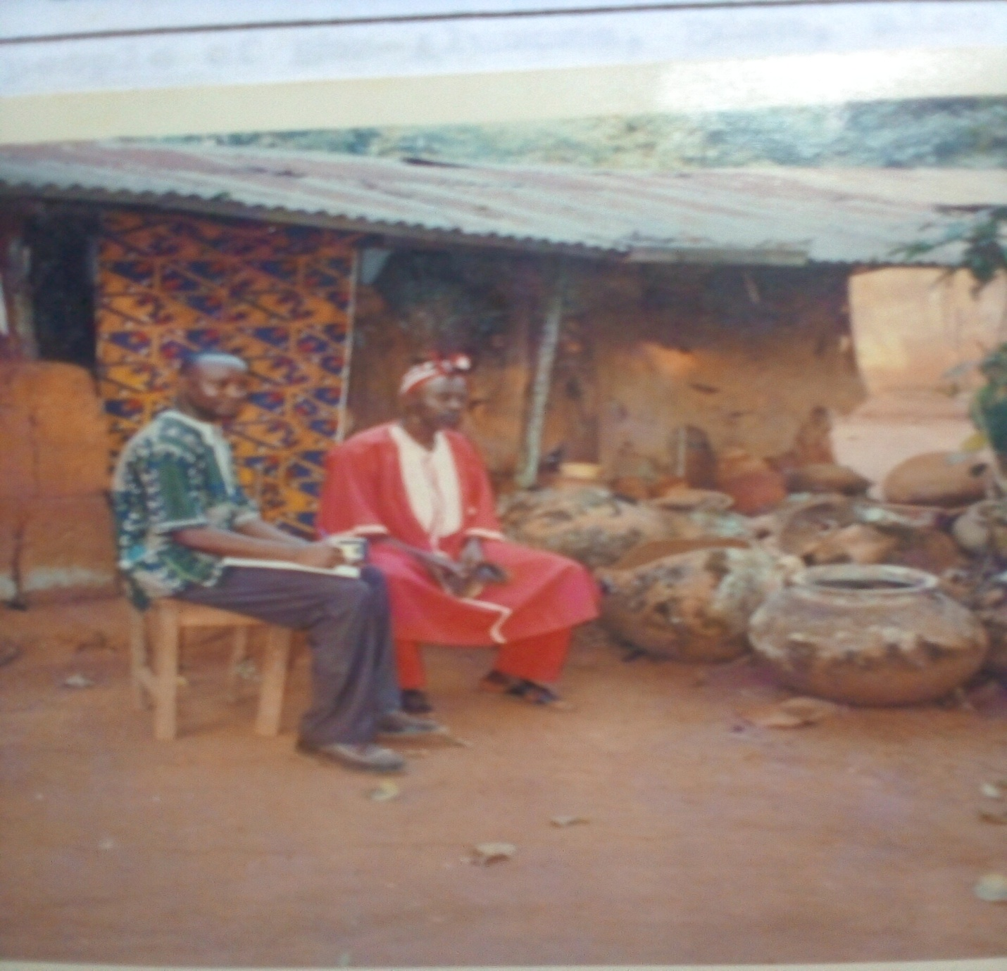

Source: Author’s (2020)

**The History and Mode of Worship of the Nnumu-Kwome Deity**

The history of the Obukpa community is tied to its community deity, Nnumu-Kwome. Nnumu-Kwome deity is a warrior goddess (focal discussion, 2020). Obukpa had hostile neighbours all around her and fought a lot of inter-village wars of expansion. These wars were caused by the fact that Obukpa had very little land and it was of poor quality. Out of land hunger, the community fought with nearly all her neighbours, including Ibagwa-Ani, Ibagwa-Aka, Ibagwa-Nkwo, Okpuje, Nsukka, Alor-Uno, and Iheakpu. It was to help the community prosecute these wars aimed at securing lands that the Nnumu-Kwome deity was founded (Ugwoke, 2011). This fact is succinctly captured Ekwueme, he noted that:

In the Obukpa community, the Nnumu-Kwome deity is celebrated for her remarkable feats during the pre-colonial inter-village wars. It was the deity that secured abundant territory for the Obukpa people. As a mark of respect and gratitude, Nnumu-Kwome came to be seen as the mother of all Obukpa. In every war she emerged victorious. Nnumu-Kwome’s power is manifested in her distinguished art of waging wars (J. Ekweme, personal communication, March 19, 2020).

 Beyond these are other notable positions that Nnumu-Kwome occupies in the Obukpa community. In Obukpa, the goddess serves as an agent of social control (E. Onoyima, personal communication, August 19, 2020). The deity is commonly used to determine the truth in situations of allegations through oath administration. It is also a common version that the deity is the goddess of high productivity, good fortune, justice, long life, good health, and fertility. This point was corroborated by Ugwuoke thus, the Nnumu-Kwome deity of Obukpa is also the goddess of wealth, beauty, guidance, and compassion (2011, p. 30). These facts were proved during the course of this research, as many young men and women were seen consulting the deity in all these capacities with different sacrifices ranging from cows to fowls.

The worshippers of Nnumu-Kwome come to the shrine located at Mgboko village, Obukpa, with different worship items—dogs, fowls, cows, goats, rams, kola nuts, yams, hot drinks (gin), etc. (Ugwuoke, 2011). The worship is conducted by the chief priest of the deity. The Nnumu-Kwome goddess is worshipped daily except on Nkwo market days. The Nkwo day is set aside as a work-free day for the chief priest to enable him to attend to his other personal and private engagements (M. Ezugwu, personal communication, June 11, 2020).

The first morning duty of the chief priest is to go into the shrine, wash his hands, and rub cam wood (Edo) on his forehead and upper right eyelid. After, he puts on a long sacrificial red robe with a local red cap. He then sits down on an animal skin that serves as a mat with the deity’s staff (the assistant chief priest, the diviner, and the messenger) by his right-hand side. Wearing a special bell (Oti) around his neck and holding a bigger one in his right hand, he jiggles the bell eight times to alert the deity of his presence. He then brings out the kola nut and splits it. On raising it up, he clears his throat and calls on the Supreme God (Ezechitoke), the ancestors of the land, the sun, and the four market days, asking them to come and take their own share of the kola nut. After this preamble, he states his wishes for the day for himself and for the people of the community, chews a bit of the kola nut, and drops the other at the front of the shrine’s altar. After this morning ritual (prayer for the community), he begins to receive worshippers who come with different items for different purposes.

Unlike many deities in Igboland, Nnumu-Kwome has a special way of being consulted and worshipped. The worship of this deity involves a hierarchy of administration. The administrative structure has three arms: the chief priest, the fortune teller or diviner (Ogbaafa), and the messengers. Although the chief priest is the one at the helm of the affairs of the shrine, anyone wanting to consult the deity first meets with the diviner (Ogbaafa). It is the diviner who interacts with the gods in the realm of the spirit in relation to the problems of the consulting fellows and recommends the sacrifices to be offered as a solution to the problem. Therefore, the work of the chief priest is one of execution of the recommendations of the deity’s diviner. From each consulting client, the diviner collects a fee ranging from N1000 to N3000 depending on the nature of the case (C. Agbo, personal communication, August 13, 2020). Onyishi seems to have put this point more lucidly when he noted thus:

Consulting the deity could be cheap or expensive depending on the demand of the consulting fellow on the deity. The purpose for which one consults determines the diviner’s fee and the nature of the sacrifice to be prescribed by him. To the men who come to the deity asking for prosperity (wealth), they often recommend the sacrifice of a given number of cows. But to the young girls who come asking to be blessed with a husband, the diviner may just recommend the sacrifice of a fowl or a dog, etc. (O. Onyishi, personal communication, August 23, 2020)

 The chief priest of the Nnumu-Kwome hires and fires the diviner and other staff of the deity, especially the messengers (Ndi Ozi Nnumu-Kwome). The deity’s messengers, besides being responsible for the sanitation of the premises, are also responsible for taking invitation letters or messages to the needed persons to appear before it to answer to cases brought against them (F. Ogbu, personal communication, July 22, 2020). One becoming a diviner in the shrine involves a process known as Isa anya or Iwa anya—washing or opening of the eyes (Nwoga, 1988). By this, the diviner undergoes a special eye-wash ritual for him to see clearly the underworld and to interpret accurately the language of the spirits and the invisible forces of nature.

Every Mgboko village male child, especially those whose parents are adherents, is dedicated to this goddess after four months of birth (J. Edoga, personal communication, September 28, 2020). This dedication is a ritual that parents of the child as adherents must do. Items needed for the dedication include four tubers of yam, a keg of palm wine, a fowl, and some ritual objects, namely can wood (Edo), yellow pepper, white chalk (Nzu), and four kola nuts (Ugwoke, 2011). These items are presented to the chief priest of the deity, who fixes the day for the yearly exercise. The initiation is an open affair that accommodates interested observers (M. Osondu, personal communication, August 19, 2020). Mbanwaeze, one of the adherents of the deity, in trying to deepen our understanding of the initiation ritual, had this to say:

On the day of the initiation, the chief priest sits on a special wooden stool outside the shrine, made specifically for the purpose. He would first invoke the spirit of our forefathers through some incantations. Assured that our ancestors have gathered, the chief priest collects the baby from the father. Facing the sun, he lifts the baby up and brings him down seven times, making incantations to the spirits of our ancestors. After this lifting up, he kills the fowl, dropping some of its blood on the head and feet of the baby (C, Mbanwaeze, personal communication, July 20, 2020).

As R. Amadi (personal communication, July 19, 2020) added, this initiation process is called Ito Nwa, meaning presenting a child to the goddess in preparation for his being chosen some day as its chief priest.

**Research Methodology, Design, and Data Collection**

The study unveils the Nnumu-Kwome’s influence as a driver of politics and the economy in Nsukka, Enugu State, Nigeria. The deity attracts clients and patronages from both the elite and the youths of Nsukkaland and beyond. In pursuit of this, the researchers made use of a combination of research methodologies. The study employed case study, ethnographic, historical, and survey research methodologies. The survey yielded information through interviews and questionnaires on the people’s opinions, feelings, and beliefs on the subject matter. The views of the devotees, natives, and the general public were sought. The survey provided valuable insights into the historical significance, practices, and evolving roles of the Nnumu-Kwome deity in Nsukka politics and economy.

The researcher adopted mixed methods of research design that combined both qualitative and quantitative data. The qualitative research design that yielded non-numerical information focused on in-depth interviews that captured the people’s perceptive and direct opinions about the deity’s prominence in the face of all adversities. The quantitative design made use of questionnaires for in-depth understanding of the factors behind the continued relevance and prominence of the deity in the face of all adverse pressures from westernisation and modernization. The researchers’ adoption of this mixed method is in line with the submissions of Creswell (1998) and Patton (1990) that research that collects only quantitative data often provides an incomplete analysis of a phenomenon or event being investigated and that the addition of qualitative data provides an added level of understanding.

The data for the study were, therefore, collected through primary and secondary sources. The study area is Obukpa, and so the primary data sources were the inhabitants of the Obukpa community, especially the local inhabitants and some migrants to the community who were thought to be familiar with the issues under investigation. Data from them were collected through questionnaires and interview protocols. A total of 50 persons (indigenes and migrants) were interviewed in a face-to-face situation. The interviews were held in an informal setting, which more or less enabled the informants to freely express their views. Some research questions evolved in the process of the interview as the researchers probed the participants for clarifications and follow-up responses. A total of 50 questionnaires were distributed in the community, which sought to gather the participants’ opinions and perceptions on the critical factors behind the avid and sustained interest of the people in patronising the deity. The secondary sources of data are obtained from published texts, journal articles, internet materials, unpublished theses, and dissertations, among others. Data gathered from the masses through quantitative and qualitative sources were analysed using content and descriptive techniques.

**Research Questions**

The research questions raised by this study investigate the current growing fellowship enjoyed by the Nnumu-Kwome deity. Specific questions culled from its research problems include:

1. What political factors have contributed to the growing popularity of the Nnumu-Kwome deity in Nsukka?
2. What economic factors are behind the Nnumu-Kwome’s growing fellowship?
3. How has the Nnumu-Kwome deity created by itself the rising interest of the people in itself?

**Research Hypotheses**

1. Nnumu-Kwome deity is a powerful symbol of ancestral spiritual protection and guidance.
2. The deity is a generous provider of wealth and other blessings.
3. Nnumu-Kwome deity is an instrument for the maintenance of the political status quo in the land.

**Discussion and Presentation of Findings**

**Nnumu-Kwome Deity in the Politics and Economy of the Nsukka-Igbo**

The study was carried out to identify the factors responsible for the resilience, the growing patronage, and the fellowship of the Nnumu-Kwome deity amongst the people of Nsukka, particularly the youths and political class. Evidence from the study shows that the Nnumu Kwome deity of the Obukpa community is patronised by the Nsukka youths and local politicians from far and near for so many reasons: First, the Nsukka Igbo politicians and youths patronise the Nnumu-Kwome deity because they see it as an effective tool for solemnising political agreements. They patronise the deity for oath-taking purposes. Oath taking here is a situation where absolute loyalty or adherence to certain agreements and conditional ties are prescribed and administered to beneficiaries of the agreement (Oviasuyi et al. 2011, 22-34). Although, the youth and politicians of the region who patronise the deity for sealing their political deals are Christians, they chose to come to the deity because of its instant justice system and incorruptible nature (Ugwuoke, 2011: 22).

Eze (2022), concurring with this view, added that the Nnum-Kwome deity serves as a fiduciary for political deals between godfathers and those they sponsor because, unlike other deities, oaths taken in this shrine cannot be circumvented. According to Eze (2022:12), to contest an elective position in Nigeria, a beginner politician must have a wealthy political godfather who bankrolls him and does everything, including buying votes, to ensure his anointed son’s victory. In other words, the Nigerian political space is one directed and manned by godfathers who act as political gatekeepers with a deeply ordered patronage system. The Nsukka-Igbo politicians, therefore, come with their “anointed sons” to the Nnumu-Kwome deity for sealing their political deals and agreements, as they have very high regard for any business done with this deity (Eze 2022: 12-13, M. Ezugwu, personal communication, June 11, 2020). The Attama (chief priest) of the Nnumu-Kwome deity succinctly captured this when he noted:

The politicians patronise this shrine because they see it as ejecha ogwu (the highest) and an insurance policy compelling obedience of their members to be voted into power. Anyone who takes an oath here and goes against it dies instantly and loses all he has to this deity. Therefore, once an oath is taken in this shrine, the parties have secured the unalloyed obedience and cooperation of the person so sworn while in office (C. Okenyi, personal communication, October 13, 2020).

Also, some youths and politicians in search of blessings, favour, and relevance in their careers also patronise this shrine. This view was clearly captured by one Mr. Makata; he argues:

I visit the Nnumu-Kwome deity because of the favours and blessings it offers through worship and sacrifices. Knowing that being remembered, recognised, and selected to contest even party primaries in Nigeria belongs to the realm of the occult, I come to this shrine to worship and offer sacrifices. The position I have attained today in politics is not unconnected with my deep relationship and cooperation with this deity (J. Makata, personal communication, December 3, 2020).

The chief priest of the deity strengthened this view when he pointed out that most politicians who visited the shrine in search of relevance often offered cows of the local breed (Efi Igbo) and promised the deity cash gratifications if selected and voted into power. He, however, lamented that many politicians have not been committed to the redemption of their vows to the deity after emerging winners at the polls (C. Okenyi, personal communication, October 13, 2020). Mr. Chuks, the deity’s assistant diviner, in narrating why the politicians from far and near patronise the deity, added another dimension. According to him, the current insecurity in the country is the chief cause of the present increased patronage the shrine enjoys from the youths and politicians. As he puts it:

The Nnumu Kwome deity is a goddess of protection. Today, there is a lot of insecurity and fear in the land. Many politicians visit this shrine to contract soul ties (Igba Ndu) with the deity. Once this is done, insecurity in the life of the client is treated as settled. This is because with the Igba-Ndu, the deity instantly takes charge of the client’s protection and perhaps those of his family members. The only condition is that all his family members, to be so protected by the deity, must be present in the shrine on the day of the covenant for when the prescribed sacrificial animal is killed; the blood is smeared on the forehead of every family member present. The smearing of the blood is the insurance and assurance of the deity’s protection (E. Chuks, personal communication, November 1, 2020).

Nnamani corroborated this submission, noting that persons and families under the Igba-Ndu tie with the deity and pay her homage yearly. The homage month and day are fixed by the deity’s chief priest. The month of February is usually selected by the chief priest. The day is one of heavy celebration as people troop to the shrine with drinks, cooked foods, and animals (goats, cows, rams, etc.) to be slaughtered for thanksgiving, the deity having protected them from kidnappers, herdsmen, and the operations of unknown gunmen (R. Nnamani, personal communication, August 20, 2020).

 Traditionally the role of deities in the economy of Igboland has mainly been in the area of agriculture, as many of the people’s deities ensure bountiful harvests, and favourable weather, among others (Ogbu, 2003; Aniago, 2015). But Nnumu-Kwome, unlike other deities, plays a more critical and crucial financial role in the lives of the people. Uniquely, the deity advances loans to youths who approach it for financial assistance. Most youths patronise the deity for financial (loan) assistance (Timothy, 2020). The Attama (chief priest), when accosted on this issue, had this to say:

“The deity is very rich and gives loans to youths liberally. Many youths come to the deity to receive loans for their businesses. Although, the loan must be paid back, the deity gives no time limit for the repayment and charges no interest.”

E. Chuks (personal communication, November 1, 2020) elaborated on this point, noting that the deity offers the youth economic assistance in two ways. First, as a giver of wealth, many clients consult the deity for prosperity. Clients who consult the deity for wealth have a time frame within which the oracle would shower them with financial prosperity. The youths of the region all believe that the deity is a generous provider of wealth. In their view, wealth is a spirit, and the spirit of wealth (rendered in Igbo as Muo Uba) resides in the shrine. One can only become wealthy when one is connected to the Muo Uba (spirit of wealth) resident in the shrine of the Nnumu Kwome deity.

Consequently, many Nsukka youths visit this deity to be connected to the Muo Uba for prosperity. The priest of the deity, completely naked, invokes and connects the said spirit with the client (see plate 4). Although, the researchers were prohibited from taking pictures of the rituals that were performed naked by the priest, one was able to steal a snapshot. As E. Chuks (personal communication, November 1, 2020), continued, the deity assists some clients by way of loan. Many clients patronise the deity for loans as the deity is seen as very rich. Properties of dead victims acquired by the deity (cash inclusive) are the deity’s chief source of wealth. The property of the dead victim so acquired by the deity (houses inclusive) could be sold, rented, or leased (J. Timothy, personal communication, March 19, 2020).

Edoga narrates the story of a businessman who took a loan from the shrine and died before paying it back. As the children refused to pay back the loan, the deity killed the sons and claimed all the man’s estate acquired by the business. Edoga warns:

It is better not to obtain any loan from the Nnumu-Kwome shrine. In money matters, Nnumu-Kwome has no mercy. Its loan must be paid back, for there is no business failure in her commercial dictionary. It kills any defaulter and collects the property (J. Edoga, personal communication, September 28, 2020).

In line with Edoga’s view, an Anglican priest serving in the area when interviewed had this to say: “Before you borrow success from the devil, check the interest rates. A loan from that kingdom is impossible to pay back”(Rev. Joseph, personal communication, September 28, 2020).

It is pertinent to note that the youth and politicians of the area also patronise the deity because of the efficacy of the deity’s allied sacred rituals and the services associated with the offices of its religious personalities, namely, the priests and the diviners (Ogbaafa). The services of these two personalities of the deity seem to have been indispensable to many Nsukka-Igbo youths and politicians in their quest for power, relevance, and wealth (J. Amadi, personal communication, July 19, 2020; J. Omeje, personal communication, March 19, 2020). The deity has honest diviners with considerable knowledge of the art and applies it to almost all needs of life (Ugwuoke, 2011, M. Jatto, personal communication, March 19, 2020). The deity’s diviners, because of their seemingly expert knowledge, are viewed and patronised by politicians and youths as people holding the key to the secret of lifelines. They are seen as having perfect knowledge of the underworld and possessing the ability to transmit that knowledge to others in need (N. Ikem, personal communication, November 12, 2020). The Nnumu-Kwome diviners undergo a special eye-wash ritual and so are said to see clearly and interpret accurately the invisible forces of nature (Ugwuoke, 2011, M. Ezugwu, personal communication, June 11, 2020).

The deity’s chief diviner, in an interview, pointed out the divination services they render to the people, thus:

Here, we do inyocha akaraka (palm divination or palmistry), also called fate in your hand. We also do Igba okwe (seed object divination) and Afa enyo (mirror divination), which encompasses both small mirror divination (Afa enyo nta) and big mirror divination (Afa enyo ugwu). By palm divination, we read and interpret the lines in one’s palm to know what the future behoves. From our divination, we tell them the fortunes as well as the misfortunes that await them in politics and prescribe solutions (H. Chukwuma, personal communication, March 1, 2020).

Ugwuowo, a veteran politician, seemed to have confirmed unintentionally the above statement when he asserted that “We visit this shrine to interrogate the future and explore the frontiers of the unknown. This is the only shrine that gives it with astounding accuracy” (J. Ugwuowo, personal communication, December 19, 2020).

Plate 4: The Chief Priest of the deity linking the youth client with the Muo Uba (spirit of wealth)

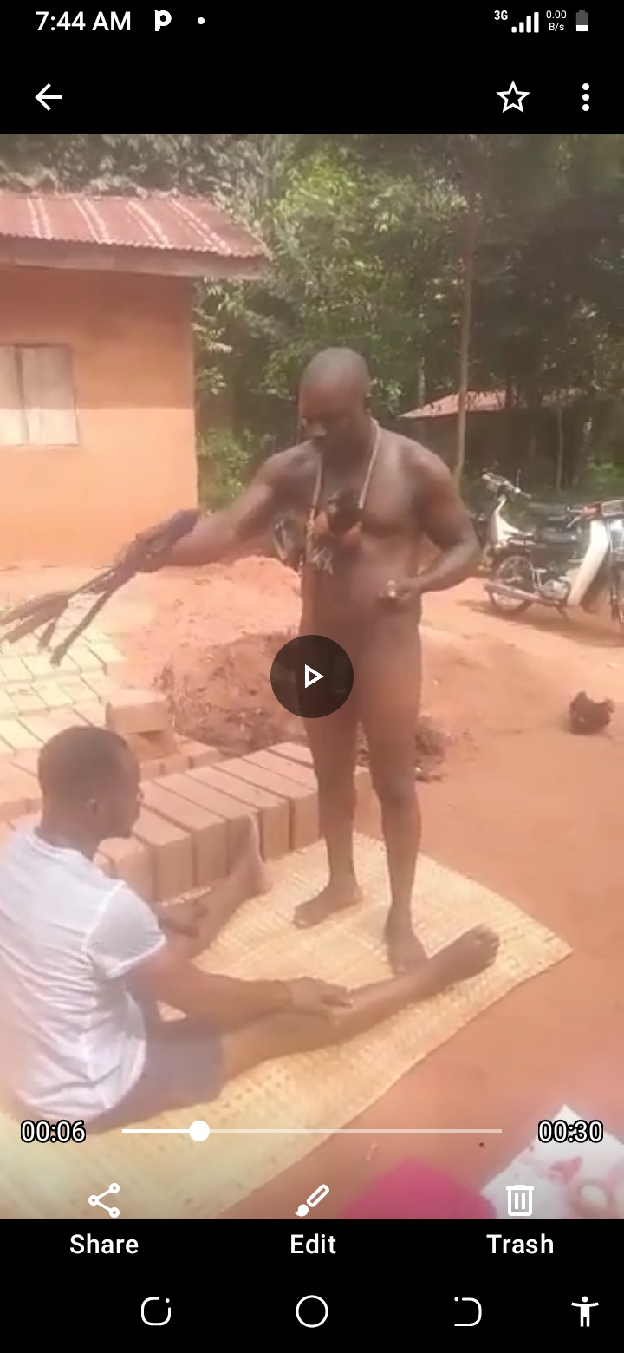

Source: Authors’ Fieldwork, 2020)

**Conclusion**

The study has demonstrated the captivating dynamics of Nnumu-Kwome of the Obukpa community as a driver of politics and the economy in Nsukka-Igbo, Enugu State of Nigeria. This deity, far from withering and dying in the face of Christianity and modern religious iconoclasm, has continued to flourish and to draw patronage from the elite of Igbo society and beyond. The politicians and youths go to this shrine with sacrifices to make personal appeals for power, protection, and wealth. The Nnumu-Kwome’s growing patronage and popularity reflect broader trends and shifts in African spirituality and religiosity in the 21st century. The deity, in the face of all pressures from Christianity, has continued to be seen by the people of the Division as a powerful symbol of ancestral wisdom and spiritual authority that provides guidance, protection, wealth, success, and solidarity.

As the Nsukka youths, like the youths of other parts of Nigeria, struggle with a high level of poverty and unemployment, they view fellowship with the deity as a source of economic empowerment, as the deity is a generous provider of wealth. The politicians come to the deity to seek the deity’s support, believing that its support could bring them victory in elections. These politicians also come to the deity to gain an edge over their opponents, as aligning themselves with the deity is a kind of connecting to the higher spiritual world for legitimacy and victory.

The deity, as a strong and unique cultural expression of the people of this region of Africa, so much demands preservation and promotion to ensure a sustainable future, having withstood globalisation with its mass erosion of the traditional values and religious practices of the people. This resilient nature of the Igbo traditional religion is not unconnected with the fact that the institution is indigenous. These politicians, while in office, are very much bound to the political and spiritual pacts and deals entered into in the shrine. This study will hopefully add to the ongoing conversations about how indigenous people have continued to value their religious heritage despite all the direct confrontations from charismatic churches. This work may also promote the ongoing dialogue of the International Council on Monuments and Sites (ICOMOS, 2014) on the sustainable cultural heritage of the people.

**Compliance with Ethical Standards**

**Disclosure of Potential Conflicts of Interest**  
The authors declare that there is no conflict of interest with respect to the research, authorship and or publication of this article.

**Research Involving Human Participants and/or Animals**  
This study was conducted in accordance with the ethical standards of the institutional and/or national research committee and with the 1964 Helsinki Declaration and its later amendments or comparable ethical standards.

**Informed Consent**  
Informed consent was obtained from all individual participants included in the study.

**Funding**

The researchers received no financial support for the research, authorship and or publication of the article.

**References**

Agbegbedia, A. O.(2013). An assessment of the method of managing conflict between pastoralists and farmers in Benue State. Nigeria. (Unpublished PhD thesis), University of Ibadan.

Afigbo , A. E. (1956). “The eclipse of South-Eastern Nigeria, 1901-1927.” *Journal of Historical Society of Nigeria 3* (3 ):19-30.

Afigbo, A. E. (1979). *Ropes of sand: Studies in Igbo history and culture.* Nsukka University Press.

Aniago, M. (2015). “Deities and shrine in African traditional religion: the “spark” in Igboland” Middle East Journal of scientific research 23(9).

Anyika, F. (1988). “African traditional religion and contemporary African society.” in I.T.K Egonu (ed,) *Readings in African Perspectives in World Culture* (92-104). Vivians Publishers.

Arinze, F. A.(1970). *Sacrifice in Ibo religion.* Ibadan University Press.

Eze, J. O. (2022). Religion and politics in Nigeria: partners in dialogue towards a failed state Multidisciplinary research journal 2((2) 23-33.

Forward, Martins(2011).. Inter-religious dialogue: a short introduction. Oxford, UK Oneworld.

Igboanuzue, Adannia. (2012). “The origin and role of Ngene deity in socio-cultural organization of Oraifite, early times to 2010.” (Unpublished B.A Project), Department of History and International Studies, University of Nigeria, Nsukka

Ifesieh, E. I.(1989). *Religion at the grassroots :Studies in Igbo Religion.* Fourth Dimension Publishers.

Ilogu, E. (1985). *Christianity and Igbo culture*. Nok Publishers.

Ikenga-Metuh, (1981). *God and man in African religion: A case study of the Igbo of Nigeria*. G. Chapman.

Ishiwu, E. (2001). “The Nkwo Deity among the Nsukka people.” (Unpublished B.A Project), Department of History and International Studies, University of Nigeria, Nsukka

Isiani, M. C. etal (2022). “Not all deities were transformed in Igboland: A cultural history of Api Opi deity.”  *Journal of Cultural Heritage and Sustainable Management*, Emerald Publishing Limited 244-257.

Larry, C. et.al. (2011). “The use of single case methodology in psychology research.” *Journal of Abnormal Psychology*, 7 (2), 92-105.

Laursen, John (1999). Religious Toleration: the variety of rites from Cyprus to Defoe. New York Martin’s press

Njoku, O. N. (2014). *Economic history of Nigeria, 19th -21st Centuries.* AP Publishers.

Nenman, Wapwera and Nakam Kangpe (2021) . Engaging the African deities in the Nigerian political theatre: towards faithful stewardship for national development, Journal of multi-disciplinary research 2 (5), 53-61

Nnanna, Ochereome. (2004), Okija Shrine a Fanatic and a Fool. News watch June 10, 2004, 23-26. (Part 1)

Nwoga, D.I. (1988). “African Cultural presence and African worldview.” in I. J. K. Egunu (ed.) *Readings in African Perspectives in World Culture*. Vivians Publishers.

Ogbu, K. (2003:33) The embattled Gods: Christianization of Igboland, 1841-1991. CP Press, Lagos.

Ogunbado, A. (2012). “impact of colonialism on religion: an experience South-western Nigeria” JOSR Journal of humanities and social sciences 5 (6 ) 51-59

Ojo, M. (2015). Incorporation of Ayelala traditional religion into Nigerian criminal justice system: An opinion survey of Igbesa community people in Ogun State, Nigeria. Issues in ethnology and anthropology 9 (4)

Oyiasuyim P, Ajagua, O. And Lawrence I (2011:34)Fetish Oath-taking in Nigerian politics and administration: bane of development. Journal of social sciences, 27(3) 193-200

Okoye, Chidumebi. (2016), “The Socio-Economic Impact of Nsi-Nkwo Deity on the People of Enugu Ukwu, 1900-2000.” (Unpublished B.A Project) Department of History and International Studies, University of Nigeria, Nsukka

Tell, January 17th, 2005, “Kalu’s Government, a Failure”

Stanton, Graham and Guy Stroumsa (1998). Tolerance and intolerance in early Judaism and Christianity. Cambridge, Cambridge University press

Ugwuoke, Samuel. (2011). “Deities in Igboland: Nnumu-Nkwome Deity in Obukpa Community up to 2010.” (Unpublished B.A Project), Department of History and International Studies, University of Nigeria, Nsukka.

Ugwu, D. C. (1997). *This is Nsukka*: AP Publishers.