The Ithuk-Ithukan Tradition: Projecting Public Awareness to Protect Water Resources

Clean water is a very important resource for humans. We facing a lot of water crisis in a lot of area such as Kenya, Ethiopia , and Somalia. On the other hand, Kampung Anyar Village that located in Banyuwangi Regency has several springs. Villagers show their gratitude because they have abundance water resoures by creating the Ithuk-Ithukan tradition which is specifically carried out as an expression of gratitude for the abundance of water sources and clean water in their area. The method used is a qualitative descriptive method. We use purposive method to ask the villagers about the tradition. The results of this study indicate that the residents of Kampung Anyar Village have a deep meaning regarding the protection of water sources. The Ithuk-ithukan tradition shows a harmonious relationship between humans and nature, where they have inadvertently implemented the principle of SDGs No. 6 Clean Water. So far very limited study that related to clean water and sanitation with tradition. In Kampung Anyar Village, Villagers not only maintain tradition by protecting and sanctifying their springs, they also take a part in safing the earth by protecting the water resources. Awareness in protecting water resources has been integrated into the villagers and is implied in the Ithuk-ithukan tradition.
Keywords : Ithuk-Ithukan, Tradition, villagers, water sources, sustainability
Introduction
Traditions are knowledge rooted in local wisdom. In Thailand, particularly Nong Sung District, there is a geographically beautiful region that attracts tourists. In addition to its integrated traditions and government regulations, the location has become an attractive tourist destination because it showcases the traditional way of life of the local people (Ritskulchai, 2024). Traditions also generally possess noble values that are a cultural heritage passed down through generations within the community. In Sumberdadi Village, Trenggalek District, for example, residents have a village cleaning tradition. They believe that holding a village cleaning tradition can bring safety and prosperity to their village. Failure to carry out the village cleaning tradition will bring disaster. It present the villagers awareness to keep their environment clean as part of tradition (Sholikah & Historia, 2021).
Meanwhile, in western Kenya, specifically in the Makueni area, people experience water shortages and must conserve water. Having rainwater harvesting at home makes life easier. However, if not, women are responsible for fetching water from the river, which can reduce their sleep and leisure time. Villagers need to spent a lot of time to go back and forth to take the water from the river (Owuor, 2025). Evidence from other African country, in Ghana, water insecurtity is shaped by both unresilience infrastructure and lack attention regarding this matter from local governance (Pienaah et al., 2025). Meanwhile in Asia, Qatar has also experienced changes in water resource policies in recent years due to rapid population growth. This has led to government policies introducing water conservation strategies by investing in desalination plants and wastewater treatment facilities (Lahlou & Al-Ansari, 2024). This demonstrates the importance of maintaining clean water sources.
Traditions related to water management in India are implemented in an integrated manner , offering promising opportunities for sustainability. Therefore, related policies need to be implemented in a decentralized manner and aligned with local wisdom (Singh & Shreya, 2025). Also in India, The people in Braj region offer insightd into sustainable conservation. These systems embody religious and socio cultural traditions, architectural ingenuity, and knowledge-based water practices (Bharti, 2025). Meanwhile, in Penanggal Village, Lumajang Regency, Indonesia, the villagers also practice the tradition of water purification. This tradition involves creating a mountain of crops, such as vegetables, as an expression of gratitude for the abundance of water in the area (Wulandari & Bahri, 2024).
During traditions, communities build collective memories. Traditions are a manifestation of the collective memory of citizens, enabling them to voluntarily carry out traditions from generation to generation. This also serves as a marker of a nation's identity. Foreign cultural influences are easily rejected and do not disrupt the citizens' original identity when they consciously maintain traditions. Febrian (Rio Febrian et al., 2025) explains through research that culture plays a fundamental role in shaping human identity. Cultural socialization is the primary process of internalizing values and norms that shape behavior and determine outlooks on life. Furthermore, globalization influences identity dynamics, creating hybrid identities that reflect a blend of local and global cultures.
Preserving traditions has several benefits that will positively impact the community. It can develop local potential, as seen in the Lasem Chinatown area, Maspati Old Village, and Selumbung Village. Cultural tourism development strategies include developing cultural attractions, preserving historic buildings as cultural heritage sites to maintain the region's identity, improving tourism support facilities, and, importantly, community participation (Choirunnisa et al., 2021). Evidence in Africa, Unwana Golden Sand Beach (UGSB) has potential as a sustainable tourism destination while perserving the cultural and environmental integrity of the region (Anyanwu et al., 2025). In Banyuwangi, Indonesia, combination of cultural, social, and technological approaches is an effective strategy for preserving the Ithuk-ithukan tradition (Putri et al., 2025).
The implementation of traditions also serves to foster social solidarity. However, evidence in Sumba, Indonesia, The belis tradition and kedde tradition requires families that holding the tradition to prepare a lot of money. By holding the tradition, it will enhance their social status. While traditions strengthen social solidarity and cultural preservation, They also cause an economic burden that might affect the family well-being (Bili et al., 2025). Also in Jambi, Indonesia, The Cuci Kampung Tradition increased spiritual values, strengthened positive images, environmental protection, solidarity, and restoration of social identity (Huda et al., 2025). In contrast, evidence in Malaysia, The Bandar tradition is a cultural activity where the community giving financial contribution to support families with sons entering marriage. It reduce the financial burden associated with wedding ceremonies and an instrument for reinforcing communal bonds, intergenerational solidarity, and the continuity of intangible cultural heritage (Wattimena et al., 2025).
When villagers perform traditional rituals together, they collaborate in preparing and executing them. This not only helps them get to know each other but also fosters a sense of group identity. Villagers also feel like an integral part of the group. This sense of belonging to a particular social group fosters awareness and a willingness to perform traditional rituals without external coercion. Evidence from China, traditions are primarily taught within the family, the primary socialization platform for humans. For example, a child who is encouraged to participate in traditional rituals by their parents from an early age will consciously perform them as they grow older without coercion (Sun et al., 2022).
Max Weber explained that there are four types of social action: goal-oriented action, value-oriented action, affective action, and traditional action. Based on the types of social action described by Max Weber, the Ithuk-Ithukan tradition in Kampunganyar Village is a traditional action. This is because the actions are based on long-standing customs or traditions. Weber also explained that it is important to understand social action from the perspective of the subject (the person acting) and the object (other people affected by the action). The Ithuk-Ithukan tradition is carried out collectively by residents from generation to generation. This tradition is carried out and passed down by their families, so that residents voluntarily follow the tradition.
Method
In this article, the author uses a qualitative method to analyze the Ithuk-Ithukan Tradition. Qualitative methods are considered more appropriate because they can provide a more detailed picture of the Ithuk-Ithukan Tradition. The author collected data by reviewing literature taken from research and writings from various sources. In addition, the author also conducted in-depth interviews with residents of Kampunganyar Village to gain their perspectives on the Ithuk-Ithukan Tradition. The author also conducted field observations in Kampunganyar Village to directly observe the water conditions there.
Informants were selected using a purposive method by interviewing residents about the Ithuk-Ithukan Tradition. Data obtained through observation and interviews were then reduced and presented descriptively. The reduced and systematically presented data were then summarized to ensure a comprehensive understanding within the research context.
Discussion
Kampunganyar Village is administratively part of Glagah District, Banyuwangi Regency. Kampunganyar Village is the largest village in Glagah District, Banyuwangi Regency. The area of Kampunganyar Village is 31.08 km² which is 41% of the area of Glagah District (BPS, 2013). The location of Kampunganyar Village is about 10 km from the center of Banyuwangi City, with a travel time of about 20-30 minutes from the city center . In Kampunganyar Village there are several water tourism locations including, Jagier Waterfall, Banyu Perosodan Tourism, Kalibendo Waterfall, Keli Kedung Water Tourism, and Jopuro Water Tourism (Romanda, 2020). The many water sources also make Kampunganyar Village a promising natural tourism potential. It also located in plateu, hence it have a cool temperature and clear air suitable for tourism and relaxation.
Ithuk-Ithukan Tradition
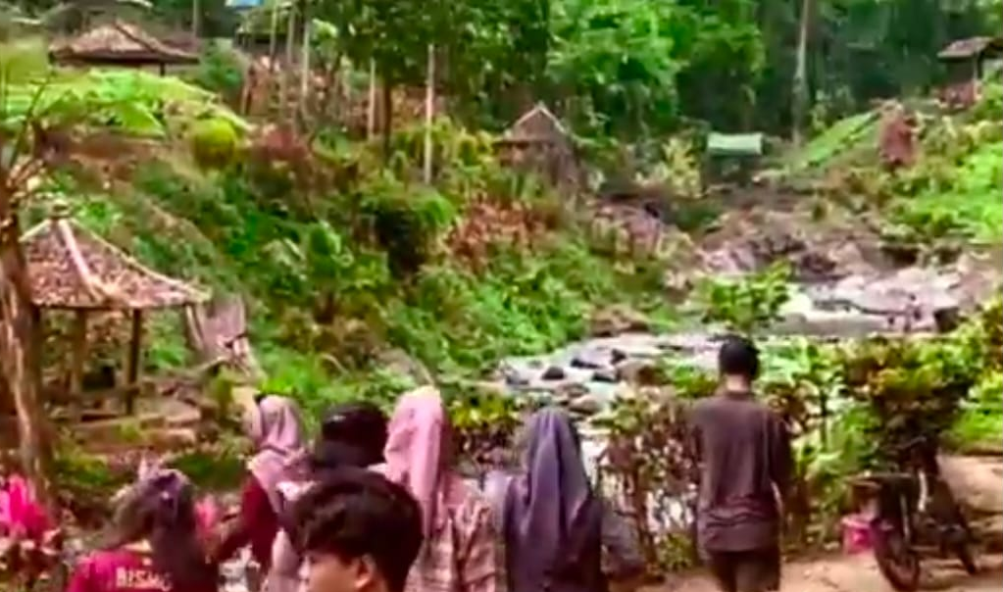
Figure 1. One of the water sources in Kampunganyar Village
In Wiring Tasi, Suppa District, Pinrang Regency, residents are optimizing the coastal tourism there. This is being done by improving the quality of human resources in the village. After conducting training for residents, they were able to improve tourism destination management, enhance community skills, and create jobs (Chahyono et al., 2022). Evidence from Kampung Blekok, Situbondo, also have a high potential for objects and natural tourist attraction, eventhough it needs improvement such as repair of damaged facilities, extending promotional efforts, and maintaining the area’s cleanliness (Estiningtyas & Lastini, 2025). This initiative is highly feasible to replicate in Kampunganyar Village, given its potential for natural beauty as a tourist attraction. The villager also have several activity that help to enhance tourist attraction. For example, villagers enjoy drinking coffee at “warung” a café where villagers can hang out while having deep conversation. They also can enjoy the beauty of the village while inhaling fresh air.
The abundance of water sources in Kampunganyar Village is also beneficial to visitors. Kampunganyar's location on a plateau makes the air cool and the water cold. The water flowing in the rivers that flow through the village is crystal clear. The water in the river is clear and inviting tourist to swim. This was evident among visiting students from other areas.
"The water is crystal clear and refreshing . There are plenty of water sources; almost every river we encountered had crystal clear water, so clear that from above we could even see the riverbed." (AMR Interview , 2024 )
In Kampung Anyar Village, Banyuwangi Regency, there is a tradition called Ithuk-Ithukan. This tradition is performed as a form of gratitude by the villagers for the abundance of water springs (sources) in the village. Culture is closely linked to local wisdom, particularly among the residents of Kampunganyar Village. The Ithuk-Ithukan ceremony exemplifies local wisdom, as the villagers deeply value water sources and the importance of preserving them. The Ithuk-Ithukan tradition begins with residents gathering in one location. Each resident brings an Ithuk (rice cake) to be eaten together. According to Max Weber's theory of traditional action, Kampunganyar Village residents perform Ithuk-Ithukan as part of their tradition.
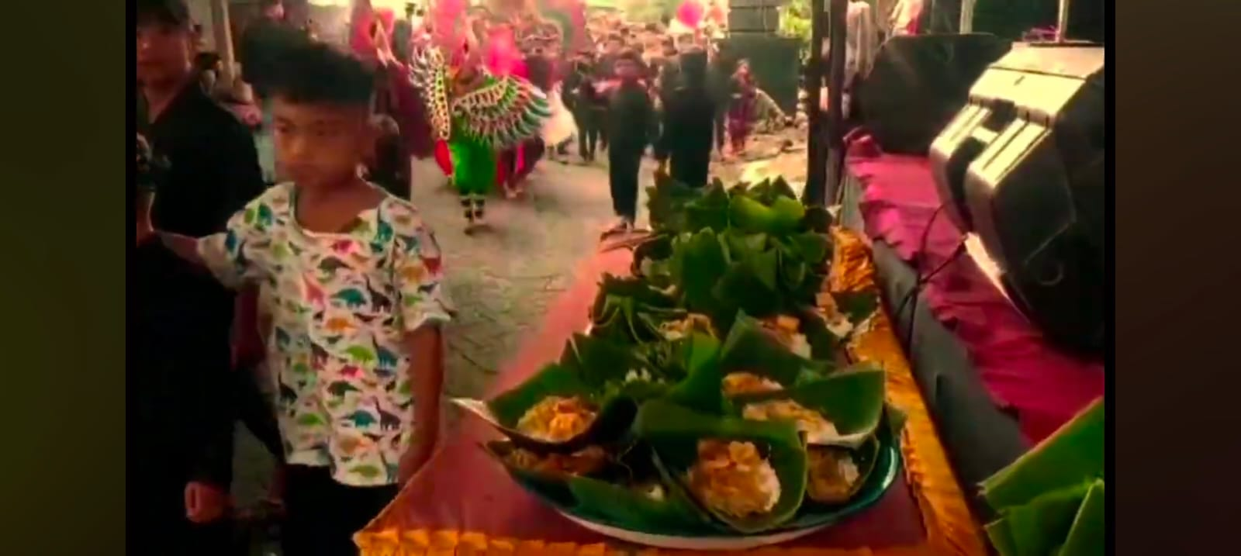
Figure 2. Ithuk
Residents of all ages in Kampunganyar Village gather to participate in the Ithuk-Ithukan tradition. Parents also feel free to invite their children to participate in this traditional ritual. Without coercion, residents gather and perform this annual ritual. This activity demonstrates the strong solidarity among the villagers. The following is an interview with the Village Secretary of Kampunganyar Village :
"Ithuk means a food mat made from banana leaves. Hundreds of Ithuk are paraded by the village residents with various dishes, such as grilled chicken ingkung. Then, the residents pray at the spring and then eat the Ithuk together. However, they are not to be eaten near the water source; they should be moved slightly away from it." (IMM Interview, 2024)
The Ithuk prepared by the villagers are collected and become an important part of the ritual. This tradition is not only deeply rooted in local culture but also rich in meaning. Residents also explained that this tradition has been going on for a long time and has been carried out by the villagers for generations. The Ithuk made and distributed are ensured to provide enough for all villagers, ensuring that no one goes hungry. This fosters solidarity within the village and fosters a sense of caring among the villagers. Villagers care for one another and ensure that no one goes hungry or without food during the Ithuk-Ithukan tradition.
Residents of Kampunganyar Village, of all ages, participate in the Ithuk-Ithukan tradition. Participants span generations. When children participate in traditional practices, local wisdom values become more deeply embedded in them. This fosters a sense of gratitude and a commitment to preserving water resources in particular and the environment in general. The villagers transfer local knowledge in the form of tradition.
Kampung Anyar Villagers blessed with abundant water sources in their environment. They are grateful and protect their water resources. This ritual is not only an expression of gratitude. Rather, it also contains a message urging humans to maintain a good relationship with nature. Currently, the impact of global warming is being felt in various parts of the world. Therefore, the discourse on the Sustainable Development Goals (SDGs) is widely echoed. However, long before the 17 goals of the SDGs were created, the residents of Kampunganyar Village had already implemented the sixth SDG, which relates to ecosystem restoration related to water resources, including mountains, forests, wetlands, rivers, groundwater, and lakes. The residents of Kampunganyar Village have practiced how humans should relate to nature. For them, water resources are very valuable.
When community awareness is created about the importance of maintaining water sources, it will be easier for residents to participate in traditional events. Residents of Kampunganyar Village orderly every year on the 12th of Dzul-Qaidah in the Hijriyah calendar. Every resident makes ithuk and collects ithuk to carry out the Ithuk-Ithukan traditional ritual. The atmosphere in this tradition is also solemn and enjoyed by all residents of Kampunganyar Village.
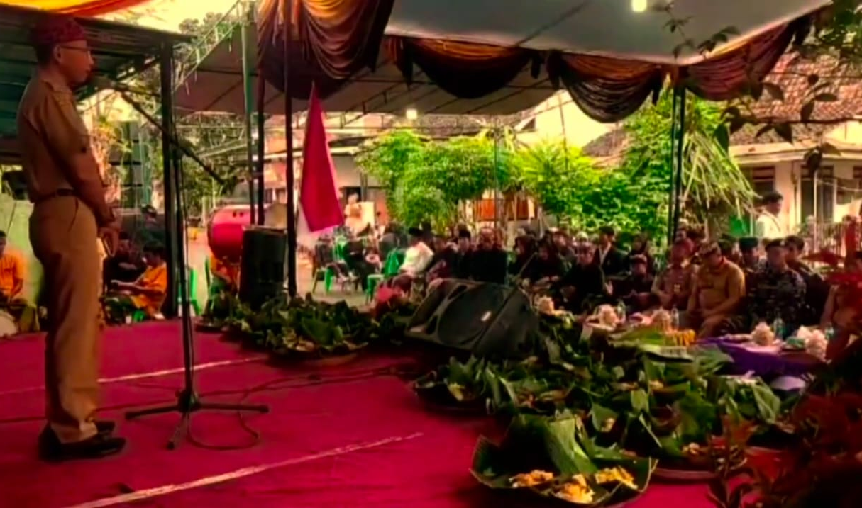
Figure 3. Speech by Village Officials at the Ithuk-Ithukan Traditional Event
Existing water sources need to be preserved. A case study in Bima found that the level of clean water suitable for consumption was only 51.13%. This low figure demonstrates the need for special government attention. Clean water and drinking water suitable for consumption are urgently needed. Comprehensive water quality monitoring is also necessary (Asryadin et al., 2023). In the case of Kampunganyar Village, migrants once polluted the water source, causing concern for residents.
"At that time, tourists came and polluted the water source. The community was caught off guard. Water sources should be sterile and not allowed to be polluted." (IMM Interview, 2024).
If a water source is polluted, it will cause problems for humans. In the case of China, the government implemented a policy of auditing the quality of company wastewater. After the implementation of this policy, the level of wastewater pollutants was reduced. This resulted in an improvement in water quality in the area (Ma et al., 2025). This shows that the Chinese government has recognized and participated in maintaining water quality there. The Chinese government has also strictly implemented SWRM ( Strict Water Resource Management ), a program that coordinates the carrying capacity of water resources and socio-economic development, harmonious interactions between humans and nature. Changes in lifestyles and traditional activities have also been a concern (Wang et al., 2018). We can conclude that China has recognized the importance of preserving water resources.
Water Related Tradition
Traditions related to water sources also occur in other areas. One example is in the Tunjung Kubutambahan Traditional Village, Buleleng, Bali, where the Air Tabar Temple is located. This temple serves not only as a place of worship but also as a social institution that fosters meanings of solidarity. Furthermore, the community uses it as a means of melukat (purification) or self-purification from impurities (mala) (Sadia, 2022). The Manggarai Indigenous Community fully understands the importance of preserving water resources, as evidenced by the "Barong Wae" traditional ritual. This tradition demonstrates a harmonious relationship between humans and nature. The "Barong Wae" traditional ritual process not only maintains existing culture but also becomes a collective memory passed down from generation to generation (Niman et al., 2023). This further reinforces the importance of tradition in fostering community awareness of environmental protection, specifically in the context of this research, maintaining clean water sources in our environment. Besides being related to the environment, tradition is also related to economic aspects.
Tradition and economic development are closely linked. Traditional practices have contribution for maintaining sustainable urban development. It able to enhancing cultural sustainability, strengthening economic resilience, and preserving cultural heritage (Shih & Agrafiotis, 2026). Evidence in Cyprus, linking digital heritage to the cultural aspect of sustainability, could preserve emotional heritage and sustain cross-communal cultural bonds in divided societies (Yılmaz, 2025). Tradition, encompassing culture, local wisdom, and traditional practices, can be a key driver of economic growth, particularly in rural areas. By harnessing and developing cultural potential, communities can increase incomes, create jobs, and foster sustainable economic development.
Tradition also serves as a form of human respect for nature. The concept of "deep ecology" is one that appropriately describes the Ithuk-Ithukan tradition. Tradition has become deeply rooted in the community's cultural system, so that awareness of preserving water and natural resources among the residents of Kampunganyar Village has arisen from within themselves. This naturally occurs because villagers are aware of the importance of preserving nature. If this awareness of preserving nature does not arise from within, it is easy to trivialize the importance of water resources, such as the habit of throwing garbage in rivers/streams. Things like this can occur when the community is not given an understanding that raises awareness. In some areas, there are still individuals who throw garbage in rivers, despite signs and warning signs around the river.
Tradition Roles in Preserving Environment
Traditions can also serve as a form of community resilience. When traditions prioritize environmental sustainability, they can help increase community resilience to climate change and natural disasters. Maintaining a healthy balance in nature ultimately helps human life, as is the case in Kampunganyar Village. When villagers protect their local water sources, the well-maintained water can be used for daily life. Even if these villagers move to another village, they will not pollute the water. This is possible because of a growing awareness that consistently protects the environment, wherever they are.
The ithuk-ithukan tradition in Kampunganyar Village indirectly teaches us to maintain our water resources. Water is essential to everything; it is essential to human life. It is indispensable for human survival, health, and socio-economic development. It is used for drinking, sanitation, agriculture (accounting for about 70% of global water use), industry, energy production, and maintaining biodiversity and ecosystems. Only about 3% of the world’s water is easily accessible for human use, making its careful management critical (D’Odorico & Rodriguez-Iturbe, 2020). The tradition also highlights a universally acknowledge principle water security and effective water resources management. This as fundamental pillars that will supporting human life and global stability, transcending local traditions to become a macro-economic and humanitarian imperative. Beyond ensuring direct consumption, the preservation of clean water resources is explicitly linked to food security, as mention above that irrigation agriculture used 70% of global fresh water, it means that efficient water use is critical for feeding the growing world population. The pressure on the planet with finite freshwater resources is disproportionately driven by the agricultural sector, where it applied in large scale is often unefficient, irrigation practices required massive freshwater, which make it very dependent, highlighted the fact that over two-thirds of the global water footprint is dedicated to crop production, frequently straining local and regional water availability (Smith & Chen, 2024).
Compounding this issue is the concept of virtual water trade, where the trade of water intensive crops or manufactured goods effectively moves water resources across geopolitical borders, a phenomenon that can severely deplete local water supplies in exporting regions, demanding a paradigm shift toward precision agriculture that implements technologies such as drip irrigation, moisture sensors, and promoting drought-resistant crop varieties to minimize evaporative losses and ensure maximal caloric output, thereby securing the nutritional needs of a population projected to exceed nine billion by mid-century. This integrated approach aligns with Water-Energy-Food (WEF) Nexus framework, which recognizes that policies impacting one resources, for instance, increasing biofuel production (energy) which requires water-intensive crops (food) and thus water can have unforeseen and damaging consequences on water ecosystems, demanding comprehensive and integrated planning that respects ecological limits and prevents resource conflicts (Yuan et al., 2024). Furthermore, the urgency of effective WRM is perhaps most acutely felt in the realm of global public health, where the failure to ensure universal access to safe water and sanitation (SDG 6.1 and 6.2) perpetuates a cycle of poverty and disease, directly responsible for millions of preventable deaths annually (Ramirez & Singh, 2023). Specifically, waterborne pathogens like Vibrio cholerae, Cryptospodirium, and various enteric viruses thrive in environments with compromised water treatment and inadequate hygiene infrastructure, leading to severe diarrheal diseases that are a leading cause of mortality in children under five in low-income settings, demonstrating the direct humanitarian cost of poor management.
The stark disparity in water access is not only environmental but also economic and social : communities lacking piped water spend disproportionate time and energy hauling water, a profound burden that stifles economic productivity and restricts educational opportunities, especially for women and girls, a critical social barrier that requires targeted WRM interventions (Johnson & Al-Bitar, 2024). Beyond infectious disease, exposure to chemical pollutant, heavy metals, and persistent organic contaminants from industrial discharge and agricultural run-off poses chronic health risks, including neurological damage, cancer, and endocrine disruption, underscoring that water quality monitoring must be comprehensive, moving beyond basic microbiological checks to include complex chemical toxicology to fully protect human populations. Critically, the central challenge of the 21st century is managing water under the conditions of a rapidly changing climate, which fundamentally alters the global hydrological cycle and introduces unprecedented uncertainty into water planning (Lee & Garcia, 2025).
Warming global temperatures accelerate the melting of glaciers and snowpacks, vital natural reservoirs that sustain river flows during dry seasons, particularly impacting major river systems like the Indus, Ganges, and Yangtze, threatening downstream populations with severe water scarcity. Simultaneously, increased atmospheric moisture capacity intensifies extreme precipitation events, leading to more frequent and catastrophic floods that compromise both urban and rural infrastructure and contaminate clean water supplies, creating a dual and paradoxical threat of ‘too much’ and ‘too little’ water. To combat this volatility, Integrated Water Resources Management (IWRM) strategies which coordinate land, water, and related resources across various sectors and political boundaries are becoming essential planning tools, often augmented by Nature Based Solutions (NBS) such as restoring wetlands, reforesting watersheds, and establishing riparian buffers, which naturally filter pollutants, recharge groundwater, and provide essential flood buffering, offering a sustainable alternative to conventional, grey infrastructure and enhancing ecological resilience (Kaur et al., 2024).
Sustainaible Water Management : A Culture Based Approach
The transition from local awareness, such as the cultural safeguarding inherent in the Kampunganyar ithuk-ithuk tradition, to effective WRM at national and international levels, therefore, requires robust governance that bridges the disconnect between human needs and environmental limitations. This governance must address the complexities of transboundary water disputes, where shared river basins (e.g., the Nile, the Mekong, the Colorado) necessitate international treaties, cooperative data sharing, and mutual accountability frameworks to ensure equitable allocation and mutual sustainability, thereby preventing water from becoming a source of geopolitical conflicts.
The succesfull implementation of WRM, globally and locally, depends less on purely technological fixes and more on establishing a deep seated social contract, the kind observed in traditional reverence for water, where conservation ethics are embedded within cultural values and reinforced by public policy, proving that local wisdom can indeed inform global policy by fostering resilient, water-conscious societies. Therefore, the proactive conservation demonstrated by villagers in Kampunganyar is not merely a regional curiosity but a mirror reflecting the essential, systemic actions required on a global scale to safeguard socio-economic development and ensure resilience for future generations (Lee & Garcia, 2025).
A culture based approach could be an alternative model of sustainable water management. Tradition and local value had a deep roots in society. It will help conservation purposes to be more participatory, adaptive, and sustainable. This research demonstrates that local wisdom and cultural traditions have significant potential to support more inclusive environmental management strategies. Therefore, integrating modern policies with local cultural practices is a crucial step in creating sustainable water resource management systems in rural communities. Meanwhile, in the context of sustainable development, practices such as Ithuk-Ithukan demonstrate that conservation strategies do not always have to rely on technological approaches or formal policies. Instead, long-standing cultural practices within a community can serve as an important foundation for creating a more sustainable, participatory, and contextual model of natural resource management. Therefore, the integration of local wisdom and development policies is a crucial step in creating environmental management strategies capable of addressing future sustainability challenges. Evidence from Indonesia, community-based water irrigation management is a form of local wisdom that can mitigate the effects of climate change through providing operational and maintenance financing. In addition, community-based irrigation management serves as social capital network (Rondhi et al., 2025).
Policy Implication : Integrating Local Wisdom into Environmental Policy
The importance of integrating local wisdom into environmental management policy is one of the main implications for this research. Some natural resource conservation policies have been designed top-down by governments or technocratic institutions without considering the local wisdom or cultural practices. Evidence in China, Targeted Poverty Alleviation (TPA) that created by the government using top-down policy have less efficiency in reducing poverty (Huang et al., 2026) The top-down policy have rules that must be obeyed by all village in the countries. Some rules may not in line with long-standing value systems and cultural practices of local communities. The top-down policy failure occurs when central government designed initiatives that fail to be implemented. Common causes include ignoring local contexts, lack of local wisdom acknowledgement, and bureaucratic inefficiencies.
The Ithuk-Ithukan tradition is an evidence that villagers already had social mechanism and collective norm that connecting human and environment (water resources). The value such as shared responsibility, respecting nature and management of natural resources, could have been a fundamental reason to develop natural resources policy that is more contextual and participative. Hence, the local government could consider policy approaches that accommodate local cultural practices as part of conservation strategies. This integration can be achieved through formal recognition of traditional practices in water source protection programs, the involvement of traditional leaders in policy planning processes, and the strengthening of local community institutions in natural resource management.
The participation from local villagers is important to keep the tradition. When the policy makers considering local people perspective, culture, and value they will be able to create a local based policy. The tradition itself must be followed by the villagers through formal policy. It ensures villagers participations and keeps the good local values that already shared by the villagers. When there are new people come to the village, they will not erase the tradition buat they not to be involved in the cultutal activity.
Closing
The Ithuk-Ithukan tradition, held in Kampunganyar Village, is carried out by residents as an expression of gratitude for the abundance of water sources in their village. This tradition is carried out by gathering, with each resident bringing food in tempeh (tempeh). Then, the food is paraded to the spring, where residents pray and perform rituals there. However, residents do not eat it at the spring, they move first to the field to eat together so as not to pollute the water source location. The actions of residents in carrying out this tradition are in accordance with Max Weber's theory of Rational Action. Residents' awareness of the importance of preserving water sources is in line with the issue of global sustainable development goals, especially Number 6 regarding the importance of clean water and sanitation.
Villagers consciously strive to protect the water sources in their village, understanding that they must coexist with nature. They also have a strong sense of responsibility for maintaining clean water sources. This awareness stems from their understanding that the abundance of water sources in their village is a gift from God that must be cared for so that the abundant water continues to provide benefits and does not cause disaster. This tradition enhance public awareness and collective responsbility to preserve environment. It also ensuring water sustainibility in Kampunganyar Village.
Performing traditions can also be a tourist attraction. The Kampunganyar Village administration is advised to explore opportunities to generate additional income by leveraging the tourism potential of these traditional rituals. The uniqueness of these traditions, not found in other regions, could be a plus point for boosting tourism in Kampunganyar Village. However, It also need to be integrated with conservation programme. Ithuk-Ithukan tradition also could be a model of community-based environmental conservation. It merge cultural value, social participation, and ecological sustainability. This model could be an inspiration to protect natural resources in other villages that have similar cultural practices. Villagers can protect their natural resources, maintaining their tradition, and generating money form tourism activity.
References
Anyanwu, O. I., Ololo, N. G., & Arua, J. E. (2025). Unwana Golden Sand Beach : Unveiling the Potential of Underdeveloped Coastal Tourism in Southeastern Nigeria. Nsukka Journal of The Humanities, 33(June), 223–236.
Asryadin, A., Aqwam, A., Endang, H. K., Khairunnisa, R., Nurhidayah, J., Hasan, H., Rahadian, M., Annas, F., Muslimin, M. I., Annas, H., & Israjunna, I. (2023). Clean Water Quality Study in Bima City. Jurnal Penelitian Pendidikan IPA, 9(SpecialIssue), 1293–1306. https://doi.org/10.29303/jppipa.v9ispecialissue.7236
Bharti, A. (2025). Living heritage and water infrastructures in Braj : Reclaiming socio ‑ cultural and ecological connections. International Journal of Anthropology and Ethnology, 9(25), 1–40.
Bili, A. C. B., Wahyono, H., Wardoyo, C., & Handayati, P. (2025). Irrational economic practices in the context of Marapu culture : ethnographic insights from Sumba , Indonesia. Journal of Cultural Heritage Management and Sustainable Development, 1–16. https://doi.org/10.1108/JCHMSD-06-2025-0175
BPS. (2013). Statistik Daerah Kecamatan Glagah 2013. Badan Pusat Statistik Kabupaten Banyuwangi.
Chahyono, Tompo, N., & Manaf, M. (2022). Pengembangan Sumber Ddaya Manusia Desa Wisata Pantai Berbasis Edukasi di Desa Tasi Kecamatan Suppa Kabupaten Pinrang. Prosiding 6th Seminar Nasional Penelitian & Pengabdian Kepada Masyarakat 2022, 589–595.
Choirunnisa, I., Karmilah, M., Islam, U., & Agung, S. (2021). Strategi Pengembangan Pariwisata Budaya Studi Kasus : Kawasan Pecinan Lasem, Kampung Lawas Maspati, Desa Selumbung. 1(2), 89–109.
D’Odorico, P., & Rodriguez-Iturbe. (2020). Health of People , Health of Planet and Our. In Springer Open (pp. 149–164).
Estiningtyas, N. R., & Lastini, T. (2025). Ecotourism Development Strategy Based on The Natural Tourism Attraction Objects and Potential Analysis in Kampung Blekok Ecotourism. IOP Conference Series : Earth and Environmental Science, 1506, 1–17. https://doi.org/10.1088/1755-1315/1506/1/012008
Huang, X., Lv, J., Song, Y., Zhou, L., & Li, S. (2026). What Drives The Efficiency of Corporate Social Responsibility Activities? Evidence From Targeted Poverty. China Accounting and Finance Review, August 2024, 728–758. https://doi.org/10.1108/CAFR-08-2024-0131
Huda, I. A. S., Utaya, S., Bachri, S., Sumarmi, S., & Sagala, I. (2025). Local customary law : the contribution of Cuci Kampung tradition as counterforce to territorial. Humanities and Social Sciences Communications, 1–12. https://doi.org/10.1057/s41599-025-05728-5
Johnson, L., & Al-Bitar, S. (2024). Socio-Economic Impacts of Water Scarcity: A Gendered Analysis of Time Poverty and Educational Attainment. International Journal of Development Studies, 41(1), 88–105.
Kaur, A., Singh, B., & Sharma, V. (2024). Evaluating Nature-Based Solutions for urban flood resilience and water quality improvement. Ecological Engineering and Sustainability, 50(5), 415–430.
Lahlou, F., & Al-Ansari, T. (2024). Multi-period optimization of water planning for a sustainable agriculture: Carbon footprint and water footprint assessment. IOP Conference Series: Earth and Environmental Science, 1372(1), 1–9. https://doi.org/10.1088/1755-1315/1372/1/012060
Lee, K., & Garcia, R. (2025). Climate Change Impacts on Transboundary River Basin Management: Integrating IWRM and Climate Resilience Frameworks. Water Policy and Governance Quarterly, 9(1), 55–78.
Ma, X., Shahbaz, M., & Song, M. (2025). Off-office audit of natural resource assets and water pollution: a quasi-natural experiment in China. Journal of Enterprise Information Management, 38(1), 292–317. https://doi.org/10.1108/JEIM-09-2020-0366
Niman, E. M., Tapung, M. mantovani, Ntelok, Z. R. E., & Darong, H. C. (2023). Kearifan Lokal Dan Upaya Pelestarian Lingkungan Air: Studi Etnografi Masyarakat Adat Manggarai, Flores, Nusa Tenggara Timur. Paradigma: Jurnal Kajian Budaya, 13(1), 1–16. https://doi.org/10.17510/paradigma.v13i1.1160
Owuor, P. M. (2025). Values, Beliefs, and Norms: A Theoretical Approach to Understanding Household Water Insecurity Coping Strategies. Water (Switzerland), 17(1). https://doi.org/10.3390/w17010025
Pienaah, C. K. A., Amoak, D., Batung, E., Dassah, C., Naamwintome, M., Antabe, R., & Luginaah, I. (2025). Water supply sources , management committees , and water insecurity in semi-arid northwest Ghana. Susutainable Water Resources Management, 11(85), 1–17. https://link-springer-com.unesalibrary.remotexs.co/article/10.1007/s40899-025-01261-0
Putri, N. S., Harianto, S., & Putri, R. T. (2025). Strategy for preserving the ithuk-ithukan tradition as the cultural identity of the Osing tribe in Rejopuro. JISBI : Jurnal Ilmu Sosial Dan Budaya Indonesia, 3(2), 166–174.
Ramirez, E., & Singh, P. (2023). The global health crisis of unsafe water: A review of enteric pathogen transmission and intervention efficacy. The Lancet Global Health Perspectives, 15(4), 450–462.
Rio Febrian, Muhammad Fajrul Islam, & Purnama Yudistira. (2025). Peran Budaya dalam Pembentukan Identitas Manusia. RISOMA : Jurnal Riset Sosial Humaniora Dan Pendidikan, 3(2), 25–35. https://doi.org/10.62383/risoma.v3i2.623
Ritskulchai, S. (2024). The Sustainable Tourism Development For Promoting Culture in Local Area : Case Study Nong Sung District , Mukdahan Province, Thailand 1 Introduction Tourism is an important industry that brings income to Thailand and also contributes to economic developm. 1–13.
Romanda, S. A. (2020). Pengembangan Desa Wisata Air Berbasis ” Smart Kampung ” Desa Kampunganyar Kabupaten Banyuwangi. Jurnal Graha Pengabdian, 2(2), 155–162.
Rondhi, M., Hadi, S., Imanuddin, M., Mori, Y., & Kondo, T. (2025). Network Governance of Rural Water Management to Cope with Adverse Impacts of Climate Change : Evidence from An Irrigated Dry Area in Central Java , Indonesia. Caraka Tani Journal of Sustainable Agriculture, 40(2), 251–265.
Sadia, I. M. (2022). Keberadaan Pura Air Tabar Di Desa Adat Tunjung Kubutambahan Buleleng. Prabha Vidya, 2(4), 77–81.
Shih, W. C., & Agrafiotis, K. (2026). Weaving Cultural Sustainability in Urban Craft Economies and the Preservation of Cultural Heritage: The Case of Kesi Silk Tapestry in Taiwan. Textile: The Journal of Cloth and Culture, 1–21.
Sholikah, R., & Historia, & D. H. (2021). Eksistensi Tradisi Bersih Desa Sebagai Upaya Mempertahankan Warisan Budaya Leluhur (Kajian Desa Sumberdadi Kecamatan Trenggalek Kabupaten Trenggalek) the Existence of the Clean Village Tradition As an Effort To Maintain the Ancient Cultural Heritage (Stud. Jurnal Program Studi Pendidikan Sejarah, 6(2), 44–54.
Singh, N., & Shreya, S. (2025). Nature-Based Solutions as Tradition in India: Lessons for Water Sustainability in the Peri-Urban. Water (Switzerland), 17(7). https://doi.org/10.3390/w17070995
Smith, J. M., & Chen, H. (2024). Optimizing water-use efficiency in irrigated agriculture: A meta-analysis of drip technology adoption. Journal of Hydrology and Water Resources, 18(2), 112–125.
Sun, Y., Lo, H., Cao, J., & Lin, R. (2022). Inheritance of Traditional Family Values : A Comparative Study of Family Ancestral Shrines and Related Paintings of Lee Family. Sustainability, 14(7188), 1–15.
Wang, X., Zhang, J., & Gao, J. (2018). The new concept of water resources management in China : ensuring water security in changing environment. Environment, Development and Sustainability, 20(2), 897–909. https://doi.org/10.1007/s10668-017-9918-8
Wattimena, M. A., Amzar, M., Bin, H., & Suarsa, A. (2025). Social Accounting and Cultural Sustainability : Unveiling the Economic Functions of the Bandar Marriage Tradition in Negeri Rutah. Journal of Accounting, Finance and Audditing Studies, 2022, 83–93.
Wulandari, A., & Bahri, S. (2024). Menilik makna ritual ruwatan air menurut pandangan ilmu etnobiologi dan perspektif Islam di Desa Penanggal Kecamatan Candipuro Kabupaten Lumajang. Filogeni: Jurnal Mahasiswa Biologi, 4(1), 48–53. https://doi.org/10.24252/filogeni.v4i1.43785
Yılmaz, E. (2025). Digital Mediation and Cultural Sustainability of Sacred Heritage in Cyprus : Communicative Memory Across a Divided Island. Nsukka Journal of The Humanities, 33(December), 41–51.
Yuan, W., Wang, Q., & Li, Z. (2024). Analyzing policy interdependencies: The Water-Energy-Food Nexus in sustainable regional development. Environmental Science & Policy Journal, 27(3), 201–218.

