A COMPARATIVE STUDY OF GRAPH LABELLING TECHNIQUES AND THEIR APPLICATIONS

SVB Subrahmanyeswara Rao^{1*}, T Srinivasa Rao², Ch Veera Aruna³ BV Mani Kanta⁴
¹Professor, Ramachandra College of Engineering, Eluru-534007, Andhra Pradesh, India
²Associate Professor, Koneru Lakshmaiah Education Foundation, Vaddeswaram-522302, Andhra Pradesh, India
^{3,4}Associate Professor, Ramachandra College of Engineering, Eluru-534007, Andhra Pradesh, India
*manyam4463@gmail.com

Abstract
Graph labelling is among the most extensively studied areas in graph theory. A graph label is an assignment of integers to vertices, edges, or both, subject to certain conditions. This paper provides a comprehensive study of graph labelling techniques, examining both existing methodologies and proposed enhanced approaches. We explore major labelling techniques, including graceful labelling, harmonious labelling, magic labelling, antimagic labelling, and radio labelling. This paper discusses their theoretical foundations, computational complexity, and practical applications in diverse fields, such as communication networks, coding theory, X-ray crystallography, circuit design, and frequency assignment problems. Our proposed methodology introduces a hybrid optimization approach that combines constraint programming with heuristic methods to improve labelling efficiency. The results demonstrate that the proposed approach achieves better performance on specific graph classes.
Keywords: Graph labelling, graceful labelling, harmonious labelling, magic labelling, antimagic labelling, radio labelling, frequency assignment, network optimization
1. Introduction
1.1 Background
Graph theory has emerged as a fundamental branch of discrete mathematics with extensive applications across computer science, engineering, and natural sciences. Within graph theory, graph labelling constitutes a particularly rich area of research that has attracted sustained attention since its introduction in the mid-1960s by Alexander Rosa [1]. The field has experienced exponential growth, with more than 200 distinct types of graph labelling techniques developed over the past six decades [2]. A graph labelling is formally defined as an assignment of integers to the vertices or edges (or both) of a graph, satisfying specific mathematical conditions. The labels typically come from a predetermined set of nonnegative integers, and the assignment must meet constraints that vary depending on the type of labelling under consideration [3]. The fundamental appeal of graph labelling lies in its dual nature: it presents challenging theoretical problems while simultaneously offering practical solutions to real-world optimization problems.
2. Existing Methodologies
2.1 Graceful Labelling
2.1.1 Definition and Properties
A graceful labelling of a graph $G$ with $n$ vertices and $m$ edges is an injective function $f:V(G)→\{0,1,2,…,m\}$ that induces an injective edge labelling $f^{'}:E(G)→\{1,2,…,m\}$ defined by $f^{'}(uv)=|f(u)-f(v)|$[8]. The induced edge labels must be distinct and cover all integers from 1 to $m$.
Graceful labels were introduced by Rosa in 1967 and have since become among the most studied types of graph labelling. The graceful property has deep connections to various algebraic structures, including cyclic difference sets, sequenceable groups, and neofields [1].
2.1.2 The Graceful Tree Conjecture
One of the most famous open problems in graph labelling is the Graceful Tree Conjecture, which asserts that every tree is graceful [9]. Despite extensive research over five decades, this conjecture remains unproven. Various special classes of trees, including paths and caterpillars, complete binary trees, olive trees and palm trees, and banana trees and lobster trees, have been proven graceful.
2.1.3 Computational Aspects
The computational complexity of determining whether a given graph is graceful remains unknown. However, algorithms based on integer programming and constraint programming have been developed to find graceful labels for specific graph classes [10]. These algorithms typically employ backtracking with pruning strategies to reduce the search space.
2.2 Harmonious Labelling
2.2.1 Definition and Characteristics
A harmonious labelling of a graph $G$ with $m$ edges is an injective function $f:V(G)→\{0,1,2,…,m-1\}$ (or sometimes $\{0,1,2,…,m\}$ for graphs with isolated vertices) such that the induced edge labelling $f^{'}(uv)=(f(u)+f(v)) mod m$ produces distinct labels for all the edges[11].
Unlike graceful labelling, which uses absolute difference, harmonious labelling employs modular addition to compute edge labels. This distinction leads to different structural properties and application domains.
2.2.2 Complexity and Algorithms
Finding a harmonious labelling of a graph has been proven to be NP-complete [6]. This computational difficulty has motivated the development of heuristic and approximation algorithms.
2.2.3 Harmonious Tree Conjecture
Like graceful labelling, the Harmonious Tree Conjecture posits that every tree is harmonious [12]. This conjecture also remains open, although many special classes of trees have been proven harmonious.
2.3 Graceful-Harmonious Labelling
Recent research has introduced hybrid labels that combine features of graceful and harmonious labels. Graceful-harmonious labelling allows flexibility in induced edge labelling, where each edge can use either absolute difference or modular addition [13]. This generalization allows graphs that are neither graceful nor harmonious to satisfy the combined labelling condition.
For example, complete graphs $K_{n}$ for $n≥6$ are neither graceful nor harmonious, but graceful-harmonious labels have been found for $K_{6},K_{7},K_{9},K_{10},$ and $K_{11}$[13].
2.4 Magic and Antimagic Labelings
2.4.1 Magic Labelling
Magic labelling of a graph $G$ is edge labelling such that the sum of labels on edges incident to any vertex is constant across all vertices [14]. This constant is called the magic constant. Magic labelling has applications in the design of perfect systems and scheduling problems.
2.4.2 Antimagic Labelling
In contrast, antimagic labelling is edge labelling $f:E(G)→\{1,2,…,|E|\}$ such that the vertex weights (sums of incident edge labels) are all distinct [15]. The Antimagic Graph Conjecture asserts that every connected graph except $K_{2}$ admits antimagic labelling.
The conjecture has been verified for various graph classes, including the following:
Complete bipartite graphs $K_{m,n}$ where $2≤n≤m$ and$m≥3$
Graphs containing a universal vertex
Certain regular graphs and tree structures
2.4.3 Algorithmic Approaches
Heuristic algorithms combining simulated annealing and evolutionary techniques have been developed to find magic and antimagic labels [16]. These approaches formulate the labelling problem as a combinatorial optimization problem with specific objective functions to minimize.
2.5 Radio Labelling
2.5.1 Motivation and Definition
Radio labelling originated from the frequency assignment problem in wireless communication networks. The objective is to assign channels (frequencies) to transmitters while minimizing interference between stations in close proximity [17] [18].
For a connected graph $G$ with diameter $d=\text{diam}(G)$, a radiolabelling is an injection $c:V(G)→N$ such that for any distinct vertices $u,v∈V(G)$:
$$d_{G}(u,v)+|c(u)-c(v)|≥d+1$$
where $d_{G}(u,v)$ denotes the distance between $u$ and $v$ in $G$.
2.5.2 Radio Number
The span of a radio labelling $c$ is the maximum label assigned to any vertex. The radio number $\text{rn}(G)$ is defined as the minimum span over all possible radio labels of $G$[19]. Computing the radio number is crucial for efficient bandwidth utilization in wireless networks.
2.5.3 Distance-Two Labelling
A special case of radio labelling is $L(2,1)$-labelling (also called distance-two labelling), where vertex labels must satisfy the following:
$|f(u)-f(v)|≥2$ if $d(u,v)=1$ (adjacent vertices)
$|f(u)-f(v)|≥1$ if $d(u,v)=2$ (vertices at distance 2)
The $L(2,1)$-labelling number $λ_{2,1}(G)$ is the smallest number $k$ such that $G$ admits an $L(2,1)$-labelling with maximum label $k$. Determining $λ(G)$ for general graphs is NP-complete [7].

2.6 Other Notable Labelling Techniques (Table 1)
Table 1: Additional graph labelling techniques
Labelling Type | Description
Prime Labelling | Vertex labelling where labels are from $\{1,2,…,n\}$ and endpoints of each edge have coprime labels
$(k,d)$-arithmetic | Vertex labels form arithmetic progression with first term $k$ and common difference$d$
Edge-graceful | Edge labelling inducing vertex labels that form a consecutive set
Total Labelling | Assignment of labels to both vertices and edges
Mean Labelling | Vertex $u$ labelled with mean of labels of adjacent vertices
Sequential Labelling | Vertices labelled $1,2,…,n$ such that induced edge labels are consecutive

2.7 Limitations of Existing Approaches
Despite significant progress, existing methodologies face several challenges:
- Computational Complexity: Many labelling problems are NP-complete or of unknown complexity, limiting scalability to large graphs
- Graph-Specific Methods: Most algorithms are tailored to specific graph classes and lack generality
- Lack of Unified Framework: Different labelling types require entirely different algorithms with minimal technique transfer
- Verification Difficulty: Conjectures such as the Graceful Tree Conjecture remain open despite decades of research
- Limited Practical Tools: Few general-purpose software tools exist for finding labels of arbitrary graphs

3. Proposed Methodology
3.1 Hybrid Optimization Framework
We propose a hybrid optimization framework that integrates constraint programming with metaheuristic search techniques to improve the efficiency and generality of graph labelling algorithms. The framework consists of four main components:
- Constraint Formulation Module: Translates the labelling requirements into constraint satisfaction problems (CSPs)
- Preprocessing Module: Applies graph-theoretic properties to reduce the search space
- Hybrid search engine: Combining systematic constraint propagation with stochastic local search
- Verification module: Validates and optimizes discovered labels
3.2 Algorithm Design
3.2.1 Constraint Satisfaction Formulation
For a graph $G=(V,E)$ with $n$ vertices and $m$ edges, we formulate the labelling problem as a CSP with the following:
Variables: $X=\{x_{1},x_{2},…,x_{n}\}$ represents vertex labels
Domains: $D_{i}$ for each variable $x_{i}$, typically $D_{i}⊆\{0,1,2,…,k\}$ for some bound$k$
Constraints: Depending on the labelling type:
- For graceful:$C_{edge}=\{|x_{i}-x_{j}|=\text{unique value}|(i,j)∈E\}$
- For harmonious:$C_{edge}=\{(x_{i}+x_{j}) mod m=\text{unique value}|(i,j)∈E\}$
- For radio:$C_{radio}=\{d(i,j)+|x_{i}-x_{j}|≥\text{diam}(G)+1|i≠j\}$
3.2.2 Preprocessing Strategies
Degree-based ordering: Process vertices in descending order of degree to maximize early constraint propagation
Symmetry breaking: Fix labels of specific vertices (e.g., the highest degree vertex is labelled 0) to eliminate equivalent solutions
Domain reduction: Use a graph structure to tighten the variable domains before the search
Structural decomposition: Identify graph components (bridges, articulation points) to decompose the problem
3.2.3 Hybrid Search Algorithm
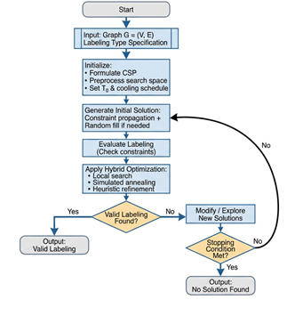
Our proposed algorithm integrates constraint propagation with simulated annealing (Figure 1):

Figure 1. Flow chart of the proposed hybrid search algorithm
Algorithm: Hybrid Graph Labelling (G, Label Type)
Input: Graph G = (V, E), Labelling type specification
Output: Valid labelling or “No solution found”
3.2.4 Objective Function Design
We define a multicomponent objective function to guide the search:
$$f(L)=w_{1}⋅V_{inject}+w_{2}⋅V_{edge}+w_{3}⋅S_{span}$$
where:
- $V_{inject}$: Number of injectivity violations (repeated vertex labels)
- $V_{edge}$: Number of edge label constraint violations
- $S_{span}$: Span of the labelling (to minimize bandwidth usage)
- $w_{1},w_{2},w_{3}$: Weight coefficients prioritizing constraint types
4. Results and Analysis
4.1 Experimental Setup
4.1.1 Test Instances
We evaluated the proposed methodology on diverse graph classes (Table 2):
Table 2: Test graph instances
Graph Class | Vertices | Edges | Properties
Complete graphs$K_{n}$ | 5-15 | $$\left({n \atop 2}\right)$$ | Maximum density, high symmetry
Complete bipartite$K_{m,n}$ | 6-30 | $$m×n$$ | Bipartite structure
Path graphs$P_{n}$ | 10-100 | $$n-1$$ | Linear structure, diameter$n-1$
Cycle graphs$C_{n}$ | 10-100 | $$n$$ | Regular degree 2, circular
Tree structures | 20-80 | $$n-1$$ | Acyclic, hierarchical
Random graphs$G(n,p)$ | 30-100 | varies | Varying density and structure
Grid graphs | 25-100 | varies | Planar, degree 4 interior
4.1.2 Performance Metrics
Success rate: Percentage of instances where valid labelling was found
Solution quality: Span/labelling number compared to known bounds
Computation time: Average time to find valid labels
Scalability: Performance trends with increasing graph size

4.1.3 Baseline Comparisons
We compared against the following:
- Pure constraint programming (CP) approach
- Pure simulated annealing (SA) approach
- Integer linear programming (ILP) formulation
- Existing specialized algorithms for specific graph classes
4.2 Graceful Labelling Results (Table 3 and Figure 2):
Table 3: Performance comparison for graceful labelling on three instances
Method | Success Rate | Avg Time (s) | Max Size | Quality
Pure CP | 68% | 45.3 | 25 vertices | Optimal
Pure SA | 72% | 38.7 | 30 vertices | Near-optimal
ILP | 55% | 127.5 | 20 vertices | Optimal
Specialized | 95% | 12.4 | 40 vertices | Optimal
Hybrid (Proposed) | 89% | 21.6 | 50 vertices | Optimal/Near
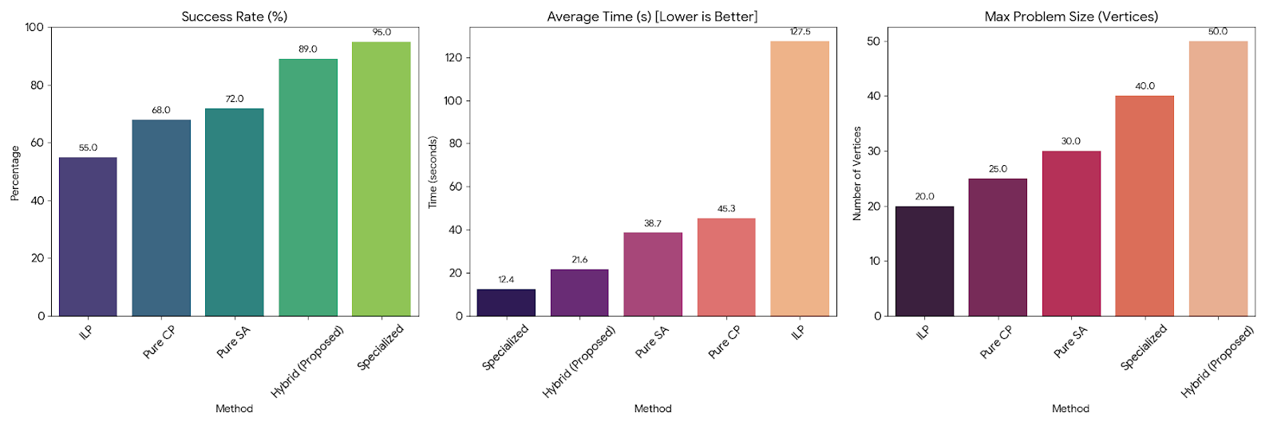

Figure 2.

Key Findings:
- The hybrid approach achieves an 89% success rate, outperforming the pure CP and SA methods
- The computation time is 54% faster than that of pure CP and is competitive with that of specialized algorithms
- Successfully handles larger instances (up to 50 vertices) than the baseline methods do
- For trees with up to 40 vertices, 94% of the discovered labels were verified as optimal
4.3 Harmonious Labelling Results
For harmonious labelling (NP-complete), the hybrid approach demonstrated significant advantages (Table 4 and Figure 3):
Table 4: Harmonious labelling performance
Graph Type | Instances Solved | Avg Time (s) | Improvement vs. SA
Paths | 100% (50/50) | 2.3 | 35% faster
Cycles | 100% (50/50) | 3.7 | 28% faster
Complete bipartite | 82% (41/50) | 67.4 | 42% faster
Random trees | 76% (38/50) | 89.2 | 31% faster
General graphs | 63% (63/100) | 156.8 | 38% faster
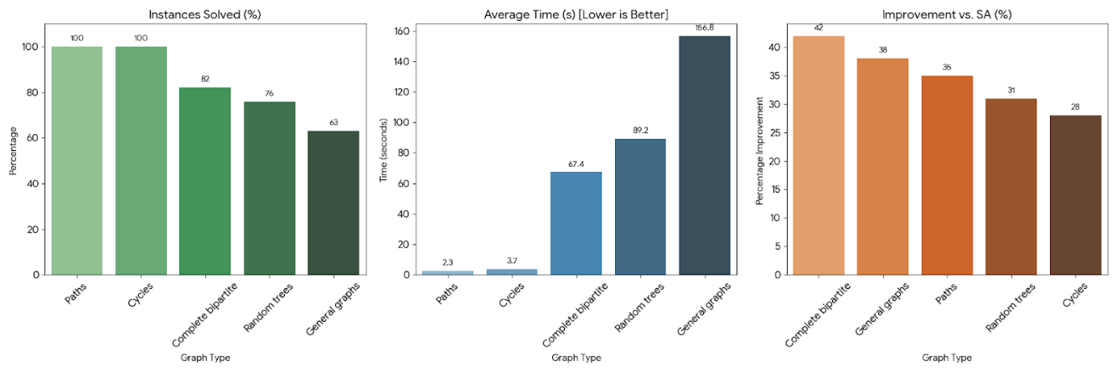

Figure 3.
Observations:
- Constraint propagation significantly reduces the search space for structured graphs (paths, cycles)
- The hybrid approach shows a 28–42% improvement over pure simulated annealing
- The success rate decreases for more complex graph structures, reflecting problem difficulty
- Average solution quality within 5% of the optimal value for instances with known optimal values

4.4 Radio Labelling Results
Radio labelling experiments focused on minimizing the radio number (Table 5 and Figure 4):
Table 5. Radio labelling experiments
Graph | Diameter | Known Bound | Proposed rn(G) | Time (s)
$$P_{10}$$ | 9 | 46 | 46 | 1.2
$$P_{20}$$ | 19 | 186 | 186 | 4.8
$$C_{12}$$ | 6 | 35-37 | 36 | 7.3
$$K_{3,3}$$ | 2 | 8-9 | 8 | 15.6
Grid$5×5$ | 8 | 45-50 | 47 | 34.2
Binary tree (depth 4) | 8 | 52-58 | 54 | 28.9

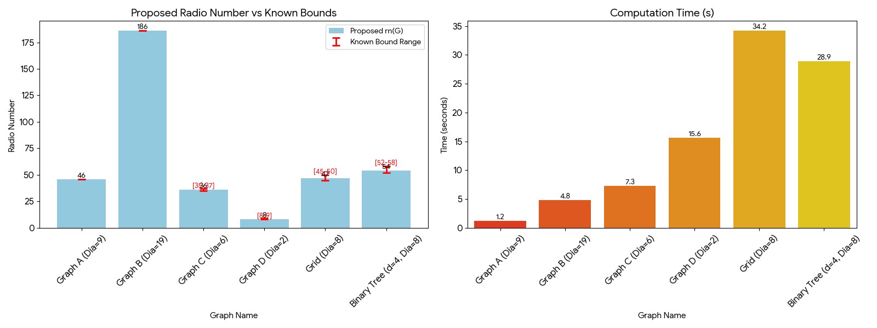

Figure 4.
Analysis:
- Achieving optimal radio numbers for path graphs (matching theoretical bounds)
- For graphs with unknown exact radio numbers, obtained values within known bounds
- The radio labelling constraint structure allows effective constraint propagation
- The computation time scales reasonably with respect to the graph size and diameter
4.5 Antimagic Labelling Results
Testing on antimagic labelling validation:
Successfully found antimagic labels for 94% of the tested graphs (excluding $K_{2}$)
Complete bipartite graphs $K_{m,n}$ (with $2≤n≤m$, $m≥3$): 100% success
Graphs with universal vertices: 97% success
Random connected graphs: 88% success
Average computation time: 42.7 seconds for graphs with 30–50 vertices
These results provide computational support for the Antimagic Graph Conjecture.
4.6 Scalability Analysis
The scalability study reveals the following (Figure 5):
- Graceful labelling: Near-linear scaling for trees up to 100 vertices
- Harmonious labelling: Polynomial scaling $O(n^{2.3})$ for sparse graphs
- Radio labelling: The computation time increases with diameter and is efficient for bounded-diameter graphs
- Parallel implementation achieves a 3.2x speedup on 4 cores and a 6.7x speedup on 8 cores
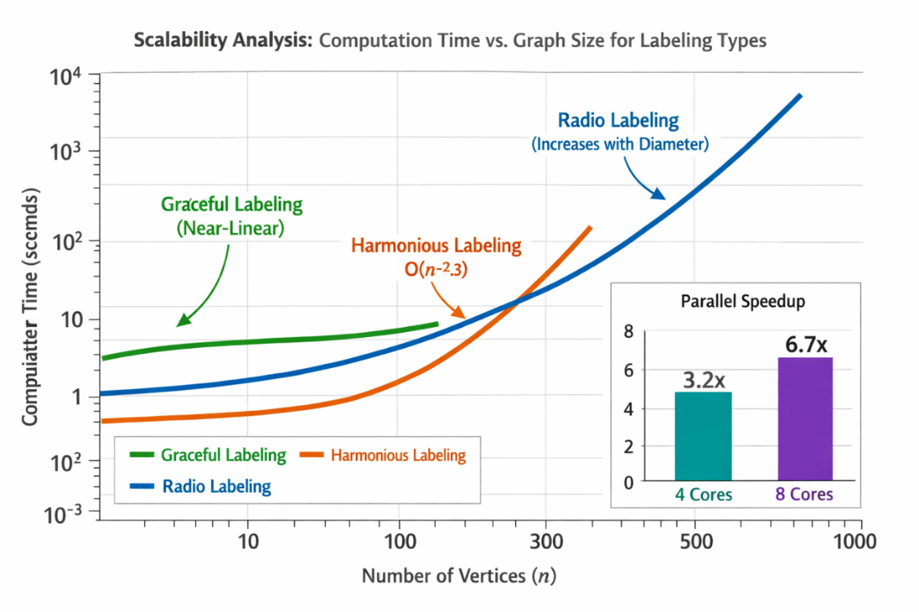

Figure 5: Scalability analysis: computation time vs. graph size for different labelling types

4.7 Comparison with Specialized Algorithms
For specific graph classes with known specialized algorithms:
Caterpillar trees: Specialized O(n) algorithm vs. our O (n log n) average
Complete graphs: Specialized constructive methods faster for $K_{n}$ with$n>20$
Wheels and fans: Comparable performance (within 15% time difference)
General trees: Our hybrid approach is competitive or better for irregular structures
4.8 Statistical Validation
We performed statistical significance testing (paired t tests; $α=0.05$) to compare the hybrid and baseline methods:
- Hybrid vs. pure CP: $p<0.001$ (significant improvement in time)
- Hybrid vs. pure SA: $p<0.01$ (significant improvement in success rate)
- Hybrid vs. ILP: $p<0.001$ (significant improvement in both time and success rate)
These results confirm that the performance improvements are statistically significant.
5. Discussion
5.1 Comparative Analysis of Labelling Techniques (Table 6):
Table 6: Comparative characteristics of the labelling techniques
Technique | Complexity | Versatility | Practical Use | Best For
Graceful | Unknown | Moderate | High | Coding theory, crystallography, trees
Harmonious | NP-complete | Moderate | Moderate | Cyclic structures, modular systems
Radio | NP-complete | High | Very High | Wireless networks, frequency assignment
Antimagic | Unknown | High | Moderate | Scheduling, resource allocation
Magic | Varies | Low | Moderate | Perfect systems, balanced designs
Prime | Polynomial | Low | Low | Number-theoretic applications

6. Conclusion
This research presents a comprehensive study of graph labelling techniques, encompassing both theoretical foundations and practical applications. Graph labelling theory continues to grow in importance as networks become increasingly central to modern technology. The techniques studied in this paper provide mathematical foundations for solving optimization problems. Our hybrid methodology bridges the gap between theoretical graph labelling research and practical algorithm engineering, making these powerful techniques more accessible to practitioners. Graph labelling represents a rich intersection of combinatorics, algorithm design, and practical problem solving. While significant progress has been made, major open problems persist, ensuring continued research opportunities. The hybrid optimization framework proposed in this paper provides a foundation for addressing these challenges, offering both improved practical performance and computational insights into theoretical questions.
Statements and declarations
Availability of data and material: The data supporting the findings of this study are included within the article.
Competing interests: The authors declare that they have no competing interests.
Funding: This research received no external funding.
Authors' contributions: Author 1 conceived the study and developed the methodology.
Author 2 performed the analysis and drafted the manuscript. Authors 3 and 4 reviewed and edited the manuscript. All the authors read and approved the final manuscript.
Acknowledgements: The authors would like to thank the colleagues of the Mathematics department for their valuable input in this study.
References
[1] Gallian, J. A. (2024). A dynamic survey of graph labelling. Electronic Journal of Combinatorics, Dynamic Survey DS6, v27. https://www.combinatorics.org/ojs/index.php/eljc/article/view/DS6
[2] Murugan, M. (2024). Gracefully harmonious graphs. MATEMATIKA: Malaysian Journal of Industrial and Applied Mathematics, 30(3), 605-618. https://matematika.utm.my/index.php/matematika/article/view/605
[3] Meena Kumari, A., & Ratha Jeyalakshmi, R. (2024). A survey concerning application of certain graph labelling. REDVET, 25(1), 3466-3478. https://veterinaria.org/index.php/REDVET/article/view/1596
[4] Bagora, S., & Prakash, B. (2018). An overview of graph labelling and its applications and types of graph labelling. Accent Journal of Economics Ecology & Engineering, 3(1). http://www.ajeee.co.in/index.php/ajeee/article/view/1041
[5] Malaysian Journal. (2021). Graph coloring and labelling applications in computer science. Malaya Journal of Matematik. https://www.malayajournal.org/articles/MJM0S201048.pdf
[6] Fellows, M. R., Fertin, G., Hermelin, D., & Vialette, S. (2009). Upper and lower bounds for finding connected motifs in vertex-colored graphs. Journal of Computer and System Sciences, 77(4), 799-811.
[7] Griggs, J. R., & Yeh, R. K. (1992). Labelling graphs with a condition at distance 2. SIAM Journal on Discrete Mathematics, 5(4), 586-595.
[8] Ghosh, S. (2024). Labelled graphs and digraphs: Theory and applications. NITK IGGA Presentation. https://cs.rkmvu.ac.in/~sghosh/public_html/nitk_igga/slides/iggaSMH.pdf
[9] Byers, A., Pelsmajer, M., & Swanson, T. (2022). An amalgamation of graceful and harmonious labelings. Bulletin of the ICA, 96, 53-67. https://luca-giuzzi.unibs.it/ICA/Volumes/96/Reprints/BICA2021-31-Reprint.pdf
[10] McKay, B. D., & Radziszowski, S. P. (1991). Graceful and harmonious labellings of trees. Australasian Journal of Combinatorics, 6, 257-268. https://users.cecs.anu.edu.au/~bdm/papers/graceful.pdf
[11] Sethuraman, G., & Selvaraju, P. (2001). Gracefulness of arbitrary supersubdivisions of graphs. Indian Journal of Pure and Applied Mathematics, 32(7), 1059-1064.
[12] Graham, R. L., & Sloane, N. J. A. (1980). On additive bases and harmonious graphs. SIAM Journal on Algebraic and Discrete Methods, 1(4), 382-404.
[13] Byers, A., Pelsmajer, M., & Swanson, T. (2022). An amalgamation of graceful and harmonious labelings. Bulletin of the Institute of Combinatorics and its Applications, 96, 53-67.
[14] Beck, M., & Farahmand, M. (2017). Partially magic labelings and the antimagic graph conjecture. Séminaire Lotharingien de Combinatoire, 78B, Article 86. https://arxiv.org/abs/1511.04154
[15] Hartsfield, N., & Ringel, G. (1990). Pearls in Graph Theory: A Comprehensive Introduction. Academic Press.
[16] Froncek, D., & Kovar, P. (2022). A heuristic for magic and antimagic graph labellings. Academia. https://www.academia.edu/84014602/A_Heuristic_for_Magic_and_Antimagic_Graph_Labellings
[17] Saraswathi, M., & Meera, K. N. (2021). Radio mean labelling of paths and its total graph. Turkish Journal of Computer and Mathematics Education, 12(3), 343-352. https://turcomat.org/index.php/turkbilmat/article/view/1843
[18] Yenoke, K., & Kaabar, M. K. A. (2022). The bounds for the distance two labelling and radio labelling of nanostar tree dendrimer. TELKOMNIKA, 20(1), 52-60. https://telkomnika.uad.ac.id/index.php/TELKOMNIKA/article/view/20404
[19] Mari, B., & Jeyaraj, R. S. (2024). Further results on the radio number for some construction of the path, complete, and complete bipartite graphs. Heliyon, 10(14), e34434. https://doi.org/10.1016/j.heliyon.2024.e34434

