**Intention of Customers as A Mediating Role: Can Social Media Marketing Affect Banking Performance: A Case of selected bank in Ethiopia?**

***Achalu Teshome (PhD) Department of Marketing Management, College of Business and Economics, Bule Hora University, Ethiopia +251911092496, achalu2014@gmail.com.***

***Abstract: The goal of the research:*** *This study examines the effects of social media marketing services on bank performance in a few Ethiopian banking sectors from the perspective of the mediating role of customer intentions.* ***Methodology:*** *This article was first produced by considering one-time surveys with a cross-sectional design. Data analysis has been done using the findings of the ordinal questionnaire, and QDAML has been built based on the model tested with SEM, AMOS, and SPSS version 26. A total of four hundred respondents and responses are included in this article. Descriptive statistics of demographic data indicate that the controlling variables are male and female responses.* ***Scientific novelty:*** *This thesis adds to the existing knowledge by expanding the range of research on consumer intention and bank performance within the banking sector.* **Conclusions:** *The results of the poll indicated that social media marketing services have a little impact on banks' performance, according to data analysis. Banks have used the information in this article to solve issues related to social media marketing services.* ***Keywords:*** *Marketing on social media, customer intent, performances of bank.*

**1. Introduction**

The impact of social media marketing services on banking performance and the mediating role of consumer intention are briefly discussed in the article. It concentrated on a small number of southern Ethiopian commercial banks in Borena. The study would help important stakeholders like banks and academics, as well as future research, policy implementation, and practice development. Through the use of software algorithms and digital marketing, consumers and digital banks can improve their service operations, procedures, and lives. There have been several technical revolutions in the banking industry. The rise of digital marketing strategies and the growing digitization of consumer behavior are responsible for the neo-bank business model approach (Affecting et al., 2018). In order to catch up to other rising nations, particularly those that are late comers, in terms of advanced economic performance, the Africa Union (2021) stated that more than half of Ethiopia is currently undergoing technical improvement (Tesfachow, 2022). Of course, the banking family has done everything in its power to use technology in order to further improve the services that they provide. Today, 4.9 billion people utilize digital marketing services on a regular basis worldwide (Union, 2021). According to Surbhi S. (2021), the banking sector as a whole has prioritized offering services via digital marketing services (DMS). Companies can boost their revenue and website traffic by utilizing digital marketing services. Because digital marketing has so many advantages, the banking sector uses it to attract customers. Businesses can increase consumer intent and banking sector profitability by using digital marketing services to encourage repeat business from customers (J. Ali & Zone, 2015).

The rise of digital marketing platforms, including social media marketing, e-banking, m-banking, and ATMs, has changed how customers access services and put pressure on conventional banking practices. Due to the ability to offer multi-channel services, digital banking has transformed the way banks engage with their customers (Alyahya et al., 2020). However, the following problems with Ethiopia's digital banking services that still need to be addressed were supported by the Ethiopia Policy Review (2019): The country's attempts to establish a functional financial transfer system have encountered many challenges. Due to its lack of infrastructure, Ethiopia confronts several difficulties, such as erratic electricity supplies, trouble with telecommunications connections, and problems with internet connectivity (Ejigu, 2016; Ethiopia Digital Strategy Plan, 2020).

This article's goal is to spread knowledge about neo-marketing systems by providing fresh perspectives on neo-banks and how they Social marketing services, bank performance, and customer intention into service companies such as banks. Therefore, the following research issues are intended to be addressed by this study: RQ1. In a chosen study of Ethiopian commercial banks, does the utilization of social media marketing services affect banks' performance? RQ2. How can social media marketing services affect the intention of customers at particular Ethiopian commercial banks? RQ3. In what ways do banking performance and social media marketing services at particular Ethiopian commercial banks depend on client intentions? Test of hypotheses H1. Customer intention is significantly impacted by social media marketing services; H2. Bank performance is significantly impacted by social media marketing services. H3. The relationship between social media marketing services and bank performance is significantly mediated by customer intention.

**II, Material and Methods**

The empirical inquiry conducted for this study was mixed research techniques. Both closed-ended and open-ended questions were included in the surveys. Ethiopia, the study region, is located between latitudes 3 and 15 north and longitudes 33 and 48 east. The country is about 1,127,127 square kilometers in size. Ethiopia is home to an estimated 122,949,682 people. Ethiopia is home to 1.47 percent of the world's population, making it the 12th most populous country in the world. 21.3% of that population resides in an urban region (FDR, 2021; UN Data, 2023; Central Statistical Agency of Ethiopia, 2007).

Figure 1. Map of the study area

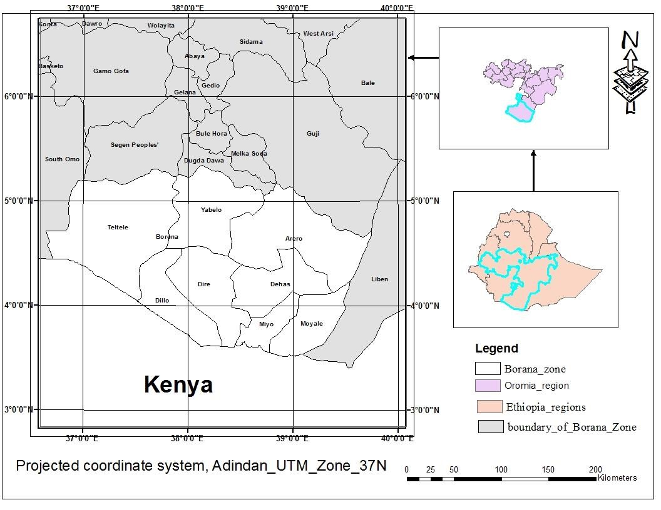

**Source: Adopted from CSA, 2007**

The primary information sources were key informants, staff members, and clients of a few chosen institutions, including the Commercial Bank of Ethiopia, Awash Bank, Abyssinia Bank, Oromia Bank, and the Cooperative Bank of Oromia. The five banks in the sample were chosen using the purposive sampling technique. After stratification by bank, 324 consumer respondents and 76 workers from chosen banks were included in the sample using a straightforward random sampling procedure. The purposive sample technique took into account those who were thought to have a fair amount of training and knowledge of CBE. questionnaires with Likert scale items and open-ended questions were created based on the current philosophy and practices of particular banks in order to collect data from the participants. Three measurement and evaluation instructors assessed the questionnaire's content validity, and a pilot study was conducted at each of the chosen banks to further assess the questionnaires' applicability and lucidity. When administering the questionnaires, data collectors took into account the convenience of the location where customers receive door-to-door service. wherein 97% of the returns were produced. Descriptive statistics including frequency, percentage, and mean scores were used in the data analysis, along with Amos version 26 software. Amos was used if it was a contemporary piece of software designed for quantitative research.

III. Responding to research inquiries

This part presents and analyzes the data collected from the respondents in accordance with the study questions. After the data and outcomes are presented, there are quick conversations.

|  |  |  |  |  |  |
| --- | --- | --- | --- | --- | --- |
| **Table 1: Mean and SD of Social Media Marketing Services** | | | | | |
| (SM19) | 400 | 1 | 5 | 4.03 | 1.196 |
| (SM20) | 400 | 1 | 5 | 4.04 | 1.130 |
| (SM21) | 400 | 1 | 5 | 3.95 | 1.165 |
| (SM22) | 400 | 1 | 5 | 3.95 | 1.123 |
| (SM23) | 400 | 1 | 5 | 4.18 | 1.272 |
| (SM24) | 400 | 1 | 5 | 4.04 | 1.138 |

The survey's results, as presented in Table 1, reveal respondents' opinions about the social media services provided by each of the chosen banks. The results of the SMM19–SMM24 survey showed that participants gave careful consideration to the social media marketing services provided by selected banks. (Mean 4.03, SD 1.196) of participants said they used social media to find sufficient information about their bank service. (Mean 4.05, SD 1.130) of participants said that we benefited from the knowledge we found on social media. Social media marketing was mentioned by (Mean 3.95, SD 1.165) of participants as a source of new knowledge about the banking service I offered. Participants said social media marketing improves their connections with banks (Mean 3.95, SD 1.123). (Mean 4.18, SD 1.270) of participants said they use social media to get location-specific information from where they are. Participants said social media increased the frequency of their interactions with banks (Mean 4.04, SD 1.138). There are no outliers because every standard deviation number is higher than zero.

**Table 2 shows the findings of the pilot study's scale reliability coefficient for the items related to social media marketing services (SM), customer intention (CI), and bank performance (BP.**

|  |  |  |  |  |
| --- | --- | --- | --- | --- |
| Alpha Cronbach's | Items | Based on Standardized Items, Cronbach's Alpha | | Explanation (Taber, 2018) |
| SM .899 | 5 | .889 | | Acceptable |
| CI .890 | 37 | .875 | Acceptable | |
|  | | | | |
| BP .856 | 23 | .850 | Acceptable | |

**Source: Own survey output, 2024**

**Table 3: Social Media Marketing Services' Internal Consistency Analyses**

|  |  |  |  |  |
| --- | --- | --- | --- | --- |
| **Marketing Services on Social Media** | | | .717 | 0.766 0.574 0.750 |
|  | (SM20) | .652 |
|  | (SM21) | .803 |
|  | (SM24) | .865 |

The scale reliability test results are displayed in Table 3. The scale reliability test results below Table 3 show that each item was internally consistent with every other item. The values range from moderate (.652) to strong (.865). According to Schober & Boer (2018) and Akoglu (2018), all of the statistics were considered acceptable because they were higher than the weak correlation requirement of 0.39. Convergent validity requires item-to-total correlation values to be greater than 0.39; if any of the values are less than this threshold, they should be removed. In order to maintain the validity of the study, social media marketing services items SMM19(.322), SMM22(.232), and SMM23(276) were eliminated and excluded from the statistical analysis process because their item-to-total scores fell below the acceptable limit. Since the item-to-total correlation value is obviously less than 0.39, it should not be included for additional analysis in order to guarantee statistical accuracy, convergent validity, and other requirements.

        The composite reliability test of the construct was used to assess internal consistency, and the results in Table 3 show that the CR value exceeding the minimum accepted value of 0.4 (Schober & Boer, 2018). The average variance extracted (AVE) for social media marketing services above the threshold of 0.50 recommended according to (Yadav et al., 2017) argued that this ensured the presence of discriminant validity in the study. The construct's Cronbach's alpha coefficient value of.717 exceeded the recommended threshold of 0.6 as recommended by (Taber, 2018; Raharjanti et al., 2022). For discriminant validity, the square root average variance (AVE) value must be greater than 0.50 which is less than what is advised suggests that convergent validity is present.

As a result, Cronbach alpha values between 0.60 and 0.70 are acceptable; but, at a more advanced level, the value must be more than 0.70. Nonetheless, a composite dependability score of 0.95 or higher is unquestionably bad (Yadav et al., 2017). All composite dependability results for social media marketing were within an acceptable range, at 0.95.

**Table 4: Convergent Validity (Ave) and Composite Reliability (Cr)**

|  |
| --- |
|  |
| Latent constructs CR AVE |
| Social media services  (CR&AVE) 0.718 0.568  Customer intent  (CR&AVE) 0.940 0.749  Performance of Bank  (CR&AVE) 0.921 0.803 |

**Source: Field data, 2024**

It is acceptable for composite reliability if CR > 0.70 and for convergent validity if AVE > 0.50 (A. Rashid & Rokade, 2019). With reference to Table 4, the AVE values fall between 0.503 and 0.804, which is higher than the suggested threshold, and the CR for all constructs is above 0.70.

**Table 5: Inter-Construct Correlation Matrix for Discriminant Validity**

|  |
| --- |
| Latent constructs |
| Latent constructs A B C |
| Social media Services  (A) 0.761  Customer intent  (B) ..788**  .843** .872**  Performance of Bank  (C) ..644** .290** .139** 0.898 |

**Source: Field data, 2024**

|  |
| --- |
| **. Correlation is significant at the 0.01 level (2-tailed). |
| *. Correlation is significant at the 0.05 level (2-tailed). |

According to Yadav et al. (2017), models are considered to have discriminant validity if the square root of AVE is greater than the interconstruct correlations. Every AVE item in table 5 above is greater than the interconstitut correlations. Accordingly, the survey's findings demonstrate that our models' discriminant reliability was met.

**IV. Examining the theory**

**Table 6: Direct Effects of Research Hypotheses**

|  |  |  |  |  |
| --- | --- | --- | --- | --- |
| Hypothesis for the research model | The Path model | Loading of Estimate | loading of P-value | Decision |
| H1 Bank performance is significantly impacted by social media services. | BP < SM | -.011 | .160 | Not Supported |
| H2 Customer intention is significantly impacted by social media services. | CI <SM | .587 | *** | Supported |

**Source: Field data, 2024**

**Table 7: Results Model for Direct Effects**

|  |  |  |  |  |
| --- | --- | --- | --- | --- |
| Hypothesis | The Path model | Loading of Estimate | loading of P-value | Decision |
| H1 | BP <- SMS | -.011 | .160 | Not Supported |
| H2 | CI <- SMS | .587 | *** | Supported |

**Source: Field data, 2024**

**V. Checking out Hypothesis H1. Social Media Marketing Services Have a Significant Impact on Bank Performance**

According to the study results in table 8 above, social media marketing services significantly improve banks' performance. Social media marketing services had a -.011 standardized direct influence on bank performance (p-value =.160 > 0.05). This indicates that bank performance decreases by -.011 for every standard deviation increase in digital teller machine services. The data indicates that the impact of social media marketing services on banks' performance is negligible. Hypothesis H1 is therefore unsupported.

**VI. Analyze Hypothesis H2 Customer Intention Is Significantly Affected by Social Media Marketing**

According to the study results in table 8 above, social media marketing does not significantly increase client intention. Social media marketing had a standardized direct effect of.587 on client intention (p-value =.0.001 < 0.05). This indicates that buyer intention increases by.587 for every standard deviation increase in social media marketing. Social media marketing significantly improves buyer intention, according to the evidence. Hypothesis H2 is thus validated. These results are consistent with study by Alyahya et al. (2020), who proposed that the ability to offer multi-channel services through digital marketing services has altered the way banks engage with their customers.

**VII. Test Hypothesis H3 for Mediation Using a 95% Confidence Interval Bootstrap Analysis.**

**Table 8: Analysis of Mediation**

|  |  |  |  |  |  |  |
| --- | --- | --- | --- | --- | --- | --- |
| Relationships | Direct influence of beta value | Indirect effect of beta  value | The interval of confidence | | The Value of P | Decision |
| Low bound | High bound |
| H3Social media 🡪 Customer intent🡪Performances of bank | .943 | .071 | .012 | .104 | 0.023 | The indirect effects are.012 and.104, which indicate no zero between them, while the direct affect p-value, which is.023, is significant due to partial mediation. |

**Source: Field data, 2024**

**Table 9: Results of the Mediation Model**

|  |  |  |  |  |  |  |
| --- | --- | --- | --- | --- | --- | --- |
| Relationships | The direct influence | The Indirect influence | The interval of confidence | | The Value of P | Decision |
| Low | High |
| BP <- CI<-SM | .943 | .071 | .012 | .104 | 0.023 | Partial mediation |

**Source: Field data February, 2024**

According to the survey results above in table 9, customer intention mediated the relationship between the independent social media marketing services and the dependent variable bank performance. The standardized regression coefficient value that was produced was.954 for the direct effect,.072 for the indirect effect, boostrap confidence interval for low.012, for high.104, and P-value.023<0.05. This suggests that customer intentions significantly mediated the relationship between internet banking services and bank performance. According to Gunzler et al. (2016), there is not only a significant relationship between the mediator and the dependent variable, but also some direct relationship between the independent. Due to the substantial direct effect p-value of.023 and the non-zero indirect effects of.012 and.104, the mediators exhibit partial mediation. However, the third hypothesis is accepted.

**VIII. Discussion**

The study's findings showed that social media marketing had a little impact on bank performance, which means that there is little correlation between bank success and social media marketing. The results of the study are in conflict with a study performed at Linnaeus University in Vaxjo, Sweden, which found that social media use improved customer satisfaction and performance. The findings of this study, however, showed that social media marketing significantly influences customer intention, indicating that there is little evidence linking social media marketing to customer intention. The study's findings showed a positive and strong mediation relationship between social media marketing and bank performance through consumer intention.These results are consistent with studies from Nigeria, where Oni (2020) proposed that service quality has a positive and significant impact on customer satisfaction. The results of the study also support a study by Heijden et al. (2016) from the Netherlands, which demonstrates that eight behavioral factors are important for fostering customer intimacy and loyalty: first, the quality of the services that employees provide; second, their ability to provide high quality; third, their empathy for the needs and wishes of customers; fourth, their understanding of those needs; fifth, their responsiveness to those needs; sixth, their courtesy toward customers; seventh, their manner of providing service; and last, the trust that customers have in employees. Additionally, the research aligns with a study by Budiman et al. (2021) that found that a company can prevent customer turnover, increase customer loyalty, lower customer sensitivity to prices, lower marketing failure costs, lower operating costs due to an increase in the number of customers, increase advertising effectiveness, and improve business reputation by achieving a high level of customer intention focusing. For company continuity, efforts to enhance the service quality system would be far more beneficial.

IX. CONCLUSION

Based on the study's findings, the following alternative solutions could be pursued: Consequently, banks must offer value to their customers through digital channels and multi-channel services if they hope to improve their bank performance. Banks and customers can achieve greater performance by using appropriate digital marketing services. The study's findings also suggested that customer intention has a negative significant relationship with banking performances, which implies that customer bad intention to bank services declined bank performances. Additionally, the study's findings implied that social media marketing services had an insignificant relationship with banking performances, suggesting that social media marketing services had no effect on bank profitability. Banks should take security and other issues extremely seriously since customers are still concerned about them. By expanding the scope of research on customer intention and bank performance in relation to digital marketing services, this dissertation contributes to the body of knowledge. Results show that digital marketing is effective in retaining current customers and attracting new ones.

**X. Acknowledgment and Conflict of Interest**

All of the responses from the chosen banks are deeply appreciated for providing crucial information for our scientific study.

**Reference**

(1)Affecting, F, & Ayal,. A. (2018).School Of Commerce Cogent Economics & Finance Factors affecting bank customers usage of electronic banking in Ethiopia : Application of structural equation modeling ( SEM ) Factors affecting bank customers usage of electronic banking in Ethiopia : Application of structural

(2) Ejigu, S. (2016). Nahusenay E-Banking Service Quality and Its Impact on Customer Satisfaction in State Owned Banks in East Gojjam Zone Ethiopia.

(3) Ethiopia Digital Strategy Plan. (2020). Ethiopia ’ s Digital Economy Ethiopia ’ s Digital Economy

(4) Fetu, A. (2019). DOI: 10.32602/jafas.2019.23 Opportunity and Challenges of Electronic-Banking System in Commercial Bank of Ethiopia (A Case Study on Gurage Zone). 106–122. https://doi.org/10.32602/jafas.2019.23

(5) Gusti, Y. (2020). The Influence Of Innovation, Customer Value And Customer Empowerment On Customer Satisfactionrjoas, 8(104), August 2020. 8(August), 88–95. Https://Doi.Org/10.18551/Rjoas.2020-08.11

(6) Hichaim, Y., Altaie, S., Mohammed, & Tayyeh, S. (2020).The Role of Digital Banking Services in Enhancing

(7) Kifle,. E. (2021). Determinants of internet banking adoption in Ethiopia A Thesis Submitted in Partial Fulfillment of the Requirements for the Degree of Masters in Business Administration

(8).Lee, J., Wewege, L., & Thomsett, M. C. (2020). Disruptions and Digital Banking Trends. Journal of Applied Finance & Banking, 10(6), 1792–6599. https://www.researchgate.net/publication/343050625.

(9).Lyimo,B (2019).Influence Of The Digital Marketing On Performance Of Banking Industry Tanzania : A Case Of Barclays Bank Winfrida Fute Tanzania

(10).M. A. Khan and Alhumoudi. (2022). Performance of E-Banking and the Mediating Effect of Customer Satisfaction : A Structural Equation Model Approach

(11).Okkonen, J.,Vuori,. V.,Palvalin,.M. ,Agboola, G., Awobajo, K., Oluwatobi,.O,. Akinbode, M., Fagbohun, M., Esse, Ugwunwa C., Segun-Adeniran, C., Asaolu, A.,& Betek, C. (2019).What is digitalization?

(12).Ranabhat. D.(2018) Views of students of Centria University of Applied Sciences

(13).Schober,. B. (2018). Correlation Coefficients: Appropriate Use and Interpretation

(14) Taber, K. S. (2018). The Use of Cronbach ’ s Alpha When Developing and Reporting Research Instruments in Science Education Content courtesy of Springer Nature , terms of use apply . Rights reserved . 1273–1296. https://doi.org/10.1007/s11165-016-9602-2

(15).Tesfachow, T.(2022). Ethiopia’s d rive to advance digital transformation

(16).Terason, S. (2021). loyalty in automobile business ” Customer value and customer brand engagement : Their effects on brand loyalty in automobile business. https://doi.org/10.21511/im.17(2).2021.09

(17). Transactions, S., Hinojo, P., Su, D., & Garc, B. (2022). Drivers of Consumer Participation in Online. 1–13.

(18).Trivsel, C., & Trivsel, S. (2017). Customer satisfaction and customer loyalty. November.

(19).Tuominen, S., Reijonen, H., Ecole, I. G., Buratti, A., & Laukkanen, T. (2021). Customer-centric strategy driving innovativeness and business growth in international markets. https://doi.org/10.1108/IMR-09-2020-0215

(20).UNCTAD Economy report. (2021).United Nations Conference on Trade and Development Embargo

(21).Union,T.(2021).Research Instruments: a Questionnaire and an Interview Guide Used To Investigate the Implementation of Higher

(22).World Bank Financial Inclusion Survey (2018).Mobile Money in Ethiopia : Advancing financial inclusion and driving growth

(23).Yadav, S., Kunwar, A., Chen, L., Wang, M., & Ollinger, N. (2017). Discriminant Validity Assessment : Use of Fornell & Larcker criterion versus HTMT Criterion Discriminant Validity Assessment : Use of Fornell & Larcker criterion versus HTMT Criterion.

(24).Yamane, T. (1967). Yamane, Taro. (1967). Statistics: An Introductory Analysis: Vol. 2nd Editio (p. 886).

(25).Yaseen, H., Al-adwan, A. S., & Al-madadha, A. (2019). Digital Marketing Adoption Among Smes In Jordan : A Mixed-Method Approach Digital Marketing Adoption Among Smes In Jordan : A Mixed- Method Approach. February.

(26).Zea, & Civelek, M. E. (2018). Essentials of Structural Equation Modeling Essentials of Structural Equation Modeling.

(27).Zuo, L., & Strauss, J. (2021). The Digitalization Transformation of Commercial Banks and Its Impact on Sustainable Efficiency Improvements through Investment in Science and Technology.