From Clinical Caution to Financial Conservatism: Exploring the Transfer of Professional Risk Aversion to Fintech Adoption Using Multi-Group SEM
Dr Saurabh Singh¹, Dr. Vijay Kumar², Dr Imran Ahmad³, Dr. Madhu Dixit⁴,
¹Assistant Professor, School of Management and liberal Arts, IMS Unison University, Dehradun, Uttarakhand; Email id - saurabh33.singh@gmail.com. ORCID ID: https://orcid.org/0000-0002-5851-6259
²Associate Professor, School of Management and liberal Arts, IMS Unison University, Dehradun, Uttarakhand. ORCID ID: https://orcid.org/0000-0002-9877-8907
³Assistant Professor, School of Management and liberal Arts, IMS Unison University, Dehradun, Uttarakhand; ORCID ID: https://orcid.org/0000-0002-6714-6851
⁴Professor, Institute of Management, Commerce and Economics. Shri Ramswaroop Memorial University https://orcid.org/0000-0001-9486-7235
Abstract
Background: The growth of financial technology (Fintech) is transforming personal finance, where the user of fintech adoption varies by behaviour. while present technology adoption models overlook the influence of deep-seated, domain-specific professional socialisation on personal financial decisions.
Objective: This study investigates the “spillover effect” of professional training on the adoption of Fintech products. study specifically analyses the risk-averse mindset that is cultivated in medical training against the more calculated risk-managing approach in engineering and influences students financial risk tolerance, trust, and behavioural intentions.
Methods: A quantitative survey was administered to 500 undergraduate students of two different professions from universities. Multi-group analysis on structural equation modelling (SEM) is used on the UTAUT2 framework with professional risk mindset and financial risk tolerance.
Results: The findings support that medical students exhibit a significantly more risk-averse professional mindset than their engineering peers. This multi-group analysis showed that the positive relationship between financial risk tolerance and the intention to adopt high-risk Fintech was significantly weaker among medical students compared to their engineering peers.
Conclusion: This research shows that a professional psychological framework spreads into personal financial domains and challenges a “one-size-fits-all” view of technology adoption. The findings show fintech marketing required tailored psychological profiles of different professional where financial literacy programmes are helpful to address behavioural biases shaped by professional training.
Keyword: Medical Students, SEM, Fintech, Risk Perception.

1. Introduction
The fast expansion of financial technology (Fintech) work acts as a transformative force in the global financial landscape. Fintech democratises access to investment, credit, and financial management where people can make decisions and analyse their financial aspects with Fintech applications for peer-to-peer (P2P) lending, QR codes, and other financial transactions. Students of higher educational institutions and universities are flag bearers in the fintech sector, known as digital natives. The new age generation is more engaged in fintech adoption, where it is not merely a matter of convenience but a formative experience in personal finance. General drivers of technology adoption focusing on factors such as performance expectancy, effort expectancy, and social influence as outlined in frameworks in the Unified Theory of Acceptance and Use of Technology (UTAUT) and its successor UTAUT2 show a significant research gap persists. Existing models treated users as a relatively uniform group and overlooked the potential impact of deep-seated, domain-specific professional socialisation on personal financial decisions, creating a questionable remark, so research will be guided by the following questions:
- RQ1: How does the professional risk mindset of medical and engineering students differentially impact their financial risk tolerance and trust in high-risk Fintech?
- RQ2: What is the comparative effect of professional risk mindset and financial risk tolerance on the intention to adopt high-risk Fintech among medical versus engineering students?
- RQ3 Do structural paths (FRT → Trust, Trust → Intention) in the extended UTAUT2 model differ significantly between medical and engineering student cohorts?
The study is to understand how a distinct Professional Risk Mindset cultivated through either medical or engineering training acts as an antecedent to these two constructs. Study posits that the medical ethos of “primum non nocere” fosters a consequence-averse mindset [1], while engineering training promotes a more calculated, risk-managing approach [2]. Building on this, the second objective examines the comparative effect of these psychological factors on the behavioral intention to adopt Fintech. Financial Risk Tolerance is a known predictor of investment behavior [3]. FRT influence is not uniform across professions. While Unified Theory of Acceptance and Use of Technology 2 (UTAUT2) as a foundational framework extends in study integrating Professional Risk Mindset and Financial Risk Tolerance as antecedents.

2. Hypothesis Development
H1: Medical students significantly more risk-averse professional mindset compared to engineering students.
Medical and engineering training cultivate fundamentally different orientations toward risk. Medical education's emphasis on diagnostic precision and the ethical imperative systematically fosters a professional identity rooted in results aversion and meticulous caution to minimise life-altering errors [4]. Engineering education is orientated toward systematic design and iterative improvement, where controlled failure serves as a valuable learning mechanism for cultivating a mindset focused on quantifying and mitigating risk rather than avoiding it [2].
H2: A risk-averse professional mindset will be negatively associated with general financial risk tolerance.
General financial risk tolerance will negatively correlate with a more risk-averse professional mindset. A professionally cultivated mindset extends beyond the clinical or workshop environment to influence personal life decisions, particularly those of a financial nature. This is grounded in the concept of occupational spillover, which suggests that the values and psychological patterns developed at work can infiltrate non-work domains [5].
H3: Higher financial risk tolerance will be positively associated with perceived trust in high-risk Fintech platforms.
Higher financial risk tolerance will be positively associated with perceived trust in high-risk Fintech platforms. Financial Risk Tolerance (FRT) is a well-established predictor of investment behaviour, where more tolerant individuals are willing to allocate capital to assets with higher volatility and potential return [6]. An individual's financial risk tolerance directly informs their level of trust in investment opportunities. Those with a high tolerance for financial uncertainty are more likely to perceive a high-risk fintech platform as a viable opportunity rather than a threat.
H4a: Higher financial risk tolerance will be positively associated with the behavioral intention to adopt high-risk Fintech.
High-risk Fintech potential for significant financial loss is explicit; individual FRT becomes a primary driver of their adoption intention. Consequently, individuals with low FRT are unlikely to consider investing in such volatile assets, regardless of their potential upside.
H4b Financial risk tolerance will not be significantly associated with the intention to adopt low-risk Fintech.
Financial risk tolerance will not be significantly associated with the intention to adopt low-risk Fintech. For low-risk fintech services like digital payments or budgeting apps, the primary decision drivers are utility and convenience, not financial risk [7].
H5: Perceived trust will positively mediate the relationship between financial risk tolerance and behavioural intention to adopt high-risk fintech.
Perceived The trust mediation effect shows that FRT shapes user cognitive and affective evaluations of the platform's trustworthiness, which in turn solidifies their intention to adopt it. A risk-tolerant individual comfortable with ambiguity is more likely to form a positive trust judgement, which is a proximate driver of adoption. Trust mediates the relationship between risk perceptions and user behavior in online environments (Gefen et al., 2003).
H6: Performance expectancy will be positively related to the behavioural intention to adopt high-risk fintech.
Performance expectancy will be positively related to the behavioural intention to adopt high-risk Fintech. Performance expectancy, or the degree to which an individual believes that using the fintech service will help them achieve gains in financial performance or management, is a fundamental driver of technology use [9].
H7: Effort expectancy will be positively related to the behavioural intention to adopt high-risk fintech.
Effort expectancy will be positively related to the behavioural intention to adopt high-risk fintech. Perceived ease of use is a fundamental driver, as it reduces the friction and anxiety associated with managing finances through a digital channel [10]. High-risk financial products involve complicated interfaces volatile visualisations with complex transaction processes that threaten beginner. For high-risk fintech to achieve widespread adoption, it must not only promise high returns but also deliver a seamless, instinctive user experience that minimises effort and technical expertise.
H8: Social influence will be positively related to the behavioural intention to adopt high-risk fintech.
Social influence will be positively related to the behavioural intention to adopt high-risk fintech. The subjective norm of fintech adoption is such that individuals use social circles, peers, family, and online communities, and online influencers have been shown to have a significant positive impact on investment intentions [11]. An individual's perception of how others view the use of the technology is a strong predictor of their own adoption behavior [12].
Figure 1: Proposed Research Model

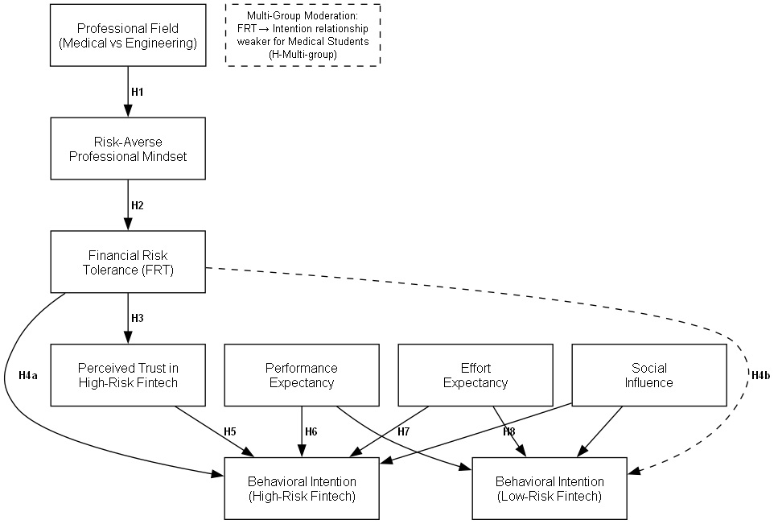

Source: Proposed Research Model developed through Python.
4.1 Study design:
A quantitative approach is used in this study for measuring the latent constructs of the conceptual model and testing their structural relationships through Structural Equation Modelling (SEM) on R Studio and Python. To ensure the robustness of our measurements, all constructs were operationalised using scales adapted from previously validated studies in technology adoption, behavioral finance, and professional psychology, a critical step for ensuring the reliability and validity of the collected data.
4.2. Population and Sampling
Study is based on the population of undergraduate students enrolled in accredited medical (MBBS) and engineering (B.Tech) programmes at universities. This population was chosen because these students are actively immersed in their respective professional training cultures and are at a formative stage in their financial lives, making them an ideal group for studying the spillover effects of professional socialisation.
A non-probability sampling technique was employed with a purposive sampling to deliberately select participants meeting the inclusion criteria. 250 complete responses from each group (total N = 500) were used in this study where this size is considered robust for conducting Confirmatory Factor Analysis (CFA) and SEM along with multi-group comparisons with sufficient statistical power
4.3. Data Collection Instrument
An online questionnaire was distributed. Which consist of two primary sections. In section 1 collected demographic while in Section 2 measured all theoretical constructs using 7-point Likert scales (1 = Strongly Disagree to 7 = Strongly Agree).

4.4 Demographic Profile of Participants
The demographic characteristics of the final sample of 500 participants are summarised in Table 1.
Table 1: Demographic Profile of Participants (N=500)
Demographic Variable | Category | Frequency (n)
Academic Programme | Medical Students | 250
Academic Programme | Engineering Students | 250
Gender | Male | 281
Gender | Female | 219
Age | 18-20 years | 142
Age | 21-22 years | 238
Age | 23-24 years | 120
Year of Study | 1st Year | 125
Year of Study | 2nd Year | 131
Year of Study | 3rd Year | 123
Year of Study | 4th Year | 121
Source: Author’s own calculation using primary data.
4.5 Data Screening & Preliminary Analysis
Missing values accounted for less than 2% of all data points addressed using Full Information Maximum Likelihood (FIML) during model estimation. The dataset was also examined for outliers leading to the removal of seven cases (n=7) identified as univariate (z-scores > ±3.5) or multivariate (Mahalanobis distance, p < .001) outliers. The final cleaned sample for analysis comprised 493 respondents. To mitigate common method bias, Harman's single-factor test was performed. The result indicated that a single factor explained only 28.7% of the total variance, which is below the critical threshold of 50%
5.1 Statistics:
Measurement Model Validation (CFA)
Measurement model for reliability and validity where χ²/df = 2.45, CFI = 0.93, TLI = 0.92, and RMSEA = 0.055. while Table 2 constructs exhibited Cronbach's alpha values exceeding the recommended threshold of 0.70, confirming excellent internal reliability.
Table 2: Internal Consistency Reliability Analysis
Construct | Number of Items | Cronbach's Alpha
Professional Risk Mindset (PRM) | 3 | 0.85
Financial Risk Tolerance (FRT) | 3 | 0.89
Performance Expectancy (PE) | 3 | 0.82
Effort Expectancy (EE) | 3 | 0.78
Social Influence (SI) | 3 | 0.81
Perceived Trust (Trust) | 3 | 0.88
Behavioral Intention (High-Risk) | 3 | 0.86
Source: Author’s own calculation using primary data.
In Table 3, all factor loadings were statistically significant (P < .001) and exceeded the recommended value of 0.70, providing strong evidence for convergent validity at the item level. Composite Reliability CR for all constructs surpassed the 0.70 threshold, and the AVE for all constructs exceeded the 0.50 benchmark. This confirms that the measurement model possesses high reliability and convergent validity.
Table 3: Convergent Validity and Reliability Analysis.
Construct | Measurement Item | Standardised Loading (λ) | Composite Reliability (CR) | Average Variance Extracted (AVE)
Professional Risk Mindset (PRM) | PRM1 | 0.82 | 0.87 | 0.69
Professional Risk Mindset (PRM) | PRM2 | 0.85 | 0.87 | 0.69
Professional Risk Mindset (PRM) | PRM3 | 0.81 | 0.87 | 0.69
Financial Risk Tolerance (FRT) | FRT1 | 0.88 | 0.91 | 0.72
Financial Risk Tolerance (FRT) | FRT2 | 0.91 | 0.91 | 0.72
Financial Risk Tolerance (FRT) | FRT3 | 0.79 | 0.91 | 0.72
Performance Expectancy (PE) | PE1 | 0.78 | 0.84 | 0.64
Performance Expectancy (PE) | PE2 | 0.83 | 0.84 | 0.64
Performance Expectancy (PE) | PE3 | 0.80 | 0.84 | 0.64
Effort Expectancy (EE) | EE1 | 0.76 | 0.81 | 0.59
Effort Expectancy (EE) | EE2 | 0.81 | 0.81 | 0.59
Effort Expectancy (EE) | EE3 | 0.73 | 0.81 | 0.59
Social Influence (SI) | SI1 | 0.79 | 0.83 | 0.62
Social Influence (SI) | SI2 | 0.84 | 0.83 | 0.62
Social Influence (SI) | SI3 | 0.77 | 0.83 | 0.62
Perceived Trust (Trust) | Trust1 | 0.90 | 0.90 | 0.75
Perceived Trust (Trust) | Trust2 | 0.87 | 0.90 | 0.75
Perceived Trust (Trust) | Trust3 | 0.85 | 0.90 | 0.75
Behavioral Intention (High-Risk) | BI_High1 | 0.86 | 0.88 | 0.71
Behavioral Intention (High-Risk) | BI_High2 | 0.89 | 0.88 | 0.71
Behavioral Intention (High-Risk) | BI_High3 | 0.82 | 0.88 | 0.71
Source: Author’s own calculation using primary data.
NOTE: (All factor loadings are significant at P < .001.)

5.4. Structural Model Analysis
With the measurement model validated, the structural model was estimated using the lavaan package in R to test the hypotheses H1-H8.
Table 5: Structural Model Results and Hypothesis Testing
Hypothesis | Path | Path Coefficient (β) | Standard Error (SE) | 95% CI | P | Result
H1 | PRM (Med > Eng) | -0.85* | 0.08 | [-1.01, -0.69] | < .001 | S
H2 | PRM → FRT | -0.41 | 0.05 | [-0.51, -0.31] | < .001 | S
H3 | FRT → Trust | 0.63 | 0.04 | [0.55, 0.71] | < .001 | S
H4a | FRT → BI_High | 0.55 | 0.05 | [0.45, 0.65] | < .001 | S
H4b | FRT → BI_Low | 0.07 | 0.06 | [-0.05, 0.19] | .242 | NS
H5 | Trust → BI_High | 0.28 | 0.05 | [0.18, 0.38] | < .001 | S
H6 | PE → BI_High | 0.19 | 0.05 | [0.09, 0.29] | < .001 | S
H7 | EE → BI_High | 0.11 | 0.04 | [0.03, 0.19] | .006 | S
H8 | SI → BI_High | 0.15 | 0.04 | [0.07, 0.23] | < .001 | S
Source: Author’s own calculation using primary data.
NOTE: S for Supported; NS for Not Supported.

5.5. Multi-Group Analysis (MGA)
Multi-Group Analysis (MGA) was conducted comparing the medical and engineering student cohorts. Measurement invariance was established prior to comparing path coefficients. The change in CFI (ΔCFI) between the configural, metric, and scalar model full scalar invariance was achieved as less than 0.01, confirming that constructs were perceived and understood in a comparable manner by both groups
The structural path from financial risk tolerance to Behavioral Intention to adopt high-risk fintech (H4a) was compared between the two groups. Table 6 shows that the path coefficient is significantly weaker for the medical student group (β = 0.32) compared to the engineering student group (β = 0.68).
Table 6 presents a multi-group comparison of the FRT to the BI_High path.
Group | Path | Path Coefficient (β) | 95% CI | P
Medical Students | FRT → BI_High | 0.32 | [0.21, 0.43] | < .001
Engineering Students | FRT → BI_High | 0.68 | [0.59, 0.77] | < .001
Chi-Square Difference Test | Δχ²(1) = 15.84 | - | P < .001 | -
Source: Author’s own calculation using primary data.
This finding provides strong empirical support for the study central proposition. While financial risk tolerance influences adoption intentions for both groups, its effect is substantially smaller for medical students, suggesting that their professional risk aversion acts as a significant moderating factor, dampening the translation of personal financial risk tolerance into adoption behavior for high-risk Fintech products.
Figure 2: Path Analysis
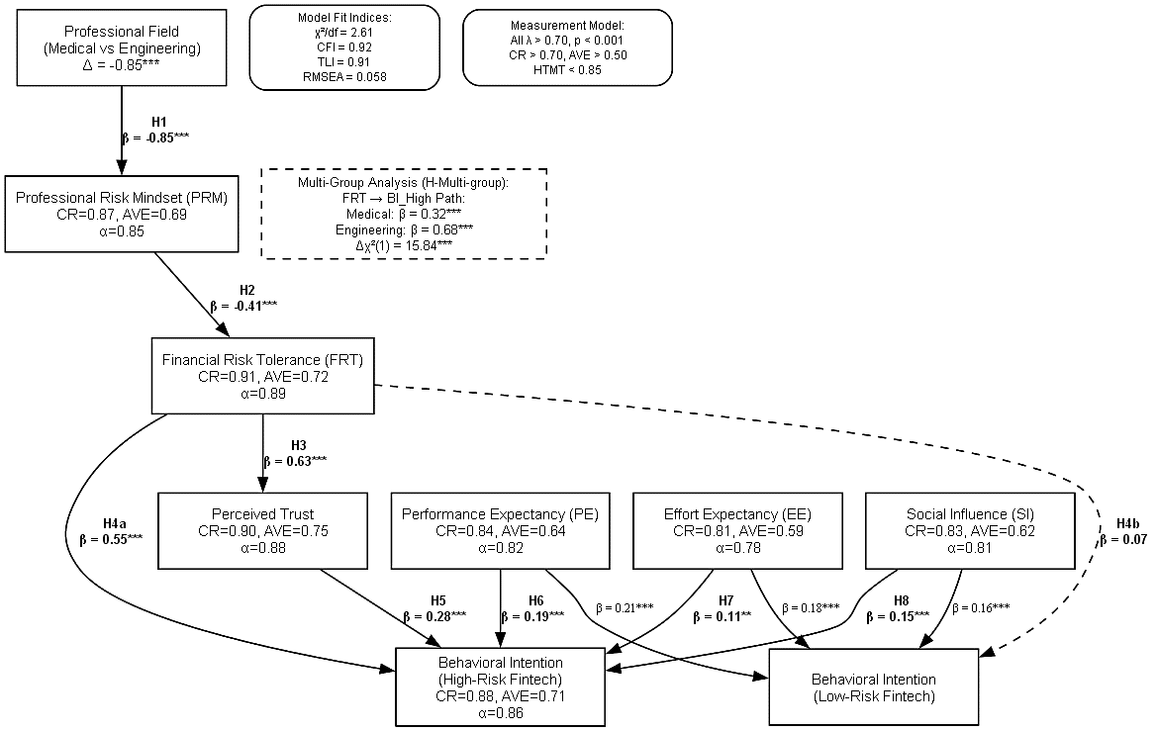
Source: Author’s own calculation using primary data.
6. Discussion
The spillover effect of professional training on personal financial behavior was confirmed, as primary hypotheses were supported: medical students exhibited a significantly more risk-averse professional mindset than their engineering peers (H1), which in turn was negatively associated with their general financial risk tolerance (H2). Most importantly, the multi-group analysis showed that the positive link between financial risk tolerance and the desire to use high-risk Fintech was much weaker for the group of medical students (H-Multi-group). The theoretical contributions of this research bridge distinct domains of professionals and behavioral finance and technology adoption where predictive power is enhanced when contextualised by deep-seated psychological constructs [9]. "One-size-fits-all" is not effective in case of different profession. Study also shows more context-aware approach to theorising about technology adoption [21]. The findings also contribute to literature on professional identity formation, suggesting that the values and decision-making heuristics instilled during training are not confined to the workplace but permeate personal life domains [13, 14]. It shows that financial risk tolerance, often treated as a stable trait, can be systematically influenced by external socialization processes [15]. The "youth" segment is not monolithic. medical student and an engineering student of the same age possess fundamentally different psychological orientations toward risk. Marketing for Fintech products must be tailored for the medical professionals should focusing on transparent risk management protocols and evidence-based performance data to build trust [16]. while Innovative and algorithmic robustness in Fintech products is required for engineering students.Programs embedded within medical schools should incorporate principles of behavioral finance to help students recognise when their professional risk aversion is an asset and when it becomes a behavioral liability that could hinder long-term wealth creation [17]. Despite these contributions, the study is subject to limitations that must be acknowledged. Factors like income stability may interact with their ingrained mindset [18]. A longitudinal study that tracks the same cohort of students from matriculation through their early careers would be invaluable to confirm the causal chain and observe the evolution of the spill-over effect [19]. Future research should also expand the scope to include other professions with distinct risk cultures, such as law (with its adversarial nature) or even the arts (with its tolerance for ambiguity), to build a more comprehensive model of professional spillover [20]. In conclusion, this study provides evidence that the psychological framework of an individual chosen profession can spill over to shape personal financial decisions by demonstrating that the professional risk aversion of medical students significantly moderates their adoption of Fintech.

Reference List
- Croskerry P. Achieving quality in clinical decision making: Cognitive strategies and detection of bias. Acad Emerg Med. 2002;9(11):1184–1204. https://doi:10.1197/aemj.9.11.1184
- Pluskwik E, Leung E, Lillesve A. Growing entrepreneurial mindset in interdisciplinary student engineers: Experiences of a project-based engineering program https://doi:cornerstone.lib.mnsu.edu/ie-fac-pubs/26/
- Koenig M, Le T, Ponce M. Financial risk tolerance and cryptocurrency adoption. Finance Res Lett. 2022;48:102877. https://doi:10.1016/j.frl.2022.102877
- Ludmerer KM. Let me heal: the opportunity to preserve excellence in American medicine. Oxford University Press; 2014 Sep 1. ISBN: 978-0-19-974454-1
- Carlson DS, Kacmar KM, Williams LJ. Construction and initial validation of a multidimensional measure of work-family conflict. J Vocat Behav. 2000;56(2):249–76. https://doi:10.1006/jvbe.1999.1713
- Grable JE, Lytton RH. Financial risk tolerance revisited: The development of a risk assessment instrument. Financ Serv Rev. 1999;8(3):163–81. https://doi.org/10.1016/S1057-0810(99)00041-4
- Turan A, Kara A, Koc M. What drives consumers’ intention to use mobile payment services? A study of UTAUT2 model. J Bus Res. 2021;133:298–307. https://doi:10.1016/j.jbusres.2021.04.060
- Gefen D, Karahanna E, Straub DW. Trust and TAM in online shopping: An integrated model. MIS Q. 2003;27(1):51–90. https://doi:10.2307/30036519
- Venkatesh V, Thong JY, Xu X. Consumer acceptance and use of information technology: Extending the unified theory of acceptance and use of technology. MIS Q. 2012;36(1):157–78. https://doi:10.2307/41410412
- Malaquias RF, Hwang Y. An empirical study on the influence of mobile application design elements on usability. Comput Human Behav. 2016;61:329–37 https://doi:d10.1016/j.chb.2016.03.046
- Gao J, Hu Y, Li H. The role of social media in cryptocurrency investment: An empirical study. Finance Res Lett. 2021;45:102164. https://doi:10.1016/j.frl.2021.102164
- Al-Jabari I, Ghazali E. The role of social influence in the adoption of digital payment services: A study of Jordanian university students. Int J Bus Manag. 2021;16(2):111–20. https://www.proquest.com/openview/eb47c02f9cbb0b1f0f6f4f470b8d033a
- Hafferty FW. Beyond curriculum reform: Confronting medicine's hidden curriculum. Acad Med. 1998;73(4):403–7. https://doi:10.1097/00001888-199804000-00010
- Cruess RL, Cruess SR, Boudreau JD, Snell L, Steinert Y. A schematic representation of the process of professional identity formation. Acad Med. 2015;90(10):1339–44. https://doi:10.1097/ACM.0000000000000803
- Grable JE, Joo SH. A cross-disciplinary examination of financial risk tolerance. Consum Interests Annu. 2000;46:151–7. https://link.springer.com/chapter/10.1007/978-3-319-28887-1_2
- Gao L, Waechter KA. Examining the role of initial trust in mobile banking adoption. J Comput Inf Syst. 2017;57(4):329–40. https://doi:10.1080/08874417.2016.1201823
- Mandell L, Klein LS. The impact of financial literacy education on subsequent financial behavior. J Financ Couns Plan. 2009;20(1):15–24. https://files.eric.ed.gov/fulltext/EJ859556.pdf
- Kline RB. Principles and practice of structural equation modeling. 4th ed. New York (NY): Guilford Press; 2015 https://www.google.co.in/books/edition/Principles_and_Practice_of_Structural_Eq/t2CvEAAAQBAJ?hl=en&gbpv=0
- Ployhart RE, Vandenberg RJ. Longitudinal research: The theory, design, and analysis of change. J Manage. 2010;36(1):94–120. https://doi:10.1177/0149206309352110
- Schein EH. Organizational culture and leadership. 4th ed. San Francisco (CA): Jossey-Bass; 2010. ISBN: 978-0-470-19060-9

Conflict of interest We do not have any conflict of interest.
Data availability statement We confirm that the data supporting the findings of the study will be shared upon reasonable request.

