Folkism in African Choral Music Performance: Cultural Expression and Identity in Leke Joel's Folk Cantata *370*

By:

Samson Oladosu EBE (Mr.)

Department of Performing Arts, Music and Film Studies

Lead City University, Ibadan, Nigeria.

+2348130068932, [ebe.samson@lcu.edu.ng](mailto:ebe.samson@lcu.edu.ng)

**Abstract**

This research aims to explore the concept of folkism as a framework for analyzing African choral music performances, with a specific focus on Leke Joel's folk cantata titled "370" as a study. Folkism, characterized by the preservation and promotion of cultural traditions and heritage, serves as a lens to explore the cultural expression and identity embedded in African choral music. The study employs a combination of musicological analysis, ethnographic research, and critical interpretation to delve into the integration of traditional elements, including melodies, rhythms, vocal techniques, language, and performance structures, within the context of African choral performance. By analyzing the performance of Leke Joel's "370," this research aims to elucidate how folkism is manifested in the delivery of the musical performance, showcasing the ways in which performers engage with and embody the cultural heritage. Findings reveal that the cantata incorporates distinct African musical features, such as the use of call and response, and polyphony, creating a complex and dynamic musical texture. These elements contribute to the immersive nature of the composition, engaging the audience with the vibrancy of African musical traditions. In conclusion, this study emphasizes the importance of embracing compositions like Leke Joel's "370" Cantata, which celebrates African cultural heritage through music. It is therefore recommended that more African composers embark on similar journeys, creating compositions that promotes the continent's rich culture and ensure the continuity of African heritage for future generations.

**Keywords:** *Folkism, African Choral Music, Performance Analysis, Cultural Expression, Identity Preservation.*

**Introduction**

African choral music is a vibrant and diverse musical tradition that reflects the rich cultural heritage of the continent. It encompasses a wide range of styles, languages, and performance practices, representing the varied ethnic groups and their unique artistic expressions. Within this musical landscape, the concept of folkism has emerged as a framework for understanding and appreciating the cultural expression and identity embedded in African choral music performance. Folkism, defined as the preservation and promotion of cultural traditions and heritage, provides a lens through which the significance and impact of this musical tradition can be examined. Agawu (2003, p. 23) and Nzewi (1997, p. 37) in their submissions both emphasized the importance of folk elements in African music, highlighting their role in preserving cultural identity and fostering a sense of community. In the context of choral music, folkism becomes particularly relevant as performers and composers draw inspiration from traditional melodies, rhythms, vocal techniques, and languages, integrating them into their artistic creations.

Therefore, this research aims to explore the concept of folkism as a framework for analyzing African choral music performances, with a specific focus on Leke Joel's "370" as a case study. By employing ethnographic methods of research through participant observation, critical interpretation, with musicological analysis of some of the songs in the cantata, this study seeks to delve into the ways in which folkism shapes and influences the performance of African choral music. It will investigate the integration of traditional elements within the performance, including vocal styles, choreography, staging, and other performative elements, to uncover the nuances of cultural expression and identity present in the live musical presentation.

Thus, this study aims to contribute to the growing body of literature on folkism in African choral music. This research will also shed light on the ways in which the concept of folkism enhances cultural expression and identity within the context of African choral music performance.

**Research Objectives**

The objectives of this research are to:

1. Identify elements of folkism as a framework for analyzing African choral music performances.

2. Ascertain the extent to which traditional elements such as vocal styles, choreography, and staging are integrated into African choral music in Leke Joel's *370.*

3. Ascertain the extent to which folkism enhances cultural expression and identity in African choral music performances.

**Research Questions**

1. How does folkism serve as a framework for understanding African choral music performances?

2. In what ways are traditional elements such as vocal techniques, choreography, and staging integrated into Leke Joel's "370"?

3. How does the concept of folkism contribute to the expression of cultural identity in African choral music performances?

**Theoretical Framework: Sam Ukala’s theory of *Folkism***

Folkism, rooted in folktales and folklore, offers a vivid portrayal of African society. Folktales, an integral part of the people's oral performance art, serve as a medium for educating the younger generation. Elders in the community gather children to impart life lessons through these stories. In Hausa culture, they are known as *Tatsunoyi*, while the Yoruba refer to them as *Aalo*. These narratives, whether purely fictional or loosely based on historical facts that have been embellished over time, defy empirical verification and instead focus on cultural transmission (Ukala, 1999).

Sam Ukala's *Folkism* is a literary and theatrical theory that seeks to reconnect African dramatic and artistic expressions with indigenous cultural traditions, particularly through the use of folklore, proverbs, songs, and communal storytelling. Developed as a response to the dominance of Western forms in African literature, *Folkism* emphasizes the incorporation of African values, performance styles, and oral traditions into modern artistic works. Central to Ukala's theory is the belief that African art should serve both as a means of cultural preservation and as a tool for social commentary, promoting the collective ideals of the community. According to Adjeketa (2023), Sam Ukala's *Folkism* is grounded in the idea that literary plays should draw from the history and customs of native African people, while also being performed in alignment with the aesthetics of African folktales, music, and presentation. This approach ensures that the performances are easily identifiable and resonate deeply with the host culture.

Ukala’s folkism theory is further subdivided into eight laws of *Aesthetic Response* specifically tailored for African folk theatre and performances. These laws form the tenet of the folkism theory; law of opening, law of joint performance, law of creativity, free enactment and responsibility, law of judgement, law of protest against suspense, law of expression of the emotions, law of ego projection, and law of closing. These laws ensure that African performances remain deeply connected to their cultural roots while engaging and involving the audience directly.

The theoretical framework of *Folkism* is relevant to this research as it emphasizes the incorporation of African cultural identity, traditions, and oral expressions into artistic works. In the context of Leke Joel's *370*, *Folkism* provides a lens for examining how African choral music performance reflects and preserves cultural heritage through the use of folktales, native musical forms, and communal involvement. It also highlights the balance between creativity and cultural responsibility, ensuring that the music resonates with African audiences by fostering emotional expression and shared identity.

**African Choral Music Performances from Inception till Date**

African choral music performances have a rich and diverse history that spans centuries, representing the cultural and artistic expressions of various African communities. From traditional vocal ensembles to contemporary choral groups, these performances have evolved and adapted over time, reflecting the social, political, and cultural changes on the African continent. Throughout history, African choral music performances have been intricately interwoven with the communal nature of African societies. Across the vast continent, communities have partaken in a rich array of collective singing experiences, frequently accompanied by the resonant melodies of traditional instruments, as noted by Arom (1991). These communal renditions, vibrant and resonant, have fulfilled a multifaceted role within the African social fabric. They have served as conduits for religious rituals, vessels for the oral transmission of stories, avenues for celebrating life's defining moments, and vital channels of communication both within and between communities. The vocal techniques that have breathed life into these performances are imbued with a distinct character, as meticulously explored by Bezerra (2016, p. 76). They encompass an intricate interplay of musical elements, characterized by call-and-response patterns, the harmonious interweaving of polyphonic voices, and the art of vocal improvisation. These techniques form the heart of African choral music, generating a sonic landscape that resonates with the spirit of communal unity, cultural storytelling, and the celebration of life itself.

The advent of Western colonial influences in African societies marked a transformative juncture in the evolution of choral music performances. Missionaries, bearing the torch of Western musical traditions, assumed a pivotal role in the propagation of choral music across the African continent. Their efforts led to the emergence of church choirs and educational institutions that ardently nurtured and promulgated the art of Western-style choral singing. Agawu (2008, p. 8). This era bore witness to a harmonious fusion, a confluence of Western harmonic structures with the time-honored vocal practices of African heritage. The resultant synergy gave birth to a unique and captivating tapestry of musical styles that would come to define African choral performances Akrofi (2004, p. 11). The interplay of these diverse musical traditions exemplifies the rich landscape of cultural exchange and musical hybridization that unfolded during this era. Western choral harmonies interwoven with the indigenous vocal techniques and rhythms of Africa, generating a soundscape that transcended geographical boundaries. This transformative encounter between worlds not only signified a change in the choral landscape but also served as a testament to the adaptability and resilience of African musical traditions, which absorbed and innovatively merged with external influences, thereby expanding the sonic horizons of African choral performances.

In the post-colonial epoch, the trajectory of African choral music performances embarked on a continued journey of evolution and transformation. This period was deeply influenced by the emergence of nationalist fervor and Pan-African movements that passionately championed the cause of preserving and propagating African musical traditions Nketia (2004, p. 11). This ideological wave kindled the collective interest in the safeguarding and celebration of indigenous musical expressions across the continent. Remarkably, this epoch witnessed the emergence of visionary composers and erudite scholars who became torchbearers for the integration of indigenous elements into choral compositions, sparking the inception of a distinctive African choral style. Figures such as Sunday Ajayi, Chinedu Osinigwe, Seun Akin Ajayi, and notably, Leke Joel himself, to cite just a handful of luminaries, undertook this artistic journey with fervor. Their contributions were instrumental in shaping a musical landscape where the fusion of traditional African elements with choral compositions gave rise to a unique and resonant African choral idiom.

The latter half of the 20th century bore witness to a remarkable upsurge in the prominence of professional choral ensembles and the expansion of music education in various African countries, as comprehensively chronicled by Oludhe (2012, p. 78). This transformative era marked a pivotal juncture where the choral landscape across the continent evolved into an ever-expanding tapestry of creative expression. Throughout this era, several illustrious choral groups ascended to international acclaim, carving their names onto the global stage as torchbearers of African choral artistry. Renowned ensembles such as the resounding Soweto Gospel Choir, the Lagos City Chorale, and the eloquent Harmonious Chorale in Ghana, among many others, demonstrated the diversity and dynamism that typify African choral music performances. These groups not only garnered international recognition but also illuminated the musical corridors with their distinct interpretations and renditions, celebrating the vibrancy of African choral traditions while resonating with audiences around the world.

In recent years, the landscape of African choral music performances has undergone a dynamic transformation, ushering in a vibrant era characterized by a harmonious blend of traditional elements and modern influences. This intricate fusion has led to the emergence of captivating renditions that interweave the timeless essence of Africa's musical heritage with contemporary genres, including the enchanting rhythms of jazz, the rhythmic pulse of pop, and the poetic cadence of hip-hop Kane (2018, p. 131). This evolving musical narrative encapsulates the spirit of innovation and adaptability that is intrinsic to the African choral tradition. Concurrently, the musical arena has borne witness to the proliferation of choral competitions and festivals like the Naija Choral Music Festival (NCMFEST), Africa Sings Festival, and so on, establishing these events as prominent fixtures in the choral calendar. They have evolved into vibrant platforms where choral groups, both local and international, converge to celebrate their artistic prowess and partake in the rich tapestry of cultural diversity. These gatherings not only serve as arenas for musical excellence but also as melting pots of cultural exchange, fostering connections among diverse communities and nurturing the spirit of collaboration.

**370 - A Folk Cantata**

"370" is a folk cantata composed and directed by Leke Joel, and performed at the Performing Arts Theatre of the University of Ilorin, Nigeria, in August 2014. The performance, enthralls the audience with rich elements of African music. Commencing with a drummer-dancer act, the audience's knowledge of Yoruba dundun drum sayings is tested. The cantata narrates the tale of three diligent young men who invest their energy in farming for their benefit.

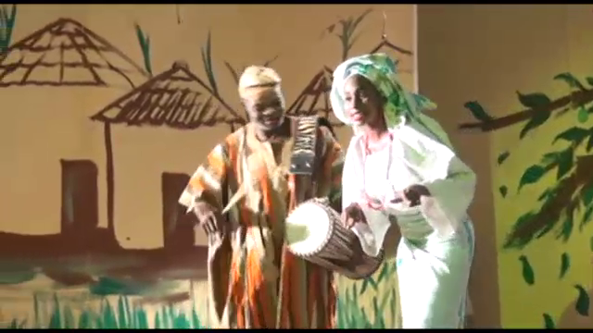

**Plate 1: Showing the Drummer and Dancer Performance**

**Source: Picture taken by the researcher**

However, one of them, named Tamedo or "370," betrays their trust and steals the entire harvest behind their backs. As the other two notice their missing yields, they seek the assistance of an herbalist who grants them a charm in the form of a broom to protect their farm. Tamedo attempts to steal again but gets hypnotized when he touches the broom, impulsively sweeping the entire farm. Fellow farmers and friends join him, and he is apprehended. Though initially intended for a deadly punishment, an elder intervenes, leading to his surrender to the police for proper judgment.



**Plate 2: Showing Tamedo Sweeping after being Hypnotized**

**Source: Picture taken by the researcher.**

Leke Joel masterfully employs the African storytelling style to compose this captivating music. The performance features a full SATB choir, serving as both actors and singers, an elderly narrator, and soloists who add beauty and aesthetics to the singing. Energetic dances elevate the tempo of the cantata, enhancing the overall experience. This innovative form of music performance receives an enthusiastic response from the audience, who cannot contain their applause throughout the show. "370" resonates as a resounding success, impressing with its captivating narrative, rich African musical elements, and engaging performance style.

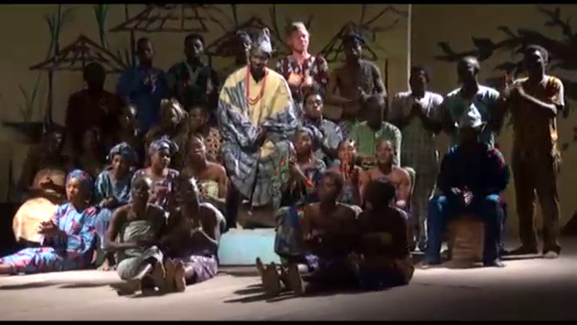

**Plate 3: Showing the SATB choir performing.**

**Source: Picture taken by the researcher.**

**Music, Cultural Expression and Identity in Leke Joel's 370 Performance**

One of the prevalent and deeply ingrained patterns of singing in African musical traditions is the Call and Response pattern. This method is characterized by a leader who initiates a musical phrase, with a chorus responding in kind. Often, two or more melodies intertwine, forming larger sectional compositions. The cantata's choir, vocal soloists, and narrator skillfully employ various vocal techniques, including call-and-response patterns and vocal improvisation, reminiscent of African vocal traditions (Bezerra, 2016). These elements not only showcase the diversity of African music but also serve as a means of cultural preservation and expression. This approach creates musical contrast through a series of distinct movements or acts, each comprised of sections that are repeated multiple times. As elucidated by Omobiyi (2005, p. 38), there are two primary varieties of call and response antiphony: "call and response proper" and "call and refrain." "Call and response proper" involves a soloist presenting an antecedent, which is then echoed by the larger group, while "call and refrain" features the lead singer performing alongside other members of the ensemble, with the audience providing the response. In the cantata "370," Leke Joel masterfully employs the Call and Response pattern, infusing it into nearly every movement of the performance. This usage not only pays homage to the rich African musical traditions but also imbues the cantata with a deep sense of communal participation and cultural resonance. The frequent incorporation of this pattern throughout the composition showcases Joel's commitment to preserving and celebrating the musical heritage of Africa while delivering a captivating and immersive musical experience.

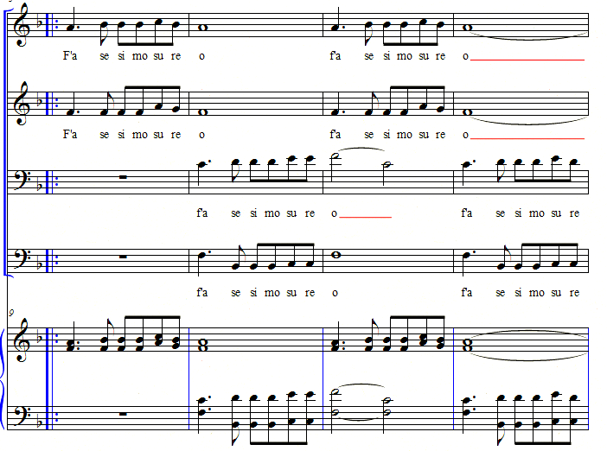

**Fig 1: Showing an excerpt of a musical score**

Furthermore, this performance also showcases the deliberate use of Polyphony, a musical technique characterized by the creation of multiple, simultaneous, and rhythmically independent parts. In polyphonic singing, the primary melody takes precedence over the resulting harmony. Each individual voice enters the performance at distinct moments in a cyclical and continuous fashion, resulting in a multifaceted and ever-evolving musical texture. Leke Joel incorporates this polyphonic technique, particularly in the song titled 'Ise Agbe,' which translates to 'Farming.' Within this performance, the interplay of various voices in a polyphonic manner not only adds depth and complexity to the musical arrangement but also serves as a testament to Joel's artistry and his commitment to celebrating the multifaceted aspects of African musical traditions. The use of polyphony in "370" enriches the musical narrative, creating a vibrant and engaging sonic experience that resonates with both traditional and contemporary elements, mirroring the dynamism of African culture.

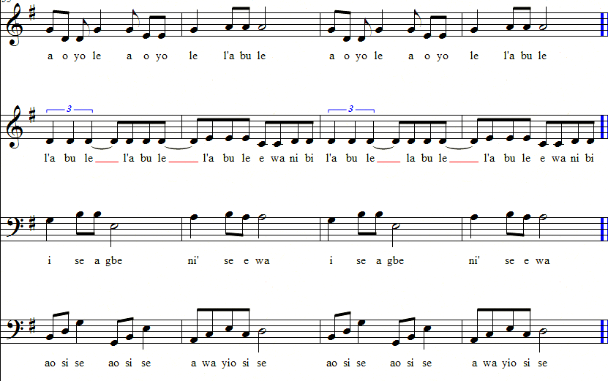

**Fig 2: Showing an excerpt of a musical score**

Moreover, Leke Joel's "370" is a showcase of cultural expression through music. This cantata brilliantly captures and celebrates African cultural elements, drawing from traditional music, language, and storytelling techniques. Joel weaves together indigenous musical idioms, rhythmic patterns, and melodic motifs that resonate with African heritage Uzoigwe (2001, p. 58). This infusion of cultural elements creates a rich and immersive musical experience, reflecting the deep respect for others embedded in African traditions. For instance, in the first scene of the cantata, young maidens play in the village square, accompanied by a Yoruba game song that says, "It is not good to poke nose."

| ***Yoruba Language***  *Call: E ma we’hin o*  *Response: We’hin Call: E ma s’ofofo Response: Ofofo Call: Ofofo ko dara*  *Response: Ko dara…* | ***English Translation***  *Do not look back*  *Look back*  *Do not be nose-pokers*  *Nose-pokers*  *It is not good to poke nose*  *It is not good…* |
| --- | --- |

**Table 1: Showing the Yoruba game song translated to English**

This game song exemplifies the core values of the Yoruba culture, emphasizing respect for others and the importance of minding one's own business. Leke Joel incorporates this chant to convey the profound African principle of valuing and respecting others. Through this cultural expressions, "370" becomes a powerful testament to the significance of African traditions in shaping the music and values of the continent.

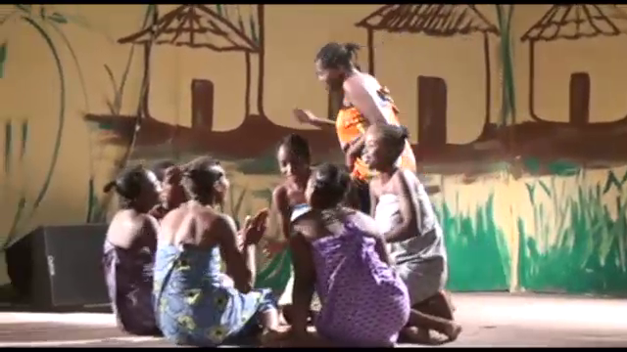

**Plate 4: Showing some of the Young Girls Playing and Singing.**

**Source: Picture taken by the researcher.**

Also, the use of indigenous musical instruments and vocal styles contributes to the authentic representation of African musical heritage. Traditional percussion instruments, such as the dundun drum, add an African rhythmic foundation to the composition, evoking a sense of community and communal celebration (Adedeji, 2018). The communal essence of Africa deeply permeates the music and performance of the cantata. Leke Joel masterfully leverages Africa's predominant occupation, agriculture, to narrate the story of communalism through music. In the performance, he vividly portrays the idea that in Africa, activities are often accomplished collectively. This is exemplified when the men engage in a game of 'ayo' while singing:

| **Yoruba**  *E je ka m’emu Ka m’emu funfun E je ka m’emu Ka m’emu amuyo Ka m’emu ka m’emu E je ka m’emu* | **English Translation**  *Let us drink palm wine*  *White palm wine*  *Let us drink palm wine*  *Let’s drink to stupor*  *We’ll drink and drink*  *Let us drink* |
| --- | --- |

**Table 2: Showing the Yoruba game song translated to English**

This musical and performance element communicates the profound sense of communalism in Africa. Joel's incorporation of the communal aspects of daily life showcases the importance of togetherness and cooperation in African societies. Through these expressions, the cantata emphasizes the enduring values of unity and shared experiences that define African communities.

The cantata "370" also delves into themes of identity, exploring the complexities of human character and morality within an African cultural context. Through the narrative of the three young men and Tamedo (also known as "370"), the cantata touches on universal themes of trust, betrayal, and the consequences of one's actions. However, these themes are framed within an African cultural setting, enabling the audience to relate to the story from an African perspective. The characters in the cantata embody different aspects of cultural identity. The young men represent hard work, diligence, and a commitment to community, which are often valued traits in many African societies (Azuonye, 2007). On the other hand, Tamedo's actions of deceit and theft challenge these cultural values, serving as a reflection of the complexities within individuals and communities. The cantata also explores the notion of justice and conflict resolution within an African cultural context. The involvement of an elder in the story, who intervenes to stop Tamedo's violent punishment and instead advocates for legal justice, reflects African communal values of wisdom and mediation (Ogundiran, 2014). This portrayal of conflict resolution contributes to a deeper understanding of cultural identity and the importance of community cohesion.

**Findings and General Observations**

Leke Joel's "370" Cantata stands as a poignant testament to the power of music in expressing and celebrating African cultural heritage. The cantata masterfully weaves together elements of traditional music, language, and storytelling techniques, creating an immersive musical experience that resonates with the rich tapestry of African traditions. This performance provides valuable insights into the preservation of African cultural heritage through music. Joel's work expertly incorporates indigenous musical idioms, rhythmic patterns, and melodic motifs. In doing so, it not only showcases African heritage but also ensures its preservation for future generations. The result is a musical journey that immerses the audience in the vibrant and diverse cultures of Africa. Moreover, the cantata vividly portrays the communal nature of African societies. By centering the narrative around the theme of farming, Joel underscores the idea that in Africa, many tasks are undertaken collectively. The music becomes a reflection of the spirit of togetherness and community that is deeply ingrained in African social life.

Leke Joel's work also embraces the call and response pattern, a common feature of African music. This pattern, where a leader sings a phrase with a chorus responding, infuses dynamic engagement into the music. It not only brings the performance to life but also connects with the audience, creating an interactive and participatory experience. Also, the use of polyphony, where multiple, simultaneous, and rhythmically independent parts are incorporated, adds depth and complexity to the composition. The song "Ise Agbe" within the cantata beautifully showcases this polyphonic complexity, reflecting the multifaceted nature of African music traditions. "370" emerges as a compelling example of how African choral music performances can serve as a vehicle for cultural expression, heritage preservation, and the incorporation of traditional musical elements. Through its masterful composition, it exemplifies the vibrant tapestry of African traditions and the dynamic nature of music as a cultural form.

**Recommendations and Conclusion.**

As we move forward, it is essential that more African music composers and artists take inspiration from performances like "370." They should endeavor to compose works that embrace and celebrate African cultural elements, thus contributing to the preservation of our cultural heritage. These compositions can serve as a means to engage with our roots, to share our traditions, and to foster a sense of collective identity and pride. It is through the creation and performance of such culturally rich compositions that we can ensure the continuity of Africa's cultural values and traditions. Just as Leke Joel's "370" has illuminated the path to preserving and promoting African heritage, more African composers have the opportunity to join this noble endeavor. In this way, we can continue to resonate with the time-honored traditions and values that define us as Africans, and we can ensure that future generations, like the generations before them, will find themselves enraptured by the melodies, rhythms, and stories that echo the vibrant tapestry of our African musical culture.

**References**

Adedeji, A. A. (2018). The folklorization of Yoruba popular music: A case study of Sina Peters. Journal of Applied Arts, 4(1), 1-18.

Agawu, K. (2003). Representing African music: Postcolonial notes, queries, positions. Routledge.

Agawu, K. (2008). African choralism. African Music, 7(3), 3-14.

Akrofi, K. (2004). African choral music: Roots and branches. In R. K. Agbede & E. D. Omojola (Eds.), Essays in Nigerian musical arts (pp. 5-22). Department of Creative Arts, University of Lagos.

Arom, S. (1991). African polyphony and polyrhythm: Musical structure and methodology. Cambridge University Press.

Azuonye, C. (2007). The art of tradition: Folkism and cultural nationalism in the Nigerian theatre. In A. Alabi (Ed.), Perspectives on Nigerian literature: 1700 to the present (pp. 119-137). Princeton University Press.

Bezerra, M. (2016). The art of call-and-response in African traditional music. Anales del Instituto de Investigaciones Estéticas, 38(110), 71-96.

Falola, T. (2018). Fela Anikulapo-Kuti: The art of music and politics. Ohio University Press.

Kane, M. (2018). Contemporary African choral music: A fusion of tradition and modernity. Journal of Pan African Studies, 11(1), 123-139.

Martinez, J. (1996). Singing to the rhythm of the pride lands: Music and identity in the lion king. Journal of Popular Music Studies, 8(2), 193-210.

Nketia, J. H. K. (2004). Ethnomusicology in Africa: Perspectives, potentials and challenges. African Music, 7(1), 1-15.

Nzewi, M.. (1997). African music: Theoretical content and creative continuum. African Music Society.

Nzewi, M. (2003). The aesthetics of Igbo music and the “folklorization” phenomenon. In R. K. Agbede & E. D. Omojola (Eds.), Essays in Nigerian musical arts (pp. 64-83). Department of Creative Arts, University of Lagos.

Ogundiran, A. (2014). Folkism and cultural preservation in Nigeria. In M. Turner (Ed.), Nigeria: Cultures of the world (pp. 89-103). Cavendish Square Publishing.

Ogunleye, A. (2020). ‘Asa: The embodiment of Yoruba folkism in contemporary Nigerian music’. International Journal of Research and Innovation in Social Science (IJRISS), 4(9), 379-387.

Oludhe, J. (2012). The development of choral music in Kenya. Research in African Literatures, 43(3), 68-82.

Omobiyi, O. (2005). Femininity in traditional festivals: the place of women in sango worship performance . Journal of Nigerian Musicologists, 1(2), 29-44

Uzoigwe, J. (2001). West African music in the music of Joshua Uzoigwe. In R. K. Agbede & E. D. Omojola (Eds.), Essays in Nigerian musical arts (pp. 51-62). Department of Creative Arts, University of Lagos.