**Economy and Education as Pillars of National Resilience: A Study of the Figure of Kemala Motik Abdul Gafur**

**Muhammad Rijal Fadli**

Universitas Esa Unggul, Indonesia

Email: [rijal.fadli@esaunggul.ac.id](mailto:rijal.fadli@esaunggul.ac.id)

**Abstract**

National resilience is an important issue in forming an independent, resilient society that can face global dynamics sustainably. Kemala Motik is an inspiring figure who combines the strength of the people's economy and quality education as a strategic foundation for strengthening the pillars of national resilience. This study aims to examine the role of Kemala Motik Abdul Gafur in economics and education as strategic elements in strengthening national resilience. This study uses a historical approach to comprehensively reveal the dimensions of his role by tracing the traces of the figure's contribution through four main stages, namely heuristics, criticism, interpretation, and writing history. These four steps dissect the relationship between Kemala Motik's real actions and their impact on social structure and national resilience. The analysis results show that his contribution is symbolic and impacts expanding access to education and empowering the community's economy, especially women. The research findings indicate that the presence of a figure like Kemala Motik is greatly needed by Indonesia in facing the challenges of the times. He is not only an agent of change but also a source of inspiration that shows that the nation's progress is built from real work at the grassroots, not only from the elite stage.

**Keywords:** Kemala Motik Abdul Gafur, Economy, Education, National Resilience, Indonesia.

**INTRODUCTION**

Globalization, as a manifestation of the ever-changing dynamics of the times, has driven humanity to continuously evolve and innovate to maintain its existence amid the waves of transformation (Akins et al., 2019). National resilience has become a central issue, encompassing not only military and political aspects but also being deeply rooted in the strength of the economy and the quality of education (Sánchez-Hernández, 2024). These two sectors—economy and education—are the fundamental pillars determining the direction and sustainability of a nation's development. Throughout history, there have always been figures who have mobilized society to be both economically self-reliant and intellectually enlightened, making the role of such individuals profoundly relevant to national resilience (Romdoni & Josias Simon Runturambi, 2024).

Kemala Motik Abdul Gafur is one such figure who played a significant role in both the economic and educational sectors. As someone who was born and raised during Indonesia's post-independence transition period, she was a witness to the nation's development and an active participant in it (Motik, 2007). Kemala Motik is recognized as a person who combines entrepreneurial spirit with a deep concern for education, particularly in fostering awareness among the younger generation about the importance of economic independence and social intelligence (Damayanti et al., 2024). Her ideas reflect a long-term vision that a nation's strength lies in its economically self-sufficient and intellectually well-educated people.

From a historical perspective, Kemala Motik's involvement in various organizations and educational institutions demonstrates that she was not only active in fieldwork but also made strategic contributions to human resource development. She was a driving force in youth entrepreneurship and a pioneer of community-based economic initiatives. She also relentlessly advocated for equitable and meaningful access to education, especially for marginalized groups. This dual commitment—between economy and education—makes her historical role highly relevant to discussions on strengthening national resilience.

Kemala Motik represents a figure who understood that education and the economy are inseparable in the context of nation-building. Economic independence without a strong educational foundation can lead to a consumptive society, while education without financial support risks remaining theoretical and impractical (Haq, 2010). Therefore, her legacy is worth revisiting as a reflection of the present and a source of inspiration for younger generations living in a digital and highly competitive era.

This study aims to analyze Kemala Motik Abdul Gafur's role in the economic and educational sectors as two strategic pillars in building national resilience. Kemala Motik is recognized not only as a historical figure but also as a thinker and change agent who consistently promoted progress through entrepreneurial approaches and educational empowerment. Her dual role reflects an integration of efforts to foster economic independence and improve the quality of human resources through inclusive and meaningful education. Tracing her journey is essential to understanding that national resilience does not solely emerge from elite-level policies but also from grassroots movements led by visionary individuals capable of mobilizing society to rise, become independent, and pursue education.

**RESEARCH METHODS**

This research employs a qualitative approach using historical methodology aimed at thoroughly examining the role of Kemala Motik Abdul Gafur in the economic and educational sectors through her historical trajectory (Fadli, 2021; Wasino & Hartatik, 2018). The historical approach in this study is carried out through four key stages: (1) Heuristics, which involves the collection of various relevant and credible historical sources or data; (2) Verification (source criticism), a process used to assess the authenticity, credibility, and validity of the collected sources; (3) Interpretation, which refers to the analysis and contextual understanding of historical data by considering the time, place, and socio-cultural conditions in which the events occurred; and (4) Historiography, which involves the systematic, logical, and chronological construction of historical narratives to build a comprehensive understanding of the events and the figure under study (Ginzburg, 2013; Kipping et al., 2013; Tröhler, 2019).

The historical approach in this research is utilized to trace and analyze Kemala Motik Abdul Gafur’s contributions through these four methodological steps: heuristics, criticism, interpretation, and historiography. The first step, heuristics, involves gathering primary and secondary historical sources. Primary sources include interviews, speeches, and official documents related to Kemala Motik’s activities, while secondary sources consist of biographies, academic articles, and media coverage. This phase is essential for constructing a valid data foundation on her youth entrepreneurship and educational development contributions.

The second step, criticism, aims to validate the authenticity and accuracy of the sources through two types of analysis: external criticism, which examines the authenticity of documents, and internal criticism, which evaluates the credibility of the content. Criticism is applied to various materials containing data on Kemala Motik’s leadership in youth organizations, her initiation of community-based economic programs, and her involvement in formal and informal education. Once the critical review is completed, the interpretation phase becomes vital in decoding the meaning of the verified data, considering the socio-historical context of her active years. This allows her roles to be understood as practical actions and as part of a long-term strategy for building national resilience.

Historiography is the final stage in the historical approach and involves composing a comprehensive historical narrative by synthesizing interpretations from various sources. At this stage, Kemala Motik Abdul Gafur’s roles in the economic and educational sectors are systematically mapped as part of an ongoing effort to build an economically self-reliant and intellectually enlightened society. This synthesis reveals that central government policies do not solely shape national resilience but also emerge from the contributions of visionary individuals like Kemala Motik, who operate through grassroots movements, social organizations, and educational initiatives. The historical approach not only reconstructs past events but also unveils the strategic dimensions of a figure’s involvement in multiple national development sectors.

**RESULTS AND DISCUSSION**

**Biography of Kemala Motik Abdul Gafur**

Prof. Dr. Hj. Kemala Motik Abdul Gafur, SE, MM. was born in Jakarta on October 6, 1944. She is the daughter of Basjaruddin Rahman Motik, a national hero known as one of Indonesia's economic development pioneers. Her father's visionary guidance in promoting entrepreneurship education profoundly influenced the direction of Kemala Motik's life (Gofur, 2010). Leadership qualities and a spirit of self-reliance were instilled in her from an early age, shaping her into a resilient woman who excelled in various fields. The following is an image of Kemala Motik as the public knows her.

Figure 1. Kemala Motik Abdul Gafur

Figure 1 features Kemala Motik in formal attire, reflecting her authority as a public figure and an inspirational leader in education, entrepreneurship, and politics. In the academic domain, she pursued higher education with unwavering dedication. She earned her bachelor’s degree in economics from the University of Indonesia and a master’s degree in management from Esa Unggul University—an institution she also founded and led as its first rector. She completed her doctoral studies at the State University of Jakarta with a focus on Educational Management. Her educational journey exemplifies her consistency and commitment to promoting high-quality education that remains relevant in an ever-changing era (Humas UEU, 2004).

Kemala Motik is widely recognized as the founder of IWAPI (Indonesian Women Entrepreneurs Association), established in 1975. This organization was born out of her passion for promoting women’s economic independence and has served as a strategic platform for Indonesian women to develop their business potential. IWAPI has remained active for nearly five decades and contributes to the emergence of strong, competitive women entrepreneurs at national and global levels (Putri et al., 2024).

Kemala Motik’s influence extends beyond economics into politics and business organizations. She served as a member of the People’s Consultative Assembly of the Republic of Indonesia (MPR RI) for two terms, from 1982 to 1987 and again from 1997 to 1999. Her involvement in KADIN (Indonesian Chamber of Commerce and Industry) and organizations such as Wanita Pembangunan Indonesia (WPI) demonstrates her consistent efforts in advocating for women’s roles and the private sector’s contribution to national development (Wahyuni & Setiawan, 2023).

The spirit of entrepreneurship instilled by her father, Basjaruddin Rahman Motik—founder of PERWABI (Indonesian People’s Warung Association) and a pioneer of KADIN—is reflected in Kemala Motik’s life journey. She carried forward her family’s legacy and expanded her influence through education and women’s empowerment (Aravik et al., 2025). Her figure stands as a true inspiration that the struggles in economic, political, and educational arenas can be synergized to realize a self-reliant and progressive Indonesia.

**Kemala Motik's Role in Strengthening the People's Economy**

Prof. Dr. Hj. Kemala Motik Abdul Gafur has significantly strengthened Indonesia's people-based economy (ekonomi kerakyatan). She recognized that the country's economic development cannot rely solely on the formal sector or large corporations but must involve broader community participation—especially women—as active agents in financial activities. Through concrete initiatives, such as the founding of IWAPI (Indonesian Women Entrepreneurs Association) in 1975, Kemala Motik actively promoted the involvement of women in small and medium enterprises (SMEs), which serve as the backbone of the national economy (DPD IWAPI Jawa Tengah, 2010; Subekti et al., 2023).

Her role in empowering the grassroots economy was further solidified by establishing IWAPI in 1975 alongside her sister, Dr Dewi Motik Pramono. Both are daughters of B. R. Motik, a prominent entrepreneur from Palembang, South Sumatra. Growing up in a family imbued with entrepreneurial spirit, the sisters learned early on that women play a vital role in supporting and driving the household economy (Suyuthi et al., 2019). Their formative experiences led to a deep awareness that women's potential in business must be nurtured and supported through strong, sustainable platforms.

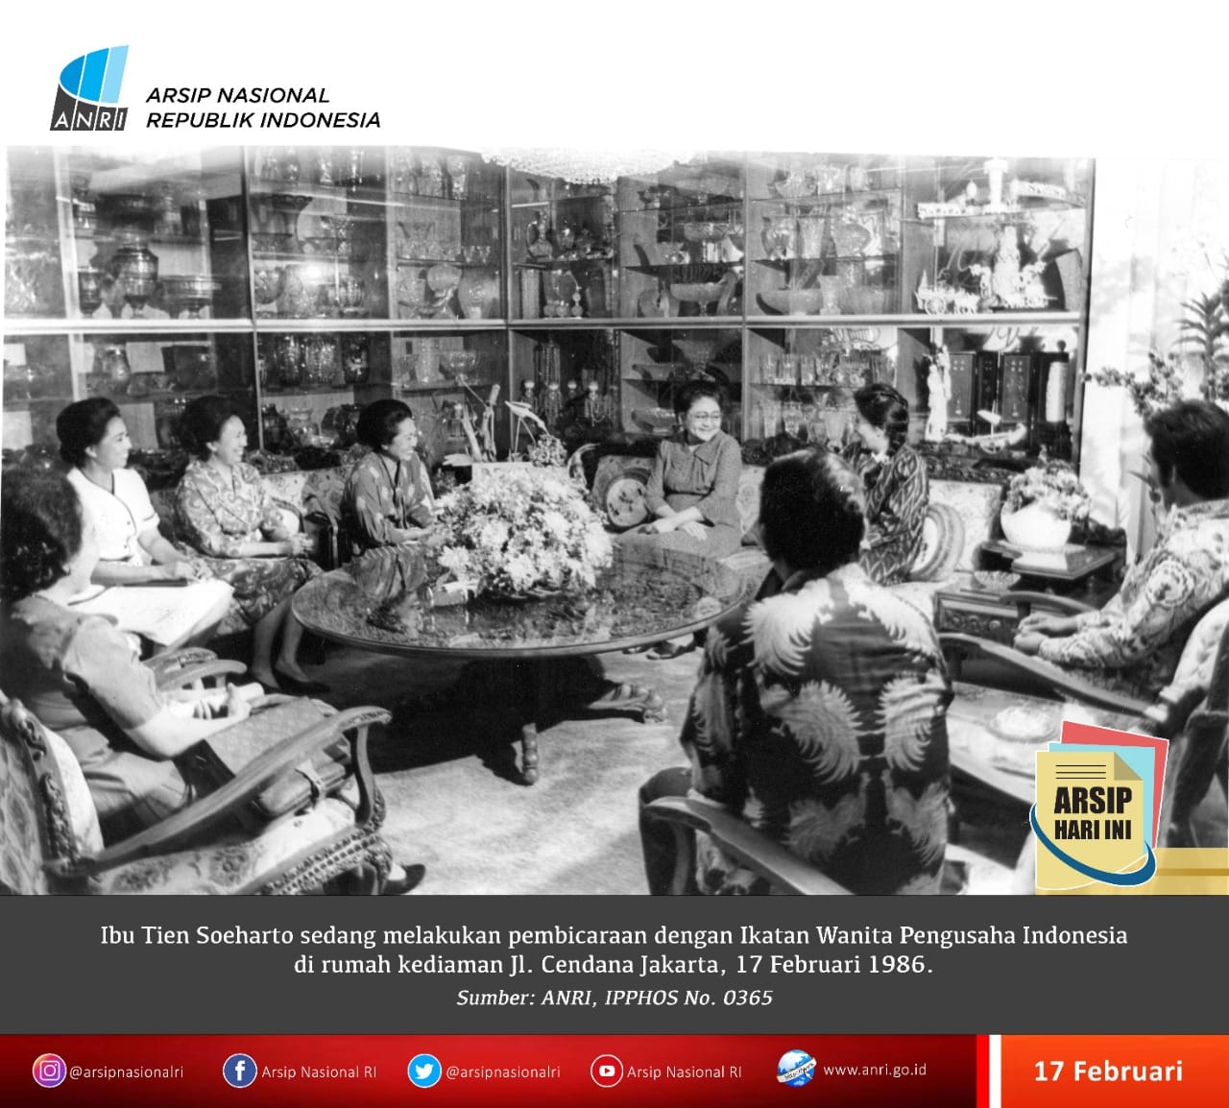

Figure 2. Kemala Motik is active in IWAPI (ANRI, 1976)

IWAPI is not merely an organization; it is a grassroots economic movement that empowers women to become economically independent. Under Kemala Motik’s leadership, IWAPI evolved into Indonesia's largest network of women entrepreneurs, facilitating training, mentoring, and access to information and markets (Solehati & Assegaf, 2022). Many businesses that began as small, locally rooted initiatives—often started by the women themselves—have grown into successful enterprises. These experiences inspire and prove that a people-based economy can flourish when given the right support and opportunities.

Beyond establishing a business association, Kemala and Dewi Motik also pioneered founding financial institutions that fund women-owned enterprises. This was a strategic step in addressing a real gap in the field: the lack of economic access for small-scale entrepreneurs (Rachman & Yuldinawati, 2016). Through this initiative, Kemala Motik demonstrated that strengthening grassroots economies is not solely about business skills but also about creating a supportive ecosystem that fosters inclusive and equitable entrepreneurial growth—particularly for groups often excluded from the formal economic system.

IWAPI has become more than just an association; it is a driving force behind a grassroots economy powered by women entrepreneurs. Under Kemala Motik’s guidance, IWAPI has supported thousands of small business owners to become more self-reliant, innovative, and competitive. Recognizing the importance of access to entrepreneurial education and practical training, she established the IWAPI Education Center in 1979 to directly instruct women on managing their businesses professionally. This initiative is a concrete example of her support for a grassroots economy grounded in local skills and knowledge.

The success of the Indonesian Women Entrepreneurs Association (IWAPI) is a clear testament to the vital role of women in national economic development. IWAPI has grown to become the largest women’s business organization in Indonesia and Southeast Asia, with a membership network that spans all 34 provinces down to the sub-district level, totalling over 30,000 members (Tokoh Indonesia, 2003). This extensive reach shows how IWAPI has successfully engaged women from diverse backgrounds to actively participate in entrepreneurship, making it a strategic platform for community-based economic growth.

With an innovative, inclusive, and collaborative spirit, IWAPI continues to evolve in response to the changing times while staying true to its core mission: to empower women to achieve economic independence. Approximately 98% of its members are from the MSME (Micro, Small, and Medium Enterprises) sector—recognized as the backbone of the national economy—while the remaining 2% are large-scale business owners who help strengthen global business networks among women (DPD IWAPI Jawa Tengah, 2010). Through training, policy advocacy, and cross-sector partnerships, IWAPI nurtures new entrepreneurs and promotes women’s leadership in sustainable and impactful economic sectors.

Beyond empowerment efforts, Kemala Motik has also created a business ecosystem including small entrepreneurs. She founded PT Arrish Rulan with her siblings, a garment manufacturing company. This enterprise not only provided jobs but also served as a model for how family-run businesses can grow while remaining committed to serving the needs of the people. She consistently emphasized the importance of collaboration between the private sector and local communities to strengthen the economy from the grassroots—not just from the centre of economic power.

Kemala Motik’s role in advancing a people-based economy reflects her strong commitment to economic justice and social inclusion. She is not merely a voice in elite forums but a hands-on figure who has worked directly with grassroots communities, empowering those often marginalized in mainstream development. Through the spirit of entrepreneurship and the courage of Indonesian women, Kemala Motik has proven that a people-based economy is not just a slogan but a real and effective development strategy that brings meaningful impact to the nation’s welfare.

**Contribution to the World of Education and Intellectual Enlightenment**

Prof. Dr Hj. Kemala Motik played a pivotal role in education and intellectual enlightenment through the founding of Universitas Indonusa Esa Unggul in 1993 under the auspices of the Kemala Bangsa Education Foundation. Established by Decree No. 107/D/0/1993, the university was born out of its vision to develop a higher education institution capable of responding to the demands of the times (Humas UEU, 2024). This initiative was a realization of her noble aspiration to contribute to the intellectual advancement of the nation, as mandated by the Preamble of the 1945 Constitution of the Republic of Indonesia. In 2014, the institution officially changed its name to Universitas Esa Unggul (UEU), as stated in Decree No. 57/E/O/2014. This change was not merely cosmetic but marked a significant transformation aimed at positioning UEU as a superior, dynamic, and globally competitive university (Ibrahim, 2024).

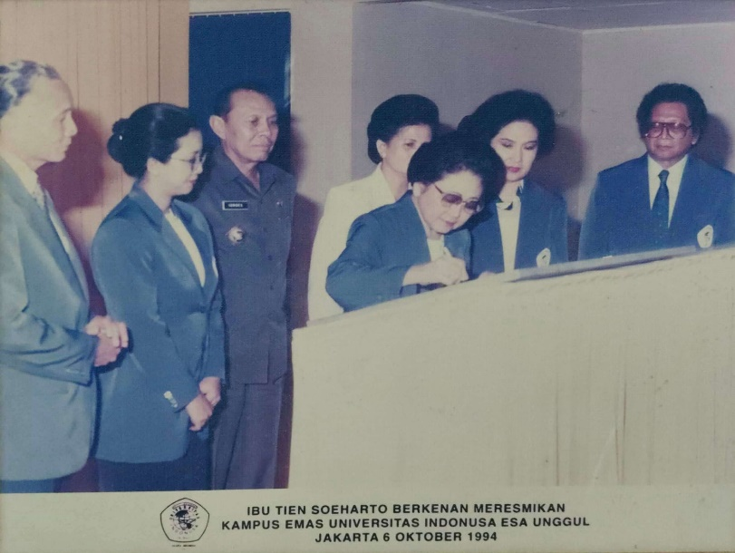

Figure 3. Inauguration of Indonusa Esa Unggul University in 1993 by Tien Soeharto

As the founder and chief visionary, Kemala Motik instilled in Universitas Esa Unggul (UEU) a grand vision to become a world-class university rooted in intellectualism, creativity, and entrepreneurship. This vision is reflected in the university’s mission: to deliver high-quality and relevant education, to foster a conducive academic atmosphere, and to shape character-driven leaders with strong competitiveness. Under her leadership, UEU has focused on academic achievement and cultivating values such as integrity, character, and an enduring spirit of innovation among students and faculty (Arman, 2015).

Over the past decade, UEU has grown rapidly into one of the leading private universities in Jakarta and nationally. The university is widely recognized as a pioneer in various academic programs, including establishing the Medical Record Academy (ARM) and the Applied Bachelor’s Program in Physiotherapy—both the first of their kind in Indonesia. These innovations reflect UEU’s boldness in directly responding to the needs of society and the labour market. Furthermore, continuous improvement in education quality, research, community service, and campus infrastructure has become a top priority in its pursuit of World Class University standards.

Kemala Motik’s intellectual legacy and nationalistic vision continue to guide UEU’s development. Globalization and technological advancements require the university to constantly adapt and embrace values that align with modern realities. These efforts have strengthened UEU as a higher education institution with solid systems and resources and as an icon of value-based education, work ethics, and the spirit of transformation inherited from its founder. With unwavering dedication, Kemala Motik’s contributions to education continue to shine as a beacon for the future generations of Indonesia (Arman, 2015).

Her impact through the founding of Universitas Esa Unggul (UEU) has significantly contributed to the intellectual advancement of the nation. What began as a relatively unknown private institution has now transformed into a thriving and in-demand university. In the 2024–2025 academic year, UEU registered 19,545 students, a remarkable achievement that reflects public trust in the quality of education it offers. This growth is deeply rooted in Kemala Motik’s vision and commitment to education as a powerful tool for real social transformation.

UEU’s development is also evident in its institutional scale, now comprising over 600 professional lecturers, 10 faculties, and 38 study programs across a broad spectrum of disciplines. With campuses expanding beyond Jakarta to Tangerang and Bekasi, UEU has extended its reach and inclusivity, welcoming more young people from diverse regions. This expansion reflects Kemala Motik’s commitment to building an institution and broadening access to quality education for the wider public. Her success proves that with a strong vision and persistent effort, an educational institution can become a cultural pillar capable of meeting the challenges of the times.

Through her educational contributions, Kemala Motik has opened the door to intellectual enlightenment for thousands of students across Indonesia. The intellectual legacy she established through this university continues to grow, positioning UEU as a key pillar in shaping an intelligent, ethical, and globally competitive generation. Her journey in education demonstrates that nation-building is not solely reliant on economic strength but also on a robust and sustainable intellectual foundation.

**Integration of Economy and Education in Realizing National Resilience**

Prof. Dr. Hj. Kemala Motik is a remarkable woman who successfully integrated two of the nation's core pillars—economy and education—as the foundation for building national resilience. She recognized that true national independence cannot be achieved through economic strength alone; it must be supported by high-quality human resources who are intellectually capable and possess strong character (Hendratmi & Sukmaningrum, 2018). From this understanding, she pioneered a women's economic empowerment movement through IWAPI (Indonesian Women Entrepreneurs Association). She established higher education institutions such as Esa Unggul University, united under a single, transformative vision: to build the nation from the grassroots (Pulubuhu et al., 2021).

In the economic sphere, Kemala Motik led initiatives to empower small-scale entrepreneurs, particularly women, to move beyond being mere complements to becoming key actors in national development. IWAPI has opened pathways for women to rise as resilient entrepreneurs through training, mentoring, and access to capital (Boserup, 1984). Kemala firmly believed that when women are economically empowered, families, communities, and the nation become stronger. Nevertheless, she also understood that economic resilience cannot be sustained without a strong foundation in education.

This realization inspired Kemala Motik to establish Universitas Esa Unggul as a space to cultivate future generations who are not only academically educated but also possess entrepreneurial spirit and global competitiveness (Sukarno & Widuatie, 2019). She viewed the university not merely as a degree-granting institution but as a centre for nurturing values, creativity, and solutions to societal challenges. By initiating flagship programs and ensuring broad access for communities across various regions, Kemala underscored that education is the right of every citizen and a transformative tool for social change.

Kemala Motik recognized that the synergy between economy and education is the key to confronting domestic and global strategic challenges. Strengthened MSMEs (Micro, Small, and Medium Enterprises) can produce job-ready and entrepreneurial graduates, creating a mutually supportive ecosystem: graduates can immediately enter the business world, while entrepreneurs can continue learning and innovating (Arman, 2015). This integrative model enhances the nation's resilience in terms of productivity, character, cultural endurance, and social cohesion.

Through her unwavering efforts, Kemala Motik has demonstrated that national resilience is not solely the government's responsibility but a shared duty of all elements of society. She positioned economy and education as two complementary wings that can carry Indonesia toward genuine independence. The integrated model she built is an inspiring example of how the vision of a single figure can respond to the demands of the times and leave a lasting legacy for the nation's progress.

**CONCLUSION**

The study of Kemala Motik Abdul Gafur illustrates that the success of building national resilience does not solely depend on political or security strength but is largely determined by the robustness of the people’s economy and the equitable distribution of quality education. Through her initiatives in women’s empowerment via entrepreneurship and her efforts to expand access to higher education, Kemala Motik exemplifies a model of leadership that blends practical action with a long-term visionary outlook. This integration underscores that development rooted in grassroots engagement is inherently more resilient and sustainable in confronting global challenges.

Kemala Motik’s legacy affirms that the synergy between a people-centred economy and inclusive education can serve as a strategic foundation for national resilience. By focusing on empowering individuals—both as economic actors and as intellectual contributors—she fosters a development paradigm that uplifts rather than excludes. Her initiatives offer a transformative path for the nation, beginning with the courage to shift from an elitist system to a more humane, participatory, and socially equitable one.

**ACKNOWLEDGMENTS**

The author would like to express sincere appreciation and gratitude to universitas Esa Unggul, particularly through the Institute for Research and Community Service (LPPM), for their full support in the implementation of this research. This study on Prof. Dr. Hj. Kemala Motik Abdul Gafur as an inspirational figure in strengthening grassroots economics and national education would not have been successfully carried out without the institutional support, academic guidance, and collaborative spirit provided. It is hoped that the results of this research will contribute meaningfully to the advancement of knowledge and serve as a lasting inspiration for future generations of the nation.

**DAFTAR PUSTAKA**

Solehati, A., & Assegaf, M. M. (2022). Pengaruh Lingkungan Sociopreneur dan Motivasi Terhadap Keberhasilan Usaha pada Wirausaha Wanita (Survei Pada Komunitas Ikatan Wanita Pengusaha Indonesia Kota Bandung). *ATRABIS Jurnal Administrasi Bisnis (e-Journal)*, *8*(1), 107–120. https://doi.org/10.38204/atrabis.v8i1.933

Akins, A., Lyver, P. O., Alrøe, H. F., & Moller, H. (2019). The Universal Precautionary Principle: New Pillars and Pathways for Environmental, Sociocultural, and Economic Resilience. *Sustainability*, *11*(8), 2357. https://doi.org/10.3390/su11082357

ANRI. (1976). Ibu Tien Soeharto melakukan Pembicaraan dengan IWAPI di Kediaman Jl. Cendana Jakarta. In *Arsip Nasional Republik Indonesia*. ANRI Jakarta.

Aravik, H., Hamzani, A. I., & Khasanah, N. (2025). Women Entrepreneurship In Indonesia: Opportunities And Challenges. *Islamic Banking : Jurnal Pemikiran Dan Pengembangan Perbankan Syariah*, *10*(2), 327–348. https://doi.org/10.36908/isbank.v10i2.1422

Arman, A. (2015). *Kemala Motik, Berkarya Tanpa Jeda; Sebuah Biografi*. Nala Publishing.

Boserup, E. (1984). *Peranan Wanita dalam Perkembangan Perekonomian*. Yayasan Obor Indonesia.

Damayanti, A., Nasution, J., & Harahap, M. I. (2024). Analisis Islamic Social Capital Terhadap Kinerja Bisnis Perempuan Kajian IWAPI Medan. *Jurnal Manajemen Terapan Dan Keuangan*, *13*(02), 651–665. https://doi.org/10.22437/jmk.v13i02.36960

DPD IWAPI Jawa Tengah. (2010). *Sejarah Singkat IWAPI*. IWAPI Jawa Tengah. https://iwapijawatengah.com/sejarah-singkat/

Fadli, M. R. (2021). Memahami desain metode penelitian kualitatif. *Humanika, Kajian Ilmiah Mata Kuliah Umum*, *21*(1), 33–54. https://doi.org/10.21831/hum.v21i1. 38075. 33-54

Ginzburg, C. (2013). *Clues, myths, and the historical method*. JHU Press.

Gofur, K. M. A. (2010). *Riwayat Hidup H. B. R. Motik*. Universitas Esa Unggul. https://www.esaunggul.ac.id/riwayat-hidup-h-b-r-motik/

Haq, A. A. (2010). *Kemala Motik*. Arsip Apa Dan Siapa Tempo. https://ahmad.web.id/sites/apa_dan_siapa_tempo/profil/K/20030623-42-K_2.html

Hendratmi, A., & Sukmaningrum, P. S. (2018). Role of Government Support and Incubator Organization to Success Behaviour of Woman Entrepreneur: Indonesia Women Entrepreneur Association. *Polish Journal of Management Studies*, *17*(1), 105–115. https://doi.org/10.17512/pjms.2018.17.1.09

Humas UEU. (2004). *Yayasan Pendidikan Kemala Bangsa*. Universitas Esa Unggul. https://www.esaunggul.ac.id/yayasan-pendidikan-kemala-bangsa/

Humas UEU. (2024). *Sejarah Universitas Esa Unggul*. Universitas Esa Unggul. https://www.esaunggul.ac.id/overview/

Ibrahim, D. (2024). *Sejarah & Filosofi Logo Universitas Esa Unggul*. Logonesia. https://logonesia.com/logo-universitas-esa-unggul/

Kipping, M., Wadhwani, R. D., & Bucheli, M. (2013). Analyzing and Interpreting Historical Sources: A Basic Methodology. In *Organizations in Time* (pp. 305–329). Oxford University Press. https://doi.org/10.1093/acprof:oso/9780199646890.003.0013

Motik, K. (2007). *Kemala Motik*. Tempo. https://www.datatempo.co/foto/tokohDetail/473/kemala-motik

Pulubuhu, D. A. T., Sutinah, & Seniwati. (2021). *Strategi Pemberdayaan Perempuan di Sulawesi Selatan*. Unhas Press.

Putri, L. A. J., Mochklas, M., & Se, F. (2024). Peran Lingkungan Sociopreneur dan Sikap Mandiri Terhadap Pengembangan Usaha Anggota IWAPI di Surabaya. *Improvement: Jurnal Manajemen Dan Bisnis*, *4*(1), 53–65. https://doi.org/10.30651/imp.v4i1.24331

Rachman, A. R., & Yuldinawati, L. (2016). Analisis Keterampilan Pengguna Internet Menggunakan Medium-related Skills Dan Content-related Skills Pada Anggota Iwapi (ikatan Wanita Pengusaha Indonesia). *EProceedings of Management - Program Studi S1 Manajemen (Manajemen Bisnis Telekomunikasi & Informatika)*, 1–13.

Rino Subekti, Silvana Syah, Hafizah Rifiyanti, Dwi Sidik Permana, & Syamsu Hidayat. (2023). Optimizing Digital Marketing at IWAPI (Indonesian Women Entrepreneurs Association) DPC Depok. *Indonesian Journal of Advanced Social Works*, *2*(4), 209–216. https://doi.org/10.55927/darma.v2i4.5903

Romdoni, D., & Josias Simon Runturambi, A. (2024). Democracy and Human Rights as Pillars of National Resilience: A Theoretical and Empirical Review. *Asian Journal of Engineering, Social and Health*, *3*(10), 2410–2418. https://doi.org/10.46799/ajesh.v3i10.454

Sánchez-Hernández, M. I. (2024). Strengthening Resilience: Social Responsibility and Citizen Participation in Local Governance. *Administrative Sciences*, *14*(10), 260. https://doi.org/10.3390/admsci14100260

Sukarno, M. B., & Widuatie, R. E. (2019). Peran Ikatan Wanita Pengusaha Indonesia di Kabupaten Jember pada tahun 1993-2016. *ISTORIA : Jurnal Pendidikan Dan Ilmu Sejarah*, *15*(1), 30–45.

Suyuthi, N. F., Yunus, Muh. K., Haerani, S., Nursyamsi, I., & Hamid, N. (2019). Social Capital Capabilities towards IWAPI Business Performance of South Sulawesi Province. *Proceedings of the 3rd International Conference on Accounting, Management and Economics 2018 (ICAME 2018)*. https://doi.org/10.2991/icame-18.2019.69

Tokoh Indonesia. (2003). *Kemala Motik: Obsesi Perempuan Pejuan*. Tokoh.Id. https://tokoh.id/tokoh/ensiklopedi/kemala-motik/

Tröhler, D. (2019). History and Historiography. In *Handbook of Historical Studies in Education* (pp. 1–17). Springer. https://doi.org/10.1007/978-981-10-0942-6_1-1

Wahyuni, & Setiawan, A. (2023). The Role of Indonesian Businesswomen Association in Developing Business Networking (1975–85). *Proceedings of the Fourth Asia-Pacific Research in Social Sciences and Humanities, Arts and Humanities Stream (AHS-APRISH 2019)*, 383–395. https://doi.org/10.2991/978-2-38476-058-9_30

Wasino, & Hartatik, S. E. (2018). *Metode penelitian sejarah: dari riset hingga penulisan*. Magnum Pustaka Utama.