Commute and Consequence: Unravelling the Academic Journey of Graduate Students in Kolkata
Abstract: This mixed-methods study investigates the academic implications of daily commuting among graduate and postgraduate students traveling from the Kolkata Metropolitan Development Area (KMDA) to higher education institutions within the Kolkata Municipal Corporation (KMC). Utilizing both quantitative and qualitative approaches, data were drawn from 440 commuter students and 100 in-depth narratives. The study integrates statistical analysis—including factor analysis and two-way ANOVA, with thematic coding to provide a comprehensive understanding of commuting’s impact on academic life. Quantitative findings revealed that longer commuting distances significantly correlated with reduced academic performance, fewer daily study hours, and diminished satisfaction levels. “Travel Distance” alone explained 37.46% of the total variance, confirming its role as a critical determinant. A significant interaction was also found between household income and parental education on commuting patterns, suggesting that socioeconomic status meaningfully shapes students' travel burdens. Qualitative data further highlighted that 40–45% of students experienced fatigue, stress, academic disruption, and campus disengagement. However, 35–40% adopted adaptive strategies such as using commute time for study, developing better time management, and building resilience. While 30% of students reported negative psychological impacts, about 20% found commuting offered mental clarity and personal growth.The convergence of both data sets underscores that the effects of commuting are not uniformly detrimental. Rather, student outcomes are mediated by socioeconomic context, personal coping mechanisms, and institutional support. These findings provide actionable insights for educational policymakers aiming to enhance commuter student support systems, particularly within the complex transit and demographic landscape of urban India.
Keywords: Daily travel, Academic performance, Commuting students, Higher education, Urban mobility, Policy implications.
Introduction:
Commuting among college students is increasingly prevalent due to housing costs, personal responsibilities, and institutional factors. While the academic effects of commuting are often considered negative, this qualitative study explores a broader range of experiences. Drawing on 100 coded student narratives, this research categorizes impacts into physical, cognitive, emotional, social, and adaptive domains. Nowadays, most college students travel to campus (Kuh et al., 2001). Despite being the vast majority of college students worldwide, commuters are the subject of widespread myths and misconceptions based on out-of-date or incorrect information (Jacoby, 2000). Although the term “commuter student” is not well-defined, Maguire and Morris (2018) described commuter students as individuals whose capacity to achieve higher education is impacted by the commute between their primary study location and place of residence. This daily travel impacts their academic performance (Ding & Feng, 2022). The impact of commuting can be seen in health, well-being, and student finances (Chairassamee et al., 2024; McCool et al., 2017). Additionally, it has been demonstrated that having educational institutions close by improves later-life incomes and academic involvement (Koedel, 2014). Geographical location has a significant impact on pupils' academic achievement. The percentage of college students who commute to campus has increased dramatically in recent years (Jacoby, 1989). Many students choose daily commuting over living on or close to an institution due to personal choices, financial restraints, and a shortage of on-campus accommodation (Stalmirska & Mellon, 2022). Although commuting can often save money, it also presents difficulties that may impact students' academic achievement and university experience (Taylor & Mitra, 2021).
A literature review shows that typical university students who move to their place of study and live in a dormitory have different experiences than commuter students (Alfano & Eduljee, 2013). Commuter students often find integrating into university social systems challenging (Giacalone, 2022; He, 2019; Smith et al., 2023). This often lowers retention and persistence rates among them (Andres & Carpenter, 1997). Although some research (Kaushik et al., 2023) shows otherwise, there is little exploration of commuter students' educational experiences in developing and poor countries in contrast to industrialized nations (Webb & Turner, 2020). In India, there are few empirical studies regarding the academic domain, economic behavior, and commuting patterns. The direct effects of local rail commuting on educational attainment are still poorly understood despite the fact that transportation plays a crucial role in influencing students' everyday lives (Lakhani, 2024). Local trains in India travel on rail tracks that cross small towns and villages, providing greater access as a result. Additionally, tickets are issued differently for local trains, where customers receive printed passes. Trains designed for long-distance travel must share routes with local trains. In addition to electricity, local trains can also run on diesel. Local trains have a far higher capability to carry passengers. In this regard, further study is needed to determine the effects of daily local rail commutes on the academic lives of graduate and postgraduate students in suburban India.
An extensive assessment of earlier research on students who commute is being discussed in this section. This review critically examines the literature on the effects of daily travel on academic achievement. Numerous elements pertaining to commuter students' status can have an impact on their academic achievement. Developing successful support measures to improve student performance requires an understanding of how commutes affect academic attainment. Numerous obstacles that commuter students must overcome can have a big effect on their academic achievement (Giacalone, 2022). They frequently deal with lengthy commutes, which can be taxing on the body and mind, in contrast to their residential colleagues. They have less time to study and participate in extracurricular activities since they have to spend it traveling to and from university (Smith et al., 2023). Additionally, commuting students could have trouble locating comfortable study areas on campus, which could cause them to get distracted or uncomfortable during their studies (Regalado & Smale, 2015). The absence of access to designated study spaces may hamper their capacity to focus and successfully assimilate the course material. Additionally, commuter students may feel socially isolated because they are deprived of the impromptu encounters and sense of belonging that residential students frequently experience (Smith et al., 2023). They might feel cut off from campus life without a solid support system, lowering their motivation and academic involvement. Furthermore, juggling work, family, and other commitments with academic requirements can lead to significant stress and little time for academic endeavors. In addition, commuter students must deal with the practical difficulties of dealing with traffic, weather, and transit delays, all of which can further interfere with their schedules and make it more difficult for them to attend classes or meet deadlines (Newbold et al., 2011). Despite this, it was observed from literatures that, independent of housing circumstances, students' academic performance is connected with the amount of time and effort they put into their college experience.
Alanzi and Alfraih (2023) sought to objectively evaluate the impact of commuting distance (duration) on accounting students' academic performance at one of Kuwait's business universities using a sample of 237 accounting students enrolled prior to and during the COVID-19 pandemic. Before the pandemic, the study found a statistically significant correlation between the academic performance of accounting students and the distance they commuted. Traffic jams, weather-related delays, and other disruptions can further disrupt their schedules and make it difficult for them to attend classes or meet deadlines (Newbold et al., 2011). Many commuter students exhibit tenacity and resolve in spite of these challenges. The findings indicated that commute distance had a significant impact on traditional classroom instruction but not on distant learning. The results of an analysis of a correlation between commuter students' total grade points and their distance from campus contradict the general theory that students who commute may have more demands on their time and fewer opportunities to develop a strong commitment to their studies and university (Nelson et al., 2016). College attendance is more sensitive to travel times for college students than for secondary school students (Kobus et al., 2015). The growth in critical thinking of resident students was significantly greater than that of commuter students (Pascarella & Others, 1992). Understanding the impact of commuting on academic accomplishment requires considering the interplay of multiple factors, including time management, stress levels, financial constraints, and resource accessibility. By addressing these problems and providing targeted support services, higher education institutions can guarantee commuter students' academic achievement and full potential.
The present study has been conducted on commuting college students from suburban areas around Kolkata, India. This covers an area of 1851.41 sq. km. With its two most significant passenger terminals, Sealdah and Howrah, the Kolkata suburban railway region serves nine districts in South Bengal, including Burdwan, Nadia, Hooghly, Howrah, East and West Midnapur, North and South 24 Parganas, and the Kolkata district itself. The network is divided into two zones, south-eastern & eastern, and has 27 terminal stations and 320 railway stations spaced an average of 2 to 2.5 km apart (Dey, 2012). This mode of transport is widely popular among the people of suburban Kolkata mainly because of its affordability in terms of cost, convenience, and frequency compared to commuting by road. By providing insights into how the diverse transportation dynamics of Kolkata's suburban railway networks affect students' academic experiences, this study aims to close this knowledge gap. The specific number of college students commuting daily by local trains in Kolkata is not available as a consolidated figure in the public domain. However, it is well known that the city's suburban railway network plays a crucial role in daily commuting for many, including students, particularly those living outside the city and attending colleges within Kolkata. The network facilitates the travel of a large commuter base, with over 1,000 local trains running on average each day. While precise data on the number of student commuters is not provided, it is reasonable to infer that a significant portion of these daily commuters are college students. For the purposes of this study, a cross-sectional investigation was conducted with 440 commuter college students who were interviewed. This sample likely provides insights into the travel patterns and challenges faced by students commuting to educational institutions via local trains.
The study seeks to answer the following research questions:
- Does commute time and distance impact students' average academic percentage?
- How do various factors—social background, academic participation, commuter engagement, and degree of academic satisfaction—correlate?
- Does a better support system for students who commute involve the creation of institutional-level policies?
The study is thought to make two contributions based on the research questions. First, to comprehend how students' academic experiences are affected by local train travel. Second, to comprise the relationship between students' socioeconomic status and their involvement in commuting so that the information produced can support academic institutions' initiatives to enhance commuter students' educational experiences.
This is how the rest of the article is structured: First, an overview of the research on commuter students is given. The study's methodology is described before the results are shown and analyzed. Finally, the conclusion section summarizes the possible ramifications for scholars and practitioners.
3. Study area: The participants in this study are students from the KMD area who commute daily by local train to colleges and universities within the KMC area (Fig. 1). An overlapping map has been created, superimposing the KMC area on the KMDA area, with the Kolkata suburban railway network drawn over it. Latitude and longitude coordinates are provided for reference.

LOCATION MAP

1. Methodology in Previous Literature and Its Adoption
The methodology used in this study draws upon well-established practices and tools from previous literature on commuting, student well-being, and academic performance. Specifically, the framework for the study is based on the Organization for Economic Cooperation and Development (OECD) well-being model, which has been widely used in research across diverse disciplines. The OECD framework is commonly applied in studies that aim to assess various dimensions of well-being and life satisfaction, offering a robust approach for understanding how students' circumstances, such as commuting, affect their overall quality of life and academic success.
In previous literature, similar mixed-methods designs have been employed to understand the complex relationships between commuting, academic engagement, and well-being. For example, studies like those by Ting (2019) and Chavez et al. (2018) utilized both quantitative tools like surveys and qualitative methods like interviews to capture the multifaceted impacts of commuting on students' academic performance. Factor analysis, a key statistical tool used in this research, is well-documented in studies exploring multidimensional constructs (e.g., life satisfaction, academic satisfaction, stress levels). Tools like the Likert scale and semi-structured interviews have been extensively used to assess subjective well-being and experiences (Smith et al., 2016; Shah & Haque, 2017).
By integrating these methods into the study design, this research adheres to rigorous, established practices, ensuring the validity and reliability of its findings in both the Indian and global context.

2. Segment-Wise Segregation of the Methodology
2.1 Questionnaire Development:
The first stage of the methodology was the design of the questionnaire, adapted from the OECD well-being framework. This questionnaire aimed to capture multiple aspects of students’ well-being, academic engagement, and the impact of commuting. By using a mix of life evaluation measures (e.g., satisfaction with academic performance) and domain-specific questions (e.g., satisfaction with time spent commuting), the survey could generate both quantitative data (satisfaction scores) and qualitative insights (experiences of commuting).
In the context of India, where commuting patterns vary widely due to the socio-economic diversity of students, this method ensures that multiple facets of student life are considered. Previous studies have employed similar approaches (Smith & Johnson, 2017), where the questionnaire adapted scales for different cultures and regions.
2.2 Sampling and Data Collection:
In the sampling process, the study used systematic sampling, a method that has been widely applied in research involving large populations. Systematic sampling ensures broad representation and mitigates bias, making it especially effective in studies that need to generalize findings across large, diverse groups (Acharya et al., 2013). This method is common in Indian research, where populations in urban areas like Kolkata are highly diverse in terms of age, socio-economic background, and educational institutions.
Data were collected using structured questionnaires, semi-structured interviews, and direct observations, allowing for a combination of quantitative and qualitative data. These methods are consistent with practices used in global research on commuting, such as Ting (2019), where mixed methods provided a nuanced understanding of the effects of commuting on academic outcomes.
2.3 Post-Field Study: Data Analysis:
The analysis involved factor analysis, Two-Way ANOVA, and descriptive statistics. Factor analysis has been widely used in educational research to identify latent variables affecting academic outcomes. This approach has been used in both Indian and global contexts, such as in studies by Hair et al. (2010), where it was used to group correlated variables affecting academic performance.
Two-Way ANOVA is employed to analyze interaction effects between categorical variables, such as household income and parental educational background, on commuting behaviors. This statistical method has been well-utilized in both the Indian context (Kumar & Gupta, 2015) and global research (Field, 2013), providing insights into socio-economic influences on academic performance.

- Questionnaire in Table Format
Category | Question Type | Scale/Range | References
Life Evaluation | Overall life satisfaction | 0–10 (0 = Not at all satisfied, 10 = Completely satisfied) | OECD (2013)
Academic Satisfaction | Satisfaction with academic life | 7-point Likert scale (1 = Very satisfied, 7 = Very dissatisfied) | Smith et al. (2016)
Eudaimonic Well-being | Sense of purpose and fulfillment | 0–10 scale (0 = Not at all, 10 = Completely fulfilled) | Ryan & Deci (2001)
Commuting Time and Distance | Time spent commuting daily | Hours per day | Shah & Haque (2017)
Socioeconomic Status | Household income | Multiple categories (e.g., Low, Medium, High) | Acharya et al. (2013)
Academic Engagement | Daily study hours | Hours per day | Field (2013)
Social/Emotional Impact | Emotional toll from commuting | 1–7 Likert scale (1 = Not at all stressful, 7 = Very stressful) | Smith et al. (2016)

- Statistical Tools: Use and References
Statistical Tool | Purpose | Reference
Factor Analysis | Group correlated variables to identify underlying factors affecting academic performance | Hair et al. (2010)
Two-Way ANOVA | Examine interaction effects between categorical variables (e.g., household income, parental education) on travel distance | Field (2013)
Descriptive Statistics | Summarize categorical variables like income, job status, etc. | Gravetter & Wallnau (2014)

5. Defining Statistical Tests: Previous Uses and Fit in Research
5.1 Factor Analysis:
Definition: Factor analysis is a statistical method used to reduce a large set of variables into a smaller number of factors that represent underlying dimensions of the data. It is typically used in studies with multidimensional constructs like well-being or academic satisfaction.
Previous Use: Factor analysis has been widely used in previous research on student well-being, such as Smith et al. (2016), where it helped identify key factors influencing life satisfaction among students.
Fit for Current Research: In this study, factor analysis is used to identify the latent constructs that affect academic performance among commuter students, such as commuting time, academic satisfaction, and family responsibilities. The method aligns with the study’s aim of understanding multiple dimensions of commuting and academic performance.
5.2 Two-Way ANOVA:
Definition: Two-Way ANOVA is a statistical test that examines the effect of two independent variables on a dependent variable, and how they interact with each other. It is used to explore complex relationships between factors.
Previous Use: This method has been used in educational studies, such as Kumar & Gupta (2015), to examine how socio-economic factors influence academic outcomes.
Fit for Current Research: In this study, Two-Way ANOVA is used to explore how socio-economic factors like household income and parental educational background influence commuting behavior and, in turn, affect academic performance. This allows the study to explore interaction effects and provide deeper insights into socio-economic influences.
5.3 Descriptive Statistics:
Definition: Descriptive statistics involve summarizing and organizing data into understandable patterns. This includes measures like mean, median, mode, and standard deviation.
Previous Use: Descriptive statistics have been widely applied in studies on commuting (e.g., Chavez et al., 2018) to summarize variables like income, job status, and travel distances.
Fit for Current Research: Descriptive statistics are employed to summarize categorical variables such as income and off-campus employment, which are important for understanding the socio-economic context of commuting students.

6. Diagram for Methodology:

7. Contextualizing Methodology: Indian and Global Perspectives
In the Indian context, commuting patterns in urban areas like Kolkata are influenced by socio-economic disparities, public transportation infrastructure, and the varied educational system. This study's mixed-methods approach allows for an in-depth understanding of how these factors contribute to student experiences and academic outcomes. India’s higher education system, particularly in major metropolitan areas, presents challenges unique to this context, such as overcrowded public transport, long commuting hours, and diverse socioeconomic backgrounds.
Globally, commuting studies often show that students face significant barriers to academic success due to commuting. Studies in the United States (e.g., Ting, 2019) have found similar trends in the negative impact of long commutes on academic performance, suggesting that the patterns observed in Kolkata may reflect broader, global trends in commuter students’ academic experiences.
By combining global research frameworks with an Indian-specific approach, this study offers insights into how commuter students across cultures manage their academic responsibilities while balancing the challenges posed by long-distance commuting.
Results (Quantitative Approach) : To do factor analysis, SPSS version 21 was used. Ten items framed into three groups through factor loading. Initially, the direct oblique method was run. In component correlation matrix ( Table no 1), no value greater than 0.32 was found. That means the items in the three factors are not intercorrelated.
Table no : 1 Component Correlation Matrix
Component | 1 | 2 | 3
1 | 1.000 | .145 | -.213
2 | .145 | 1.000 | .042
3 | -.213 | .042 | 1.000
Extraction Method: Principal Component Analysis.
Rotation Method: Oblimin with Kaiser Normalization.

Consequently, varimax rotation was carried out.0.639 is the KMO for sample adequacy. Any value over 0.5 is favorable. Thus, there is good sampling adequacy here. The Bartlett's Test of Sphericity "P" value in this case is 0.000, which is less than 0.001. It is therefore statistically significant ( Table no 2).
Table no: 2 KMO and Bartlett's Test
Kaiser-Meyer-Olkin Measure of Sampling Adequacy. |  | .639
Bartlett's Test of Sphericity | Approx. Chi-Square | 2725.886
Bartlett's Test of Sphericity | df | 45
Bartlett's Test of Sphericity | Sig. | .000
There is a strong positive link between items two, three, and ten and item one, or travel distance. They then go on to have values of 0.908, 0.885, and 0.372 (Table no 3). The association between items six (0.228) and nine (0.240) is modest to moderately positive. Variable seven has a very weak positive association (0.198) with travel distance.
Table no : 3 Correlation Matrixª
 |  | TRAVELDISTANCE | TIMEOFTRAVEL | TRAVELCOST | GRADUATE% | DAILYSTUDYHOURS | AVGHOLIDAYSH | B10 | D7 | D12 | D14
Correlation | TRAVELDISTANCE | 1.000 | .908 | .885 | -.429 | -.360 | .228 | .198 | -.297 | .240 | .372
Correlation | TIMEOFTRAVEL | .908 | 1.000 | .851 | -.424 | -.368 | .242 | .176 | -.227 | .203 | .402
Correlation | TRAVELCOST | .885 | .851 | 1.000 | -.387 | -.275 | .162 | .237 | -.212 | .158 | .302
Correlation | GRADUATE | -.429 | -.424 | -.387 | 1.000 | .662 | .136 | .088 | .190 | -.164 | -.236
Correlation | DAILYSTUDYHOURS | -.360 | -.368 | -.275 | .662 | 1.000 | .053 | .046 | .414 | -.123 | -.092
Correlation | AVGHOLIDAYSH | .228 | .242 | .162 | .136 | .053 | 1.000 | -.067 | .069 | .294 | .044
Correlation | B10 | .198 | .176 | .237 | .088 | .046 | -.067 | 1.000 | .313 | .478 | .311
Correlation | D7 | -.297 | -.227 | -.212 | .190 | .414 | .069 | .313 | 1.000 | .182 | .096
Correlation | D12 | .240 | .203 | .158 | -.164 | -.123 | .294 | .478 | .182 | 1.000 | .605
Correlation | D14 | .372 | .402 | .302 | -.236 | -.092 | .044 | .311 | .096 | .605 | 1.000
Sig. (1-tailed) | TRAVELDISTANCE |  | .000 | .000 | .000 | .000 | .000 | .000 | .000 | .000 | .000
Sig. (1-tailed) | TIMEOFTRAVEL | .000 |  | .000 | .000 | .000 | .000 | .000 | .000 | .000 | .000
Sig. (1-tailed) | TRAVELCOST | .000 | .000 |  | .000 | .000 | .000 | .000 | .000 | .000 | .000
Sig. (1-tailed) | GRADUATE | .000 | .000 | .000 |  | .000 | .002 | .032 | .000 | .000 | .000
Sig. (1-tailed) | DAILYSTUDYHOURS | .000 | .000 | .000 | .000 |  | .133 | .169 | .000 | .005 | .027
Sig. (1-tailed) | AVGHOLIDAYSH | .000 | .000 | .000 | .002 | .133 |  | .080 | .074 | .000 | .180
Sig. (1-tailed) | B10 | .000 | .000 | .000 | .032 | .169 | .080 |  | .000 | .000 | .000
Sig. (1-tailed) | D7 | .000 | .000 | .000 | .000 | .000 | .074 | .000 |  | .000 | .022
Sig. (1-tailed) | D12 | .000 | .000 | .000 | .000 | .005 | .000 | .000 | .000 |  | .000
Sig. (1-tailed) | D14 | .000 | .000 | .000 | .000 | .027 | .180 | .000 | .022 | .000
a. Determinant = .002

The "Travel distance," which makes up 37.463% of the variance component alone, is the most important determinant factor (Table No. 4). After combining with component one, components two (20.238%) and three (12.682%) account for almost 70% of the variance (70.383%). These three elements are the decisive ones. The issue is shown in the diagram in the scree plot (Fig. 1), which is precisely elbow-shaped. There are three elements visible above the "Eigenvalue" of 1. Component four did not satisfy the limit, although being comparatively closer to Eigenvalue 1. The other elements are far apart.

Table no :4 Total Variance Explained
Component | Initial Eigenvalues |  |  | Extraction Sums of Squared Loadings |  |  | Rotation Sums of Squared Loadingsª
Component | Total | % of Variance | Cumulative % | Total | % of Variance | Cumulative % | Total
1 | 3.746 | 37.463 | 37.463 | 3.746 | 37.463 | 37.463 | 3.314
2 | 2.024 | 20.238 | 57.701 | 2.024 | 20.238 | 57.701 | 2.191
3 | 1.268 | 12.682 | 70.383 | 1.268 | 12.682 | 70.383 | 2.104
4 | .985 | 9.850 | 80.233
5 | .685 | 6.846 | 87.079
6 | .640 | 6.396 | 93.475
7 | .280 | 2.796 | 96.271
8 | .172 | 1.724 | 97.995
9 | .124 | 1.241 | 99.236
10 | .076 | .764 | 100.000
Extraction Method: Principal Component Analysis.
a. When components are correlated, sums of squared loadings cannot be added to obtain a total variance.

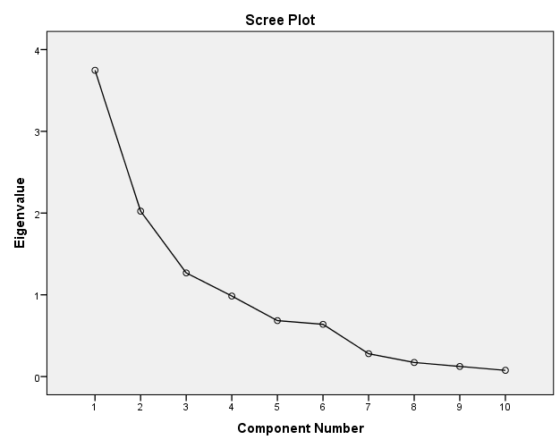

In the rotated component matrix, items one, two and three are grouped together in factor one( Table 5). They have high correlative values. In factor two, all four variables are also appropriately grouped. Three items of factor three are also loaded quite perfectly. Although item no. six can be seen in both factors one and three, a higher value was attached to factor three only. In a co-efficient display format, the absolute value below 0.5 is suppressed.

Table no :5 Rotated Component Matrixª
 | Component
 | 1 | 2 | 3
TRAVELDISTANCE | .913
TIMEOFTRAVEL | .900
TRAVELCOST | .874
GRADUATE % |  |  | .811
DAILYSTUDYHOURS |  |  | .804
AVGHOLIDAYSH | .511 |  | .518
B10 |  | .750
D7 |  | .508
D12 |  | .816
D14 |  | .723
Extraction Method: Principal Component Analysis.
Rotation Method: Varimax with Kaiser Normalization.ª
a. Rotation converged in 5 iterations.
The values of extractions are very high in the communalities matrix(Table no: 6). There are no values below 0.5. It is hence, ideal. These extraction values provide proportion of variance of each variable that can be explained by the factors Here, extraction values are high, so these are good extraction values.
Table no :6 Communalities
 | Initial | Extraction
TRAVELDISTANCE | 1.000 | .917
TIMEOFTRAVEL | 1.000 | .890
TRAVELCOST | 1.000 | .819
GRADUATE % | 1.000 | .737
DAILYSTUDYHOURS | 1.000 | .709
AVGHOLIDAYSH | 1.000 | .530
B10 | 1.000 | .573
D7 | 1.000 | .543
D12 | 1.000 | .694
D14 | 1.000 | .625
Extraction Method: Principal Component Analysis.

Using household income and parental education as independent variables and trip distance as the dependent variable, a two-way ANOVA was conducted (Table 7). The succeeding levels of household income and parental education are two and four, respectively. .

Table 7 .Between-Subjects Factors
 |  | N
HOUSEHOLDINCOME | 1 | 60
HOUSEHOLDINCOME | 2 | 170
HOUSEHOLDINCOME | 3 | 130
HOUSEHOLDINCOME | 4 | 80
PARENTALEDUCATIONLEVEL | 1 | 250
PARENTALEDUCATIONLEVEL | 2 | 190

The p-value in Levene's Test of Equality is 0.000( Table.8) . Consequently, the null hypothesis is disproved. The homogeneity of variances is the subject of the test. For us to be unable to reject the null hypothesis, it must be 0.05 in this case. The homogeneity of variances assumption in this study is being broken here. In other words, we are stating that the dependent variable's error variance is not the same for each group. According to the null hypothesis, it is equal.
Table.8 Levene's Test of Equality of Error Variancesª
Dependent Variable: TRAVEL DISTANCE
F | df1 | df2 | Sig.
62.720 | 7 | 432 | .000
Tests the null hypothesis that the error variance of the dependent variable is equal across groups.
a. Design: Intercept + HOUSEHOLDINCOME + PARENTALEDUCATIONLEVEL + HOUSEHOLDINCOME * PARENTALEDUCATIONLEVEL
In the table of test between-subject effects, there is a statistically significant variation of “household income” on the dependent variable “travel distance. The value here is 0.000, which is less than 0.05, which should be the “Alpha “ level. There is no difference in the variance in parental education level on travel distance, as the significant value here is 0.76. But the interaction of parental education level and household income on independent variables is statistically significant, i.e.0.10 having a low partial eta squared effect size of 0.026.
Table 8 : Tests of Between-Subjects Effects
Dependent Variable: TRAVELDISTANCE
Source | Type III Sum of Squares | df | Mean Square | F | Sig. | Partial Eta Squared
Corrected Model | 318801.199ª | 7 | 45543.028 | 25.141 | .000 | .289
Intercept | 595119.349 | 1 | 595119.349 | 328.518 | .000 | .432
HOUSEHOLDINCOME | 243024.756 | 3 | 81008.252 | 44.718 | .000 | .237
PARENTALEDUCATIONLEVEL | 5736.595 | 1 | 5736.595 | 3.167 | .076 | .007
HOUSEHOLDINCOME * PARENTALEDUCATIONLEVEL | 20681.520 | 3 | 6893.840 | 3.806 | .010 | .026
Error | 782580.619 | 432 | 1811.529
Total | 1783160.000 | 440
Corrected Total | 1101381.818 | 439
a. R Squared = .289 (Adjusted R Squared = .278)

Four tiers of household income existed. Income below one lakh is referred to as level 1, and income between one and three lakhs is referred to as level 2. Level four refers to income beyond six lakhs, while level three denotes income between three and six lakhs. It can be observed that there are statistically significant differences between all four levels at the pairwise comparison level. Every significance value is 0.000 in this case.

Table: 9 Pairwise Comparisons
Dependent Variable: TRAVELDISTANCE
(I) HOUSEHOLDINCOME | (J) HOUSEHOLDINCOME | Mean Difference (I-J) | Std. Error | Sig.^{b} | 95% Confidence Interval for Difference^{b}
 |  |  |  |  | Lower Bound | Upper Bound
1 | 2 | 30.833* | 6.755 | .000 | 12.929 | 48.737
1 | 3 | 65.393* | 6.927 | .000 | 47.033 | 83.753
1 | 4 | 70.850* | 7.624 | .000 | 50.644 | 91.056
2 | 1 | -30.833* | 6.755 | .000 | -48.737 | -12.929
2 | 3 | 34.560* | 5.068 | .000 | 21.127 | 47.992
2 | 4 | 40.017* | 5.985 | .000 | 24.154 | 55.879
3 | 1 | -65.393* | 6.927 | .000 | -83.753 | -47.033
3 | 2 | -34.560* | 5.068 | .000 | -47.992 | -21.127
3 | 4 | 5.457 | 6.178 | 1.000 | -10.918 | 21.833
4 | 1 | -70.850* | 7.624 | .000 | -91.056 | -50.644
4 | 2 | -40.017* | 5.985 | .000 | -55.879 | -24.154
4 | 3 | -5.457 | 6.178 | 1.000 | -21.833 | 10.918
Based on estimated marginal means
*. The mean difference is significant at the .05 level.
b. Adjustment for multiple comparisons: Bonferroni.

The homogenous subgroup of the Ryan-Einot-Gabriel-Welsch Rangea post hoc test classified family incomes in contrast to travel distance (Table 10). As can be observed, income levels three and four belong to the same group, or the first group. Levels one and two belong to the third and second groups, respectively, and are then independent. This is a significant result.

Table no : 10 TRAVEL DISTANCE
Ryan-Einot-Gabriel-Welsch Range^{a,b}
HOUSEHOLDINCOME | N | Subset
HOUSEHOLDINCOME | N | 1 | 2 | 3
4 | 80 | 11.50
3 | 130 | 17.69
2 | 170 |  | 51.41
1 | 60 |  |  | 89.33
Sig. |  | .588 | 1.000 | 1.000
Means for groups in homogeneous subsets are displayed.
Based on observed means.
The error term is Mean Square(Error) = 1811.529.
a. Critical values are not monotonic for these data. Substitutions have been made to ensure monotonicity. Type I error is therefore smaller.
b. Alpha = .05.
Even though our findings supported previous research, they went against the general consensus of earlier limited investigations. Future institutional management and higher education policies in sub-urban India will benefit from the findings.

Results (Qualitative Approach)

The thematic analysis of 100 in-depth student narratives revealed a nuanced picture of the commuting experience. Approximately 40–45% of participants reported negative academic impacts, including fatigue, stress, missed classes, and reduced engagement in campus activities. In contrast, 35–40% of respondents described positive coping strategies, often centered on improved time management and the productive use of travel hours for studying. Psychological effects were mixed: around 20% highlighted benefits such as mental clarity and preparation time, while approximately 30% reported negative outcomes, including heightened anxiety and reduced motivation.
Figure 1 illustrates the distribution of responses by theme, indicating that although negative academic impacts remain the most prevalent, a substantial proportion of students adapt effectively to the challenges of commuting. Figure 2 further shows the relative share of negative impacts, positive adaptations, and psychological benefits, providing a balanced view of the varied experiences among the commuting student population.
The findings suggest that strategic time use during commutes—such as listening to recorded lectures or reviewing notes—can help students maintain or even enhance their academic performance despite the demands of travel. Conversely, those experiencing chronic lateness, physical exhaustion, and elevated stress levels consistently reported declines in grades and participation. Overall, commuting emerges as both a potential barrier and a catalyst for personal growth, with outcomes largely dependent on individual coping strategies and the degree of institutional support available.

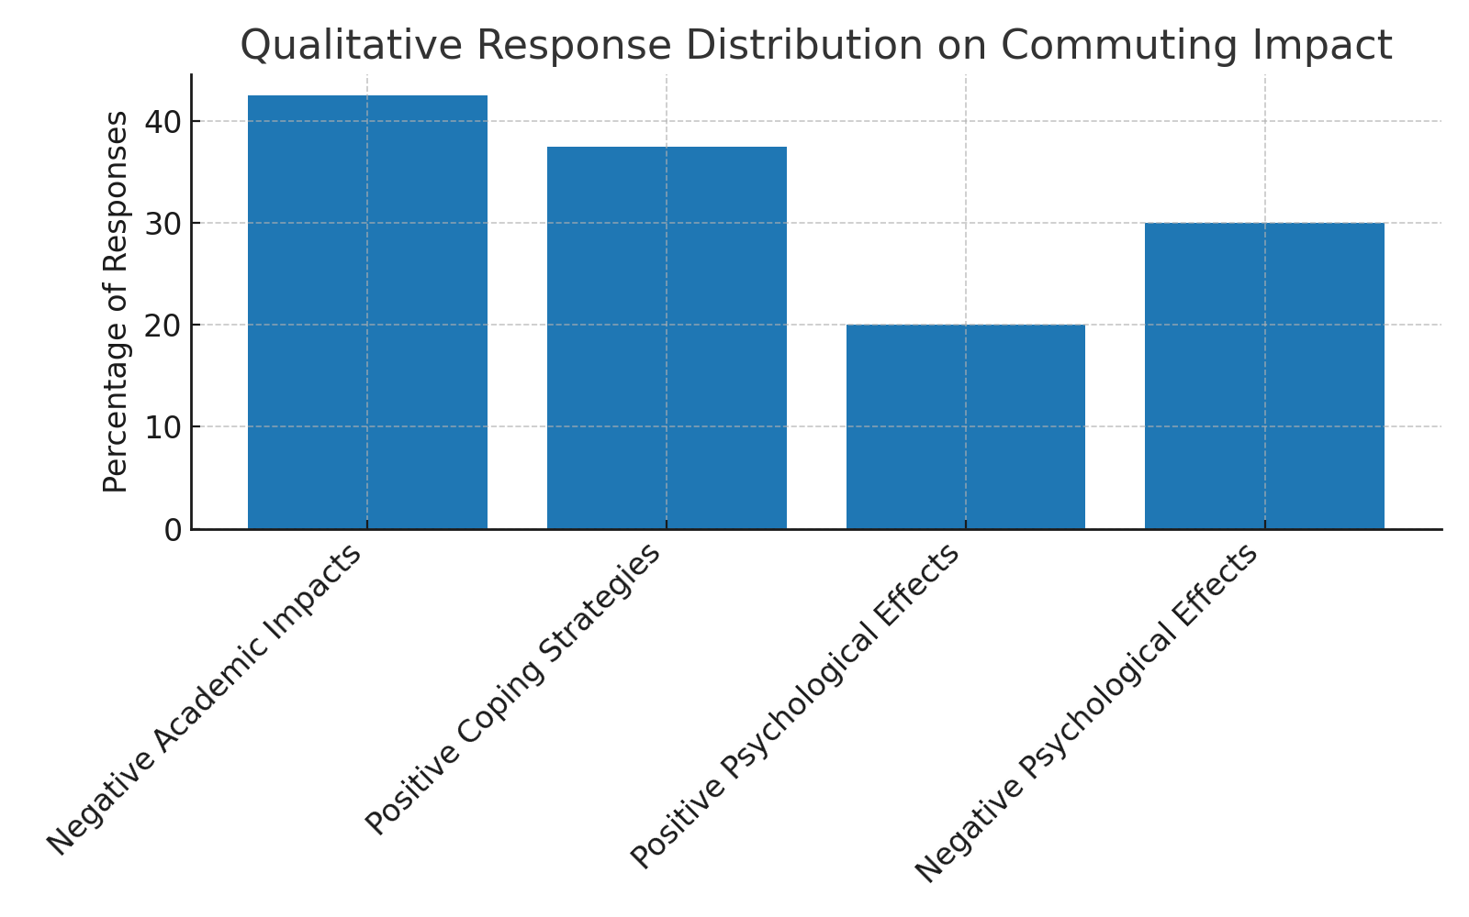
Fig :1
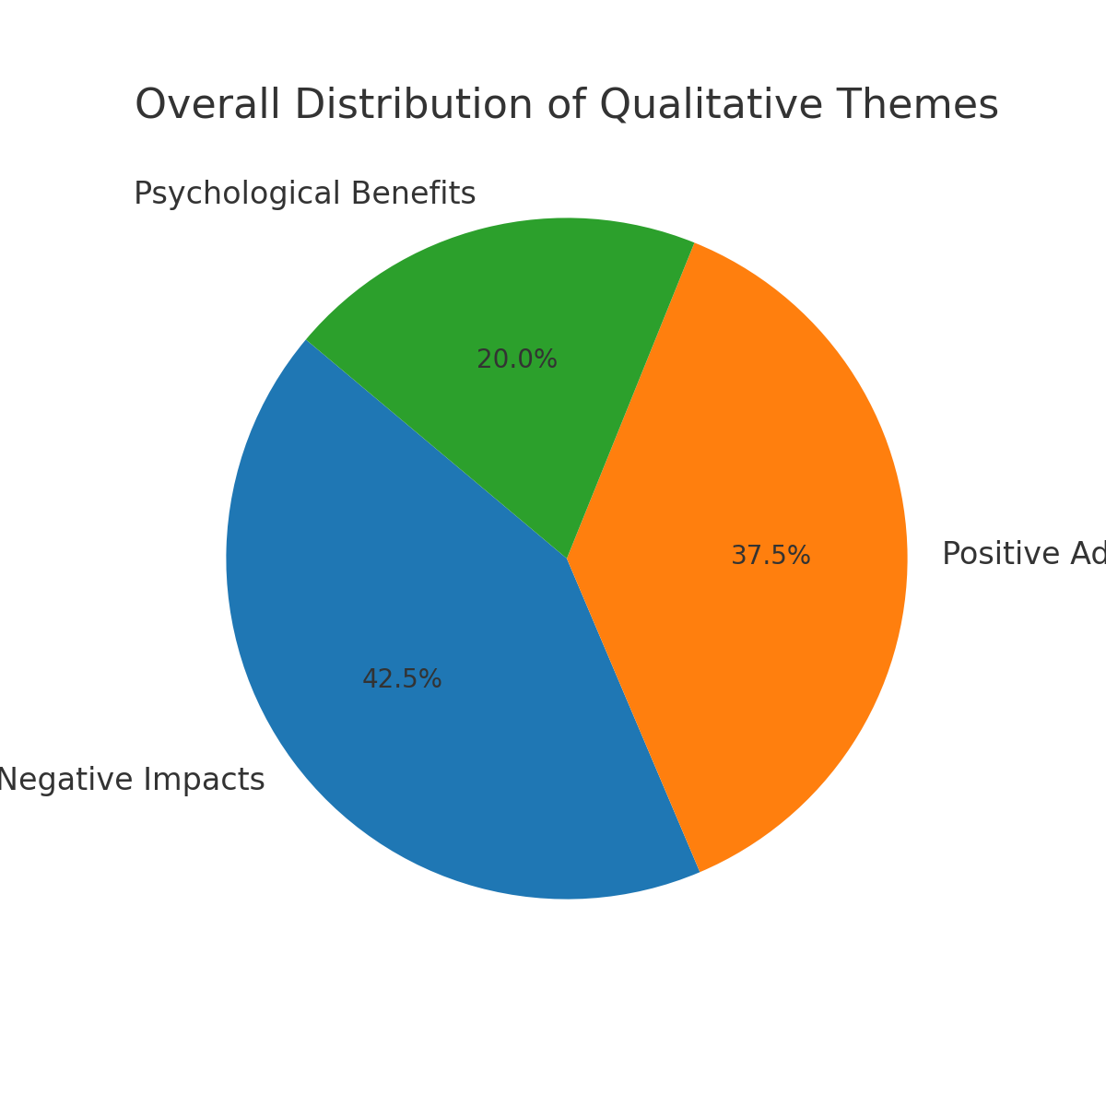
fig :2

6. Discussion (Quantitative Approach)
By calculating the descriptive data, it is discovered that commuters typically go 40 km (39.36) by local rail. This trip takes an average of one hour and twelve minutes. It is evident that there is a positive correlation between trip distance and rising travel expenses and duration. Despite their claims that local train travel on the Indian Railway is more economical than alternative options, commuter students frequently expressed their frustration with delays. Sometimes, this delay makes it difficult for students to go to university lessons on time. In their 2021 research paper, Arshad and Ahmed discussed this issue and stated that railway systems worldwide struggle to prevent train delays; in India, the situation is significantly worse than in other developing nations because of the large passenger volume and inadequate modernisation of the previous system. The relationship between average graduation marks (-.429) and trip distance is clearly negatively correlated. There is also a negative correlation between their average daily study hours (-.360). The majority of long-distance students attempt to get up early for independent study instead of studying late at night. This allows them to access the college's class schedule easily. Long commutes have been shown in numerous studies to impact academic performance negatively(Alanzi & Alfraih, 2023; Jamil et al., 2022; Liu & Jung, 1980; Tigre et al., 2017). The output is not an exception, even if it is contradictory or has no relationship (Cordes et al., 2022; Nelson et al., 2016; Phansikar et al., 2019; Van Dijk et al., 2014). Travel distance and holiday study hours have a moderately beneficial association(0.228). This demonstrates that whereas short-distance commuters do not sacrifice their study time during the holidays, long-distance commuters typically attempt to increase their study time to fully compete with their peers. The relationship between travel distance, household responsibilities, and academic performance highlights the challenges faced by long-distance commuters. A moderate positive correlation (0.372) suggests that increased travel distance is associated with the belief that household chores reduce study time. This is particularly evident for long commuters who often shoulder significant family responsibilities, leaving less time for academic pursuits. Consequently, their academic performance suffers. Additionally, the findings reveal a negative correlation (-0.297) between commuting distance and academic satisfaction, indicating that as travel distance increases, students feel less satisfied with their academic progress. These results emphasize the need for strategies to reduce the burden of commuting (Whalen et al., 2013)and household responsibilities to support students' academic success and satisfaction. Feelings that family responsibilities and time-consuming transportation negatively affect academic performance tend to show a low to moderate positive correlation with increasing distance. Their successive values are 0.240 and 0228. The connection between family responsibilities, transportation challenges, and academic performance highlights significant barriers for students. This research indicates that as the distance between home and institution increases, students often feel greater strain from time-consuming commutes and family obligations. These factors, in turn, can hinder their academic success. Although the correlation is low to moderate, it underscores the importance of addressing these external pressures. Average graduation percentage of commuter students is 57.34%. The average daly study hour is less than four hours and the mean value is 3.64. although average holiday study hour is high . here the mean value is 5.53. . The study employed dual measures to assess satisfaction: a 0-to-10 scale for "life evaluation questions," where 10 denotes "completely satisfied," and a 7-point Likert scale for "domain evaluation questions," with 1 indicating "complete satisfaction" and 7 representing "no satisfaction. “The mean scores for domain evaluation items—B10 (3.95), D7 (6.25), D12 (6.25), and D14 (5.86)—reveal notable dissatisfaction among long-distance commuters. Specifically, the high scores for D7, D12, and D14 suggest that these individuals perceive significant barriers to academic success, primarily due to family responsibilities, household work, and the demands of commuting. These findings highlight a critical relationship between commuting distance and satisfaction levels. Longer commutes correlate with reduced satisfaction regarding academic achievements and increased perceptions of external hurdles. The between-subject factors analysis of a two-way ANOVA reveals critical socioeconomic disparities among the participants. A significant proportion (52%) of respondents belong to households with an annual income of less than 3 lakh rupees, and within this group, 13.64% report an annual income of less than 1 lakh rupees. These statistics underscore that many students originate from economically disadvantaged families, which likely impacts their access to resources and overall academic performance. Additionally, 58% of commuter students are identified as first-generation learners. This finding highlights another layer of educational inequity, as these students often lack the familial academic support systems available to those from more privileged or experienced educational backgrounds.
The analysis reveals a significant relationship between socioeconomic background, parental education level, and commuting distances among students. The mean travel distances for different household income levels (Levels 1 to 4) were 83.25 km, 52.42 km, 17.86 km, and 12.40 km, respectively, indicating that students from lower-income families tend to commute significantly longer distances. Table no eleven shows that those with a first-generation parental education level commute a higher distance( 'x̄' 44.12 km) than second-generation college-going students. The interaction between household income and parental education level also provides a contrasting result. In each household income group, students coming from 1st level of the parental educational group have higher mean values of distances. The interactional average mean distance of the level 1 group is 89.33 km, and the fourth group is 11.50 km. Again, it proves that students with lower economic backgrounds, having a “first generation learner” background, commute higher distances than their counterparts. However, no direct relationship was found between parents' educational level and household income.

Table no :11 Descriptive Statistics
Dependent Variable: TRAVELDISTANCE
HOUSEHOLDINCOME | PARENTALEDUCATIONLEVEL | Mean | Std. Deviation | N
1 | 1 | 101.50 | 102.977 | 40
1 | 2 | 65.00 | 20.520 | 20
1 | Total | 89.33 | 86.292 | 60
2 | 1 | 49.00 | 37.210 | 110
2 | 2 | 55.83 | 56.770 | 60
2 | Total | 51.41 | 45.043 | 170
3 | 1 | 15.71 | 3.560 | 70
3 | 2 | 20.00 | 17.408 | 60
3 | Total | 17.69 | 12.247 | 130
4 | 1 | 16.00 | 4.394 | 30
4 | 2 | 8.80 | 3.580 | 50
4 | Total | 11.50 | 5.229 | 80
Total | 1 | 44.12 | 55.985 | 250
Total | 2 | 33.11 | 40.358 | 190
Total | Total | 39.36 | 50.088 | 440

In Figure 2, the mean travel distances for household income levels three and four are relatively close to each other, both falling below 20 km. In contrast, the second income group exhibits a higher mean travel distance, distinctly separated from levels three and four. The first and lowest income group stands out with the highest mean travel distance overall.
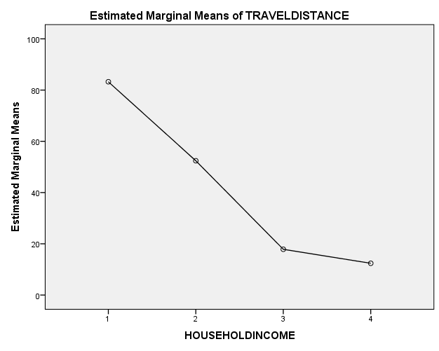
Fig : 2
This analysis in Figures 3 and 4 highlights the relationship between parental education levels, household income, and travel distances for students. In Figure 3, first-generation learners (parental education level one) have higher estimated marginal means of travel distance than second-generation college students (parental education level two). In Figure 4, the blue line represents first-generation learners, and the green line represents second-generation students. In both cases, high-income groups (household income groups three and four) exhibit lower travel distances. Household income group two (3 to 6 lakhs per annum) is positioned farther from the other two groups.
Interestingly, when interacting with the third household income group, both parental education groups align in similar positions on the graph. The interaction effect between parental education group two and household income group one shows estimated marginal means of travel distance above 60 km. In contrast, the interaction effect between parental education group one and household income group one shows significantly higher estimated marginal means, above 100 km.
These findings suggest that lower parental education and lower household income contribute to higher travel distances for students. This interaction emphasizes the socio-economic disparities that influence students' commuting patterns and, by extension, may affect their academic performance and opportunities.
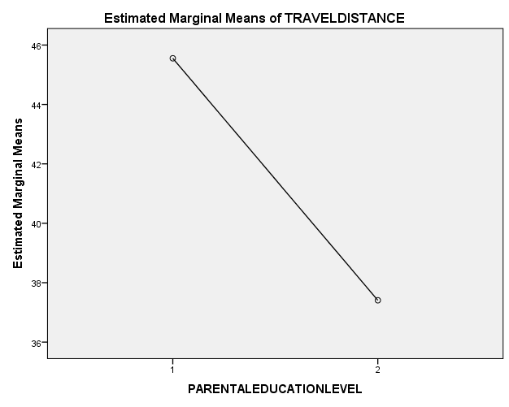
Fig:3
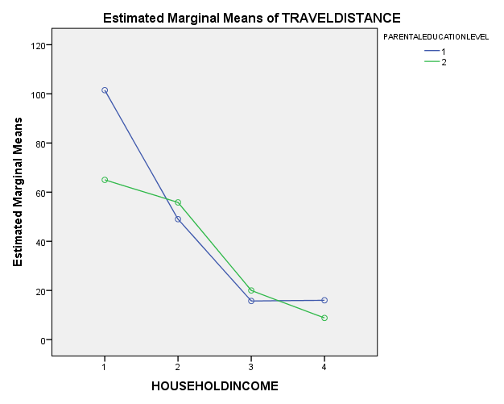
Fig :4
This data underscores the need for structural interventions. Institutions can help by offering support mechanisms, such as remote learning options(Turner et al., 2024), flexible schedules, or resources to reduce the burden of transportation and family demands, ultimately fostering a more supportive environment for academic achievement.
Discussion (Qualitative Approach)
The qualitative evidence offers a multidimensional understanding of commuting, moving beyond numerical summaries to capture the personal and social contexts in which it occurs. While the most frequently cited experiences involve fatigue, stress, and disrupted academic schedules, these should not be interpreted solely as deficits. The narratives show that commuting is embedded in a broader web of responsibilities, financial constraints, and personal ambitions, which together shape how students perceive and respond to their daily travel. These factors underscore that commuting is not merely a logistical challenge but a lived experience shaped by broader socioeconomic and personal contexts.
In contrast to deficit-focused interpretations, the adaptability demonstrated by many participants reframes commuting as a space for self-regulation and skill building. Approximately one-third of respondents shared stories of deliberate adjustments—ranging from reorganizing their day to maximizing transit downtime through targeted study. This reframing positions commuting not just as an obstacle, but as a structured period that can facilitate personal growth and sharpen academic focus when managed strategically. The psychological dimension reinforces this complexity: while some students experienced the commute as a mentally taxing obligation, others leveraged the routine for emotional preparation and cognitive readiness. Such diversity of responses reflects the heterogeneity of student experiences and points toward the critical role of individual agency.
The visualizations in Figures 3 and 4 illustrate these themes through a radar chart and a horizontal bar distribution, offering a fresh perspective on the relationships between thematic categories. These graphics emphasize not only the relative size of each theme but also their structural balance, highlighting that while negative consequences are more frequently reported, adaptive strategies and psychological benefits remain a significant part of the commuting narrative. Such findings suggest that institutional policies should aim to minimize barriers while amplifying the potential gains associated with commuting.
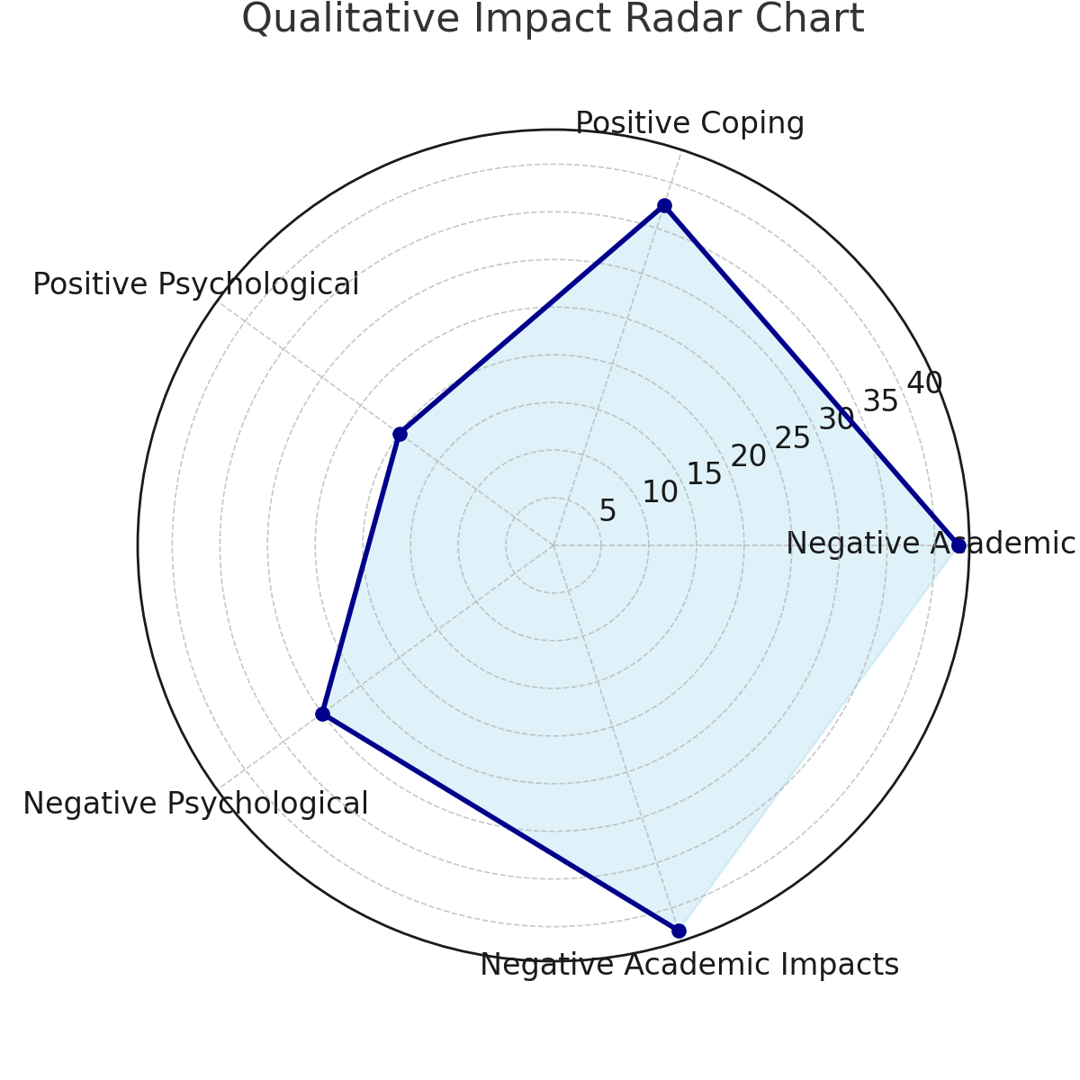
Fig:3
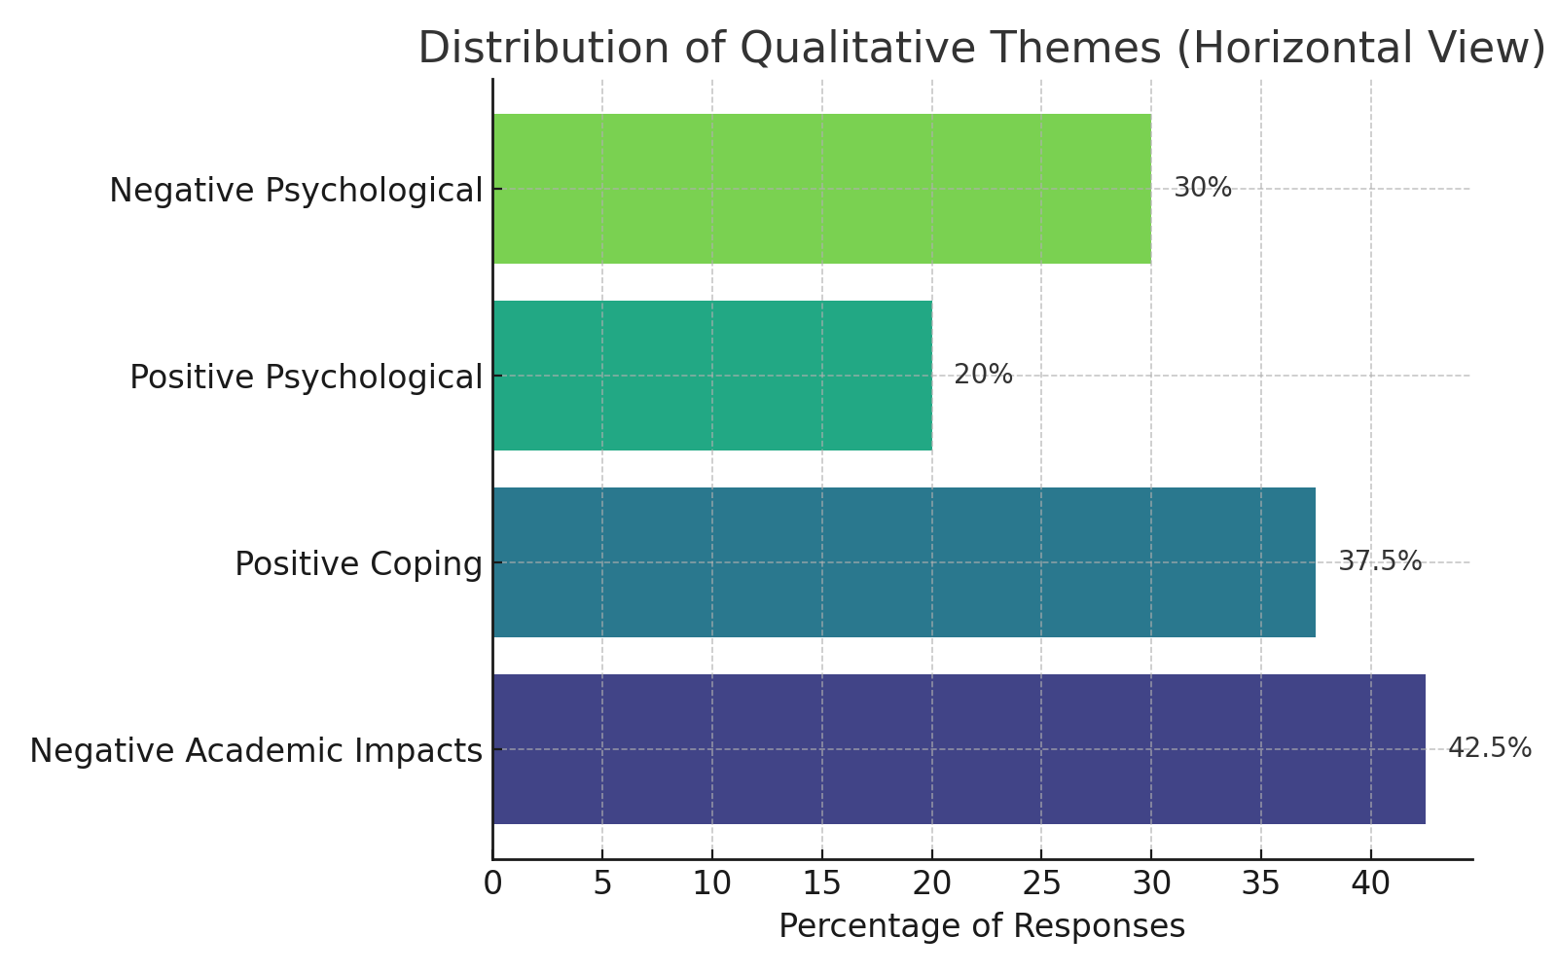
Fig:4

Conclusion: The study concludes by demonstrating the intricate connection between college students' commute habits, parental educational attainment, and socioeconomic background. First-generation students and those from lower-income families typically have lengthier commutes, which has a detrimental effect on their academic achievement, study habits, and level of satisfaction. Since those with lower household incomes and first-generation educational backgrounds frequently bear the brunt of longer travel distances, which are associated with increased academic challenges and lower academic satisfaction, the findings highlight the crucial role that socioeconomic disparities play in influencing students' academic experiences.
These findings have significant implications for academics and professionals. It is imperative that scholars look more closely at how socioeconomic issues, student commutes, and academic achievement interact. Gaining a deeper understanding of these trends can help one better understand how socioeconomic obstacles impact educational equity. These findings highlight how crucial it is for practitioners—especially those in higher education administration—to take socioeconomic gaps into account when creating student support networks and regulations. In particular, reducing the commuting costs for first-generation and lower-income students is essential to raising their academic performance.
Suggestions for improving institutional support systems include:
- Flexible Class Scheduling: More evening or weekend programs could assist commuter students better manage their study schedules(Jacoby, 1989) and lessen the negative effects of lengthy commutes.
- Subsidized Transportation: To ease some of the financial burden on students who commute large distances, educational institutions might collaborate with nearby transit networks to provide subsidized or discounted travel passes(Thomas & Jones, 2017.).
- Academic Support Services: Students who spend a lot of time traveling may find that their academic difficulties are lessened by offering extra academic resources such study spaces, tutoring, and online learning environments(Kenyon, 2024).
- On-Campus Accommodation: Providing reasonably priced on-campus housing choices could lessen the need for daily travel (Taylor & Mitra, 2021; Vale et al., 2018)and the stress it causes for students from lower-income families or those who have long commutes.
- Mental Health and Well-being Programs: Institutions must to acknowledge the toll that long-distance commuting takes on students' mental and physical health and provide counseling (Parker et al., 2023)and support services to assist them in overcoming these obstacles.
Universities can create a more encouraging learning atmosphere by creating institutional-level regulations that highlight the particular difficulties faced by commuter students, particularly those from underprivileged backgrounds. Flexible class schedules, online courses, reasonably priced transportation, and on-campus accommodation are a few examples of important initiatives. Long commutes can generate stress, which can be reduced by offering focused academic and mental health support, improving students' chances of success. Peer support groups can also make commuting students feel more a part of the university community(Krause, 2007; Paolini, 2024). All kids, regardless of socioeconomic status, would have access to the tools and opportunities necessary for academic success thanks to these regulations.
References :
- Alanzi, K. A., & Alfraih, M. M. (2023). Does students’ commuting influence their academic performance? Journal of Applied Research in Higher Education, 15(5), 1706–1716. https://doi.org/10.1108/JARHE-07-2022-0211
- Alfano, H., & Eduljee, N. (2013). Differences in Work, Levels of Involvement, and Academic Performance Between Residential and Commuter Students. College Student Journal, 47(2), 334–342.
- Andres, L., & Carpenter, S. (1997). Today’s Higher Education Students: Issues of Admission, Retention, Transfer, and Attrition in Relation to Changing Student Demographics. For full text: http://www. https://eric.ed.gov/?id=ED444638
- Chairassamee, N., Chancharoenchai, K., & Saraithong, W. (2024). Getting there: How commuting time and distance impact students’ health. PLOS ONE, 19(12), e0314687. https://doi.org/10.1371/journal.pone.0314687
- Cordes, S. A., Rick, C., & Schwartz, A. E. (2022). Do Long Bus Rides Drive Down Academic Outcomes? Educational Evaluation and Policy Analysis, 44(4), 689–716. https://doi.org/10.3102/01623737221092450
- Dey, T. (2012, April 18). Suburban Railway Network Analysis of Kol | PDF | Kolkata | Suburb. Scribd. https://www.scribd.com/document/513378786/Suburban-Railway-Network-Analysis-of-Kol
- Dey, T. (2012, April 18). Suburban Railway Network Analysis of Kol | PDF | Kolkata | Suburb. Scribd. https://www.scribd.com/document/513378786/Suburban-Railway-Network-Analysis-of-Kol
- Ding, P., & Feng, S. (2022). How School Travel Affects Children’s Psychological Well-Being and Academic Achievement in China. International Journal of Environmental Research and Public Health, 19(21), Article 21. https://doi.org/10.3390/ijerph192113881
- Giacalone, M. D. (2022). “A Hard Shuffle To Get It All Done”: Challenges Faced By Commuter Students In Historically White Sororities And Fraternities. College Student Affairs Journal, 40(3), 136–150. https://doi.org/10.1353/csj.2022.0031
- He, F. (2019). Undergraduate Commuter Students: Challenges and Struggles. Journal of Student Affairs, New York University, 15, 43–49.
- Jacoby, B. (1989). The student-as-computer: Developing a comprehensive institutional response. School of Education and Human Development, The George Washington Univ.
- Jacoby, B. (2000, March 1). Why Involve Commuter Students in Learning? | New Directions for Higher Education | EBSCOhost. https://doi.org/10.1002/he.10901
- Jamil, D., Rayyan, M., Hameed, A. K. A., Masood, F., Javed, P., & Sreejith, A. (2022). The Impact of Commute on Students’ Performance. Journal of Medical and Health Studies, 3(3), Article 3. https://doi.org/10.32996/jmhs.2022.3.3.9
- Kaushik, A., Rai, S., Thakur, G., & Kumar, P. (2023). Effect of commuting on the academic performance of students in higher technical education and their physical and emotional state. Innovations in Education and Teaching International, 0(0), 1–12. https://doi.org/10.1080/14703297.2023.2216677
- Kenyon, S. (2024). Commuter students: Does reducing the need to travel enable more inclusive, equitable participation? Widening Participation and Lifelong Learning, 26(3), 115–142. https://doi.org/10.5456/WPLL.26.3.115
- Kobus, M. B. W., Van Ommeren, J. N., & Rietveld, P. (2015). Student commute time, university presence and academic achievement. Regional Science and Urban Economics, 52, 129–140. https://doi.org/10.1016/j.regsciurbeco.2015.03.001
- Koedel, C. (2014). Higher education structure and education outcomes: Evidence from the USA. Education Economics, 22(3), 237–256. https://doi.org/10.1080/09645292.2011.616714
- Krause, K.-L. (2007). Social Involvement and Commuter Students: The First-Year Student Voice. Journal of The First-Year Experience & Students in Transition, 19(1), 27–45.
- Kuh, G. D., Gonyea, R. M., & Palmer, M. (2001). The disengaged commuter student: Fact or fiction? https://hdl.handle.net/2022/24256
- Lakhani, K. K. (2024). Local Train Commuting Impacts Students’ Academic Outcomes.
- Liu, R., & Jung, L. (1980). The commuter student and student satisfaction. Research in Higher Education, 12(3), 215–226. https://doi.org/10.1007/BF00976093
- McCool, S., Cohen, W., Couper, J., & Madden, J. (2017). Commuting to placement: 3rd International Enhancement in Higher Education Conference. 1–11. http://www.enhancementthemes.ac.uk/conference/event-resources/day-2-parallel-session-papers
- Nelson, D., Misra, K., Sype, G. E., & Mackie, W. (2016). An Analysis of the Relationship between Distance from Campus and GPA of Commuter Students. Journal of International Education Research, 12(1), 37–46.
- Newbold, J. J., Mehta, S., & Forbus, P. (2011). Commuter Students: Involvement and Identification with an Institution of Higher Education. The Academy of Educational Leadership Journal.stil https://www.semanticscholar.org/paper/Commuter-Students%3A-Involvement-and-Identification-Newbold-Mehta/1499c8317f2832ec574555765e95a012d251989a
- Paolini, J. (2024). IMPACT OF SOCIAL INTEGRATION ON STUDENT PERSISTENCE IN COMMUTER STUDENTS. Theses and Dissertations. https://rdw.rowan.edu/etd/3218
- Parker, J., Yacoub, A., Mughal, S., & Mamari, F. (2023). Family support and psychological distress among commuter college students. Journal of American College Health, 71(2), 479–488. https://doi.org/10.1080/07448481.2021.1895805
- Pascarella, E., & Others, A. (1992). Cognitive Impacts of Living on Campus versus Commuting to College. https://eric.ed.gov/?id=ED357706
- Phansikar, M., Ashrafi, S. A., Khan, N. A., Massey, W. V., & Mullen, S. P. (2019). Active Commute in Relation to Cognition and Academic Achievement in Children and Adolescents: A Systematic Review and Future Recommendations. International Journal of Environmental Research and Public Health, 16(24), Article 24. https://doi.org/10.3390/ijerph16245103
- Regalado, M., & Smale, M. (2015). Serving the Commuter College Student in Urban Academic Libraries. Urban Library Journal, 21(1). https://doi.org/10.31641/ulj210104
- Smith, B. T., Charlton, K., & Allen, A. B. (2023). Commuter Students and Psychological Sense of Community: How Ties to Home Relate to Academic Success. Open Education Studies, 5(1). https://doi.org/10.1515/edu-2022-0189
- Stalmirska, A. M., & Mellon, V. (2022). “It feels like a job …” Understanding commuter students: Motivations, engagement, and learning experiences. Journal of Hospitality, Leisure, Sport & Tourism Education, 30, 100368. https://doi.org/10.1016/j.jhlste.2021.100368
- Taylor, R., & Mitra, R. (2021). Commute satisfaction and its relationship to post-secondary students’ campus participation and success. Transportation Research Part D: Transport and Environment, 96, 102890. https://doi.org/10.1016/j.trd.2021.102890
- Thomas, L., & Jones, R. (2017). Student engagement in the context of commuter students. https://www.lizthomasassociates.co.uk/projects/2018/Commuter%20student%20engagement.pdf
- Tigre, R., Sampaio, B., & Menezes, T. (2017). THE IMPACT OF COMMUTING TIME ON YOUTH’S SCHOOL PERFORMANCE. Journal of Regional Science, 57(1), 28–47. https://doi.org/10.1111/jors.12289
- Turner, R., Webb, O., & Pritchard, C. (2024). Academic engagement amongst commuter students: A comparative analysis. Higher Education. https://doi.org/10.1007/s10734-024-01349-0
- Vale, D. S., Pereira, M., & Viana, C. M. (2018). Different destination, different commuting pattern? Analyzing the influence of the campus location on commuting. Journal of Transport and Land Use, 11(1), 1–18.
- Van Dijk, M. L., De Groot, R. H., Van Acker, F., Savelberg, H. H., & Kirschner, P. A. (2014). Active commuting to school, cognitive performance, and academic achievement: An observational study in Dutch adolescents using accelerometers. BMC Public Health, 14(1), 799. https://doi.org/10.1186/1471-2458-14-799
- Webb, O. J., & Turner, R. (2020). The association between residential arrangements and academic performance in UK university students. Journal of Further and Higher Education, 44(10), 1320–1334. https://doi.org/10.1080/0309877X.2019.1684461
- Whalen, K. E., Páez, A., & Carrasco, J. A. (2013). Mode choice of university students commuting to school and the role of active travel. Journal of Transport Geography, 31, 132–142. https://doi.org/10.1016/j.jtrangeo.2013.06.008

