Adonis Beyond the Frame: Visual Tradition and Mythic Transformation in Shelley’s Adonais

Dr. Amjad Alsyouf
¹Ajloun University College, Al-Balqa Applied University, Jordan
²Faculty of English Studies, Arab Open University, Jordan

Abstract
This article reconsiders Percy Bysshe Shelley’s Adonais within the longer visual genealogy of the Adonis myth in European art. Before Shelley transformed Adonis into a figure of metaphysical survival, the youthful body had already been stabilized within engraving and marble as an aestheticized image of death. Focusing on Antonio Tempesta’s The Death of Adonis (1593) and Giuseppe Mazzuoli’s Dying Adonis (c. 1709), the study traces how early modern print culture and Baroque sculpture frame, contain, and materially secure the wounded body, converting violent loss into composed visual form. Against this tradition of framed narrativity and sculptural permanence, Shelley’s elegy gradually dismantles corporeal fixity. While visual art arrests the dying body within line and mass, Adonais disperses the figure into atmosphere, light, and presence, shifting myth from spatial containment to temporal and metaphysical expansion. The movement from engraved contour and marble surface to poetic diffusion marks not only a change of medium but a reconfiguration of myth itself.

Keywords Adonais, Adonis, Tempesta, Mazzuoli, engraving, Baroque sculpture, ekphrasis, Romantic myth

Introduction
Shelley’s Adonais (1821), traditionally studied as an elegy to John Keats, has also been interpreted as an examination of the philosophical theme of loss, as well as a contemplation on the theme of poetic immortality. There is another lineage to the poem and the image of Adonis than what the normative study of Adonais provides, and it is necessary to consider that lineage in regard to an art tradition predating Shelley by thousands of years. Before Shelley recreated and reinterpreted the myth of Adonis through poetry, images of Adonis had already been created and circulated throughout Europe, from classical sculptural ideals through early modern engraving and Baroque marble.
This study focuses in particular on two representative works within that visual history: Antonio Tempesta’s The Death of Adonis (1593), an engraving that stages the fatal hunt within a disciplined linear frame (hereafter Tempesta 1593), and Giuseppe Mazzuoli’s Dying Adonis (c. 1709), a marble sculpture that monumentalizes the fallen youth in polished permanence (hereafter Mazzuoli 1709). These two visual logics, framed narrativity and material stabilization, form the principal points of comparison with Shelley’s elegy.
The embodied representation of Adonis was used repeatedly throughout the ages by painters as an opportunity to present the idealized male body in relation to themes of youth, loss, and the vulnerability of beauty to time. In the case of Adonis, even the moment of his death was repeatedly composed in ways that preserve beauty and aesthetic harmony, so that mortality becomes readable without becoming visually chaotic. The body of Adonis was represented using various devices to frame him, light him or stabilize him creating a spectacle of mortality, whilst still offering a composed image of grief. In the history of the myth of Adonis, the body of Adonis continues to exemplify the convergence of two different aspects: the physical body (corporeality) and the moment at which the aesthetic arrests time, halting the subject at the edge of loss.
While Shelley draws on this inherited visual logic, he does not reproduce it. In his elegy Adonais, the mythological body transforms from a solid and sculptural form into one that is less substantial as the poem progresses. In the beginning of the elegy, Shelley writes a ritualistic lament about the death of Adonis, stating “I weep for Adonais—he is dead!” (St. I), something which may be painted within a scene of mourning. However, as he continues to write in the poem, the dead body of Adonis as a visual object is gradually stripped of its stability. What earlier art could hold in marble or contain within a framed scene, Shelley releases into pure light, atmosphere, and metaphysical being. So, by the time Shelley states “He lives, he wakes—’tis Death is dead, not he” (St. XLI), then he has shifted the terms of representation themselves. Rather than being represented visually as a singular form (as a figure to be seen), the dead youth is now understood as a being who is an entity throughout nature, through the mind and through the cosmos.
This study will explore how to interpret Adonais as more than a Romantic elegy; it also functions as a critique of visual history as it pertains to the mythic, responding to the framed narrativity of engraving and the monumental stillness of marble death. Methodologically, this study adopts a comparative intermedial approach, reading visual form and poetic figuration as mutually illuminating structures rather than as illustrative analogues. It will examine the lineage of Adonis throughout European painting and sculpture, and evaluate the aestheticization of mythic death throughout visual culture, in order to demonstrate how Shelley’s poem disrupts an established iconographic tradition. The Adonis of visual tradition is an aestheticized body stabilized within form, while the Adonais of Shelley transforms that inherited image into a political and philosophical force that defies visual constraint. In moving from images to abstractions, from framed bodies to atmospheric presences, Shelley transforms the myth into a medium of resistance against erasure, against aesthetic rigidity, and against the reduction of death to drama.
While Adonais disrupts and assimilates the visual legacies of the myth, it is through participation in the iconic memory of Adonis, and through dismantling the fixedness of that memory, that the Romantic conception of myth is redefined. Shelley’s poem creates a new fluid and dynamic space between images, language and the cultural memory through the reproduction of the iconographic memorial to Adonis. Thus Shelley’s elegy is situated at a crucial juncture between visual and poetic traditions, where myth begins to exceed the sculptural, engraved, and monumental forms that had previously identified it. Seen in this broader perspective, the transformation of Adonis also illustrates how cultural memory travels across artistic media, allowing myth to circulate between visual representation and literary imagination.

The Visual Genealogy of Adonis in European Painting and Sculpture
The cultural tradition of Adonis undergoes a process of metamorphosis into an abstract entity through Shelley’s poetry. However, the image of the god Adonis as a recognizable symbol was already established by pre-existing visual regimes which defined the visual parameters for the representation of beauty and suffering. This development included visual renditions of Adonis from classical sculpture to early modern engravings and later marble monuments of death. Print culture matters here not only as iconography but as repeatable visual evidence: engraving participates in what has been described, via Ivins, as the “exactly repeatable pictorial statement” that enables comparison across viewers and sites (Woodward 2007, 607). In Tempesta’s case, this repeatability stabilizes the wound-event itself, ensuring that the fallen body circulates as a standardized visual formula rather than as a singular occurrence. In works such as Antonio Tempesta’s engraved Death of Adonis (1593), the fatal encounter is disciplined within the boundaries of the frame, while in Giuseppe Mazzuoli’s marble Dying Adonis (c. 1709), the fallen youth is held at the threshold between life and death through the permanence of stone. Tempesta’s engraving belongs to the late sixteenth-century Roman print culture that disseminated mythological subjects across Europe, while Mazzuoli worked within the post-Bernini Baroque sculptural milieu in Rome, where marble drama and devotional theatricality shaped the language of death.
In Tempesta, the body extends diagonally across the compressed foreground, the advancing boar and clustered figures contained within a tightly etched field that directs the eye laterally rather than into depth. The engraved contour both narrates and arrests the violence, rendering the wound legible without allowing it to rupture the compositional order. The dense cross-hatching around the boar and the clustering of figures compress spatial recession, flattening the event into a legible surface that privileges narrative clarity over atmospheric depth. Griffiths emphasizes that printmaking depends upon reproducible processes that allow an image to circulate across impressions while retaining artistic intentionality (Griffiths 1996, 12). Artists constructed an iconographical context in which the male figure could be represented, viewed, and interpreted through posture, gesture, narrative action, and material form. Moreover, the mythological figure of Adonis was not only narrated but materialized through form, position, orientation, and material stability. Panofsky’s distinction between primary subject matter and “symbolical values” helps clarify how the figure of Adonis operates not merely as narrative content but as a carrier of culturally embedded meaning (Panofsky 1939, 14). As the poem later laments, “He will awake no more, oh, never more!” (St. XXII).

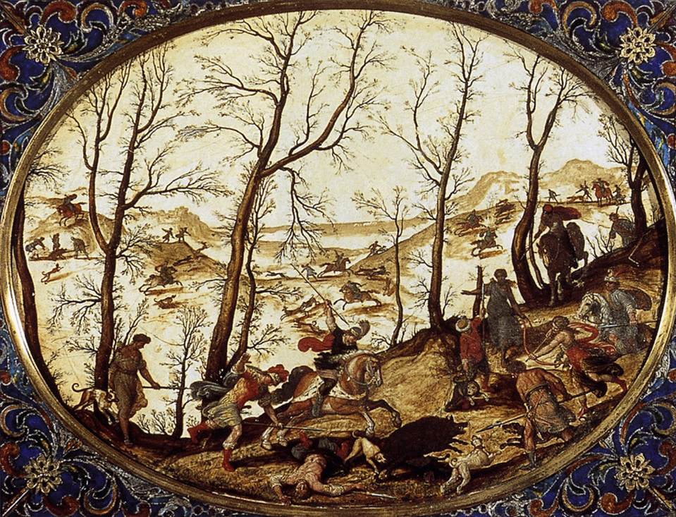
Figure 1. Antonio Tempesta, The Death of Adonis, 1593, engraving. Source: Wikimedia Commons (public domain).

Throughout these visual traditions the artist presents the viewer with a stabilized aesthetic experience of Adonis’ body. Whether standing in inherited classical balance or laid out within an engraved scene of violence (as in Tempesta 1593), Adonis remains composed, his body legible even in collapse. In Tempesta, the legibility of the body depends upon linear contour within the engraved frame; in Mazzuoli, it depends upon the sculptural volume of marble, which stabilizes the fallen form in three-dimensional permanence. As Figure 1 demonstrates, the engraved lines both narrate and contain the violence within a disciplined visual boundary. Mythology provides a structured context for both the general concept of the nude male and provides insight into the visual experiences of male nudity related to aesthetic balance and proportion. Even death provides a structured context for the visible form of Adonis’ body and maintains its physical coherence.
This logic is most dramatically expressed in the subsequent use of marble in later sculptures. In sculptures such as Giuseppe Mazzuoli’s Dying Adonis, death is not merely a story, but rather is monumentalized. That monumentalization is not neutral: recent material-focused scholarship insists that the image’s power depends on material conditions—indeed, that “only the material resistance allows for the peculiar latency” by which an image acts on the beholder (Bredekamp, quoted in van Gastel 2017/18, 78). The type of finish that can be achieved on the smooth surface of a marble sculpture creates an aesthetic experience that is no longer merely visual, but contains an understanding of how the body is constructed and viewed. The musculature of the body, while no longer standing or supporting itself under its weight, retains its ability to be visually inspected and evaluated as a functional body.
The repetition of images of Adonis in different artistic media (sculpture, engraving, and marble) creates a collective reference to Adonis as an image that accumulates what can be defined as iconographic memory. This accumulation of iconographic memory parallels what Northrop Frye calls the “cyclical pattern of myth,” in which recurrence stabilizes meaning through repetition (Frye 1957, 158–60). In visual culture, however, recurrence depends upon material fixation: the image must be framed, carved, or engraved in order to endure. In that sense, your sequence is not only diachronic; it asks for comparative looking, the kind of viewing that, when attached to death-images, produces meaning through repetition, framing, and analogy rather than through a single ‘original’ scene (Clifford 2023, 107–109). The viewer can identify the muscle definition of a youth, a youth poised to hunt, a youth wounded, and youth lying in an isolated landscape. It is not just a story; it is an image that has become so solidified in visual expression that the visual representations of Adonis and the mythology surrounding him have merged and become inseparable.
Nevertheless, Shelley’s verse prevents us from maintaining this whole figure, in that the classical balance of the sculpture, fragmented by the framed violence of engraving and fixed in marble as a representation of death, is destabilized through the use of language to create a new figure. Whereas visual art produces mass and line, Shelley’s poem releases both of these characteristics into the realm of abstraction. The representation of a body in sculptural form is converted to a body that is not physically present in Shelley’s work.
This becomes evident only when we consider Shelley’s work against this visual history. The sculpted body as a stable form; the framed body as a site of violence; and the body in marble as a permanent representation of death are part of the legacy that Adonais must first identify in order to exceed the limits set by this legacy.

The Aestheticization of Mythic Death in Visual Culture
The visual genealogy of Adonis highlights the youth of the body and the more concealed continual aestheticization of death. European mythological death does not typically appear to be chaotic in painting and sculpture, but rather appears as if it has been carefully arranged, balanced, and made readable through compositional balance. The blood of the boar’s gaping wound does not visually dominate the surface; nor is the body to be disfigured. Only the form remains as a reminder of the Myth.
This orderly arrangement of violent death is part of a larger visual logic. One way to name that logic is thanatological viewing: images do not only show death, they recruit viewers into structured reflection, so that the artwork mediates how death can be imagined at all (Clifford 2023, 107–108). Mythical death gives artists a symbolic vocabulary through which they can transform visible violence into contemplation. In this manner, when the god dies, the feeling of horror will not be evoked; instead, contemplation of the beauty of life will occur. By preventing the body from beginning to decay, artists transform the moment just before the dissolution into a frozen image. Therefore, the image has a sociocultural purpose; it transforms the rupture (death) of the symbol (body) into order.
The depiction of Adonis illustrates the concept of controlled representation, which includes representations of emotion expressed through the posture, gesture, and the arrangement of figures within a framed scene of violence. The condition of the mourner is determined by the physical attributes of the landscape (atmospheric) and the body (lit). In the case of Adonis, the elements of mourning remain accentuated yet restrained in their representational form. The body and landscape elements are positioned to allow the viewer to experience the form of Adonis in relationship to the effects of lost life.
Although the viewer experiences a controlled emotion through the art of physical representation, the aestheticization of the subject is consistent with our understanding of early modern theories of the beautiful. The ideal form of a male exemplifies a classic proportion (or equilibrium) of the subject which has not been corrupted by the condition of being mortal. Thus, the subject of Adonis possesses a corporeal image that has been preserved through his physical representation. The eye of the beholder is able to travel over the surface of the subject’s body (the musculature, the posture and the tactile characteristics of the skin). Mortality becomes an object of safe contemplation as a result of its visual permanence.
The visual permanence of the subject demonstrates a contradiction. The myth or story of Adonis is about loss, whereas the artistic representation of Adonis and the objects associated with him creates an artistic continuity of the subject. The painted or sculpted representation of Adonis will never disappear, and the corporeal image will continue as an ongoing source of memory for the viewer of the object. Events of the mythic story that were inherently ephemeral have become physically stable and solidified by the artistic representation of the subject. The object freezes time and domesticates death. As Alex Potts has argued, neoclassical sculpture negotiates mortality by presenting the body as both ideal and suspended, a form whose material permanence tempers the instability of flesh (Potts 2000, 7–12). Mazzuoli’s Dying Adonis exemplifies this paradox: the marble surface promises endurance even as the subject embodies extinction. Mazzuoli 1709 materializes this logic: the dying body is carved into a medium that stages the tension between collapse and permanence, inviting sustained contemplation rather than decay. Wittkower’s account of Baroque sculpture emphasizes its capacity to heighten dramatic tension through suspended action, a dynamic that resonates with Mazzuoli’s poised collapse (Wittkower 1958). The torso twists subtly as the weight of the body sinks into the marble support, while the polished surface absorbs light rather than fragmenting it; the viewer must circle the sculpture to apprehend the full contour of the figure, yet the material itself resists any suggestion of physical dissolution.
As visible in Figure 2, the polished marble surface stabilizes the fallen body even as the pose signals its impending collapse. Yet Shelley reminds us that “The life can burn in blood, even while the heart may break” (St. XXXII), a formulation that unsettles the stability visual art seeks to impose.

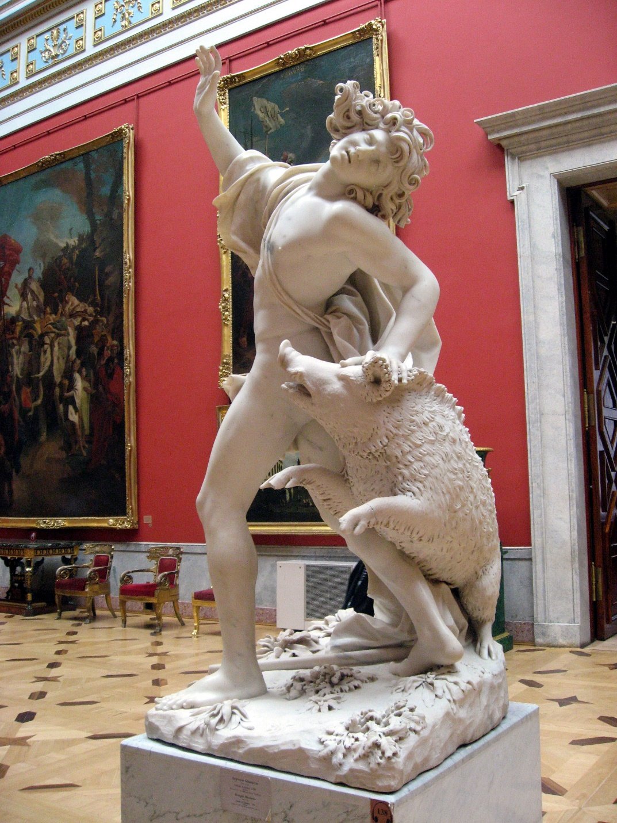
Figure 2. Giuseppe Mazzuoli, The Death of Adonis (Dying Adonis), c. 1709, marble. Source: Wikimedia Commons / Wikipedia (public domain).

Recognizing the extent to which the cultural memory has been shaped by this pattern of repetition over time is essential. Repetition over time fosters a sense of familiarity with the connection between death (mythic) and beauty (aesthetically). In contrast, the elegy unfolds temporally: “Month follow month with woe, and year wake year to sorrow” (St. XXI), emphasizing duration rather than suspension. Therefore, when the audience sees the dying Adonis, the audience does not perceive the myth as a break in the action of the narrative, but rather as an example of iconic imagery. Within the frame, the illuminated and neat body of the deceased Adonis is present. In Tempesta 1593, even the moment of attack is contained within compositional discipline; the wound event is narratively explicit, yet visually ordered. The sign of the wound identifies that Adonis is mortal; however, its form remains intact. As Clifford notes for Adonis imagery in funerary contexts, formal elements, including ‘framing devices,’ can prompt meditation on death while keeping identity and meaning in play rather than ‘collapsing’ into a single fixed reading (Clifford 2023, 108–109).
Adonais by Shelley also appears to follow the same tradition; its opening statement, “I weep for Adonais—he is dead!” (St. I) resembles a painting of mourning. By repeating grief, he is establishing a patterned mourning similar to that exhibited in Renaissance paintings. The first stanzas contain imagery similar to what was in Renaissance works, such as "pale flower," "dead leaves," dimmed light, etc. All of these represent vanitas art, as all of the flowers have died, and therefore represent passing youth.
Despite the fact that these images have some visual correlation, the natural images that Shelley uses lack fixity, in that the symbols of nature represent movement; leaves fall, flowers die, and seasons change. Therefore, Shelley used cycles instead of fixity. In contrast, the image of the corpse was always available to be viewed, while the image of Adonais eventually exceeds its artistic form. The most important difference in this regard has to do with time. Visual art freezes the mythical body in time, so that death is held at a single moment of time – departure, wounding, lament. Shelley’s elegy progresses with time; it develops and shifts through the stages of grief; it is not merely the dead body that the poem centres on. It begins as a lament and ends as a transcendental transformation of the body. Therefore, the poem’s body cannot be contained by the aestheticization of the body.
While European art converts mythic death into visual balance, Adonais de-stabilizes that visual balance from the inside out using language. The aestheticization of the dead body is acknowledged and, in some ways, echoed, but the aestheticized dead body cannot withstand the transformation of the body that takes place through Adonais. Shelley’s treatment of the relationship between form and mortality suggests that death, through the use of form, cannot be contained and, therefore, will need to be transformed through the use of language. Thus, the tension between containment and dissolution provides a foundation for the most radical act of Adonais, the continued loss of the visible body. If European painting memorialized Adonis by rendering him as a fixed image, Shelley will redeem him by relieving him of his image.

Shelley’s Textual Disruption of the Visual Body
In contrast to the intactness of the visible corporeality of Adonis in sculpture and engraving, Adonais gradually and consciously dismantles this embodiment. The process of that dismantling is gradual, not sudden. The initial invocation of the vision in the first stanza of the poem, “I weep for Adonais—he is dead!” (St. I) provides us a tangible body to mourn. The overtly rhetorical style of the stanza has an almost sculptural quality to it due to its stillness, whereas the command to “weep” is repetitive and therefore summons an audience akin to viewers positioned before a framed scene of mourning.
However, even in these opening stanzas of the poem, the body itself is curiously vague; there are no anatomical details or formal or compositional framing for the limbs or wounds. The absence of this information within the body is noteworthy and is a significant difference from the visual arts, in which artists portray the detail of flesh, gesture and surface. Therefore, the poem refuses to anchor death in a stable visual form. This is the basic dilemma of ekphrasis: a verbal representation ‘may refer to an object… but it can never bring its visual presence before us in the way pictures do;” as Mitchell puts it, “Words can ‘cite,’ but never ‘sight’ their objects” (Mitchell 1994, 2). In James Heffernan’s formulation, ekphrasis is “the verbal representation of visual representation,” a mode that inevitably stages rivalry between image and word (Heffernan 1993, 3). Adonais intensifies this rivalry by refusing to supply the visual density that engraving and sculpture demand. Instead, we encounter decomposition and psychic disturbance: “Like corpses in a charnel; fear and grief / Convulse us and consume us day by day” (St. XXXIX).
Predatory imagery at the moment of Stanza XXVIII initially appears to have recaptured the visual power of the imagery:
The herded wolves, bold only to pursue;
The obscene ravens, clamorous o’er the dead;
The vultures to the conqueror’s banner true
Who feed where desolation first has fed,
And whose wings rain contagion,—how they fled
This evokes a scene that could be painted on a canvas – dark sky, the body that has died there, and carrion birds – a compositional logic clearly visible in the engraved hunt of Tempesta 1593. The strong, kinetic, and even violent nature of the language used suggests an accumulation of images that have yet to be accumulated into a final image and painted onto the above canvas; yet the language does not consolidate itself into a fixed image. Mitchell calls this the persistence of “ekphrastic indifference” – the recognition that description cannot finally become depiction (Mitchell 1994, 2). The body itself never becomes visually present. In Tempesta, by contrast, the wounded body occupies the foreground as an object of sight; Shelley withholds this visual confirmation, allowing hostility to circulate without anchoring it to a stable corporeal form. The predatory images function only as allegories of hostility towards a cultural identity but do not provide a direct visual defense against the act of murder, thereby preventing the reader from directly reaching to the body to perceive its existence.
The more profound break with visual tradition in the poem occurs between the loss of the use of corporeal physicality and the use of space as an instrument to describe the transition. In Stanza XLII, Shelley states that:
He is made one with Nature: there is heard
His voice in all her music, from the moan
Of thunder, to the song of night’s sweet bird;
He is a presence to be felt and known
In darkness and in light, from herb and stone
The transition is elucidated by the disappearance of the corporeal body and the existence of the audible body. The idea of the presence of the body shifts from the land to the atmosphere. The body is no longer a figure positioned within landscape; Adonais is now dispersed into the landscape. The shift from land as setting to atmosphere as medium removes the physical body as an object and replaces it with an environmental presence. Adonais becomes “A presence to be felt and known / In darkness and in light” (St. XLII), a formulation that explicitly displaces sight with sensation. As such, the mythic male youth no longer is framed within the physical body; he is now unbounded.
The famous declaration caps the process: “He lives, he wakes—’tis Death is dead, not he” (St. XLI). This line overthrows the visual logic that iconographic tradition has established over centuries. In the visual arts, a powerful moment is the moment of the viewer seeing the fallen body of Adonis at the moment of his death. Shelley rejects this premise completely, instead making death itself the thing that dies (rather than presenting death in material form). Thus, the viewing of the corpse is no longer central to the function of the visual image. Therefore, what is represented is no longer the physical body, but the metaphysical concept of death itself.
The most remarkable transformation in the poem, however, is in the poem’s final redefinition of Adonais as something to be diffused rather than something to be formed: “He is a portion of the loveliness / Which once he made more lovely” (St. XLIII). The resistance of visualizing the phrase shows, again, that it is impossible to paint something abstract (e.g., "a portion of the loveliness") without reconstituting it into a figure (i.e., by making the physical body of the subject visible). Shelley has deliberately avoided the reconstitution of a morphological outline for Adonais. Consequently, he becomes relational in nature, more a part of a field of beauty than a distinct object in that field.
The total removal of the physical form of the body from the myth of Adonis represents Shelley’s dramatic break with the historical tradition of representing the male figure in an iconic and symbolic way. Whereas European art established the figure of Adonis as an iconic image to be contemplated, as exemplified in the suspended marble body of Mazzuoli 1709, Shelley reconfigures and releases the figure of Adonis from the static and immortalized form traditionally associated with visual art by presenting survival rather than preservation. The transformation of the figure of Adonis as a dead body into a living being marks the transition of the myth from an icon to a process of becoming. Shelley has created a total shift in the way that visual representation is understood, moving from seeing to knowing. As he declares, “He has outsoared the shadow of our night” (St. XL), a movement that replaces horizontal repose with vertical transcendence. A central question now becomes: What does the transformation of the dying young man represent? The poem will not let the myth continue to be confined to the corporeal body and thus will replace the image of the static body with an experience characterised by movement – light, sound, breath and cosmic expansion.
This removal of the visible body from the myth of Adonis also disrupts the power of visual representation itself. The myth that has historically relied upon form has now expanded beyond form and transformed into a reference of expression, and thus what has already been established and defined in painting and sculpture as an idea of permanence has been completely changed by Shelley. The disruption enacted by the text lays the groundwork for the Romantic reconceptualization of Adonis as a symbol of political and philosophical transformation rather than as a static aesthetic object, and thus the myth of Adonis is further separated from its origins in aesthetic experience.

From Erotic Icon to Political Symbol: The Romantic Reconfiguration
In the tradition of visual art, Adonis has largely been treated as an erotic figure. The story of his life describes male beauty as an errant thing transgressing the rules of time and space, and is told in the context of ancient Greek mythology. By so doing, the erotic potency of youth becomes neutralized by time – in much the same way that the male body, although idealized, was prepared to be looked upon by society’s males as youthful beauty, and, as an object of desire and contemplation even after death.
Shelley creates a new version of the myth of Adonis. In Adonais, the body of the youthful male is not distinguished as an object of beauty; while the body becomes the site of discourse of the cultural vulnerability of the youth. The death of Keats is not the mourning of his beautiful flesh but is an emotional response to the killing of a social voice. Here the elegy leans on what Clifford calls the way ideas about dying are “shaped by other people’s deaths and by models of dying proposed by art;” but Shelley redirects the model away from the beautiful corpse toward cultural and ideological hostility (Clifford 2023, 107). “What softer voice is hushed over the dead? / Athwart what brow is that dark mantle thrown?” (St. XXXV). The poem is constantly displacing the image of the material body toward historical reference and cultural context.
Shelley’s denunciation of the predatory elements that surround the poet (the wolves, ravens, and vultures) does not reference nature, but rather the hostility of ideology. The accusation becomes explicit: “Our Adonais has drunk poison—oh!” (St. XXXVI), shifting the wound from mythic animal violence to cultural aggression. These entities in nature exemplify the extreme of the ideologies that Shelley expresses, such as critical hostility to creativity, institutional repression of creativity, or cultural neglect of creativity. The death of the corpse is an experience, not of beauty but of vulnerability. Beauty thus experiences violence.
The process of converting a persecuted lineage of thinkers into a broader context has reached its apex through Shelley’s depiction:
“He is made one with the eternal thought
Of the great world…” (St. XXXVIII),
and later,
“The inheritors of unfulfilled renown
Rose from their thrones…” (St. XLVII).
The central idea is that Adonais is no longer a part of the pantheon of lustful deities, but rather a member of a historically based community of enlightened minds who are struggling against oppression and censorship. The transition from a sensual type of eroticism to that of the way those who struggle are portrayed intellectually takes place in the character and image of Adonais. Adonais will have been thus mixed with a genealogy of those who have historically resisted. “The inheritors of unfulfilled renown / Rose from their thrones” (St. XLV), situating him within a lineage of intellectual struggle.
Many Romantic writers have employed this type of recoding of classical mythology. As Owen Ware has recently shown, Romantic writers do not simply inherit classical myth; they reactivate it as a philosophical medium through which historical crisis becomes legible (Ware 2024, 18–22). Shelley’s Adonais performs precisely this reactivation, shifting Adonis from erotic spectacle to historical sign. Instead of treating ancient myth as mere ornamentation for contemporary concerns, these writers used myths to express anxiety around current social issues such as political oppression, censorship, exile and artistic marginalization. In Shelley’s work, Adonais serves as a representation of a writer whose literary career has been truncated because of the political climate of the time. Instead of viewing Adonais solely as wounded by the boar of myth, a wound traditionally framed and contained within visual form, we can also view this wound now from the perspective of being attacked due to the rejection by the audience and/or the institutional powers of the time.
The redefinition of the relationship between the physical body of the poet and the poetry arises from Shelley’s earlier setting aside of the visible body of the poet. The physical representation of the poet within visual tradition does not carry sufficient political weight to function within an insurrectionary context. The construct of the dematerialized Adonais of Shelley, on the other hand, creates a new way of utilizing a poet as a vehicle for expressing the political and historical impulses that cross boundaries. While Shelley places Keats within a struggle as opposed to a static representation when he writes about “the kings of thought / Who waged contention with their time’s decay” (St. XLVIII), the movement from horizontal repose to vertical ascent reinforces this change in the context of his creation of Adonais.
In earlier visual representations such as Tempesta’s engraved hunt, the body of Adonis remains contained within a framed landscape; in Shelley, the image of Adonais exists outside of landscape, having been released from aesthetic bondage. The motion of Adonais upward can be interpreted as more than a spiritual accomplishment; it can also be read as symbolic of an individual who no longer accepts being defined by their culture or the systems that produce cultural representations of humanity.
Shelley’s creation of Adonais can be understood in the context of Romanticism as political myth. The beautiful youth becomes the embodiment of innocence and the fragility of the artist, and yet, paradoxically, through the death of an artist, Shelley’s creation of Adonais demonstrates the ongoing, systemic violence perpetrated on creators by the societies in which they live. Shelley’s creation of Adonais represents a new myth and a change in the center of the myth from erotic loss to historical endurance. Adonais is not maintained in his status as an image; rather he is developed into a principle. While earlier visual traditions represented Adonis as an image of tragic sensuality, Shelley has reconstructed Adonais through his defiant image of continuity.
This Romantic reconfiguration prepares the final movement of the argument, that is the emergence of myth beyond image, beyond body, and beyond frame. It is a myth that resists visual fixation altogether.

Myth Beyond Image: Resistance to Visual Containment
By the closing stanzas of Adonais, the myth has been liberated from the circumstances that provided its historical visual framework. The youthful form that dominated earlier visual traditions – positioned, framed, and rendered static – has been removed from its position as representative. Instead, Shelley diffuses Adonais throughout the realm of being and makes it impossible to be contained by any frame of reference whatsoever.
The transformation is explicit in the lines: “He is a portion of the loveliness / Which once he made more lovely” (St. XLIII). A "portion of the loveliness," for example, does not have a form or surface that can be identified. Its absence of borders, edges, or volume also means it has neither boundaries nor limits. While paintings are based upon outline and sculptures are based upon mass, Shelley encourages us to let go of our historical conceptions of the two and allows us to abandon the mythological being as an actual referent, and regards him as a relative presence. Material-oriented image theory is clear about this point: “non-physical images are not part of the equation” because the image’s force depends on material resistance; precisely what Shelley suspends when Adonais becomes presence rather than body (van Gastel 2017/18, 78).
This diffusion intensifies in the poem’s cosmic imagery. Adonais becomes “a presence to be felt and known / In darkness and in light” (St. XLII). The use of presence replaces the use of sight as a means of understanding. It is also important to note that Shelley creates this diffusive experience of the myth through the use of light and darkness, which are at once contradictory. In addition, he changes the myth from a commodity to be gazed upon, into experiences of light and darkness that allow the reader to discover the beauty contained within them. This transformation from a commodity to be experienced also has an impact on how the reader will interpret this poem.
The art-historical implications of this transformation are profound. Visual representations, by virtue of their nature, have a contained aspect, which framework dictates wherein the body is to be framed; it creates a stable moment in time, and it therefore creates a stopping point to movement. In Tempesta, that containment is literal, as the etched border encloses the scene; in Mazzuoli, the marble mass fixes the fallen body within a sculptural perimeter. Shelley’s poem, lacking both frame and mass, disperses the figure beyond such limits. While the most dynamic Baroque compositions remain stable and confined to the canvas or marble, Adonais cannot be contained within any particular moment or pose; the poetry insists upon movement: ascension, transformation, recurring. Myth becomes temporal rather than spatial. Shelley makes this transformation explicit: “Life, like a dome of many-coloured glass, / Stains the white radiance of Eternity” (St. LII).
The notion of visual representation has been redefined by movement, causing the reconceptualization of aesthetic memory and the related content of the aesthetic image. The repetitiveness of the same image in the art of painting creates an established existence of conformism regarding a representation of mythological iconography (youthful hunter, grieving Venus, wounds); however, Adonais creates an expansive mythical figure through metaphysical means, indicating that “He lives, he wakes—’tis Death is dead, not he” (St. XLI). This mystical youthful figure will not be reincarnated as a body; instead, he will live as a force. As Georges Didi-Huberman explains in his discussion of “survival” (Nachleben) of images, all representations of figures are alive and exist only as traces when viewed across multiple media and their respective temporalities (Didi-Huberman 2002, 39-44). Therefore, the way in which Adonais has been disbursed by Shelley can be interpreted as poetic translation of surviving materiality. Paul de Man has stated that Shelley’s own figure cannot provide the same authority as any of the images contained within the poem and, consequently, repeatedly “disfigures” the perceived stability of visual form within Adonais (de Man 1979, 102). The disfigurement of visual representation, through repetition, is paralleled in the way that the authority of an image is demystified or dislocated by virtue of its repeated uses in different contexts.
Shelley’s display of defiance is more of a resistance toward stillness than a mere eroticization; furthermore, in the former poetic and visual traditions, the beauty of Adonis could represent the boundary between life and death. However, in Shelley’s vision, the limit of the boundary of death no longer limits the possibilities of his vision, as it thereby provides a means by which to realize the fragmentation of existence. Adonis is no longer represented as the remnants of a deceased body; with the death of Adonis, the mythology of Adonis does not close but creates uncertainty within these mythologies.
In bearing witness to these changes, Adonais reveals an intrinsic tension associated with the visual histories of myth, because the act of visual representation itself can result in a conversion of myth into ornamental, decorative art, thus separating art from its historical relevance. Shelley claims his authority over myth by conceptualizing his own myths as opposed to ornamenting his understanding of myth. He therefore reclaims the symbol value that existed in myth, while removing the bodily fixity through which the gaze stabilizes symbolic order.
In the above instance, Shelley is not abandoning the visual tradition; he is changing it. The poem also acknowledges the collective memory manifested in iconographic history, some of which relate to the realisation achieved through centuries of sculpting human, painted flesh; the poem achieves an alternative experience of the aesthetics of the iconic image distinct from iconographic tradition. Therefore, the achievement of a new image in (or through) language, by which Shelley creates Adonais, is not one of aesthetic objects, but of cultural endurance exemplified by experience that exceeds visual representations.
The progression from the engraved hunt of Tempesta and the sculpted marble body of Mazzuoli to Shelley’s atmospheric imagery represents not only a shift of medium but also a shift in the ontology of myth. Myth, transformed from a visible body to a pervasive force, will continue to exist as an image released from marble and canvas and instead inhabit the unstable generative space of poetic imagination.

Conclusion
Once the visual genealogy of Adonis has been traced from classical sculpture through engraved narrative and into marble monument, we can see just how stable the aestheticization of mythic death is within European art. Across medium and period, the youthful body has remained the focal point of mythic death: idealized, contained, and preserved within a framework that represents visual harmony. Whether contained within the engraved lines of Tempesta 1593 or stabilized in the marble surface of Mazzuoli 1709, the dying body remains visually legible and materially secured. In both cases, the wound is presented as visible and bounded, never dissolving into the formlessness that Shelley later permits. Mortality is presented in a manner that is contemplative and not destructive. The dying god becomes a beautiful object of contemplation.
Shelley’s use of the name ‘Adonais’ continues the artistic tradition of iconography, but at the same time, he illustrates how that tradition is restricted. More specifically, Shelley explores the limitations and abilities of the images associated with death; that is, artworks represent possible ways to think along with analogies of mortality, but they also illustrate how those modes of thought are governed by culture (Clifford 2023, 107–108). While the visual arts are capable of erecting monuments to the body of the dead god, Shelley’s task is to deconstruct said body. While Shelley’s elegy begins in expected expressive forms of mourning and lamentation, it consistently and repeatedly refuses to establish stable representations of the corpse. Instead, it breaks up representations of the body into luminous forms of sound, light, and presence, as the elegy progresses from representations of the body to representations of the atmosphere around the body, and therefore breaks away from uses of visual forms of representation.
Adonis, as a beautiful eroticized youth, has been dematerialized in Shelley’s poem so as to allow for a re-figuring of the boy as a political/historical symbol through the poem’s counter-discourse of immortality: There are two historic types of immortality; in the past, mankind lived on through presentation in marble or framed pictures; in the present, mankind will continue to exist through myth; or, through myth – the ability of myth to exceed the immanent limits of the physical world through language. Shelley effectively transforms this once beautiful, fragile boy into something that now signifies the survival of culture, as a result of the abuses done to it, through his romantic re-imagining of the myth of Adonis; thus, the myth will no longer be limited to being displayed exclusively through pictures or statuary, but will now be a living medium for the affirmation of one’s opposition to be forgotten.
As an extension of the above argument, one can assert that art history will undergo a significant transformation as a result of this transformation. A move away from pictoriality represents a disruption of pictorial containment. Pictorial representation has relied on frames, as well as on limits, for the purposes of arresting the viewer’s gaze. However, Shelley disrupts this reliance on pictoriality. The myth cannot be confined to a sole pose or to the limitations of all previous visual representations: it now exists in space/time and metaphysical expansion beyond the single image that defined its original form. In this sense, Shelley’s poem demonstrates how literary language can reactivate inherited visual symbols, transforming aesthetic memory into a continuing cultural process. Prior pictorial traditions have defined the myth as being beautiful in form, however, Shelley liberates the myth from its previous beautiful form into the expanded time and metaphysics of the myth.
Adonis is an important example of a transitional period in the transition of mythic imagery. Adonais not only attests to an artistic heritage spanning generations, but it also provides a critique of the cultural and historical assumptions upon which all this historical imagery is based. Although the young body that originally gave rise to the myth is no longer centre stage in the mythological image, it is now viewed as an integral part of the totality of Adonis’ being, "a portion of the loveliness / Which once he made more lovely." It cannot be recreated graphically through representation; Adonis lives on as a force rather than as a material object or fixed reality within the space of historical time. It endures cosmically: “The soul of Adonais, like a star, / Beacons from the abode where the Eternal are” (St. LV).
Shelley’s work on the mythological tradition of Adonis does not erase or downplay the existing visual representations of Adonis but instead adds another way to understand it. He takes the mythology surrounding him as material and measurable and changes that understanding into one that is abstract, divine and transcendent. Although the myth can be adequately represented visually in a photograph, Shelley frees us from being restrained by the visual representation of Adonis in our imaginative experience through the poem Adonais, leading us to the conclusion that there are numerous interpretations of Adonis’s totality that can exist beyond our contemporary photographic visual representations of him. “He lives, he wakes—’tis Death is dead, not he” (St. XLI).

References
Clifford, Brandon. 2023. “Thanatological Viewing and the Framing of Death in Visual Culture.” Journal of Visual Culture 22 (1): 107–109.
de Man, Paul. 1979. “Shelley Disfigured.” In The Rhetoric of Romanticism. New York: Columbia University Press.
Didi-Huberman, Georges. 2002. The Surviving Image: Phantoms of Time and Time of Phantoms. Translated by Harvey Mendelsohn. University Park: Pennsylvania State University Press.
Frye, Northrop. 1957. Anatomy of Criticism: Four Essays. Princeton: Princeton University Press.
Griffiths, Anthony. 1996. Prints and Printmaking: An Introduction to the History and Techniques. London: British Museum Press.
Heffernan, James A. W. 1993. Museum of Words: The Poetics of Ekphrasis from Homer to Ashbery. Chicago: University of Chicago Press.
Mazzuoli, Giuseppe. c. 1709. The Death of Adonis (Dying Adonis). Marble sculpture. Image available via Wikipedia (public domain): https://en.wikipedia.org/wiki/The_Death_of_Adonis_(Mazzuoli)
Mitchell, W. J. T. 1994. Picture Theory: Essays on Verbal and Visual Representation. Chicago: University of Chicago Press.
Panofsky, Erwin. 1939. Studies in Iconology. Oxford: Oxford University Press.
Potts, Alex. 2000. The Sculptural Imagination: Figurative, Modernist, Minimalist. New Haven: Yale University Press.
Shelley, Percy Bysshe. 2002. Adonais. In Shelley’s Poetry and Prose, edited by Donald H. Reiman and Neil Fraistat. New York: Norton.
Tempesta, Antonio. 1593. The Death of Adonis. Engraving. Image available via Wikimedia Commons (public domain): https://commons.wikimedia.org/wiki/File:Antonio_Tempesta_-_The_Death_of_Adonis_-_WGA22049.jpg
van Gastel, Joris. 2017/18. “Materiality and the Agency of Images.” Journal of Art Historiography 17/18: 78.
Ware, Owen. 2024. Return of the Gods: Mythology in Romantic Philosophy and Literature. Oxford: Oxford University Press.
Wittkower, Rudolf. 1958. Art and Architecture in Italy 1600–1750. Harmondsworth: Penguin.
Woodward, Richard. 2007. “Ivins and the Repeatable Image.” Print Quarterly 24 (4): 607.

