Personal Financial Resilience under Socioeconomic Crises in an Emerging Economy: Evidence from Nigeria
Akinyede, Oyinlola Morounfoluwa (PhD)
ORCID ID: 0000-0001-6587-0531
+2347069328922
foluesan@gmail.com, akinyedeo@run.edu.ng

ADEYEMO Ojo Stephen,
ORCID: 0009-0002-3709-3186
stephenadeyemo36@gmail.com

ATOLAGBE Lanre Aderemi
ORCID: 0009-0008-2136-6040
laatolagbe@gmail.com

ADEWUYI Diekola Isiaka
ORCID: 0009-0009-7887-0560
adewuyione@gmail.com

ALADEJEBI Michael Olukayode
ORCID: 0009-0000-5547-7912
micholad7@gmail.com

IKHU-OMOREGBE, Sunday
ORCID: 0009-0006-6134-6664
sundayikhuomoregbe@gmail.com

Department of Financial Studies, Redeemer’s University, Ede Osun State, Nigeria.

Abstract
This study aims to describe the financial crises caused by financial and non-financial factors. It describes the financial and non-financial antecedents. The study examines the socioeconomic factors and personal financial crises by applying a quantitative survey of 430 individuals and employing statistical analysis, including PLS-SEM. The study examines the impact of income and job loss, poor health, poverty, and inequality on mobilisation strategies for emergency savings, debt repayment, and the use of social support. It shows that health-related financial crises, income volatility, and sudden financial shocks impact a person's financial resilience. As a result, behavioural changes in social behaviour have to be made to finance social behaviour. Instead of being directly affected, the authors explain that inequality and poverty do lead to a focus on the support mechanisms. It has been established that a person's ability to bounce back from poverty and economic shocks is rooted in strengthening social behavioural finance. This underscores the need for a financial resilience approach. People need to be financially balanced in a way that is consistent with their social support needs. The authors conclude that states need to combine financial systems and social support systems. This will be useful to individuals in adapting to and economically recovering from shocks.
Keywords: Financial Resilience, Socio-Economic Crises, Income Instability, Health Crises, Social Support Networks, Economic Shocks, Social Support Networks
JEL codes: D14, G51, G53, I31

1. INTRODUCTION
Socioeconomic crises disrupt the global economy, create uncertainty, and put not only people but also the global economy under extreme financial strain. These pressures have been evident worldwide during major downturns such as the 2008 financial crisis and the COVID-19 pandemic (Kaftan et al., 2023). Crises led to reduced economic activity, increased unemployment, and inflation, as well as reduced production. Their effects are usually lopsided; low-income and vulnerable households bear the most significant pressure, often due to unstable earnings, limited savings capacity, and the rising cost of living (French et al., 2021).
In this sense, personal financial resilience has become an important conceptualisation for explaining how people withstand and recover from economic shocks. According to Setyorini et al (2021), financial resilience is defined as "the ability to withstand disruptions, manage resources effectively in a sustainable manner, and maintain financial stability in adverse conditions". This ability involves strategic financial behaviour: savings, budgeting, and credit management, while also requiring the helping hand of the given social networks, community support, and government intervention, like welfare programs.
To enhance financial resilience, an integrated approach that considers both financial and non-financial factors is required. The backdrop evidence of the 2008 economic crunch and the COVID-19 crisis underscores the need for immediate policy and mechanism establishment to support citizens' efforts to adapt to socio-economic shocks (Szyja, 2025; Afolabi et al., 2023a).
The economics literature has yet to provide sufficient empirical evidence demonstrating how specific socio-economic crises can impact personal financial resilience; this has only increased the interest of scholars from different disciplines in the subject. Hence, this study examines how poverty, health shocks, and income/job instability affect individuals’ financial resilience.
Objectives:
- To analyse the influence of poverty and income inequality on personal financial resilience.
- To examine the effect of access to healthcare and basic needs on personal financial resilience.
- To assess the impact of income level and employment stability on personal financial resilience.

2. LITERATURE REVIEW
2.1 Theoretical Review
A Vulnerability Theory lens offers a clear structural view of how macro-level socioeconomic crises unfold into distinct micro-level financial outcomes. This theory, which is based on the research of hazards and development economics, views vulnerability as the result of a person, or a household, being external, having an external shock, an inherent sensitivity to the external shock, and, importantly, having an ability to adjust (Adger, 2006; Turner et al., 2003). In the Nigerian context, this means that events such as the 2023 removal of the fuel subsidy and the currency devaluation are not the same type of shock. Instead, the impact of such events depends on prior socioeconomic position. Most recently, this inequality was documented by Oluwatobi et al. (2022) in Nigeria, which showed that wage-labour and transport-related households are more inflation-sensitive than public-sector wage-employed workers. Financial resilience, from this view, is the positive outcome of adaptive capacity, the resources and strategies employed to counteract negative impacts. In this respect, vulnerability theory shifts the analytical focus from the crisis event to the underlying sources that explain why some are devastated, and others endure.
Bourdieu's Theory of Capital offers a complementary and sophisticated sociological explanation of the composition and activation of this adaptive capacity. Bourdieu accentuates that individuals manoeuvre social space with varying degrees of capital: economic (money, assets), cultural (skills, knowledge), social (connections, obligations), and symbolic (prestige, power) (Bourdieu, 1986). During a crisis, financial resilience becomes a process of dynamic capital conversion and deployment. Obasaju et al. (2023) show that, during recent contractions of Nigeria’s economy, middle-class urbanites employed cultural capital (digital skills) to diversify income on internet-based economic opportunities, while a significant number of informal workers tapped into thick social capital, family networks, and communal savings (esusu) for liquidity free of interest. The use of this perspective is important for transcending purely economic considerations. It clarifies why, in a given context, two households with the same income may exhibit very different resilience: one may have social capital that facilitates access to informal credit and cultural capital that enables adaptive livelihood strategies, while the other, with the same income, is capital-poor and consequently more at risk. The combination of Bourdieu's and Vulnerability Theory is invaluable in this regard, because the structuring of exposure, as articulated by the latter, is complemented by the resourceful, agentic responses of the former.
2.2 Empirical Review
The socioeconomic crises continually motivate new research into personal financial resilience. The groundwork for resilience is defined in Hallegatte (2014). It distinguishes between micro- and macroeconomic resilience in the context of disasters. The author categorises macroeconomic resilience into two types. The first is referred to as immediate, and the second as dynamic. Immediate resilience refers to mitigating production losses, whilst dynamic resilience concerns the economy's ability to recover over time. Microeconomic resilience, in contrast, refers to mechanisms that mitigate households' vulnerability and is primarily defined by income, savings, credit access, and social protection frameworks, enabling households to survive financial shocks (García Mata & Zerón Félix, 2022). The financial resilience most abundant in the COVID era is most pronounced, as Brasil et al. (2024) note that without it, individuals were at significant financial risk during the pandemic. Furthermore, Khetan et al. (2022) documented the effects of the COVID-19 pandemic on global financial resilience and noted considerable differences in resilience by income level. It is observed that in less developed countries, responses were far greater, attesting to the need for a specific focus on resilience to build income levels in response to the inequalities created by socioeconomic crises.

Given the current situation, the economic recovery goals from the relief efforts should be balanced with funding resilience in most cases. (AbrantesBraga & VeludodeOliveira, 2019).

Oke & Akinyede (2024) in the article "Financial Inclusion in Income and Employment in the Post-COVID Era in Nigeria" relied on primary data from 439 respondents and examined the effect of (a) access to financial services; (b) transaction costs, and (c) barriers to financial services using Structural Equation Models (SEMs) and the Smart-PLS tool in economic outcomes. Among the various economic outcomes, the authors concluded that greater access and lower costs are economically positive (leading to greater employment and income) and that barriers to financial services affect employment, not income.

Liu and Chen (2023) developed a model that integrates financial assets, accessibility of financial services, financial literacy, and social capital. The study underscored that levels of financial resilience have statistically significant relationships with the socio-economic variables income, education, and employment status. Hence, there is a need for targeted efforts to bolster financial resilience in developing countries.

Salignac et al. (2019) categorised resilience levels such that high resilience could be interpreted as the presence of intricate systems of variables that affect financial resilience.

The importance of a more tailored construct of financial resilience implies that the ability to access financial means is not, by itself, enabling. Means should also be of the right quality and terms, and in conditions that empower individuals to manage their situations. Salignac et al. (2022) argued that countries that enhance their inclusive policies can combat poverty and stimulate economic growth, and this was the basis of their study on how financial inclusion fosters resilience in economically peripheral regions, geographically and financially.

That said, Martin et al. (2020) expand their research to the regional level of financial resilience, thereby stressing the importance of a more precise grasp of the local economy's capacity to absorb external shocks. For this reason, Bruneckiene et al. (2019) developed the Resilio model and the Resindicis index, which operationalise the resilience measure from the national to the city scale. The ability of customised quantitative metrics to pinpoint and articulate resilience policy to address gaps has been stressed. For instance, McKnight and Rucci (2020) identified cross-country differences in resilience, especially at the household level, particularly among households with low savings or high debt. So did Hamid et al.

(2023) approximated and mentioned that strategic financial management and investment on the ground may enhance financial resilience.

The role of financial education on financial prudence has also been explored. Setyorini et al. (2021) indicate that financial literacy and planning are the most important channels through which household financial resilience is strengthened, as it manifests in sound financial conduct. Lusardi et al. (2021) corroborated this, as financial vulnerability in poverty-stricken black households is in part the result of insufficient financial literacy. This indicates that the quality of financial education can empower people to respond effectively to the economic crisis.

The impact of other non-financial variables, such as cognitive skills and psychological resilience, on financial resilience has also been explored by Mundi and Vashisht (2023). They posit that cognitive skills and demographic attributes, such as gender and education, are important in defining financial resilience at the individual level among millennials and single parents. Accordingly, the study's findings proposed policies to enhance financial literacy and shield vulnerable populations from the abusive use of sophisticated financial instruments and the ensnarement of debt.

It is also closely related to the concept of personal financial management behaviours described by Goyal et al. (2021). They, however, posited that PFMB notably drove financial satisfaction, resilience, and well-being.

Multiple factors contribute to PFMB, including demographics, psychology, and socioeconomic status. It is also proposed that improving PBMF also improves financial resilience. Johnston et al. (2021) noted self-efficacy as one of the noncognitive skills, which, according to their findings, is significant for psychological resilience. They also emphasised that financial resources are not the only factors that guarantee resilience.

In the financial resiliency theory, Pandin et al. (2023) introduced adaptive and transformative financial strategies. They emphasise the importance of temporality and flexibility in household financial management, particularly during crises. The outcome demonstrated that households must re-strategise their finances to maintain consistency during economic disruptions. It also reaffirmed the fundamental, intricate, and dynamic interrelation in the triad or system of financial resilience, encompassing financial, psychological, and social elements.

Based on the literature review, the need to develop global resilience strategies is clear. Enabling individuals and communities to counter the socioeconomic crises, both in financial and nonfinancial aspects, is of utmost importance.

PERSONAL FINANCIAL RESILIENCE
Social Support Network (SSN),

Low Debt Level (LDL),

Emergency Savings (ES).

Poverty and Inequality (PI),
SOCIO-ECONOMIC CRISIS
Health Crisis (HC),

Income and Job Instability (IJI).

Figure 1: Conceptual Framework for the Study Variables

3. METHODOLOGY
3.1. Introduction

This framework analyses the individual's ability to endure and bounce back from the effects of financial loss, and the related economic determinants of adjusting income, job loss, inflation, and recession. This chapter describes the research design, research questions, and hypotheses, sampling rationale, data collection, analysis procedures, and ethical framework of the study.

A quantitative research design was adopted to analyse the interplay among the various dimensions of the socio-economy and the factors of financial resilience. This particular approach was chosen for its ability to aid in discovering and establishing relationships and, thus, in providing an understanding of the phenomenon in question. The study aims to provide sufficient evidence to answer the question of which factors influence financial resilience through structured data collection and statistical analysis.

The respondents in the study comprised adults aged 18 and above, drawn from a diverse adult population across various socioeconomic and geographical backgrounds. To ensure fair representation of respondents' income levels, employment types, and rural-urban dichotomy, stratified sampling was employed. To achieve statistical significance in the study, Cochran’s formula was used to determine the required sample size; thus, a minimum sample of 385 respondents was obtained, even if not all respondents responded.

The study used two sampling methods: simple random sampling and snowball sampling to reach Nigerian Adults (working class), including employees, employers, and the self-employed. This type of sampling captures the most remarkable diversity across varying levels of financial resilience.

Validation tools include the Financial Resilience Scale (FRS) and financial literacy assessments. The survey contained four major components: demographics, phenomenological experiences, financial resilience, and financial literacy. These components included Age, Gender, Level of Education, Income, Employment, Location, Budgeting, Saving, and Emergency Preparedness. Surveys were administered in both digital and printed formats. To enhance diversity and access, the survey was administered in person, via email, through social media, and on an online research panel.

3.2 Estimation Techniques

For inferential analysis, the author has chosen partial least squares structural equation modelling (PLSSEM). PLSSEM is beneficial for modelling intricate relationships in situations where the data are in an exploratory, non-normal format or in small sample sizes. In addition, PLSSEM allows the simultaneous evaluation of the measurement and structural models. These features support the study's analytical objectives, making it a strong candidate as a technique.

The model evaluation was conducted using standardised factor loadings, Cronbach's alpha, composite reliability, and average variance extracted. Constructs' discriminant validity was confirmed using the Fornell-Larcker and Heterotrait-Monotrait (HTMT) methodologies. Smart PLS 4 was used to run the computations.

3.3 Ethical Considerations

The study adhered to the ethical guidelines for research involving human subjects. Ethical clearance was granted, participation was voluntary, and the respondents signed an informed consent form. Confidentiality and anonymity were strictly maintained, as the information is stored in a secure facility for research purposes only. There was only a minimal conceivable risk, either in the physical, psychological, or social aspects, that may have arisen during the survey design. This has firmly established the researchers' commitment to protecting participants' rights and welfare.

3.4 Model Specification

The model presents personal financial resilience as dependent upon the socioeconomic crisis factors:

Personal Financial Resilience = f(Socio-Economic Crisis)

Personal financial resilience is operationalised by using three indicators: Social Support Network (SSN), Low Debt Level (LDL), and Emergency Savings (ES). The main socioeconomic crisis variables are Poverty and Inequality (PI), Health Crisis (HC), and Income and Job Instability (IJI). Therefore, the following empirical models will be specified based on these constructs:

SSN = β₀ + β₁PI + β₂HC + β₃IJI + e₁
LDL = µ₀ + µ₁PI + µ₂HC + µ₃IJI + e₂
ES = α₀ + α₁PI + α₂HC + α₃IJI + e₃

Where:
β₀, μ₀, and α₀ represent the intercepts,
β₁–β₃, μ₁–μ₃, and α₁–α₃ are the regression coefficients for the explanatory variables, and
e₁–e₃ denote the respective error terms.

SEM stands for Structural Equation Modelling, which concerns economic models and the interrelationships among the construction variables, as shown in the SEM framework in Figure 2.

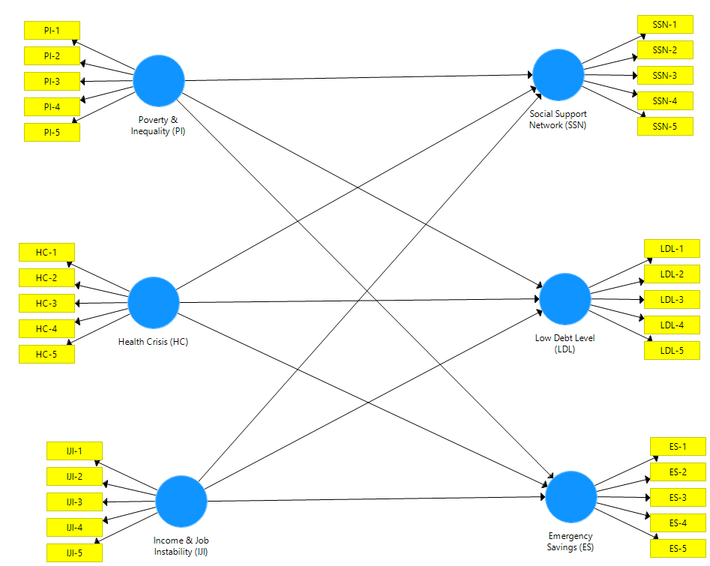
Figure 2: SEM Framework for the Study Variables
3.5 Approach to Estimation
Descriptive analysis uses frequency distribution tables and percentages. For inferential analysis, the technique used was Partial Least Squares Structural Equation Modelling (PLS-SEM). Model assessment utilised standardised factor loadings, Cronbach's alpha, composite reliability, and average variance extracted. Further, the discriminant validity of construct variables was evaluated using the Fornell-Larcker and Heterotrait-Monotrait (HTMT) criteria. Computation was done using Smart-PLS 4.
4. RESULTS AND DISCUSSIONS
4.1 Model Assessment
The results of the analysis of measurement items are presented in Table 1. Since the recommended criterion for acceptable factor loading is above 0.6, only such items which satisfied this criterion have been considered for further path analysis. This means that the chosen indicators can adequately measure their respective constructs of interest. The reliability of the constructs exceeded the minimum threshold of 70%, as confirmed by multiple methods (Cronbach's Alpha, rho_A, and Composite Reliability). This suggests that all items are reliable for measuring their respective constructs together.
Average Variance Extracted (AVE) was also used to confirm convergent validity and to assess the extent to which the measurement items of the constructs are related to one another. The cutoff is set at 0.5, and as shown in Table 1, the AVEs for all constructs exceed the cutoff.

Table 1: Model Assessment Parameters
Constructs | Items | Loadings | Cronbach's Alpha | rho_A | Composite Reliability | Average Variance Extracted (AVE)
Emergency Savings (ES) | ES1 | 0.725 | 0.846 | 0.870 | 0.889 | 0.618
Emergency Savings (ES) | ES2 | 0.755
Emergency Savings (ES) | ES3 | 0.862
Emergency Savings (ES) | ES4 | 0.788
Emergency Savings (ES) | ES5 | 0.793
Health Crisis (HC)_ | HC1 | 0.684 | 0.725 | 0.728 | 0.829 | 0.549
Health Crisis (HC)_ | HC3 | 0.766
Health Crisis (HC)_ | HC4 | 0.791
Health Crisis (HC)_ | HC5 | 0.720
Income & Job Instability (IJI) | IJI1 | 0.759 | 0.765 | 0.765 | 0.850 | 0.587
Income & Job Instability (IJI) | IJI2 | 0.793
Income & Job Instability (IJI) | IJI3 | 0.784
Income & Job Instability (IJI) | IJI4 | 0.726
Low Debt Level (LDL) | LDL1 | 0.631 | 0.759 | 0.776 | 0.836 | 0.506
Low Debt Level (LDL) | LDL2 | 0.767
Low Debt Level (LDL) | LDL3 | 0.763
Low Debt Level (LDL) | LDL4 | 0.712
Low Debt Level (LDL) | LDL5 | 0.675
Poverty & Inequality (PI) | PI2 | 0.711 | 0.749 | 0.793 | 0.827 | 0.548
Poverty & Inequality (PI) | PI3 | 0.626
Poverty & Inequality (PI) | PI4 | 0.746
Poverty & Inequality (PI) | PI5 | 0.859
Social Support Network (SSN) | SSN1 | 0.730 | 0.774 | 0.776 | 0.847 | 0.525
Social Support Network (SSN) | SSN2 | 0.791
Social Support Network (SSN) | SSN3 | 0.708
Social Support Network (SSN) | SSN4 | 0.699
Social Support Network (SSN) | SSN5 | 0.692
Source: Smart-PLS 4 (2025)
4.2 Discriminant Validity
The study adopted the Fornell, Larcker, and Heterotrait Monotrait (HTMT) criteria developed from the determination of the discriminant validity of the construct variables and presented in Tables 2 and 3.
The Fornell-Larcker criterion requires that the square root of the AVEs (diagonal and bolded values) must be greater than the inter-construct correlations (all other values). According to Table 3, this condition exists. Moreover, all HTMT measures shown in Table 4 do not exceed the maximum cap of 0.9, thereby confirming that the discriminant validity problem does not arise among the construct variables.
Table 2: Fornell-Larcker Criteria
 | Emergency Savings (ES) | Health Crisis (HC) | Income & Job Instability (IJI) | Low Debt Level (LDL) | Poverty & Inequality (PI) | Social Support Network (SSN)
Emergency Savings (ES) | 0.786
Health Crisis (HC)_ | 0.312 | 0.741
Income & Job Instability (IJI) | 0.344 | 0.676 | 0.766
Low Debt Level (LDL) | 0.607 | 0.461 | 0.542 | 0.712
Poverty & Inequality (PI) | 0.172 | 0.590 | 0.527 | 0.289 | 0.740
Social Support Network (SSN) | 0.582 | 0.467 | 0.436 | 0.641 | 0.222 | 0.725
Source: Smart PLS 4 (2025)

Table 3: Heterotrait Monotrait Ratios
 | Emergency Savings (ES) | Health Crisis (HC) | Income & Job Instability (IJI) | Low Debt Level (LDL) | Poverty & Inequality (PI) | Social Support Network (SSN)
Emergency Savings (ES)
Health Crisis (HC) | 0.390
Income & Job Instability (IJI) | 0.411 | 0.812
Low Debt Level (LDL) | 0.786 | 0.608 | 0.687
Poverty & Inequality (PI) | 0.189 | 0.770 | 0.672 | 0.324
Social Support Network (SSN) | 0.7300 | 0.620 | 0.566 | 0.871 | 0.260
Source: Smart-PLS 4 (2025)
4.4 Path Analysis
Goodness-of-fit criteria for SEM are depicted in Table 4. According to the SRMR, the model has good resolution at 0.078, as it should not exceed 0.08. Besides that, there are mixed indications for model fit indices. Although the value d_ULS=2.28 is far above the acceptable threshold set by HI95=1.74, the value d_G=0.568 is below it, qualifying within the required threshold of HI95=1.27. Furthermore, the NFI is approaching 1 for the goodness-of-fit criterion. The overall fit of the structural model is therefore assessed as good.
Table 4: Model Fit
Criteria | Saturated Model | Benchmark
SRMR | 0.078 | < 0.08
d_ULS | 2.28 | <HI₉₅=1.74
d_G | 0.568 | <HI₉₅=1.27
ChiSquare | 1308.23
NFI | 0.715 | Approx = 1
Source: Smart-PLS 4 (2025)

4.5 Structural Model
Figure 3 shows the hypothesised paths in this study. This includes the t-statistics of the regression results of the path relationships.
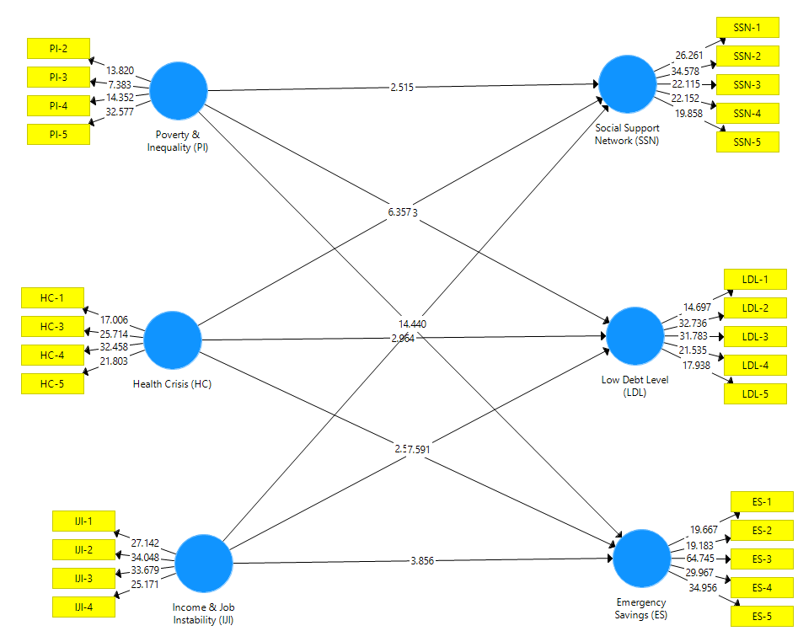
Figure 3: Path Diagram

4.6 Hypotheses Testing
Table 5: Path Estimates
Paths | Beta | T-Statistics | P-values | Decision on Ho
Health Crisis (HC)_ > Emergency Savings (ES) | 0.177 | 2.581 | 0.01 | Reject
Health Crisis (HC)_ > Low Debt Level (LDL) | 0.20 | 2.964 | 0.003 | Reject
Health Crisis (HC)_ > Social Support Network (SSN) | 0.373 | 6.357 | 0.00 | Reject
Income & Job Instability (IJI) > Emergency Savings (ES) | 0.262 | 3.856 | 0.00 | Reject
Income & Job Instability (IJI) > Low Debt Level (LDL) | 0.438 | 7.591 | 0.00 | Reject
Income & Job Instability (IJI) > Social Support Network (SSN) | 0.254 | 4.44 | 0.00 | Reject
Poverty & Inequality (PI) > Emergency Savings (ES) | 0.07 | 1.099 | 0.272 | Accept
Poverty & Inequality (PI) > Low Debt Level (LDL) | 0.06 | 1.083 | 0.279 | Accept
Poverty & Inequality (PI) > Social Support Network (SSN) | 0.132 | 2.515 | 0.012 | Reject
Source: Smart-PLS 4 (2025)
4.6.1 Results
Table 5 summarises the t-statistics and p-values for the path coefficients. In the COVID Health Crisis, the positive path coefficient (β = 0.177) and the accompanying t-statistic (t = 2.581) attain significance at the 5% level (p = 0.01). Thus, accepting the alternative hypothesis, health crises were found to have a significant effect on emergency savings. Likewise, the path from Health Crisis to Low Debt Level is positive (β = 0.20), and the t-statistic indicates a significant effect of health crises at the 0.003 significance threshold (t = 2.964; p = 0.003). The coefficient linking Health Crisis to Social Support Network is positive (β = 0.373) and significant (t = 6.357; p = 0.00), indicating a strong influence of health crises on social support networks.
Furthermore, the coefficient from Income & Job Instability to Emergency Savings is positive (β = 0.262), and the t-statistic is significant (t = 3.856; p = 0.00), indicating a direct, significant correlation. Such direct and significant results are again corroborated when we analyse the paths from Income & Job Instability to Low Debt Level (β = 0.438) and Social Support Network (β = 0.254). T-tests indicate that these measures are significant at the 5% level (p < 0.05), thus rejecting the null hypothesis that income and job instability do not affect low levels of debt and social support networks.
Conversely, the coefficients from Poverty & Inequality to Emergency Savings (β = 0.07), Low Debt Level (β = 0.06), and Social Support Network (β = 0.132) yield adverse outcomes. The t-statistic analyses for Emergency Savings (t = 1.099; p = 0.272) and Low Debt Level (t = 1.083; p = 0.279) at the 5% level are not statistically significant. Hence, the null hypotheses for these paths cannot be rejected, implying that poverty and inequality do not have any significant effect on emergency savings or low debt levels. However, the Social Support Network yields significant t-statistics (t = 2.515; p = 0.012), indicating that poverty and inequality significantly influence social support networks.
4.6.2 Discussion
Results from our study establish that health crises are strong determinants of personal financial resilience, exerting significant effects on emergency savings, low debt levels, and social support networks. Worldwide, these findings harmonise well with the assertion that health-related shocks, sudden illness, or pandemics do bring about severe interruptions in terms of household financial stability while reinforcing the adaptive coping strategies that are so externally stimulated in this manner (Jalili et al, 2025; Kumar et al., 2021; Banerjee & Duflo, 2019). Research conducted during health crises in regions such as South Asia and Sub-Saharan Africa shows that households spend (or liquidate) their savings, borrow from informal lenders, and tap their social networks (i.e., family and friends) to manage the new financial risks (Okomu et al., 2021). This suggests that social capital may mitigate the effect of health crises on financial fragility.

The same income and job instability that characterised financial resilience and influenced savings, debt, and social borrowing also described turbulence in the labour market and inconsistencies in income flows in Nigeria and emerging markets. Such conditions have been described as debilitating to households' ability to protect themselves from economic shocks (Afolabi et al., 2023b; Osabohien et al., 2020). There is global evidence that labour market insecurity leads to less financial planning, lower savings, and increased community participation. Therefore, the importance of resilience in having uninterrupted income becomes amplified (OECD, 2020; Furman et al., 2018). The other side discusses significant but nearly insignificant deleterious effects of poverty and the unequal distribution of wealth on emergency savings and low debt levels, implying that households chronically deprived socioeconomically may lack the financial muscle to rely on other means of support in times of crisis.
Such consequences have been observed in studies in LMICs operating in resource-poor contexts, where resource-poor households exhibit low resilience to economic shocks even though their potential is supported by social networks (DemirgüçKunt et al., 2020; World Bank, 2021). In this study, poverty and inequality exerted a substantial effect on social support, reinforcing the idea that the more marginalised a population is, the more it tends to rely on community ties and informal support to cope with adverse conditions (Hill et al., 2020). Their overall findings suggest that acute, short-term shocks, such as health crises and income losses, affect personal financial resilience much more directly and seriously than do structural, long-term shocks, namely poverty and inequality. Such differentiation confirms a significant finding from the literature worldwide: while structures of disadvantage limit financial capacity, acute shocks prompt immediate behavioural changes and decision-making that rely on the social setup (Thu et al., 2022; Bufe et al., 2021). The findings underline the importance of combining financial, social, and policy strategies to strengthen the resilience of the most vulnerable to health and economic shocks.
4.7 Limitations and Future Research
It is paradoxical and painful to state the obvious, only to then acknowledge the known limitations. Measuring the impact of socioeconomic crises on individual financial resilience is cross-sectional in design, capturing financial resilience at a single point in time and making no provision for causal inference or longitudinal observations of behavioural changes. As the responses were self-reported, the dataset is subject to response, social desirability, and self-presentation biases. Within the specific study population, the findings may support other studies at the intersection of risk tolerance, financial anxiety, coping strategies, and related areas. However, they may not be wholly applicable to other sociodemographic, geographical, or contextual settings empirically studied or theorised.

To overcome these shortcomings, future studies should employ a longitudinal or panel design to explore financial resilience over time. Moreover, the studies should empirically examine as many psychological and behavioural variables as possible to conceptualise the underlying mechanisms of financial resilience fully.

5. CONCLUSION

Health crises motivate households to exhaust emergency savings, mitigate debt, and more deeply rely on social support networks, resulting in detrimental impacts on personal financial resilience. Income and job instability, on the other hand, are positive drivers of the social support and financial coping strategies households employ. The prevailing social networks of support and community action in response to crises result from a lack of financial resources and inequality and reflect a more marginalised status.

Compared to structural issues such as poverty and inequality, shocks to the system (such as health and income disruptions) affect financial behaviours more deeply and immediately. Financial resilience, as a concept, encompasses social capital and a set of financial strategies; enhanced social support and financial literacy increase a household's adaptive, coping, and resilience thresholds. The findings aimed at emerging economies, especially Nigeria, signal the need for integrated approaches to increase the functioning (or operational) space of social support to improve financial socialisation and preparedness. More specifically, we observe that acute health and income disruptions affect social support networks, savings, debt, and emergency funds.

In contrast, long-term illnesses appear to have little direct impact on financial activities, but the opposite is true for social capacities, pertaining to social issues such as poverty and inequality. However, the results still reinforce the idea that financial resilience is not solely dependent on the monetary aspect, but also on social and community support structures, as well as the individual's coping mechanisms. Therefore, building resilience would encompass systemic thinking that integrates the diverse strategic components of financial social planning, coupled with supportive frameworks that steer people and families toward greater proactivity, adaptability, and economically disruptive recovery resilience.

REFERENCES

Abrantes Braga, F. D. M., & VeludodeOliveira, T. (2019). Development and validation of scales related to financial well-being. International Journal of Bank Marketing 37 (4), 1025–1040.
Adger, W. N. (2006). Vulnerability. Global Environmental Change, 16(3), 268–281. https://doi.org/10.1016/j.gloenvcha.2006.02.006
Afolabi, B., Adeyemo, S., & Oladipo, O. (2023a). Socioeconomic shocks and household financial resilience in Nigeria. Journal of African Economies, 32(1), 45–65.
Afolabi, T. S., Ayodele, T. D., Akinyede, O. M., Williams, H. T., & Adeyanju, O. D. (2023b). Banking Resilience and Government Response During the COVID-19 Pandemic: Evidence from Nigeria. Banks and Banking Systems 18 (2).
Banerjee, A., & Duflo, E. (2019). Good Economics for Hard Times. PublicAffairs.
Bourdieu, P. (1986). The forms of capital. In J. G. Richardson (Ed.), Handbook of theory and research for the sociology of education (pp. 241–258). Greenwood Press.
Brasil, C.V., Bressan, A. A., & Vieira, K. M., et al. (2024). Financial Resilience, Financial Ignorance, and their impact on financial wellbeing during the COVID-19 pandemic: evidence from Brazil. Int Rev Econ 71, 273–299. https://doi.org/10.1007/s12232023004436.
Bruneckiene, J., Pekarskiene, I., SPalekiene, O., & Simanaviciene, Z. (2019). An assessment of socioeconomic systems’ resilience to economic shocks: The case of Lithuanian regions. Sustainability 11 (3), 566.
Bufe, S., Roll, S., Kondratjeva, O., Skees, S., & Grinstein-Weiss, M. (2022). Financial Shocks and Financial Well-Being: What Builds Resiliency in Lower-Income Households? Soc Indic Res. 161(1):379407. doi: 10.1007/s1120502102828y. Epub 2021 Oct 21. PMID: 34697514; PMCID: PMC8528660.
DemirgüçKunt, A., Klapper, L., Singer, D., & Van Oudheusden, P. (2020). The Global Findex Database 2017: Measuring Financial Inclusion and the Fintech Revolution. World Bank.
French, D., McKillop, D., & Stewart, E. (2021). Personal finance apps and low‐income households. Strategic Change 30 (4), 367–375.
Furman, J., et al. (2019). Labour market dynamics and household financial resilience. Brookings Papers on Economic Activity, 2019(1), 45–101.
GarcíaMata, O., & ZerónFélix, M. (2022). A review of the theoretical foundations of financial wellbeing. International Review of Economics 69 (2), 145–176.
Goyal, K., Kumar, S., Rao, S., Colombage, S., & Sharma, A. (2021). Financial distress and COVID19: evidence from working individuals in India. Qualitative Research in Financial Markets 13 (4), 503–528.
Hallegatte, S. (2014). Economic resilience: definition and measurement. World Bank Policy Research Working Paper, no. 6852.
Hamid, F. S., Loke, Y. J., & Chin, P. N. (2023). Determinants of financial resilience: Insights from an emerging economy. Journal of Social and Economic Development, 25, 479499. https://doi.org/10.1007/s4084702300239y
Hill, K. & Hirsch, D. & Davis, A. (2020). The Role of Social Support Networks in Helping LowIncome Families through Uncertain Times. Social Policy and Society. 20, 116. 10.1017/S1474746420000184.
Jalili, R., Gilani, N., Najafi, B. et al. (2025). Health financial resilience in individuals and households: a scoping review of components, strategies and outcomes. BMC Public Health 25, 3021. https://doi.org/10.1186/s12889025244675
Johnston, D. W., Kung, C. S., & Shields M. A. 2021. Who is resilient in a time of crisis? The importance of financial and non‐financial resources. Health Economics 30 (12), 3051–3073.
Kaftan, V., Kandalov, W., Molodtsov, I., Sherstobitova, A., & Strielkowski, W. (2023). Socioeconomic stability and sustainable development in the postCOVID era: lessons for the business and economic leaders. Sustainability 15 (4), 2876.
Khetan, A. K., Yusuf, S., LopezJaramillo, P., Szuba, A., Orlandini, A., MatNasir, N., et al. (2022). Variations in the financial impact of the COVID19 pandemic across 5 continents: a crosssectional, individual level analysis. EClinicalMedicine.
Kumar, S., et al. (2021). Health shocks and financial resilience: Evidence from India. World Development, 140, 105348.
Liu, Z., & Chen, J. K. (2023). Financial Resilience in China: Conceptual Framework, Risk and Protective Factors, and Empirical Evidence. J Fam Econ Iss. https://doi.org/10.1007/s10834023099437.
Lusardi, A., Hasler, A., & Yakoboski, P. J. (2021). Building up financial literacy and financial resilience. Mind & Society 20, 181–187.
McKnight, A., & Rucci, M. (2020). The financial resilience of households: 22 country study with new estimates, breakdowns by household characteristics and a review of policy options.
Mirjalili, S. H., & Saadat, H. (2020). Indicators of economic Vulnerability. MPRA Paper 125887, University Library of Munich, Germany.
Mundi, H. S., & Vashisht, S. (2023). Cognitive abilities and financial resilience: evidence from an emerging market. International Journal of Bank Marketing 41 (5), 1010–1036.
Obasaju, B., Aiyepola, O., & Onanuga, O. T. (2023). Digital hustles and social threads: Capital conversion and livelihood adaptation in Lagos during economic downturn. Journal of Asian and African Studies, 58(7), 1245–1263. https://doi.org/10.1177/00219096221121345
OECD (2020). Employment and social outcomes in times of crisis. OECD Publishing.
Oke, O. E., & Akinyede, O. M. (2024). Financial Inclusion in PostCOVID19 Era: Effects on Income and Employment. Journal of Management 1(1), 1–11.
Okumu, M., Ansong, D., Ansong, D., Koomson, I., & Chen, D. (2021). How Financial Resilience Shapes Social and Public Health Policy Choices in SubSaharan Africa: Empirical Insights from the COVID19 Pandemic. Available at SSRN: https://ssrn.com/abstract=3955418 or http://dx.doi.org/10.2139/ssrn.3955418
Oluwatobi, S., Olurinola, I., Alege, P., & Ogundipe, A. (2022). Heterogeneous impacts of macroeconomic shocks on household welfare in Nigeria: A microsimulation analysis. Economic Modelling, 116, 106000. https://doi.org/10.1016/j.econmod.2022.106000
Osabohien, R., et al. (2020). Economic shocks and household resilience in SubSaharan Africa. African Development Review, 32(3), 341–356.
Pandin, M. Y. R., Sandari, T. E., Surahman, D., & GS, A. D. (2023). Financial Resilience Strategy on Cancer Survivors Household in East Java. JEJAK: Jurnal Ekonomi dan Kebijakan 16 (1).
Salignac, F., Hanoteau, J., & Ramia, I. (2022). Financial resilience: a way forward towards economic development in developing countries. Social Indicators Research, 1–33.
Salignac, F., Marjolin, A., Reeve, A., & Muir, K. (2019). Conceptualizing and measuring financial resilience: A multidimensional framework. Social Indicators Research 145, 17–38.
Setyorini, N., Indiworo, R.H.E., & Sutrisno, S. 2021. The role financial literacy and financial planning to increase financial resilience: household behaviour as mediating variable. Media Ekonomi dan manajemen 36 (2), 243–255.
Szyja, P. (2025). Economic resilience to natural hazards and its measurement. Economics and Environment, 93(2), 1041. https://doi.org/10.34659/eis.2025.93.2.1041
Thu, K.M., Bernays, S. & Abimbola, S. A literature review exploring how health systems respond to acute shocks in fragile and conflictaffected countries. Confl Health 16, 60 (2022). https://doi.org/10.1186/s13031022004848
Turner, B. L., Kasperson, R. E., Matson, P. A., McCarthy, J. J., Corell, R. W., Christensen, L., Eckley, N., Kasperson, J. X., Luers, A., Martello, M. L., Polsky, C., Pulsipher, A., & Schiller, A. (2003). A framework for vulnerability analysis in sustainability science. Proceedings of the National Academy of Sciences, 100(14), 8074–8079. https://doi.org/10.1073/pnas.1231335100
World Bank (2021). Poverty and Shared Prosperity 2020: Reversals of Fortune. Midgley, J. (2021). Reversals of Fortune: Poverty and Shared Prosperity.

