Administrative And Legal Regulation of Submitting Executive Documents
at the Location of the Debtor’s Financial Assets

Abstract
The growing role of enforcement of court decisions as a guarantee of protection of rights determined the relevance of studying the problems of submitting enforcement documents at the location of the debtor's financial assets, in particular, reducing information asymmetry and jurisdictional uncertainty. The aim was to substantiate an integrated administrative and legal metamodel based on a combination of topological, empirical, and algorithmic analysis. The methodological design integrated normative-dogmatic, precedential, and formal-procedural approaches, supplemented by topologizing of models, content analysis of judicial practice, algorithmization, and synthesis-modelling. The results showed that the effectiveness of submitting enforcement documents was determined by the configuration of procedural nodes of access to financial assets, and not by formal territoriality, which confirmed the shift to an administratively managed bank-centred locus. Further research prospects are related to empirical testing of bank-centred territoriality, econometric analysis of costs and execution times, and standardization of the integration of administrative and information registers with enforcement procedures.
Keywords: administrative regulation, executive acts, asset localization, enforcement, banking localization, information disproportion, procedural formalization

Introduction
The relevance of the study was determined by the persistent doctrinal and practical uncertainty of the administrative and legal mechanisms for the actual execution of court decisions, despite their recognition as a key socio-legal guarantee of the protection of rights and freedoms (Lytvyn et. al., 2022). Comparative studies of anti-corruption regulation in the European Union (EU) countries (Melnyk et al., 2022) confirmed the direct dependence of the effectiveness of law enforcement on the level of institutional transparency and availability of financial information. At the same time, the procedural localization of assets in the national legal systems of the EU member states remains poorly unified. An analysis of the practice of judicial interpretation in Ukraine (Antoshkina et. al., 2023) confirmed that the lack of unified procedural guidelines caused variability in decisions regarding the place of submission and execution of executive documents. The classical theories of debtor-in-possession financing (Triantis, 1993; Skeel Jr., 2003) laid the theoretical foundations for managing financial risks in insolvency proceedings. However, their analytical focus did not extend to the administrative and procedural mechanisms of localization of financial assets in terms of enforcement. The combination of these approaches justified the need for research aimed at formalizing procedural territoriality, as well as administrative and information mechanisms for submitting enforcement documents in the current context of public administration.
Academic research lacks an integrated administrative and legal approach to the submission of enforcement documents at the location of the debtor’s financial assets. At the same time, the procedural localization of assets as a managed locus that integrates territoriality, access to information, and proportional judicial control were not covered by the systemic analysis.
Regulatory fragmentation, jurisdictional uncertainty, and information asymmetry in enforcement proceedings led to low enforceability of decisions and high transaction costs when submitting enforcement documents regarding the debtor's financial assets.
It was assumed that the combination of bank-centred territoriality, administrative-informational asset discovery, and proportional procedural guarantees forms the optimal administrative and legal model of submitting enforcement documents with minimized regulatory risks and increased enforceability of decisions.
The aim of the study was to form and substantiate an integrated administrative and legal metamodel for submitting enforcement documents at the location of the debtor's financial assets based on topological, empirical, and algorithmic analysis. Research objectives:
- carry out a hierarchical topologization of procedural models of administrative and legal regulation of the submission of enforcement documents according to the criteria of territoriality, information access, and the level of judicial control;
- conduct a content analysis of court decisions in order to identify regulatory factors of the submission of enforcement documents regarding the debtor’s financial assets;
- formalize the procedural mechanisms of the submission and execution of enforcement documents by algorithmizing metamodels and submodels;
- construct an integrated bank-centric administrative and information metamodel of the submission of enforcement documents by the location of the debtor’s financial assets.

Literature Review
The analysis shows that the submission of enforcement documents at the location of the debtor’s financial assets becomes an independent significant research vector. It functions as a critical point of interaction between administrative law, financial control mechanisms, and procedural economy. An academic summary of this phenomenon was appropriate due to the increasing complexity of financial infrastructures, cross-border nature of assets, and structural asymmetry of access to information. The analysis identified systemic defects of regulatory models and the limits of their effectiveness.
As regards information transparency and administrative localization of assets, Hess (2021) and Cabral (2021) recorded different regulatory trajectories of information asymmetry reduction. The European model relied on formalized access to financial registers (ZPO §§755, 802l; EAPO), but retained jurisdictional fragmentation and inequality of access between public and private creditors. On the contrary, the Brazilian CPC-2015 integrated coercive disclosure and subsidiary state participation, increasing enforcement efficiency by expanding the debtor’s procedural obligations.
Zhixun (2022) and Cabral (2021) clearly debated on the degree of judicial centralization. The Chinese administrative judicial model established an all-inclusive enforcement jurisdiction, where the court dominated the detection, identification and spatial binding of financial assets. The hybrid Brazilian structure reduces the burden on the court, while increasing the transaction costs of coordination, which called into question the scalability of filing enforcement documents in mass proceedings. The problem of informal collection and the limits of administrative coercion was interpreted in conflicting ways by Kępiński (2022) and Setiawan et. al, (2023). Polish practice formalized the criteria for excessive enforcement, linking the violation of the debtor’s rights with illegitimate methods of searching and pressuring for the localization of assets. On the contrary, the Indonesian approach revealed a regulatory deficit, which imply that collection services actually replaced state mechanisms for filing and executing enforcement claims.
In the area of compensatory liability, Chirtoaca (2023) and Usman and Umar (2025) presented different models of expanding the property base of enforcement. Subsidiary management liability was an asset pool extension tool through the causal attribution of management decisions. The criminalization of violations in bankruptcy and PKPU procedures, in turn, performed a preventive function, stabilizing the administrative and legal channels for submitting claims to financial assets.
The cross-border and financial risk dimensions were synthesized in Widhayaka et al. (2024) and Sondang (2025). The first position recorded the regulatory fragmentation of international bankruptcy and the lack of recognition and cooperation procedures, which blocked the effective submission of enforcement documents regarding foreign assets. The second empirically linked the rise in NPLs to a lack of administrative certainty of parties’ obligations, demonstrating a systemic link between risk management, financial discipline, and enforcement effectiveness.
The review showed the fragmentation of doctrinal approaches, the dominance of nationally isolated models, and the absence of a unified administrative and legal logic of spatial binding of enforcement. An underestimation of coordination costs, risks of privatization of coercion and a lack of integrated criteria of proportionality between efficiency and protection of the debtor’s rights was revealed. This justified the need for a comprehensive study of the administrative and legal regulation of the submission of enforcement documents at the location of the debtor's financial assets as an independent and methodologically incomplete academic problem.

Methods and Materials

Research procedure
The research design was built as a phased analytical-synthetic procedure aimed at formalizing the administrative and legal mechanisms for submitting executive documents through procedurally managed localization of the debtor’s financial assets. The phased logic of the study covered four interconnected stages. The first stage involved a topological analysis of procedural models for submitting executive acts. The second stage was an empirical content analysis of judicial practice carried out in order to identify regulatory factors for asset localization. The third stage provided for a procedural algorithmization of the identified metamodels and submodels. At the fourth stage, an integrated bank-centric metamodel was synthesized, which combined regulatory, institutional and procedural parameters, ensuring increased regulatory certainty and enforceability (Figure 1).

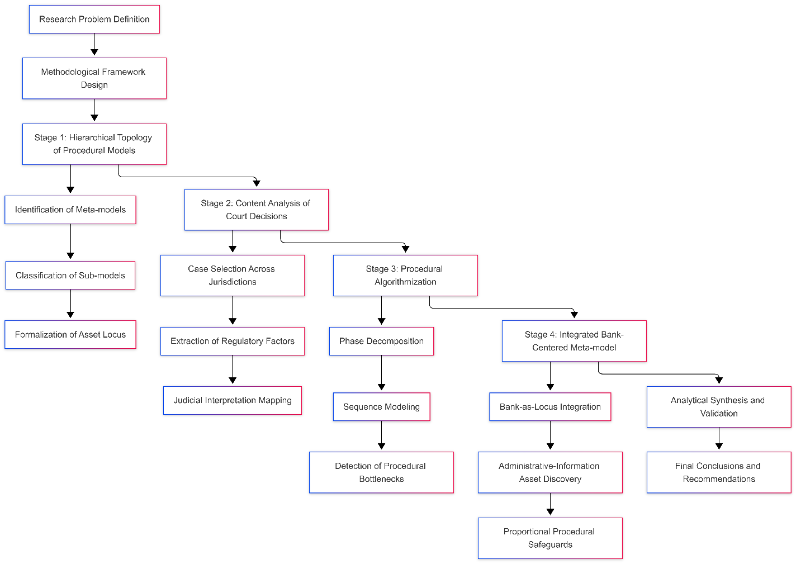
Figure 1 - Sequential research design for modelling the administrative and legal submission of enforcement documents based on the location of the debtor’s financial assets
Source: developed by the authors

Sample
The following sample was used in this study (Table 1). The years of 2012–2025 were defined as a period of institutional reconfiguration of enforcement tools: from the “information turn” (asset discovery, disclosure duties, registry-based tracing) to supranational banking unification and constitutional revision of extrajudicial mechanisms. The geographical scope (Ukraine/EU/continental Europe/Anglo-American systems/Asia/Latin America) was chosen for a critical comparison of legal practices. This enabled comparing three competing logics of territoriality: bank-as-locus (account as a jurisdictional object), situs-of-debt (debt as a mobile financial asset), and court-centric discovery (state monopoly on localization). This configuration minimized the methodological blindness of one legal family and made it possible to identify systemic trade-offs between procedural economy, proportionality of coercion, and transaction costs of proving the “location of the asset” when submitting enforcement documents.
Table 1 - Comparative sample of procedural models of territorial binding of submission of enforcement documents to the localization of the debtor’s financial assets (2012–2025; Europe—North America—Asia—Latin America)
Country / Regulatory acts / Submission rules (territoriality by location of financial assets) | Procedural actions for localization of assets and submission of enforcement documents / Procedural model | Known court cases (localization of financial assets / territoriality of submission)
Ukraine / Law “On Enforcement Proceedings” No. 1404-VIII (2016); Law “On Bodies and Persons…” No. 1403-VIII (2016) / Art. 24 of Law No. 1404 (place of enforcement: place of residence/stay of the debtor or location of his property; for funds — practically tied to the banking/financial infrastructure within the district) | The collector submitted an enforcement document to the enforcement agent in the district, justified the localization of the property (account/funds/bank claim), after the opening of proceedings, seizure of funds, requests to banks, collection/write-off were applied / Mixed: decentralized (state/private enforcement agents) + administrative data exchange | Case No. 260/1562/19 (position on “bank ≠ property” in the dispute about the place of execution); review of the CCS of the Supreme Court (02/03/2021) on the acceptance of documents at the location of the bank; No. 925/791/21 (evidence of the localization of property within the district); No. 924/90/22 (OP CCS of the Supreme Court, 08/18/2023 — criteria for determining the place of execution)
EU / Regulation (EU) No. 655/2014 on EAPO (2014) / Art. 14 (obtaining information to identify accounts in a specific Member State); procedural link to the State of execution/bank as “place of account” | The creditor initiated the European Account Preservation Order, provided grounds for the probable localization of the account; the competent authority of the executing state ensured the identification of the bank/account and the imposition of the blocking / Supranational unification relying on national information authorities | C-555/18 K.H.K. (2019) (interpretation of the procedural aspects of the EAPO and protection in cross-border banking jurisdiction)
Germany / ZPO (reforms 2009/2013) / §755 ZPO (establishment of the debtor’s place of residence); §802l ZPO (requests to pension/tax/registration authorities; bank details via tax channels); territoriality of enforcement supported by Sachauflärung tools | The bailiff collected data, initiated information requests, after identifying accounts, arrests/seizures were imposed; the submission of documents was de facto oriented towards the possibility of accessing data within the scope of competence / Administrative and information (enhanced role of the bailiff) within the judicial system | (Precedents were used regarding the admissibility/limits of information requests and the proportionality of interference; the discourse was dominated by cases about the balance of access to data and the personal data protection)
France / CPCE / CPC; saisie-attribution mechanism (codifications and reforms 1991–2012) / Principle of territoriality of the third party debtor (bank/legal entity): the effect of the seizure of the account was linked to the “place of establishment” of the bank (head office or authorized agency capable of making the payment) | The collector filed an enforcement title with the bailiff (huissier/commissaire de justice), carried out a saisie-attribution at the bank, localizing the “creditor’s claim to the bank” as a financial asset / Centralized-professional (strong role of bailiffs; emphasis on “situational localization” of the debt) | Cass. 2e civ., 14.02.2008, n°05-16.167 (funds in a foreign bank branch); Cass. 1re civ., 09.03.2011 (extraterritorial effect of saisie-attribution due to the unity of the property of the legal entity-bank)
Netherlands / DCCP/Rv; conservatoir derdenbeslag practices; EAPO (post 2014) / National rules on third-party attachment + application of EAPO to EU accounts; submission was linked to the court/competent authority capable of authorising beslag on a bank claim | The collector obtained court seizure permit, defined the asset as a claim against the bank; in the cross-border dimension, EAPO or exequatur / Judicial sanction (high threshold of formal judicial involvement) was used | HR 02.12.2022, ECLI:NL:HR:2022:1804 (Hoch Capital) (aspects of European bank attachment/procedural safeguards)
United Kingdom (England and Wales) / CPR Part 72 (TPDO) / Part 72: third party “within the jurisdiction” and location of debt as key to admissibility; submission focused on location of third party debtor (bank/issuer) within the jurisdiction | The creditor initiated an interim TPDO, “fixed” the debtor’s monetary claim against the bank/third party, then converted it into a final order; localization was determined not by the physical place of payment, but by the “situs of debt” / Jurisdictional situational (the rule “debt where the debtor of the debt is”) | Taurus Petroleum v SOMO [2017] UKSC 64 (situs of debt under a letter of credit and the admissibility of interception of funds in London)
USA (New York) / CPLR Art. 52 (enforcement), restraining notices/turnover / Territorial attachment was limited by the “separate entity rule” doctrine for bank branches; submission/restriction of assets depended on whether the account was considered localized in a specific branch | The lender filed a restraining notice/turnover motion; fragmentation was in effect for foreign branches, which increased transaction costs of asset search / Branch-fragmented (bank branches as separate “loci” of assets) | Koehler v Bank of Bermuda, 12 N.Y.3d 533 (2009) (turnover and asset availability); Motorola Credit Corp. v Standard Chartered Bank, 24 N.Y.3d 149 (2014) (separate entity rule confirmation)
Canada (Quebec) / Rules of seizure/garnishment (saisie avant jugement), Provincial procedures / jurisdiction for seizure of debt/royalty was determined by the third party debtor’s attachment (the debt “sat” where the debtor of the debt was located/subject to judgment) even if the actual funds were located outside the province | The creditor filed a motion for pre-judgment seizure/garnishment in a Quebec court, locating the asset as a third-party receivable from the debtor / Tort-in-law localization (asset = claim against a third party) | International Air Transport Association v Instrubel, 2019 SCC 61 (garnishment/ jurisdiction despite “out-of-province” placement of funds)
Singapore / Rules of Court; garnishee proceedings (Order 49 / rule reforms) / Submission focused on the bank as garnishee and proof of the debtor's ownership of the funds; in complex structures (joint accounts) a higher prima facie standard was required | The creditor received a garnishee order to show cause, proved the location of the funds in the bank and the ownership of the account/share; judicial restrictions on joint accounts were applied / Judicial and evidentiary (emphasis on the standard of proof of ownership of the asset) | Timing Ltd v Tay Toh Hin [2020] SGHC 169; [2021] SGHC 5 (garnishment of joint accounts and “strong prima facie” criteria)
Brazil / CPC, Law No. 13.105/2015 (2015) / CPC-2015 expanded the debtor’s procedural obligations regarding the disclosure of assets and introduced general coercive clauses (atypical measures), which effectively supported the presentation/execution at the location of the discovered assets (in particular financial ones) | After the creditor exhausted the search for assets, the court/staff carried out subsidiary asset discovery; tools such as credit registries, “bad debtor lists”, notarial notifications, private sales were used / Hybrid (creditor-search → judicial subsidiarity + compulsory disclosure) | STJ, REsp 1.788.950/MT (23.04.2019) (practice of applying general mandatory clauses in execution)
China / CPL/Enforcement rules; asset reporting; “dishonest debtors” regimes / Court dominated asset discovery; debtor asset reporting and sanctions for non-declaration shaped the institutional “localization compass” (accounts/assets) | The court applied direct measures (freezing accounts), indirect coercive (active pressure) and deterrent (public lists/restrictions); the creditor took limited part in the search / Court-centric all-inclusive | (Typical cases were concentrated in the practice of the SPC regarding the forced freezing of accounts and sanctions for non-declaration; the doctrine featured decisions on inclusion in the “dishonest debtor list” as a tool for forcing the disclosure of assets)
Indonesia / Fiduciary Law №42/1999; Bankruptcy Law No. 37/2004; Bank Indonesia Reg. No. 14/2/PBI/2012 / Parate execution regarding the subject of the fiduciary pledge reduced the role of the court; the assets were localized through extrajudicial mechanisms, which created the risk of disproportion of procedural guarantees | Creditor/collector initiated extrajudicial seizure/realization; judicial control was incomplete, which increased the likelihood of abuse in “localizing” the asset / Extrajudicial execution (high speed ↔ high risks of violations) | MK (Constitutional Court) Decision No. 18/PUU-XVII/2019 (limiting the automaticity of parallel execution and strengthening the debtor's guarantees)
Poland / Acts 1993 (unfair competition) and 2007 (unfair commercial practices) + UOKiK practice / Although the acts were not “on the submission of enforcement documents”, they defined the limits of admissibility of search/pressure in the localization of assets, which indirectly regulated the administrative contour of recovery | Courts have qualified some informal practices as violations of personal rights/collective interests; this has narrowed the range of extrajudicial methods of “asset tracing” / Protective-restrictive (priority of the rights of the debtor-consumer over aggressive asset tracing) | (A series of decisions of regional courts and appellate courts regarding abusive debt collection as an interference with personal rights when attempting to establish assets/their “effective location”)
Moldova / Law No. 149/2012 “About insolvency” (29.06.2012) / Effects of opening insolvency: moratorium on individual enforcement (Art. 81 – in practical description) and concentration of actions through the administrator/liquidator; this changed the “place of filing” from asset-location to insolvency forum | Individual enforcement was blocked; creditors’ claims were channelled into a collective procedure with centralized inventory/identification of assets and control of the administrator, i.e. the "locus" shifted from the geography of assets to the procedural concentration of proceedings / Collective insolvency forum model (procedural concentration of assets and claims) | In open sources, the details of individual asset-location disputes were given unevenly; instead, the moratorium/consolidation was normatively fixed as the key mechanism.
Source: developed by the authors for Malskyy (2022); Hofeld (2024); Berglund (2010); Stănescu (2025); Rott (2025); Markworth (2022); de Batz (2023); Namura & Koyanagi (2021); Garcia and Prast (2003); Vriesendorp and Pool (2025); Gardner and Gray (2022); Harris (2003); Healy (2004); Stargatt and Taylor (2025); Sarra (2000); Deschamps (2019); Eu (2021); Chan (2016); Cabral (2019); de Azevedo, Cabello, Junior and Teixeira (2025); Yuan (2004); Cao (2023); Iriyani (2018); Sianipar and Prasetyawati (2024); Gawel and Chojnacki (2024); Gawełko-Bazan (2022); Stanescu and Bogdan (2021); Chirtoacă (2023)

Methods
The chosen methodological design was determined by the need to combine normative-dogmatic, empirical-precedential, and formal-procedural analyses. This made it possible to eliminate jurisdictional uncertainty and reduce information asymmetry when submitting enforcement documents at the location of the debtor’s financial assets. The complementarity of the methods ensured end-to-end validation of the results, namely from the typology of models to their algorithmic integration:
1. Hierarchical topology of procedural models. The method was used for the systematic classification of national and cross-border enforcement regimes by disinguishing metamodels and submodels according to the criteria of territoriality, access to information, and intensity of judicial control. This enabled formalizing the “place of the asset” as a procedurally controlled locus and to identify structural gaps between the models.
2. Content analysis of court decisions. The method was used to empirically verify the regulatory factors of the submission of enforcement documents (territoriality, evidentiary thresholds, bank binding) in court practice. The result was the establishment of stable patterns of interpretation of asset localization and confirmation of the determining role of banking infrastructure and information access.
3. Procedural algorithmization of metamodels and submodels. The method provided the formalization of law enforcement logic in the form of phased and sequential algorithms of submission and execution. This made it possible to identify critical points of delay in the circulation of information and optimize transitions between stages, taking into account the principles of proportionality and due process.
4. Development of an integrated bank-centric administrative and information metamodel. Synthesis-modelling was used to combine effective elements of previous methods into a holistic architecture with minimized regulatory risks. The result is a unified model that increases the enforceability of decisions through early asset identification, administrative verification, and proportionate judicial review.

Research tools
MermaidChart was used for UML modelling, providing a formalized, declarative, and reproducible representation of procedural algorithms in the form of sequence- and phase-oriented diagrams. The use of this tool was methodologically justified due to its ability to accurately reflect topologized administrative-legal metamodels. It also supported modular decomposition of phases of submission of executive documents and provided transparent verification of the logic of procedural control and localization of financial assets.

Results
The first stage was aimed at a formalized topological analysis of procedural models of filing enforcement documents by location of the debtor’s financial assets (Table 2). Such a step was necessary to decompose regulatory heterogeneity, eliminate conceptual eclecticism and identify stable administrative and legal archetypes of territoriality of enforcement. Topologization ensured analytical comparability of models in different jurisdictions and created a basis for further empirical operationalization.
Table 2 - Hierarchical topology of procedural models of administrative and legal regulation of filing enforcement documents by location of the debtor’s financial assets
Meta-model | Sub-model | Country / regulatory acts; rules for submitting enforcement documents | Mechanisms for locating assets and submitting enforcement documents | Court cases
A. Bank-as-locus | A1. EAPO-bank node | EU / Regulation (EU) No 655/2014; Art. 14 (obtaining account-information in the executing State; account/bank as “location of asset”) | Localization through identification of bank/account by information authority; submission in the enforcement state | C-555/18, K.H.K. (2019); C-291/21, Starkinvest (2023)
A. Bank-as-locus | A2. Saisie-attribution | France / CPCE/CPC; saisie-attribution; territoriality determined by the “location” of the bank/authorized institution capable of effecting payment | Asset = claim against bank; territoriality through bank establishment capable of making payment | Cass. 2e civ., 14.02.2008, n°05-16.167; Cass. 1re civ., 09.03.2011
A. Bank-as-locus | A3. Derdenbeslag + EAPO | Netherlands / DCCP/Rv; conservatoir derdenbeslag; EAPO (after 2014); submission — to the court that authorized the beslag on the bank claim | Court sanction of attachment of bank claim; cross-border — through EAPO | HR 02.12.2022, ECLI:NL:HR:2022:1804 (Hoch Capital)
B. Situs-of-debt | B1. TPDO | United Kingdom / CPR Part 72; territoriality – through third party “within jurisdiction” and situs of debt | Asset = debt of a third party; location of asset = place of enforceability of debt | Taurus Petroleum v SOMO [2017] UKSC 64; Masri v Consolidated Contractors [2009] UKHL 43
B. Situs-of-debt | B2. Garnishment-jurisdiction | Canada (Quebec) / Provincial saisie/garnishment rules; jurisdiction – through court control over third-party debtor | Localization through jurisdictional control over garnishee, regardless of physical location of funds | International Air Transport Association v Instrubel, 2019 SCC 61
C. Registry-discovery | C1. Sachaufklärung | Germany / ZPO; §§755, 802l; territoriality was effectively supported by access to Drittauskünfte/registers | Registry and tax requests of the bailiff; submission was tied to access to data | BGH, I ZB 78/16 (05.10.2017); BVerfG, 1 BvR 679/21 (19.04.2021)
C. Registry-discovery | C2. Coercive disclosure | Brazil / CPC (Law No. 13.105/2015); coercive measures/disclosure obligations; submission focused on a court capable of applying coercion and on the “discovered” account | Subsidiary asset discovery by the court; compulsion to disclose assets | STJ, REsp 1.788.950/MT (23.04.2019)
D. District-executor mixed | D1. Executor's district + bank | Ukraine / Law No. 1404-VIII, Art. 24; Law No. 1403-VIII; filing — by place of residence/stay or location of property (for funds — through the banking infrastructure of the district) | Localization of funds as a bank claim within the enforcement district | №260/1562/19; Огляд КЦС ВС 03.02.2021; №925/791/21; №924/90/22 (ОП КГС ВС, 18.08.2023)
E. Proof-threshold / fragmentation | E1. High-proof garnishment | Singapore / Rules of Court; garnishee proceedings; increased prima facie/strong prima facie in complex accounts | Increased standard of proof of ownership/beneficial interest | Timing Ltd v Tay Toh Hin [2020] SGHC 169; [2021] SGHC 5
E. Proof-threshold / fragmentation | E2. Separate entity rule | CIF (Ym.-Qjhr) / CPLR Art. 52; separate entity rule; “place of asset” was split into branches | Branch localization of accounts; territorial “splitting” of the asset | Koehler v Bank of Bermuda, 12 N.Y.3d 533 (2009); Motorola Credit Corp. v Standard Chartered Bank, 24 N.Y.3d 149 (2014)
F. Forum-shift / extra-judicial | F1. Parate execution | Indonesia / Fiduciary Law No. 42/1999; Bank Indonesia Reg. No. 14/2/PBI/2012; “location of assets” was established through extrajudicial channels | Extrajudicial localization and realization of the subject of collateral | MK Decision No. 18/PUU-XVII/2019
F. Forum-shift / extra-judicial | F2. Protective constraint | Poland / Acts 1993/2007; UOKiK practice; regulations on dobra osobiste; territoriality was indirectly “cleansed” of abusive methods | Limitations of informal asset tracing as a violation of the debtor's rights | I ACa 1096/18 (14.12.2018); V ACa 501/21 (11.10.2021)
F. Forum-shift / extra-judicial | F3. Insolvency forum | Moldova / Law No. 149/2012; moratorium on individual enforcement; shift from asset-location to insolvency-forum | Moratorium and concentration of claims; shift from asset-location to insolvency forum | CSJ Moldova, dec. nr. 3ra-1690/19 (2019); dec. nr. 3ra-1207/21 (2021)
Source: developed by the authors
The topological cross-section (Table 2) revealed a structural polarization between models that treated a financial asset as a banking-jurisdictional object and models that constructed the “place of the asset” through the legal situs of the claim or procedural concentration. An asymmetry was recorded between the level of normative certainty of territoriality and the actual mechanisms for proving it, as well as an increase in coordination and evidentiary costs in fragmented and hybrid regimes. This confirmed that the administrative and legal regulation of the submission of enforcement documents is built not as a unified institution, but as a set of competing models with a different balance of efficiency, proportionality, and legal certainty. The identified topological differences necessitated the transition to content analysis of court decisions aimed at empirically verifying how the regulatory factors of territoriality were actually interpreted by the courts. The next stage made it possible to compare regulatory constructs with judicial reasoning, practices of proving the localization of financial assets, and actual criteria for accepting enforcement documents (Table 3).
Table 3 - Content analysis of court decisions in debt collection cases (focus: regulatory factors of filing enforcement documents at the location of the debtor’s financial assets)
Case / Jurisdiction / Metamodel (submodel) / Key regulatory factor of submission | Court interpretation of the location of a financial asset | Procedural effect
C-555/18, K.H.K. (2019) / ЄС / A1. Bank-as-locus (EAPO-bank node)  Bank-centred territoriality (Reg. 655/2014, art. 14) | The asset was identified through a bank in the enforcement state, regardless of the location of the debtor | Submission became possible through banking jurisdiction as an autonomous locus
C-291/21, Starkinvest (2023) / ЄС / A1. Bank-as-locus (EAPO-bank node)  Title validity + bank binding | Territoriality depended on the qualification of the enforcement document and the identification of the account | Formal submission barrier raised
Cass. 2e civ., 14.02.2008 / France / A2. Bank-as-locus (saisie-attribution)  Territoriality of the third party (bank) | Financial asset was qualified as a claim on the bank as a single legal entity | Expanded permissibility of filing despite branch structure
Cass. 1re civ., 09.03.2011 / France / A2. Bank-as-locus (saisie-attribution)  Procedural control of the bank | The localization of the asset was limited by the bank’s ability to execute the seizure within the jurisdiction | Extraterritorial effect of submission narrowed
HR 02.12.2022 (Hoch Capital) / The Netherlands / A3. Bank-as-locus (derdenbeslag + EAPO)  Judicial sanction + proportionality | The asset was recognized as localized in the bank subject to judicial control | Requirements for substantiation of submission strengthened
Taurus Petroleum v SOMO (2017) / United Kingdom / B1. Situs-of-debt (TPDO)  Situs of debt | The location of the asset was identified with the place of debt collection | Submission allowed without physical localization of funds
Masri v Consolidated Contractors (2009) / United Kingdom / B1. Situs-of-debt (TPDO)  Jurisdictional reach | Ancillary procedural actions were recognized as sufficient for asset-tracing | Expanded preparatory phase before submission
IATA v Instrubel (2019) / Canada (QC) / B2. Situs-of-debt (garnishment)  Court control over garnishee | The asset “sat” where the third party controlled it | Moved submission from geography of funds to jurisdiction
BGH I ZB 78/16 (2017) / Germany / C1. Registry-discovery (Sachaufklärung)  Executor’s registered access | The location of the assets was based on administrative data | Territoriality became a function of access to information
BVerfG 1 BvR 679/21 (2021) / Germany / C1. Registry-discovery (Sachaufklärung)  Proportionality of information requests | The court limited excessive interference with financial data | Balanced efficiency and protection of rights
STJ, REsp 1.788.950/MT (2019) / Brazil / C2. Coercive disclosure  Atypical coercive measures | The court allowed forced disclosure of assets as a condition of submission | Reduced information asymmetry
№924/90/22 (ОП КГС ВС, 2023) / Ukraine / D1. District-executor mixed  Article 24 of Law No. 1404-VIII | The place of execution required evidentiary location of funds | Raised standard of proof of territoriality
№260/1562/19 / Ukraine / D1. District-executor mixed  “Bank ≠ property” | The mere fact of bank presence did not determine the locus of the asset | Limited formal submission
Timing Ltd v Tay Toh Hin (2020–2021) / Singapore / E1. High-proof garnishment  Strong prima facie ownership | Localization depended on the proven ownership of the funds | Submission complicated by high evidentiary threshold
Motorola v SCB (2014) / США (NY) / E2. Separate entity rule  Branch account localization | The asset “sat” in a specific bank branch | Fragmented submission
Koehler v Bank of Bermuda (2009) / США (NY) / E2. Separate entity rule  Personal jurisdiction | The court allowed turnover without in-state localization of the asset | Partially offset branch barrier
MK No. 18/PUU-XVII/2019 / Indonesia / F1. Parate execution  Constitutional guarantees | Extrajudicial localization required procedural control | Limited automated submission
I ACa 1096/18 (2018) / Poland / F2. Protective constraint  Protection of personal rights | Aggressive asset-tracing recognized as a violation | Narrowed permissible submission methods
V ACa 501/21 (2021) / Poland / F2. Protective constraint  Collective interests of consumers | Territoriality cleared of informal practices | Raised regulatory barriers
CSJ 3ra-1690/19 (2019) / Moldova / F3. Insolvency forum  Moratorium | The submission was transferred to the insolvency forum. | Blocked individual execution
CSJ 3ra-1207/21 (2021) / Moldova / F3. Insolvency forum  Concentration of requirements | The localization of assets was carried out through the liquidator. | Replaced asset-location logic
Source: developed by the authors
The content analysis of court decisions (Table 3) confirmed the consistency of empirical interpretations with the previously established topology of procedural metamodels and submodels. Case law systematically reconstructed the “location of a financial asset” as derived from a dominant regulatory factor: banking jurisdiction, situs of debt, information availability, evidentiary threshold, or procedural concentration. It was noted that regulatory territoriality in most jurisdictions did not function as a geographical category. Instead, it was a procedurally constructed locus dependent on control over a third party, access to data, or judicial sanction. This was consistent with the results of the literature review and the topological stage, where fragmentation and competition of models were identified instead of a unified administrative-legal approach. The revealed correlation between regulatory factors and judicial criteria for asset localization justified the need to move to procedural modelling. At the next stage, the topologized metamodels and submodels were formalized using UML modelling. This approach contributed to the identification of the logic of procedures, regulatory risks, and opportunities for optimizing the submission of enforcement documents by location of the debtor’s financial assets (Appendix A).
Procedural algorithmization of topologized metamodels (Table 4) showed that the efficiency of filing enforcement documents correlates with the level of locus asseti formalization. It also depended on institutional access to financial data and minimization of evidentiary and coordination costs. Models A1 (EAPO-bank node) and C1/C2 (registry-based discovery + coercive disclosure) demonstrated the highest enforcement efficiency. In these models, territoriality was reduced to banking or information jurisdiction, and information asymmetry was reduced by administrative channels. E2 (separate entity rule) and F1 (parate execution) were the least effective were because of branch fragmentation, high transaction costs or lack of procedural guarantees, which confirmed the conclusions of the literary, topological, and content analyses. The obtained results substantiated the need for synthesis-modelling of an optimal metamodel that would combine bank-centred territoriality, administrative-informational asset discovery, and proportional procedural guarantees. The final stage was aimed at building an integrated model of administrative and legal regulation of the submission of enforcement documents at the location of the debtor’s financial assets with minimized regulatory risks and increased enforceability (Appendix B).
The synthesis-modelling (Appendix B) confirmed that the optimal procedural configuration was created by combining bank-centred territoriality as a stable locus of the asset. It also included administrative-informational asset discovery to reduce information asymmetry and proportional procedural safeguards as a tool for legitimizing coercion:
- phase 1 (Bank-centred territoriality) — eliminates geographical uncertainty through the fixation of bank-as-locus;
- phase 2 (Administrative-information discovery) — reduces informational asymmetry without excessive judicial centralization;
- phase 3 (Proportional safeguards) — integrates standards of proportionality because of due process and judicial review;
- phase 4 (Execution) — ensures high enforceability through direct impact on the financial infrastructure.
Unlike branch-fragmented or purely court-centric structures, the integrated model reduced information asymmetry, minimized jurisdictional conflicts, and reduced transaction costs for proving territoriality. Consistency with the results of the previous stages was manifested in the transformation of the “location of the asset” from a formal geographic category into a procedurally managed locus associated with access to financial infrastructure and controlled information channels. The proposed metamodel optimizes the collection process through early identification of financial assets through a banking node, subsequent administrative verification of data, and final procedural fixation of the place of submitting the enforcement document. Such multi-phase algorithmization ensures predictability of law enforcement, limits the possibilities of forum shopping, and neutralizes the risks of excessive or arbitrary interference in the debtor’s property. Procedural guarantees serve as a corrective mechanism that maintains a balance between the effectiveness of enforcement and the protection of fundamental rights.
The obtained synthesis-modelling results confirmed the hypothesis advanced in the study. The combination of bank-centred territoriality, administrative-informational asset discovery, and proportional procedural guarantees formed an internally consistent and regulatory stable model of filing enforcement documents at the location of the debtor’s financial assets. This model systematically eliminates jurisdictional uncertainty and information asymmetry.

Discussion
The discussion was necessary to compare fragmented technological, insolvency, behavioural, and fiscal-supervisory approaches to debt collection in a single analytical plane. This step identified the extent to which existing concepts ignored the administrative and legal aspect of the submission of enforcement documents and the spatial localization of financial assets. The discussion analysis provided a test of the explanatory power of the opponents’ models regarding the stage of enforcement.
In terms of algorithmization and normative certainty of the implementation of approaches, Jankowski and Paliński (2024) and Przybyłek et. al, (2025) outlined a technological shift towards rule-based and AI-driven solutions to mass collection. At the same time, these models functioned within the organizational logic of collectors and did not formalize the spatial and legal status of financial assets. The results of our study showed that algorithmic optimization did not eliminate jurisdictional uncertainty and information asymmetry without an administratively fixed locus for submitting enforcement documents.
In the area of insolvency and reorganization regulation, the work of Alle (2021) and Gurrea-Martínez (2022) focused on the internal architecture of collective procedures and the redistribution of claims priorities. This approach preserved the value of enterprises ex ante, but left out of consideration the ex post stage of enforcement. In contrast, our study transformed the category of “place of asset” into a procedurally managed administrative node that ensured the enforceability of decisions outside the insolvency forum. The regulation of collection practices and behavioural restrictions, represented by Stănescu (2022) and Romeo and Sandler (2021), aimed to reduce abuse and stabilize consumer lending. However, the emphasis on conduct-restrictions and licensing did not eliminate the structural problem of identification and territorial attribution of financial assets. The obtained results showed that the administrative and legal localization of assets determined the effectiveness of the submission of enforcement documents, and not only the behavioural control of the subjects of collection.
Fiscal supervisory approaches by Cornelia and Ciprian (2025), Oluyeju and Oluyeju (2023) interpreted enforcement as a tool for macro-regulatory influence on compliance and financial stability. In these studies, the effectiveness of enforcement was associated with the intensity of control or supervisory mechanisms. Instead, our study showed that effectiveness was ensured not by increasing coercion (the use of power coercion / measures to ensure mandatory compliance with established norms), but by structural optimization of the process of submitting enforcement documents through bank-centred territoriality and administrative-information channels.
The extrajudicial and contextual solutions presented in Dewi et al. (2023) demonstrated rapid or socially conditioned effects, but remained normatively unstable. Parate execution and social factors explained individual empirical results, but did not shape the systemic legal architecture of enforcement. Our study confirmed that only an integrated administrative and legal metamodel with procedurally guided localization of financial assets ensured predictability, legitimacy, and sustainable enforceability of enforcement.
The reviewed studies of the opponents recorded individual aspects of the efficiency of collection — algorithmization of decisions, insolvency priorities, behavioural restrictions or supervisory coercion, but did not offer a holistic procedural architecture of territorial submission of enforcement documents. The results could be implemented in the practice of enforcement agencies, courts and legislative design as a tool for optimizing the administrative and legal architecture of financial asset collection.
The key gaps remained the lack of a formalized locus of financial assets, unresolved information asymmetry and jurisdictional fragmentation at the ex post stage of enforcement. Our findings will attempt to eliminate these deficiencies by conceptualizing bank-centred territoriality, administrative and informational asset discovery, and proportional guarantees as an integrated metamodel. This will ensure regulatory certainty, legitimization of coercion, and increased enforceability of decisions — elements that are missing in the opponents’ approaches.

Limitation
The study was reduced to the normative-dogmatic and forensic-analytical level and did not include empirical verification of the actual time and financial costs of implementation. The comparative analysis was based on representative but selective jurisdictions, which limited the full extrapolation of the results. The algorithmization of the metamodel was not accompanied by a quantitative assessment of the regulatory impact and implementation effects.

Recommendations
Further research should be directed at empirical testing of the effectiveness of bank-centred territoriality in different administrative enforcement regimes. A promising approach is to combine procedural modelling with econometric analysis of transaction costs and enforcement times. It is also recommended to develop applied standards for integrating administrative information registers with judicial and enforcement proceedings.

Conclusions
Main results of the study. The results of this study give grounds to establish that the effectiveness of the submission of enforcement documents was determined not by formal territoriality, but by the configuration of procedural nodes of access to financial assets. Topological reconstruction revealed a systemic fragmentation between court-centric, branch-local and extrajudicial models, while content analysis of court decisions showed a stable tendency towards procedural reinterpretation of the “location of the asset” through information and control channels. Judicial practice actually confirmed the shift from a geographical criterion to an administratively managed locus associated with banking infrastructure and regulatory access to data. Procedural algorithmization showed that isolated mechanisms of coercion or disclosure of information did not provide either predictability or sustainable enforceability. An integrated bank-centric administrative-information metamodel synthesized the stability of the territorial anchor, reduced information asymmetry, and proportional procedural guarantees, eliminating jurisdictional conflicts and regulatory gaps. So, the study proved that the enforcement was optimized through a restructuring of the process of submitting enforcement documents, and not through the intensification of coercion, which formed a normatively stable and legitimate architecture of administrative and legal regulation.
The academic novelty of the study was the creation of an integrated bank-centric administrative-information metamodel for the submission of enforcement documents. This allowed transforming the concept of “location of financial asset” from a formal-territorial category into a procedurally controlled administrative-legal locus. This study is the first to carry out a hierarchical topologization of procedural models of enforcement with subsequent algorithmization of their functional phases and empirical verification through content analysis of court decisions. This made it possible to substantiate the structural relationship between banking infrastructure, information access channels, and proportional procedural guarantees as the core of effective administrative and legal regulation. The practical significance of the results was the possibility of using the proposed metamodel for the unification and standardization of procedures for the submission of enforcement documents in national and cross-border enforcement proceedings. The obtained conclusions provided a regulatory and procedural basis for reducing information asymmetry, minimizing jurisdictional conflicts and increasing the enforceability of decisions without increasing coercive pressure. The obtained results can serve as a basis for implementation in the activities of enforcement agencies, judicial bodies and legislative initiatives, ensuring the optimization of administrative and legal mechanisms for the recovery of financial assets.

References
Alle, A. (2021). Balancing debtor and creditors’ interests in bankruptcy reorganization proceedings: Best practices for the procedural design of claims’ classification. SSRN Electronic Journal. doi:10.2139/ssrn.4009910
Antoshkina, V., Shevchenko, D., Shchokin, R., Boiko, O., & Fokin, Y.F. (2023). The practice of legal interpretation by judicial authorities in Ukraine: theoretical and organizational principles. Relacoes Internacionais no Mundo Atual, 3(41), 506–523, e-6403. From https://revista.unicuritiba.edu.br/index.php/RIMA/article/view/e-6403
Berglund, M. (2010). Scope of application of EU law in the judicial procedures of debt collection in civil and commercial matters. LeXonomica, 2(2), 161-183. From https://journals.um.si/index.php/lexonomica/article/view/1042
Cabral, A. (2019). Execution and Enforcement Proceedings in Brazilian Law. Ritsumeikan law review= Ritsumeikan law review, (37), 95-109. From https://shorturl.at/dSW3z
Cabral, A. (2021). Searching assets and pressuring the debtor for an effective enforcement: An overview of the brazilian execution proceedings. In Effective enforcement of creditors’ rights (pp. 187–198). Singapore: Springer Singapore. doi:10.1007/978-981-16-5609-5_18
Cao, Z. (2023). Court pays enforcement costs? Funding of enforcement proceedings in china. In YSEC yearbook of socio-economic constitutions. Cham: Springer International Publishing. doi:10.1007/16495_2023_52
Chan, A. (2016). Global and regional practices in financial restructuring and bankruptcy laws: Lessons to be learned from singapore. In Global insolvency and bankruptcy practice for sustainable economic development (pp. 219–264). London: Palgrave Macmillan UK. doi:10.1007/978-1-137-56175-6_6
Chirtoacă, R. (2023). Precautionary measures to protect the debtor’s estate from insolvency proceedings. In Adapting to Change Business Law insight from Today's International Legal Landscape (pp. 80-90). ADJURIS–International Academic Publisher. From https://www.ceeol.com/search/chapter-detail?id=1242178
Chirtoaca, R. (2023). Subjects-participants in the procedure for the execution of the judicial decision for subsidiary liability of the members of the insolvable debtor's management bodies. Acta Universitatis George Bacovia. Juridica, (2), 556-560. From https://ibn.idsi.md/vizualizare_articol/224960
Cornelia, S. M., & Ciprian, R. (2025). Tax coercion versus voluntary compliance: The impact of forced enforcement on taxpayers in the european union. Annals-Economy Series, 3, 139-154. From https://www.utgjiu.ro/revista/ec/pdf/2025-03/12_Senatovici.pdf
de Azevedo, R. R., Cabello, O. G., Junior, M. D. R., & Teixeira, A. F. (2025). Consequences of (poor) financial management of court-ordered payments in Brazilian municipalities. Revista Contemporânea de Contabilidade, 22(56), 1-18. From https://dialnet.unirioja.es/servlet/articulo?codigo=10440491
de Batz, L. (2023). Financial market enforcement in France. European Journal of Law and Economics. doi:10.1007/s10657-023-09761-0
Deschamps, M. (2019). Conflict-of-laws rules on assignments of receivables in the United States and Canada. Uniform Law Review, 24(4), 649–663. doi:10.1093/ulr/unz041
Dewi, M. (2023). Juridical review of the process of resolving problem credit through parate execution. FOCUS: Jurnal of Law, 4(2), 101-109. doi:10.47685/focus.v4i2.600 (http://jurnal.publikasi-untagcirebon.ac.id/index.php/focus/article/view/600)
Eu, A. Z. (2021). Disclosure obligations of a debtor under the Singapore scheme of arrangement: Lessons from England and the US. International Insolvency Review, 31(1), 23–44. doi:10.1002/iir.1443
Garcia, G., & Prast, H. (2003). Depositor and Investor protection in the EU and the Netherlands: A Brief History. Journal of European Economic History, 32(3), 307-348. From https://shorturl.at/KvFDJ
Gardner, J., & Gray, M. (2022). Regulation of abusive informal debt collection practices: The U.K. debt collection industry: why regulation isn't enough. In Regulation of debt collection in europe (pp. 201–222). London: Routledge. doi:10.4324/9781003343158-11
Gawel, J., & Chojnacki, A. (2024). Collecting debts under polish law. Com. L. World, 38, 14. From https://shorturl.at/SsFCT
Gawełko-Bazan, K. (2022). Legal institutions regulating the subject and rules of liability of debtor’s heirs: Comments on the background of polish and german law solutions. Kwartalnik Prawa Międzynarodowego, II(II), 165–180. doi:10.5604/01.3001.0015.9982
Gurrea-Martínez, A. (2022). The treatment of debtor-in-possession financing in reorganization procedures: An economic and comparative approach. SSRN Electronic Journal. doi:10.2139/ssrn.4067966
Harris, T. S. (2023). Closing the cracks and the courts: A comparative analysis of debt collection regulation in the united kingdom and the united states. Vand. J. Transnat'l L., 56, 211. From https://shorturl.at/QRMFE
Healy, E. K. (2004). All's fair in love and bankruptcy-analysis of the property requirement for section 109 eligibility and its effect on foreign debtors filing in us bankruptcy courts. Am. Bankr. Inst. L. Rev., 12, 535. From https://shorturl.at/RMKHI
Hess, B. (2021). The effective disclosure of the debtor’s assets in enforcement proceedings. In Effective enforcement of creditors’ rights (pp. 27–41). Singapore: Springer Singapore. doi:10.1007/978-981-16-5609-5_4
Hofeld, H. S. (2024). Legal regulation of fraudulent transactions in Ukraine. Law & Safety, 77. https://shorturl.at/3onxb
Iriyani, D. (2018). The status of debtor and creditor in the process of deferment of debt payment obligation (DDPO) in the perspective of debt agreement and bankruptcy law in Indonesia. JL Pol'y & Globalization, 79, 91. From https://shorturl.at/4ZH1A
Jankowski, R., & Paliński, A. (2024). Debt collection model for mass receivables based on decision rules—a path to efficiency and sustainability. Sustainability, 16(14), 5885. doi:10.3390/su16145885
Kępiński, J. (2022). Regulation of abusive informal debt collection practices in Poland. In Regulation of debt collection in europe (pp. 138–157). London: Routledge. doi:10.4324/9781003343158-8
Lytvyn, N., Andrushchenko, H., Zozulya, Y.V., Nikanorova, O.V., & Rusal, L.M. (2022). Enforcement of Court Decisions as a Social Guarantee of Protection of Citizens Rights and Freedoms. Prawo i Wiez, 2022 (39), 80-102. doi:10.36128/priw.vi39.351
Malskyy, M. (2022). Legal regulations of enforcement procedure in selected foreign jurisdictions. Comparative Law Review, 28(1), 393-409. From https://www.ceeol.com/search/article-detail?id=1122391
Markworth, D. (2022). Debt collection services in Germany. In Regulation of debt collection in europe (pp. 66–82). London: Routledge. doi:10.4324/9781003343158-4
Melnyk, D. S., Parfylo, O. A., Butenko, O. V., Tykhonova, O. V., & Zarosylo, V. O. (2022). Practice of the member states of the european union in the field of anti-corruption regulation. Journal of Financial Crime, 29(3), 853-863. doi:10.1108/JFC-03-2021-0050
Namura, H., & Koyanagi, S. (2021). Proposal for a procedure to strengthen creditor’s claims while protecting debtor’s quality of life and privacy in japan. In Effective enforcement of creditors’ rights (pp. 95–109). Singapore: Springer Singapore. doi:10.1007/978-981-16-5609-5_11
Noor, A., Chandra, L. A., Manurung, N., & Sule, A. M. (2024). The position of debt collectors in the implementation of parate execution of fiduciary guarantees based on law number 42 of 1999 concerning fiduciary guarantees. Journal of Law, Politic and Humanities, 4(6), 1921–1931. doi:10.38035/jlph.v4i6.577
Oluyeju, M., & Oluyeju, O. (2023). Normative framework for the regulation of holdout creditors in the sovereign debt market. International Community Law Review, 1–36. doi:10.1163/18719732-bja10111
Przybyłek, M., Przybyłek, A., Wojciechowski, K., & Shkroba, I. (2025). Towards a smart debt collection system: A Design Science Research approach. Journal of Big Data, 12(1). doi:10.1186/s40537-025-01252-0
Romeo, C., & Sandler, R. (2021). The effect of debt collection laws on access to credit. Journal of Public Economics, 195, 104320. doi:10.1016/j.jpubeco.2020.104320
Rott, P. (2025). Debt collection in germany between public law regulation, unfair commercial practices and data protection law. Journal of European Consumer and Market Law, 14(1). From https://shorturl.at/p5vd5
Sarra, J. (2000). Debtor in possession financing: The jurisdiction of canadian courts to grant super-priority financing in CCAA applications. Dalhousie LJ, 23, 337. From https://shorturl.at/8Ft0n
Setiawan, Y. A., Mashdurohatun, A., & Baraktullah, A. H. (2023). Legal reconstruction of debt collection by debt collector services to default debtor based on justice values. International Journal of Business, Economics and Law, 28, 197-206. From https://shorturl.at/SvzzB
Sianipar, J. R., & Prasetyawati, E. (2024). Legal protection for debtors when there is a transfer of debt by creditors without the debtor's consent. International Journal of Social Sciences and Humanities, 2(2), 44–48. doi:10.55681/ijssh.v2i2.1310
Skeel Jr, D. A. (2003). The past, present and future of debtor-in-possession financing. Cardozo L. Rev., 25, 1905. From https://heinonline.org/hol-cgi-bin/get_pdf.cgi?handle=hein.journals/cdozo25&section=67
Sondang, M. B. (2025). The impact of bad credit on debtor and creditor accountability in fiduciary-based bussiness financing. Golden Ratio of Finance Management, 5(1), 75–87. doi:10.52970/grfm.v5i1.883
Stănescu, C. G. (2025). EU Informal Debt-Collection Regulation: Failure by Design? (p. 289). Oxford University Press. doi: 10.1093/oso/9780198966159.001.0001 (https://library.oapen.org/handle/20.500.12657/102404)
Stanescu, C. G., & Bogdan, C. (2021). Regulatory arbitrage and non-judicial debt collection in central and eastern europe: Tax sheltering and potential money laundering. Account. Econ. Law, 11, 119. From https://shorturl.at/ODg3H
Stănescu, C.-G. (2022). Regulating informal debt collection in the European Union. In Regulation of debt collection in europe (pp. 1–23). London: Routledge. doi:10.4324/9781003343158-1
Stargatt, Y. C., & Taylor, L. L. P. (2025). In the united states bankruptcy court for the district of delaware. Proceedings recorded by electronic sound recording, 302, 683-0221. From https://shorturl.at/uDcvI
Sukmariningsih, R. M., Mulyani, S., & Noor, A. (2024). Legal framework of tax debt collection and tax authorities' right of preference in bankruptcy. Pakistan Journal of Life and Social Sciences (PJLSS), 22(2). doi:10.57239/pjlss-2024-22.2.00302
Triantis, G. G. (1993). Theory of the regulation of debtor-in-possession financing, A. Vand. L. Rev., 46, 901. From https://heinonline.org/hol-cgi-bin/get_pdf.cgi?handle=hein.journals/vanlr46&section=34
Usman, K. D., & Umar, R. (2025). Law enforcement against criminal acts committed by curators in the context of their independence in administering debtors assets during PKPU and bankruptcy proceedings. Fortiori Law Journal, 5(01), 50–69. doi:10.47200/flj.v5i01.3056
Vriesendorp, R. D., & Pool, J. M. W. (2025). A comparative study on the compensation of bankruptcy trustees in insolvent estates. International Insolvency Review. doi:10.1002/iir.70009
Widhayaka, U. W., Retnaningsih, S., & Sufiarina. (2024). The law politics of bankruptcy decision execution against debtor's assets abroad. International Journal of Research in Business and Social Science (2147- 4478), 13(6), 437–454. doi:10.20525/ijrbs.v13i6.3756
Yuan, A. A. (2004). Enforcing and collecting money judgments in china from a us judgment creditor's perspective. Geo. Wash. Int'l L. Rev., 36, 757. From https://heinonline.org/hol-cgi-bin/get_pdf.cgi?handle=hein.journals/gwilr36&section=38
Zhixun, C. A. O. (2022). Discovery of debtor’s assets in the enforcement of monetary judgments in China. Ritsumeikan law review, 40, 69-87. From https://shorturl.at/98BB4

Appendix A
Table ‒ Procedural algorithmization of topologized metamodels and submodels of submission of executive documents by location of the debtor's financial assets
UML model
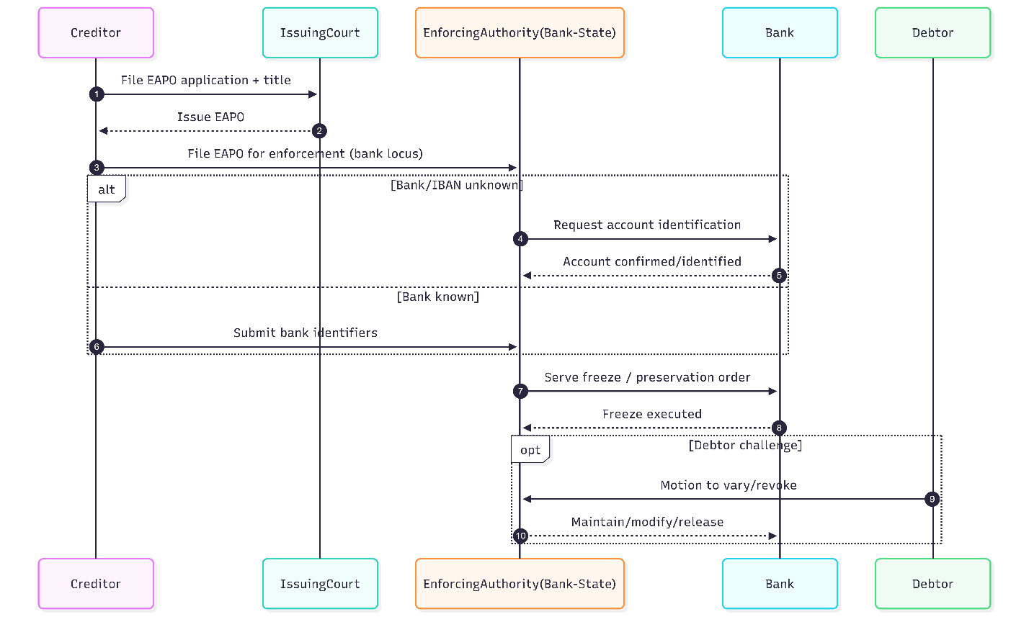
A1. EAPO-bank node
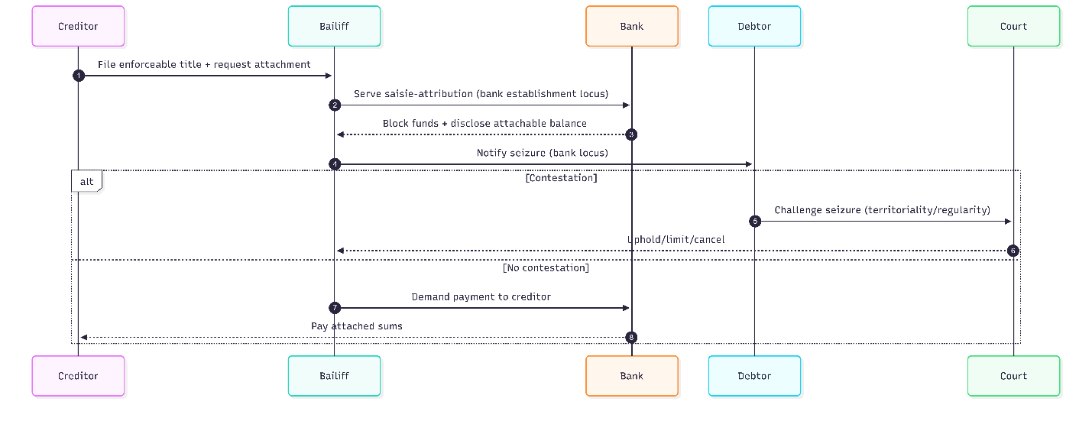
A2. Saisie-attribution
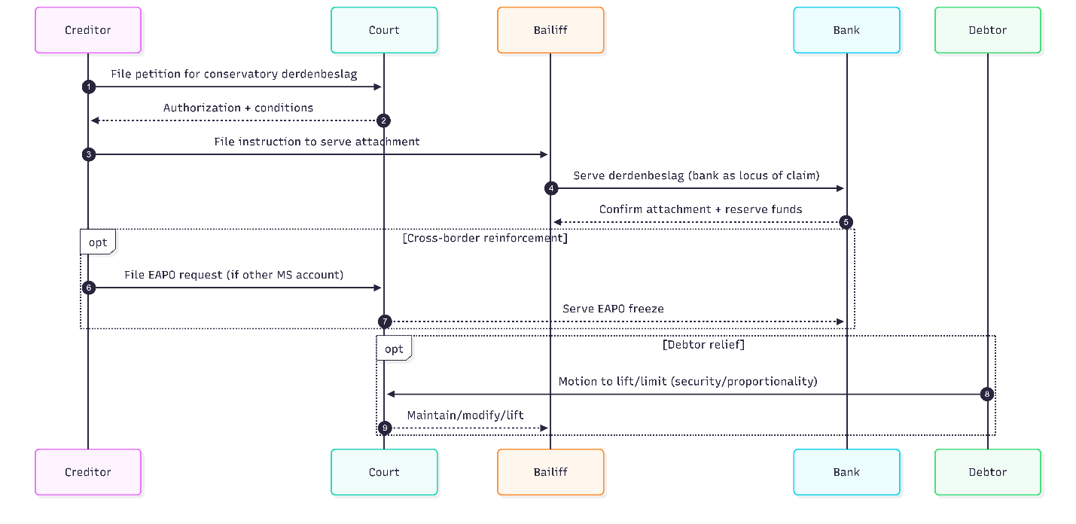
A3. Derdenbeslag + EAPO
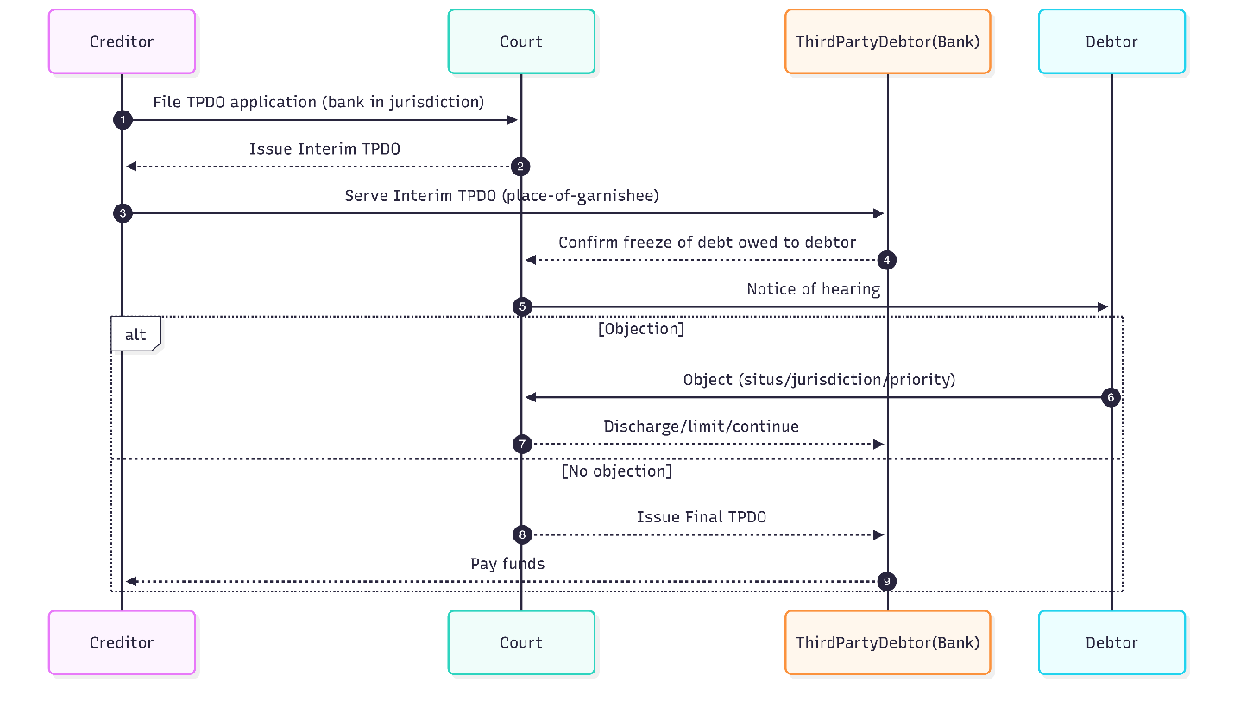
B1. TPDO
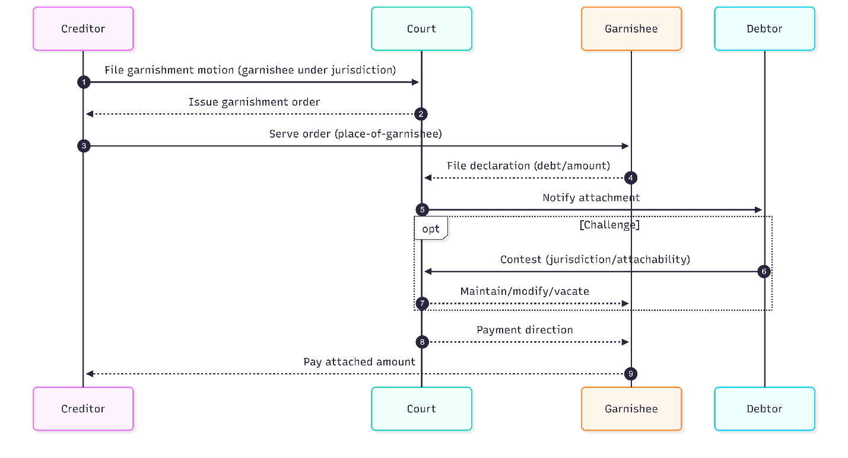
B2. Garnishment-jurisdiction
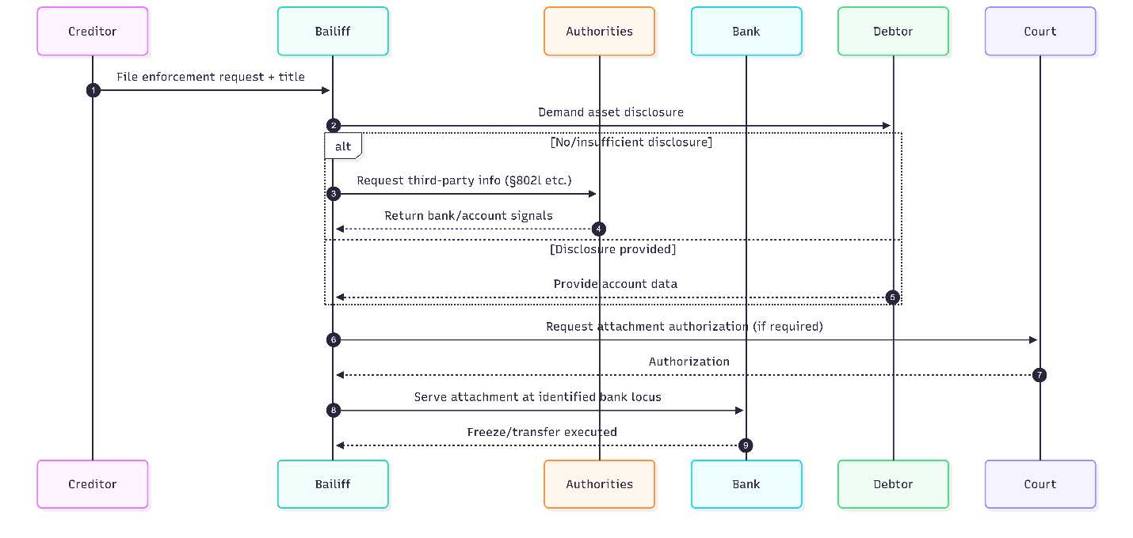
C1. Sachaufklärung
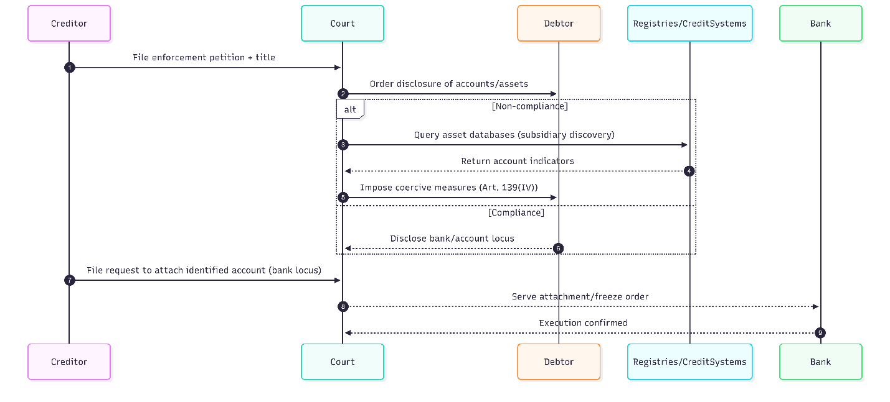
C2. Coercive disclosure
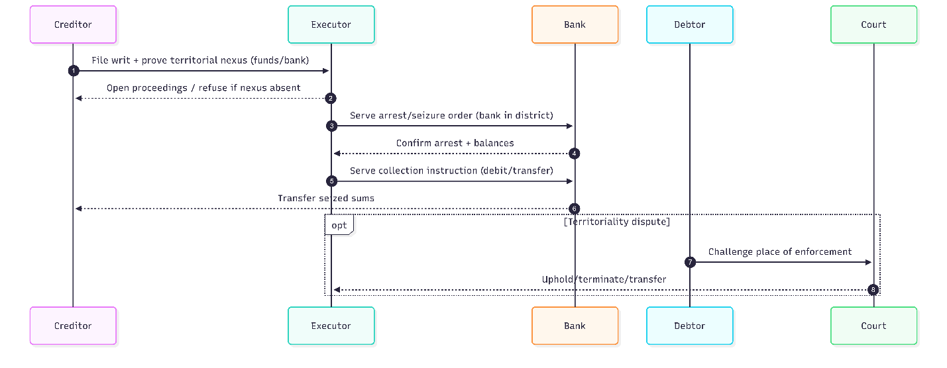
D1. Executor district + bank
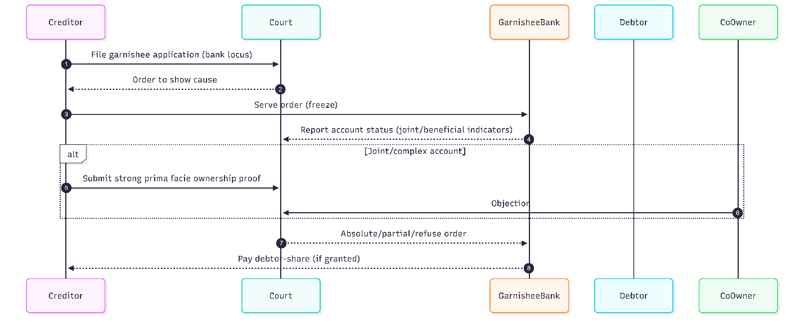
E1. High-proof garnishment
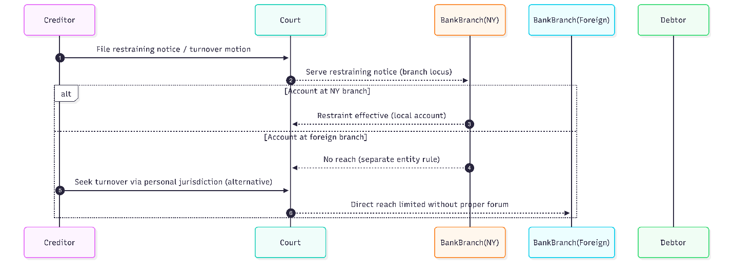
E2. Separate entity rule
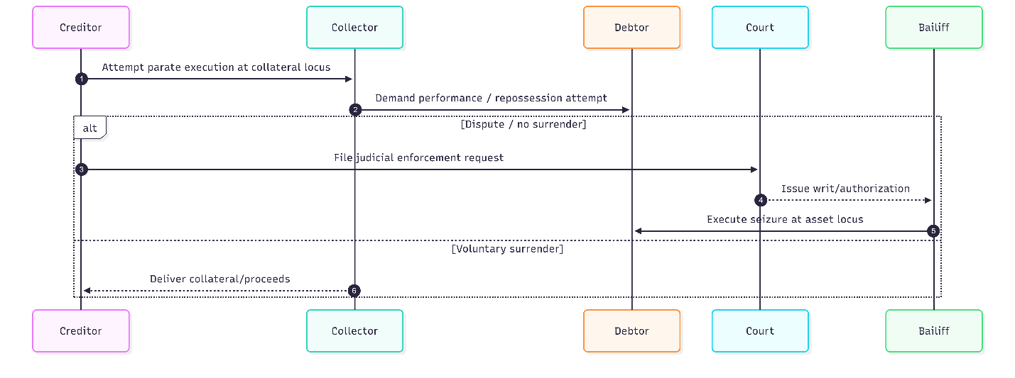
F1. Parate execution
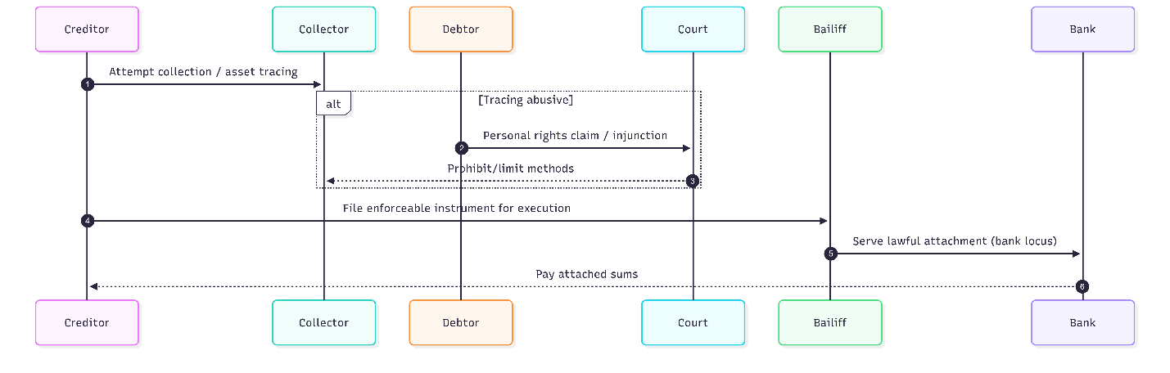
F2. Protective constraint
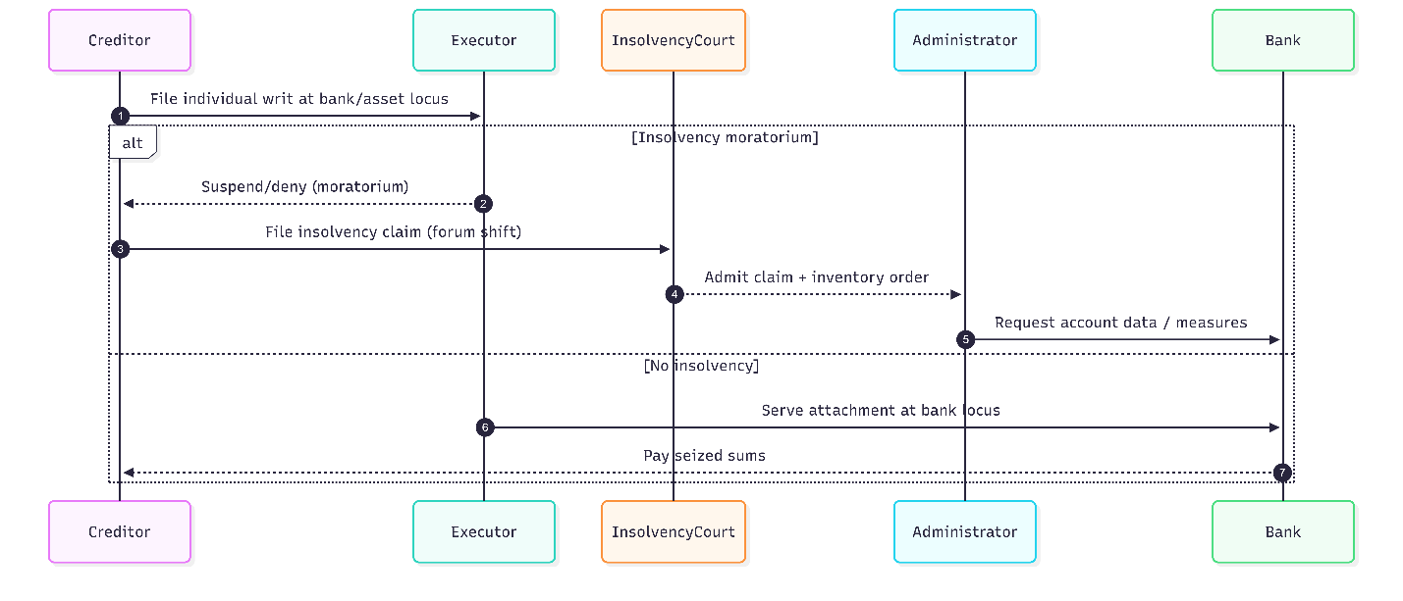
F3. Insolvency forum
Source: developed by the authors

Appendix B
Table ‒ Integrated bank-centric administrative and information metamodel for submitting enforcement documents by location of the debtor's financial assets
Optimization synthesis modelling phase
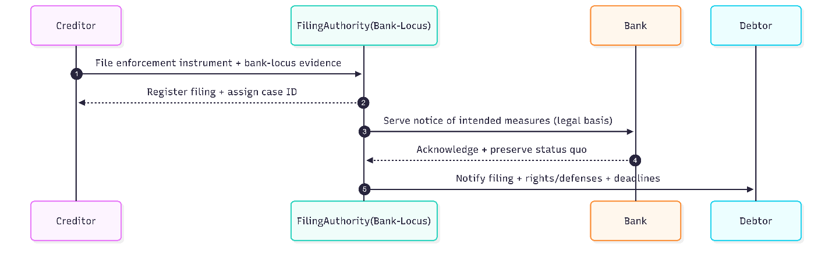
Phase 1 — Filing & Bank-Centric Territoriality
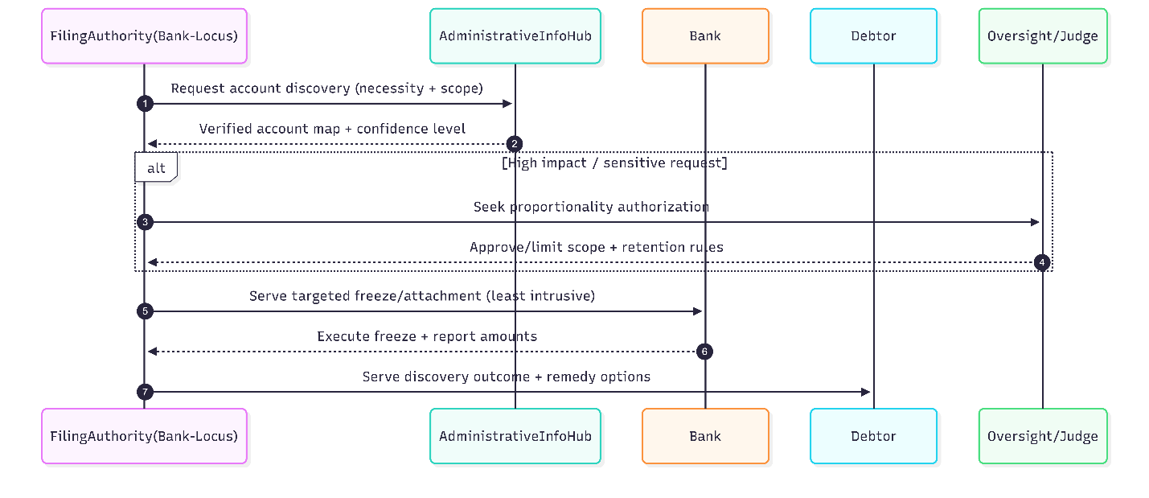
Phase 2 — Administrative-Informational Asset Discovery
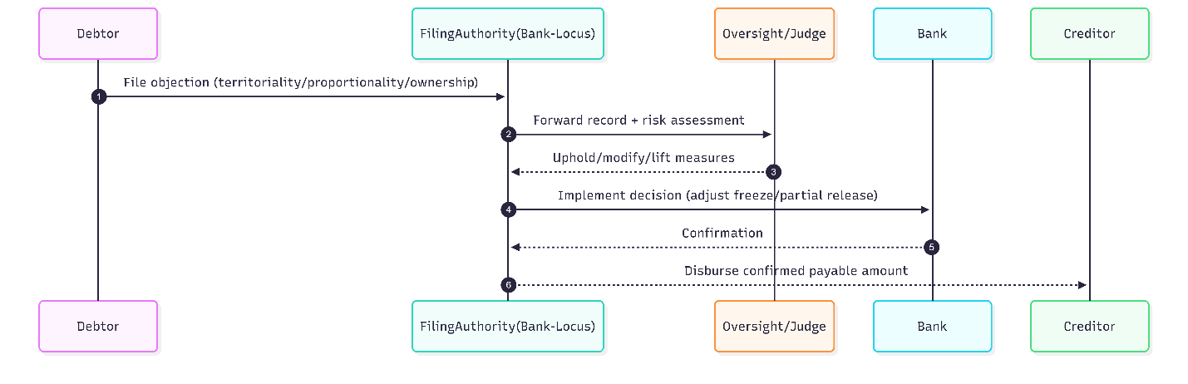
Phase 3 — Contestation, Review & Safeguards
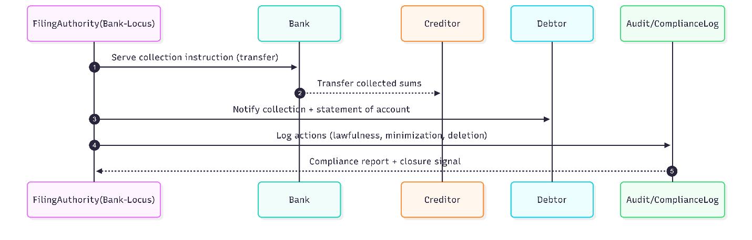
Phase 4 — Collection, Allocation & Closure
Source: developed by the authors

