**SCULPTURAL CONFIGURATION OF TABLETS ON CONSUMER’S ACCEPTABILITY OF ANTIHYPERTENSIVE MEDICINES IN ABIA STATE, SOUTH-EAST, NIGERIA.**

Chikelue Chris Akabuike

Department of Fine and Applied Arts,

University of Nigeria, Nsukka.

E-Mail: [chikelue.akabuike@unn.edu.ng](mailto:chikelue.akabuike@unn.edu.ng)

Phone: +2348063871617

Nkeiruka Grace Osuafor

Department of Clinical Pharmacy & Pharmacy Practice

Madonna University Nigeria

# **Abstract**

**Background**: The sculptural configurations (shapes, and sizes) of tablets may affect the acceptability of medicines among patients.

**Aim**: To assess the effects of sculptural configuration (shapes and sizes) of tablets on consumers' acceptability of antihypertensive medicines in Abia State, Southeast Nigeria.

**Method:** The study was a cross-sectional study conducted among hypertensive patients between April to August 2021. Five drawings of different shapes but the same size and three drawings of different sizes of tablets were presented to the patients. A self-administered questionnaire was used to collect data on the preferences of shapes and sizes of tablets. The data were analyzed with descriptive statistics using IBM SPSS version 23.

**Results:** The most preferred tablet sculptural configuration among the consumers was small-sized and round-shaped tablets. Capsules are also an acceptable dosage form for consumers of antihypertensive drugs.

**Conclusion:** The sculptural configurational design for the antihypertensive tablet should encompass a round-shaped small-sized tablet.

**Keywords:** Sculptural design, hypertensive patients, size, shape, tablet, drug acceptability.

# **INTRODUCTION**

Sculptural design has affected most of the works of humanity including tablet design. Tablet is a sculpted pharmaceutical solid dosage form containing drug substance generally with suitable diluents and prepared by either compression or molding methods.1 Tablets are widely manufactured and prescribed medicine dosage forms.2–4 They provide some advantages over other dosage forms.5 Consequently, most antihypertensive medicines are produced as tablets. Regular use of antihypertensive medicines is essential to achieving optimal blood pressure control among patients.6,7 Optimal blood pressure prevents the development of most myocardial localized necrosis, stroke, end-stage renal disease, and cardiovascular diseases 8. However, the medicine's aesthetic appeal may have an impact on the acceptability and use of antihypertensive medicines among consumers. Acceptability in this regard is the ability and willingness of the end-user to take the drug product as intended 9. To ensure optimal blood pressure control, anti-hypertensive medicines must be used as intended by hypertensive patients.

Acceptability of tablets by patients is paramount to adherence which ultimately affects treatment outcome.10,11 The sculptural design (shape and size) and aesthetic values of tablets may influence acceptability of medicines.10–12 Currently, medicines are produced to meet individual’s specific aesthetic needs through patient-centric medicine design.13 However, information on the acceptability of tablets due to the instrumentality of aesthetic values and sculptural configurations among hypertensive patients is scarce.

Sculptural configuration comprises shape, and size, these determine how patients visually perceive the tablets. It has been documented that the size and shape of tablets and capsules affect the preference, ease of swallowing" and oesophageal transit in adults.11,14. In considering the preference of size and shape, a large oblong tablet was preferred over a small and medium round tablet, while, a large capsule size is associated with higher strength of medicine 15. It was reported that difficulty in swallowing tablets increases with the size of the tablet, especially among patients with swallowing difficulties.11,16 The shape of tablets has been related to evoking body sensations and triggering energizing or calming effects.17 When tablets of preferred shapes, and sizes are prescribed for a patient, it increases their confidence in the physician and also compliance.18 Generally, these artistic designs and sculptural configurations of tablets usually determine how patients psychologically perceive these tablets. These psychological perceptions may also affect how easily a patient accepts or rejects the use of the tablet. Hence, the assessment of patient acceptability is a requirement for the development of pediatric medicinal products in Europe.19,20 However, the acceptability of tablets by hypertensive patients in Nigeria has often been neglected.

Hypertensive patients form the bulk of consultations in the outpatient department in hospitals. 21 Medicines remain the most effective method for control of hypertension as most hypertensive patients are eventually placed on medications.7 However, studies on antihypertensive tablets have focused on the prescription pattern of drugs.22,23 Other studies have assessed the availability of antihypertensive drugs in health facilities.24,25 There have also been investigations on adherence to antihypertensive medicines.26,27 Whereas, barriers to the use of medications may arise due to the sculptural configuration of these tablets 11. These barriers consequently lead to abandonment or noncompliance with medicines by hypertensive patients. To facilitate drug administration and overcome medication challenges among hypertensive patients, their needs and preferences should be considered in the drug product design. Therefore, this study was conducted to assess the effects of sculptural configurational of tablets on consumers' acceptability of antihypertensive medicines in Abia State, Southeast Nigeria.

In particular, the study examined how tablet size impacts a patient's willingness to take it, examined how tablet shape influences a patient's desire for antihypertensive tablets, and examined whether other solid dose forms are acceptable to hypertensive patients.

## **Material and Methods**

## **Study design and setting**

The study was a cross-sectional study conducted in the Federal Medical Centre (FMC) Umuahia, among hypertensive patients between April to August 2021. The center was chosen as a study site because it is the only tertiary hospital in Abia state with a great number of outpatient consultations.

## **Population and sample**

The population for the study consists of all hypertensive patients attending cardiovascular and family medicine clinics in FMC Umuahia. Based on the data collected on the number of patients consulted for hypertension monthly, a sample size of 286 patients was calculated using sample size calculation tables at a 95% confidence level and precision level of ±5. The sample was selected using a convenient sampling method. Participants were hypertensive patients who had been taking their medications for at least three months and picked up their prescriptions from the hospital's National Health Insurance Pharmacy section. The study excluded patients who were not cooperating and elderly people without informed caregivers.

## 

**Study Instrument**

The study instrument was a 23 items self-administered questionnaire developed after reviewing various questionnaires that have been used in accessing the acceptability of oral solid dosage forms.3,11,14 Experts in questionnaire design analyzed the survey questions and made necessary modifications. To test the comprehension of the question, it was piloted on 20 hypertensive patients who were collecting medication in the Federal Medical Centre Umuahia's General Outpatient Department Pharmacy. Corrections were made to the questionnaire before it was administered to the participants. There were six sections in the questionnaire. The first section focused on demographic information, the second on color preferences, the third on size information, the fourth on shape information, the fifth on the packaging, and the sixth on the acceptability of alternative tablet designs. In this paper, we discuss the data on the acceptability of sizes, shapes, and alternative dosage forms.

**Data collection and analysis**

Hypertensive patients collecting their medicines from the National Health Insurance Pharmacy unit of the hospital were invited to participate in the study. A structured self-administered questionnaire was used to collect data on the preferences of sizes and shapes of tablets. The acceptability of sizes was investigated with a picture (Figure 1) of three different sizes of tablets of the same shape and color. The picture was given to each respondent from where they answered questions on their most preferred size, which is the size they will prefer to swallow, and the least preferred size. They were asked to choose the size that they think will produce the most antihypertensive effect and the least antihypertensive effect. The three tablets had different diameters of 8.05mm, 9.85mm, and 11.95mm denoted as small, medium, and large sizes respectively 28.

**(Insert figure 1 here).**

To assess their acceptability for shapes of the tablet, five drawings (Figure 2) of tablets with the same size but various shapes were presented to the patients. They were asked to choose the shape of the tablet which appeals to them most and which they will prefer most to swallow, the second preferred shape, and the least preferred shape.

**(Insert figure 2 here).**

To make the study more robust, questions were asked on other types of oral solid dosage forms that will be preferred by the patient. A capsule, granules in the sachet, effervescent tablet, orally disintegrating tablet, and chewable tablet were presented to the patient. The method of administration was explained to the patient and they were asked to choose their preferred oral solid dosage form. The questionnaire was filled out and returned on the spot. The participants signed a consent form before participating in the study.

All collected data were analyzed with descriptive statistics using IBM Statistical Package for Service Solution version 23 29.

# **RESULTS**

## **Demographic variables**

A total of two hundred and eighty-five (285) questionnaires were valid and analyzed. Approximately three quarter of the respondents were males (n=200;70.2%). More than half (n=152;53.3%) of the patients were between 41-50 years of age. A little more than a quarter (n=95; 33%) earned between N201,000 to N300,000 in a month. An equal proportion (n=95;33.3%) rated their health status as good or fair. Demographic variables are detailed in Table 1.

**(Insert Table 1 here)**

**Preference of size**

Most respondents (n = 209; 73.3%) preferred to swallow the small-sized tablet while the remaining choose the medium-sized and none choose the large-sized tablet for swallowing. Large sized tablets were the least preferred (n = 171; 60%). More than half (n = 171; 60%) of the respondents felt small-sized tablets will produce the best antihypertensive effect. Table 2. shows the details of size preferences.

**(Insert Table 2 here)**

## **Acceptability of shapes**

The round-shaped tablet was the first (n =190; 66.7%) and second (n = 133; 46.7%) most preferred shape of tablet for antihypertensive drug consumers. A heart-shaped tablet was not chosen as the first preferred tablet but was the second option for one-fifth (n = 57; 20%) of the respondents. The least preferred shape of tablet was triangular shaped (n =133; 46.7%). Acceptability of shape is detailed in Table 3.

**(Insert Table 3 here)**

## **Acceptability of other solid dosage forms**

Most consumers preferred antihypertensive medicines to be formulated as a capsule (n = 190; 66.7%). A fewer proportion (n = 38; 13.30%) accepts dispersible tablets while none choose granules in sachet and chewable tablets. The reason for choosing each of the dosage forms was the same as all respondents said their choice is easier to swallow.

**(Insert Figure 3 here)**

# **DISCUSSION**

The study investigated the effects of the sculptural configuration of tablets on consumers' acceptability of antihypertensive medicines in Abia State, Southern Nigeria. The sculptural designs are the sizes and shapes of tablets that might affect the acceptability of the medicines.

Most of the patients (70.2%) that have antihypertensive drugs on their prescription and were consequently included in the study were males. The male proportion is higher than in other reports in Southern Nigeria (46.2%) 30, and (52.8%) 31. This might be attributed to the higher utilization of drugs by the male gender under the National Health Insurance Scheme 32. Small-sized tablets were accepted by most of the respondents, which is similar to other studies. 3,18,33 This may be attributed to easy transit attributed to small-sized tablets along the esophagus 11.

The first and second most preferred shape of antihypertensive tablets in FMC Umuahia was round while the oval shape was not taken as a first choice but was chosen by more consumers as a second option. This contradicts a Malaysian report 18 of oval shape as the first choice while the circular shape was the second. The difference is that our study investigated consumers of the same African descent. Again, our study looked at only tablets as against other solid dosage forms. This might also imply that round and oval shapes are acceptable shapes for oral dosage forms.

Consumers preferred antihypertensive drugs to be capsules which contradicts orally disintegrating tablets 3. In contrast, the preference for capsules in our study corresponds to a Malaysian study 33. The difference may be attributed to the ages of the respondents included in our study. Patients had a low preference for granules in a sachet which is similar to another report among gastroenteritis patients that rejected granules 12. The study reported no reason for rejection of granules except that patients preferred tablets. This might imply that disease conditions may play a role in the nature of the solid dosage form accepted by patients. However, the reason for choosing capsule as an alternative dosage form was the ease of swallowing which has been reported in other studies. 14,34

# **CONCLUSION**

From the results, the preferred size and shape of antihypertensive are small-sized and round shapes respectively. We concluded that antihypertensive tablets should be designed in small-sized and round-shaped configurations. The capsule is an acceptable dosage form for hypertensive patients in Abia State. These sculptural designs will increase consumers’ acceptability of antihypertensive tablets.

# REFERENCES

1. Bhowmik D, Duraivel S, Rajalakshmi AN, Kumar KPS. Tablet manufacturing processs and defects of tablets. *Elixir Int J Pharm*. 2014;70:24368-24374.

2. Shendge RS, Salunkhe KS, Girish K. Formulation development of modified release dosage form of antihypertensive drug. *Eur J Mol Clin Med*. 2020;7(4):2124-2133.

3. Alyami H, Dahmash E, Alyami F, et al. Dosage form preference consultation study in children and young adults : paving the way for patient-centred and patient-informed dosage form development. *Eur J Hosp Pharm*. 2017;24:332-337. doi:10.1136/ejhpharm-2016-001023

4. Tiwari S, Mahapatra SP. Dosage Unit Dosages Form:Tablet An overview. *Int J Humanit Enginerring Pharm Sci*. 2015;1(9).

5. Lopez FL, Ernest TB, Tuleu C, Gul MO. Formulation approaches to pediatric oral drug delivery : benefits and limitations of current platforms. *Expert Opin Drug Deliv*. 2015;12(11):1727-1740. doi:10.1517/17425247.2015.1060218

6. Piepoli MF, Hoes AW, Agewall S, et al. 2016 European Guidelines on cardiovascular disease prevention in clinical practice. *Eur Heart J*. 2016;37(29). doi:10.1093/eurheartj/ehw106

7. Chobanian A V, Bakris GL, Black HR, et al. The Seventh Report of the Joint National Committe on Prevention , Detection , Evaluation , and Treatment of High Blood Pressure. *US Dep Heal Hum Serv*. Published online 2004:49.

8. Mathers CD, Loncar D. Projections of global mortality and burden of disease from 2002 to 2030. *Plos Med*. 2006;3(11):e442. doi:10.1371/journal.pmed.0030442

9. Goyanes A, Scarpa M, Kamlow M, Gaisford S, Basit AW, Orlu M. Patient acceptability of 3D printed medicines. *Int J Pharm*. 2017;530(1-2):71-78. doi:10.1016/j.ijpharm.2017.07.064

10. Drumond N, van Riet-Nales DA, Karapinar- Carkit F, Stegemann S. Patients’ appropriateness, acceptability, usability and preferences for pharmaceutical preparations: Results from a literature review on clinical evidence. *Int J Pharm*. Published online 2017. doi:10.1016/j.ijpharm.2017.02.029

11. Liu F, Ghaffur A, Bains J, Shaheen H. Acceptability of oral solid medicines in older adults with and without 1 dysphagia: a nested pilot validation questionnaire based observational 2 study. *Int J Pharm*. 2016;512(2):374-381. doi:https://doi.org/10.1016/j.ijpharm.2016.03.007

12. Mackenzie-smith L, Marchi P, Timeus S. Patient Preference and Physician Perceptions of Patient Preference for Oral Pharmaceutical Formulations : Results from a Real-Life Survey. *Inflamm Intest Dis*. 2018;3:43-51. doi:10.1159/000493346

13. Møller M, Natalja F, Susanne G, Sofia K, Sporrong K. Perceptions , preferences and acceptability of patient designed 3D printed medicine by polypharmacy patients : a pilot study. *Int J Clin Pharm*. Published online 2019. doi:10.1007/s11096-019-00892-6

14. Ibrahim IR, Mohamed IMI, Al-haddad M. Prefernces of colour, size, shape, and taste of oral solid dosage forms. *Pharmacologyonline*. 2010;2:754-762.

15. Köteles F, Fodor D, Cziboly Á, Bárdos G. Expectations of Drug Effects Based on Colours and Sizes – the Importance of Learning. *CEMED*. 2009;3(1):99-107. doi:10.1556/CEMED.3.2009.1.9

16. Overgaard ABA, Højsted J, Hansen R, Christrup LL. Patients ’ evaluation of shape , size and colour of solid dosage forms. *Pharm World Sci*. 2001;23(5):185-188.

17. Blazhenkova O, Dogerlioglu-demir K. The shape of the pill : Perceived effects , evoked bodily sensations and emotions. *PLoS One*. 2020;15(9):1-23. doi:10.1371/journal.pone.0238378

18. Hasamnis A, Patil S, Mohanty BK, Thu K, Kumar A. Attitude of doctors towards physical characteristics of solid oral dosage forms. *J Pharm bioallied Sci*. 2010;2(2):151. doi:10.4103/0975-7406.66998

19. European Medicines Agency (EMA). *Guidelines on Pharmaceutical Development of Medicines for Paediatric Use*. European Medicines Agency (EMA); 2013. doi:10.1001/archderm.1970.04000010065011

20. Kozarewicz P. Regulatory perspectives on acceptability testing of dosage forms in children. *Int J Pharm*. 2014;469(2):245-248. doi:10.1016/j.ijpharm.2014.03.057

21. Karimi A, Haerizadeh M, Soleymani F, Haerizadeh M, Taheri F. Evaluation of medicine prescription pattern using World Health Organization prescribing indicators in Iran : A cross ‑ sectional study. *J Res Pharm Pract*. 2014;3(2):39-45. doi:10.4103/2279-042X.137058

22. Osuafor NG, Ukwe CV, Okonta MJ. Prescription pattern of cardiovascular and / or antidiabetic drugs in Abuja district hospitals. *Int J Pharm Pharm Sci*. 2019;11(9):21-27.

23. Ukwe C V, Ubaka CM. Antihypertensive drug prescribing in a tertiary hospital in Eastern Nigeria. *Trop J Pharm Res*. 2012;11(February):297-305.

24. Osuafor NG, Ukwe CV, Okonta M. Evaluation of affordability of cardiovascular , diabetes , and global medicines in Abuja, Nigeria. *PLoS One*. 2021;16(8). doi:10.1371/journal.pone.0255567

25. Kaiser HA, Hehman L, Forsberg BC, Simangolwa M, Sundewall J. Availability , prices and affordability of essential medicines for treatment of diabetes and hypertension in private pharmacies in Zambia. *PLoS One*. 2019;14(12):1-18. doi:https://doi.org/10.1371/journal.pone.0226169

26. Hilleman DE. Adherence and Health Care Costs with Single-Pill Fixed-Dose Combinations in Hypertension Management. 2014;20(1):93-100.

27. Okwuonu CG, Ojimadu NE, Okaka EI, Akemokwe FM. Patient-related barriers to hypertension control in a Nigerian population. *Int J Gen Med*. 2014;7:345-353. doi:10.2147/IJGM.S63587

28. Kandela B, Sheorey U, Banerjee A, Bellare J. Study of tablet-coating parameters for a pan coater through video imaging and Monte Carlo simulation. *Powder Technol*. 2010;204(1):103-112. doi:10.1016/j.powtec.2010.07.024

29. Nile N, Dale H, Bent C, Hadlai H. statistical product and service solution (SPSS). Published online 2018.

30. Etuk E, Isezuo SA, Chika A, Akuche J, Ali M. Prescription pattern of anti-hypertensive drugs in a tertiary health institution in Nigeria. *Ann Afr Med*. 2008;7(3):128-132.

31. Ekwunife OI, Ubaka CM. Drug Utilization Review of Antihypertensive Therapy Among Patients with Compelling Indications in two Hospitals in South-Eastern Nigeria. *J Pharm Pharmacol Res*. 2011;2(1):25-28.

32. Okoro RN, Shekari BG. Physicians’ drug prescribing patterns at the national health insurance scheme unit of a teaching hospital in the North Eastern Nigeria. *Arch Pharm Pract*. 2013;4(1):3-9. doi:10.4103/2045-080X.111574

33. Ibrahim IR, Mohamed IM, Al-haddad M. Consumer Preferences and Perceptions towards the use Colored Oral Solid Dosage Forms in Baghdad. *Arch Pharm Pract*. 2010;1(1):15-19.

34. Buckalew LW, Coffield KE. An investigation of drug expectancy as a function of capsule colour and size and preparation form. *J Clinial Psychopharmacol*. 1982;2(4):245-248.

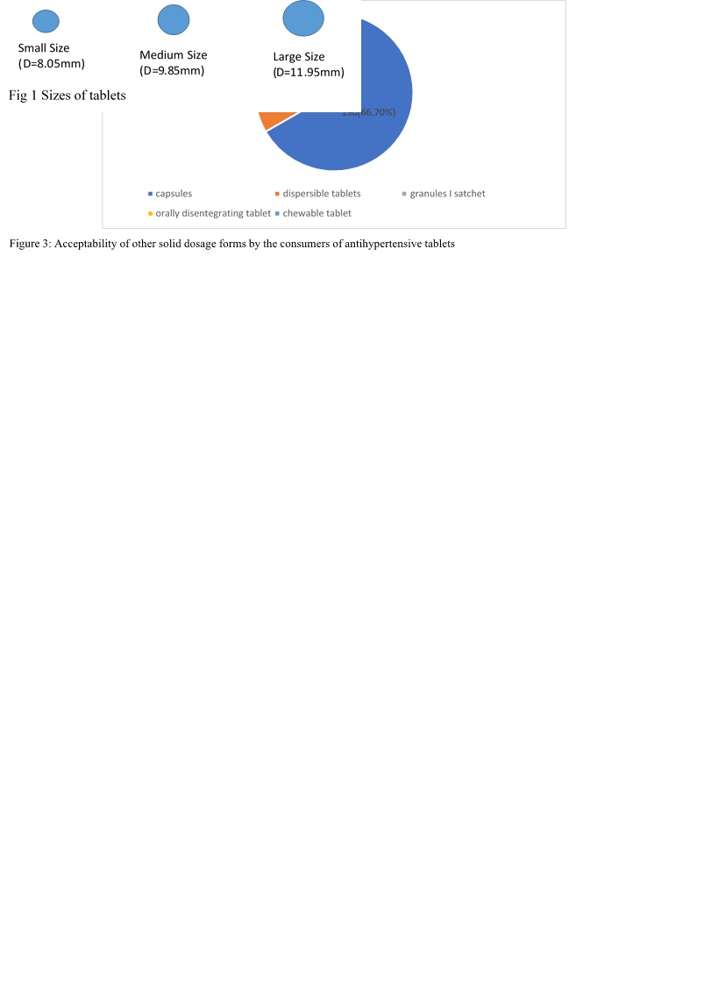

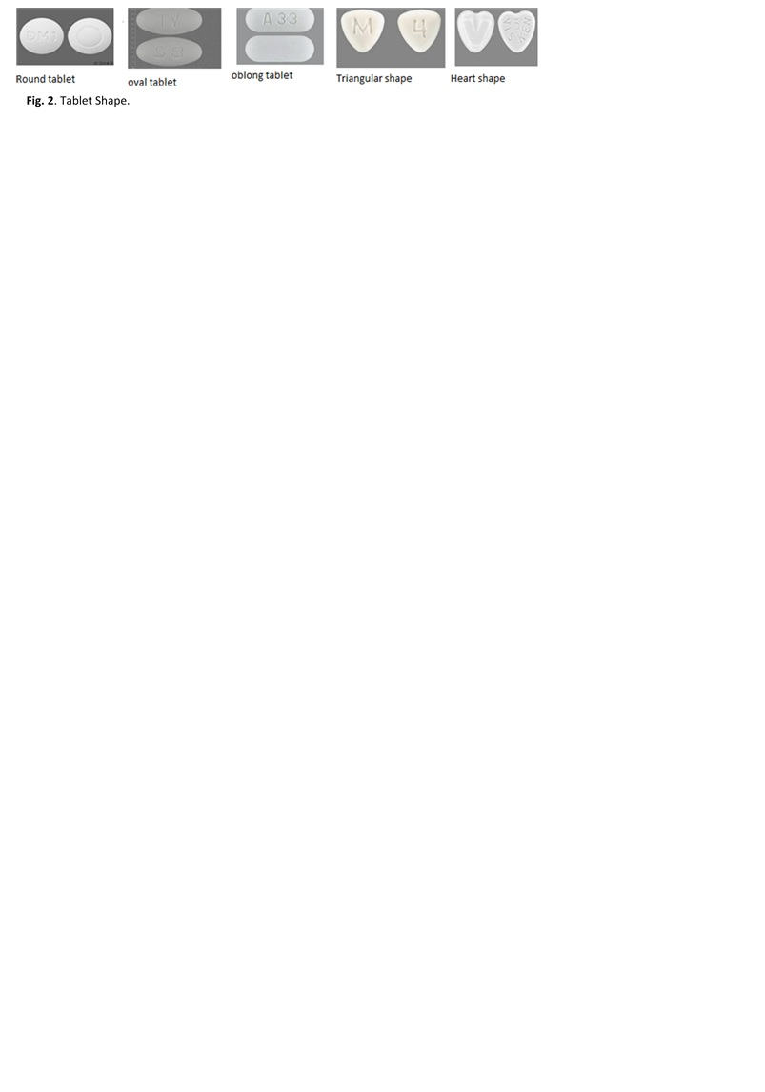

**Table. 1 demographic data of respondents**

|  |  |  |
| --- | --- | --- |
| Demographic variables | n | % |
| **Gender** |  |  |
| Females | 85 | 29.8 |
| Males | 200 | 70.2 |
| **Age of the respondents** |  |  |
| ≤40 | 76 | 26.7 |
| 41-59 | 152 | 53.3 |
| ≥60 | 57 | 20 |
| **Highest educational qualification** |  |  |
| ≤ primary school | 19 | 6.7 |
| Secondary | 38 | 13.3 |
| Tertiary | 190 | 66.7 |
| Higher degree | 38 | 13.3 |
| **Monthly income** |  |  |
| ≤100,000 | 57 | 20 |
| 101,000-200,000 | 76 | 26.7 |
| 201,000-300,000 | 95 | 33.3 |
| >300,000 | 57 | 20 |
| **Health status** |  |  |
| Excellent | 38 | 13.3 |
| Very good | 57 | 20 |
| Good | 95 | 33.3 |
| Fair | 95 | 33.3 |
| Poor |  |  |
| The average number of tablets swallowed daily |  |  |
| 1-2 | 38 | 13.3 |
| 3-4 | 114 | 40 |
| 5-6 | 76 | 26.7 |
| >6 | 57 | 20 |

**Table 2. Respondents' antihypertensive tablet size preference**

|  |  |  |
| --- | --- | --- |
| Acceptability of sizes | N | % |
| Size of tablet respondents most preferred to swallow |  |  |
| Small | 209 | 73.3 |
| Medium | 76 | 26.7 |
| Large | 0 | 0 |
| Total | 285 | 100 |
| Least preferred size of tablet |  |  |
| Small | 38 | 13.3 |
| Medium | 76 | 26.7 |
| Large | 171 | 60 |
| Total | 285 | 100 |
| The size that will produce the best antihypertensive effect |  |  |
| Small | 171 | 60 |
| Medium | 95 | 33.3 |
| Large | 19 | 6.7 |
| Total | 285 | 100 |
| Size of the tablet with the least antihypertensive effect |  |  |
| Small | 76 | 26.7 |
| Medium | 57 | 20 |
| Large | 152 | 53.3 |
| Total | 285 | 100 |

**Table 3**. Shapes of tablets preferred by consumers of antihypertensive drugs

|  |  |  |
| --- | --- | --- |
| Acceptability of tablet shapes | N | % |
| The shape of tablet the respondents most preferred to swallow |  |  |
| Round | 190 | 66.7 |
| Oval | 19 | 6.7 |
| Triangle | 38 | 13.3 |
| Oblong | 38 | 13.3 |
| Heart | 0 | 0 |
| Total | 285 | 100 |
| Second most preferred tablet shape |  |  |
| Round | 133 | 46.7 |
| Oval | 95 | 33.3 |
| Triangle | 0 | 0 |
| Oblong | 0 | 0 |
| Heart | 57 | 20 |
| Total | 285 | 100 |
| Least preferred tablet shape |  |  |
| Round | 38 | 13.3 |
| Oval | 0 | 0 |
| Triangle | 133 | 46.7 |
| Oblong | 95 | 33.3 |
| Heart | 19 | 6.7 |
| Total | 285 | 100 |

