AUTOMATIC SPEAKER VERIFICATION USING AMALGAMATED FEATURES EXTRACTION AND CLASSIFICATION
Krithika Venket V S^{1*}, Safia Naveed²
¹Assistant Professor, Department of Information Technology, KCG College of Technology, Karapakkam, Chennai, TamilNadu, India - 600097
²Associate professor, Department of Computer Science Engineering, KCG College of Technology, Karapakkam, Chennai, TamilNadu, India - 600097
Corresponding author: Krithivenket07@gmail.com¹
Abstract: Automatic Speaker Verification Using Amalgamated Features Extraction and Classification Using Deep Learning aims to enhance the accuracy of speaker verification systems by leveraging a combination of advanced acoustic features and a robust deep learning classifier. In this research, key acoustic features such as Mel-frequency cepstral coefficients (MFCC), Short-time Fourier transform (STFT), power spectrogram, mel-scaled spectrogram, spectral contrast, and tonal centroid features (tonnetz) are meticulously extracted from speech signals in enrolment phase. These features capture diverse aspects of speech, including frequency distribution, energy levels, and tonal variations, which are crucial for distinguishing between speakers. The extracted features are amalgamated to form a comprehensive feature set that provides a rich representation of the speaker’s unique voice characteristics. In the authentication phase, a novel deep learning-based classifier, referred to as Amalgamated Deep Neural Network for Automatic Speaker Verification (ADNNASV), is employed. This classifier is designed to efficiently handle the complexity of the amalgamated feature set, ensuring robust performance in differentiating between speakers. By integrating these sophisticated features with the deep classifier, the system demonstrates an improved ability to verify speakers, even in challenging conditions such as noisy environments or variations in speech patterns. The combination of feature extraction techniques and the amalgamated classifier contributes to a significant improvement in the accuracy and reliability of automatic speaker verification systems, making this approach a promising advancement in the field of speech recognition and authentication.
Keywords: Speaker Verification, Audio Feature Extractions, Deep Learning Algorithm
- INTRODUCTION
Automatic speaker verification is a biometric technique that aims to verify the identity of a speaker based on their unique vocal characteristics. This technology has found its way into various applications, such as access control systems that authenticate individuals before granting them access to secure facilities or resources, financial transaction platforms that utilize voice-based authentication to protect sensitive information, and security systems that leverage speaker verification to bolster overall security measures.
The fundamental principle behind automatic speaker verification is the premise that each individual possesses a unique voice signature, much like a fingerprint or iris pattern. By extracting and analyzing various acoustic features from a speaker's voice, these systems can reliably distinguish one individual from another, enabling secure and convenient authentication.
The process of automatic speaker verification typically involves two phases: enrollment and authentication. During the enrollment phase, the system collects and processes speech samples from the user, extracting relevant features that will later be used to build a unique voice model or template for that individual. In the authentication phase, the system compares the features extracted from the user's current speech sample against the previously stored template, determining whether the claimed identity matches the individual's true identity.
Challenges and difficulties in speaker recognition
Speech recognition is still a very cumbersome problem; Following are the problem that is still challenges for speaker recognition.
1. Body language
Automatic speaker recognition system recognizes a person through their voice whereas ahuman speaker communicates with speech along with some body language. Such type of information is completely missed by Automatic speaker recognition system.
2. Noise
Speech is expressed in a domain of sounds, a clock ticking, a PC humming, a radiosound and a human speaker in background and so forth. This is generally known as noise that is, undesirable data in the speech signal. ASR helps in identifying and filtering such noises from the sample speech signal.
3. Spoken language ̸Written language
Communication in spoken language has been recognized as less complicated whencompared to written language for a long time. The spoken language has several performance errors and is grammatically not much complex at the time of speaking. In any case, it has gotten clear over the most recent years that communication through spoken language is different from written language. These differences have to be identified and addressed with the help of ASR. Written language is normally a single direction correspondence whereas the speech is dialogue exchange oriented.
4. Realization
The acknowledgment of speech changes after some time. If similar words were utteredagain and again, the subsequent speech signal could never appear to be identical. Regardless of whether the speaker attempts to sound precisely the equivalent, there will consistently be some little contrasts in the acoustic wave produced by the speaker.
5. The gender of the speaker
People have various voices, and the fundamental motivation to this is ladies have all inall shorter vocal tract when compared to men. The principal tone of ladies' voices is approximately twice than that of men's as a result of this distinction.
6. Anatomy of vocal tract
Each speaker has remarkable physical traits, and this influences the speech. The variousattributes such as vocal cord length and its shape, cavity formation and lungs size etc. changes over time. These properties change after some time, depending on the age as well as health of the speaker.
7. Speed of speech
A speaker talks in various methods of speed in various occasions. The speaker speaksfaster in stressed condition and speaks slow in tired situation. A person likewise talks invarious speeds in the event of known or unknown matters.
Goal of the research work
The main objective of this research work is to design and develop a robust and portablespeaker verification system in noisy environment. It has been observed that the performance of the speaker verification system degrades in mismatch conditions.The main goal of this work is to design and develop a speaker verification system with high accuracy.
Chapter 1 gives an introduction of speaker recognition and stages of speaker recognitionfrom speech and a brief history of speaker verification research. The overview of the research problem and main objectives of the thesis have also been stated elaborately in this chapter. Chapter 2 gives literature review on speaker recognition, robust speaker recognition, feature extraction, classifications and normalization techniques. Chapter 3 describes details proposed techniques such as database consideration, framework evaluation, feature extraction techniques, classifications and normalization processes.Chapter 4 describes the experimental setup. Chapter 5 highlights the concluding remarks based on the present study as well as various tools and the techniques used during the study with their relative advantages and disadvantages. Finally, the possible benefits, which can be acquired by further extending the present study, have been discussed. Scope of future work is also discussed.
- RELATED WORKS
Automatic Speaker Verification (ASV) systems have become an integral part of biometric security applications, offering a reliable means of identity verification through voice recognition. However, the growing sophistication of spoofing attacks, such as replay, synthesized, and adversarial attacks, poses a significant challenge to the robustness of these systems. Recent research has focused on improving the resilience of ASV systems by developing advanced detection techniques and countermeasures. In this context, several studies have explored the vulnerabilities of ASV systems and proposed novel approaches to enhance their performance in the face of emerging threats.
He, Z., & Wu, T. (2020) have proposed a novel data-driven filter design method for speech processing, which optimizes filter parameters using speech data. It introduces a frame-selection approach to develop a speech-signal-based frequency warping scale and employs principal component analysis (PCA) to compute filter frequency responses. Unlike deep learning-based methods, the proposed method requires minimal unlabeled speech data. Experiments in automatic speaker verification (ASV) demonstrate that the new filterbank outperforms the traditional melfilterbank, mel-frequency cepstral coefficients (MFCCs), and speech-signal-based frequency cepstral coefficients (SFCCs). Significant improvements were observed in equal error rate (EER) for speaker verification tasks using VoxCeleb1, with 9.75% improvement over MFCCs for the i-vector back-end and 4.43% improvement for the x-vector system. Further enhancement was achieved by fusing the proposed method with the MFCC-based approach.
Avila, A. R., O’Shaughnessy, D., & Falk, T. H. (2021) have addressed the challenge of intra-speaker variability due to emotional speech, which negatively impacts speaker recognition systems. Unlike the focus on mitigating channel effects or spoofing attacks, limited research has targeted the effects of emotional variability. The authors propose a method to reduce the mismatch between neutral and emotional speech using a Gaussian mixture model to learn a prior distribution of neutral speech for each speaker. This model helps minimize differences between neutral and affective speech spaces. Validated on four multilingual emotional datasets, the method shows consistent improvement across eight emotional states, significantly reducing the equal error rate compared to the baseline.
Dua, M., Sadhu, A., Jindal, A., & Mehta, R. (2022) have focused on enhancing Automatic Speaker Verification (ASV) systems, which verify identity based on voice, to resist malicious replay attacks. While most existing approaches target single-replay attacks, the authors explore a multi-replay attack detection scenario using three back-end models: Convolutional Neural Network (CNN), Long Short-Term Memory (LSTM), and a hybrid of both. The hybrid model employs mel-spectrograms for the CNN-based part and Constant-Q Cepstral Coefficients for the LSTM. Tested on the Voice Spoofing Detection Corpus, the hybrid model outperforms others, achieving an Equal Error Rate (EER) of 0.036 for single-replay attacks and 0.0296 for two-replay attacks. Additionally, the model shows noise robustness, making it suitable for diverse environments and future research.
In recent advancements in Automatic Speaker Verification (ASV) systems, the work by Dua, Joshi, and Dua (2023) introduces a novel approach leveraging data augmentation techniques to improve speaker verification. Their research emphasizes the importance of enriching training datasets to enhance the robustness and accuracy of ASV systems, particularly in challenging scenarios. The method demonstrated significant improvements, suggesting that data augmentation can help overcome limitations caused by limited or imbalanced datasets in speaker verification tasks.
Similarly, Sankala and Kodukula (2023) explored a different aspect of ASV systems by focusing on the adversarial vulnerabilities of activation functions. Their study highlights how specific activation functions, integral to the deep learning architectures used in ASV systems, are susceptible to adversarial attacks. This research sheds light on the security aspects of ASV systems, emphasizing the need for more robust defenses against such vulnerabilities to ensure reliable speaker verification in adversarial environments.
Together, these studies contribute to the growing body of knowledge on improving the performance and security of ASV systems, with one focusing on data-driven enhancements and the other on securing the systems against malicious attacks.
Mittal and Dua (2022) provide a comprehensive review and analysis of automatic speaker verification (ASV) systems, focusing on the growing threat of spoofing attacks and the various techniques developed to detect them. Their study critically examines different spoof detection methods, highlighting the need for robust countermeasures in ASV systems to maintain reliability in security-sensitive applications.
Yoon et al. (2020) present a novel replay attack that targets ASV systems, revealing vulnerabilities in the systems' defenses against replayed audio inputs. Their findings emphasize the importance of developing stronger protections against replay attacks, a significant challenge in ASV systems' security landscape.
Das et al. (2020) explore the attacker's perspective on ASV systems, providing an overview of how malicious entities can exploit weaknesses in these systems. This research offers valuable insights into the methods attackers use, underscoring the importance of proactive defenses in the design of future ASV systems.
Khan et al. (2022) investigate the impact of the COVID-19 pandemic on ASV systems, particularly how the widespread use of face masks and altered speech patterns during the pandemic have affected verification accuracy. Their work calls for realigning ASV techniques to adapt to these new challenges, ensuring reliable performance even in the era of COVID-19.
Delgado et al. (2021) discuss the ASVspoof 2021 challenge, which evaluates the performance of ASV systems in detecting spoofing attacks. The paper outlines the evaluation plan and stresses the importance of continuous advancements in countermeasures to keep pace with evolving spoofing techniques.
Tong et al. (2021) introduce ASV-Subtools, an open-source toolkit designed to facilitate the development and evaluation of ASV systems. This toolkit provides researchers and developers with a practical resource for improving system performance, particularly in the face of diverse verification challenges.
Finally, Gao et al. (2021) examine the detection and evaluation of human- and machine-generated speech in spoofing attacks on ASV systems. Their work contributes to the development of more effective detection mechanisms, highlighting the importance of distinguishing between genuine and spoofed speech in real-world ASV applications.
In conclusion, the growing threat of spoofing attacks necessitates continuous advancements in the development of robust ASV systems. The reviewed studies highlight various approaches, from data-driven techniques to new tools and evaluations, that aim to improve ASV systems' resistance to attacks. Addressing these challenges will be key to ensuring the reliability and security of ASV systems in a variety of real-world applications.
- METHODOLOGY

Speaker recognition systems generally operate in four main stages: preprocessing, front-end processing, training/modeling, and validation. Here's a breakdown of these stages:
Preprocessing:
This is the first and crucial step in the speaker recognition process. During this phase, the input speech signal is prepared for further analysis by performing several key operations. These include filtering to remove unwanted noise, normalization to adjust the signal's amplitude, transformation, trimming, alignment, windowing, and smoothing. Offset correction is also applied to account for any shifts in the signal. The goal of preprocessing is to create clean, high-quality feature vectors that represent the speaker's voice. This step plays a pivotal role in improving the system’s overall performance by eliminating background noise and enhancing the clarity of the input speech signal.
Feature Extraction:
At this stage, the preprocessed speech signal is analyzed to extract meaningful information. In the process of speech production, both biological and behavioral characteristics are linked to the speaker's identity. These unique traits are found in the spectral and supra-segmental features of a speech signal. Among these, spectral-based features are the most commonly used in speaker recognition systems (SRS). These extracted features are critical for both training and testing the system. Some popular techniques for representing speech signals include Mel-frequency cepstral coefficients (MFCC), Short-time Fourier transform (STFT), power spectrogram, mel-scaled spectrogram, spectral contrast, and tonal centroid features (tonnetz). While various methods exist, MFCC remains the most widely used for feature extraction in speaker verification systems due to its effectiveness in capturing speaker-specific characteristics.
Training
Automatic speaker recognition essentially involves analyzing speech, extracting its features, and modeling them into a vector, using Amalgamated Deep Neural Network Automatic Speaker Verification algorithm during the training phase, as well as sorting control records based on specific patterns during the validation phase.
Testing:
Testing stage is the last period of SRS and is performed in the wake of preparing stage. During the testing (or acknowledgment) stage, the speaker acknowledgment framework is presented to speech data not seen during the preparation stage. Speech samples from an obscure speaker or from an inquirer are utilized to ascertain feature vectors utilizing a similar technique as in the enrolment procedure. These vectors are then passed to the classifier that plays pattern making task deciding the nearest coordinating speaker model. This procedure brings about a decision making process which decides either the speaker character (in speaker identification) or acknowledges/rejects the petitioner personality (in speaker confirmation) as can be seen.
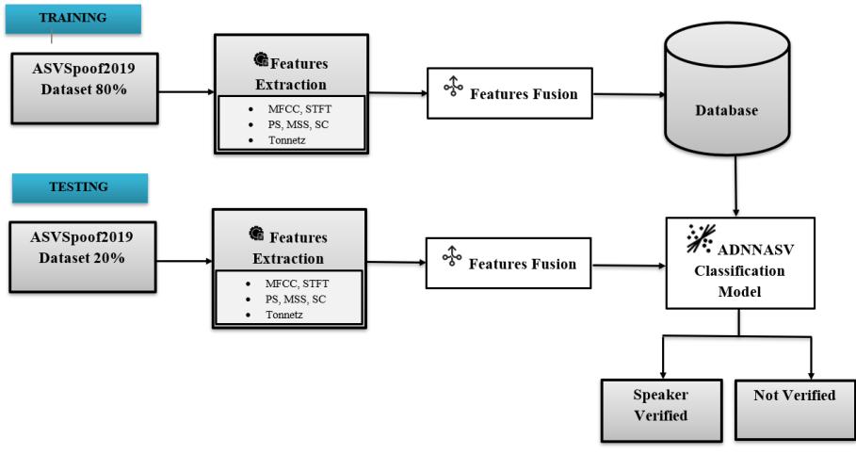
Figure 1: System Flow Diagram
The above diagram illustrates the training and testing process of the proposed system. The ASVSPoof2019 dataset is divided into 80% as training set and 20% as testing set. Then features are extracted using following feature extraction techniques like Mel-frequency cepstral coefficients (MFCC), Short-time Fourier transform (STFT), power spectrogram, mel-scaled spectrogram, spectral contrast, and tonal centroid features (tonnetz). The extracted features are fused and train the model. Finally testing set is evaluated against trained ADNNASV model and predict the result as “Speaker verified or Not”.
- EXPERIMENTAL RESULTS
This chapter compares the performance of the Amalgamated Deep Neural Network for Automatic Speaker Verification (ADNNASV) with two commonly used models: Convolutional Neural Networks (CNN) and Gaussian Mixture Models (GMM).
The models are evaluated in two conditions: with feature fusion and without feature fusion. Two key performance metrics, accuracy and error rate, are used to assess their performance:
Accuracy: Represents the proportion of correctly classified speaker verifications out of the total verifications.
Accuracy = (Correct Predictions / Total Predictions) × 100 (1)
Error Rate: Represents the proportion of incorrect verifications, essentially the inverse of accuracy.
Error Rate = 100 – Accuracy (2)
The ASVspoof 2019 dataset is used to evaluate automatic speaker verification (ASV) systems' vulnerability to spoofing attacks. The dataset is divided into training, development, and evaluation sets. Each subset contains recordings from different speakers, along with genuine and spoofed utterances generated using various attack methods such as text-to-speech synthesis (TTS) and voice conversion (VC).
Table 1: ASVSpoof2019 Dataset
Category | Number of Speakers | Genuine Utterance | Spoof Utterance
Training Set | 20 | 2,580 | 22,800
Development Set | 20 | 2,548 | 22,296
Evaluation Set | 67 | 7,355 | 63,882

In above table, the Training Set consists of recordings from 20 speakers with a total of 2,580 genuine utterances and 22,800 spoofed utterances, which are used for model training.The Development Set, also from 20 speakers, includes 2,548 genuine and 22,296 spoofed utterances. This set is primarily used to validate models during development and test them before evaluation.The Evaluation Set includes a larger speaker pool of 67 speakers, with 7,355 genuine and 63,882 spoofed utterances. This set is used for final model evaluation and performance assessment.
Table 2: Performance Comparison of Proposed ADNNASV with existing models
Model | With Feature Fusion Accuracy (%) | Without Feature Fusion Accuracy (%) | With Feature Fusion Error Rate (%) | Without Feature Fusion Error Rate (%)
Proposed ADNNASV | 98.5 | 92.3 | 1.5 | 7.7
CNN | 95.8 | 88.1 | 4.2 | 11.9
GMM | 90.7 | 83.4 | 9.3 | 16.6

This above table depicts the performance comparison between the proposed ADNNASV, CNN, and GMM models under two different scenarios: with and without feature fusion. Feature fusion significantly improves accuracy across all models by combining diverse acoustic features, leading to a more robust representation of speaker characteristics. The proposed ADNNASV model achieves the highest accuracy at 98.5% with feature fusion and a low error rate of 1.5%, indicating its superior ability to differentiate between speakers compared to CNN and GMM models.
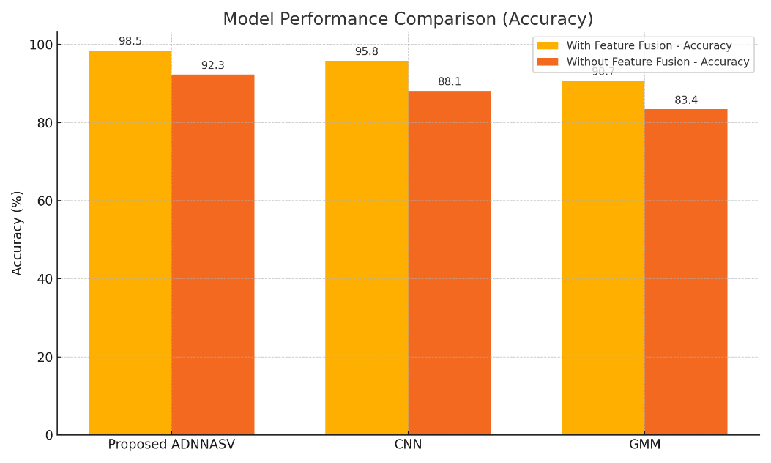
Figure 2: Proposed model Accuracy Comparison chart
The above chart visually represents the accuracy of the proposed ADNNASV, CNN, and GMM models, both with and without feature fusion. It is evident that feature fusion significantly enhances the accuracy of all models, with the ADNNASV model performing the best in both scenarios. The ADNNASV achieves an accuracy of 98.5% with feature fusion, demonstrating the advantage of combining multiple acoustic features for speaker verification.

Figure 3: Proposed Model Error Rate comparison
The chart illustrates the error rate of the ADNNASV, CNN, and GMM models, both with and without feature fusion. It clearly shows that feature fusion reduces the error rate across all models, with the ADNNASV model achieving the lowest error rate of 1.5% with feature fusion.

- CONCLUSION
This work successfully implements an Automatic Speaker Recognition (ASR) system using advanced neural networks. By analyzing voice signals, we introduced a new approach to recognize speakers, using a combination of key acoustic features like Mel-frequency cepstral coefficients (MFCC), power spectrograms, mel-scaled spectrograms, spectral contrast, and tonal centroid features (tonnetz). These features provided the foundation for training the model, and the ADNNASV (Amalgamated Deep Neural Network for Automatic Speaker Verification) algorithm proved to be highly effective at classifying speakers. The performance analysis clearly shows that our model outperforms traditional models like CNN and GMM, especially when feature fusion is applied. With a remarkable accuracy of 98.5% and a low error rate of just 1.5%, our approach demonstrates the power of deep learning in improving speaker recognition. Looking ahead, this work confirms the potential of deep learning models to make significant advances in speaker verification. The success of our system suggests that combining different acoustic features can significantly enhance accuracy. In the future, hybrid models that blend multiple deep learning techniques could take speaker identification even further, perhaps even recognizing speakers in multiple languages.
REFERENCES
- He, Z., & Wu, T. (2020). A robust speaker verification system based on deep learning and hybrid feature learning. Digital Signal Processing, 104, 102795. https://doi.org/10.1016/j.dsp.2020.102795
- Avila, A. R., O’Shaughnessy, D., & Falk, T. H. (2021). Automatic speaker verification from affective speech using Gaussian mixture model based estimation of neutral speech characteristics. Speech Communication, 132, 21-31.
- Dua, M., Sadhu, A., Jindal, A., & Mehta, R. (2022). A hybrid noise robust model for multireplay attack detection in Automatic speaker verification systems. Biomedical Signal Processing and Control, 74, 103517.
- Dua, M., Joshi, S., & Dua, S. (2023). Data augmentation based novel approach to automatic speaker verification system. e-Prime-Advances in Electrical Engineering, Electronics and Energy, 6, 100346.
- Sankala, S., &Kodukula, S. R. M. (2023). On Adversarial Vulnerability of Activation Functions in Automatic Speaker verification System. Procedia Computer Science, 222, 613-623.
- Mittal, A., & Dua, M. (2022). Automatic speaker verification systems and spoof detection techniques: review and analysis. International Journal of Speech Technology, 25(1), 105-134.
- Yoon, S. H., Koh, M. S., Park, J. H., & Yu, H. J. (2020). A new replay attack against automatic speaker verification systems. IEEE Access, 8, 36080-36088.
- Das, R. K., Tian, X., Kinnunen, T., & Li, H. (2020). The attacker's perspective on automatic speaker verification: An overview. arXiv preprint arXiv:2004.08849.
- Khan, A., Javed, A., Malik, K. M., Raza, M. A., Ryan, J., Saudagar, A. K. J., & Malik, H. (2022). Toward realigning automatic speaker verification in the era of COVID-19. Sensors, 22(7), 2638.
- Delgado, H., Evans, N., Kinnunen, T., Lee, K. A., Liu, X., Nautsch, A., ... & Yamagishi, J. (2021). ASVspoof 2021: Automatic speaker verification spoofing and countermeasures challenge evaluation plan. arXiv preprint arXiv, 2109.00535.
- Tong, F., Zhao, M., Zhou, J., Lu, H., Li, Z., Li, L., & Hong, Q. (2021, June). ASV-Subtools: Open source toolkit for automatic speaker verification. In ICASSP 2021-2021 IEEE International Conference on Acoustics, Speech and Signal Processing (ICASSP) (pp. 6184-6188). IEEE.
- Gao, Y., Lian, J., Raj, B., & Singh, R. (2021, January). Detection and evaluation of human and machine generated speech in spoofing attacks on automatic speaker verification systems. In 2021 IEEE Spoken Language Technology Workshop (SLT) (pp. 544-551). IEEE.

