ANALYSIS OF NEW-GENERATION TRAIN COMPARTMENT DESIGN USING VIRTUAL REALITY TECHNOLOGY

Ambar Mulyono¹ , Lu’lu’ Purwaningrum² , Ainun Aulia Isnaini³
Universitas Sebelas Maret
Jalan Ir. Sutami 36 Kentingan, Jebres, Surakarta, Jawa Tengah
ambarmulyono@staff.uns.ac.id, lulu_purwaningrum@staff.uns.ac.id, ainunauliaisnaini1234@gmail.com

ABSTRACT

This research aims to implement the passengers’ preferences in the visual design of the new-generation train compartment currently being developed by PT INKA. The main issue is how the visual design characteristics of the compartment can align with passengers' desires. The method used in this study is the V-type Kansei Engineering, which involves several stages, including collecting Kansei words, distributing a semantic differential questionnaire using 3D images through Virtual Reality media. The data were analyzed using multiple linear regression tests. The results show that the impression of modernity is the most important aspect in creating the interior design of the new-generation train compartment. The best design according to passenger preferences is design number 4 (D4), which features a minimalist theme, dark brown color, matte finish, flat mirror frame, blanket, and stripe accents on the flat fabric area.

Keywords: interior design, Kansei engineering, new-generation, train compartments, virtual reality.

ABSTRAK

Penelitian ini bertujuan untuk menerapkan preferensi penumpang dalam desain visual kompartemen kereta generasi baru yang saat ini sedang dikembangkan oleh PT INKA. Permasalahan utama yang diangkat adalah bagaimana karakteristik desain visual kompartemen dapat selaras dengan keinginan penumpang. Metode yang digunakan dalam penelitian ini adalah Kansei Engineering tipe V, yang melibatkan beberapa tahapan, termasuk pengumpulan kata Kansei, penyebaran kuesioner semantic differential menggunakan media gambar 3D melalui Virtual Reality. Data dianalisis menggunakan uji regresi linier berganda. Hasil penelitian menunjukkan bahwa kesan modernitas merupakan aspek paling penting dalam menciptakan desain interior kompartemen kereta generasi baru. Desain terbaik menurut preferensi penumpang adalah desain nomor 4 (D4), yang menampilkan tema minimalis, warna cokelat tua, lapisan akhir doff, bingkai cermin datar, selimut, dan aksen garis pada area kain datar.

Kata kunci: desain interior, Kansei Engineering, generasi baru, kompartemen kereta, realitas virtual.

INTRODUCTION
The comfort aspect of long-distance transport is very much needed. Satisfaction arises when the performance received meets or exceeds expectations. Customers feel satisfied after comparing the service outcomes with their expectations and perceptions (Kusumaningrum & Asfirotun, 2013). One of the most widely used modes of transportation in Indonesia is the train. The first railway was used on the island of Java, specifically in Semarang, running from Kemijen to Tanggung, and was completed in 1867 with a length of 26 kilometers (Ravico, & Susetyo, 2021). The lack of comfort in long-distance trains makes passengers feel tired and bored while travelling (Sutasman, & Pasaribu, 2013). Currently, many trains do not provide a comfortable resting place for passengers to support the most common activity performed during the journey, namely, sleeping (Vitanata, 2014). Therefore, in order to improve the comfort of passengers, it is essential to develop the standardization of the train class and to improve sleeping facilities (Ulfia, 2020).
Sleeping facilities are one of the amenities provided in luxury class trains. In Indonesia, passenger trains are divided into three main classes Executive, Business, and Economy each offering different levels of facilities, pricing, and comfort (Arfianto et al, 2013). A luxury train is a Executive train with special facilities that allows passengers to sleep on a seat that can be reclined into a position of 140 degrees and rotated 180 degrees during long travel periods called sleeper trains (Yohanny, 2024). In 2018, the luxury class train was first introduced under the name sleeper train, followed by the launch of Luxury 2 in 2019. According Puspitasari et al each Luxury 2 carriage is equipped with 26 seats (PT Kereta Api Indonesia (Persero), 2018). According to data from PT KAI Headquarters in September 2022, the number of passengers in the luxury class train reached 135,308. However, during the period from December 2021 to January 2022, there were only 4,832 ticket purchases for the luxury class, which was the lowest compared to other train classes (Puspitasari et al, 2024).
This is a type of passenger train equipped with sleeping facilities. Sleeper trains that have been operating in Indonesia are the sleeper trains of the first generation (Taksaka) and the second generation (Argo Lawu, Argo Dwipangga, Gajayana) shown in Figure 1 and Figure 2.
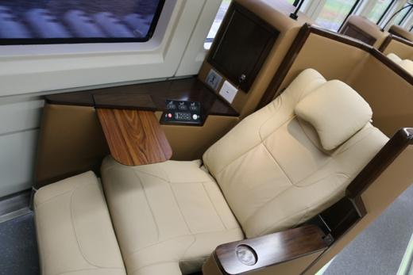
Figure 1. Generation 1st Sleeper Train

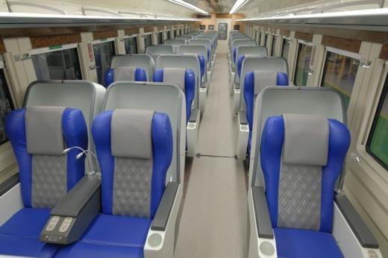
Figure 2. Generation 2nd Sleeper Train
When on a long journey, passengers tend to sleep and feel comfortable in enclosed spaces, making privacy an important aspect to consider Ulfia, (2020), especially for employees on business trips who need more rest during the journey. Additionally, train passengers may want to work and not be disturbed by others during the trip. Efforts to improve comfort standards are currently being pursued by PT INKA through the development of a more privatized sleeper train design in the form of compartments, known as the New Generation Train. This train covers a distance of approximately 10,000 km along the northern and central routes. The chosen routes are likely those that require more than 10 hours of travel and rest in between (Tristiyono, 2009) . These trains serve passengers by allowing them to rest or sleep comfortably and privately during the journey. The existence of these sleeper trains marks a significant difference between the new generation and the previous ones, in terms of comfort, pricing, design, and available facilities. According to Tjiptono, there are several facility aspects that can be used as a basis for evaluation, namely: planning aspects, spatial layout, equipment completeness, lighting, the atmosphere or ambiance of a space, and the message conveyed through graphic design elements (Wulandari et al, 2022).
One of the comfort factors is visual comfort, in which passengers pay attention to the visual beauty of the interior environment (Wiyanto, 2021). Visual comfort inside train carriages is achieved when it aligns with passenger preferences. Since passengers are the direct users of the service, it is crucial to gain a deep understanding of train carriage design from their perspective (Yohanny et al, 2025). Efforts to implement passengers' preferences in train carriage visual design can be carried out using the Kansei Engineering method (Muhaemin, 2020).. Kansei Engineering is a method that can identify feelings and emotions, thereby facilitating the researchers' creativity in translating passenger preferences into train carriage design.
The Kansei Engineering method has been widely applied in the transportation industry, including by well-known brands such as Mazda, Hyundai, and Toyota, as well as in various studies related to train seat design in Indonesia and the evaluation of user preferences in vehicle interior design (Yohanny, & Mulyono, 2025). Kansei Engineering plays a vital role in train interior design due to its ability to translate the emotional needs and preferences of train passengers into concrete design elements. The purpose of Kansei Engineering is to understand what consumers want by analyzing the emotions they feel, using descriptive Kansei words from multiple references to convert those emotional responses into concrete design elements (Donida et al, 2019). The visual aspects in this approach include seat colors, window types that influence lighting, and the texture of materials used all of which can be analyzed to understand their impact on perceived comfort, safety, and aesthetics experienced by users while on the train. Thus, Kansei Engineering helps create train interior designs that not only function well but also offer a positive and pleasant emotional experience for passengers, ultimately contributing to improved transportation service quality.
Computer visualization is becoming increasingly important for optimizing questionnaire data collection to communicate messages about train compartment design (Sheppard, 2001)., and train manufacturers need better insight into what and how they communicate their products. VR is a technology that enables virtual interaction through computer simulations with interactive 3D animation, providing an immersive environment that engages respondents. VR technology offers a much-needed solution for enhanced visual output. The use of 3D animation provides a visual experience of train compartment interior design that makes users feel as if they are truly present inside the train compartment (Liu & Yang, 2022; Daniela, 2020; Grabowski, 2020). The use of VR technology will enhance the accuracy of user perception regarding the interior design of the new-generation train compartments, optimizing both efficiency and design evaluation.
Previous research by Yohanny et al. has examined user preferences and perceptions of the visual impression of new-generation train compartment interior design using Kansei Engineering, focusing on the correlation between design elements and users’ emotional responses (Yohanny et al., 2022; Yohanny & Mulyono, 2022). However, both studies were limited to two-dimensional visual approaches and cognitive perceptions without immersive experience involvement. Meanwhile, research by Kurniayasa et al. demonstrated the potential of Augmented Reality technology in enhancing children’s learning experiences, but it has not yet been applied in the transportation design context (Kurniayasa et al., 2025). Therefore, there is a research gap in the development and analysis of new-generation train compartment designs using Virtual Reality (VR) technology, which enables users to directly and immersively experience the interior atmosphere of trains. This approach presents a novelty by integrating more realistic visual and spatial experiences, thus offering a more accurate representation of comfort, aesthetics, and user preferences in train interior design.
This research aims to implement the desires of passengers of the New Generation train compartments currently being developed by PT Industri Kereta Api Indonesia (INKA) in the form of visual design. To achieve this goal, the research question is: How can user preferences be translated into the visual interior design of new-generation train compartments?
The urgency of the research titled Analysis of New Generation Train Compartment Design Using Virtual Reality Technology lies in the need to create interior transportation designs that are not only visually appealing but also provide optimal user experience before physical implementation. New-generation train compartment designs require in-depth evaluation of comfort, aesthetics, and functionality factors that are often difficult to assess using only 2D images or static prototypes. Virtual Reality (VR) technology enables immersive and interactive spatial simulation, allowing users to directly experience the interior and provide more accurate and realistic feedback. This is essential for minimizing design errors, reducing development costs, and enhancing user satisfaction and safety. Therefore, this study is both relevant and urgent in supporting innovations in public transportation design that are more responsive to the needs of modern society.

METHOD
The first step in V-type Kansei engineering is the collection of the Kansei word and the setting of the Kansei word (Xue et al., 2020). Kansei words can be searched from interviews, magazines, books, or journals related to the design of the railway compartment. After gathering the words of Kansei as many as 200 words (Yohanny, 2024). it was selected again objectively to be 40 words. The next step is to choose the word Kansei that more represents the user against the railway department using the questionnaire done on the employees of PT INKA. The next step is the determination of the differential semantic scale used to facilitate respondents in assessing design, Kansei word that has been specified, then searching for the opposite word or antonym of the word that will be attached in the questionnaire. The next step, design creation, first specifies the item and category. Items are specific characteristics in the design, and categories are small groups within each item. Items and categories on the final results of the study show that the significant influences on the word Kansei are cultural and minimalistic themes, green, brown, and blue, glossy and doff finishes, ornamental decorations, and paintings. From the results of the items and categories obtained in the first research will be developed into new items and Categories in this research, which will be distributed across 10 designs. Each design has the same item value and category. The design was created using the 2020 SketchUp software, and continued with rendering using the Enscape software connected with the Oculus software.
There are several stages of data capture using the Oculus Rift S: (a) Explanation of the questionnaire procedure, (b) Installation of VR glasses that can be seen in Figure 3, (c) Respondents will see 3D images on the VR goggles generated from the computer layer in Fig. 4, (d) Each design displayed, respondents give the assessment read by the researchers in Figure 5.
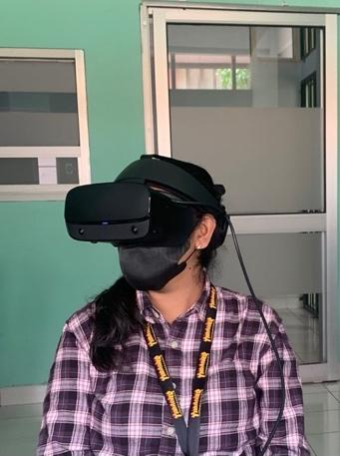

Figure 3. Usage of the Oculus Rift S glasses
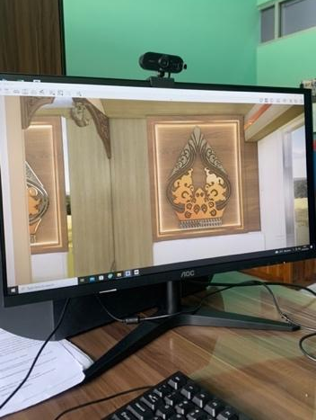

Figure 4. PC Screen View
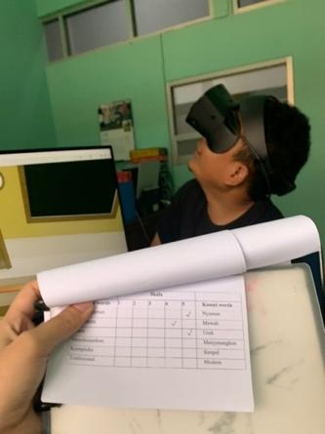
Figure 5. The questionnaire was read when the respondents were wearing the Oculus Rift S glasses

2.3 Analysis Methods
In the meantime, independent variables (X) obtained from the distribution of items and categories that are qualitative data will be converted into quantitative data (values 1 and 0) called dummy variables. The data was subsequently inserted into the Statistical Package for the Social Sciences (SPSS) software version of IBM SPSS version 17.0 for Windows, Chicago, USA, for validity and reliability testing. The next step is a statistical double linear regression test used to analyze data from observations that have proven valid and reliable. The regression test aims to find out the inter-variable relationship that exists between a row to a column.

RESULT AND DISCUSSION

3.1 Kuesioner Results
The process of creating the questionnaire in this study begins with collecting the Kansei words, which are properties or object words that describe the object of the study. The stage collects and determines the Kansei words quoted from previous research and produces 6 words applied to the semantic differential scale to assess user preferences that can be seen in Table 1).

Table 1. Skala Semantic Diferensial

Opposite Word | 1 | 2 | 3 | 4 | 5 | Kansei Word
Not Comfortable |  |  |  |  |  | Comfortable
Unassuming |  |  |  |  |  | luxurious
Normal |  |  |  |  |  | Unique
Boring |  |  |  |  |  | Pleasant
Complex |  |  |  |  |  | Simple
Traditional |  |  |  |  |  | Modern

The design sample process begins with the determination of the items and categories that become the design specifications of the railway compartment. The design samples consist of seven items, and each item consists of two to three categories, which will distinguish the designs from each other. The determination of theme and color categories was obtained on the first questionnaire as done by (Yohanny & Mulyono, 2022; Hamdani, 2025) then this research developed it into the following items and categories: (a) themes: culture and minimalism; (b) colors: brown, green and blue; (c) decoration: ornaments and paintings; (d) glossines: glossy and doff; (e) frames mirminbuild in: ornament and polos; (f) motifs on the place of fabric: batik and polos motifs; Here is the making of 10 variants of the design of the railway compartment according to the items and categories that have been specified:

Table 2. Virtual Reality Design

Kode | Treatment | Link Virtual Reality
D1 | Theme: Culture  Color: Brown  Decoration: Ornament  Glossines: Doff  Frame Mirror: Ornament  Blanket: Batik motif  List on Fabric Place: Batik motif | https://api2.enscape3d.com/v3/view/39f3bde2-f94e-4375-9076-5c8cb8596eb4
D2 | Theme: Minimalist  Color: Green  Decoration: Painting  Glossines: Doff  Frame Mirror: Poles  Blanket: Poles  List on Fabric Place: Poles | https://api2.enscape3d.com/v3/view/4952920e-d169-4b0d-8572-2c7018854786
D3 | Theme: Culture  Color: Blue  Decoration: Ornament  Glossines: Glossy  Frame Mirror: Ornament  Blanket: Batik motif  List on Fabric Place: Batik motif | https://api2.enscape3d.com/v3/view/5df69ea4-4152-49d9-a117-583336e24b45
D4 | Theme: Minimalist  Color: Brown  Decoration: Painting  Glossines: Doff  Frame Mirror: Poles  Blanket: Poles  List on Fabric Place: Poles | https://api2.enscape3d.com/v3/view/b4d56b63-4730-4277-a2f5-bb3a90783ebb
D5 | Theme: Culture  Color: Green  Decoration: Ornament  Glossines: Glossy  Frame Mirror: Ornament  Blanket: Batik motif  List on Fabric Place: Batik motif | https://api2.enscape3d.com/v3/view/ea09dbb0-b587-4c8f-b765-2fdb4c914234
D6 | Theme: Minimalist  Color: Blue  Decoration: Painting  Glossines: Doff  Frame Mirror: Poles  Blanket: Poles  List on Fabric Place: Poles | https://api2.enscape3d.com/v3/view/ee30d0ee-6771-41e7-8f4f-e50ef12cfff7
D7 | Theme: Culture  Color: Green  Decoration: Ornament  Glossines: Doff  Frame Mirror: Ornament  Blanket: Batik motif  List on Fabric Place: Batik motif | https://api2.enscape3d.com/v3/view/4ceec767-04e4-4ba6-a6ec-efe271a744f4
D8 | Theme: Minimalist  Color: Blue  Decoration: Painting  Glossines: Glossy  Frame Mirror: Poles  Blanket: Poles  List on Fabric Place: Poles | https://api2.enscape3d.com/v3/view/1ffc1c9d-aeed-49b8-af5d-683b61b9250b
D9 | Theme: Culture  Color: Brown  Decoration: Ornament  Glossines: Glossy  Frame Mirror: Ornament  Blanket: Batik motif  List on Fabric Place: Batik motif | https://api2.enscape3d.com/v3/view/93567b7f-edc6-4bc1-862b-445018548b01
D10 | Theme: Minimalist  Color: Green  Decoration: Painting  Glossines: Doff  Frame Mirror: Poles  Blanket: Poles  List on Fabric Place: Poles | https://api2.enscape3d.com/v3/view/403a0243-8446-475b-a46c-7287d6e87df7

3.2. Validity and Reliability Test Results
The validity test is used to determine the accuracy of the statement to be made to the respondent in the questionnaire (Donida et al, 2019). The questionnaire is said to be valid, but the questionnaire question is capable of translating something that will be measured by that questionnaire. The number of respondents is 30, so that the questionnaire is declared valid when r counts > r table (at the level of significance 5 % R table = 0,361, at the degree of importance 1 % R Table = 0,463) and the questionnaires are declared invalid when r count < r table. The validity test is performed as many as 10 times according to the number of designs that have been made. From the result that has been done get the result a correlation value greater than the r table. A questionnaire is stated to be reliable if the answers from the survey results are consistent. The rehabilitation test was carried out using the Cronbach Alpha statistic test with the help of the SPSS 17.0 software. The variable was declared reliable when given Cronbach's Alpha (α) > 0.6. Based on the validity and rehabilitation tests that have been carried out, the result is that the entire item of statement is declared valid and reliable.
3.3 Linear Regression Result
The result of the regression test on this intersection is intended to find out which far the influence of the independent variable (X) on the dependent variable (Y) in a study is. The double linear regression test was performed with the inclusion of Y1 dependent variables, i.e. the word Kansei comfortable, and the X independent variable, x1.1: cultural theme, X1.2: minimalistic theme, X2.1: brown color, X2.2: blue color, X2.3: green color, X3.1: painting decoration, X3.2: ornamentation decorations, X4.1: glossy, X4.2: doff, X5.1: ornamental mirror frame, x5.2: plain mirrors frame, X6.1: blankets with batik patterns, x6.2: blanks with batik pattern, X7.1: batik motifs on the list of places of fabric, X7.2: plains on the site list of fabrics. Regression analysis is done based on the selected Kansei word, so that the double linear regression analysis is performed as many as six times.

Table 3. Regression Score “Comfort”
Mosel Summary

Model | R | R Square | Adjusted R Square | Std. Error of the Estimate
1 | .262 | .069 | .053 | .86708

Item dan Kategori | t | Sig. | Partial Correlations
X2.1 | .403 | .687 | .024
X2.3 | .792 | .429 | .046
X4.2 | -2.031 | .043 | -.118
X5.1 | -2.113 | .035 | -.122
X7.2 | -2.947 | .003 | -.169
From the regression test will be seen which of the variables that have a value of significance < 0.05 indicates a significant X variable against the variable Y. By looking at Table 3 output above, then variable that affects the word 'comfortable' is doff (X4.2), ornament on the frame of the mirror (X5.1), a pure motif on the list where the fabric is. (X7.2).
The t count must be larger than the t table in order to conclude that, partially, the X variable has a significant influence on the Y variable. Here's how to determine the tables:
t table = t ($α$/2;n-k-1) (1)Refer to Eq. (1), the evaluation of t (0,05/2; 300-15-1) = t (0,025; 286) = 1,984
The t value of the table obtained is 1,984, so the independent variable that meets the t count > t table requirement is doff (X4.2), ornament on the mirror frame (X5.1), motif on the list where the tissue is located. (X7.2). In the correlations column, partial indicates the level of the variable that affects Y1(comfortable), which most affects the word ‘comfortable’, that is, the green color element.
Tabel 3. Anova Skor “Comfort”

ANOVA

Model | Sum of Squares | df | Mean Square | F | Sig.
Regression | 16.334 | 5 | 3.267 | 4.245 | .001^{b}
Residual | 221.036 | 294 | .752
Total | 237.370 | 299

The meaning value of the "comfortable" word (Y) is 0,002<0,05, so it can be interpreted independently (X7.2, X2.3, X4.2, X2.1, X5.1) jointly influencing the "convenient" word. The F test is performed to see how the influence of all X variables together on the variable Y. The above table shows that the significance value is 0.001<0,005 (p value < α), so the X variable is used correctly to predict the "comfortable" word score. The value of f debt must be greater than f table, with the calculation formula F table as follows:
f table = f (k ; n–k) (2)
Refer to Eq. (2), the evaluation of f (15; 300 – 15) = f (15; 284) = 1,96
Table 4. Exclude Variable “Nyaman”

Excluded Variables

Model | Beta In | t | Sig | Partial Correlation | Collinearity Statistics Tolerance
X1.1 | .^{b} | . | . | . | .000
X1.2 | .^{b} | . | . | . | .000
X2.2 | .^{b} | . | . | . | .000
X3.1 | .^{b} | . | . | . | .000
X3.2 | .^{b} | . | . | . | .000
X4.1 | .^{b} | . | . | . | .000
X5.2 | .^{b} | . | . | . | .000
X6.1 | .^{b} | . | . | . | .000
X6.2 | .^{b} | . | . | . | .000
X7.1 | .^{b} | . | . | . | .000

Table 4 shows the output of the double linear regression test on the convenience Kansei occurrence, excluding variables, i.e., elimination of the independent variable to be used in determining the influence on the dependent variable. Elimination of variables aims to obtain the best model with the minimum error standard. A small error standard can be characterized by the absence of an independent inter-variable multicollinearity. Eliminated variables are cultural theme, minimalist theme, blue color, ornamentation, painting decoration, glossy, pure mirror frame, blanket cover motif, pure blanket motif, and blue motif on the site list. Meanwhile, the valid variables indicated are brown color, green color, doff, decoration on the frame of the mirror, and pure motifs on the location list of the site.
3.3 Favourite Design Results
In addition to validity, reliability, and regression tests, data is also grouped from the most comfortable, most luxurious, most unique, most fun, most simple, most modern, and best design categories. The calculation of the mean on the questionnaire data is done to show the best design graphs for each Kansei word. The average of each design is obtained from the total number of data respondents divided by the number of respondents. After that, the average of every design is summed and divided by the amount of designs (10 designs of railway compartments), then the overall average is found
.

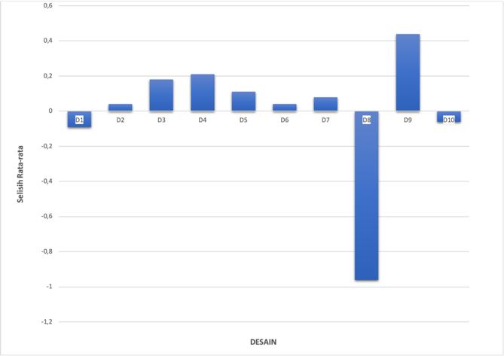
Picture 6. The most comfortable designs

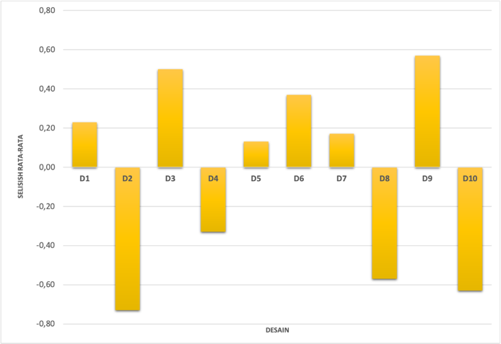
Figure 7. The most luxurious designs

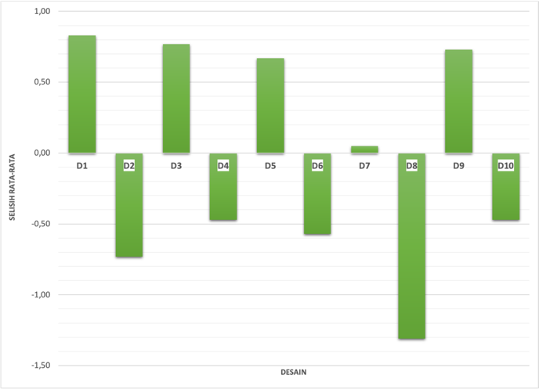
Figure 8. The Most Unique Designs

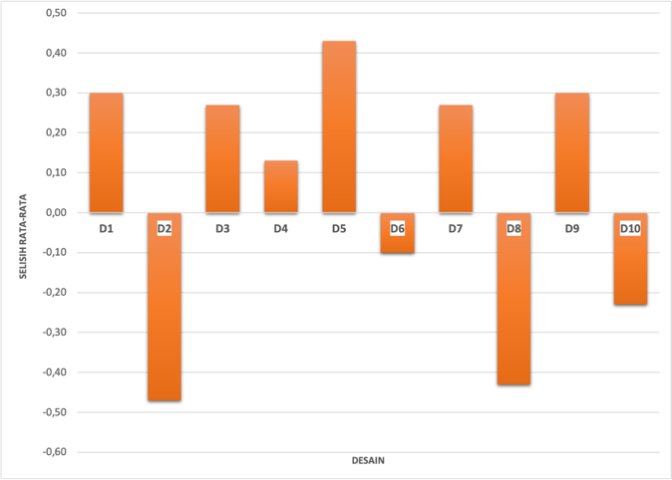
Picture 9. The most pleasant designs

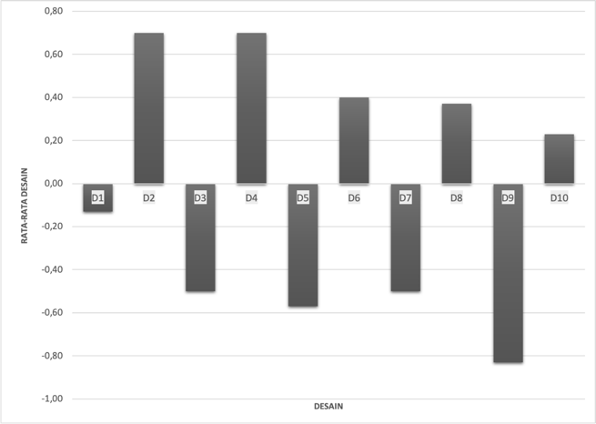
Figure 10. The simplest design

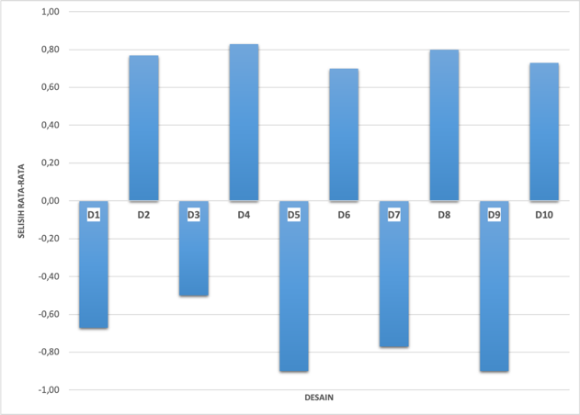
Figure 11. Most modern designs

Based on Figure 6, it is known that the most comfortable design is the design of the railway compartment number 9 (D9), whereas the design number 8 (D8) has a result far below the mean that can be understood is that the design Number 8(D8) is said to be uncomfortable. Figure 7, the design of the train compartment Number 9(D9) is called the most luxurious design. Design number 2 (D2) is called the simplest design with the lowest average. Based on 10, design number 2 (D2) and design number 4 (D4) show balanced graphics that can be understood as the simplest design, and design 9 (D9) is said to be the most complex design. Figure 11 shows that in addition to being said as the simplest design, design 4(D4) is also said to have been the most modern design, and design number 5 (D5), whereas design number 9(D9) gets the lowest average, can be categorized as the most traditional design.
3.4 Design With Highest Average

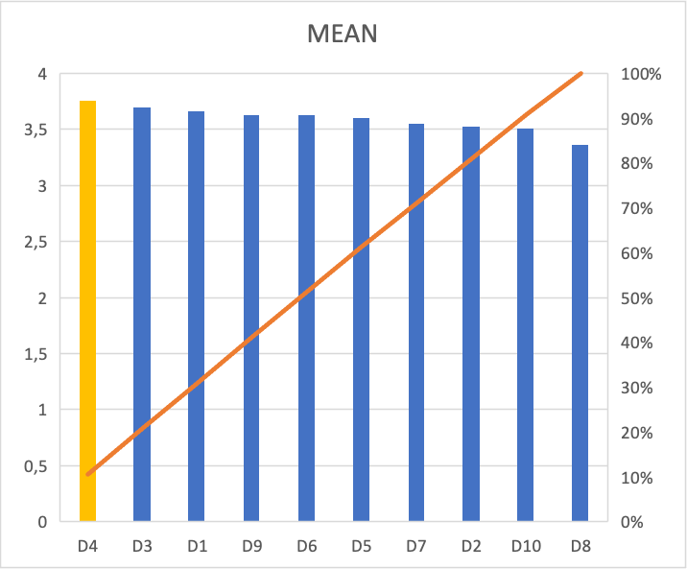

Figure 12. Design with Highest Average

The result of the average of each design presented in Figure 4.9 shows that the design of the railway compartment with the highest average value is design number 4 (D4) with the specification of the minimalist theme, brown color, doff, plain glass frame, blanket, and list on plain tissue. The second order is the third design 3 (D3) with the traditional theme specification, old blue color, ornamental decoration, glossy, mirror frame ornaments, blankets, and lists on the tissue site of batik motifs. The third order, namely the design 1 (D1) with cultural themes specifications, old brown colour, painting decorations, Doff, glass frame with ornament, and batik motifs on the blanket, and a list of tissues on the site.

CONCLUSION
In Based on the analysis of the research can be concluded as follows:
- There is an influence of independent variables X2.1 (brown), X2.3 (green), X4.2 (doff), X5.1 (ornaments on mirror frames) and X7.2 (pure motifs on weaving lists) simultaneously on dependent variables Y1 (comfortable), Y2 (luxurious), Y3 (unique), Y4 (pleasant), Y5 (simple), and Y6 (modern).
- The highest R-square value is the word ' modern' that can be given priority when designing the interior of a new-generation railway compartment.
- Occurs when excluding variables or eliminating independent variables to be used in determining influence on dependent variables. Eliminated variables are X1.1(cultural frame), X1.2 (minimalist theme), X2.2 (blue color), X3.1 (painting decoration), X4.2 (glossy), X5.1 (glossy mirror frame) and X6.2 (pole blanket motif), and X7.1 (patch motif on fabric list).
- The most comfortable and luxurious design can be said to be the design of the railway compartment number 9 (D9) with the specification of cultural themes, young brown colors, ornamental decorations, glossy, mirror frames with ornaments, and batik motifs on blankets and lists on tissue. The most unique design is the first design (D1) with specifications of cultural theme, old brown color, painting decoration, doff, mirrors frame with ornaments, and the most enjoyable design is a design number 5 (D5) with cultural theme specifications, green color, decoration of paintings, glOSSY, glass frames of ornament, and Batik motif on blanket and list of tissue places. Design number 2 (D2) and design number 4 (D4) are said to have been the simplest designs, with design specification number 2(D2) using the themes of minimalistic, young green colour, Doff, polite mirror frame, and list on polite tissue sites.
- The best design that fits the user's preferences is design number 4 with a minimalistic theme, old brown base colors, doff material, and pole decoration.

CONFLICT OF INTEREST

The author declares that they have no conflicts of interest with anyone.

REFERENCE
Arfianto, M. R., Sukmadi, T., & Winardi, B. Penumpang kelas eksekutif, bisnis, dan ekonomi (di depo gerbong kereta api Indonesia).
Donida, D. A. H., Prastawa, H., & Mahacandra, M. (2019). Perancangan desain kemasan produk Carica dengan konsep Kansei Engineering dan model Kano. Industrial Engineering Online Journal, 8(2), 1–13. Retrieved from https://ejournal3.undip.ac.id/index.php/ieoj/article/view/23753
Fleta, A. (2021). Analisis pencahayaan alami dan buatan pada ruang kantor terhadap kenyamanan visual pengguna. Jurnal Patra, 3(1), 1–10.
Grabowski, A. (2020). Virtual reality and virtual environments: a tool for improving occupational safety and health. CRC Press.

Hamdani, M. F. (2025). Membedah uji prasyarat: Kunci pemilihan uji hipotesis dalam. Kaisa Jurnal Pendidikan dan Pembelajaran, 5(1), 46–59.
Kurniayasa, M. Z., et al. (2025). Media pembelajaran pengenalan alat transportasi untuk anak usia dini menggunakan augmented reality. Vol. 9(1), 284–290.
Kusumaningrum, A. E., & Asfirotun, J. (2013). Analisis kepuasan pengguna jasa terhadap kinerja PT. Kereta Api Indonesia (Persero) (KRL Commuter Line Jakarta Kota-Bogor). Proceeding PESAT (Psikologi, Ekonomi, Sastra, Arsitektur, Teknik Sipil), 5, 350–357.
Liu, X., & Yang, S. (2022). Study on product form design via Kansei engineering and virtual reality. Journal of Engineering Design, 33(6), 412–440. https://doi.org/10.1080/09544828.2022.2078660
Kuleto, V., & Paun, D. (2022). “New Perspectives on Virtual and Augmented Reality: Finding New Ways to Teach in a Transformed Learning Environment”, Edited by Linda Daniela, Routledge, 2020, Book Review. EdTech journal, 2(1), 81-88.
Muhaemin, M. N. A. (2020). Pengembangan fungsionalitas sistem informasi dengan pendekatan Kansei Engineering. Infotronik Jurnal Teknologi Informasi dan Elektronika, 5(1), 43–47. https://doi.org/10.32897/infotronik.2020.5.1.6
Puspitasari, S. M. D. T., Dessy, & Gunawan, P. (2024). Pengaruh fasilitas dan kualitas pelayanan Kereta Api Indonesia terhadap kepuasan penumpang kelas luxury. Jurnal Ilmiah Wahana Pendidik, 10(13), 154–169.
Ravico, R., & Susetyo, B. (2021). Sejarah pembangunan jalur kereta api sebagai alat transportasi di Sumatera Selatan tahun 1914-1933. Agastya Jurnal Sejarah dan Pembelajarannya, 11(1), 68. https://doi.org/10.25273/ajsp.v11i1.8052
Sheppard, S. R. (2001). Guidance for crystal ball gazers: Developing a code of ethics for landscape visualization. Landscape and Urban Planning, 1(4), 183–199.
Sembada, Y. S., & Martinus. (n.d.). Pengembangan desain kereta restorasi pada kereta api jarak jauh. Jurnal Tingkat Sarjana Seni Rupa dan Desain ITB, 1(1), 1–6.
Soltanpour, A., Mesbah, M., & Habibian, M. (2018). Perceived service quality in urban rail transit: A comparison of structural equation models. Retrieved from https://www.researchgate.net/publication/335986275
Tristiyono, B. (2020). Desain interior kereta api kelas eksekutif generasi terbaru dengan konsep modular. Jurnal IDEA.
Ulfia, F. N. (2020). Desain Sleeper Seat Untuk Kereta Kelas Sleeper Luxury Dengan Menerapkan Konsep Chrysalis (Private, Comfort) Untuk Menunjang Kenyamanan Dalam Perjalanan Jarak Jauh (Doctoral dissertation, Institut Teknologi Sepuluh Nopember).

Wulandari, A., Cakranegara, P. A., Widyo Widjajanti, W., & Lemus Vergara, A. Y. (2022). Pengaruh fasilitas wisata, kualitas pelayanan dan promosi terhadap kepuasan wisatawan di Kabupaten Pesisir Selatan. Fair Value Jurnal Ilmiah Akuntansi dan Keuangan, 4(11), 5339–5344. https://doi.org/10.32670/fairvalue.v4i11.1785
Xue, L., Yi, X., & Zhang, Y. (2020). A hybrid approach of the product image design of train seats based on Kansei engineering theory. International Journal of Innovative Computing, Information and Control, 16(3), 813–829. https://doi.org/10.24507/ijicic.16.03.813
Yohanny, D. K., Mulyono, A., & Purwaningrum, L. (2022). Analisis preferensi pengguna dari kesan visual desain interior kompartemen kereta api new generation dengan metode Kansei Engineering. Jurnal Perkeretaapian Indonesia (Indonesian Railway Journal), 6(2), 71–84. https://doi.org/10.37367/jpi.v6i2.228
Yohanny, D. K. (2022). Analisis Preferensi Pengguna dari Kesan Visual Desain Interior Kompartemen Kereta Api New Generation dengan Metode Kansei Engineering.

Yohanny, D. K., Purwaningrum, L. U. L. U., & Mulyono, A. (2025). Application of Kansei Engineering in various train compartment designs to determine the user’s affective response. IIUM Engineering Journal, 26(1), 466–479. https://doi.org/10.31436/IIUMEJ.V26I1.3239
Yohanny, D. K., & Mulyono, A. (2022). An established scholar review towards Kansei Engineering for railway product design. Atlantis Press International BV. https://doi.org/10.2991/978-94-6463-126-5
Vitanata, D. (2014). Sarana Tidur Yang Nyaman Dan Berprivasi Pada Kereta Api Eksekutif Jarak Jauh. Calyptra, 2(2), 1-17.

