A NOVEL AUTHENTICATION PROTOCOL FOR SECURING COMMUNICATION USING BLOCK CHAIN IN WIRELESS SENSOR NETWORK

Shilpi Sharma¹*, Bijendra Kumar²
^{1*}Department of Computer Science Engineering
Netaji Subhas University of Technology
Azad Hind Fauj Marg, Dwarka Sector-3, Dwarka, Delhi, 110078
²Department of Computer Science Engineering
Netaji Subhas University of Technology
Azad Hind Fauj Marg, Dwarka Sector-3, Dwarka, Delhi, 110078
^{1*}shilpi02sharma02@gmail.com

Abstract: The security of Wireless Sensor Networks (WSNs) is a critical concern due to their widespread application in various fields, including environmental monitoring, healthcare, military operations, and smart cities. Traditional security practices in WSNs rely on centralized authentication and encryption methods, but face challenges due to decentralized sensor nodes (SNs), vulnerability to attacks, and inefficiencies in handling large networks, making security a critical issue. This research introduces a Block chain-Driven Authentication Protocol (BCDAP) to improve the security and reliability of WSNs by comprising four essential stages that ensures secure, scalable and efficient authentication. To optimize energy consumption and prolong the network lifespan, a Radio Energy Optimization (REO) technique is introduced. Additionally, a Block chain Enforced Identity Protection (BCEIP) secures the identities of Cluster Heads (CHs) and SNs preventing identity duplication and other security vulnerabilities. The proposed Unified Identity and Confirmation protocol (UICP) generates unique identifiers for each node and utilizes BC based authentication to mitigate risks such as identify spoofing and unauthorized access. This approach eliminates single points of failure which significantly improves WSN security, scalability, and effectiveness. Finally, the performance of the proposed system will be evaluated by implementing the protocol executed by employing the AVISPA tool. Its effectiveness will be assessed by testing it against various backend tools available within framework.

Keywords: Wireless Sensor network, Block Chain Driven Authentication Protocol, Radio Energy Optimization, Block Chain Enforced Identity Protection, Cluster head, Sensor Node, Unified Identity and Conformation protocol.

1. INTRODUCTION
WSNs are now essential components of many applications, including as smart cities, industrial automation, healthcare systems, and tracking the environment [1]. These networks are made up of autonomous SNs that may collect and send data from the environment around them. The intrinsic characteristics of WSNs, such as limited energy resources, scattered deployment in remote or harsh environments, and wireless transmission, present distinct security and operational problems [2].
Data privacy and confidentiality in WSNs are essential because they are deployed in critical environments where any compromise might result in substantial operational and safety issues [3]. Traditional WSN security techniques typically use centralised systems for identity authentication and data protection. However, these centralised systems are prone to single points of failure, exposing the entire network to attackers and diminishing overall reliability [4]. Furthermore, when WSNs grow in size and scope, centralised systems fail to efficiently manage and authenticate an increasing number of nodes, resulting in scalability concerns and performance degradation [5].
The energy limits of SNs exacerbate these issues. To increase the network's lifespan and guarantee continued operation, effective energy management is essential. [6]. Traditional security measures frequently assume uniform energy distribution among nodes, which rarely matches the real-world situation. This discrepancy results in unequal energy consumption among nodes, causing some nodes to consume their energy faster and shortening the total network lifespan [7-8]. Energy depletion in crucial nodes can cause network partitioning, in which parts of the network become isolated, severely limiting data transmission and overall network functionality [9].
Furthermore, the absence of adaptive energy management mechanisms in standard WSN security practices means that energy-intensive processes like encryption and decryption can disproportionately affect nodes with low energy reserves [10-11]. As these nodes consume their energy faster, the network's resistance to security risks weakens, making it more vulnerable to attacks over time. The failure of important nodes can also cause a cascading effect, in which the loss of a few nodes drastically reduces the overall network's performance and dependability [12].
In addition to energy depletion, standard security measures frequently fail to account for WSNs' dynamic nature, which allows nodes to join or leave the network owing to mobility, battery fatigue, or environmental conditions [13]. Static security settings are ineffective in such environments because they cannot adapt to changing network topologies and node energy levels [14]. This inflexibility not only affects the security but also the overall efficiency of the network. Thus, there is an urgent need for novel ways that address both security vulnerabilities and energy efficiency thoroughly.
To solve these issues, this study presents a unique framework for incorporating block chain (BC) technology and decentralised authentication methods into WSNs. BC technology, which was originally intended as a decentralised, includes intrinsic properties such as tamper resistance, transparency, and decentralisation. By extending these features to WSNs, BC has the potential to transform how identity authentication, data integrity, and network management are handled in distributed environments.

MOTIVATION OF THE RESEARCH:
- The increasing vulnerabilities in WSNs due to diverse attacks emphasise the need for a more secure communication protocol.
- The potential of BC to offer decentralized, tamper resistant solutions for authentication and data integrity motivated its application in WSNs for secure node communication.
- Due to the quick expansion of IoT devices, a solution that can manage many nodes without sacrificing security or speed is required.
- Tradition authentication methods face challenges in securely managing nodes in dynamic environments. This research aims to improve the efficiency and robustness of authentication process.
- The need to prevent identity duplication and malicious activities through unique identifiers and digital signatures inspired the creation of a more secure identification mechanism.

This proposed study's primary contribution is as follows:
- Introduce the novel authentication protocol BCDAP leverages BC technology to enhance the security, scalability and efficiency of WSNs.
- A REO technique was developed to increase utilization of energy and extend the useful lifetime of the network by optimizing routing and energy use in SNs.
- Implemented a secure identity protection mechanism as BCEIP using public and private BCs to prevent identity duplication mitigate security vulnerabilities and safeguard the identities of CHs and SNs.
- Designed a protocol UICP for generating unique identifiers for each node and conducting BC based authentication to prevent identity spoofing, unauthorized access and single points of failure.
- Enhanced the scalability of WSNs by ensuring efficient communication, secure identity management and energy optimization enabling the system to handle large networks without compromising security or performance.
The article's remainder is organized as follows: The introduction is emphasized in Section 1, the relevant works of the existing techniques are discussed in Section 2, the suggested methodology is described in Section 3, the implementation details and results of the proposed method are discussed in Sections 4 and 5, and the article is concluded in Section 6.

2. LITERATURE REVIEW
WSNs are critical components of IoT systems, distinguished by their distributed, low-cost, and low-performance SNs. Because of their susceptibility, strong node authentication is required to resist malicious attacks. BC technology has emerged as a possible approach for improving security in these networks.
A BC-based plan for registration, mutual authentication, data sharing, and nonrepudiation in the Internet of Wireless Sensor Things (IoWST) was put up by Khan et al. [15]. Nodes were divided into coordinators, cluster chiefs, and SNs under the system. A consortium BC, deployed on the coordinators, stored the identities of legitimate nodes. Coordinators also executed smart contracts to assist SNs with authentication, data sharing, and nonrepudiation. An artificial intelligence-based Inter Planetary File System (IPFS) was used for storing ambient data from nodes. The Stellar Consensus Protocol was employed to enhance transaction throughput and network efficiency but the transaction latency was high.
Mubarakali et al. [16] developed a secure authentication method for WSNs using BC technology. The system, part of an IoT network, includes BS, CHs, and normal SNs. The BC network is a hierarchical model with a small chain and a global chain among network nodes. The hybrid model ensured secure identity connections across different communication scenarios. The system outperformed others in terms of security and computational efficiency, but consumes high energy consumption due to the primary use of access points for global BC transmission and consensus.
BC technology offers a decentralized solution for distributed IoT systems, addressing the security concerns of traditional protocols that rely on trusted third parties, thereby reducing single point failure. Cui et al. [17] created a BC-based multi-WSN authentication scheme for IoT, dividing nodes into BS, CH nodes, and ordinary nodes. They created a hybrid BC model, combining local and public chains for mutual identity authentication. The scheme provided good security and efficiency, but high energy consumption was identified for transmission and consensus processes.
WSNs are crucial IoT devices with limited processing, memory, and energy. They face threats like untrusted regions and data accuracy. Authentication mechanisms verify data from authorized sources, but existing protocols have security deficiencies like ID spoofing attacks. BC, an emerging technology, offers significant security benefits, including crypto graphical security and immutability. Dener et al. [18] developed a new BC-based authentication protocol for WSNs. The system model included SNs, cluster nodes, a BS, and private BC networks. A security and efficiency analysis was conducted on the WiSeN SN. The study found that block size increased with transactions, requiring high BC storage. Despite this limitation, the study emphasized the importance of integrating high-level security aspects into WSN applications.
Awan et al. [19] used a blockchain-based authentication model to address the issue of malicious node detection in WSNs. They used both public and private blockchains, with SNs and CHs authenticated on the private blockchain. The model calculated trust values to remove malicious nodes and performed secure routing based on the most trustworthy nodes. Simulation results showed high throughput and a high packet delivery ratio due to highly trusted nodes. The model effectively detected malicious nodes, ensuring only registered nodes could participate in the network, therefore the routing is not performed well in the inter network.
Amjad et al. [20] developed a secure BC-based identity authentication system for end-nodes in WSNs. They found a mechanism for cluster head selection to address limited energy in WSNs. The system authenticates nodes based on credentials to prevent malicious activities. Integrating BC technology with WSNs enhances network security by allowing only authenticated nodes to join. The study found minimal transaction costs during the authentication phase, but high computational costs associated with storing sensed data in BC.
Traditional identity authentication solutions rely on a trusted central entity, making them inefficient in handling single points of failure. They also require large amounts of identity authentication or public key information, making them difficult to expand and use in distributed situations. Additionally, users prefer to protect their information privacy during identity verification, making existing BC-based identity verification schemes challenging to apply effectively. By addressing these issues, Gao et al. [21] developed a BC-based privacy protection identity authentication scheme. Users generated multiple identity information for identity certificates, which were distributed using ECDSA signature and RSA encryption algorithms. The scheme aimed to protect real identity information and reduce storage overhead. It avoided single points of failure and could be applied in distributed scenarios. Security analysis and performance evaluations confirmed the scheme's feasibility. However, this scheme could be potential scalability issues as the number of identity certificates and transactions on BC increase overtime, which might impact overall system performance and efficiency.
Aziz et al. [22] developed a BC-based authentication scheme for secure routing in WSNs. The scheme prevents malicious nodes from affecting the routing process, with node registration managed by a Certificate Authority Node (CAN). Base Stations authenticate each node, and mutual authentication is performed using the SHA-256 hashing algorithm. The proposed routing protocol uses a CH to send data, improving packet delivery ratio and network lifetime. However, this approach is not applicable to larger networks or realistic routing environments.
WSNs are characterized by their low-cost, low-performance, and self-managed distributed sensor network structure with numerous nodes. This unique setup provides convenience but also vulnerability, highlighting the need for robust node authentication mechanisms to defend against malicious attacks. BC technology has emerged as a promising solution to bolster IoT security in WSNs. Chen et al. [23] developed a BC-empowered Authentication Scheme (BAS) for WSNs, which uses BC-stored identity information to manage nodes. Simulation experiments showed that BAS effectively suppressed worm spread and infection. However, the application faced technical challenges such as balancing storage and communication overhead and managing dynamic node grouping. As BC technology continues to evolve, new problems and challenges may arise in the future.
While BC technology provides strong security benefits for WSNs by decentralising authentication and reducing single points of failure, its implementation confronts continued issues such as scalability, high energy consumption, and adaptability to varied network conditions. As BC technology advances, solving these difficulties will be critical to its wider use in securing IoT systems such as WSNs.

2.1 Cryptoanalysis Of Existing Authentication Schemes
Authentication protocols play an important role in ensuring the security of WSNs, However, many of the traditional schemes face challenges in terms of cryptographic strength, efficiency and vulnerability to various attacks.
- Centralized Authentication Schemes
Many traditional WSN authentication schemes rely on centralized approach where a single BS or a trusted third party manages the authentication process. Symmetry key based schemes such as those using the Advanced Encryption Standard (AES) [29] are commonly employed due to their simplicity and speed. These schemes depend on a single, shared secret key for encrypting and decrypting data between nodes. However, this schemes are prone to significant vulnerabilities and it pose challenges in key management, particularly in large-scale WSNs, as they increase the risk of network breaches and single point of failure, making them susceptible to Denial of Service (DoS) and identity spoofing attacks.

- Public Key Infrastructure (PKI) Based schemes
It provide a secure alternative to symmetric key systems by using public and private keys. They rely on a Certificate Authority (CA) to issue digital certificates for node authentication [30]. However, offers robust security features, including encryption and non-repudiation but its main drawback in WSNs is the computational overhead associated with public key operations, which leads particularly for SNs with low resources, might result in excessive delays and higher energy usage.

- Lightweight Authentication Schemes
To address the resource constraints of WSNs, light weight schemes such as those based on Elliptic curve Cryptography (ECC) have used which, in contrast to conventional RSA, offers robust security with reduced key sizes based schemes [31] making it suitable option for low power devices like SNs. However, these schemes face vulnerabilities such as replay attacks and scalability issues, as key distribution and management become more complex in larger networks.

- Hybrid Authentication Schemes
It combines BC technology with traditional cryptographic methods to secure WSNs. [32] These schemes aim to use BC for decentralized identity management and conventional encryption for data protection [33]. However, they introduce challenges like energy consumption and performance issues. One major issue is the computationally expensive proof of Work consensus mechanisms, which are unsuitable for energy-constrained environments like WSNs. Additionally, the time required for consensus can introduce latency, potentially impacting network performance.

- Vulnerabilities and Attack Resistance
Traditional authentication schemes face significant threats to WSN security, including the Sybil attack, replay attacks, and Man-in-the-Middle (MITM) attacks [34]. Sybil attacks involve a single malicious node creating multiple fake identities, particularly in centralized and PKI-based systems. Replay attacks capture valid authentication messages and can be reused for unauthorized access. Man-in-the-Middle attacks intercept and alter communication between legitimate entities in symmetric key systems.
By addressing these challenges, the proposed BCDAP uses BC technology to decentralize the authentication process, eliminating the risk of a single point of failure. The distributed ledger securely stores and manages cryptographic keys and identities across the network, reducing the risk of key compromise and enhancing network resilience. Also incorporates REO technique to reduce the energy impact on SNs which provide secure authentication and high energy efficiency. Instead, BC smart contracts handle identity verification and session key generation, ensuring efficient and secure node authentication without the computational overhead of PKI-based systems. Nonce-based session key generation ensures unique and resistant to replay attacks. The distributed ledger facilitates seamless identity management across large-scale WSNs, addressing scalability issues in lightweight authentication schemes. BCDAP also integrates Radio Energy Optimization techniques to reduce usage of energy of SNs, making the protocol both energy-efficient and secure. It mitigates the risk of Sybil attacks by recording each node's identity on a tamper-proof BC ledger.

3. PROPOSED METHODOLOGY
Traditional security practices in WSNs rely on centralized authentication and encryption methods, which can become single points of failure and compromise the entire system. The static nature of identity authentication and management in traditional WSNs often leads to issues such as identity spoofing, duplication, and unauthorized access. The reliance on pre-assigned or simple ID allocation methods exacerbates these vulnerabilities, leading to communication errors and potential breaches.
Traditional security mechanisms assume uniform energy distribution, leading to uneven consumption and reduced network lifespan. Lack of an adaptive, energy-aware security framework undermines WSNs' robustness and reliability. Additionally, scalability struggles with delayed authentication, increased computational overhead, and potential errors.
To enhance security in WSNs, the integration of BC technology can significantly improve their security and reliability. BC provides a decentralized and tamper-resistant framework that significantly improves the security and reliability of WSNs. Each SN functions as a BC node, participating in the consensus process to validate and record transactions securely.

Figure 1: Block Diagram of Proposed Work
The proposed study introduces the BCDAP, which consists of three stages to provide a robust, scalable, and secure authentication framework, the flow Diagram is represent in Figure 1. This protocol begins with cluster-based routing, maintaining static IDs, communication errors, and security vulnerabilities. A new scheme called Radio Energy Optimization (REO) Technique is proposed for routing, which calculates energy expenditure in network activities and performs clustering tasks, improving overall efficiency and longevity of the network.
BCEIP is proposed to securely identities of Cluster Heads (CHs) and SNs, ensuring authenticity and preventing duplicate entries through the use of public and private BCs. When the nodes communicate each other’s that faced challenges such as susceptibility to attacks and inefficiency in managing numerous nodes and their identities. The UICP technique solves the difficulties associated with managing many nodes and their identities. Public and private keys are generated along with digital IDs (SNID, CMID, and GID). Nodes are given digital signatures and identification identifiers by base stations (BSs). SNs can only join a single cluster system after completing local BC enrolment. The internal BC node performs smart contract execution, transaction validation, and security checks during authentication. This process enhances security by identity management, eliminating single points of failure, and reducing the risk of malicious attacks.

3.1 Cluster Based Routing With Radio Energy Optimization (REO)
In WSNs routing is a critical process that determines how SNs communicate with each other and transmit data to the central sink or base station. Traditional cluster based routing methods often suffer from inefficiencies such as use of static IDs, which can lead to security risks like identity duplication and communication errors. Furthermore, unoptimized routing can cause uneven energy distribution among nodes, leading to premature node depletion and reducing the overall lifespan of network. To address these issues, the proposed REO technique integrates a radio energy model that optimizes the energy consumed during network activities. This model considers factors such as energy needed for transmitting, receiving and processing data in SNs. The REO technique manages three important phases.

- Cluster Formation
This involves grouping SNs into cluster based on proximity and energy levels, allowing for more efficient data collection and communication. Nodes in a heterogeneous network are assigned varying initial energies and divided into static clusters, with advance nodes receiving more energy than normal nodes based on network requirements and applications. Following the deployment of nodes and the provision of initial energy for heterogeneous nodes, the network is divided into clusters in the subsequent stage of the proposed REO schemes as,
$Normal nodes E_{norm}=E_{0}$ (1)
$Advanced nodes E_{advan}=E_{0}(1+a)$ (2)
Then the overall network energy is given as
$n.E_{0}\left(1-m\right)+n.m.E_{0}\left(1+a\right)=n.E_{0}(1+a.m)$ (3)
Where $m$the number of advance nodes is, $n$ is the total number of nodes, $E_{0}$ is the initial energy, and$α$ is the extra energy factor for advance nodes.
$P_{norm}=\frac{P_{des}}{(1+a.m)}$ (4)
$P_{advan}=\frac{P_{des}}{\left(1+α.m\right)}(1+α)$ (5)
During this stage, nodes are randomly placed inside a predetermined network area, which may change based on the network's needs. The CH is chosen for each cluster in the subsequent step following the initial stage.

- Cluster Head Selection
In this stage, CH selection is carried out for each cluster during every round. The nodes' energy levels serve as the basis for the selection procedure, ensuring each node gets an opportunity to serve as a CH and take on its duties. The proposed approach uses both initial and remaining energy as criteria for selecting CHs. Nodes generate a random number between 0 and 1, which is then compared to a threshold function. If the random number is below the threshold, it is designated as CH for that round. The threshold function considers the probability of CH selection, initial energy, round number, and node's residual energy. Every round, a certain number of nodes are picked as CHs; those that are not chosen in one round have another chance. Finding the best CH nodes from the network node pool in each round is the aim. The REO flowchart is displayed in Figure 2. To choose the most energy-efficient node as the CH and increase the network's longevity, the threshold function is increased by the node's initial energy to residual energy ratio.
The threshold functions for normal and advanced nodes are denoted as $T_{norm}(n)$ and $T_{advan}(n)$ whose normal node is expressed as
$T_{norm}\left(n\right)=\frac{p}{1-p×\left(r mod \frac{1}{p}\right)}$ (6)
Where $p$is the probability of a node being selected as CH and $r$ represents the current round. The probability of $P_{norm}$ of selecting a normal node as CH is given by
$P_{norm}=\frac{p_{des}}{1+m.α}$ (7)
$p_{des}$ is the desired percentage of CHs in network, m is proportion of advanced nodes to normal nodes and $α$ is the energy factor representing how much energy an advanced node has compared to a normal node.
Then the threshold function for normal nodes is expressed as
$T_{norm}\left(n\right)=\frac{P_{norm}}{1-P_{norm}×\left(r mod \frac{1}{P_{norm}}\right)}$ (8)
This equation ensures that normal nodes are selected as CHs with appropriate probability.
Also the equation (5) & becomes
$P_{advan}=\frac{p.(1+α)}{1+m.α}$ (9)
The threshold function for advanced nodes is given in equation (10) which ensures that are more likely to be selected as CHs taking into account their higher energy reserves.
$T_{advan}\left(n\right)=\frac{P_{advan}}{1-P_{advan}×\left(r mod \frac{1}{P_{advan}}\right)}$ (10)
The ratio of starting energy to node residual energy can be added to the threshold function to choose the most energy-efficient node as CH. The modified threshold for advanced node is,
$T_{advan}^{'}\left(n\right)=T_{advan}(n)×\frac{E_{residual}(n)}{E_{initial}(n)}$ (11)
A node is chosen as a CH if it satisfies the threshold function's requirements; if not, the clustering phase is repeated for more nodes in order to find a suitable CH.

C. Data transmission to the Sink
In order to prevent collisions, the REO protocol's transmission phase entails gathering data from every SN in the cluster and sending it using time division multiple access [24]. After removing redundancy, the CH combines the data before sending it to the BS. The CH needs to have adequate energy for the procedure because the data transfer uses a lot of node energy. The network's lifetime may be shortened if low-energy nodes turn into CH in the first round. Therefore, by taking node energy into account during the CH selection process, REO guarantees the network stays stable for a greater number of rounds.

Figure 2: Working process of proposed REO

3.2. Block Chain Enforced Identity Protection (BCEIP)
In traditional WSN setups, identity management is often centralized, creating single points of failure and making the network vulnerable to attacks such as identity spoofing and unauthorized access. The BCEIP technique addresses these issues by utilizing BC technology to decentralize and secure identity management. Given the limited the computational power and storage capacity of SNs, they collect data and transmit it to their respective CHs. After then, it turns to accept the data and send it to BSs in the vicinity that have an abundance of resources including storage, energy and computational capabilities. The public BC operates on the BSs, while the private BC is implemented on CHs.
In this scheme both SNs and users undergo a secure registration process utilizing the decentralized and tamper resistant nature of BC technology.

- Sensor Node Registration:
This process ensures that each node within the WSN is assigned a unique identity (SNID) which is securely stored and verified on the BC. This prevents the identity duplication and unauthorized node participation in the network.

- Identity Assignment: Each SNs are assigned unique IDs during registration to distinguish them within the network and prevent duplication.
$SNID=H({MAC}_{SN,}{ID}_{node})$ (12)
Where $H$cryptographic hash function (SHA-256) is, ${MAC}_{SN,}$ is the media access control address of SN, ${ID}_{node}$ is a predefined node identifier.
- Registration Verification: Every node creates a set of public and private cryptographic keys during registration, which are shared within the network and secure within the node. The BS verifies the unique ID against its database to prevent duplicates.
If SNID not in database: Register Node
Else: Reject Registration
This ensures that every node has a unique identity and no duplication occurs in the network
- Verification of Authenticity: The BS initiates SN registration by sending requests, requiring generated IDs and public keys, and verifies against a pre-defined list to ensure only authorized nodes are registered.
- Smart Contract Implementation: It deployed on public BC securely records the identity and key information of each SN, preventing unauthorized changes and ensuring accountability.

- User Registration:
It operates under the same BC based framework where user credentials are securely registered and stored as hashed values ensuring that users accessing the network are authenticated and their identities are immutable. This phase involves several steps.
- Credential Submission: Users are required to provide a secure username and password for verification during subsequent login attempts. The password $P$ is hashed using a secure hash function$H$. $H\left(P\right)=P^{'}$ (13)
Where $P^{'}$ is the hashed password stored in database.
- Identity Verification: The system authenticates a user's identity by comparing their credentials with stored information in a secure database, granting them network access if they match.
- Unique User ID Assignment: Each registered user is assigned a unique ID that securely links their credentials to their identity, ensuring a secure and efficient authentication process.
- Registration Confirmation: Once the credentials are verified the system assigns a unique User ID $UID$to each registered user.
$UID=H\left({User}_{info}\right)$ (14)
${User}_{info}$ Includes unique user related data.
By leveraging BC’s decentralized ledger, the registration process becomes more secure and transparent, significantly enhancing the system’s resistance to attacks such as identify spoofing and unauthorized access.
Initialization, registration, and authentication are some of the phases that make up the registration process, which smoothly interacts with the authentication scheme. All of the network's nodes are configured by the BS during the initialization phase. It creates the public and private keys that are necessary for confirming the integrity of messages for CHs, SNs, and itself. Every node is given a distinct Media Access Control (MAC) address, and BS, CH, and SN are identified by their corresponding BSID, CHID, and SNID. The registration of CHs occurs through a smart contract deployed on the public BC, where their identity information is recorded. This smart contract checks whether a CH node already exists and verifies the validity of CH’s MAC address, along with the accuracy of its identity. If these verification steps are successfully completed, the public BC documents the CH’s identities. In the event of identity verification failure, an error message is generated. The registration process for SNs is conducted on a private BC, mirroring that of CHs. SNs must complete this process before joining the BC network, and their identity information is stored on the private BC. SNs and their CHs are connected after deployment. The usage of BC guarantees that an identity cannot be changed or tampered with after it has been assigned. This immutability prevents attackers from modifying node identities or introducing fake node into the network.
WSNs are vulnerable to both internal and external assaults. By preventing unauthorized parties from accessing the network, node registration and authentication aid in the prevention of external attacks. Internal nodes, however, could conduct malevolently by sending misleading information. To participate in the network, any node is required to undergo a registration procedure. When SN communicates with a CH, who uses the secret BC to determine SN's identity. Similarly, when CH interacts with BS which authenticates the CH through the public BC. Furthermore, when two CHs exchange information, mutual authentication becomes necessary. Both CHs submit authentication request to the BS for the purpose of validation. In instances of internal adversarial actions, nodes may demonstrate self-serving behaviours, thereby compromising the integrity of network. It is crucial to identify and eradicate malicious node subsequent to their registration. To facilitate this process, a trust value is computed for each node, which aids in the detection and removal of malevolent entities from the network. The procedure for assessing the trustworthiness of nodes are delineated in the following section.

3.3 Unified Identity And Confirmation Protocol (UICP)
In WSNs, the UICP is essential for managing the identities of several nodes since it makes sure that every node is securely authenticated and uniquely identifiable before engaging in any network communication. Identity management gets more difficult as networks grow. In order to provide an extra degree of security, UICP assigns unique identifiers and verifies identities via BC-based enrolment procedure. This decentralized authentication approach eliminates the risk of single points of failure, improving both the security and scalability of network.
The UICP relies on BC smart contracts to automatically validate identity requests and node transactions during the authentication phase. These smart contracts preform pre-programmed credential checks and based on results either grant or deny access to node. This process strengthen the networks defences by preventing identity spoofing and ensuring the unauthorized nodes cannot connect to the network.

3.3.1 Login And Authentication Phase
This phase marks the initiation of participation for both users and SNs in the network under BC framework. During this phase, user and SNs submit their unique credentials such as User IDS (UIDs) and SNIDs which are verified against the immutable BC ledger. Upon successful verification, a session key is generated using cryptographic function enabling secure communication between authenticated entities and the network. This approach ensures that both the authentication process and data exchange remain secure, eliminating risks such as identity spoofing, unauthorized access and single points of failure. This process includes:
- Credential Verification: The WSN is accessed through a login interface, where users input credentials, and their stored information is verified by hashing and comparing the password.
If $H\left(P\right)=P^{'}$ Then: Grant Access
- Verification process: The system authenticates a user by checking their credentials against the stored user database, if they match, access is denied otherwise.
- Session Key Generation: The system generates a unique session key $SK$based on the user's credentials and node identifiers, ensuring secure communication between the user and the sensor network incorporating both UIDs Nonce N:
$$SK=H\left(UID\left\|N\right.\right)$$
This session key will be used for encrypting the data exchanges during the session.
- Authentication Tokens: To enhance security, the system can use authentication tokens to confirm user identity, which can be time-stamped and encrypted to prevent replay attacks.
- Mutual Authentication: BAN logic (Burrows-Abadi-Needham) makes sure that the user and the SNs verify each other's identities in order to guard against unwanted access and maintain mutual confidence. It enables both parties (e.g., user and WSN or SN and CH) to authenticate each other’s identity, ensuring both sender and receiver are verified. This mutual authentication reduces the risk of unauthorized access and strengthens the overall security framework of the WSN.

3.3.2 Password Change Phase
To further enhance security, the password change phase allows the users to update their credentials periodically, which includes:
- Initiation of Password change: Users can request to change their passwords through the secure interface. This request triggers a verification process to confirm the user’s identity.
- Identity Verification for Password Change: The system may require users to enter their current password before allowing them to create a new one. This step ensures that only the authorized user can make changes to their account.
If $H\left(P_{current}\right)=P^{'}$ Then: Allow Password Change.
- New Password Registration: Once verified, users are prompted to enter a new password, which must meet predefined security criteria. The user submits a new password${ P}_{new}$, which is then hashed and updated in database.
$$H\left(P_{new}\right)=P_{new}^{'}$$
- Updating Credentials: After the new password is submitted, the system updates the user’s credentials in database and re-encrypts the new password with a secure hashing algorithm. The previous password is deleted to prevent any unauthorized access.
- Confirmation of Change: Upon successful password update, the system sends a confirmation message to user which ensures transparency and reinforcing trust in the authentication mechanism.
By integrating BC technology, the UICP guarantees decentralized, secure and scalable node management. Every node is assigned a unique identifier (SNID for SNs, CMID for cluster members, GID for gateways) generated using hash functions to prevent duplication. This identifier combined with digital signatures, guarantees secure identity validation, protecting the network from spoofing and unauthorized access. The BC ledger is used for storing information about all nodes allowing each node to validate the identity and status of other nodes through this ledger. Initially, when the network is empty, the genesis block is mined with critical values as there are no previous blocks for validation. This forms the foundation for future block validation and node authentication. Whenever a new node tries to connect to the network, a sequence of steps occurs to ensure secure association.
- The nodes submit a request for affiliation to the central authority (CA).
- The CA issues a computational problem for the node to solve.
- The node computes the solution and sends it to the CA.
- The CA compares its computed value with the node’s solution.
- If the value match, the node is deemed safe, otherwise two more attempts are allowed before the node is considered malicious and blacklisted.
Following authentication, the CA gives the node a unique ID and adds it to the CA's authenticated list, which is subsequently shared with all other network nodes to ensure uniformity. If a node is considered malicious and added to the blacklist which cannot be authenticated by any CA in the network ensuring comprehensive network protection. After the node believed safe, it is integrated into the BC which follows the specific steps.
- The block header is hashed using SHA-256 and verified against target value.
- If the target is not met, the nonce is incremented and the hashing process is repeated until a valid hash is obtained.
- The validated header is then broadcast to other CAs for verification.
- Once 51% of CAs approve, the block is mined and the node’s unique ID is encrypted and sent back to the node.
In cases where a node migrates to another cluster, the system ensures seamless cross cluster authentication without revalidating the node. For instance, when a previously authenticated node (eg. Node a1) migrates from cluster A (managed by CA A) to cluster B, it transmits its encrypted unique ID from CA A to CA B along with an association request. The identity is deemed authentic if over 50% of CAs verify it. CA B then verifies the node by checking its identity against the ledger and requesting the symmetric key for secure communication. If the node has been previously authenticated, it decrypts the verification message which confirming its authenticity.
This entire process ensures a robust BC backed identity confirmation that not only prevents malicious nodes from entering the network, but also allows for smooth cross-cluster communication. By using BC and smart contracts, UICP provides decentralized secure and scalable node management ensuring the integrity of network even as it grows in size.

4. IMPLEMENTATION
The system will be simulated using AVISPA, a tool for the Automated Validation of Internet security Protocols and Applications. AVISPA [25] allows user to build and analyse formal security protocol models using the High Level Protocol Specification Language (HLPSL), which defines security protocols, their properties and the roles of entities involved, including their communication sessions and knowledge (eg. Private/public keys). The HLPSL code is converted into an Intermediate Format (IF) for analysis. Four verification tools are Constraint-Logic based Attack Searcher (CL-AtSe), on the Fly Model Checker (OFMC), SAT based Model Checker (SATMC), and Tree Automata based protocol Analyzer (TA4SP) which all check for security flaws. The SPAN tool provides a visual representation of protocol’s execution including potential attacks. The combined protocol was structured into two distinct phases while being defined in the HLPSL language. These phases are initial and final authentication.
The HLPSL language is used to create both authentication protocols, and the software's numerous backend utilities were used to assess each protocol's performance. Four entities are engaged in the initial authentication: the new node, the CA of cluster where the node is joining and other central authorities were treated as a single entity since their roles are identical in the protocol’s execution. The symmetric keys $K_{nc}$ and $K_{cc}$ are used for communication between the new node and the CA as well as between the CA and other CAs. This protocol's main goal is enabling the CA to safely authenticate the new node using the distinct ID that the CA generates.
The final protocol consists of a node migrating from one cluster to another, a new cluster CA, a previous cluster CA, and a BC. The BC is considered an entity in this specification as it is passively used to check and retrieve the node's details during the protocol execution. Symmetric keys${ K}_{nb}$, $K_{bp}$, and $K_{bc}$ are used for encrypted communication between the node and the new CA, the new CA and the previous parent CA, and the new CA and the BC. The protocol aims to establish and maintain communication secrecy between nodes and new CAs.

5. RESULTS
An Oracle VM box was used to use the SPAN AVISPA tool to identify potential system attacks. The backend tools provided by AVISPA were used to simulate potential attacks. The protocols tested against the two backend tools namely OFMC and CL-AtSE were used in this research for Initial Authentication Protocol and Final Authentication. These simulation results for initial authentication is represented in Figure 3 and 4, and final authentication results are shown in Figure 5 and 6 whose statistics variation are represented in Table 1.The results are expected to be obtained due to utilizing block creation cost as a defense against intrusions in BC technology. However, the computational complexity of assuming multiple identities simultaneously by malicious nodes is computationally complex and requires high processing power, which is currently absent in wireless networks. Additionally, a built-in trust architecture in the system means that central administrators with fewer bad nodes have greater trust values, which lowers their shareholding power.

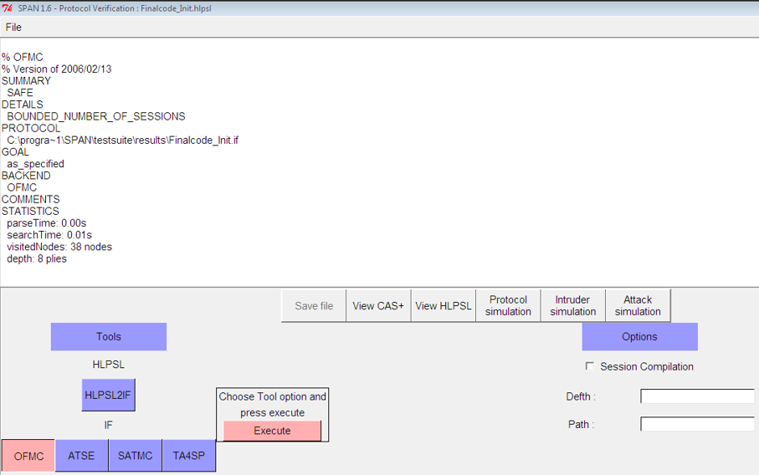

Figure 3: Initial Authentication for OFMC

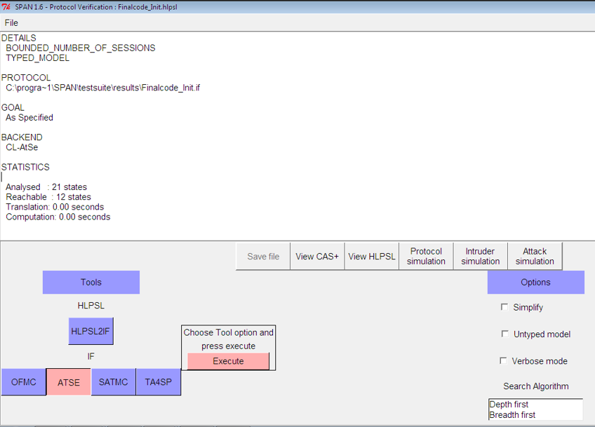

Figure 4: Initial Authentication for CL-AtSE
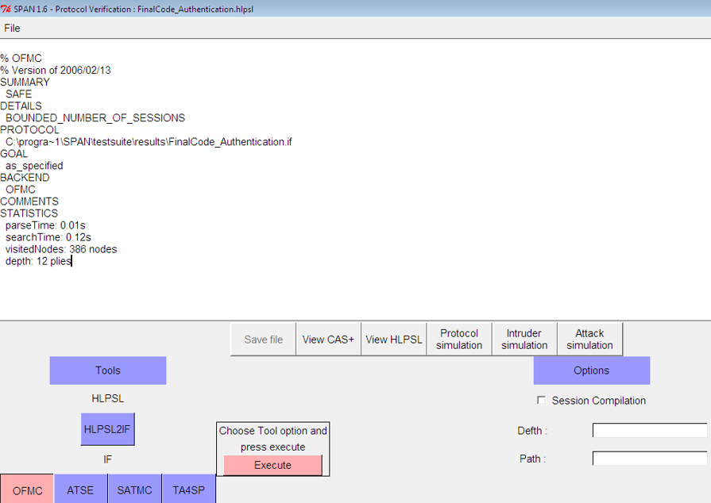

Figure 5: Final Authentication result for OFMC

Table 1: Performance statistics of Initial and Final Authentication protocols using OFMC and AtSE

Back end Tool | Statistics | Initial Authentication | Final Authentication
OFMC | Parse Time | 0.00s | 0.00s
OFMC | Search Time | 0.01s | 0.12s
OFMC | Visited Node | 38 nodes | 386 nodes
OFMC | Depth | 8 piles | 12 piles
CL-AtSE | Analysed | 21 states | 8080 states
CL-AtSE | Reachable | 12 states | 1360 states
CL-AtSE | Translation | 0.00s | 0.02s
CL-AtSE | Computation | 0.00s | 0.00s

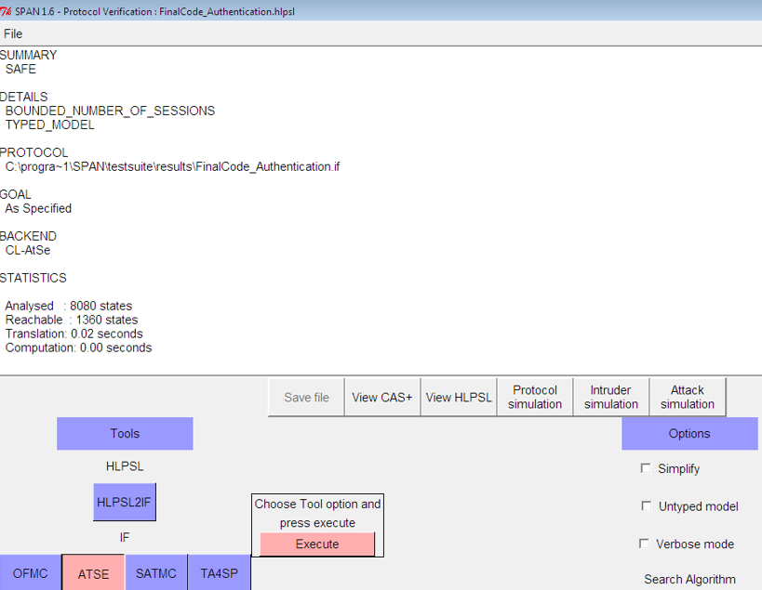
Figure 6: Final Authentication for CL-AtSE
Based on the simulation outcomes through OFMC and AtSE, the security and performance of the proposed BC structure were analysed and validated. These tools are commonly used for the formal verification of security protocols enabling the identification of potential vulnerabilities and ensuring that the BC architectures meets predefined security standards.

5.1 Results From OFMC Verification
In a simulation results Figure 7, which illustrates the normal message transaction flow between the BS, CH and SNs where no intruders are present in OFMC protocol which runs as intended with each node successfully going through BC based authentication process. The smart contracts execute properly validating the digital signatures and unique identifiers assigned to nodes ensuring that are authenticated and allowed to communicate. Meanwhile all messages are exchanged between nodes to maintain integrity and are not altered in transit, thereby smooth authentication process without any tampering. This is because of REO scheme works efficiently prolonged network life by managing node energy consumption effectively during cluster based routing.
When intruders are introduced into the simulation, the tools examine the system’s resilience to various attacks such as man in the middle, replay, impersonation or DoS attacks. The intruders attempt to interfere with the normal operation of the protocol by trying to impersonate nodes, intercept message or modify data. Figure 8 shows the message sequence diagram (MSD) with interference by intruders, highlighting their attempts to manipulate the system using the OFMC tool. The OFMC tool detects interference in authentication processes by highlighting areas and demonstrating how the protocol reacts to intruders. It uses nonces and cryptographic techniques like digital signatures to secure communication, preventing unauthorized access. When a legitimate node tries to impersonate another, OFMC detects errors in the digital signature validation process, which prompts a smart contract to reject the bogus node. With each message's distinct nonce, the BCs immutable ledger avoids duplicate intercepted communications. Also, OFMC makes sure that messages that have been replayed are recognised and removed. It also confirms that because all messages are hashed and signed before being transmitted, cryptographic protections prevent attempts to launch man-in-the-middle attacks.

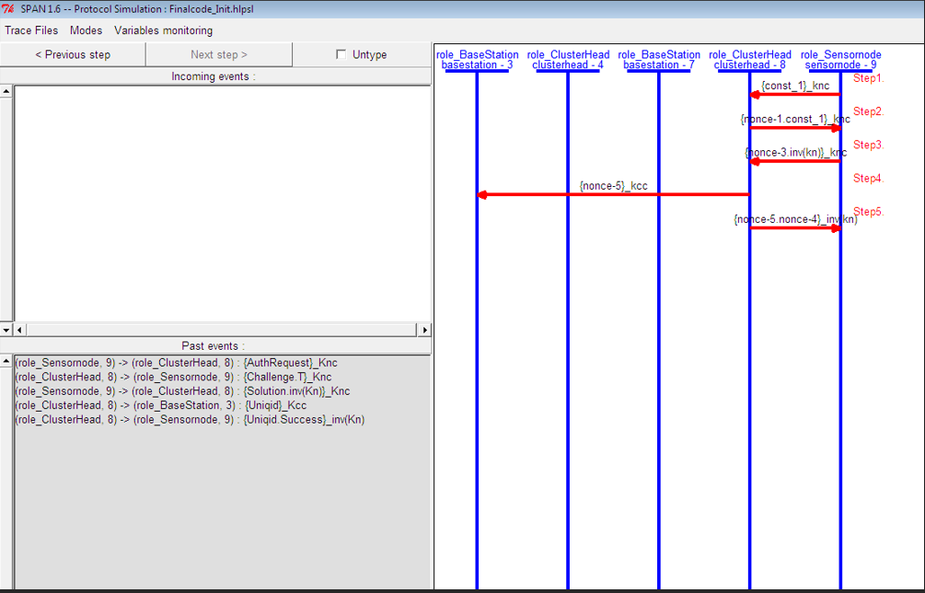

Figure 7: MSD for Initial Phase of BC based Authentication Protocol using OFMC
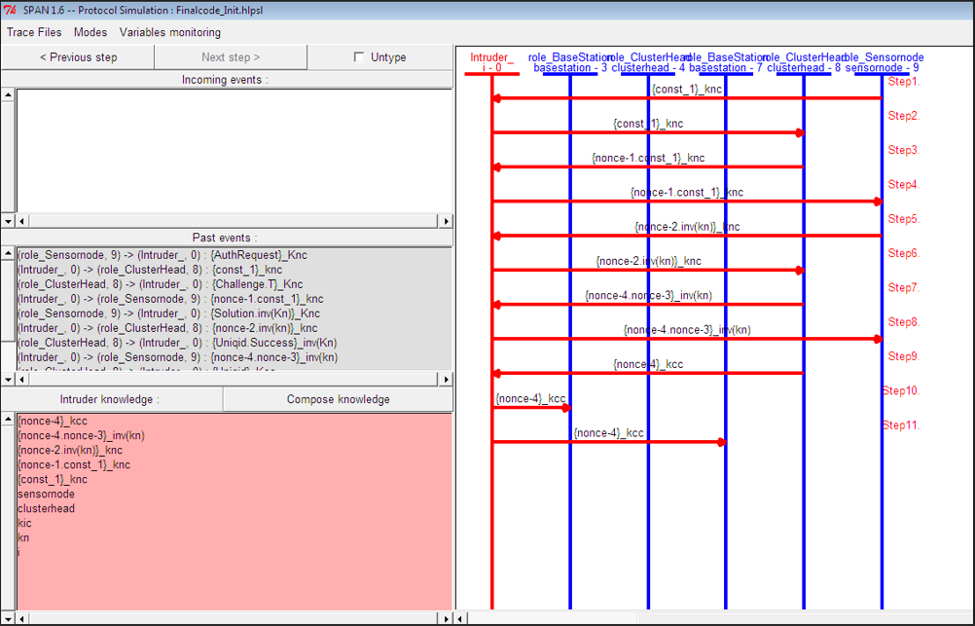

Figure 8: MSD for BC-Based Authentication Protocol with Intruder Interception using OFMC

5.2. Results From CL-ATSE Verification
Figure 9 depicts a secure message transaction between BS, CH and SNs without the presence of intruders using CL-AtSE which confirms that the BC structure operates logically with no inconsistencies in node identification or message exchanges. The assignment of unique node IDs (SNID, SMID and GID) proceeds seamlessly.

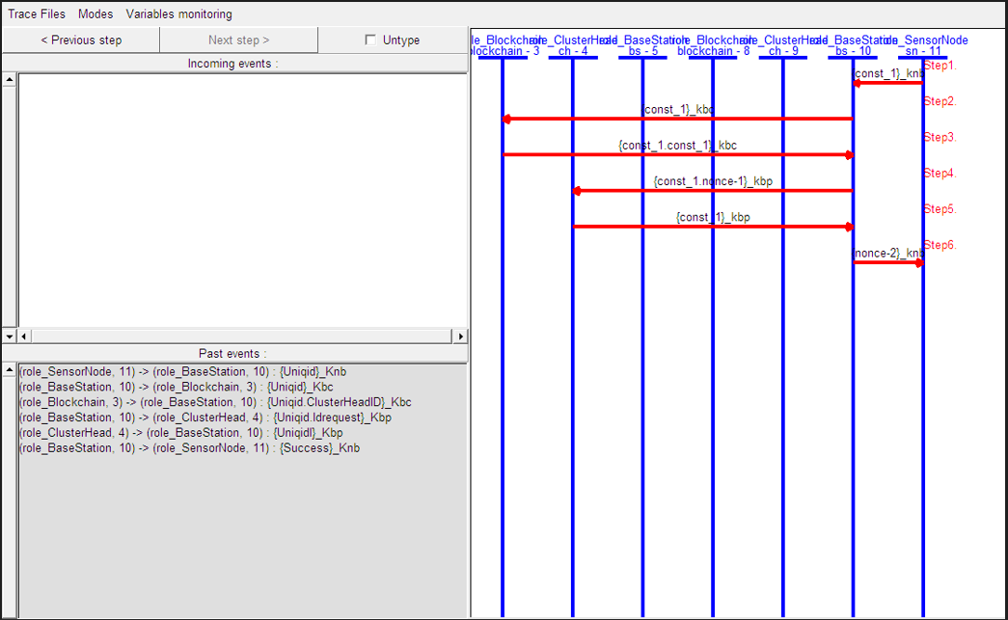

Figure 9: MSD for Initial Phase of BC based Authentication Protocol using CL-AtSE

This protocol satisfies all security properties under normal conditions. Nodes are successfully added to the network, their identities are stored immutably on the BC and there no risks of replay or message spoofing in the absence of malicious behaviour.
Figure 10 represents message transaction with intruders present, demonstrating the impact of intruder interference using the CL-AtSE tool. This result indicates that the BC topology works logically, with no inconsistencies in node identification or message exchange. The assignment of unique node IDs (SNID, CMID, and GID) is seamless. Under typical situations, the protocol meets all of the security requirements. Nodes are successfully joined to the network, their identities are immutably maintained on the BC, and there is no chance of replay or message spoofing in the absence of malicious behaviours.
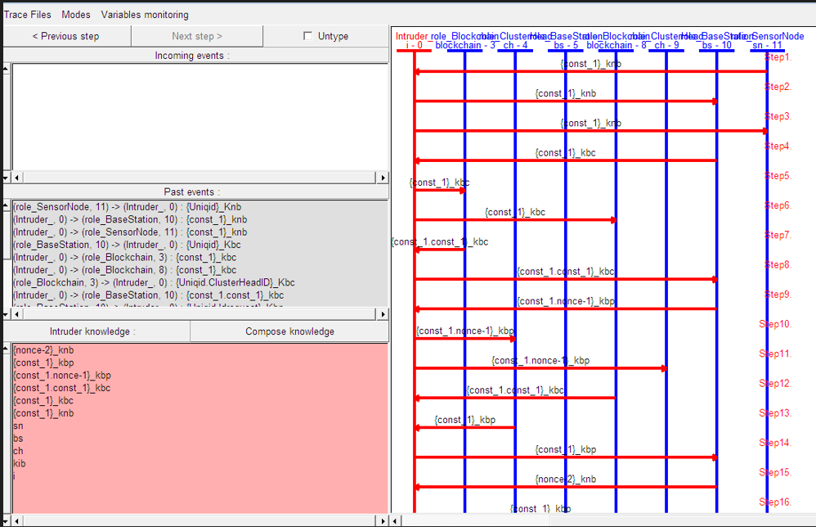

Figure 10: MSD for BC-Based Authentication Protocol with Intruder Interception using CL-AtSE

If a node fails multiple authentication attempts (due to an attacker controlling it or trying to use a false identity), the system automatically adds it to a blacklist, which is shared across the network. This ensures that malicious nodes are banned from re-entering the network, even though other CHs or base stations.

5.3 Analysis Of Informal Security
This section perform to evaluate how the proposed BCDAP mitigates potential vulnerabilities and how it compares to existing authentication schemes in terms of security.

- Resistance to Replay Attacks
Traditional authentication schemes, especially those relying on symmetric keys, face the risk of replay attacks, where attackers can intercept and reuse valid data for unauthorized access. BCDAP counters this by using nonce-based session key generation, ensuring uniqueness for each session. This combination of cryptographic nonce and a hash function rejects replayed authentication messages, providing a more robust defence against replay attacks and enhancing overall communication integrity.

- Mitigation of Sybil Attacks
WSN authentication schemes are vulnerable to Sybil attacks, where malicious nodes create multiple fake identities to disrupt network operations. BCDAP mitigates this risk by using a tamper-proof distributed ledger and BC consensus mechanism. This ensures each node has a uniquely registered identity, making it nearly impossible for attackers to generate fake identities. This approach significantly improves over centralized systems.

- Protection Against MITM Attacks
Another significant vulnerability in many WSNs is the risk of MITM attacks, where an attacker intercepts and alters communication between two legitimate entities. BCDAP addresses this by implementing mutual authentication via BC-based smart contracts. These contracts verify the identities of both parties, ensuring only verified nodes can participate in data exchanges. Additionally, communication is encrypted using session keys, providing an extra layer of protection against MITM attacks. BCDAP's use of BC-based verification offers enhanced security by preventing unauthorized interception or tampering with transmitted data.

- Prevention of Single Points of Failure (SPF)
In centralized authentication schemes, SPF such as compromised BS or CA can lead to collapse of network security. BCDAP eliminates this by distributing identity management across the BC, ensuring no single node or authority can compromise the network. This decentralization reduces targeted attacks and improves network resilience, unlike centralized systems where a single breach can expose the entire network to malicious activity.

- Energy Efficient Security (EES)
Existing Hybrid authentication schemes combining BC and traditional cryptographic methods often struggle with energy efficiency, especially in resource-constrained WSNs. BCDAP addresses this by integrating REO technique, which optimizes security processes for low power consumption. Further it uses to minimize energy use, ensuring robust security without overwhelming SN resources, giving it an edge over existing solutions with high energy costs.

- Defence against Identity Spoofing
Traditional centralized and light weight authentication schemes often face issues related to this attack, where attackers impersonate legitimate nodes to gain unauthorized access. BCDAP’s use of BC immutability ensures that once a node is registered, its identity cannot be altered or tampered with. The consensus-based identity verification process and tamper-resistant ledger prevent attackers from introducing fake nodes or altering node identities. This makes BCDAP a more secure alternative to traditional schemes that rely on less secure identity management techniques.
By comparing several existing BC based security solutions from the study [17] BC based multi WSN (BCMWSN), [26] Bubbles of Trust (BoT), [27] User Authentication Scheme using BC (UASBC) and [28] Three Tier BC (TTBC), as shown in Table 2, summarizes the vulnerabilities mitigated by various authentication schemes. The comparison further emphasizes BCDAP’s superiority in terms of security and efficiency. With its robust protection against Sybil, Spoofing, Replay an MITM attacks as well as its elimination of SPF and focus on EES, BCDAP stands out as a more scalable and secure solution for modern WSNs.

Table 2: Comparitive Analysis of Security Solutions against various attacks

Attacks | BoT[26] | UASBC [27] | TTBC [28] | BCMWSN [17] | proposed
Sybil
Spoofing
Message replay
Man in the Middle
EES
SPF

5.4 Message Size
The proposed work have compared the message size transmitted by different nodes such as CH nodes, ordinary nodes and BS during both registration and Authentication phase, with respect to previously established methods. For each phase, the Figure 11 compares the performance.

Figure 11: Analysis of transmitted message sizes across different nodes

This visualization highlights the optimized performance of the proposed method in comparison to the existing approach [17]. The proposed model shows a significant reduction in message sizes for all nodes across both phases. The CH node exhibits the largest message transmission in both models but with noticeable improvements in the proposed approach, especially in the authentication phase. The ordinary node and base station also benefits from reduced message sizes, indicating increased network efficiency in the proposed model.

5.5. Computation And Cost Comparison
This section compares the computational costs and resource efficiency of the proposed BCDAP with existing methods, focusing on its advantages in terms of computational overhead, energy consumption, and scalability for resource-constrained WSNs. Traditional WSN authentication schemes have high computational costs due to public key operations and certificate validation. Hybrid schemes using BC and traditional encryption often use resource-intensive consensus mechanisms like PoW, which are not suitable for energy-constrained environments like WSNs. The BCDAP offers improved computational efficiency, which require less computational power and reduce energy impact on SNs. Additionally, BCDAP's REO technique minimizes energy required for authentication and communication processes, making it suitable for large-scale WSNs with limited resources. Table 3 provides a comparative analysis of different authentication methods [35] such as ECO-LEACH, LEACH, DDR-LEACH, PEGASIS and LEACH-PSO used in WSNs, focussing on key factors such as computational cost, energy consumption and scalability highlighting how the proposed BCDAP outperforms traditional method in terms of efficiency and resource usage. ECO-LEACH and PEGASIS exhibit high computational costs 740s and 700s and limited scalability, making them less suitable for large networks. LEACH, DDR-LEACH and LEACH-PSO offer moderate computational costs ranging from 590s to 620s and moderate scalability, balancing the energy use and network performance. In contrast, the proposed method demonstrates a low computational cost, minimal energy consumption and high scalability making it an optimized solution for large, more efficient WSNs.

Table 3: Comparitive Analysis

Method | Computational Cost (per average network life time) | Average Energy Consumption (Joules) | Scalability
ECO-LEACH [35] | High (740s) | 0.6 | Limited
LEACH [35] | Moderate (590s) | 0.8 | Moderate
DDR-LEACH [35] | Moderate (650s) | 0.7 | Moderate
PEGASIS [35] | High (700s) | 0.9 | Limited
LEACH-PSO [35] | Moderate (620s) | 0.75 | Moderate
Proposed | Low (500s) | 0.5 | High

6. CONCLUSION
The proposed research introduces a BDCAP for WSNs to significantly enhance security, scalability and reliability against various attacks. This protocol was rigorously evaluated using the AVISPA tool, employing OFMC and CL-AtSE back ends to detect potential vulnerabilities. The results confirmed the protocol’s resilience in authenticating nodes, even in the presence of malicious intruders. By leveraging the decentralized nature of BC, BCDAP ensured secure communication between nodes, mitigating risks such as identify spoofing and unauthorized access. The protocol effectively managed network transactions maintaining seamless communication during normal conditions and swiftly detecting and neutralizing threats when intruders were present. The inclusion of BCs immutable ledger further bolstered security by preventing tampering and manipulation by malicious nodes. Moreover, the REO technique ensured the protocol’s performance remained energy efficient even in resource constrained WSNs, thereby prolonging the network’s lifespan. The study concludes that the integration of BC within WSNs guarantees communication efficiency and scalability while also improving security. Future work will focus on optimizing the computational efficiency of proposed BC based authentication protocol to better suit resource constrained environments like WSNs. Additionally, enhancing the protocol’s defences against more advanced and sophisticated attack vectors will be explored to further strengthen network security.

CONFLICT OF INTEREST
They author declare that have no conflict of interest

Ethical Approval
Institutional Review Board approval was not required.

Consent for Participate
All contributors agreed and given consent to participate.

Consent for Publication
All contributors agreed and given consent to Publish.

Data availability
No data, models, or code were generated or used during the study

Competing interests
None

Funding
The authors state that this work has not received any funding.

Author Contribution
The authors confirm contribution to the paper as follows and all authors reviewed the results and approved the final version of the manuscript.

REFERENCES
- Daousis, S., Peladarinos, N., Cheimaras, V., Papageorgas, P., Piromalis, D. D., & Munteanu, R. A. (2024). Overview of Protocols and Standards for Wireless Sensor Networks in Critical Infrastructures. Future Internet, 16(1), 33.
- Lata, S., Mehfuz, S., & Urooj, S. (2021). Secure and reliable wsn for internet of things: Challenges and enabling technologies. IEEE Access, 9, 161103-161128.
- Abidin, S., Vadi, V. R., & Rana, A. (2021). On confidentiality, integrity, authenticity, and Freshness (CIAF) in WSN. In Advances in Computer, Communication and Computational Sciences: Proceedings of IC4S 2019 (pp. 87-97). Springer Singapore.
- Ismail, S., Dawoud, D. W., & Reza, H. (2023). Securing wireless sensor networks using machine learning and blockchain: A review. Future Internet, 15(6), 200.
- Gautam, A. K., & Kumar, R. (2021). A comprehensive study on key management, authentication and trust management techniques in wireless sensor networks. SN Applied Sciences, 3(1), 50.
- Lin, D., Wang, Q., Min, W., Xu, J., & Zhang, Z. (2020). A survey on energy-efficient strategies in static wireless sensor networks. ACM Transactions on Sensor Networks (TOSN), 17(1), 1-48.
- Nakas, C., Kandris, D., & Visvardis, G. (2020). Energy efficient routing in wireless sensor networks: A comprehensive survey. Algorithms, 13(3), 72.
- Wang, Z., Ding, H., Li, B., Bao, L., & Yang, Z. (2020). An energy efficient routing protocol based on improved artificial bee colony algorithm for wireless sensor networks. ieee access, 8, 133577-133596.
- Alaerjan, A. (2023). Towards sustainable distributed sensor networks: An approach for addressing power limitation issues in WSNs. Sensors, 23(2), 975.
- Al-Atawi, A. A. Extending the Energy Efficiency of Nodes in an Internet of Things (IoT) System via Robust Clustering Techniques.
- Gil Canalias, S. (2024). Securing IoT Communications with Blockchain-Based Authentication (Bachelor's thesis, Universitat Politècnica de Catalunya).
- Adday, G. H., Subramaniam, S. K., Zukarnain, Z. A., & Samian, N. (2022). Fault tolerance structures in wireless sensor networks (WSNs): Survey, classification, and future directions. Sensors, 22(16), 6041.
- Adu-Manu, K. S., Engmann, F., Sarfo-Kantanka, G., Baiden, G. E., & Dulemordzi, B. A. (2022). WSN protocols and security challenges for environmental monitoring applications: A survey. Journal of Sensors, 2022(1), 1628537.
- Ilyas, M., Ullah, Z., Khan, F. A., Chaudary, M. H., Malik, M. S. A., Zaheer, Z., & Durrani, H. U. R. (2020). Trust-based energy-efficient routing protocol for Internet of things–based sensor networks. International Journal of Distributed Sensor Networks, 16(10), 1550147720964358.
- Khan, A. U., Javaid, N., Khan, M. A., & Ullah, I. (2023). A blockchain scheme for authentication, data sharing and nonrepudiation to secure internet of wireless sensor things. Cluster Computing, 26(2), 945-960.
- Mubarakali, A. (2022). An efficient authentication scheme using blockchain technology for wireless sensor networks. Wireless Personal Communications, 127(1), 255-269.
- Cui, Z., Fei, X. U. E., Zhang, S., Cai, X., Cao, Y., Zhang, W., & Chen, J. (2020). A hybrid blockchain-based identity authentication scheme for multi-WSN. IEEE Transactions on Services Computing, 13(2), 241-251.
- Dener, M., & Orman, A. (2023). Bbap-wsn: a new blockchain-based authentication protocol for wireless sensor networks. Applied Sciences, 13(3), 1526.
- Awan, S., Sajid, M. B. E., Amjad, S., Aziz, U., Gurmani, U., & Javaid, N. (2022). Blockchain based authentication and trust evaluation mechanism for secure routing in wireless sensor networks. In Innovative Mobile and Internet Services in Ubiquitous Computing: Proceedings of the 15th International Conference on Innovative Mobile and Internet Services in Ubiquitous Computing (IMIS-2021) (pp. 96-107). Springer International Publishing.
- Amjad, S., Aziz, U., Gurmani, M. U., Awan, S., Sajid, M. B. E., & Javaid, N. (2021). Blockchain based Authentication for end-nodes and efficient Cluster Head selection in Wireless Sensor Networks. In Complex, Intelligent and Software Intensive Systems: Proceedings of the 15th International Conference on Complex, Intelligent and Software Intensive Systems (CISIS-2021) (pp. 195-205). Springer International Publishing.
- Gao, S., Su, Q., Zhang, R., Zhu, J., Sui, Z., & Wang, J. (2021). A Privacy‐Preserving Identity Authentication Scheme Based on the Blockchain. Security and Communication Networks, 2021(1), 9992353.
- Aziz, U., Gurmani, M. U., Awan, S., Sajid, M. B. E., Amjad, S., & Javaid, N. (2022). A blockchain based secure authentication and routing mechanism for wireless sensor networks. In Innovative Mobile and Internet Services in Ubiquitous Computing: Proceedings of the 15th International Conference on Innovative Mobile and Internet Services in Ubiquitous Computing (IMIS-2021) (pp. 87-95). Springer International Publishing.
- Chen, Y., Yang, X., Li, T., Ren, Y., & Long, Y. (2022). A blockchain-empowered authentication scheme for worm detection in wireless sensor network. Digital Communications and Networks.
- Bhawiyuga, A. (2024). Data Collision Avoidance based on TDMA in LoRa Wireless Sensor Networks. Journal of Information Technology and Computer Science, 9(2), 195-207.
- Vigan‘o L(2006) Automated security protocol analysis with the AVISPA tool. Electron. Notes Theor. Comput. Sci. 155:61–86
- M. T. Hammi, B. Hammi, P. Bellot, and A. Serhrouchni, “Bubbles of trust: A decentralized blockchain-based authentication system for iot,” COMPUTERS & SECURITY, vol. 78, pp. 126–142, 2018.
- R. Almadhoun, M. Kadadha, M. Alhemeiri, M. Alshehhi, and K. Salah, “A user authentication scheme of iot devices using blockchain-enabled fog nodes,” in 2018 IEEE/ACS 15th Interna tional Conference on Computer Systems and Applications (AICCSA), 2018.
- Z. Bao, W. Shi, D. He, and K. K. R. Chood, “Iotchain: A three-tier blockchain-based iot security architecture,” CoRR, vol. abs/1806.02008, 2018.
- Guerrero-Sanchez, A. E., Rivas-Araiza, E. A., Gonzalez-Cordoba, J. L., Toledano-Ayala, M., & Takacs, A. (2020). Blockchain mechanism and symmetric encryption in a wireless sensor network. Sensors, 20(10), 2798.
- Li, B., Zheng, M., & Ma, M. (2024). A Novel Security Scheme Supported by Certificateless Digital Signature and Blockchain in Named Data Networking. IET Information Security, 2024(1), 6616095.
- Gurusamy, V., Praveenkumar, P., Jebaraj, J. R., Ranjithi, M., & Raphael, B. L. (2024, March). A lightweight multi-layer authentication protocol for wireless sensor networks in IoT applications. In AIP Conference Proceedings (Vol. 2966, No. 1). AIP Publishing.
- Ismail, S., Dawoud, D. W., & Reza, H. (2023). Securing wireless sensor networks using machine learning and blockchain: A review. Future Internet, 15(6), 200.
- Dener, M., & Orman, A. (2023). Bbap-wsn: a new blockchain-based authentication protocol for wireless sensor networks. Applied Sciences, 13(3), 1526.
- Saeed, K., Khalil, W., Al-Shamayleh, A. S., Ahmed, S., Akhunzada, A., Alharthi, S. Z., & Gani, A. (2023). A comprehensive analysis of security-based schemes in underwater wireless sensor networks. Sustainability, 15(9), 7198.
- AB, F. K. (2023). ECO-LEACH: A Blockchain-Based Distributed Routing Protocol for Energy-Efficient Wireless Sensor Networks.

